Synthesis of supramolecular complex based on β-cyclodextrin and melamine
To synthesise β-CD/ME supramolecular complex, 1702.5 mg of β-CD (99%, Yuwi Jinchi Cosmetics Co Ltd. China.) was dissolved in 100 ml of distilled water. Also, 189 mg of ME was dissolved in 100 ml of distilled water. Both solutions were mixed separately for 30 min, then stirred (72 °C, 900 r/min) for 3 hours. The resulting supramolecular product was then precipitated at 0 °C for 24 hours. The resulting product was filtered and dried at 87 °C (5 hours). For purification, the product was dissolved in distilled water and the resulting solution was recrystallised by cooling in a refrigerator at a temperature of 0 ºC. The above recrystallisation process was repeated 3 times. As a result, 1380.8 mg (73%) of targetted product was formed. The resulting solid state product was named β-CD/ME supramolecular complex. The reaction schema for the synthesis of a supramolecular complex based on β-cyclodextrin and melamine is written as follows (Schema 1):
Schema 1S. Reaction procedure of β-CD/ME supramolecular complex.
Figure 1S. Raman spectroscopy of β-CD.
Figure 2S. Raman spectroscopy of ME.
Figure 3S. Raman spectroscopy of β-CD/ME.

Figure 4S. IQ of β-CD.
Figure 5S. IQ of ME.
Figure 6S. IQ of β-CD/ME.
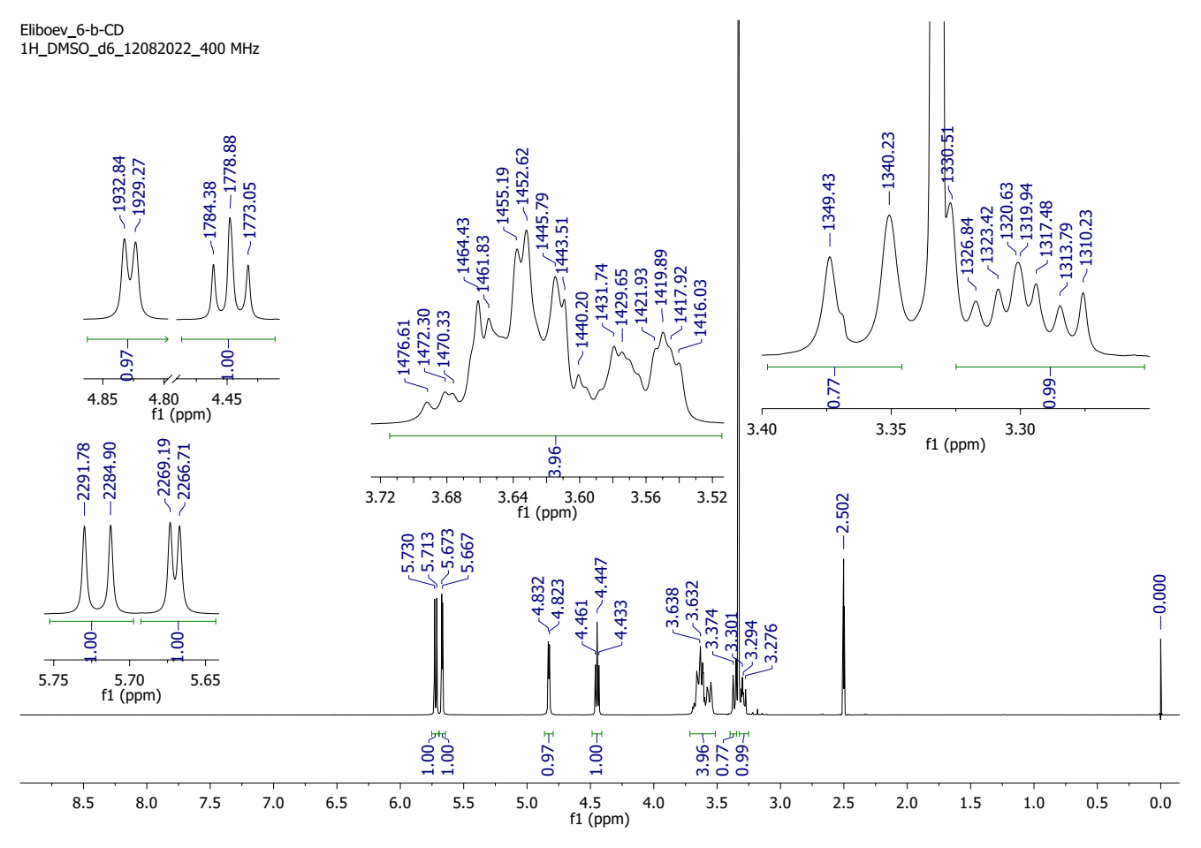
Figure 7S. ¹H NMR of β-CD.
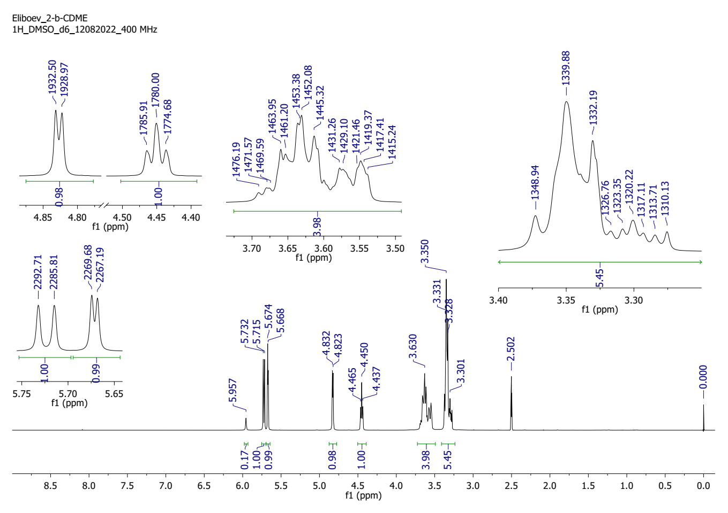
Figure 8S. ¹H NMR of β-CD/ME.

Table 1S. TG results of β-SD.
№ | Temperature, ºC | Mass loss, % | Rate in mass loss, mg/min | DTA, uV
1 | 37 | - | - | -5.238
2 | 80 | 1.0843 | 0.0741 | -8.654
3 | 90 | 1.3253 | 0.2376 | -7.81
4 | 100 | 2.8112 | 1.5867 | -12.032
5 | 110 | 4.8193 | 1.0684 | -17.062
6 | 120 | 7.3092 | 1.3196 | -20.652
7 | 130 | 10.2811 | 1.6062 | -19.42
8 | 140 | 11.4458 | 0.6473 | -12.882
9 | 150 | 12.0482 | 0.4100 | -2.714
10 | 160 | 12.0482 | 0.0000 | 2.728
11 | 170 | 12.1687 | 0.0681 | 4.418
12 | 180 | 12.4498 | 0.1731 | 4.724
13 | 190 | 12.4498 | 0.0000 | 4.692
14 | 200 | 12.4498 | 0.0000 | 4.686
15 | 210 | 12.4498 | 0.0000 | 4.582
16 | 220 | 12.4498 | 0.0000 | 4.37
17 | 230 | 12.4498 | 0.0000 | 4.692
18 | 240 | 12.4498 | 0.0000 | 4.864
19 | 250 | 12.4498 | 0.0000 | 4.934
20 | 260 | 12.4498 | 0.0000 | 4.98
21 | 270 | 12.4498 | 0.0000 | 4.967999
22 | 280 | 12.4498 | 0.0000 | 5.16
23 | 290 | 12.4498 | 0.0000 | 5.3
24 | 300 | 12.8514 | 0.2187 | 5.176
25 | 310 | 12.8514 | 0.0000 | 4.604
26 | 320 | 13.7349 | 0.4667 | 3.474
27 | 330 | 14.5783 | 0.4650 | 6.9
28 | 340 | 22.7309 | 4.6893 | 13.298
29 | 350 | 34.2972 | 6.3955 | 14.748
30 | 360 | 48.1526 | 7.7011 | 17.096
31 | 370 | 62.0482 | 7.6258 | 18.504
32 | 380 | 72.4900 | 5.4313 | 20.206
33 | 390 | 79.0763 | 3.4655 | 21.434
34 | 400 | 81.9277 | 1.4945 | 24.194
35 | 410 | 82.9317 | 0.5289 | 24.65
36 | 420 | 83.9357 | 0.5147 | 22.838
37 | 430 | 85.1406 | 0.6044 | 21.34
38 | 440 | 85.5422 | 0.2112 | 20.5
39 | 450 | 85.9438 | 0.2016 | 19.562
40 | 460 | 86.3454 | 0.1993 | 18.676
41 | 470 | 87.1486 | 0.4002 | 18.164
42 | 480 | 87.7912 | 0.3344 | 17.834
43 | 490 | 88.3534 | 0.2895 | 17.53
44 | 500 | 88.7550 | 0.2105 | 17.234

Table 1S (continue). TG results of ME.
№ | Temperature, ºC | Mass loss, % | Rate in mass loss, mg/min | DTA, uV
1 | 35.4 | - | - | 0.82
2 | 80 | 0.0000 | 0.0000 | 7.916
3 | 90 | 0.0000 | 0.0000 | 7.99
4 | 100 | 0.0000 | 0.0000 | 8.008
5 | 110 | 0.0000 | 0.0000 | 7.902
6 | 120 | 0.4717 | 0.2306 | 7.682
7 | 130 | 0.4717 | 0.0000 | 7.076
8 | 140 | 0.4717 | 0.0000 | 6.568
9 | 150 | 0.4717 | 0.0000 | 5.952
10 | 160 | 0.8491 | 0.1896 | 5.43
11 | 170 | 0.9434 | 0.0470 | 4.878
12 | 180 | 0.9434 | 0.0000 | 4.318
13 | 190 | 0.9434 | 0.0000 | 3.774
14 | 200 | 1.0849 | 0.0682 | 3.184
15 | 210 | 1.4151 | 0.1588 | 2.548
16 | 220 | 1.4151 | 0.0000 | 1.942
17 | 230 | 1.8868 | 0.2118 | 1.452
18 | 240 | 2.0283 | 0.0704 | 0.83
19 | 250 | 2.3585 | 0.1542 | 0.176
20 | 260 | 2.8302 | 0.2198 | -0.432
21 | 270 | 2.8302 | 0.0000 | -1.182
22 | 280 | 3.6321 | 0.3688 | -2.064
23 | 290 | 4.2453 | 0.2772 | -4.818
24 | 300 | 5.7547 | 0.6685 | -6.342
25 | 310 | 7.2642 | 0.6762 | -8.2079
26 | 320 | 10.1887 | 1.2952 | -10.558
27 | 330 | 14.1038 | 1.6722 | -14.822
28 | 340 | 19.2453 | 2.2527 | -18.114
29 | 350 | 26.6981 | 3.1388 | -22.314
30 | 360 | 36.3679 | 4.0392 | -24.75
31 | 370 | 48.6792 | 4.8096 | -26.02
32 | 380 | 62.3113 | 4.8963 | -27.02
33 | 390 | 84.4340 | 8.2774 | -25.838
34 | 400 | 90.7075 | 3.9075 | -17.836
35 | 410 | 92.9245 | 1.1783 | -12.422
36 | 420 | 93.3962 | 0.2349 | -13.792
37 | 430 | 93.8679 | 0.2121 | -15.408
38 | 440 | 94.3396 | 0.2049 | -16.84
39 | 450 | 94.8113 | 0.1986 | -17.834
40 | 460 | 94.8113 | 0.0000 | -18.638
41 | 470 | 95.2830 | 0.2028 | -19.54
42 | 480 | 95.3774 | 0.0398 | -20.39
43 | 490 | 95.7547 | 0.1618 | -21.152
44 | 500 | 96.2264 | 0.2044 | -21.724
Table 1S (continue). TG results of mechanical mixture (β-CD +ME).
№ | Temperature, ºC | Mass loss, % | Rate in mass loss, mg/min | DTA, uV
1 | 35,4 | - | - | -0.296
2 | 80 | 0.0433 | 0.0031 | -5.354
3 | 90 | 1.3853 | 0.6709 | -8.368
4 | 100 | 3.1602 | 0.8410 | -12.57
5 | 110 | 5.2381 | 1.0886 | -16.63
6 | 120 | 8.0952 | 1.3284 | -19.866
7 | 130 | 9.9567 | 0.9892 | -16.702
8 | 140 | 10.7792 | 0.4690 | -9.31
9 | 150 | 11.2554 | 0.2685 | -2.786
10 | 160 | 11.2554 | 0.0000 | -0.268
11 | 170 | 11.2554 | 0.0000 | 0.08
12 | 180 | 11.2554 | 0.0000 | -0.16
13 | 190 | 11.6883 | 0.2317 | -0.56
14 | 200 | 11.6883 | 0.0000 | -0.914
15 | 210 | 12.1212 | 0.2297 | -1.294
16 | 220 | 12.1212 | 0.0000 | -1.8
17 | 230 | 12.5541 | 0.2218 | -2.182
18 | 240 | 12.5541 | 0.0000 | -2.058
19 | 250 | 12.5541 | 0.0000 | -2.168
20 | 260 | 12.9437 | 0.1997 | -2.626
21 | 270 | 12.9870 | 0.0217 | -3.17
22 | 280 | 13.5498 | 0.2857 | -3.662
23 | 290 | 14.2857 | 0.3685 | -3.994
24 | 300 | 15.6710 | 0.6830 | -3.332
25 | 310 | 17.7056 | 1.0365 | -0.326
26 | 320 | 19.4805 | 0.9437 | 5.401999
27 | 330 | 23.3766 | 2.0827 | 8.74
28 | 340 | 40.1732 | 8.6255 | 14.258
29 | 350 | 62.3377 | 11.8122 | 24.602
30 | 360 | 68.5281 | 3.8220 | 48.196
31 | 370 | 71.4286 | 1.6176 | 50.518
32 | 380 | 72.9004 | 0.7057 | 43.622
33 | 390 | 74.0260 | 0.5066 | 36.332
34 | 400 | 75.2814 | 0.5682 | 30.152
35 | 410 | 76.1905 | 0.4112 | 24.886
36 | 420 | 77.0563 | 0.3893 | 20.328
37 | 430 | 78.3550 | 0.5944 | 16.734
38 | 440 | 78.7879 | 0.1997 | 13.746
39 | 450 | 79.6537 | 0.3977 | 11.412
40 | 460 | 80.5195 | 0.4025 | 9.746
41 | 470 | 81.6450 | 0.5327 | 8.598
42 | 480 | 82.7273 | 0.5021 | 7.736
43 | 490 | 83.9827 | 0.5895 | 7.086
44 | 500 | 85.2814 | 0.6098 | 6.686
Table 1S (continue). TG results of β-CD/ME complex.
№ | Temperature, ºC | Mass loss, % | Rate in mass loss, mg/min | DTA, uV
1 | 26,1 | - | - | 2.52
2 | 80 | 2.9839 | 0.0977 | 3.342
3 | 90 | 5.4839 | 0.6624 | 2.798
4 | 100 | 7.6613 | 0.5769 | 1.69
5 | 110 | 10.7258 | 0.8352 | 0.61
6 | 120 | 14.5161 | 1.0359 | 0.694
7 | 130 | 16.9355 | 0.6032 | 1.996
8 | 140 | 17.7419 | 0.2791 | 3.788
9 | 150 | 18.5484 | 0.2433 | 4.716
10 | 160 | 18.7097 | 0.0461 | 5.0520
11 | 170 | 19.3548 | 0.1977 | 5.362
12 | 180 | 20.1613 | 0.2370 | 5.448
13 | 190 | 20.5645 | 0.1172 | 5.47
14 | 200 | 20.9677 | 0.1129 | 5.522
15 | 210 | 20.9677 | 0.0000 | 5.464
16 | 220 | 20.9677 | 0.0000 | 5.484
17 | 230 | 22.0161 | 0.2888 | 5.38
18 | 240 | 22.8226 | 0.2221 | 5.322
19 | 250 | 23.3871 | 0.1563 | 5.5
20 | 260 | 23.3871 | 0.0000 | 5.618
21 | 270 | 23.3871 | 0.0000 | 5.628
22 | 280 | 23.3871 | 0.0000 | 5.596
23 | 290 | 23.9516 | 0.1519 | 5.686
24 | 300 | 25.0000 | 0.2854 | 6.002
25 | 310 | 25.8065 | 0.2256 | 6.4019
26 | 320 | 26.9355 | 0.3160 | 6.846
27 | 330 | 28.2258 | 0.3436 | 6.6519
28 | 340 | 34.3548 | 1.6751 | 10.136
29 | 350 | 43.4677 | 2.4708 | 11.552
30 | 360 | 62.5000 | 5.5309 | 12.628
31 | 370 | 75.4839 | 3.4923 | 13.706
32 | 380 | 84.1935 | 2.3166 | 16.298
33 | 390 | 88.7097 | 1.2243 | 19.194
34 | 400 | 90.3226 | 0.4180 | 19.408
35 | 410 | 91.9355 | 0.4081 | 17.618
36 | 420 | 92.7419 | 0.2045 | 15.94
37 | 430 | 93.5484 | 0.2079 | 14.83
38 | 440 | 94.3548 | 0.2043 | 13.888
39 | 450 | 94.3548 | 0.0000 | 13.304
40 | 460 | 95.1613 | 0.2004 | 12.87
41 | 470 | 95.1613 | 0.0000 | 12.4
42 | 480 | 96.7742 | 0.4014 | 11.922
43 | 490 | 97.0968 | 0.0812 | 11.53
44 | 500 | 97.2581 | 0.1852 | 10.686

Table 2S. Results of gravimetric determination of the effectiveness of β-CD/ME inhibitor at different temperatures and concentrations in 0.5 M HCl medium.
C_{ing}, mg/L/mM | Тemperatura, К | CR_{Grav.}, mg/sm²·soat | η_{Grav.}, % | θ_{Grav.}
Fon | 303 | 1.67 | - | -
25/0.02 | 303 | 0.269 | 83.89 | 0.8389
50/0.04 | 303 | 0.211 | 87.37 | 0.8737
75/0.06 | 303 | 0.124 | 92.57 | 0.9257
100/0.08 | 303 | 0.052 | 96.89 | 0.9689
Fon | 313 | 1.84 | - | -
25/0.02 | 313 | 0.332 | 81.96 | 0.8196
50/0.04 | 313 | 0.268 | 85.43 | 0.8543
75/0.06 | 313 | 0.224 | 87.83 | 0.8783
100/0.08 | 313 | 0.15 | 91.85 | 0.9185
Fon | 323 | 2.01 | - | -
25/0.02 | 323 | 0.412 | 79.50 | 0.7950
50/0.04 | 323 | 0.351 | 82.54 | 0.8254
75/0.06 | 323 | 0.302 | 84.98 | 0.8498
100/0.08 | 323 | 0.252 | 87.46 | 0.8746
Fon | 333 | 2.18 | - | -
25/0.02 | 333 | 0.521 | 76.10 | 0.7610
50/0.04 | 333 | 0.473 | 78.30 | 0.7830
75/0.06 | 333 | 0.421 | 80.69 | 0.8069
100/0.08 | 333 | 0.378 | 82.66 | 0.8266

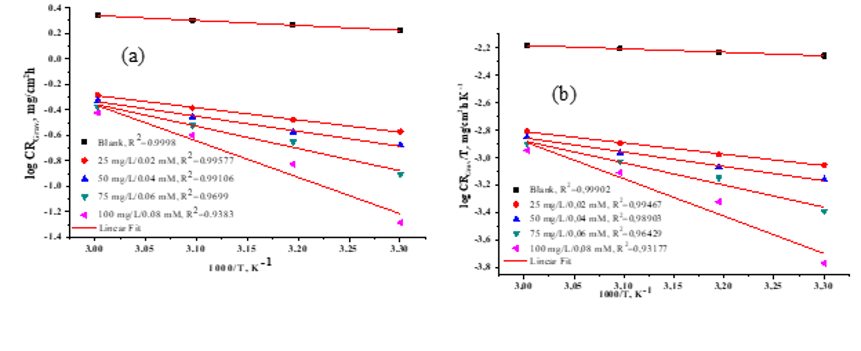Figure 9S. (a) Arrhenius and (b) trans-station plots of the corrosive and inhibited systems
(β-CD/ME).
Table 3S. Thermodynamic activation function values for systems that are both uninhibited and inhibited (β-CD/ME).
Functions | Blank | 25 mg/L/ 0.02 mM | 50 mg/L/ 0.04 mM | 75 mg/L/ 0.06 mM | 100 mg/L/ 0.08 mM
E_{a}, kJ/mol | 7.45 | 18.42 | 22.53 | 33.39 | 54.59
∆H_{a}, kJ/mol | 4.81 | 15.78 | 19.89 | 30.75 | 51.94
∆S_{a} kJ/mol T | -382.09 | -361.16 | -349.71 | -317.57 | -254.04
E_{a}-∆H_{a} | 2.64 | 2.64 | 2.64 | 2.64 | 2.65

Figure 10S. (a) Arrhenius and (b) trans-station plots of the corrosive and inhibited systems
(β-CD/ME).
Table 4S. Values in thermodynamic functions of activation for uninhibited and inhibited systems (β-CD/ME).
Temperature, K | $K_{ads}$, M⁻¹ | ∆$G_{ads}^{o}$, kJ/mol | ∆$H_{ads}^{o}$, kJ/mol | ∆$S_{ads}^{o}$, J/mol K
303 | 183.48 | -23.25 | -12.86 | -119.5
313 | 234.74 | -24.66 | -12.86 | -119.5
323 | 273.97 | -25.86 | -12.86 | -119.5
333 | 291.54 | -26.84 | -12.86 | -119.5

Figure 11S. Raman spectra of Fe surface after immersion in 0.5 M HCl.
Figure 12S. Raman spectra of Fe surface after immersion in 0.5 M HCl with the addition of β-CD/ME.

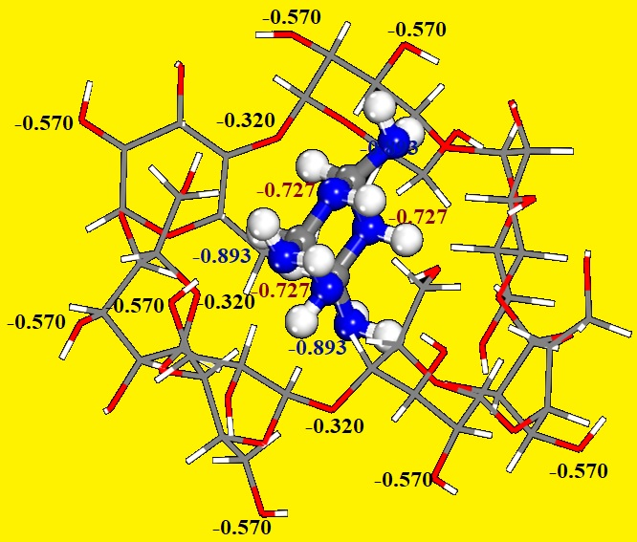
Figure 13S. The Mulliken Atomic Charges (MAC) distribution for oxygen (O) and nitrogen (N) atoms in the supramolecular (host-guest) complex of β-cyclodextrin and melamine inhibitor.
Table 5S: Calculated theoretical parameters of the β-cyclodextrin and melamine supramolecular(Host-guest) Complex inhibitor.
Theoretical parameters | Complex inhibitor
E_{HOMO} (eV)  E_{LUMO} (eV)  ΔE (eV)  I (eV)  A (eV)  χ (eV)  η (eV)  σ (eV⁻¹)  ∆N  ∆E_{back-donation} | -5.717  0.240  5.951  5.717  -0.240  2.738  2.978  0.335  0.715  -0.744

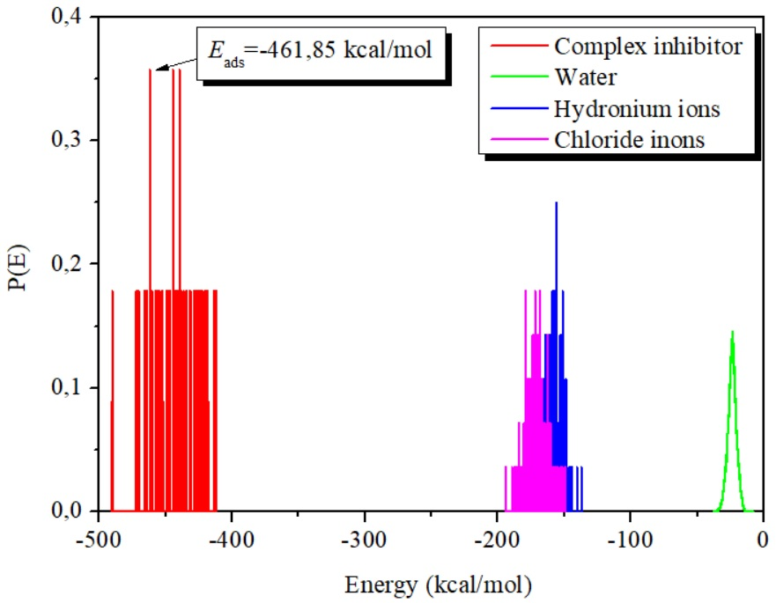
Figure 14S. Adsorption energy distribution curves of the β- cyclodextrin and melamine supramolecular(Host-guest) Complex inhibitor, obtained via MC.

