Supplementary Figures and figures legends
Figure S1
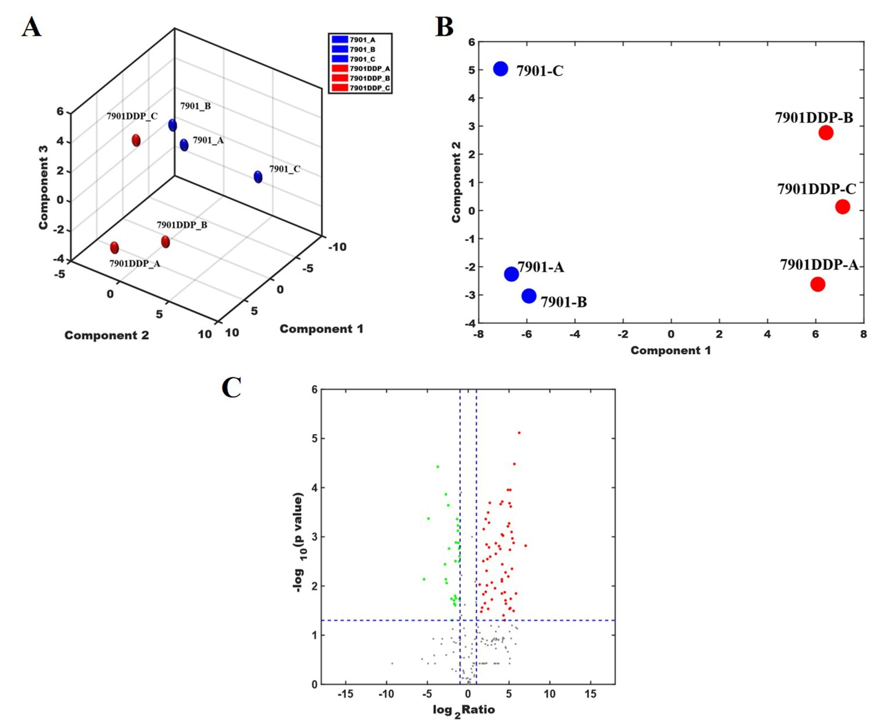Figure S1. Principal Component Analysis (PCA) for the differentially expressed proteins between SGC7901R cells exosomes and SGC7901S cells exosomes that detected by LC-MS/MS. (A) PCA chart. (B) PCA chart (two dimensional graph). (C) Differential protein screening volcano graph. The X-axis represents the ratio of protein in the experimental group and the control group, and the Y-axis represents the p value of the repeated test results, and each point in the figure represents a protein. Red areas are up-regulated proteins and green areas are down-regulated proteins.

Figure S2
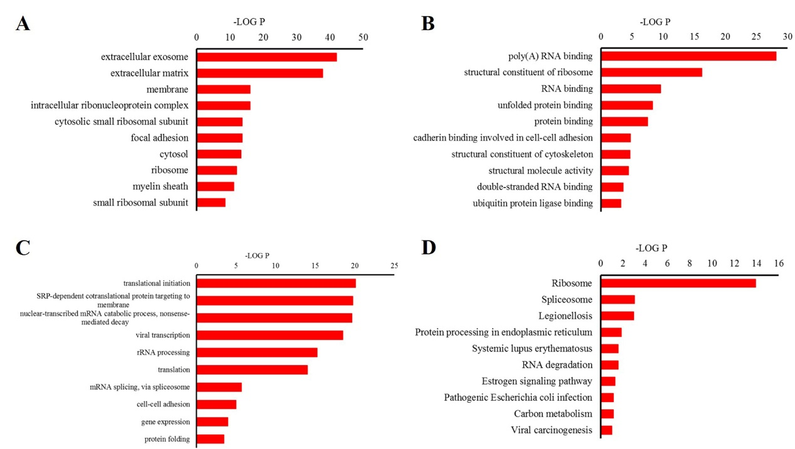
Figure S2. GO (Gene Ontology) and KEGG analysis for the differentially expressed proteins between SGC7901R cells exosomes and SGC7901S cells exosomes that detected by LC-MS/MS. (A) 10 subcellular localization entries with the highest number of differential proteins. (B) 10 molecular function entries with the highest number of differential proteins. (C) 10 biological process items with the highest number of differential proteins. (D) The main signaling pathway to the enrichment of differential proteins.

Figure S3
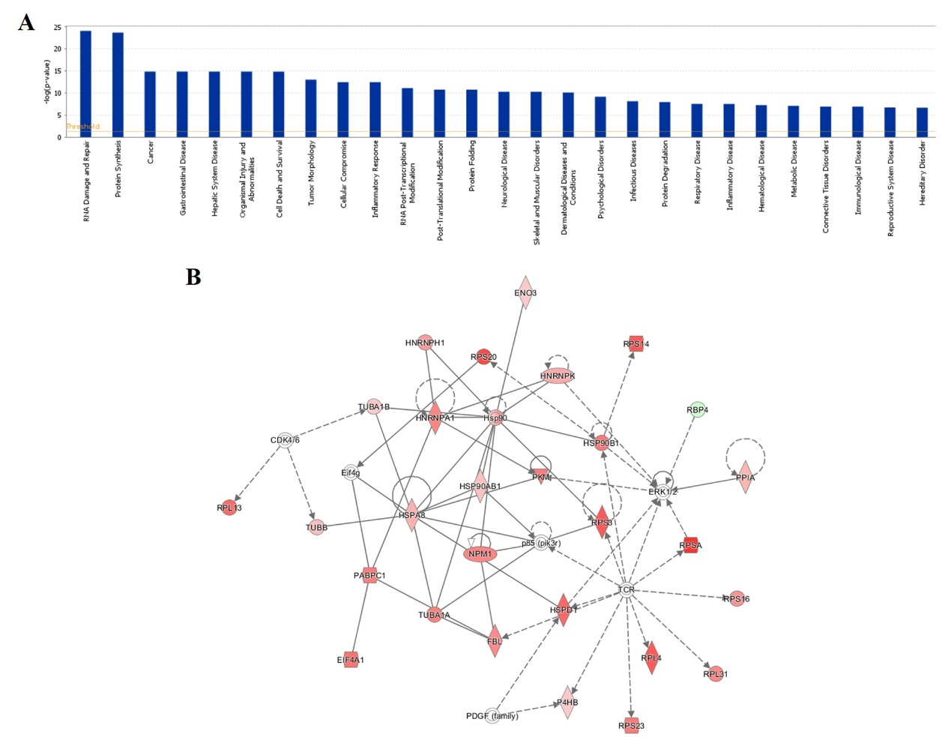
Figure S3. Functional enrichment analysis and network analysis for the differentially expressed proteins between SGC7901R cells exosomes and SGC7901S cells exosomes that detected by LC-MS/MS. (A) Functional enrichment analysis for the differentially expressed proteins. (B) Protein Synthesis, RNA Damage and Repair, Cancer related function network diagram. Red means up-regulation, and green means down-regulation.

