Table. 1 Number of images used in soil moisture estimation models by classification and rating.
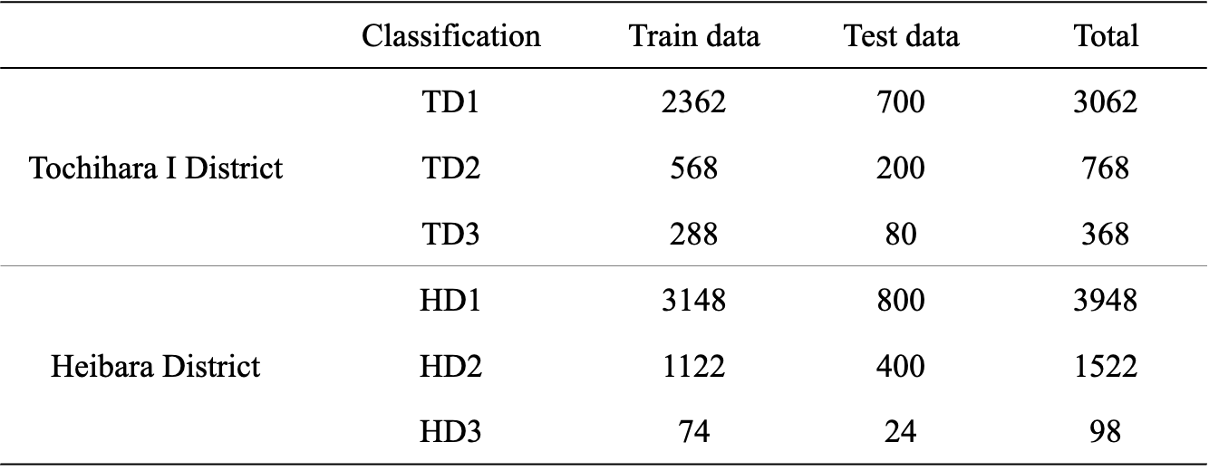

Table. 2 Confusion matrix of the soil moisture estimation model
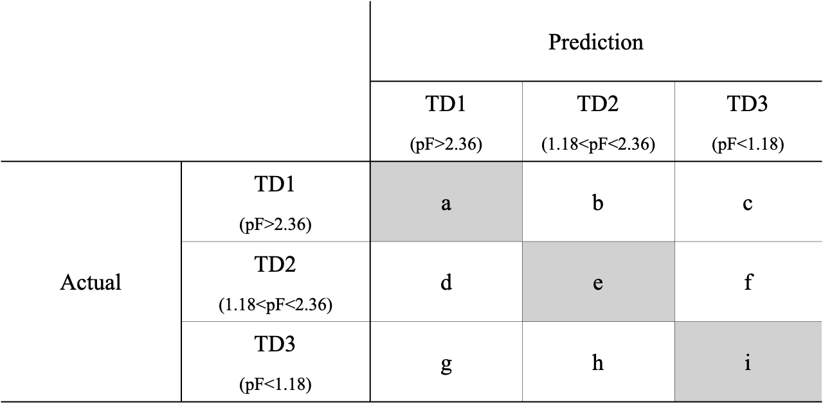

Table. 3 Number of images used irrigation decision models by classification and rating.
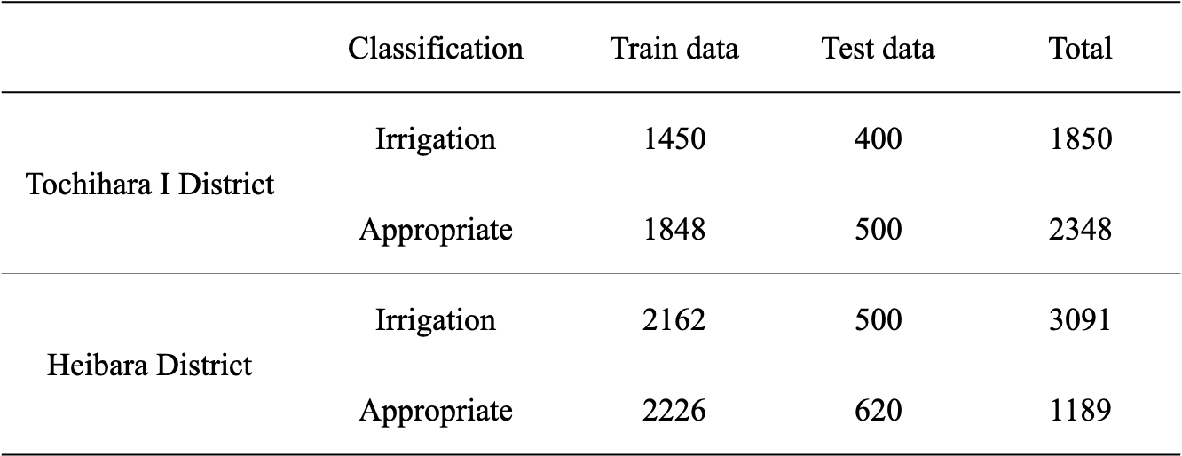

Table. 4 Confusion matrix of irrigation decision model
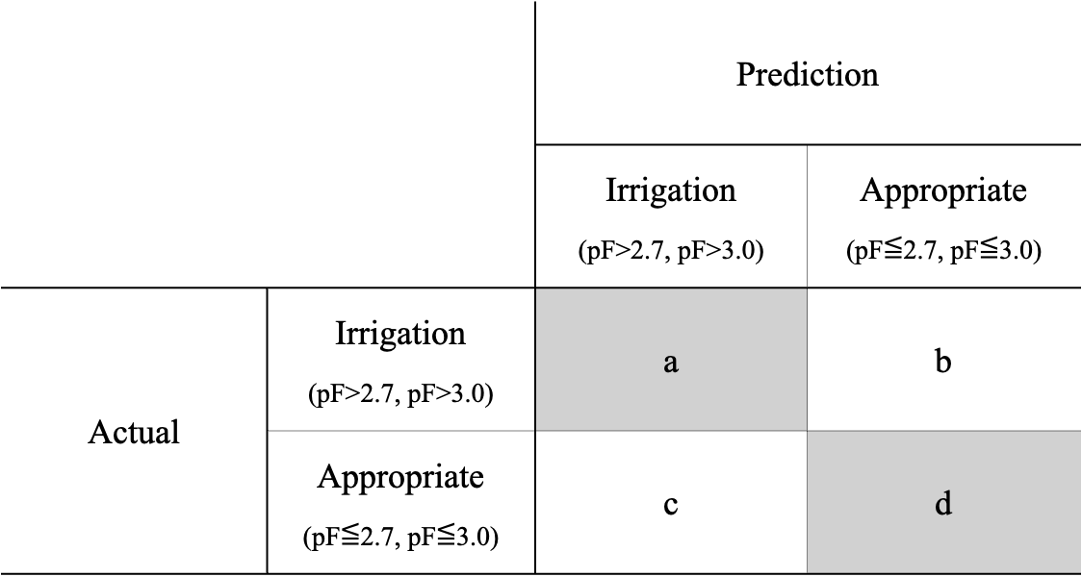

Table. 5 TSm model evaluation results
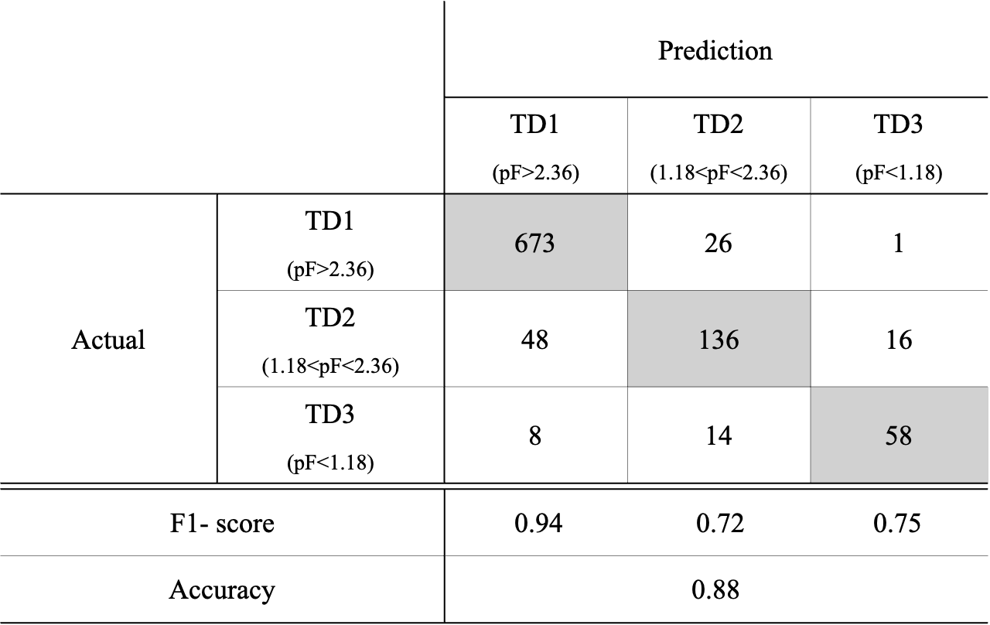

Table. 6 HSm model evaluation results
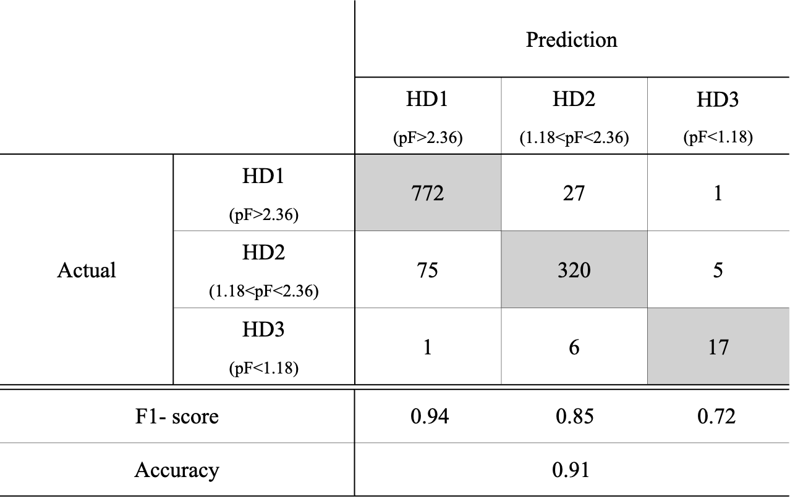

Table. 7 TIr model evaluation results
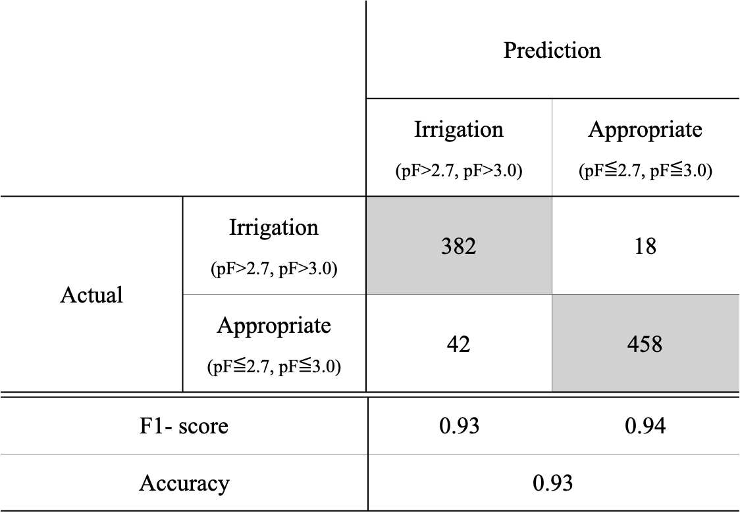

Table. 8 HIr model evaluation results
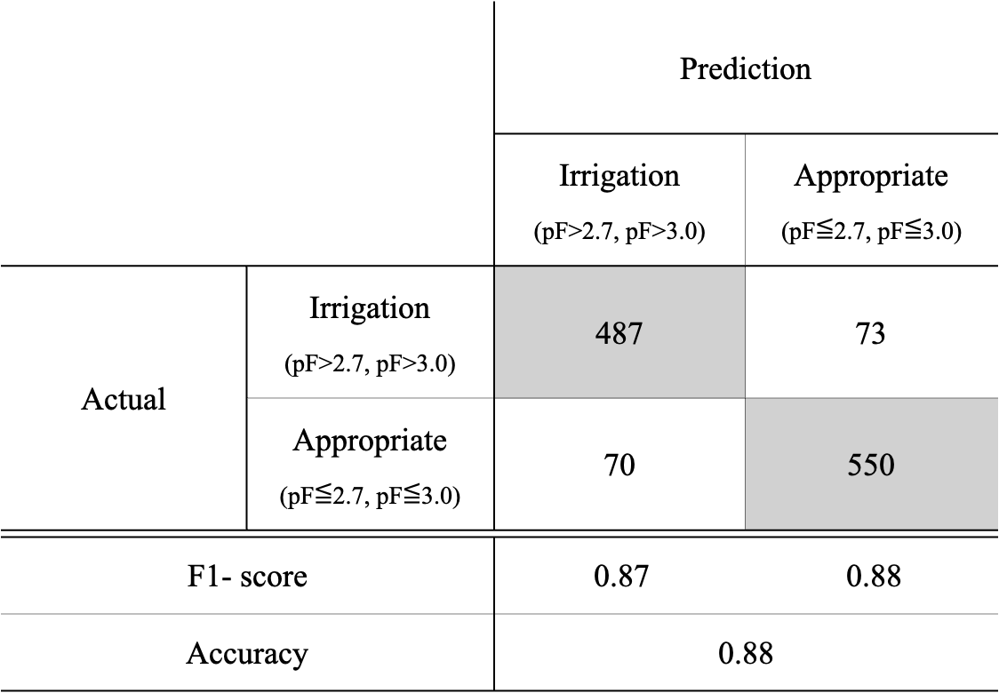

Table. 9 CIr model evaluation results
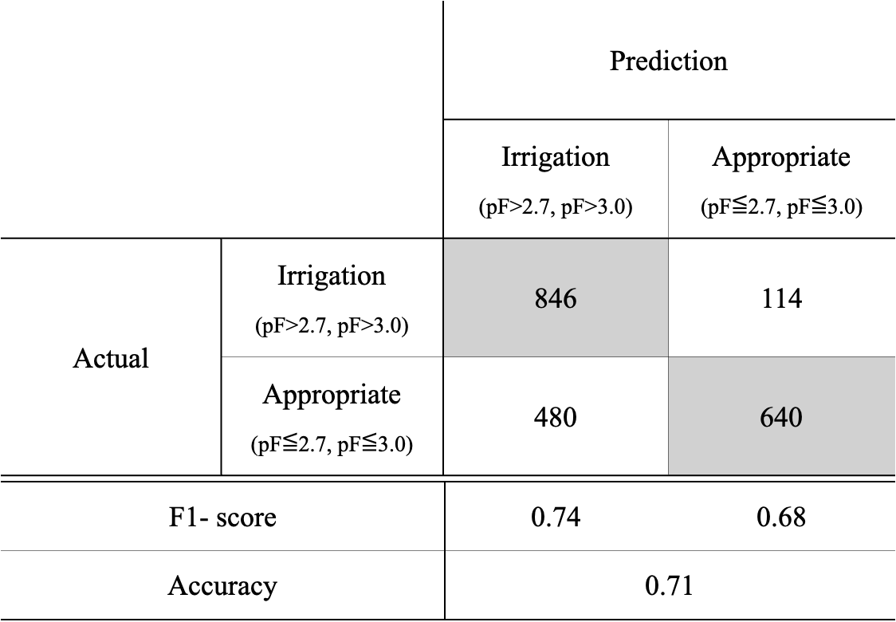

Table. 10 Results of the TIr model assessment of Heibara Danchi.
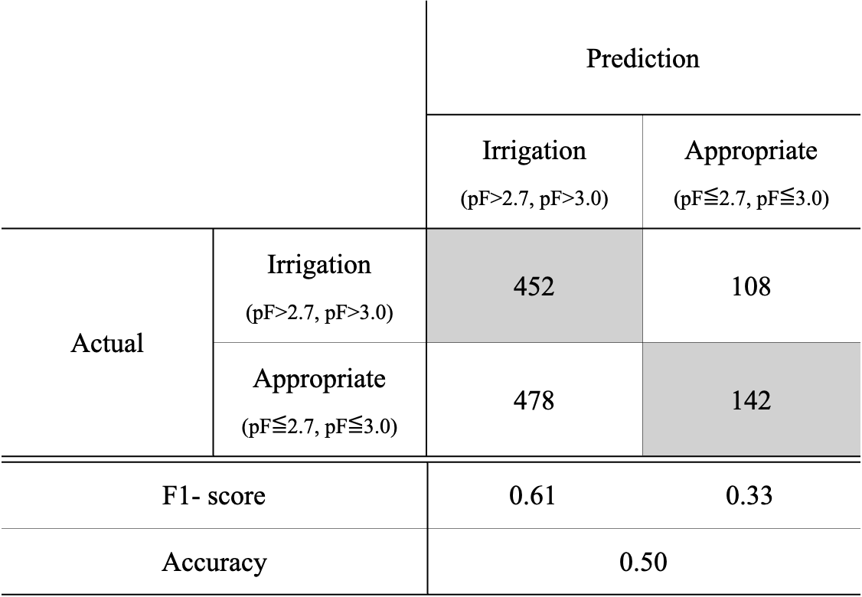

Table. 11 Results of the HIr model assessment of Tochihara Ⅰ Danchi.
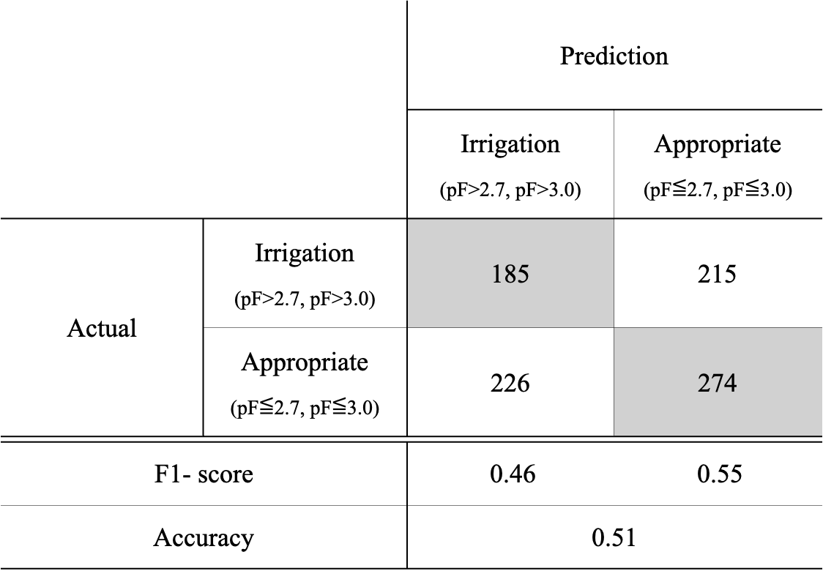

Table. 12 Percentage of the number of misjudged from each camera in the irrigation decision model.
