Supporting Information

Monodispersed Mesoscopic Star-Shaped Gold Particles via Silver Ion-assisted Multi-directional Growth for Highly Sensitive SERS-active Substrates

Sumin Kim^{1, 3, †}, Sunghoon Yoo^{1, 3, †}, Dong Hwan Nam^{1, 3}, Hayoung Kim^{1, 3}, Jason H.
Hafner^{4, *}, Seunghyun Lee^{1, 2, 3, *}

¹ Department of Applied Chemistry, Hanyang University ERICA, Ansan, 15588, Republic of
Korea
² Department of Chemical and Molecular Engineering, Hanyang University ERICA, Ansan,
15588, Republic of Korea
³ Center for Bionano Intelligence Education and Research, Hanyang University ERICA,
Ansan, 15588, Republic of Korea
⁴ Department of Physics and Astronomy, Rice University, 6100 Main St, Houston, TX 77005-1827, United States

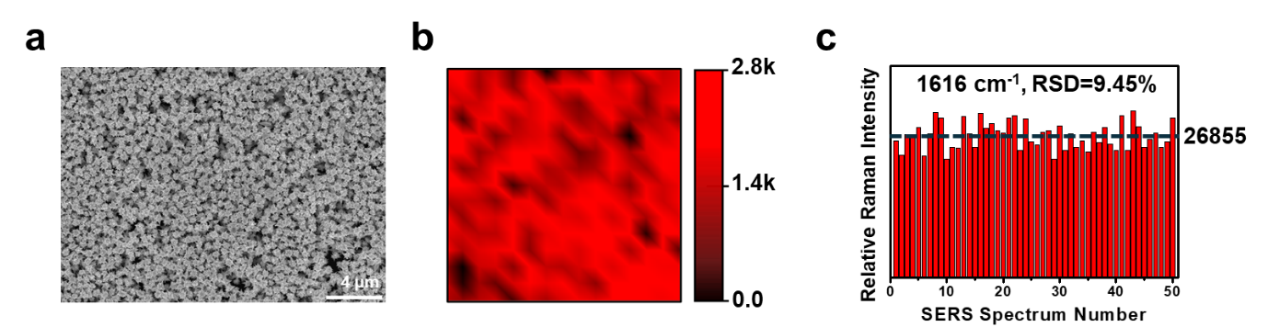
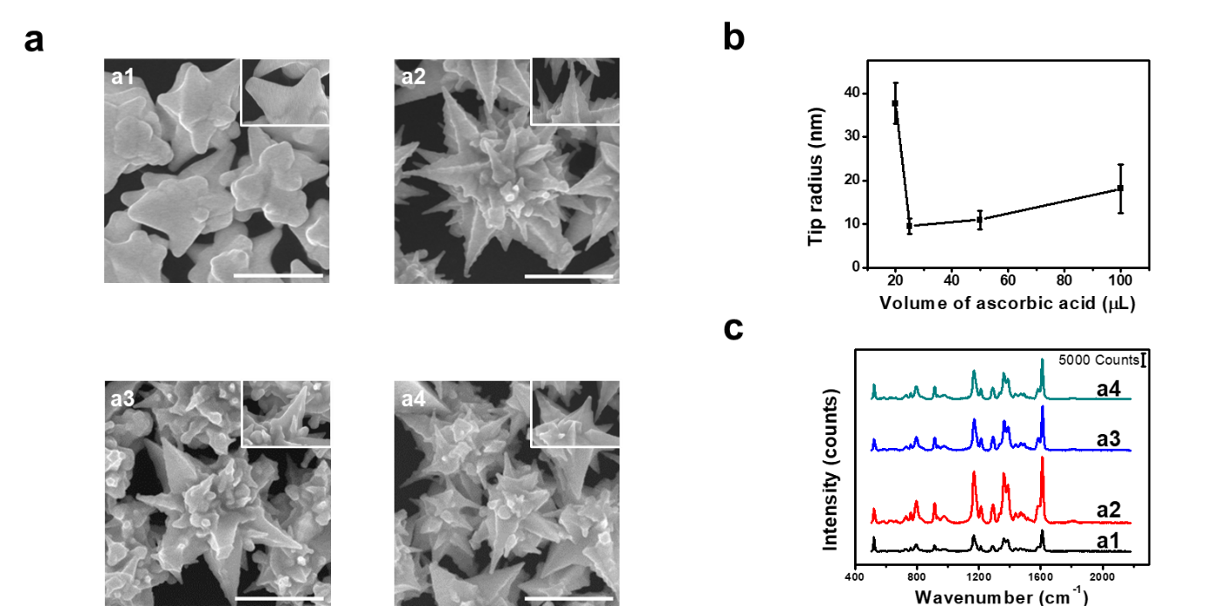
Fig. S2. (a) SEM image of the tip of a gold meso-stars substrate. (b) Raman mapping image measured on a 30 μm × 30 μm area of the SERS substrate. (c) RSD for the Raman peak intensities at 1616 cm⁻¹. The data are based on the measurement of MGITC at 10⁻⁶ M.
Fig. S1. (a) SEM images of the tip of gold meso-stars synthesized by adjusting the volume of AA in growth solutions A and B (a1–a4 correspond to AA volumes of 20, 25, 50 and 100 μL). All scale bars represent 1 μm. (b) Corresponding tip radius of curvature. (c) SERS signals according to AA in growth solution A and B volume.

