SUPPLEMENTARY INFORMATION

Recovering water from fossil fuel to break the constraints of sustainable development of resource-based cities

Zhaohao Li ¹, Dan Gao ^{1, 2,} *, Tianyi Zhi ¹, Huan Liu ³, Heng Zhang ¹,
Haiping Chen ^{1, 4}, Jizhen Liu ⁵
1 School of Energy, Power and Mechanical Engineering, North China Electric Power University, Beijing, China
2 National Institute of Energy Development Strategy, North China Electric Power University, Beijing, China
3 State Key Joint Laboratory of ESPC, School of Environment, Tsinghua University, Beijing, China.
4 Beijing Key Laboratory of Pollutant Monitoring and Control in Thermoelectric Production Process, North China Electric Power University, Beijing, China
5 School of Control and Computer Engineering, North China Electric Power University, Beijing, China
Corresponding author E-mail address: gaodan@ncepu.edu.cn

This file includes:
Supplementary Notes 1-4
Supplementary Figures S1-S6
Supplementary Tables S1-S5
and Supplementary References.

Supplementary Notes

Supplementary Note 1 Scenarios for ways to recover water from fossil fuels
(a) Basic scenario
The high temperature flue gas is produced when the fossil fuels is used in the industry. The relative humidity of flue gas is very low, and the condensation is difficult to occur by cooling alone. Therefore, the porous ceramic membranes with a pore size between 2-50 nm are generally used to recover water from it. According to Kelvin's theorem¹ (Eq. S1), when the high temperature flue gas flows in this range of pore channels, the water vapor is affected by the bending interface and the surface tension, and its saturation pressure in the capillary channel is lower than that at the plane. As a result, the flue gas that is unable to undergo film condensation may undergo capillary condensation in the pore channel of 2-50 nm. Eventually, it turns moisture from the gas state into the liquid state.
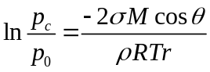 (S1)
where p₀ and p_{c} are the saturated vapor pressure on a plane interface and in the capillary, respectively, Pa; σ is the surface tension, N/m; M is the molar mass, kg/mol; θ is the contact angle of wall, °; ρ is the density, kg/m³; R is the ideal gas constant, J/(mol·K); T is the temperature, K; r is the radius of curvature, m.
Compared with the traditional water recovery methods, the advantages of our proposed method that recovering water from fossil fuels are mainly reflected in two aspects. First, the porous ceramic membranes are filled with the pore channels, the specific surface area is large, and the condensation heat transfer area is significantly increased. Second, the formed condensate can be transferred to the cooling medium side through the pore channel, which weakens the adverse effect of the condensate accumulation on the heat transfer performance to a certain extent. According to Ref. [2], the water vapor condensing performance of the porous ceramic membranes is 50-80% higher than that of the stainless steel pipes of the same size.
(b) Wet gas scenario
When the fossil energy contains the sulfur element, industrial applications need to install the desulfurization devices. The relative humidity of flue gas discharged from the desulfurization device is almost 100%, which is easy to condense. In this case, the porous ceramic membranes with a large pore size can be used to recover water from it. The hot and cold fluids are separated from the two sides of the macroporous ceramic membranes. At the cold end, the main function of the fluid is to cool the membrane surface temperature to the condensation temperature. At the hot end, the saturated wet flue gas can condensate on the surface of the macroporous ceramic membranes. Under the synergistic action of pressure and temperature gradients, the formed condensate permeates into the ceramic membrane. It is eventually carried away by the cooling fluid to complete the water recovery process³.
(c) Wastewater treatment scenario
Utilizing the wet desulfurization devices, the plants produce a great number of wastewater. Aiming at the wastewater treatment scenario, the coupling scheme of the pretreatment, the low temperature flash evaporation and the hot membrane distillation can be adopted⁴. First, Ca(OH)₂ and Na₂CO₃ are added to the desulfurization wastewater, and the wastewater is filtered by the porous ceramic membranes to separate the pollutants. Then, the pre-treated wastewater enters the multi-effect low temperature flash system. The water vapor formed by the evaporation of wastewater condenses into the salt water in the condensing chamber. Among them, the first heat source generally utilizes the heat carried by the flue gas. Finally, the salt water enters the hot membrane distillation unit and is heated again. The formed water vapor flows across the membrane under the actions of pressure gradient, and it condenses on the low pressure side to obtain the fresh water.

Supplementary Note 2 Recovery performance calculation
(a) Calculation of the water recovery performance
The industrial combustion reaction of the fossil fuels can produce a mixture of gases containing water vapor, which is the source of water recovery. According to the combustion equation, each kilogram of the hydrogen element completely burns can produce 11.1 cubic meters of water vapor, the mass of hydrogen element in each kilogram of the fuel is 0.01H_{ar} kilograms, and the resulting volume of water vapor is 0.111H_{ar} cubic meters per kilogram. The volume of water vapor produced by the vaporization of water in the fuel is calculated by Eq. (S2). The densities of the dry air and the water vapor are 1.293 kg/m³ and 0.804 kg/m³, respectively. Assuming that the mass of water vapor contained in each kilogram of the dry air is d_{k} kilograms, the volume of water vapor contained in the air is calculated by Eq. (S3). Based on this, the total volume of water vapor contained in the industrial waste gas can be calculated, as shown in Eq. (S4)⁵.
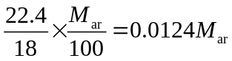 (S2)
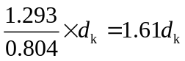 (S3)
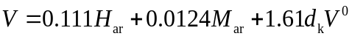 (S4)
where H_{ar} and M_{ar} are the proportions of the hydrogen element and the water contents in the as received base of the fuel, respectively; V is the volume of water vapor in the industrial waste gas, m³/kg; V⁰ is the volume of the industrial waste gas, m³/kg, which can be calculated by Eq. (S5).
(S5)
where C_{ar}, S_{ar}, and O_{ar} are the proportions of the carbon, the sulfur and the oxygen elements in the as received base of the fuel, respectively.
Finally, Eq. (S6) is used to calculate the mass of the recovered water.
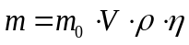 (S6)
where m is the mass of the recovered water, kg; m₀ is the mass of the fuel, kg; η is the efficiency of the recovered water.
(b) Calculation of the heat recovery performance
The temperature of the formed water vapor in the combustion of fossil fuels is high, and the recovered liquid water also has a certain heat. Therefore, when evaluating the recovery performance, the recovered heat is generally calculated⁶. When the high-temperature industrial waste gas flows through the low-temperature ceramic membranes, part of the heat is released in the form of the sensible heat, and it is transferred to the cooling water side under the action of the convective heat transfer and the heat conduction. The other part of the heat is released as the latent heat, which causes the water vapor to condensate into the liquid water. The latent and sensible heats together constitute the total thermal energy released by the high temperature flue gas. According to the experimental research⁷, most of the energy is released in the form of latent heat, accounting for about 75% of the total heat. In the calculation of latent heat, the key is to determine the mass of condensed water vapor. The product of the condensation is the liquid water, and the mass is conserved as it goes from gas to liquid. Thus, the heat recovery performance can be estimated by Eq. (S7).
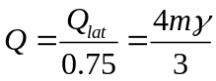 (S7)
where Q and Q_{lat} are the total and the recovered heat, respectively, kJ; γ is the latent heat coefficient of vaporization, kJ/kg.
According to the second law of thermodynamics, the grade of thermal energy is directly related to the economy. For example, the economic benefits of the large quantities of the low-grade heat are still limited. Therefore, the amount of the heat that can be utilized is calculated with the help of the Carnot cycle efficiency⁸.
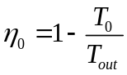 (S8)
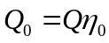 (S9)
where Q₀ is the heat can be utilized, kJ; η₀ is the Carnot cycle efficiency; T₀ and T_{out} are the ambient and cooling water outlet temperatures, respectively, K.

Supplementary Note 3 Calculation of the economic costs
We utilize the full life cycle assessment method⁹ to evaluate the economics of recovering water from the fossil energy. The economic cost mainly includes the equipment cost, the construction cost, the operation cost, the maintenance cost and the demolition cost. Among them, the equipment cost is calculated by Eq. (S10).
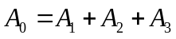 (S10)
where A₀ is the equipment cost, yuan; A₁ is the cost of the porous ceramic membrane, yuan; A₂ is the cost of the stainless steels and other fittings for the manufacture of the membrane module, yuan; A₃ is the cost of the auxiliary equipment, such as the pumps and the fans, yuan. Among them, A₁ can be calculated by Eq. (S11).
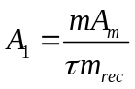 (S11)
where A_{m} is the unit price of the porous ceramic membrane, yuan/m²; τ is the annual operating time of the plant, h; m_{rec} is the water recovery performance of the porous ceramic membranes, kg/(m²·h). The porous ceramic membrane is the core material of this water recovering method. According to the relationship among the numbers of the porous ceramic membranes, the stainless steels, and the auxiliary equipment in the pilot-scale experiments and the engineering demonstration, the values of A₂ and A₃ can be estimated in the large-scale application.
The construction and demolition costs are both costs incurred at the beginning and end of the application of the above equipment in the plant, which are mainly related to the number of equipment. According to the engineering research data, we use 0.15A₀ and 0.05A₀ respectively to represent these two costs. The operating cost mainly refers to the cost of electric energy consumed during the operation of the auxiliary equipment, which is represented by 0.4A₃. The porous ceramic membrane is a novel material, and the membrane module is an important protection object in the maintenance process. Here, we use 0.1A₁ to represent the maintenance cost. As a result, the economic cost of the full life cycle can be calculated.
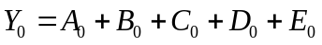 (S12)
where Y₀ is the economic cost of the full life cycle, yuan; B₀ is the construction cost, yuan; C₀ is the operating cost, yuan; D₀ is the maintenance cost, yuan; E₀ is the demolition cost, yuan. Among them, the equipment cost, the construction cost, and the demolition cost are the one-time investments. While the operating and maintenance costs are the costs that are incurred annually.

Supplementary Note 4 Division method of the specific industries in the city
First, we calculate the proportion of each industry in the GDP of the city. Second, we assign values to the development potential of various industries in the city, as shown in Supplementary Table S2. Third, the existing GDP development of each industry is assigned a 30% coefficient, and the development potential of each industry is assigned a 10% coefficient. Fourth, Eqs. (S13)-(S16) are used to calculate the future development of the city. According to the ranking of the development coefficient of each city in the primary, secondary and tertiary industries, the main industries in the future can be finally determined¹⁰.
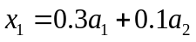 (S13)
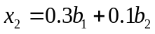 (S14)
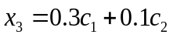 (S15)
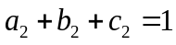 (S16)
where x₁, x₂, and x₃ are the development coefficients of the city in the primary, secondary and tertiary industries, respectively; a₁, b₁, and c₁ are the proportions of the GDP of the city's primary, secondary and tertiary industries in the overall GDP, respectively; a₂, b₂, and c₂ are the potential coefficients of the city's future development in the primary, secondary and tertiary industries, respectively.

Supplementary Figures
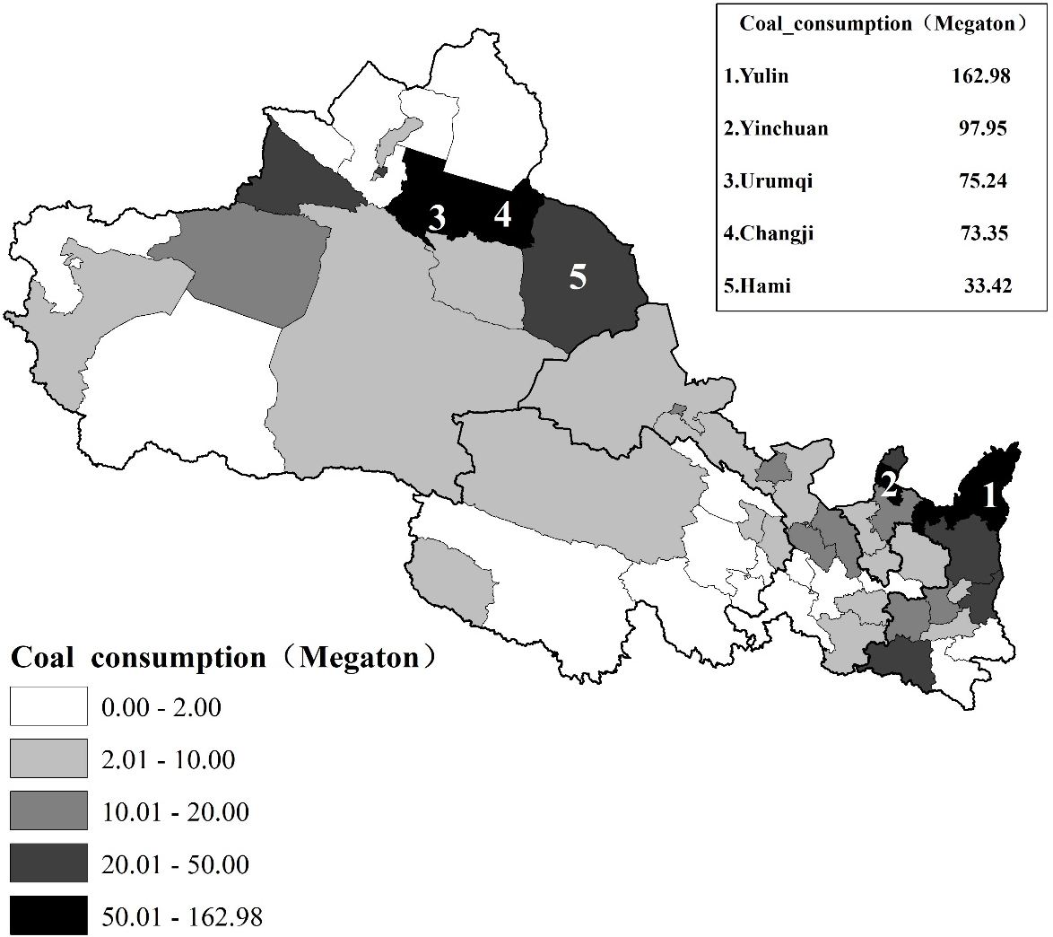
Fig. S1 Distribution of the coal consumption.
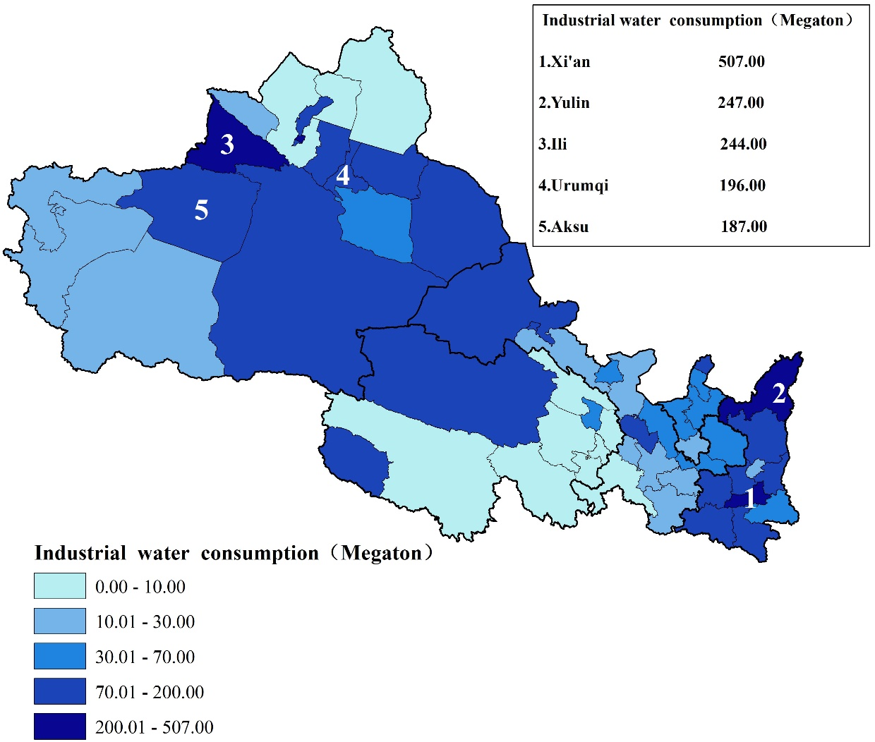
Fig. S2 Distribution of the water consumption in the secondary industry.

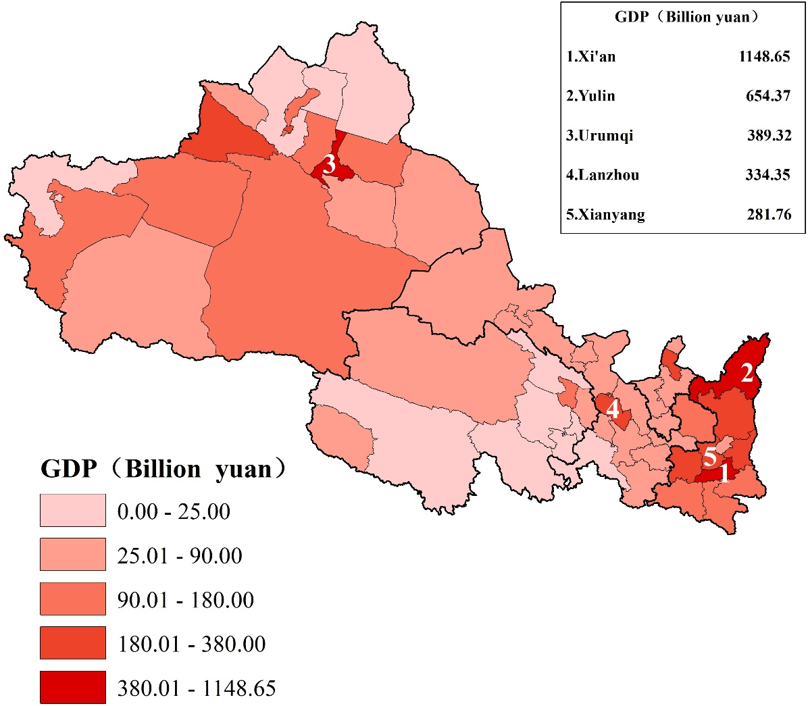
Fig. S3 Distribution of the GDP.

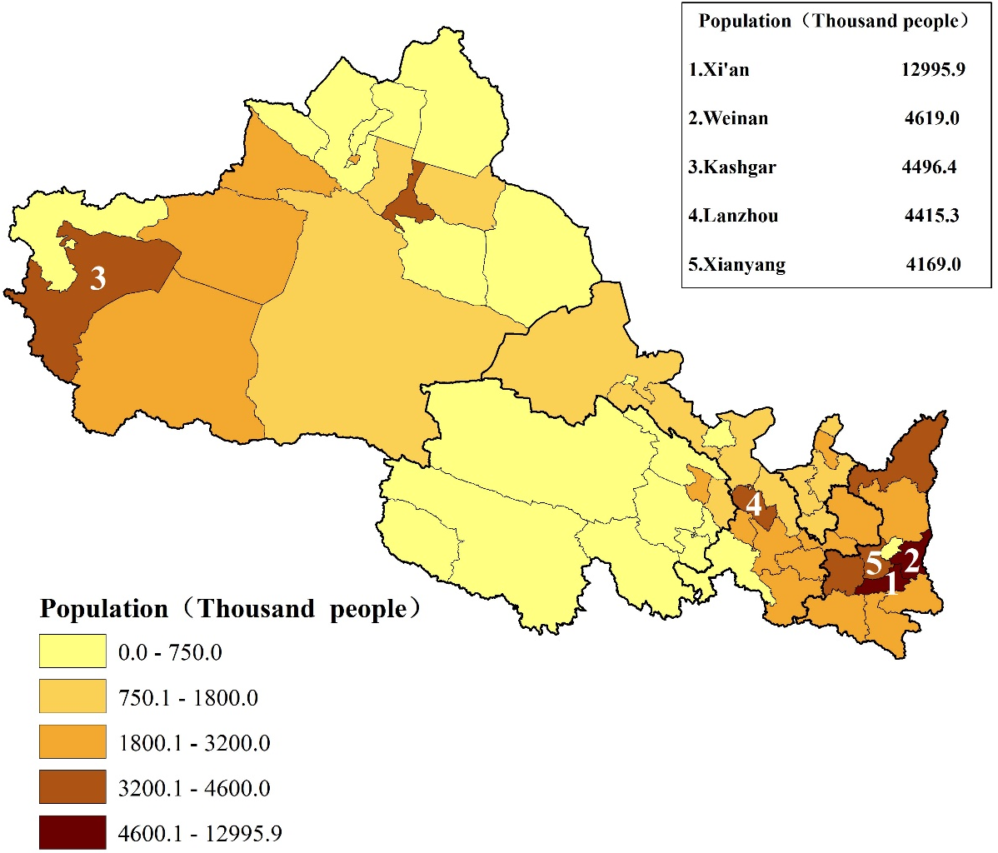
Fig. S4 Distribution of the population.

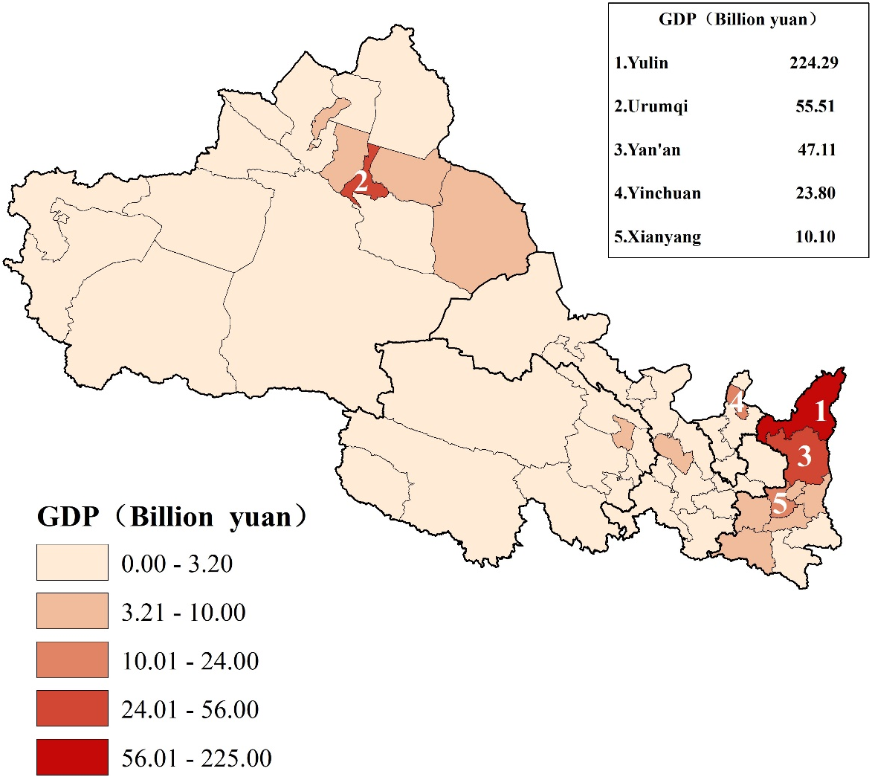
Fig. S5 Distribution of the GDP growth in the wastewater treatment scenario.

Supplementary Tables
Supplementary Table S1 Economic costs in the basic scenario.
Cities | Cost of ceramic membranes (Million yuan) | Cost of stainless steels (Million yuan) | Cost of auxiliary equipment (Million yuan) | Construction cost (Million yuan) | Operating cost (Million yuan/year) | Maintenance cost (Million yuan/year) | Demolition cost (Million yuan)
Aksu | 327.94 | 68.32 | 49.19 | 66.82 | 19.68 | 32.79 | 22.27
Ankang | 6.88 | 1.43 | 1.03 | 1.40 | 0.41 | 0.69 | 0.47
Baiyin | 322.57 | 67.20 | 48.38 | 65.72 | 19.35 | 32.26 | 21.91
Baoji | 188.37 | 39.24 | 28.26 | 38.38 | 11.30 | 18.84 | 12.79
Bayingol | 197.17 | 41.08 | 29.58 | 40.17 | 11.83 | 19.72 | 13.39
Bortala | 17.32 | 3.61 | 2.60 | 3.53 | 1.04 | 1.73 | 1.18
Changji | 1159.38 | 241.54 | 173.91 | 236.22 | 69.56 | 115.94 | 78.74
Dingxi | 16.51 | 3.44 | 2.48 | 3.36 | 0.99 | 1.65 | 1.12
Gannan | 15.61 | 3.25 | 2.34 | 3.18 | 0.94 | 1.56 | 1.06
Guoluo | 5.84 | 1.22 | 0.88 | 1.19 | 0.35 | 0.58 | 0.40
Guyuan | 46.17 | 9.62 | 6.93 | 9.41 | 2.77 | 4.62 | 3.14
Haibei | 12.77 | 2.66 | 1.92 | 2.60 | 0.77 | 1.28 | 0.87
Haidong | 71.62 | 14.92 | 10.74 | 14.59 | 4.30 | 7.16 | 4.86
Hainan | 25.43 | 5.30 | 3.81 | 5.18 | 1.53 | 2.54 | 1.73
Haixi | 79.04 | 16.47 | 11.86 | 16.11 | 4.74 | 7.90 | 5.37
Hami | 523.36 | 109.03 | 78.50 | 106.63 | 31.40 | 52.34 | 35.54
Hanzhong | 572.81 | 119.34 | 85.92 | 116.71 | 34.37 | 57.28 | 38.90
Hotan | 15.61 | 3.25 | 2.34 | 3.18 | 0.94 | 1.56 | 1.06
Huangnan | 14.05 | 2.93 | 2.11 | 2.86 | 0.84 | 1.41 | 0.95
Ili | 427.70 | 89.10 | 64.16 | 87.14 | 25.66 | 42.77 | 29.05
Jiayuguan | 169.23 | 35.26 | 25.38 | 34.48 | 10.15 | 16.92 | 11.49
Jinchang | 336.05 | 70.01 | 50.41 | 68.47 | 20.16 | 33.61 | 22.82
Jiuquan | 91.61 | 19.09 | 13.74 | 18.67 | 5.50 | 9.16 | 6.22
Karamay | 435.39 | 90.71 | 65.31 | 88.71 | 26.12 | 43.54 | 29.57
Kashgar | 35.16 | 7.32 | 5.27 | 7.16 | 2.11 | 3.52 | 2.39
Kizilsu Kirgiz | 5.31 | 1.11 | 0.80 | 1.08 | 0.32 | 0.53 | 0.36
Lanzhou | 351.03 | 73.13 | 52.65 | 71.52 | 21.06 | 35.10 | 23.84
Linxia | 9.41 | 1.96 | 1.41 | 1.92 | 0.56 | 0.94 | 0.64
Longnan | 44.62 | 9.30 | 6.69 | 9.10 | 2.68 | 4.46 | 3.03
Pingliang | 24.07 | 5.02 | 3.61 | 4.90 | 1.44 | 2.41 | 1.63
Qingyang | 52.56 | 10.95 | 7.88 | 10.71 | 3.15 | 5.26 | 3.57
Shangluo | 7.63 | 1.59 | 1.14 | 1.56 | 0.46 | 0.76 | 0.52
Shizuishan | 377.12 | 78.57 | 56.57 | 76.83 | 22.63 | 37.71 | 25.61
Tianshui | 50.04 | 10.43 | 7.51 | 10.20 | 3.00 | 5.00 | 3.40
Tongchuan | 77.63 | 16.17 | 11.65 | 15.82 | 4.66 | 7.76 | 5.27
Turpan | 158.05 | 32.93 | 23.71 | 32.20 | 9.48 | 15.80 | 10.73
Urumqi | 1373.71 | 286.19 | 206.06 | 279.89 | 82.42 | 137.37 | 93.30
Weinan | 537.94 | 112.07 | 80.69 | 109.61 | 32.28 | 53.79 | 36.54
Wuwei | 96.97 | 20.20 | 14.55 | 19.76 | 5.82 | 9.70 | 6.59
Wuzhong | 316.89 | 66.02 | 47.53 | 64.57 | 19.01 | 31.69 | 21.52
Xi’an | 170.19 | 35.46 | 25.53 | 34.68 | 10.21 | 17.02 | 11.56
Xianyang | 355.57 | 74.08 | 53.34 | 72.45 | 21.33 | 35.56 | 24.15
Xining | 117.72 | 24.52 | 17.66 | 23.99 | 7.06 | 11.77 | 8.00
Yan’an | 730.27 | 152.14 | 109.54 | 148.79 | 43.82 | 73.03 | 49.60
Yinchuan | 1667.46 | 347.39 | 250.12 | 339.75 | 100.05 | 166.75 | 113.25
Yulin | 2666.71 | 555.56 | 400.01 | 543.34 | 160.00 | 266.67 | 181.11
Yushu | 8.04 | 1.67 | 1.21 | 1.64 | 0.48 | 0.80 | 0.55
Zhangye | 67.45 | 14.05 | 10.12 | 13.74 | 4.05 | 6.75 | 4.58
Zhongwei | 89.24 | 18.59 | 13.39 | 18.18 | 5.35 | 8.92 | 6.06

Supplementary Table S2 The development characteristics of the city.
Cities | Specific industries | Reasons
Aksu | Primary industry | It is praised as the lush southern type fields beyond the Great Wall.
Ankang | Primary industry | The climate here is mild and humid.
Bayingol | Primary industry | There are a great number of lakes, rivers and plain oases in the city.
Bortala | Primary industry | Sayram Lake is located here.
Guoluo | Primary industry | There are unique plateau animals and plants.
Haibei | Primary industry | The largest inland saline lake in China, Qinghai Lake, is located here.
Haidong | Primary industry | The largest inland saline lake in China, Qinghai Lake, is located here.
Hainan | Primary industry | The largest inland saline lake in China, Qinghai Lake, is located here.
Haixi | Primary industry | The source area of the Yangtze River is located here.
Hanzhong | Primary industry | There is fertile land here.
Huangnan | Primary industry | The First Bay of the Yellow River is located here.
Ili | Primary industry | The GDP of the primary industry in the city ranks first in Northwest China.
Pingliang | Primary industry | The greening degree of the city ranks first in Gansu Province.
Shangluo | Primary industry | The water resource of the city is abundant.
Weinan | Primary industry | The GDP of the primary industry in the city ranks second in Northwest China.
Yushu | Primary industry | The Sanjiangyuan Nature Reserve is located here.
Zhangye | Primary industry | This place has a unique Danxia landform.
Baiyin | Secondary industry | It has abundant metal mineral resources.
Baoji | Secondary industry | The GDP of the secondary industry in the city ranks third in Northwest China.
Changji | Secondary industry | Many thermal power plants are located here.
Hami | Secondary industry | It has abundant coal reserves.
Jinchang | Secondary industry | The proportion of GDP in the secondary industry to the total GDP ranks third in the northwest region.
Jiuquan | Secondary industry | The Chinese space launch site is located here.
Karamay | Secondary industry | It has abundant oil reserves
Qingyang | Secondary industry | It has abundant reserves of oil, natural gas, and coal.
Shizuishan | Secondary industry | It has abundant coal reserves.
Tongchuan | Secondary industry | It has abundant metal mineral resources.
Wuzhong | Secondary industry | Many thermal power plants are located here.
Yan’an | Secondary industry | It has abundant coal reserves.
Yinchuan | Secondary industry | It has abundant coal reserves.
Yulin | Secondary industry | It has abundant coal reserves.
Zhongwei | Secondary industry | It is a strategic channel for the project of natural gas transmission from West to East China.
Dingxi | Tertiary industry | It is an important hub of the Tang and Tibetan ancient road.
Gannan | Tertiary industry | It is a key city for trade with the Tibetan region.
Guyuan | Tertiary industry | It is a transportation hub city.
Hotan | Tertiary industry | It is the core city of southern Xinjiang region.
Jiayuguan | Tertiary industry | The most impregnable pass in Chinese history is located here.
Kashgar | Tertiary industry | It is the tourist city.
Kizilsu Kirgiz | Tertiary industry | It is a border city bordering two countries.
Lanzhou | Tertiary industry | It is a node city of the Silk Road economic belt.
Linxia | Tertiary industry | It is the central city of the tea-horse trade in Chinese history.
Longnan | Tertiary industry | It is a city at the junction of three provinces.
Tianshui | Tertiary industry | It is the Internet celebrity city.
Turpan | Tertiary industry | It is the tourist city.
Urumqi | Tertiary industry | The GDP of the tertiary industry in the city ranks second in Northwest China.
Wuwei | Tertiary industry | It is the central city of the Hexi Corridor.
Xi’an | Tertiary industry | It is the most economically developed city in Northwest China.
Xianyang | Tertiary industry | It is a historic ancient city.
Xining | Tertiary industry | It is the economic core city of the Qinghai-Tibet Plateau.

Supplementary Table S3 The coefficients of primary industrial development in the cities.
Cities | Coefficients of primary industrial development | Key industry for development
Yushu | 0.286 | Primary industry
Haibei | 0.193 | Primary industry
Huangnan | 0.187 | Primary industry
Hainan | 0.181 | Primary industry
Ili | 0.178 | Primary industry
Aksu | 0.171 | Primary industry
Pingliang | 0.171 | Primary industry
Zhangye | 0.166 | Primary industry
Bortala | 0.165 | Primary industry
Weinan | 0.159 | Primary industry
Guoluo | 0.155 | Primary industry
Haidong | 0.147 | Primary industry
Hanzhong | 0.146 | Primary industry
Bayingol | 0.143 | Primary industry
Shangluo | 0.142 | Primary industry
Ankang | 0.141 | Primary industry
Haixi | 0.120 | Primary industry

Supplementary Table S4 The coefficients of secondary industrial development in the cities.
Cities | Coefficients of secondary industrial development | Key industry for development
Karamay | 0.316 | Secondary industry
Yulin | 0.314 | Secondary industry
Jinchang | 0.313 | Secondary industry
Hami | 0.300 | Secondary industry
Yan’an | 0.288 | Secondary industry
Baoji | 0.272 | Secondary industry
Shizuishan | 0.266 | Secondary industry
Qingyang | 0.262 | Secondary industry
Wuzhong | 0.256 | Secondary industry
Yinchuan | 0.249 | Secondary industry
Zhongwei | 0.240 | Secondary industry
Tongchuan | 0.233 | Secondary industry
Jiuquan | 0.232 | Secondary industry
Changji | 0.226 | Secondary industry
Baiyin | 0.219 | Secondary industry

Supplementary Table S5 The coefficients of tertiary industrial development in the cities.
Cities | Coefficients of tertiary industrial development | Key industry for development
Gannan | 0.314 | Tertiary industry
Urumqi | 0.310 | Tertiary industry
Lanzhou | 0.291 | Tertiary industry
Hotan | 0.288 | Tertiary industry
Dingxi | 0.288 | Tertiary industry
Xi’an | 0.285 | Tertiary industry
Linxia | 0.284 | Tertiary industry
Guyuan | 0.279 | Tertiary industry
Xining | 0.276 | Tertiary industry
Longnan | 0.265 | Tertiary industry
Tianshui | 0.261 | Tertiary industry
Kashgar | 0.258 | Tertiary industry
Kizilsu Kirgiz | 0.252 | Tertiary industry
Wuwei | 0.248 | Tertiary industry
Xianyang | 0.214 | Tertiary industry
Turpan | 0.199 | Tertiary industry
Jiayuguan | 0.194 | Tertiary industry

Supplementary References
1 Yang, Q. et al. Capillary condensation under atomic-scale confinement. Nature 588, 250 (2020).
2 Bao, A. et al. Nanoporous membrane tube condensing heat transfer enhancement study. Int. J. Heat Mass Tran. 84, 456-462 (2015).
3 Xiao, L. et al. Macroporous ceramic membrane condenser for water and heat recovery from flue gas. Appl. Therm. Eng. 186, 116512 (2021).
4 Ma, S. et al. Research on desulfurization wastewater evaporation: Present and future perspectives. Renew. Sust. Energ. Rev. 58, 1143-1151 (2016).
5 Han, Y. Modeling and techno-economic analysis of a water and heat recovery system based on ceramic membrane in coal-fired power plant. North China Electric Power University (2021) [Chinese].
6 Zhao, S. et al. Simultaneous heat and water recovery from flue gas by membrane condensation: Experimental investigation. Appl. Therm. Eng. 113, 843-850 (2017).
7 Li, Z. et al. Experimental research on the heat transfer and water recovery performance of transport membrane condenser. Appl. Therm. Eng. 160, 114060 (2019).
8 Pandya, S. et al. Pyroelectric energy conversion with large energy and power density in relaxor ferroelectric thin films. Nat. Mater. 17, 432 (2018).
9 Meys, R. et al. Achieving net-zero greenhouse gas emission plastics by a circular carbon economy. Science 374, 71 (2021).
10 Wang, X. et al. Research on the impact of green finance on the upgrading of China's regional industrial structure from the perspective of sustainable development. Resour. Policy 74, 102436 (2021).

