Highly aligned bacterial cellulose/PPy graded conductive membranes for cell differentiation under electrical stimulation
Li Wang ^{a,1}, Fuyu Qi ^{b,1}, Hao Wang ^{b,1}，Shuangshuang Li ^{b}，Sanming Hu^{d}, Zhijun Shi^{b, e,*}, Guang Yang^{b,*}, Hong Chen^{c,*}
ª Wuhan Branch of the National Science Library, Chinese Academy of Sciences, Wuhan 430071, PR China
^{b} Department of Biomedical Engineering, College of Life Science and Technology, Huazhong University of Science and Technology, Wuhan 430074, PR China
^{c} Department of Rehabilitation, Tongji Hospital, Tongji Medical College, Huazhong University of Science and Technology, PR Wuhan 430030, China
^{d} School of Biomedical Engineering and Imaging, Xianning Medical College, Hubei University of Science and Technology, Xianning 437100, P.R. China
^{e} Guangdong Provincial Key Laboratory of Advanced Biomaterials, Southern University of Science and Technology, Shenzhen 518055, P.R. China.

*Corresponding author.
Hong Chen (chenhong1129@hust.edu.cn)
Guang Yang (gyang-hust@hust.edu.cn)
Zhijun Shi (shizhijun@hust.edu.cn)
Tel: +86 27-87793523
Fax: +86 27-87792265

- Results and disscussion

1.1 Digital images
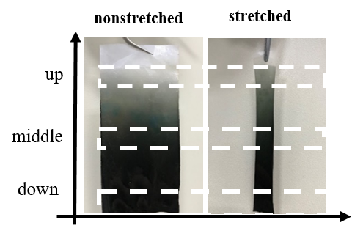
Fig. S1. Digital images of nonstretched and stretched BC/PPy gradient conductive membranes.

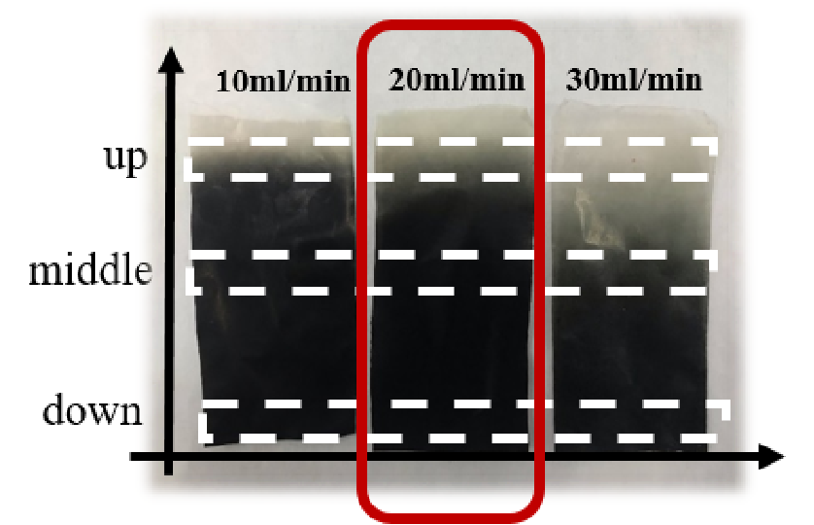

Fig. S2. Digital images of 10, 20, 30-BC/PPy gradient conductive membranes.

1.2. Morphological characterizations of the BC/PPy gradient conductive membranes
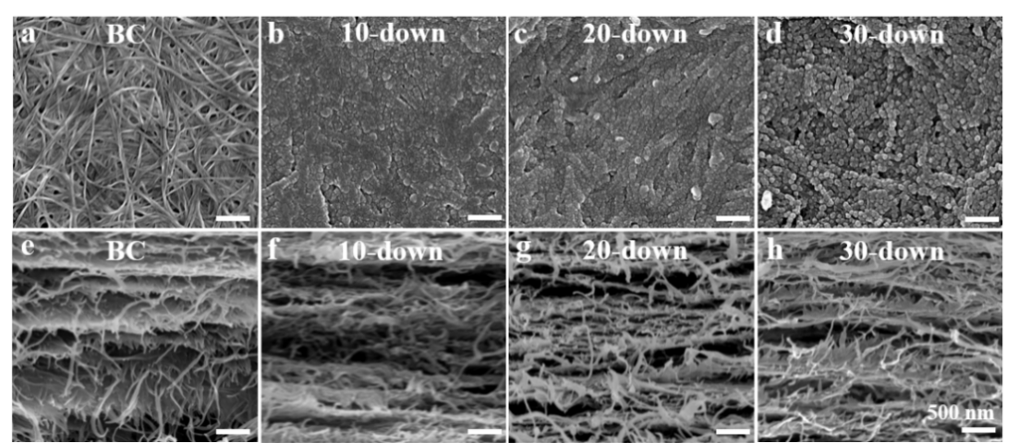
Fig. S3. Surface (a-d) and cross-sectional (c-h) FESEM images of the BC (a, e), 10 (b, f), 20 (c, g) and 30 (d, h)-down segment of BC/PPy gradient conductive membrane.

1.3. C-AFM
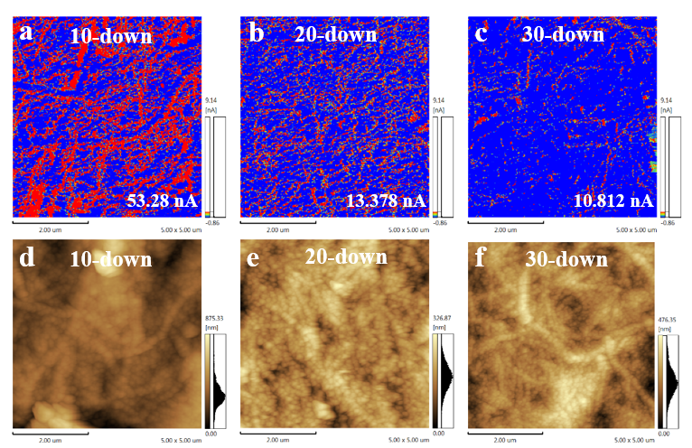
Fig. S4. AFM images of current (a-c) and height (d-f) of 10 (a, d), 20 (b-e) and 30 (c-f) -down segment of BC/PPy conducative gradient membranes.

1.4. Electrical conductivity
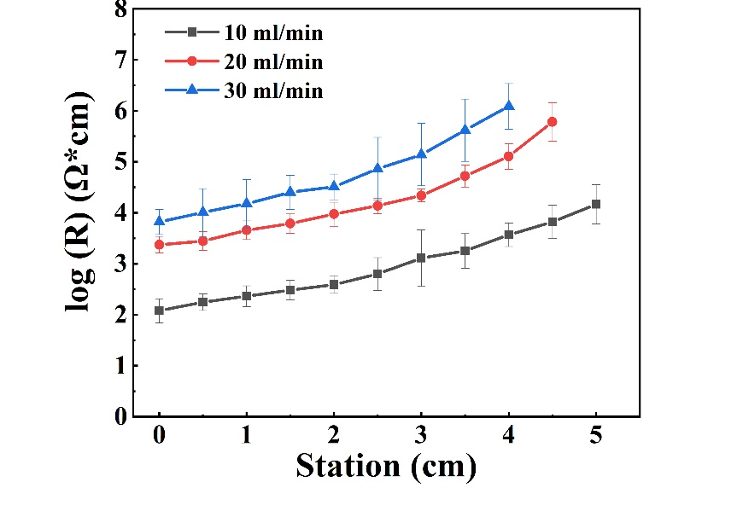
Fig. S5. The log (R) values of 10, 20, 30-BC/PPy conducative gradient membranes.

1.5. TGA
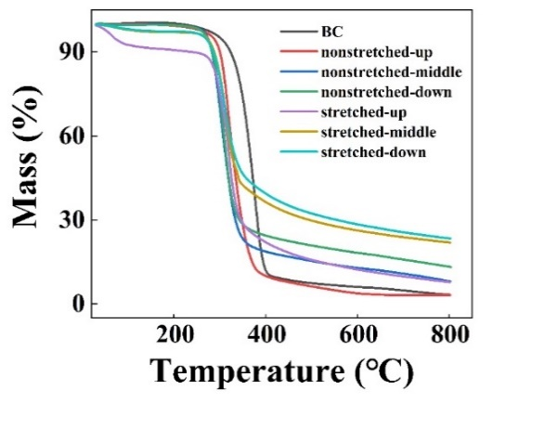
Fig. S6. TGA images of BC, nonstretched and stretched BC/PPy conducative gradient membranes.

1.6 Elements analysis
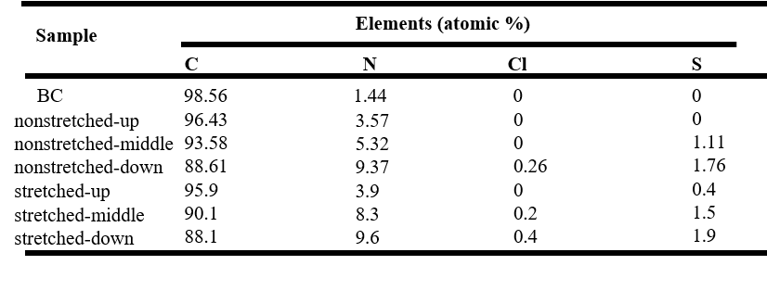
Table S1. Elements analysis of BC, nonstretched and stretched BC/PPy conducative gradient membranes.

1.7. Contact angle test
Samples | Water contact angle (°) | Image of drops
BC | 46 | 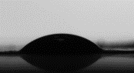
nonstretched-up | 68 | 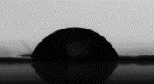
nonstretched-middle | 88 | 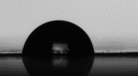
nonstretched-down | 96 | 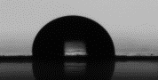
stretched-up | 83 | 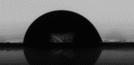
stretched-middle | 90 | 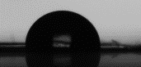
stretched-down | 122 | 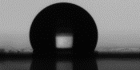
Table S2. Contact angles of the nonstretched and stretched BC/PPy gradient conductive membranes.

1.8. MTT
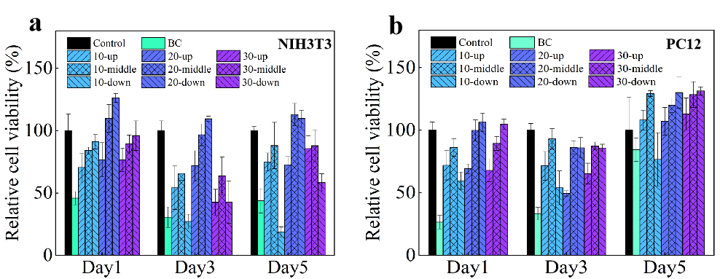

Fig. S7. MTT assay of NIH3T3 (a) and PC12 (b) cells cultured on Control (petri dish), BC, 10, 20 and 30-BC/PPy conductive gradient membranes.

1.9. Direction of neurite extension
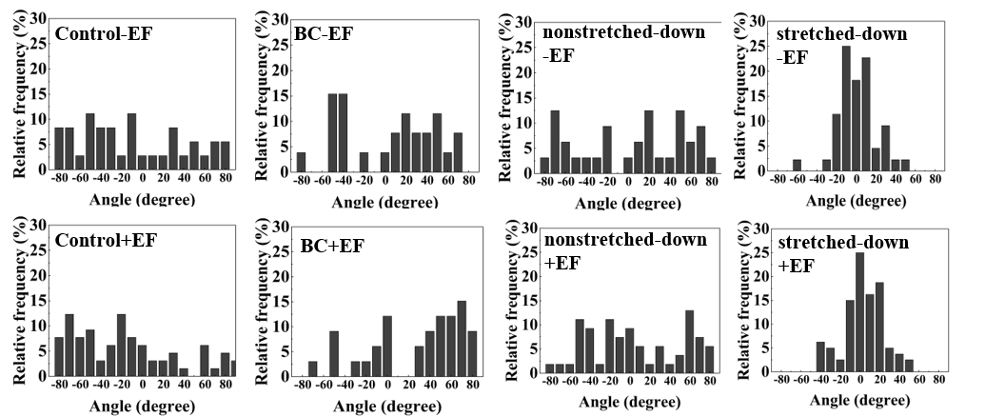
Fig. S8. The direction of PC12 cell neurite extension after culturing on Control (petri dish), BC, nonstretched-down and stretched-down BC/PPy gradient conductive membranes in the absence or presence of electrical stimulation, respectively.

