Supplemental Material

Lone-pair activated ferroelectricity and stable 180° charged domain wall in Bi monolayer

Shulin Zhong¹, Xuanlin Zhang², Jian Gou*¹, Lan Chen^{3,4}, Su-Huai Wei⁵, Shengyuan A. Yang⁶, Yunhao Lu*^{1,2}

¹ School of Physics, Zhejiang University, Hangzhou 310027, China
² State Key Laboratory of Silicon and Advanced Semiconductor Materials, School of Materials Science & Engineering, Zhejiang University, Hangzhou 310027, China
³ Institute of Physics, Chinese Academy of Sciences, Beijing, China.
⁴ School of Physics, University of Chinese Academy of Sciences, Beijing, China
⁵ Beijing Computational Science Research Center, Beijing 100193, China
⁶ Research Laboratory for Quantum Materials, IAPME, Faculty of Science and Technology, University of Macau, Macau SAR, China

Table S1. Calculated values of spontaneous polarization P_{S} (in units of ×10⁻¹⁰ C/m), formation energy of 90° n-DW, 180° n-DW, 180° c-DW and 90° c-DW, respectively (in units of meV/Å). “-” represents the DWs can not be relaxed by DFT, or it would so be driven into a single domain.
 | P_{S} | $$E_{90° n-DW}^{f}$$ | $$E_{180° n-DW}^{f}$$ | $$E_{180° c-DW}^{f}$$ | $$E_{90° c-DW}^{f}$$
SnTe | 2.07 | 3.39 | 13.21 | - | -
GeTe | 3.05 | 5.66 | 30.69 | - | -
GeSe | 3.40 | 8.94 | 50.53 | - | -
GeS | 4.25 | 11.03 | 100.03 | 271.13 | -
Bi | 0.44 | 27.10 | 26.56 | 18.87 | 37.64
Sb | 0.20 | 28.34 | 21.13 | 14.99 | 47.96
As | 0.28 | 23.31 | 4.90 | 8.00 | 33.44

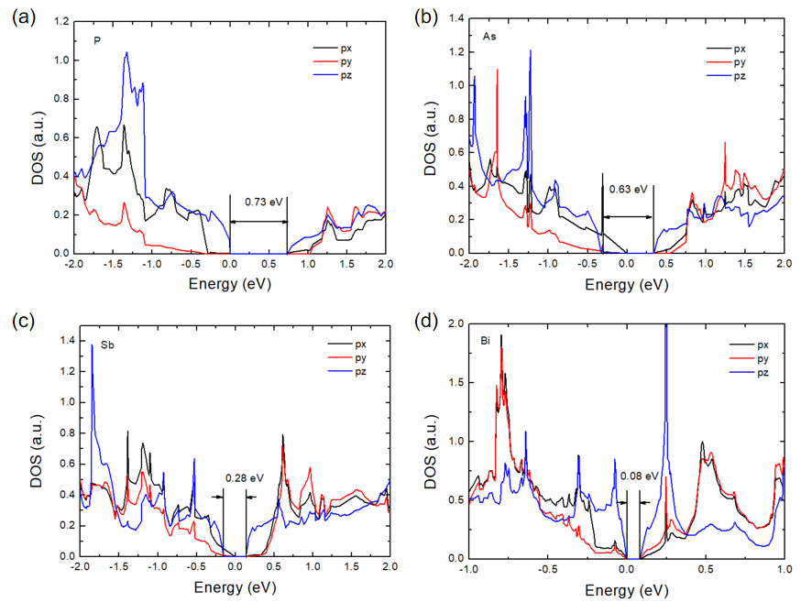
Fig. S1. Projected density of states (PDOS) of p_{x}, p_{y} and p_{z} orbitals in (a) P, (b) As, (c) Sb and (d) Bi monolayer with centrosymmetric environment.

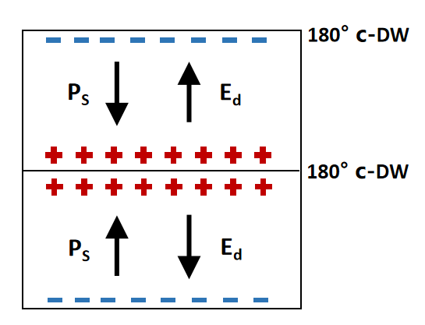
Fig. S2. Bound charges and depolarizing fields of head-to-head c-DW. Directions of the polarization $P_{S}$ and depolarizing field $E_{d}$ are indicated with arrows. “+” and “−” indicate positive and negative bound charges.

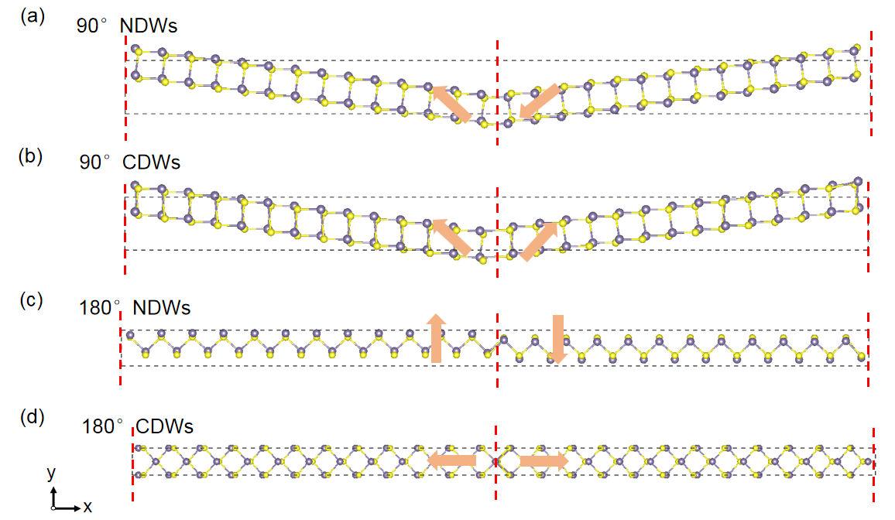
Fig. S3. Simulation model of the (a) 90° n-DW, (b) 90° c-DW, (c) 180° n-DW and (d) 180° c-DW. The red dashed line represents DWs. Grey spheres indicate Sn/Ge atoms and yellow spheres indicate S/Se/Te atoms, respectively. The orange arrows show the direction of spontaneous polarization.

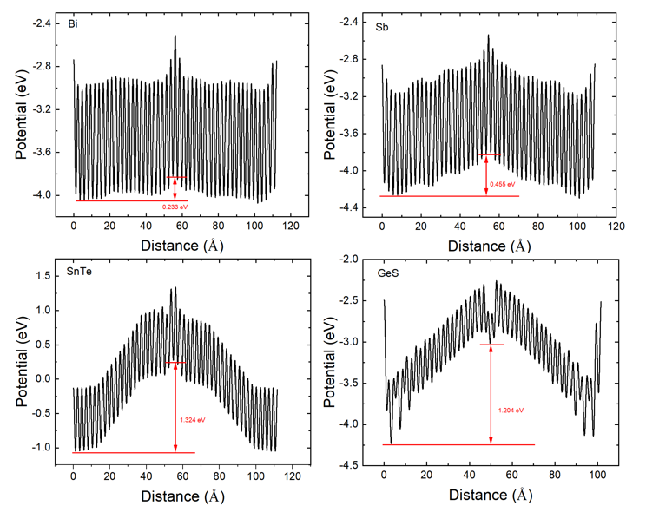
Fig. S4. The potential distribution of 180° c-DW in Bi, Sb, SnTe and GeS, respectively.

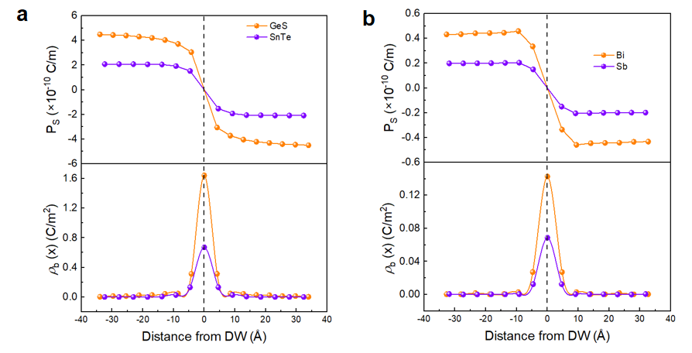
Fig. S5. Properties of the 180° c-DW of (a) compounds (SnTe, GeS) and (b) single element (Bi, Sb) monolayer, respectively. Top: polarization profile of the corresponding supercells. Bottom: smoothed bound charge density (ρ_{b}) distribution. The centers of the DWs are indicated by black dashed lines.

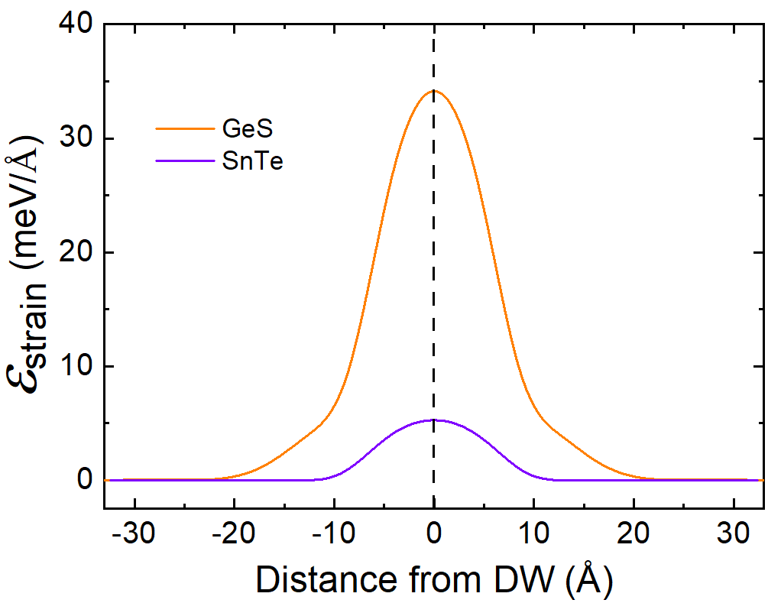
Fig. S6. The strain energy distribution of 180° c-DW in GeS and SnTe, respectively. The black dashed line indicates the center of DWs.

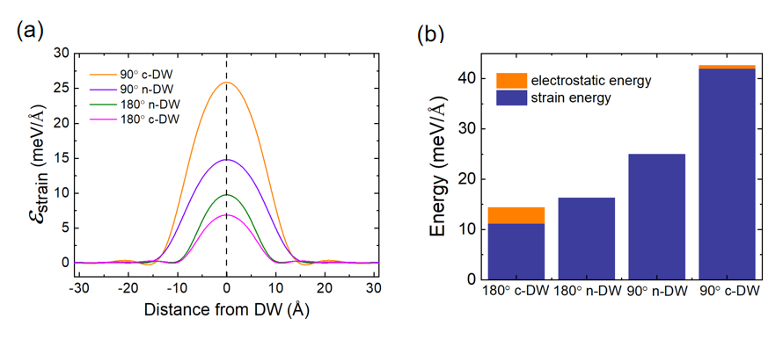
Fig. S7. (a) The strain energy distribution of four typical DW models in Sb. The black dashed line indicates the center of DWs. (b) The total electrostatic energy and strain energy of four typical DW models in Sb.

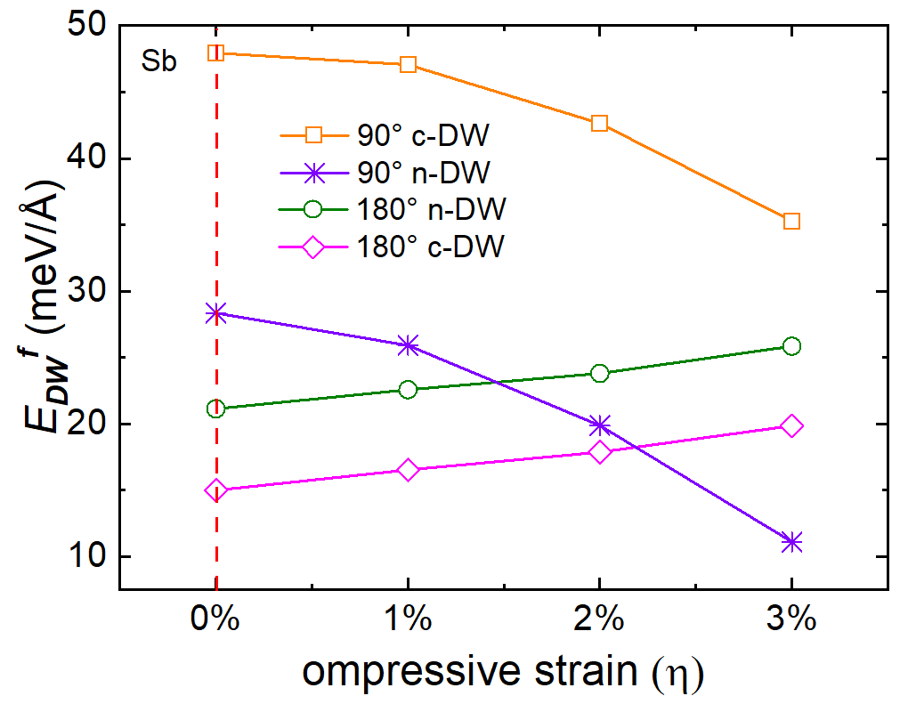
Fig. S8. The formation energy of four typical DW models in Sb as a function of compressive lattice strain η. The dashed red line represents the free-standing state of each DW.

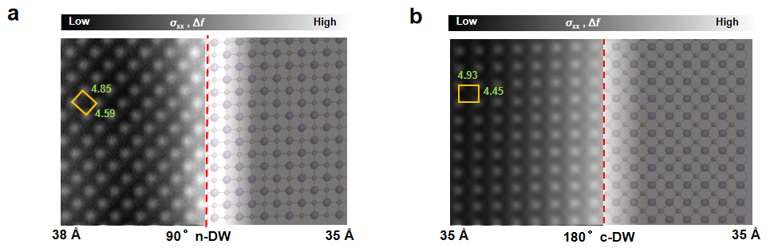
Fig. S9. (a) nc-AFM image of the left half of 90° n-DW (left) and atomic structure of the right half of the 90° n-DW (right) in Bi are shown jointly. (b) nc-AFM image of the left half of 180° c-DW (left) and atomic structure of the right half of 180° c-DW (right) in Bi are shown connectedly. Both strain maps in (a) and (b) are calculated from the local atomic position (left) and DFT results (right) to superimpose on corresponding halfs. Polynomial fitting has been employed for the strain map around the 180°c-DW by nc-AFM. Two spheres with different radiis indicate the two non-equivalent atoms. The orange box is defined as the size of the unit cell away from DWs, with the lattice constants labelled (in units of Å). 38 Å and 35 Å represent the domain size.

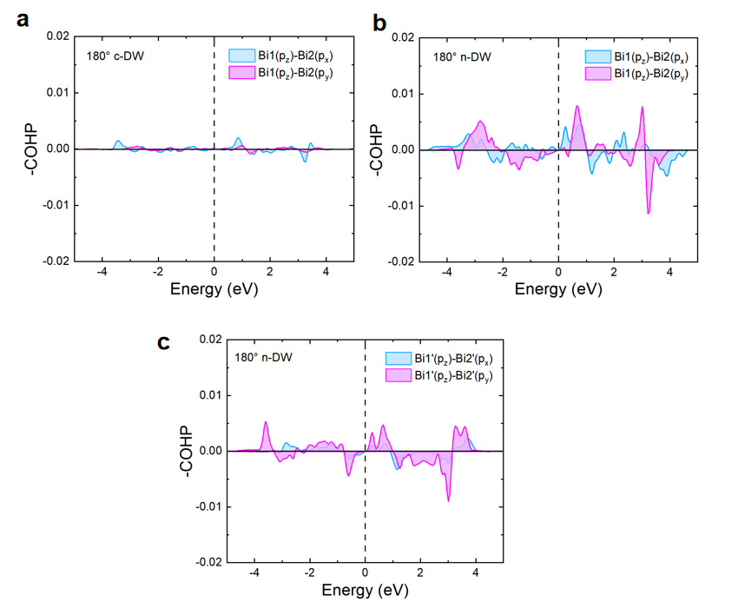
Fig. S10. (a) COHP for Bi1 p_{z} - Bi2 p_{x} and Bi1 p_{z} - Bi2 p_{y} of 180° c-DW. (b) COHP for Bi1 p_{z} - Bi2 p_{x} and Bi1 p_{z} - Bi2 p_{y} of 180° n-DW. (c) COHP for Bi1’ p_{z} - Bi2’ p_{x} and Bi1’ p_{z} - Bi2’ p_{y} of 180° n-DW.

