Supplementary Materias

Construction of Symmetric Mo/S/Ag Cluster Complexes from a Dinuclear Molybdnum Precursor [Et₄N]₂[(edt)₂Mo₂O₂(µ-S)₂] (edt = ⁻SCH₂CH₂S⁻)
Figure S1. ¹H NMR spectra measured in DMSO-d₆ of [(edt)₂Mo₂O₂(μ₂-S)₂Ag₂(dppm)₂] 2.

Figure S2. ³¹P NMR spectra measured in DMSO-d₆ of [(edt)₂Mo₂O₂(μ₂-S)₂Ag₂(dppm)₂] 2.

Figure S3. ¹H NMR spectra measured in CDCl₃ of [(µ₂-Cl)₂Ag₄(µ₃-Cl)₂(dppm)₂]·4DMF 3.

Figure S4. ¹H NMR spectra measured in DMSO-d₆ of [^{n}Pr₄N]₂[{Mo₂Ag₂S₂O₂(edt)₂}₃(μ₆-S)]·1.5CH₃CN 4.

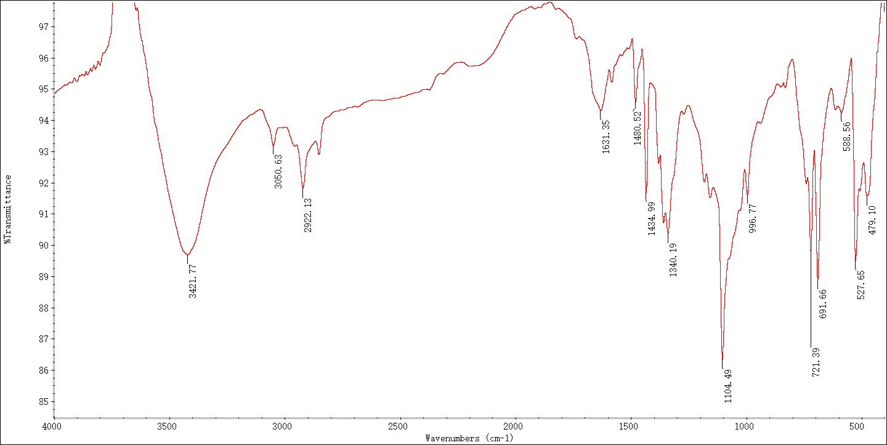
Figure S5. IR spectrum of [(edt)₂Mo₂O₂(μ₂-S)₂Ag₂(dppm)₂] 2.

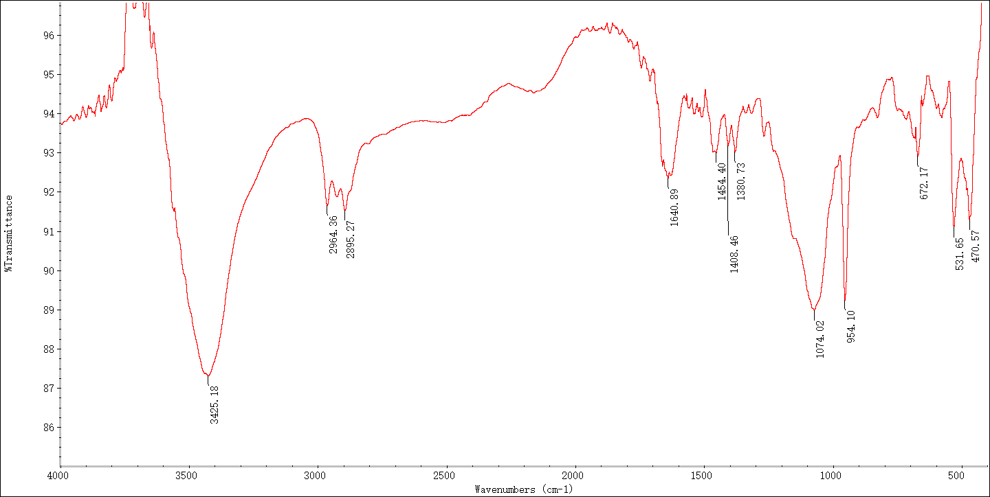
Figure S6. IR spectrum of [^{n}Pr₄N]₂[{Mo₂Ag₂S₂O₂(edt)₂}₃(μ₆-S)]·1.5CH₃CN 4.

