Extended Data Information
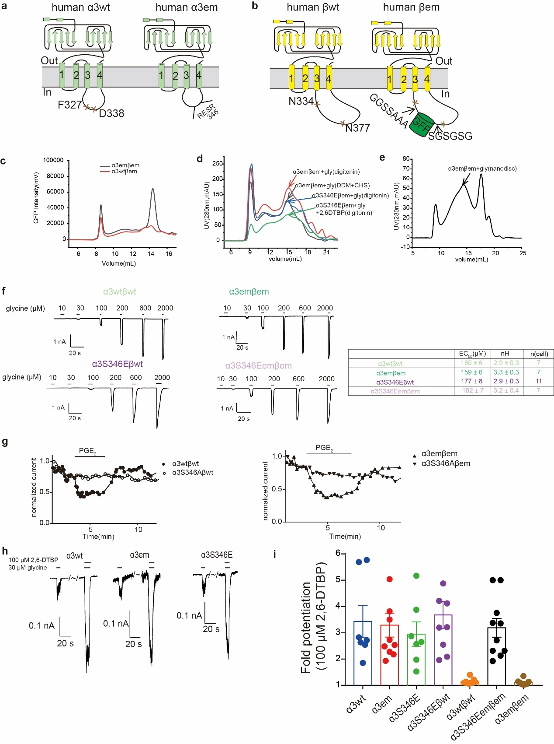
Extended Data Figure 1 | Biochemistry, the topology, and whole cell voltage-clamp electrophysiology of ⍺3β and ⍺3S346Eβ GlyRs.
a, The topology diagrams of human ⍺3wt and ⍺3em. b, The topology diagrams of human βwt and βem. c, FSEC of ⍺3wtβem and ⍺3emβem expressed at 1:3 of ⍺3: β virus ratio. The elution traces represented GFP fluorescence (excitation: 480nm, emission: 515nm) from a Superose6 increase 10/300 column. d, Representative size-exclusion chromatography profile of the α3emβem with glycine in DDM plus CHS, α3emβem with glycine in digitonin, α3S346Eemβem with glycine in digitonin, and α3S346Eemβem with glycine plus 2, 6-DTBP in digitonin. e, Representative size-exclusion chromatography profile of the α3emβem with glycine reconstituted in lipid nanodiscs. f, Left: Representative whole cell patch-clamp electrophysiology recordings of glycine dose response for Fig.1a. Right: EC₅₀, nH (Hill coefficient), and n (cells) are listed. g, Left: Time course of inhibition by 10 μM PGE₂ of glycine-induced currents through α3wtβwt, α3S346Aβwt GlyRs in Fig.1f. Right: Time course of inhibition by 10 μM PGE₂ of 1 mM glycine-evocked currents through α3emβem, α3S346A(em)βem GlyR in Fig.1f. h, Representative traces of 30 μM glycine-induced whole-cell currents recorded from HEK293T cells expressing ⍺3wt, ⍺3em, ⍺3S346E GlyR in the absence or presence of 100 μM 2, 6-DTBP. i, 30 μM glycine-evoked currents increase fold potentiation of ⍺3wtβwt, ⍺3emβem, ⍺3S346Eβwt, ⍺3S346Eemβem, ⍺3wt, ⍺3em and ⍺3S346E induced by 100 uM 2, 6-DTBP.
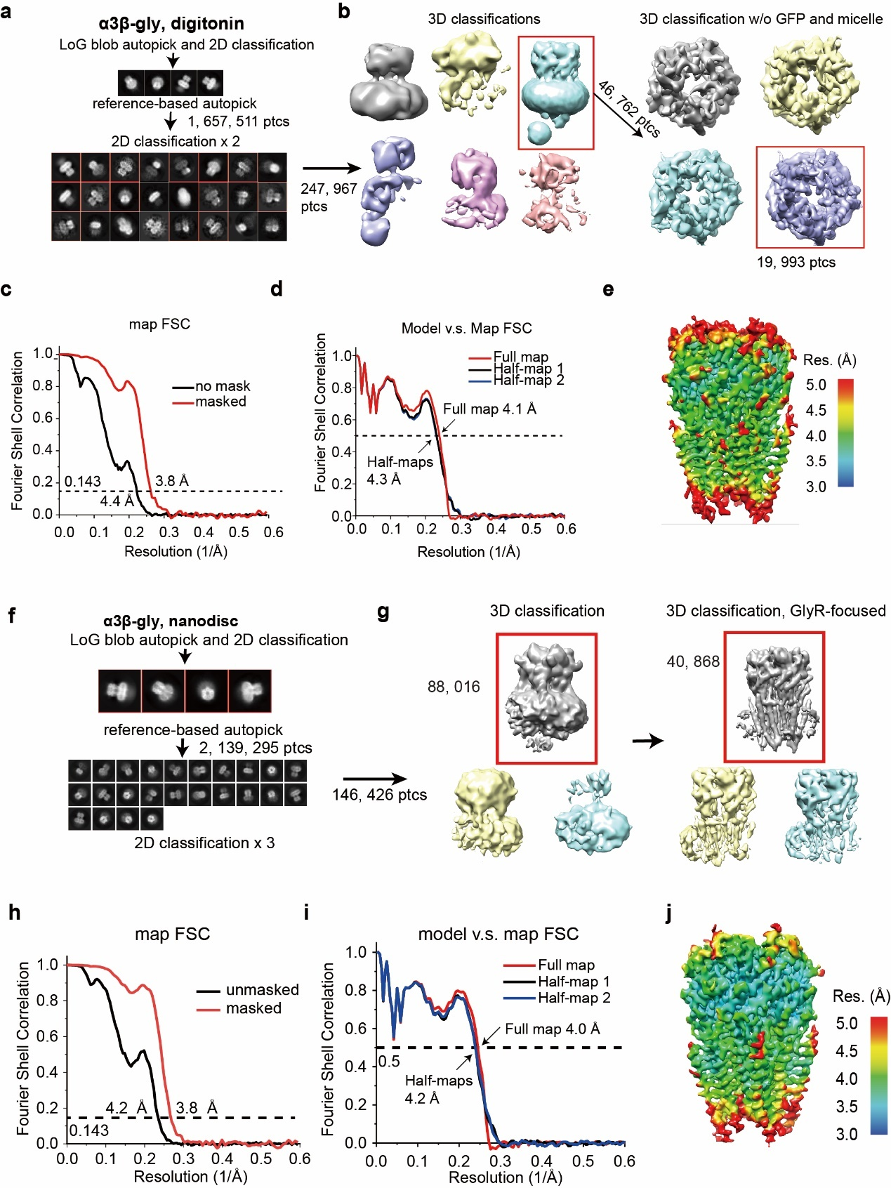
Extended Data Figure 2 | Overview cryo-EM data processing for ⍺3β GlyRs.
a-e, Cryo-EM data processing for ⍺3β-gly GlyR in digitonin. (a and b) Selected (red boxes) 2D and 3D classes average for ⍺3β-gly GlyR. 6 classes resulting from 3D classification. 1 good 2D class was selected for further refined. A further 3D classification into 4 classes without particle alignment was performed. Particle signal subtraction was performed to focus on the TMD. 1 good class resulted in a final of 19,993 particles. (c) The gold standard FSC curves from the final map of ⍺3β-gly GlyR in digitonin. (d) FSC between the atomic model and half maps/full map. Resolution at FSC of 0.5 was indicated. (e) Local resolution map for ⍺3β-gly GlyR in digitonin. f-j, Cryo-EM data processing for ⍺3β-gly GlyR in nanodisc. (f) Selected (red boxes) 2D and 3D classes average for ⍺3β-gly GlyR in nanodisc. 3 classes resulting from 3D classification. The 1 good classes in boxes were selected for further refined. A further 3D classification into 3 classes without particle alignment was performed. Particle signal subtraction was performed to entire GlyR. 1 good class resulted in a final of 40,868 particles. (h) Gold standard FSC curves of the final maps of ⍺3β-gly GlyR in nanodisc. (i)FSC between the atomic model and half maps/full map. Resolution at FSC of 0.5 was indicated. (j) Local resolution map for ⍺3β-gly GlyR in nanodisc. Local resolutions are calculated using ResMap.
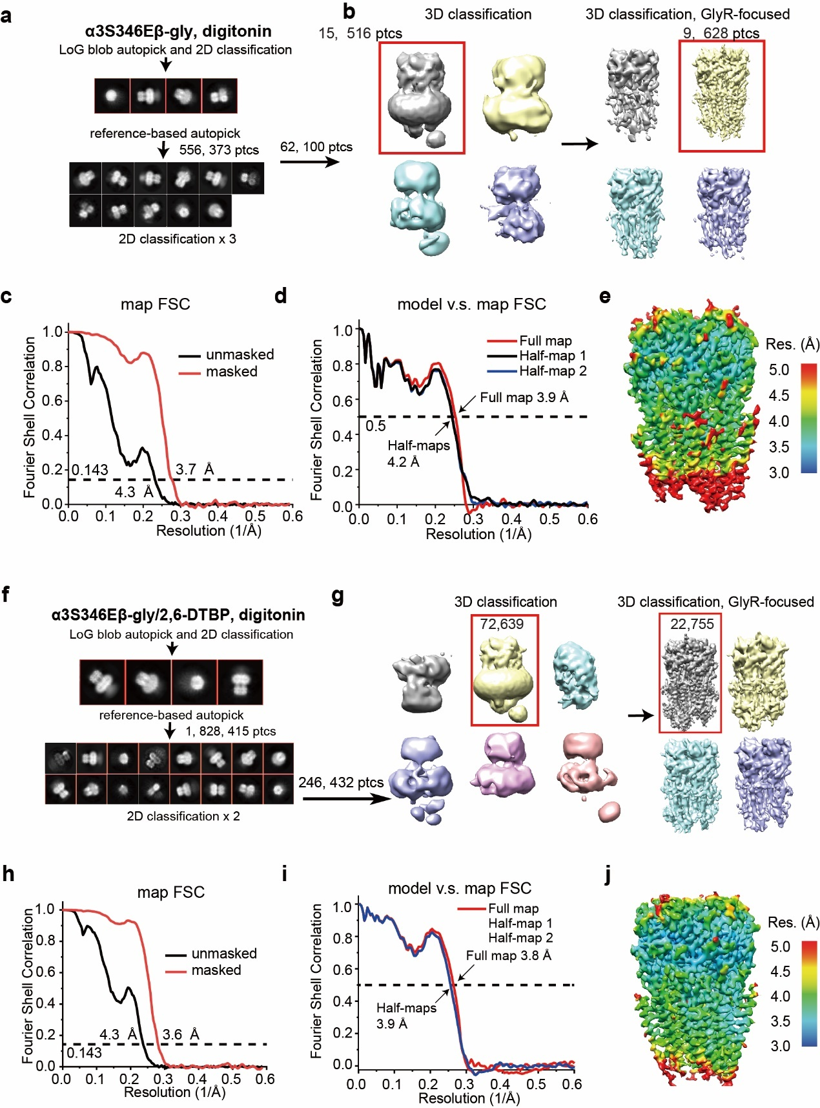
Extended Data Figure 3 | Overview cryo-EM data processing for ⍺3S346Eβ GlyRs.
a-e, Cryo-EM data processing for ⍺3S346Eβ-gly GlyR in digitonin. (a and b) Selected (red boxes) 2D and 3D classes average for ⍺3S346Eβ-gly GlyR. 4 classes resulting from 3D classification. One good class was selected for further refined. A further 3D classification into 4 classes without particle alignment was performed. Particle signal subtraction was performed to focus on entire GlyR. 1 good class resulted in a final of 9,628 particles. (c) The gold standard FSC curves from the final map of ⍺3S346Eβ-gly GlyR in digitonin. (d) FSC between the atomic model and half maps/full map. Resolution at FSC of 0.5 was indicated. (e)Local resolution map for ⍺3S346Eβ-gly GlyR in digitonin. f-j, Cryo-EM data processing for ⍺3S346Eβ-gly/2, 6-DTBP GlyR in digitonin. (f) Selected (red boxes) 2D and 3D classes average for ⍺3β-gly/2, 6-DTBP GlyR in digitonin. (g) 6 classes resulting from 3D classification. The 1 good classes in boxes were selected for further refined. A further 3D classification into 4 classes without particle alignment was performed. Particle signal subtraction was performed to entire GlyR. 1 good class resulted in a final of 22,755 particles. (h) Gold standard FSC curves of the final maps of ⍺3S346Eβ-gly/2, 6-DTBP GlyR in digitonin. (i) FSC between the atomic model and half maps/full map. Resolution at FSC of 0.5 was indicated. (j) Local resolution maps for ⍺3S346Eβ-gly/2, 6-DTBP GlyR in digitonin. Local resolutions are calculated using ResMap.
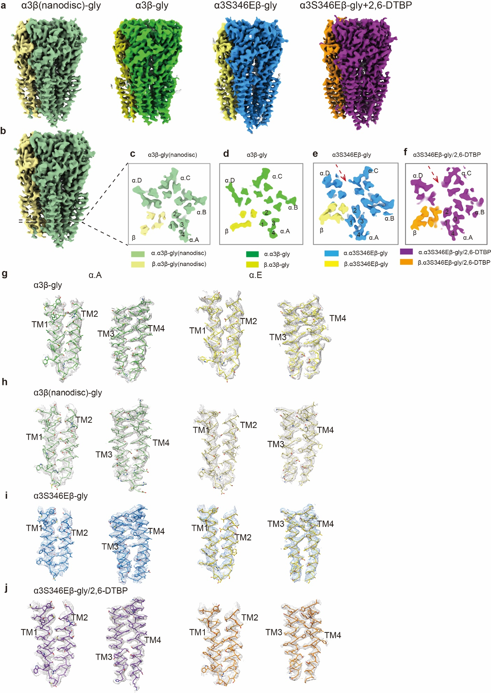
Extended Data Figure 4 | Map quality and cryo-EM densities for selected regions of ⍺3β and ⍺3S346Eβ GlyRs.
a, A side view for ⍺3β-gly (nanodisc), ⍺3β-gly, ⍺3S346Eβ-gly, and ⍺3S346Eβ-gly/2, 6-DTBP GlyRs from the density maps. b-f, Representative side view for ⍺3β GlyR density map(b), a TMD slice from the experimental density maps for ⍺3β-gly(nanodisc)(c), ⍺3β-gly(d), ⍺3S346Eβ-gly(e), and ⍺3S346Eβ-gly/2, 6-DTBP(f) GlyR. g-j, M1-M4 helices of the ⍺3 subunit and β subunit for ⍺3β-gly (nanodisc) (h), ⍺3β-gly(g), ⍺3S346Eβ-gly(i), and ⍺3S346Eβ-gly/2, 6-DTBP(j) GlyRs. ⍺ subunits and β subunit are respectively colored in light green and light yellow for ⍺3β-gly (nanodisc). ⍺ subunits and β subunit are respectively colored in green and yellow for ⍺3β-gly. ⍺ subunits and β subunit are respectively colored in blue and light yellow for ⍺3S346Eβ-gly. ⍺ subunits and β subunit are respectively colored in purple and orange for ⍺3S346Eβ-gly GlyR.

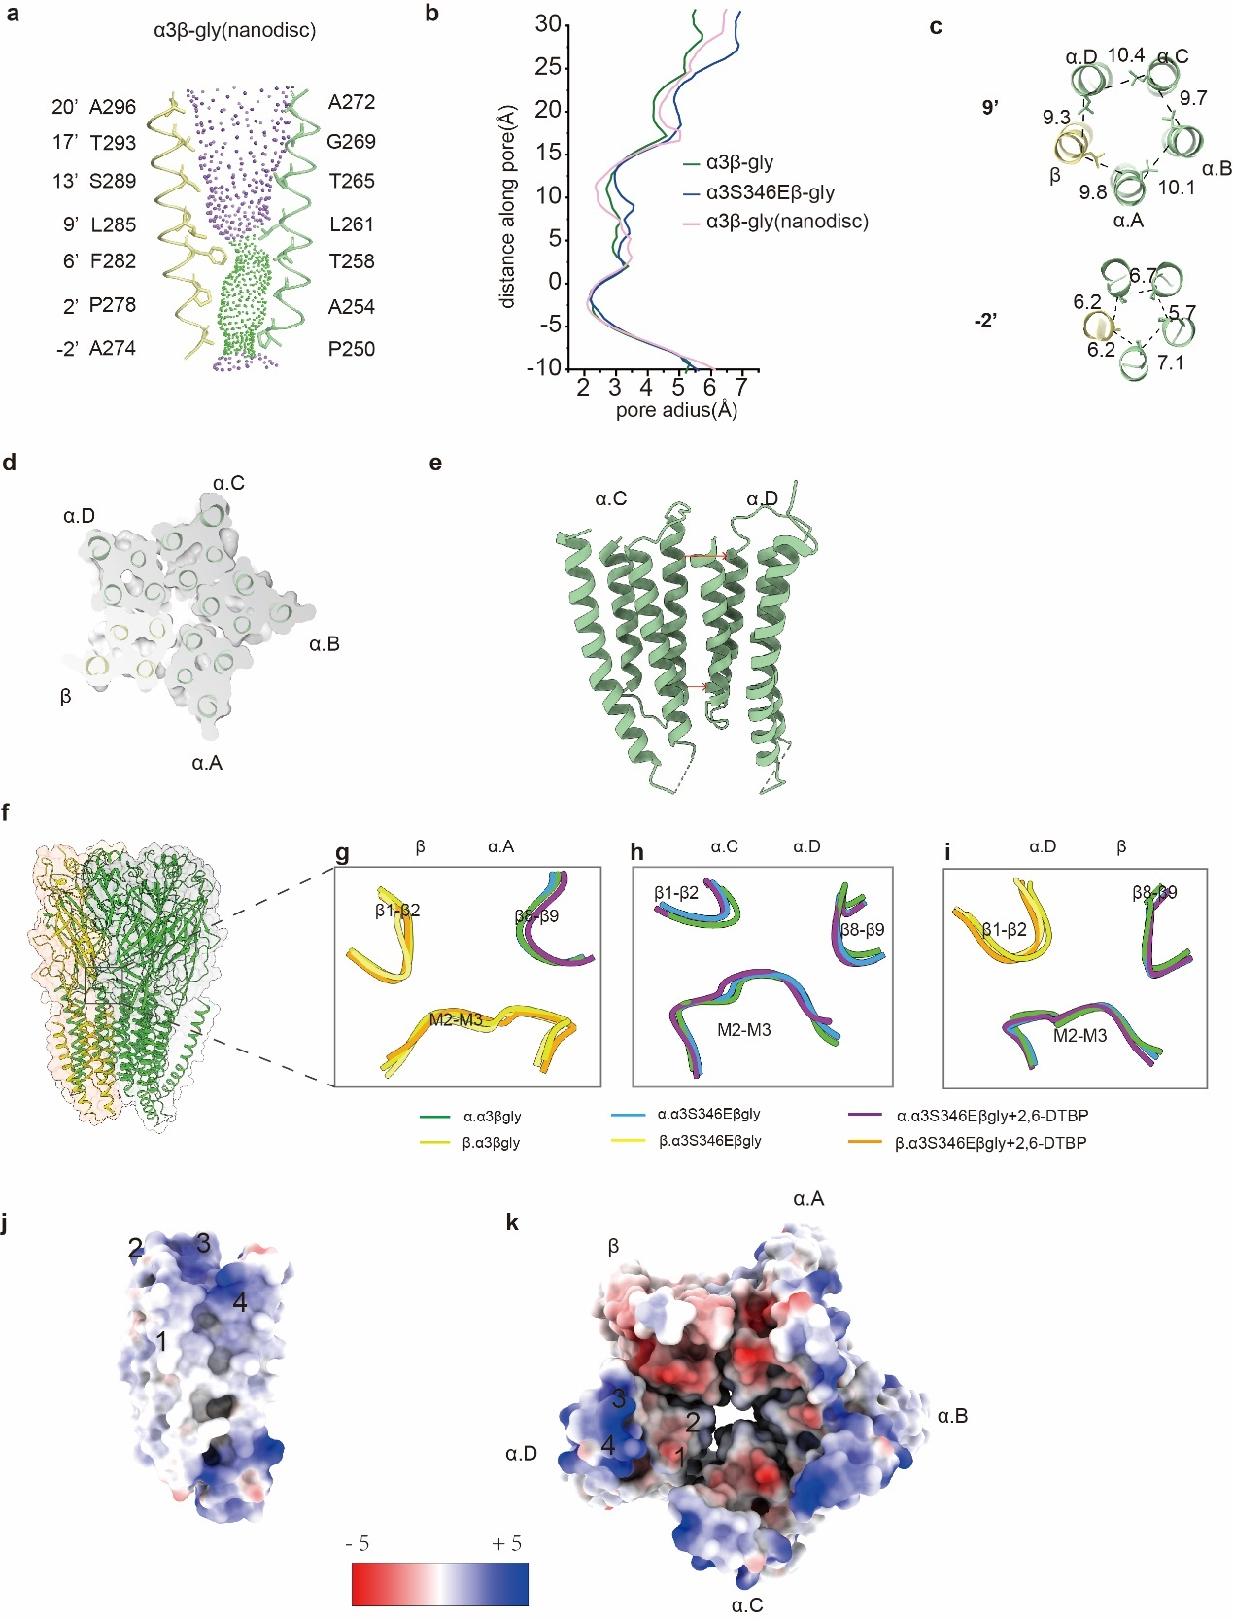
Extended Data Figure 5 | Overall structure conformation of ⍺3β-gly GlyR in nanodisc and conformational changes at the ECD-TMD interface.
a, Ion permeation pathways for ⍺3β-gly GlyR in nanodisc. M2 helices are shown as cartoon and the side chains of pore-lining residues as sticks. Purple, green, red spheres define radii of > 3.3 Å, 1.8-3.3 Å, and < 1.8 Å, respectively. b, Plot of pore radii calculated by the HOLE program for the ⍺3β-gly in nanodisc(pink), ⍺3β-gly (green), ⍺3S346Eβ-gly (blue) GlyRs. c, Cross-sections of M2 helices at residues 9’ (top) and -2’ (bottom) for ⍺3β-gly GlyR in nanodisc with distances between neighboring Cα shown in Å. d, Z-slice in the TMD at 2’ for ⍺3β-gly GlyR in nanodisc. e, The cartoon representation of the TMD interfaces between ⍺.C and ⍺. D subunits for ⍺3β-gly GlyR in nanodisc. Red arrow indicates increased distance between adjacent ⍺ subunits at -2’ (down) and 19’(up). f-i, Overlay of ECD-TMD interface between ⍺3β-gly, ⍺3S346Eβ-gly, and ⍺3S346Eβ-gly/2, 6-DTBP at β (+) ⍺. A (-) (g), ⍺. B (+) ⍺.C (-) (h) and ⍺. D(+) β(-) (i) interfaces. j, ⍺. A TMD surface of ⍺3β-gly GlyR in digitonin colored according to electrostatic potentials. k, down to top view of surface of ⍺3β-gly GlyR in digitonin colored according to electrostatic potentials.

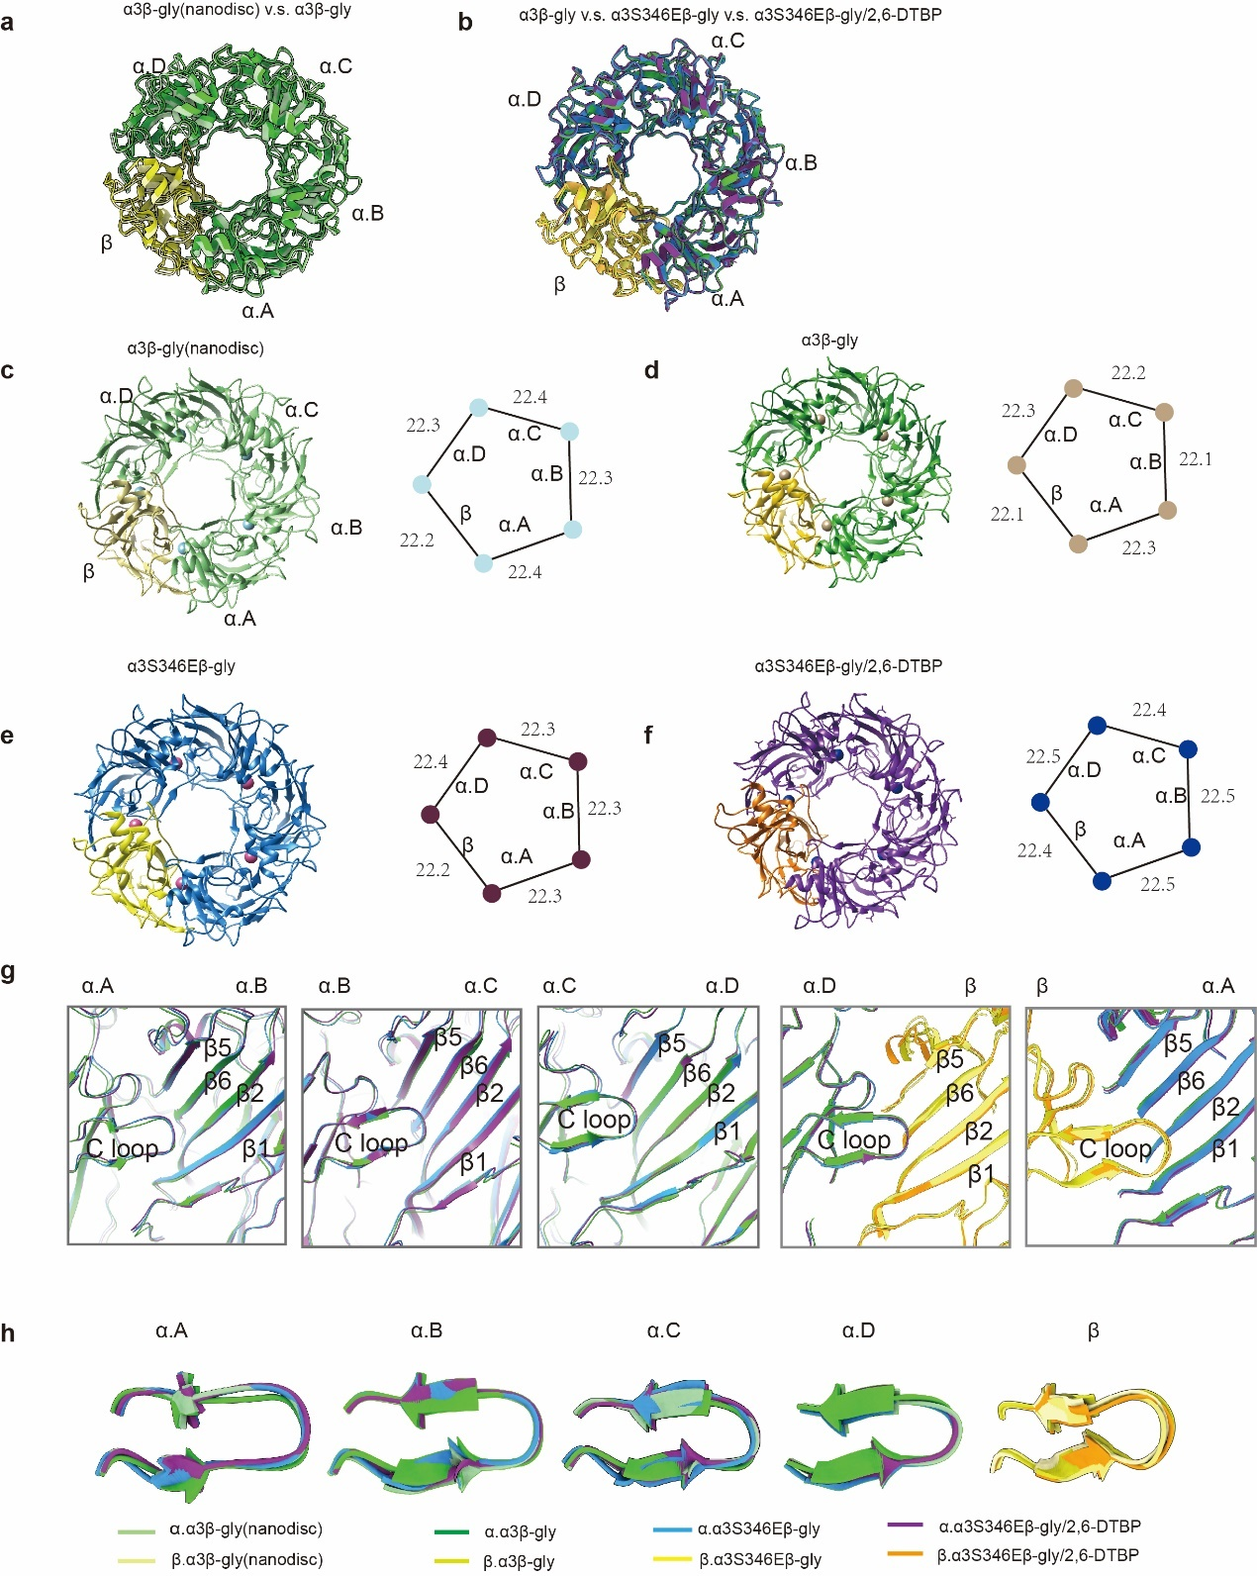
Extended Data Figure 6 | The same conformation for the ECD between ⍺3β-gly, ⍺3S346Eβ-gly and ⍺3S346Eβ-gly/2, 6-DTBP GlyRs
a, Top-down view of ECD by superimposition of ECD between ⍺3β-gly GlyR in nanodisc (α: light green, β: light yellow) and ⍺3β-gly GlyR in digitonin (α: green, β: yellow). b, Top-down view of ECD by superimposition of ECD between ⍺3β-gly (α: green, β: yellow), ⍺3S346Eβ-gly (α: blue, β: light yellow) and ⍺3S346Eβ-gly/2, 6-DTBP (α: purple, β: orange) GlyRs in digitonin. c, d, e, f, Cartoon representation of ECD with diagram on the right showing distances between the centers of mass of two adjacent subunits for ⍺3β-gly(nanodisc)(c), ⍺3β-gly(d), ⍺3S346Eβ-gly(e), ⍺3S346Eβ-gly/2, 6-DTBP(f) GlyRs. g, Superposition of all 5 glycine binding pockets in each of ⍺3β-gly (α: green, β: yellow), ⍺3S346Eβ-gly (α: blue, β: light yellow) and ⍺3S346Eβ-gly/2, 6-DTBP GlyRs in digitonin. h, Overlay of all 5 C-loop in each of ⍺3β-gly (α: green, β: yellow), ⍺3S346Eβ-gly (α: blue, β: light yellow) and ⍺3S346Eβ-gly/2, 6-DTBP GlyRs in digitonin.

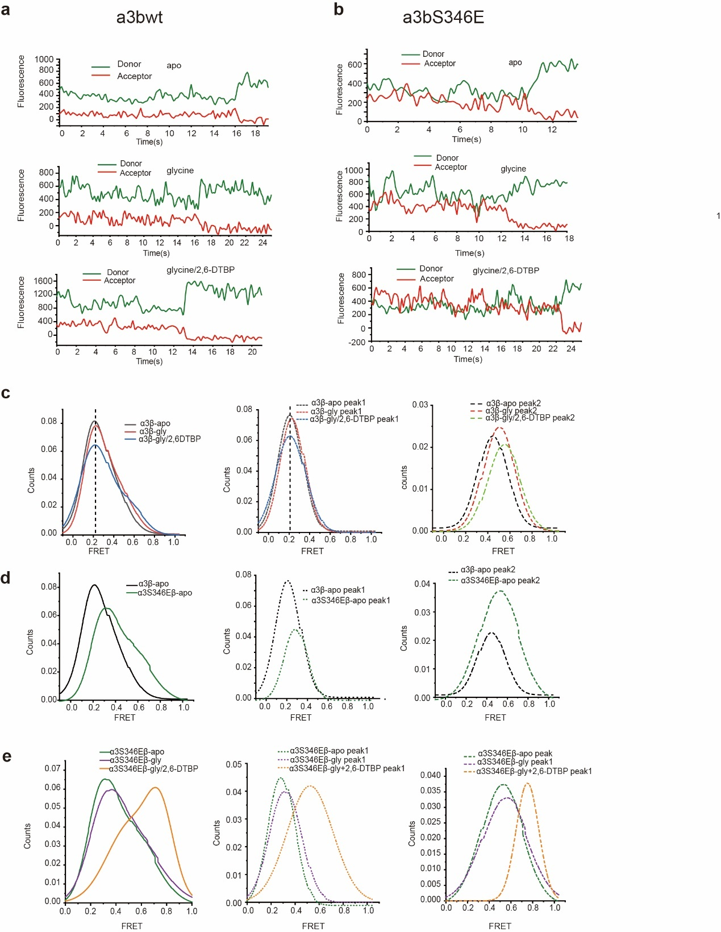
Extended Data Figure 7 | smFRET analysis of the effect of ⍺3S346E mutation and 2, 6-DTBP on internal conformation of the M3/M4 loop
a, Representative single-molecule fluorescence time traces of α3β in apo (top), in presence of glycine (middle) and in presence of glycine plus 2, 6-DTBP (bottom). b, Representative single-molecule fluorescence time traces of α3S346Eβ in apo (top), in presence of glycine(middle) and in presence of glycine plus 2, 6-DTBP (bottom). c, Left: Overlay of smFRET population histogram in apo, in presence of glycine and in presence of glycine and 2, 6-DTBP for α3β GlyR. Overlay of Gaussian fits smFRET population histogram peak1 (centered at lower FRET, ~0.2, middle panel) and peak2 (centered at higher FRET value, right panel) in apo, in presence of glycine and in presence of glycine and 2, 6-DTBP for α3β GlyR. d, Left: Overlay of smFRET population histogram for α3β and α3S346Eβ GlyRs in apo. Overlay of Gaussian fits smFRET population histogram peak1(centered at lower FRET value, middle panel) and peak2 (centered at higher FRET value, right panel) for α3β and α3S346Eβ GlyRs in apo. e, Left: Overlay of smFRET population histogram in apo, in presence of glycine and in presence of glycine and 2, 6-DTBP for α3S346Eβ GlyR. Overlay of Gaussian fits smFRET population histogram peak1 (centered at lower FRET, middle panel) and peak2 (centered at higher FRET, right panel) in apo, in presence of glycine and in presence of glycine and 2, 6-DTBP for α3S346Eβ GlyR.

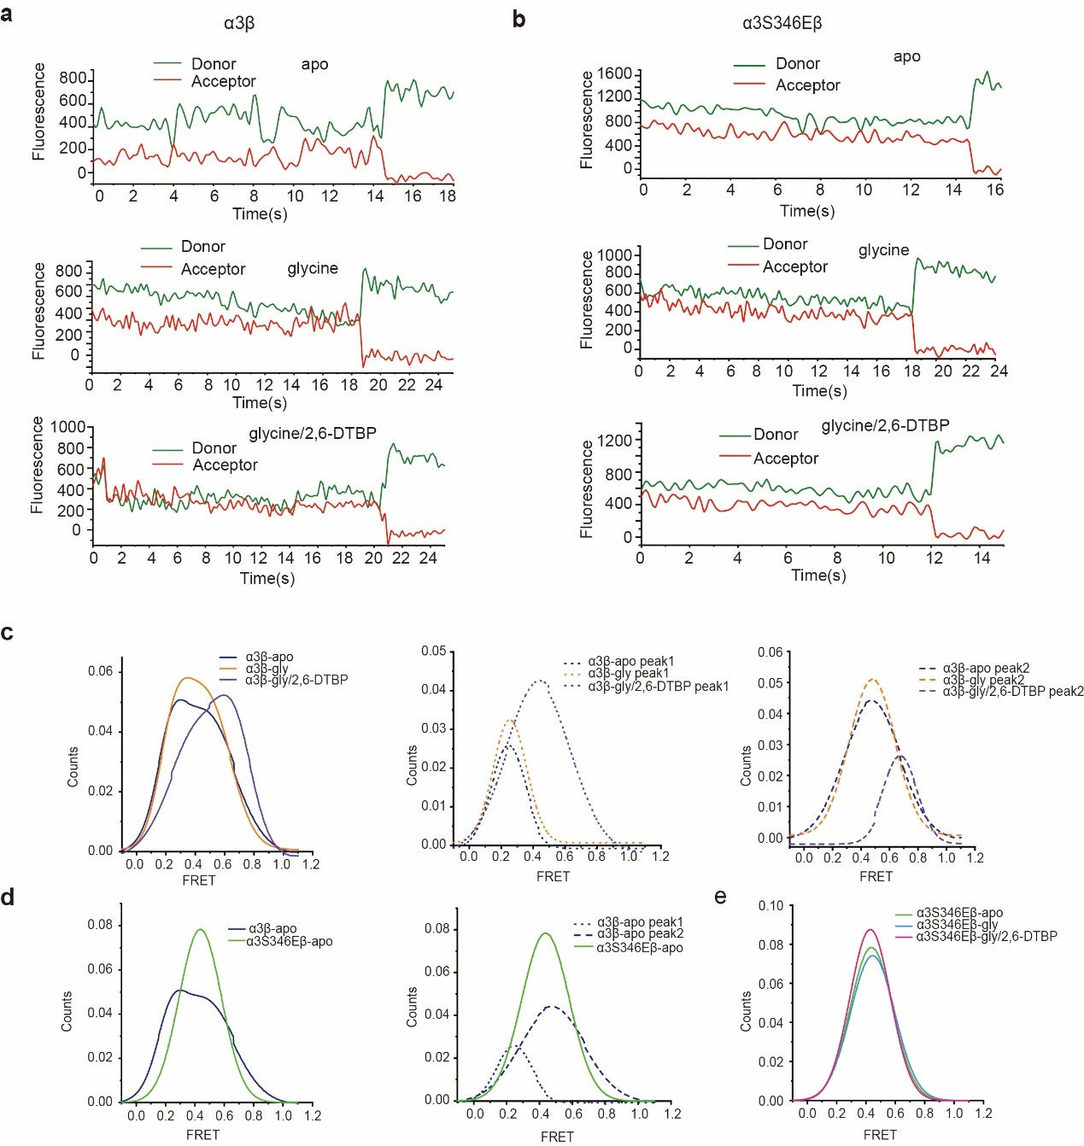
Extended Data Figure 8 | smFRET analysis of the effect of ⍺3S346E mutation and 2, 6-DTBP on distance between the M3/M4 loops of different α subunits
a, Representative single-molecule fluorescence time traces of α3β in apo(top), in presence of glycine(middle) and in presence of glycine and 2, 6-DTBP (bottom). b, Representative single-molecule fluorescence time traces of α3S346Eβ in apo(top), in presence of glycine(middle) and in presence of glycine and 2, 6-DTBP (bottom). c, Left: Overlay of smFRET population histogram in apo, in presence of glycine and in presence of glycine and 2, 6-DTBP for α3β GlyR. Overlay of Gaussian fits smFRET population histogram peak1(centered at lower FRET, middle panel) and peak 2 (centered at higher FRET, right panel) in apo, in presence of glycine and in presence of glycine and 2, 6-DTBP for α3β GlyR. d, Left: Overlay of smFRET population histogram for α3β and α3S346Eβ GlyRs in apo. Right: Overlay of Gaussian fits smFRET population histogram peak 1 (centered at lower FRET) and peak 2 (centered at higher FRET) for α3β and α3S346Eβ in apo. e, Overlay of smFRET population histogram in apo, in presence of glycine and in presence of glycine plus 2, 6-DTBP for α3S346Eβ GlyR.

Extended Data Table 1 Cryo-EM data collection, refinement and validation statistics
 | α3β-gly  (nanodisc)  (EMD44754-)  (PDB:9BOY) | α3β-gly  (EMD-44755)  (PDB:9BOZ) | α3S346Eβ-gly  (EMD-44756)  (PDB: 9BPO) | α3S346Eβ-gly/2, 6-DTBP  (EMD-44763)  (PDB:9BP7)
Data collection and processing
Magnification | 105,000 | 105,000 | 105,000 | 105,000
Voltage (kV) | 300 | 300 | 300 | 300
Electron exposure (e–/Å²) | 69.6 | 69.6 | 69.6
Defocus range (μm) | -1.0 to -2.5 | -1.0 to -2.5 | -1.0 to -2.5 | -1.0 to -2.5
Pixel size (Å) | 0.83 | 0.83 | 0.83 | 0.83
Symmetry imposed | C1 | C1 | C1 | C1
Initial particles(no.) | 2,139,295 | 1,657,511 | 556,373 | 1,828,415
Final particles (no.) | 40,868 | 19,993 | 9,628 | 22,755
Map resolution (Å)  FSC threshold | 3.8  0.143 | 3.8  0.143 | 3.7  0.143 | 3.6  0.143
Refinement
Initial model used (PDB code) | 8DN4 | 8DN4 | 8DN4 | 8DN2
Model resolution (Å)  FSC threshold | 4.1  0.5 | 4.1  0.5 | 4.0  0.5 | 3.9  0.5
Model composition  Non-hydrogen atoms  Protein residues  Ligands | 13820  1717  NAG:5 GLY:3 | 13733  1705  NAG:5 | 13744  1708  NAG:5 GLY:4 | 13732  1706  NAG:5 GLY:3
B factors (Å²)  Protein  Ligand | 88.61  86.59 | 116.52  135.27 | 56.57  55.17 | 71.79  60.46
R.m.s. deviations  Bond lengths (Å)  Bond angles (°) | 0.005  1.004 | 0.003  0.604 | 0.003  0.606 | 0.003  0.527
Validation  MolProbity score  Clashscore  Rotamer outliers (%) | 2.05  11  1.67 | 2.4  15  4.96 | 2.32  10  4.96 | 2.07  7  3.55
Ramachandran plot  Favored (%)  Allowed (%)  Disallowed (%) | 96  4.2  0.12 | 96  3.4  0.30 | 96  3.8  0.06 | 96  3.4  0.24

states | Peak1 center | Peak1 precent | Peak2 center | Peak2 precent
α3β apo | 0.20 ± 0.01 | 76% | 0.42 ± 0.02 | 24%
α3β gly | 0.22 ± 0.01 | 73% | 0.48 ± 0.01 | 27%
α3β gly+2, 6-DTBP | 0.20 ± 0.02 | 75% | 0.53 ± 0.06 | 25%
α3S346Eβ apo | 0.28 ± 0.01 | 41% | 0.51 ± 0.06 | 59%
α3S346Eβ glycine | 0.30 ± 0.01 | 42% | 0.54 ± 0.11 | 58%
α3S346Eβ gly+ 2, 6-DTBP | 0.52 ± 0.04 | 67% | 0.75 ± 0.01 | 33%
Extended Data Table 2 smFRET distribution statistics form Gaussian fit for internal conformation of M3/M4 loop
Errors represent S.E.M.
States | Peak1 center | Peak1 precent | Peak2 center | Peak2 precent
α3β apo | 0.25 ± 0.01 | 24% | 0.50 ± 0.04 | 76%
α3β gly | 0.26 ± 0.02 | 28% | 0.48 ± 0.03 | 72%
α3β gly+2, 6-DTBP | 0.44 ± 0.04 | 68% | 0.71 ± 0.01 | 32%
States | Peak center |  | Peak precent
α3S346Eβ apo | 0.48 ± 0.01 |  | 100%
α3S346Eβ gly | 0.49 ± 0.01 |  | 100%
α3S346Eβ gly+ 2, 6-DTBP | 0.44 ± 0.01 |  | 100%
Extended Data Table 3 smFRET distribution statistics form Gaussian fit for the distances between different M3/M4 loops
Errors represent S.E.M.

