Supplementary Figure 1A: Genome-Wide Association Study (GWAS) for Calories to Satiation. This Manhattan plot displays the results of a GWAS investigating genetic variants associated with calories to satiation in the ad libitum meal. The absence of significant peaks across the genome highlights that no genetic variants reached the threshold for genome-wide significance (p < 5 x 10^-8).
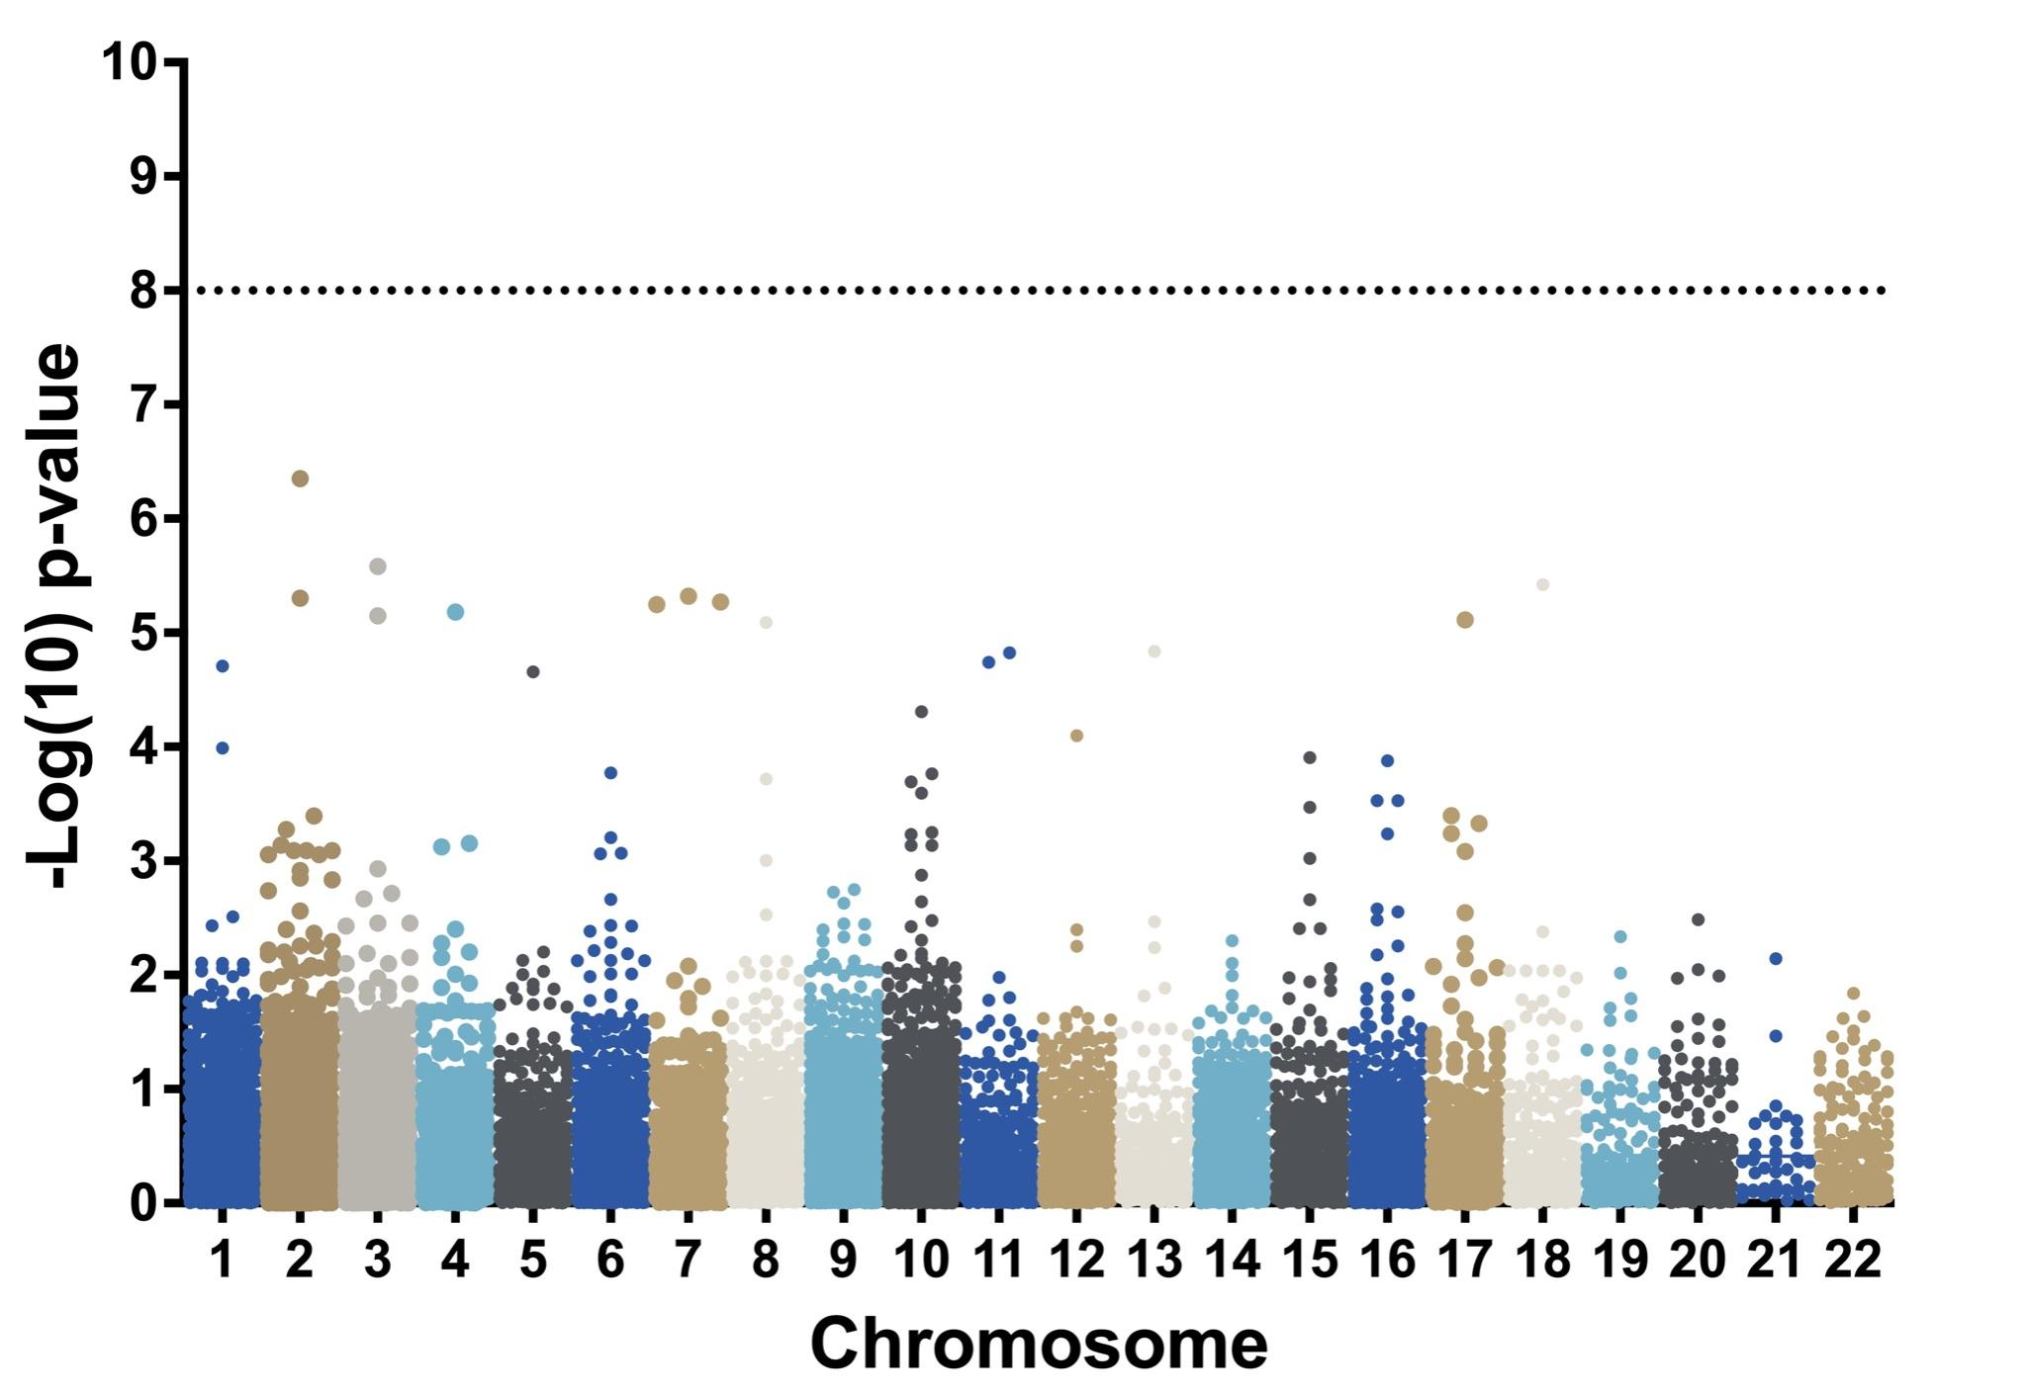

Supplementary Figure 1B: Volcano plot of association with calories to satiation traits. Each point represents the association of a variability of a SNP with CTS among male (blue) and female (red) subjects. The x-axis shows the magnitude and direction of the association and the y-axis the significance of the association.

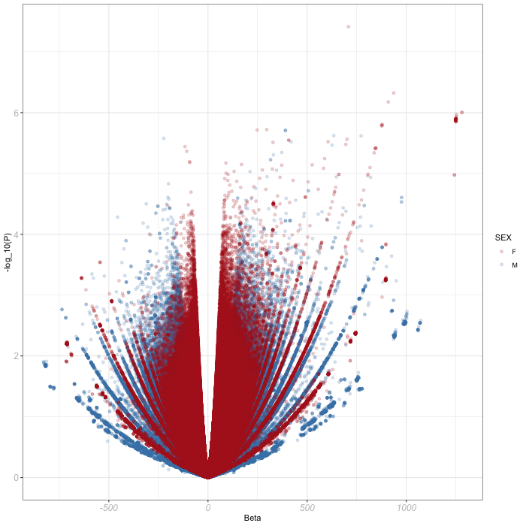

Supplementary Figure 2: A) Representational overview of the genotype and CTS data collected; samples from females marked in red and from males in blue. B) GWAS performed between genotypes in samples collected from females and CTS (n=359). C) As with B, but with only male samples (n=124). D) Selection of parameters using the SNPs from 41 gene regions and beta values from either $B_{f}$ or $B_{m}$ and Gene Risk Score function, where the function ${GRS}_{g}$ computes the gene risk score for gene $g$ on sample $S$ using GWAS weights $B∈\{B_{f},B_{m}\}$, $k_{g}$ is the number of genotyped SNPs around gene $g$, ${Cont}_{g}$ calculates the contribution factor using the genomic context of SNP $i$ and the regression weight $β_{i}$for the SNP in $B$, and $δ_{s,i}$ is the dosage of risk alleles of SNP $i$ in sample $S.$ Here, ${Cont}_{g}=β_{i} if \left|Pos\left(i\right)-Pos(g)\right|<1×{10}^{6}$, otherwise 0, where Pos is the coordinate of the SNP or the coordinate of the end of gene g nearest SNP i. E) Feature matrix $F$ (n=497) contains all GRSs calculated using both $B_{f}$ and $B_{m}$ along with anthropometric features $A. T$he target matrix $T$ contains a 1 for HS+ or 0 for HS- for each sample when CTS is greater than or less than the sex-specific CTS threshold, respectively. The $F_{Sel}$ features are chosen based on these data using backward feature selection, which begins using all features and iteratively removes features that whose removal maximally improves the AUC until no features remain. The selected features $F_{Sel}$are those that produced the maximum AUC. F) Final model training and testing, where $S_{Te}=\left\{s | s in phentop trial\right\}$, $S_{V}=\left\{s | s in lira trial\right\}, S_{Tr}=\left\{s | s in neither trial\right\}$. The CTS_{GRS} is an SVC model trained samples $S_{Tr}$ (n=483) using the selected features $F_{Sel}$ against target variable $T$, oversampled using SMOTE to create an additional 225 synthetic samples (total training n=708). The performance of the CTS_{GRS}, including ROC-AUC, SN, and SP, was measured using the outputs of CTS_{GRS} ($F_{Sel}$) against $T$ using data from samples $S_{Te}$ (n=57) or $S_{V}$ (n=119). After removing samples with outlier CTS < 500, n=50 and 110, respectively.

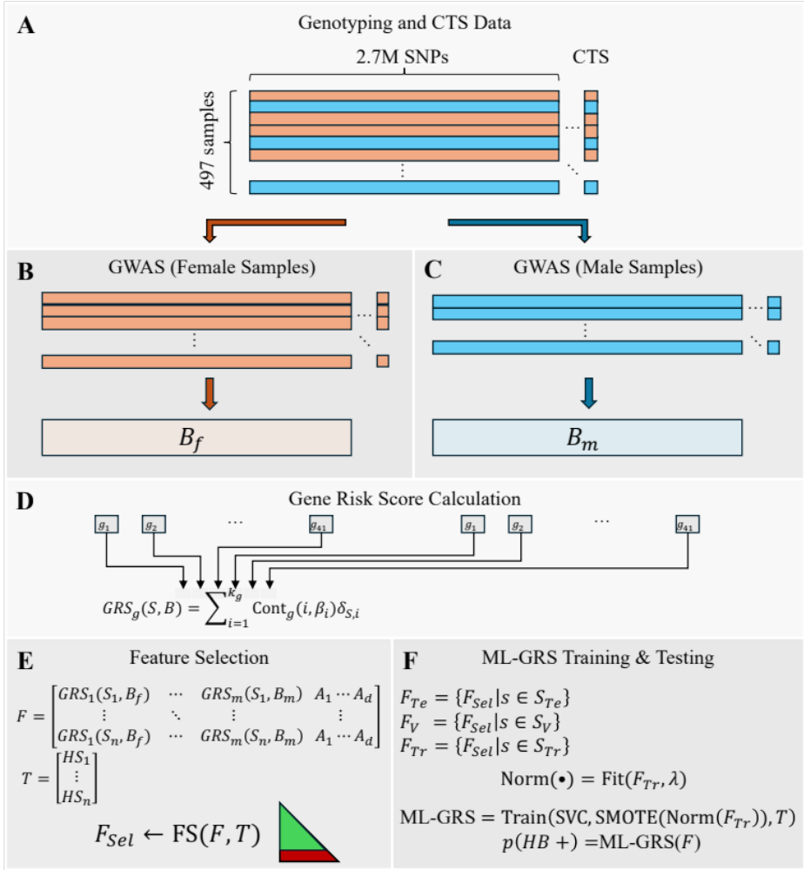

Supplementary Figure 3: Flowchart diagram for the training, validation, and independent testing cohort for development of the machine-learning assisted gene risk score for calories to satiation.
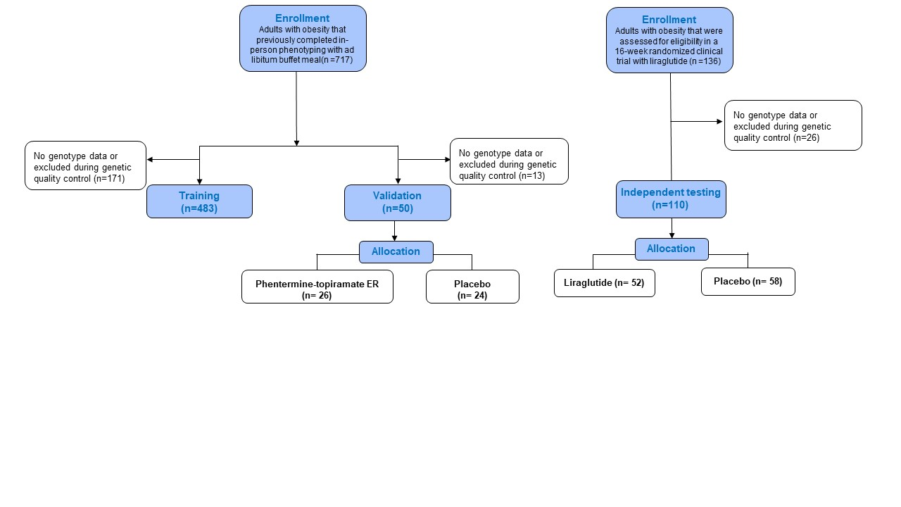

Supplementary Figure 4: Flowchart diagram for a 12-month, placebo-controlled, randomized clinical trial with phentermine-topiramate extended-release.
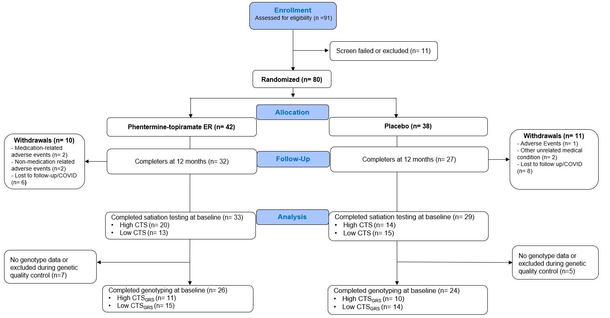

Supplementary Figure 5: Flowchart diagram for a 16-week, placebo-controlled, randomized clinical trial with liraglutide.
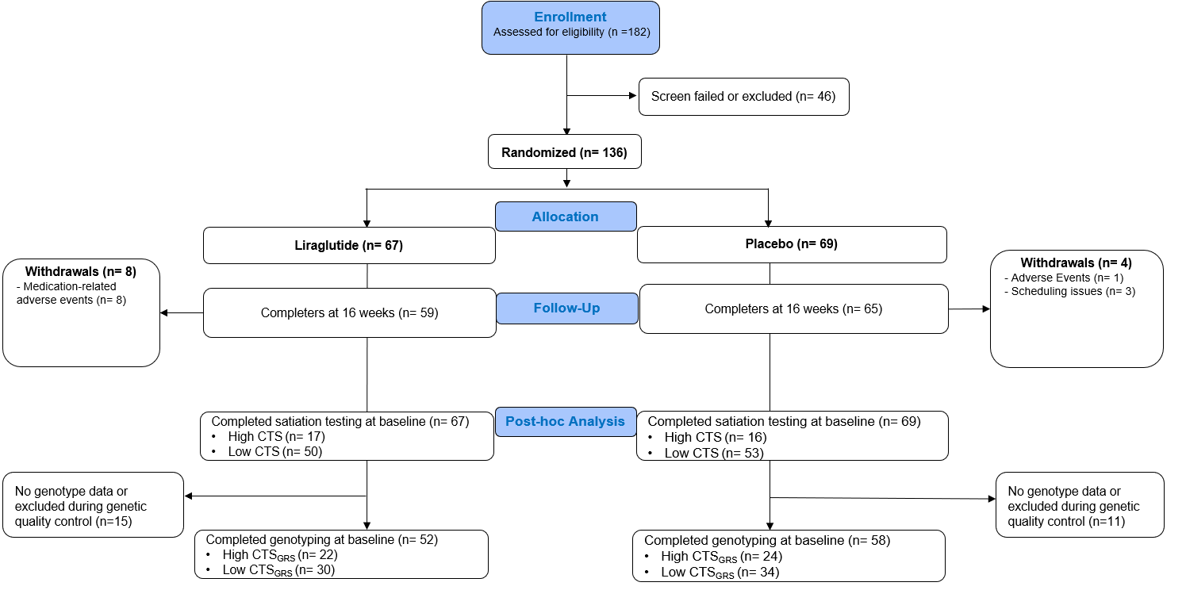

Supplementary Figure 6: Beeswarm plot of Shapley Additive Explanations (SHAP) values for the CTS_{GRS} model representing the contribution of specific features to model output. Each point for a given feature represents a sample with its horizontal position representing the magnitude and direction that feature effects the probability of high calories to satiation. The color scale indicates the relative value of that feature for that sample as ranked among all other samples. Features are ranked by the mean absolute SHAP value, i.e., magnitude of effect on predictions.
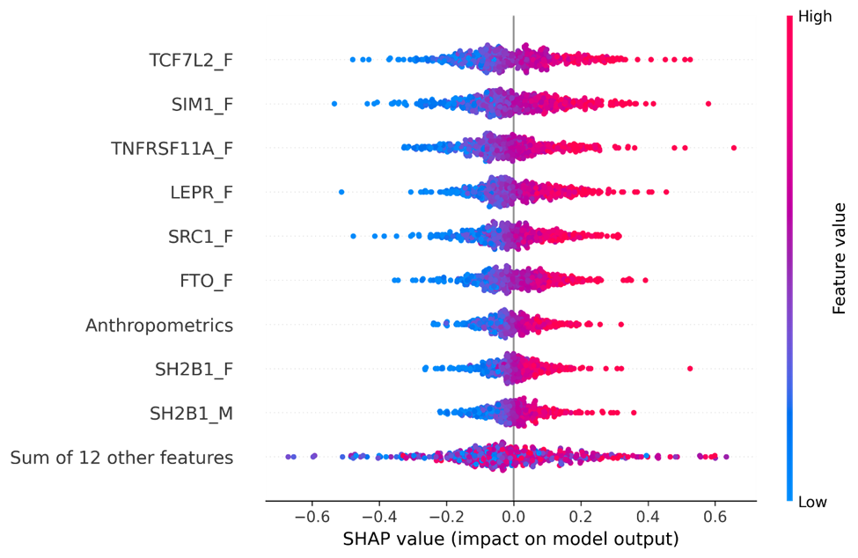

Supplementary Figure 7: Performance of the CTS_{GRS} model in predicting weight loss outcomes of a 12-month, placebo-controlled, randomized clinical trial with phentermine-topiramate extended-release. A) The CTS_{GRS} model had an AUC of 0.71 for predicting responders achieving at least 15% of total body weight loss at 12 months in participants that were assigned to phentermine-topiramate extended-release. B) Violin plots showing individual weight loss outcomes for participants that completed the 12-month trial stratified by treatment allocation and CTS_{GRS} score. C) Proportion of responders achieving a total body weight loss superior to 5, 10, and 15% by treatment allocation and CTS_{GRS} group at 12-months.

Supplementary Figure 8: Performance of the CTS_{GRS} model in predicting weight loss outcomes of a 16-week, placebo-controlled, randomized clinical trial with liraglutide. A) The CTS_{GRS} model had an AUC of 0.75 for predicting responders achieving at least 4% of total body weight loss at 16 weeks in participants assigned to phentermine-topiramate extended-release. B) Violin plots showing individual weight loss outcomes for participants that completed the 16-week trial stratified by treatment allocation and CTS_{GRS} score. C) Proportion of responders achieving a total body weight loss superior to 4, 5, and 6% by treatment allocation and CTS_{GRS} group at 16-weeks.

Supplementary Table 1. Demographic characteristics and parameters of energy balance regulation by sex.

 | All participants | Females | Males | p-value
 | 717 | 538 | 179
Age, years | 41.1 ± 11.4 | 41.4 ± 11.0 | 40.3 ± 12.4 | 0.32
Weight, kg | 105.6 ± 22.9 | 102.4 ± 20.8 | 115.0 ± 26.1 | <.0001
Height, cm | 168.9 ± 8.8 | 165.6 ± 6.6 | 178.7 ± 7.1 | <.0001
Harris-Benedict, kcal/day | 1877.6 ± 348.2 | 1747.4 ± 210.6 | 2269.0 ± 385.4 | <.0001
BMI, kg/m2 | 37.0 ± 7.1 | 37.3 ± 7.0 | 35.9 ± 7.4 | 0.03
Systolic blood pressure, mmHg | 130.3 ± 14.8 | 128.4 ± 14.6 | 136.1 ± 14.0 | <.0001
Diastolic blood pressure, mmHg | 79.1 ± 10.8 | 78.5 ± 10.9 | 81.2 ± 10.5 | 0.003
Pulse, bpm | 73.2 ± 11.7 | 74.1 ± 11.32 | 70.6 ± 12.6 | 0.001
Waist circumference, cm | 111.2 ± 15.2 | 110.0 ± 14.6 | 114.7 ± 16.4 | 0.001
Hip circumference, cm | 122.9 ± 13.3 | 124.3 ± 13.3 | 118.6 ± 12.3 | <.0001
Waist/hip, ratio | 0.90 ± 0.08 | 0.88 ± 0.07 | 0.96 ± 0.07 | <.0001
Gastric emptying 120 min, ratio | 0.46 ± 0.17 | 0.50 ± 0.15 | 0.36 ± 0.16 | <.0001
Gastric emptying T 1/2, min | 127.0 ± 32.7 | 132.7 ± 31.5 | 109.9 ± 30.3 | <.0001
Calories to satiation, kcal | 917.4 ± 315.4 | 835.2 ± 259.1 | 1164.2 ± 340.5 | <.0001
VAS-hunger 2 hours CTS, mm | 24.4 ± 22.0 | 23.8 ± 22.1 | 26.3 ± 21.5 | 0.32
VAS-Fullness 2 hours CTS, mm | 67.5 ± 23.4 | 68.2 ± 23.2 | 64.8 ± 23.8 | 0.21
VAS-satisfaction 2 hours CTS, mm | 66.5 ± 24.6 | 65.9 ± 25.1 | 68.3 ± 22.8 | 0.37
Total Lean Mass, kg | 54.7 ± 10.7 | 50.5 ± 6.5 | 68.9 ± 9.8 | <.0001
Lean Mass, % | 53.1 ± 6.2 | 51.1 ± 4.7 | 59.7 ± 6.0 | <.0001
Fat Mass, % | 0.5 ± 0.1 | 0.5 ± 0.1 | 0.41 ± 0.1 | <.0001
Hx of prior use of AOM, n (%) | 149 (20.8) | 117 (21.7) | 32 (17.9) | 0.25
Diabetes, n (%) | 43 (6.0) | 26 (4.8) | 17 (9.5) | 0.03
Abbreviations used: AOM, anti-obesity medications; BMI, body mass index; CTS, calories to satiation; Hx, history; VAS, visual analog scale. Categorical variables were compared with Fisher’s exact tests and continuous variables with independent t tests. Continuous variables are presented as mean ± standard deviation.

Supplementary Table 2. A) Individual features included in the multivariate models. B) Parameter estimates of multivariable linear regression models to estimate calories to satiation during an ad libitum buffet meal. C) Model characteristics.

A .Individual characteristic regression inputs
Combined  (n=88) | Demographic  (n=711) | Anthropometric  (n=711) | Questionnaires  (n=216) | Hormones  (n=314) | Body Composition  (n=394) | Electronic Medical Record  (n=692)
Age (years) | Age (years) | Weight (kg) | Three-Factor Eating Questionnaire, emotional eating component (points) | Plasma Ghrelin at fasting, 15, 45, and 90 minutes (ug/dL) | Total lean mass (gm) | History of diabetes (Yes, No)
Sex (M/F) | Sex (M/F) | Height (m) | Three-Factor Eating Questionnaire, cognitive restraint component (points) | Plasma PYY at fasting, 15, 45, and 90 minutes (ug/dL) | Total fat-free mass (gm) | History of hypothyroidism (Yes, No)
Race (White, black, asian, other) | Race (White, black, asian, other) | Hip circumference (cm) | Three-Factor Eating Questionnaire, uncontrolled eating component (points) | Plasma GLP-1 at fasting, 15, 45, and 90 minutes (ug/dL) | Total Tissue Fat (%) | History of gastro-esophageal reflux (Yes, No)
Weight (kg) |  | Waist circumference (cm) | Hospital Anxiety and Depression Scale, Depression component (Points) |  |  | History of metabolic dysfunction-associated steatosis liver disease (Yes, No)
Height (m) |  |  | Hospital Anxiety and Depression Scale, Anxiety component (Points) |  |  | History of use of anti-obesity medications (Yes, No)
Hip circumference (cm) |  |  | Weight Efficacy Lifestyle Questionnaire, Physical Discomfort (points) |  |  | History of smoking  (Yes, No)
Waist circumference (cm) |  |  | Weight Efficacy Lifestyle Questionnaire, Social Pressure (points)
Plasma PYY at fasting, 15, 45, and 90 minutes (ug/dL) |  |  | Weight Efficacy Lifestyle Questionnaire, Positive Activities (points)
Plasma GLP-1 at fasting, 15, 45, and 90 minutes (ug/dL) |  |  | Weight Efficacy Lifestyle Questionnaire, Negative Emotions (Points)
Total Tissue Fat (%) |  |  | Weight Efficacy Lifestyle Questionnaire, Availability (Points)
 |  |  | Alcohol Use Disorders Identification Test (Points)

B. Parameter estimates for each model
Combined
Parameter | Estimate | Std Error | Prob>|t|
Age at study, years | -1.22 | 3.46 | 0.72
Sex, Female | -13.74 | 73.39 | 0.85
Race, Non-White | -37.45 | 100.35 | 0.71
Height, m | 601.17 | 639.05 | 0.35
Weight, kg | 5.96 | 4.01 | 0.14
Waist circumference, cm | 0.01 | 4.71 | 1.00
Hip circumference, cm | -2.25 | 7.53 | 0.77
Plasma GLP-1 AUC, ug/dL | 0.07 | 0.10 | 0.48
Plasma PYY AUC, ug/dL | 0.00 | 0.01 | 0.69
Total Tissue Fat, % | -1432.83 | 1130.97 | 0.21
Demographics
Parameter | Estimate | Std Error | Prob>|t|
Age at study, years | -3.49 | 0.91 | 0.0001*
Sex, Female | -170.26 | 12 | <.0001*
Race, Asian | -170.52 | 63.63 | 0.008*
Race, Black | -65.86 | 55.87 | 0.24
Race, Other | 92.12 | 48.95 | 0.06
Anthropometrics
Parameter | Estimate | Std Error | Prob>|t|
Height, m | 997.99 | 165.41 | <.0001*
Weight, kg | 4.48 | 1.2 | 0.0002*
Waist circumference, cm | -1.08 | 1.39 | 0.47
Hip circumference, cm | -5.69 | 1.6 | 0.0004*
Hormones
Parameter | Estimate | Std Error | Prob>|t|
Plasma Ghrelin fasting, ug/dL | -0.29 | 0.54 | 0.59
Plasma Ghrelin 15 mint, ug/dL | 0.33 | 0.52 | 0.53
Plasma Ghrelin 45 min, ug/dL | -0.50 | 0.94 | 0.6
Plasma Ghrelin 90 min, ug/dL | -1.04 | 1.02 | 0.31
Plasma GLP-1 fasting, ug/dL | 10.85 | 9.96 | 0.28
Plasma GLP-1 15 min, ug/dL | -3.62 | 7.25 | 0.62
Plasma GLP-1 45 min, ug/dL | 3.009 | 3.4 | 0.38
Plasma GLP-1 90 min, ug/dL | -3.11 | 3.52 | 0.38
Plasma PYY fasting, ug/dL | 1.57 | 1.51 | 0.3
Plasma PYY 15 min, ug/dL | -0.39 | 1.55 | 0.8
Plasma PYY 45 min, ug/dL | -3.59 | 0.94 | 0.0002*
Plasma PYY 90 min, ug/dL | 2.54 | 0.61 | <.0001*
Body Composition
Parameter | Estimate | Std Error | Prob>|t|
Total lean mass, gm | -0.02 | 0.06 | 0.67
Total fat-free mass, gm | 0.04 | 0.05 | 0.51
Total Tissue Fat, % | -442.28 | 250.9 | 0.09
Questionnaires
Parameter | Estimate | Std Error | Prob>|t|
Three-Factor Eating Questionnaire - cognitive restraint component, points | -13.80 | 9.6 | 0.15
Three-Factor Eating Questionnaire - uncontrolled eating component, points | 14.16 | 6.77 | 0.04*
Weight Efficacy Lifestyle Questionnaire - Negative Emotions, Points | -11.66 | 5.74 | 0.04*
Weight Efficacy Lifestyle Questionnaire - Availability, Points | -0.84 | 6.25 | 0.89
Weight Efficacy Lifestyle Questionnaire - Social Pressure, points | -4.84 | 4.93 | 0.33
Weight Efficacy Lifestyle Questionnaire - Physical Discomfort, points | 8.42 | 5.95 | 0.16
Weight Efficacy Lifestyle Questionnaire - Positive Activities, points | 8.43 | 5.79 | 0.15
Alcohol Use Disorders Identification Test, Points | 8.41 | 17.79 | 0.64
Hospital Anxiety and Depression Scale -Anxiety component, Points | -14.81 | 9.96 | 0.14
Hospital Anxiety and Depression Scale -Depression component, Points | 15.57 | 10.97 | 0.16
Three-Factor Eating Questionnaire - emotional eating component, points | -19.16 | 10.04 | 0.06
Electronic Medical Record
Parameter | Estimate | Std Error | Prob>|t|
History of gastro-esophageal reflux, No | 6.38 | 18.23 | 0.73
History of metabolic dysfunction-associated steatosis liver disease, No | -6.88 | 37.09 | 0.85
History of diabetes, No | -63.78 | 25.25 | 0.0118*
History of use of anti-obesity medications, No | 11.2 | 20.84 | 0.59
History of hypothyroidism, No | 35.42 | 18.26 | 0.05
History of smoking, No | -14.24 | 22.56 | 0.53

C- Model characteristics
 | Sample Size | Adjusted  R squared | Lower Limit  95% CI | Upper Limit  95% CI | p-value
Combined | 88 | 0.35 | 0.45 | 0.25 | 0.001
Demographics | 711 | 0.24 | 0.19 | 0.29 | 0.001
Anthropometrics | 691 | 0.17 | 0.12 | 0.22 | 0.001
Hormones | 341 | 0.12 | 0.06 | 0.18 | 0.001
Body Composition | 394 | 0.22 | 0.15 | 0.29 | 0.001
Questionnaires | 239 | 0.05 | 0.03 | 0.15 | 0.05
Electronic Medical Record | 692 | 0.02 | 0.005 | 0.05 | 0.07

Supplementary table 3 Distribution of CCK, Ghrelin, GLP-1, and PPY at -15 (fasting) and 15, 45, and 90 minutes after a standard 320 kcal breakfast, divided by gender and correlated to calories to satiation.
 | Total |  |  |  | Female |  |  |  | Male
 | N | Mean ± SD | R | p-value | N | Mean ± SD | R | p-value | N | Mean ± SD | R | p-value
CCK at -15 min, ug/dL | 255 | 0.35 ± 0.32 | 0 | 0.95 | 177 | 0.33 ± 0.2 | 0.04 | 0.63 | 78 | 0.38 ± 0.49 | -0.11 | 0.34
CCK at 15 min, ug/dL | 255 | 4.31 ± 3.87 | -0.06 | 0.34 | 177 | 4.31 ± 3.57 | -0.03 | 0.65 | 78 | 4.32 ± 4.49 | -0.12 | 0.31
CCK at 45 min, ug/dL | 255 | 7.45 ± 5.25 | 0.03 | 0.68 | 177 | 7.42 ± 5.62 | 0.03 | 0.72 | 78 | 7.52 ± 4.3 | 0.02 | 0.87
CCK at 90 min, ug/dL | 253 | 6.25 ± 5.12 | 0.24 | <.0001 | 175 | 5.88 ± 4.48 | 0.2 | 0.01 | 78 | 7.09 ± 6.29 | 0.25 | 0.03
Ghrelin at -15 min, ug/dL | 339 | 70.22 ± 51.32 | -0.04 | 0.49 | 243 | 71.57 ± 47.24 | -0.04 | 0.5 | 96 | 66.82 ± 60.6 | 0.01 | 0.9
Ghrelin at 15 min, ug/dL | 341 | 65.3 ± 59.33 | -0.03 | 0.63 | 243 | 65.85 ± 60.58 | -0.1 | 0.11 | 98 | 63.93 ± 56.37 | 0.13 | 0.19
Ghrelin at 45 min, ug/dL | 341 | 45.45 ± 30.22 | -0.06 | 0.23 | 244 | 46.95 ± 32.1 | -0.08 | 0.22 | 97 | 41.69 ± 24.63 | 0.07 | 0.47
Ghrelin at 90 min, ug/dL | 338 | 39.13 ± 22.97 | -0.12 | 0.03 | 241 | 40.86 ± 23.57 | -0.11 | 0.09 | 97 | 34.82 ± 20.89 | 0 | 0.97
GLP-1 at -15 min, ug/dL | 335 | 4.72 ± 2.55 | 0.06 | 0.24 | 237 | 4.56 ± 2.4 | 0.06 | 0.38 | 98 | 5.12 ± 2.86 | -0.04 | 0.69
GLP-1 at 15 min, ug/dL | 345 | 6.56 ± 3.69 | 0.02 | 0.75 | 245 | 6.44 ± 3.59 | 0.01 | 0.82 | 100 | 6.85 ± 3.92 | -0.04 | 0.68
GLP-1 at 45 min, ug/dL | 346 | 13.09 ± 9.33 | 0.05 | 0.31 | 246 | 12.9 ± 9.22 | 0.05 | 0.4 | 100 | 13.56 ± 9.63 | 0.03 | 0.76
GLP-1 at 90 min, ug/dL | 342 | 13.48 ± 11.42 | 0.16 | 0.004 | 242 | 12.84 ± 10.71 | 0.14 | 0.03 | 100 | 15.01 ± 12.9 | 0.11 | 0.26
PYY at -15 min, ug/dL | 341 | 78.72 ± 24.63 | 0.05 | 0.4 | 243 | 78.08 ± 22.68 | 0.07 | 0.31 | 98 | 80.32 ± 28.96 | -0.02 | 0.85
PYY at 15 min, ug/dL | 339 | 87.91 ± 28.07 | 0.01 | 0.86 | 241 | 87.27 ± 26.07 | 0.02 | 0.72 | 98 | 89.48 ± 32.58 | -0.05 | 0.62
PYY at 45 min, ug/dL | 338 | 119.41 ± 45.46 | 0.01 | 0.87 | 242 | 119.98 ± 46.92 | 0.09 | 0.15 | 96 | 117.98 ± 41.75 | -0.13 | 0.21
PYY at 90 min, ug/dL | 335 | 139.83 ± 67.52 | 0.18 | <0.001 | 238 | 136.99 ± 64.04 | 0.26 | <.0001 | 97 | 146.81 ± 75.28 | 0.04 | 0.67
R represents the correlation from a simple linear regression analysis, demonstrating the relationship between individual time points for hormones and calories required for satiation. The p-values in the table were calculated to assess the strength and significance of this association.

Supplementary Table 4. Demographic characteristics and parameters of energy balance regulation by low and high calories consumed to satiation (CTS).

 | High CTS | Low CTS | p-value
 | n=179 | n=161 | p-value
Age, years | 39.1 ± 10.6 | 43.2 ± 11.9 | <0.001
Females, n (%) | 134 (75%) | 121 (75%) | 0.95
Weight, kg | 109.6 ± 23.0 | 104.5 ± 22.7 | 0.04
Height, cm | 170.6 ± 9.0 | 168.1 ± 8.9 | 0.01
Harris-Benedict, kcal/day | 1938.6 ± 355.3 | 1855.2 ± 359.8 | 0.03
BMI, kg/m2 | 37.6 ± 7.4 | 36.87 ± 6.7 | 0.31
Systolic blood pressure, mmHg | 129.6 ± 14.8 | 132.5 ± 15.9 | 0.08
Diastolic blood pressure, mmHg | 76.9 ± 10.8 | 81.3 ± 10.8 | 0.95
Pulse, bpm | 72.2 ± 11.3 | 75.3 ± 12.3 | 0.02
Waist circumference, cm | 113.0 ± 15.7 | 112.7 ± 15.1 | 0.89
Hip circumference, cm | 124.6 ± 13.3 | 123.0 ± 13.1 | 0.26
Waist/hip, ratio | 0.90 ± 0.08 | 0.92 ± 0.08 | 0.25
Gastric emptying 120 min, ratio | 0.44 ± 0.16 | 0.50 ± 0.16 | <0.001
Gastric emptying T 1/2, min | 121.9 ± 28.9 | 130.8 ± 32.4 | 0.008
Calories to satiation, kcal | 1293.9 ± 260.0 | 618.1 ± 116.8 | <0.001
VAS-hunger before satiation test, mm | 66.5 ± 22.2 | 53.7 ± 24.9 | <0.001
VAS-fullness before satiation test, mm | 15.1 ± 15.4 | 30.2 ± 21.5 | <0.001
VAS-hunger 2 hours CTS, mm | 23.0 ± 20.7 | 23.4 ± 21.9 | 0.91
VAS-Fullness 2 hours CTS, mm | 68.3 ± 23.2 | 67.7 ± 24.6 | 0.85
Lean Mass, % | 53.1 ± 7.3 | 53.0 ± 5.9 | 0.90
Fat Mass, % | 0.48 ± 0.07 | 0.48 ± 0.06 | 0.87
Diabetes, n (%) | 15 (8.57) | 11 (6.47) | 0.25
Hx of prior use of AOM, n (%) | 43 (25) | 40 (23.5) | 0.26
Abbreviations used: AOM, anti-obesity medications; BMI, body mass index; CTS, calories to satiation; Hx, history; VAS, visual analog scale. Categorical variables were compared with Fisher’s exact tests and continuous variables with independent t tests. Continuous variables are presented as mean ± standard deviation.

Supplementary table 5. List of selected candidate genes for the development of the polygenic risk score for satiation.
Gene | Gene name | Gene location  (GRCh38/hg38) | # of GRS SNPs
ADRA2A | adrenoceptor alpha 2A | chr10:111,077,029-111,080,907 | 1,268
AGRP | agouti related neuropeptide | chr16:67,482,571-67,483,547 | 875
BDNF | Brain-derived neurotrophic factor | chr11:27,654,893-27,720,779 | 1,035
CADM2 | cell adhesion molecule 2 | chr3:84,959,546-86,066,835 | 1,249
FAIM2 | Fas apoptotic inhibitory molecule 2 | chr12:49,866,896-49,903,900 | 1,067
FANCL | FA complementation group L | chr2:58,159,243-58,241,345 | 1,100
FGFR4 | fibroblast growth factor receptor 4 | chr5:177,086,915-177,098,144 | 1,592
FTO | FTO alpha-ketoglutarate-dependent dioxygenase | chr16:53,704,156-54,121,941 | 1,873
GHRL | ghrelin and obestatin prepropeptide | chr3:10,285,750-10,290,914 | 1,810
GIPR | gastric inhibitory polypeptide receptor | chr19:45,668,221-45,683,722 | 1,599
GLP1R | glucagon-like peptide 1 receptor | chr6:39,048,781-39,091,303 | 1,596
GNB-3 | G protein subunit beta 3 | chr12:6,840,925-6,847,393 | 1,689
GNPDA2 | glucosamine-6-phosphate deaminase 2 | chr4:44,701,795-44,726,556 | 949
GPRC5B | G protein-coupled receptor class C group 5 member B | chr16:19,856,691-19,884,848 | 1,317
HOXB5 | homeobox B5 | chr17:48,591,257-48,593,779 | 1,000
KCTD15 | potassium channel tetramerization domain containing 15 | chr19:33,796,870-33,815,761 | 1,527
LEPR | leptin receptor | chr1:65,420,668-65,641,559 | 1,395
LINGO1 | leucine rich repeat and Ig domain containing 1 | chr15:77,613,670-77,696,148 | 865
MBOAT4 | membrane-bound O-acyltransferase domain containing 4 | chr8:30,131,671-30,144,665 | 1,305
MC4R | melanocortin 4 receptor | chr18:60,371,062-60,372,775 | 1,228
MTCH2 | mitochondrial carrier 2 | chr11:47,617,317-47,642,559 | 755
NCOA1 | nuclear receptor coactivator 1 | chr2:24,492,058-24,770,702 | 1,234
NEGR1 | neuronal growth regulator 1 | chr1:71,395,943-72,282,539 | 1,398
NPY1R | neuropeptide Y receptor Y1 | chr4:163,323,962-163,332,596 | 1,350
NPY2R | neuropeptide Y receptor Y2 | chr4:155,208,636-155,217,076 | 1,363
NPY5R | neuropeptide Y receptor Y5 | chr4:163,350,219-163,351,636 | 1,347
NR1H4 | nuclear receptor subfamily 1 group H member 4 | chr12:100,473,708-100,564,413 | 1,137
NUDT3 | nudix hydrolase 3 | chr6:34,279,679-34,392,669 | 1,645
OLFM4 | olfactomedin 4 | chr13:53,028,813-53,052,057 | 1,185
PCSK1 | proprotein convertase subtilisin/kexin type 1 | chr5:96,390,333-96,433,248 | 1,168
POMC | proopiomelanocortin | chr2:25,160,915-25,168,903 | 882
PTBP2 | polypyrimidine tract binding protein 2 | chr1:96,721,783-96,823,738 | 1,153
SH2B1 | S2HB adaptor protein 1 | chr16:28,863,843-28,874,205 | 675
SIM1 | SIM bHLH transcription factor 1 | chr6:100,385,009-100,464,921 | 1,213
TCF7L2 | transcription factor 7 like 2 | chr10:112,950,664-113,166,160 | 1,129
TFAP2B | transcription factor AP-2 beta | chr6:50,818,871-50,847,619 | 924
TMEM18 | Transmembrane protein 18 | chr2:663,877-677,406 | 1,249
TNFRSF11A | TNF receptor superfamily member 11a | chr18:62,325,310-62,391,288 | 1,571
TNNI3K | TNNI3 interacting kinase | chr1:74,235,387-74,544,428 | 899
UCP-3 | uncoupling protein 3 | chr11:74,000,277-74,009,085 | 1,068
UCP2 | uncoupling protein 2 | chr11:73,974,672-73,982,843 | 1,094

Supplementary Table 6. List of Single Nucleotide Polymorphisms (SNP) used for the development of the polygenic risk score.

Number | SNP | Spearman Correlation | T-value | P-value
1 | kgp17140923 | 0.167727 | 3.905758 | 0.000106
2 | kgp6282984 | 0.161602 | 3.759224 | 0.00019
3 | kgp15719150 | 0.153522 | 3.566602 | 0.000395
4 | kgp2496504 | 0.145592 | 3.378276 | 0.000783
5 | kgp10708165 | 0.13185 | 3.053468 | 0.002376
6 | rs7186637 | 0.13173 | 3.050649 | 0.002398
7 | kgp18047302 | 0.131427 | 3.043508 | 0.002455
8 | rs9811546 | 0.129501 | 2.998133 | 0.002845
9 | kgp4442651 | 0.129446 | 2.99683 | 0.002857
10 | kgp2375678 | 0.129032 | 2.987093 | 0.002948
11 | kgp6124457 | 0.127011 | 2.939538 | 0.003431
12 | kgp5650467 | 0.125371 | 2.900956 | 0.003876
13 | exm-rs3817334 | 0.125066 | 2.893792 | 0.003964
14 | rs16953089 | 0.118577 | 2.741448 | 0.006325
15 | rs16952608 | 0.115806 | 2.676503 | 0.007671
16 | kgp7628825 | 0.115031 | 2.658344 | 0.008091
17 | kgp692638 | 0.114593 | 2.648092 | 0.008337
18 | rs7598617 | 0.113752 | 2.628417 | 0.008829
19 | rs6708615 | 0.113341 | 2.618783 | 0.009078
20 | kgp4853206 | 0.112258 | 2.593441 | 0.009766
21 | kgp2989978 | 0.107702 | 2.486915 | 0.013194
22 | kgp2698156 | 0.107496 | 2.482123 | 0.013371
23 | kgp8569918 | 0.106749 | 2.464657 | 0.014032
24 | rs953567 | 0.106505 | 2.458961 | 0.014254
25 | kgp10318111 | 0.106362 | 2.455627 | 0.014386
26 | kgp9879049 | 0.105697 | 2.440103 | 0.015012
27 | kgp7337450 | 0.105207 | 2.428668 | 0.015488
28 | rs9870384 | 0.103619 | 2.391608 | 0.017124
29 | rs1105985 | 0.103369 | 2.385763 | 0.017396
30 | rs1822300 | 0.103165 | 2.381006 | 0.01762
31 | kgp16450975 | 0.101863 | 2.350636 | 0.019109
32 | kgp16358165 | 0.101863 | 2.350636 | 0.019109
33 | kgp16275485 | 0.101863 | 2.350636 | 0.019109
34 | kgp16433458 | 0.101863 | 2.350636 | 0.019109
35 | kgp16405397 | 0.101863 | 2.350636 | 0.019109
36 | kgp4221755 | 0.101863 | 2.350636 | 0.019109
37 | kgp16477195 | 0.101863 | 2.350636 | 0.019109
38 | kgp4735166 | 0.101774 | 2.348572 | 0.019214
39 | rs818215 | 0.101007 | 2.330687 | 0.020146
40 | rs17091269 | 0.099938 | 2.305768 | 0.021511
41 | kgp1418098 | 0.099693 | 2.300056 | 0.021835
42 | kgp8510591 | 0.099359 | 2.292278 | 0.022283
43 | rs10838738 | 0.098462 | 2.271371 | 0.023527
44 | rs13334933 | 0.098437 | 2.270801 | 0.023562
45 | kgp11428873 | 0.098125 | 2.263527 | 0.024009
46 | rs9936768 | 0.098116 | 2.26331 | 0.024023
47 | kgp2615591 | 0.097459 | 2.248023 | 0.024987
48 | rs10305432 | 0.096607 | 2.228182 | 0.02629
49 | kgp11789386 | 0.094991 | 2.190555 | 0.028921
50 | kgp10699695 | 0.092869 | 2.141206 | 0.032715
51 | kgp8097781 | 0.092849 | 2.140742 | 0.032753
52 | kgp6969125 | 0.092642 | 2.135919 | 0.033146
53 | kgp6008222 | 0.092423 | 2.130833 | 0.033565
54 | kgp8209301 | 0.091954 | 2.119913 | 0.03448
55 | kgp3279741 | 0.09192 | 2.11912 | 0.034547
56 | kgp11054248 | 0.091699 | 2.113999 | 0.034984
57 | rs6667659 | 0.090809 | 2.093314 | 0.036799
58 | kgp590141 | 0.090569 | 2.087719 | 0.037303
59 | rs10490895 | 0.090253 | 2.080372 | 0.037974
60 | kgp6569390 | 0.089927 | 2.072807 | 0.038676
61 | kgp15504852 | 0.089762 | 2.068964 | 0.039036
62 | kgp235847 | 0.089292 | 2.05805 | 0.040077
63 | kgp2343306 | 0.089041 | 2.05222 | 0.040642
64 | kgp8443782 | 0.087881 | 2.025275 | 0.043343
65 | rs4301023 | 0.087361 | 2.013209 | 0.044601
66 | kgp432157 | 0.086693 | 1.997692 | 0.046264
67 | kgp6294121 | 0.086045 | 1.982636 | 0.047927
68 | kgp9138399 | 0.085955 | 1.980544 | 0.048162
69 | kgp9715819 | 0.085618 | 1.972732 | 0.049048
70 | rs3845345 | 0.085618 | 1.972732 | 0.049048
71 | rs6604871 | 0.085618 | 1.972732 | 0.049048
72 | kgp918084 | 0.085498 | 1.96994 | 0.049368
73 | kgp4634414 | 0.08527 | 1.964646 | 0.04998
74 | rs7527501 | 0.084596 | 1.949002 | 0.051825
75 | rs3856029 | 0.084596 | 1.949002 | 0.051825
76 | kgp9947320 | 0.084588 | 1.94883 | 0.051846
77 | rs720090 | 0.084549 | 1.947931 | 0.051954
78 | rs977145 | 0.083553 | 1.92481 | 0.054791
79 | rs12135145 | 0.083553 | 1.92481 | 0.054791
80 | kgp1068110 | 0.083553 | 1.92481 | 0.054791
81 | kgp7284958 | 0.083376 | 1.920705 | 0.055308
82 | kgp2950350 | 0.083376 | 1.920705 | 0.055308
83 | rs16953002 | 0.083187 | 1.916315 | 0.055866
84 | rs290481 | 0.082742 | 1.906004 | 0.057193
85 | rs3828137 | 0.082393 | 1.897916 | 0.058253
86 | rs637871 | 0.082274 | 1.895154 | 0.058619
87 | rs11125662 | 0.082226 | 1.894037 | 0.058767
88 | kgp3446380 | 0.081984 | 1.888432 | 0.059517
89 | rs17224310 | 0.081984 | 1.888432 | 0.059517
90 | kgp5392217 | 0.081984 | 1.888432 | 0.059517
91 | kgp2383281 | 0.081984 | 1.888432 | 0.059517
92 | kgp782640 | 0.081466 | 1.876415 | 0.061151
93 | kgp21635081 | 0.081369 | 1.874171 | 0.06146
94 | rs12032861 | 0.081202 | 1.870282 | 0.061999
95 | rs1872552 | 0.080926 | 1.863893 | 0.062893
96 | kgp8125391 | 0.080392 | 1.851503 | 0.064656
97 | kgp409747 | 0.080325 | 1.849964 | 0.064878
98 | rs1486087 | 0.080217 | 1.847453 | 0.065242
99 | rs836964 | 0.080151 | 1.845921 | 0.065464
100 | rs9436297 | 0.0799 | 1.84011 | 0.066314
101 | kgp6402441 | 0.079309 | 1.826419 | 0.068353
102 | rs1545255 | 0.078718 | 1.812703 | 0.070447
103 | kgp12241790 | 0.078614 | 1.810314 | 0.070816
104 | rs35681 | 0.078364 | 1.804514 | 0.071722
105 | kgp2042396 | 0.078283 | 1.802625 | 0.072018
106 | rs3826169 | 0.078283 | 1.802625 | 0.072018
107 | rs3102916 | 0.077925 | 1.794345 | 0.073331
108 | kgp6072312 | 0.077806 | 1.791583 | 0.073773
109 | kgp10784457 | 0.077806 | 1.791583 | 0.073773
110 | kgp5527704 | 0.077335 | 1.780681 | 0.07554
111 | kgp12498401 | 0.077335 | 1.780681 | 0.07554
112 | kgp892392 | 0.077333 | 1.780616 | 0.075551
113 | kgp10812923 | 0.076865 | 1.769797 | 0.077339
114 | rs10493544 | 0.076807 | 1.768452 | 0.077564
115 | exm-rs10767664 | 0.076371 | 1.758355 | 0.079268
116 | kgp8874091 | 0.076267 | 1.755928 | 0.079682
117 | kgp2457524 | 0.075821 | 1.745619 | 0.08146
118 | rs9677360 | 0.075184 | 1.730853 | 0.084063
119 | rs7103411 | 0.075176 | 1.730682 | 0.084094
120 | rs988748 | 0.075176 | 1.730682 | 0.084094
121 | kgp1616578 | 0.07475 | 1.72081 | 0.085872
122 | rs3102906 | 0.07475 | 1.72081 | 0.085872
123 | kgp11818021 | 0.074695 | 1.719535 | 0.086104
124 | kgp5070734 | 0.074692 | 1.71948 | 0.086114
125 | kgp6519946 | 0.074582 | 1.716921 | 0.086581
126 | kgp3635413 | 0.074466 | 1.714236 | 0.087073
127 | rs1003986 | 0.074419 | 1.71316 | 0.087271
128 | rs943762 | 0.07432 | 1.710868 | 0.087694
129 | kgp6895955 | 0.074133 | 1.706539 | 0.088497
130 | kgp15475437 | 0.074117 | 1.706162 | 0.088567
131 | rs5445 | 0.07411 | 1.705989 | 0.088599
132 | kgp7749359 | 0.074037 | 1.704295 | 0.088915
133 | kgp10556806 | 0.074037 | 1.704295 | 0.088915
134 | rs1591382 | 0.073567 | 1.693436 | 0.090963
135 | rs35682 | 0.073055 | 1.681585 | 0.093242
136 | rs12933996 | 0.072769 | 1.674957 | 0.094536
137 | kgp4773550 | 0.072678 | 1.672847 | 0.094951
138 | rs6233 | 0.072617 | 1.671454 | 0.095226
139 | rs11594681 | 0.072405 | 1.66655 | 0.096198
140 | rs1003985 | 0.072378 | 1.665916 | 0.096324
141 | kgp5905138 | 0.072305 | 1.664225 | 0.096662
142 | kgp54820 | 0.072283 | 1.663708 | 0.096765
143 | kgp15891030 | 0.072279 | 1.663613 | 0.096784
144 | kgp1937988 | 0.071943 | 1.655851 | 0.098347
145 | kgp5787334 | 0.071943 | 1.655851 | 0.098347
146 | kgp15622188 | 0.071943 | 1.655851 | 0.098347
147 | rs7518885 | 0.071943 | 1.655851 | 0.098347
148 | rs1514175 | 0.071368 | 1.642554 | 0.101072
149 | kgp6125022 | 0.071296 | 1.640878 | 0.101419
150 | kgp4152198 | 0.071264 | 1.64014 | 0.101573
151 | rs7616936 | 0.071122 | 1.63685 | 0.102259
152 | kgp1127580 | 0.070989 | 1.633785 | 0.102901
153 | kgp7273935 | 0.070837 | 1.63027 | 0.103642
154 | rs10305512 | 0.070549 | 1.623596 | 0.10506
155 | rs7187609 | 0.070388 | 1.619889 | 0.105854
156 | kgp10561318 | 0.070103 | 1.613285 | 0.107281
157 | kgp264437 | 0.070068 | 1.612471 | 0.107458
158 | kgp8769262 | 0.069804 | 1.606373 | 0.108791
159 | kgp12057556 | 0.069798 | 1.606227 | 0.108823
160 | rs4386132 | 0.069753 | 1.605198 | 0.109049
161 | kgp1244888 | 0.069421 | 1.597527 | 0.110748
162 | kgp665347 | 0.069309 | 1.594923 | 0.111329
163 | rs1486090 | 0.069293 | 1.594547 | 0.111413
164 | kgp5555721 | 0.069261 | 1.593805 | 0.111579
165 | kgp7894359 | 0.068987 | 1.587473 | 0.113005
166 | rs7193938 | 0.068797 | 1.583095 | 0.114
167 | rs9925908 | 0.068797 | 1.583095 | 0.114
168 | rs9871198 | 0.068667 | 1.580091 | 0.114686
169 | kgp3395086 | 0.068574 | 1.577937 | 0.11518
170 | rs11030104 | 0.068568 | 1.577796 | 0.115212
171 | kgp2818301 | 0.068294 | 1.57145 | 0.116678
172 | kgp10978885 | 0.068269 | 1.570883 | 0.11681
173 | rs9861237 | 0.067972 | 1.564011 | 0.118415
174 | kgp7545237 | 0.067914 | 1.562675 | 0.118729
175 | kgp2849902 | 0.067907 | 1.56251 | 0.118768
176 | kgp8038575 | 0.067834 | 1.560816 | 0.119167
177 | rs842192 | 0.067799 | 1.560017 | 0.119356
178 | rs9924877 | 0.067741 | 1.558683 | 0.119672
179 | rs290487 | 0.067684 | 1.557364 | 0.119984
180 | kgp7666751 | 0.067541 | 1.554057 | 0.120771
181 | rs9822731 | 0.067169 | 1.545466 | 0.122834
182 | kgp10829441 | 0.066626 | 1.532899 | 0.125901
183 | rs7178761 | 0.066613 | 1.532602 | 0.125974
184 | rs4078063 | 0.066613 | 1.532602 | 0.125974
185 | rs708258 | 0.066543 | 1.530976 | 0.126375
186 | rs17022413 | 0.066442 | 1.528645 | 0.126952
187 | kgp18204408 | 0.066442 | 1.528645 | 0.126952
188 | kgp313427 | 0.066115 | 1.521101 | 0.128834
189 | kgp1355091 | 0.065468 | 1.506152 | 0.132627
190 | rs6585196 | 0.065161 | 1.499043 | 0.134461
191 | kgp22835587 | 0.06511 | 1.497865 | 0.134767
192 | rs2143734 | 0.064871 | 1.492345 | 0.136207
193 | rs2303175 | 0.064856 | 1.492013 | 0.136294
194 | rs3732136 | 0.064758 | 1.489751 | 0.136888
195 | kgp17476155 | 0.064621 | 1.486585 | 0.137722
196 | kgp17176845 | 0.064621 | 1.486585 | 0.137722
197 | kgp1944871 | 0.06421 | 1.477094 | 0.140248
198 | rs1044677 | 0.06413 | 1.475234 | 0.140747
199 | kgp7996450 | 0.064036 | 1.473072 | 0.141329
200 | rs17729386 | 0.063748 | 1.46641 | 0.143133
201 | kgp3664637 | 0.063413 | 1.458673 | 0.145251
202 | rs35683 | 0.06341 | 1.458617 | 0.145266
203 | rs17022384 | 0.063168 | 1.453013 | 0.146815
204 | kgp11528471 | 0.063105 | 1.451564 | 0.147218
205 | kgp4280672 | 0.063021 | 1.449611 | 0.147762
206 | rs11600974 | 0.063021 | 1.449611 | 0.147762
207 | kgp18059549 | 0.063006 | 1.449281 | 0.147854
208 | rs1861868 | 0.06282 | 1.444982 | 0.149057
209 | kgp15546318 | 0.062231 | 1.431373 | 0.152916
210 | kgp12563751 | 0.061977 | 1.425515 | 0.154601
211 | kgp5766551 | 0.061897 | 1.42367 | 0.155134
212 | rs4640343 | 0.061828 | 1.422068 | 0.155598
213 | rs9309989 | 0.06176 | 1.420494 | 0.156055
214 | kgp370158 | 0.06176 | 1.420494 | 0.156055
215 | kgp173451 | 0.061571 | 1.416148 | 0.157323
216 | rs7612090 | 0.061242 | 1.408547 | 0.159559
217 | kgp3890866 | 0.061234 | 1.408365 | 0.159613
218 | kgp9026044 | 0.061038 | 1.403839 | 0.160956
219 | rs357200 | 0.061038 | 1.403839 | 0.160956
220 | kgp914141 | 0.06083 | 1.399039 | 0.16239
221 | kgp15656986 | 0.060777 | 1.397803 | 0.16276
222 | kgp15393521 | 0.060777 | 1.397803 | 0.16276
223 | rs9988578 | 0.060777 | 1.397803 | 0.16276
224 | rs11209939 | 0.060777 | 1.397803 | 0.16276
225 | kgp4025272 | 0.060704 | 1.39613 | 0.163263
226 | rs2665272 | 0.06058 | 1.393263 | 0.164128
227 | rs12030511 | 0.060372 | 1.388458 | 0.165584

Supplementary Table 7. Number of samples with high or low CTS_{GRS} predictions categorized by actual high or low CTS in the A) validation and B) independent testing cohorts.

A: Validation Cohort
Predicted CTS_{GRS} |  | Actual CTS |  | Total
Predicted CTS_{GRS} |  | High | Low | Total
Predicted CTS_{GRS} | High | 17 | 4 | 21
Predicted CTS_{GRS} | Low | 12 | 17 | 29
Total |  | 29 | 21 | 50
B: Independent Testing Cohort
Predicted CTS_{GRS} |  | Actual CTS |  | Total
Predicted CTS_{GRS} |  | High | Low | Total
Predicted CTS_{GRS} | High | 18 | 28 | 46
Predicted CTS_{GRS} | Low | 11 | 53 | 64
Total |  | 29 | 81 | 110

Supplementary Table 8. Demographic characteristics and parameters of energy balance in the training cohort, validation cohort and independent testing cohort

 | Training cohort | Validation cohort | Independent testing cohort
 | n = 483 | n = 50 | n = 110
Age, years | 41.2 ± 11.2 | 41.2 ± 10.0 | 38.6 ± 10.8
Female, n(%) | 359 (74.3) | 43 (86.0) | 93 (84.5)
Weight, kg | 106.3 ± 23.4 | 109.6 ± 26.6 | 103.4 ± 14.3
Height, cm | 169.2 ± 9.0 | 168.6 ± 9.2 | 167.8 ± 7.9
Harris-Benedict, kcal/day | 1889.9 ± 357.0 | 1809.5 ± 360.6 | 1895.3 ± 189.4
BMI, kg/m2 | 37.0 ± 7.4 | 38.2 ± 6.9 | 36.7 ± 4.3
Gastric emptying 120 min, ratio | 0.53 ± 0.17 | 0.47 ± 0.16 | 0.55 ± 0.14
Gastric emptying T 1/2, min | 127.4 ± 34.0 | 127.9 ± 30.2 | 114.9 ± 25.2
Calories to satiation, kcal | 927.5 ± 318.8 | 929.1 ± 314.9 | 980.7 ± 321.9
Fat Mass, % | 48.4 ± 6.6 | 50.8 ± 4.7 | 47.0 ± 6.0
Abbreviations used: BMI, body mass index.

Supplementary Table 9. Demographic characteristics and parameters of energy balance in the validation cohort for participants that underwent ad libitum meal testing for the 12-month, placebo-controlled, randomized clinical trial with phentermine-topiramate extended-release.

 | Phentermine - Topiramate | Placebo
 | n= 33 | n= 29
Age, years | 41.8 ± 9.6 | 41.0 ± 10.2
Females, n (%) | 28 (84.8) | 25 (86.2)
Weight, kg | 108.9 ± 17.7 | 108.4 ± 19.3
Height, cm | 167.9 ± 7.5 | 169.0 ± 9.8
Harris-Benedict, kcal/day | 1787.5 ± 250.4 | 1796.4 ± 299.1
BMI, kg/m2 | 38.2 ± 5.3 | 37.9 ± 5.3
Systolic blood pressure, mmHg | 133.8 ± 16.3 | 130.4 ± 11.4
Diastolic blood pressure, mmHg | 82.7 ± 11.1 | 79.5 ± 10.2
Pulse, bpm | 74.2 ± 9.7 | 76.8 ± 10.9
Waist circumference, cm | 115.3 ± 13.3 | 113.8 ± 9.1
Hip circumference, cm | 126.8 ± 10.5 | 125.8 ± 11.4
Waist/hip, ratio | 0.9 ± 0.1 | 0.9 ± 0.1
Gastric emptying 120 min, ratio | 0.5 ± 0.1 | 0.5 ± 0.2
Gastric emptying T 1/2, min | 119.7 ± 29.0 | 136.5 ± 31.3
Calories to satiation, kcal | 918.4 ± 297.9 | 907.8 ± 301.3
VAS-hunger 2 hours CTS, mm | 25.2 ± 18.9 | 30.3 ± 22.2
VAS-Fullness 2 hours CTS, mm | 69.4 ± 17.9 | 63.2 ± 19.4
VAS-satisfaction 2 hours CTS, mm | 70.0 ± 19.5 | 61.0 ± 22.1
Total Lean Mass, kg | 53.6 ± 9.3 | 54.2 ± 10.6
Fat Mass, % | 48.5 ± 6.5 | 47.7 ± 4.5
Weight observation at 3 months, % | 29 (87.9) | 27 (93.1)
Weight observation at 6 months, % | 27 (81.8) | 25 (86.2)
Weight observation at 9 months, % | 24 (72.7) | 23 (79.3)
Weight observation at 12 months, % | 23 (69.7) | 23 (79.3)
Abbreviations include: BMI, body mass index; Calories to satiation, CTS; Visual Analogue Scale, VAS.

Supplementary Table 10. Demographic characteristics and parameters of energy balance in the validation cohort for participants that underwent genotyping for the 12-month, placebo-controlled, randomized clinical trial with phentermine-topiramate extended-release.
 | Phentermine - Topiramate | Placebo
 | n= 26 | n= 24
Age, years | 41.2 ± 9.8 | 41.4 ± 10.6
Females, n (%) | 22 (84.6) | 21 (87.5)
Weight, kg | 107.5 ± 19.0 | 107.6 ± 19.8
Height, cm | 167.7 ± 7.8 | 169.2 ± 10.7
Harris-Benedict, kcal/day | 1773.3 ± 272.9 | 1784.7 ± 311.3
BMI, kg/m2 | 37.7 ± 5.4 | 37.5 ± 5.0
Systolic blood pressure, mmHg | 133.4 ± 16.7 | 130.2 ± 12.5
Diastolic blood pressure, mmHg | 81.1 ± 11.8 | 79.3 ± 10.6
Pulse, bpm | 72.6 ± 9.3 | 75.7 ± 10.3
Waist circumference, cm | 112.4 ± 12.2 | 112.6 ± 9.3
Hip circumference, cm | 124.8 ± 9.5 | 125.2 ± 11.6
Waist/hip, ratio | 0.9 ± 0.1 | 0.9 ± 0.1
Gastric emptying 120 min, ratio | 0.5 ± 0.2 | 0.5 ± 0.2
Gastric emptying T 1/2, min | 121.9 ± 29.8 | 133.4 ± 32.2
Calories to satiation, kcal | 964.3 ± 311.1 | 903.9 ± 322.7
VAS-hunger 2 hours CTS, mm | 27.7 ± 19.4 | 33.6 ± 21.9
VAS-Fullness 2 hours CTS, mm | 67.0 ± 18.0 | 64.9 ± 20.1
VAS-satisfaction 2 hours CTS, mm | 67.8 ± 20.0 | 62.3 ± 20.1
Total Lean Mass, kg | 53.2 ± 9.9 | 54.1 ± 11.1
Fat Mass, % | 48.1 ± 6.5 | 47.2 ± 4.7
Weight observation at 3 months, % | 23 (88.5) | 22 (91.7)
Weight observation at 6 months, % | 21 (80.8) | 21 (87.5)
Weight observation at 9 months, % | 20 (76.9) | 20 (83.3)
Weight observation at 12 months, % | 19 (73.1) | 20 (83.3)
Abbreviations include: BMI, body mass index; Calories to satiation, CTS; Visual Analogue Scale, VAS.

Supplementary Table 11. Demographic characteristics and parameters of energy balance in the independent testing cohort for participants that underwent phenotyping for the 16-week, placebo-controlled, randomized clinical trial with liraglutide.

 |  |  | Liraglutide | Placebo
 |  |  | n= 67 | n= 69
Age, years |  |  | 40.1 ± 10.6 | 37.8 ± 10.6
Female, n (%) |  |  | 59 (88.1) | 59 (85.5)
Weight, kg |  |  | 101.8 ± 14.3 | 103.2 ± 14.5
Height, cm |  |  | 166.7 ± 7.7 | 168.2 ± 7.6
Harris Benedict, kcal/day |  |  | 1864.1 ± 183.4 | 1899.2 ± 189.3
BMI, kg/m2 |  |  | 36.6 ± 4.5 | 36.4 ± 4.1
Gastric emptying 120 min, ratio |  |  | 0.5 ± 0.1 | 0.6 ± 0.1
Gastric emptying T 1/2, min |  |  | 121.2 ± 25.1 | 110.9 ± 26.6
Calories to satiation, kcal |  |  | 885.4 ± 338.4 | 967.1 ± 345.9
Fasting gastric volume, mL |  |  | 203.8 ± 49.4 | 209.3 ± 50.8
Postprandial gastric volume, mL |  |  | 590.6 ± 118.6 | 601.4 ± 123.3
Fat Mass, % |  |  | 47.8 ± 5.2 | 46.6 ± 6.8
Weight observations at 5 weeks, % |  |  | 65 (97.0) | 64 (92.8)
Weight observations at 16 weeks, % |  |  | 60 (89.6) | 61 (88.4)
Abbreviations include: BMI, body mass index; Calories to satiation, CTS.

Supplementary Table 12. Demographic characteristics and parameters of energy balance in the validation cohort for participants that underwent genotyping for the 12-month, placebo-controlled, randomized clinical trial with liraglutide.
 | Liraglutide | Placebo
 | n= 52 | n= 58
Age, years | 39.5 ± 10.9 | 37.7 ± 10.8
Female, n (%) | 45 (86.5) | 48 (82.8)
Weight, kg | 103.1 ± 14.2 | 103.8 ± 14.4
Height, cm | 167.1 ± 7.7 | 168.5 ± 8.0
Harris Benedict, kcal/day | 1882.4 ± 184.7 | 1906.9 ± 194.4
BMI, kg/m2 | 36.9 ± 4.5 | 36.5 ± 4.0
Gastric emptying 120 min, ratio | 0.5 ± 0.1 | 0.6 ± 0.2
Gastric emptying T 1/2, min | 121.0 ± 23.2 | 109.5 ± 26.0
Calories to satiation, kcal | 940.2 ± 304.4 | 1017.0 ± 335.3
Fasting gastric volume, mL | 208.7 ± 50.1 | 209.6 ± 50.1
Postprandial gastric volume, mL | 597.0 ± 118.5 | 598.1 ± 120.4
Fat Mass, % | 47.6 ± 4.8 | 46.4 ± 6.8
Weight observations at 5 weeks, % | 51 (98.0) | 54 (93.1)
Weight observations at 16 weeks, % | 47 (90.4) | 51 (87.9)
Abbreviations include: BMI, body mass index; Calories to satiation, CTS.

Supplementary Table 13. Performance of the CTS_{GRS} predictions for characterization of responders, defined by a total body weight loss percentage of at least A) 15% in participants assigned to phentermine-topiramate extended release at 52 weeks, and B) 4% in participants assigned to liraglutide at 16 weeks.

A: Phentermine-Topiramate
Predicted CTS_{GRS} |  | Response (TBWL>15%) |  | Total
Predicted CTS_{GRS} |  | Yes | No | Total
Predicted CTS_{GRS} | High | 4 | 5 | 9
Predicted CTS_{GRS} | Low | 1 | 9 | 10
Total |  | 5 | 14 | 19
B: Liraglutide
Predicted CTS_{GRS} |  | Response (TBWL>4%) |  | Total
Predicted CTS_{GRS} |  | Yes | No | Total
Predicted CTS_{GRS} | High | 9 | 11 | 20
Predicted CTS_{GRS} | Low | 23 | 4 | 27
Total |  | 32 | 15 | 47

