Supporting Information for:

Divergent impacts of ocean tipping and global warming on habitability

Jesse F. Abrams^{1,}*, Chi Xu², Chris A. Boulton¹, Marten Scheffer^{3,4}, Paul D.L. Ritchie⁵, Mark S. Williamson^{1,5}, Ashish Ghadiali¹, Laura Jackson⁶, Jennifer V. Mecking⁷, Timothy M. Lenton¹

¹ Global Systems Institute, University of Exeter, Exeter, EX4 4QE, UK
² School of Life Sciences, Nanjing University, Nanjing 210023, China
³ Santa Fe Institute, Santa Fe, NM 87501, USA
⁴ Wageningen University, NL-6700 AA, Wageningen, The Netherlands
⁵ Faculty of Environment, Science and Economy, University of Exeter, Exeter, UK
⁶ Met Office, Exeter, UK
⁷ National Oceanography Centre, Southampton, UK

*Corresponding author: Jesse F. Abrams
Email: j.abrams@exeter.ac.uk

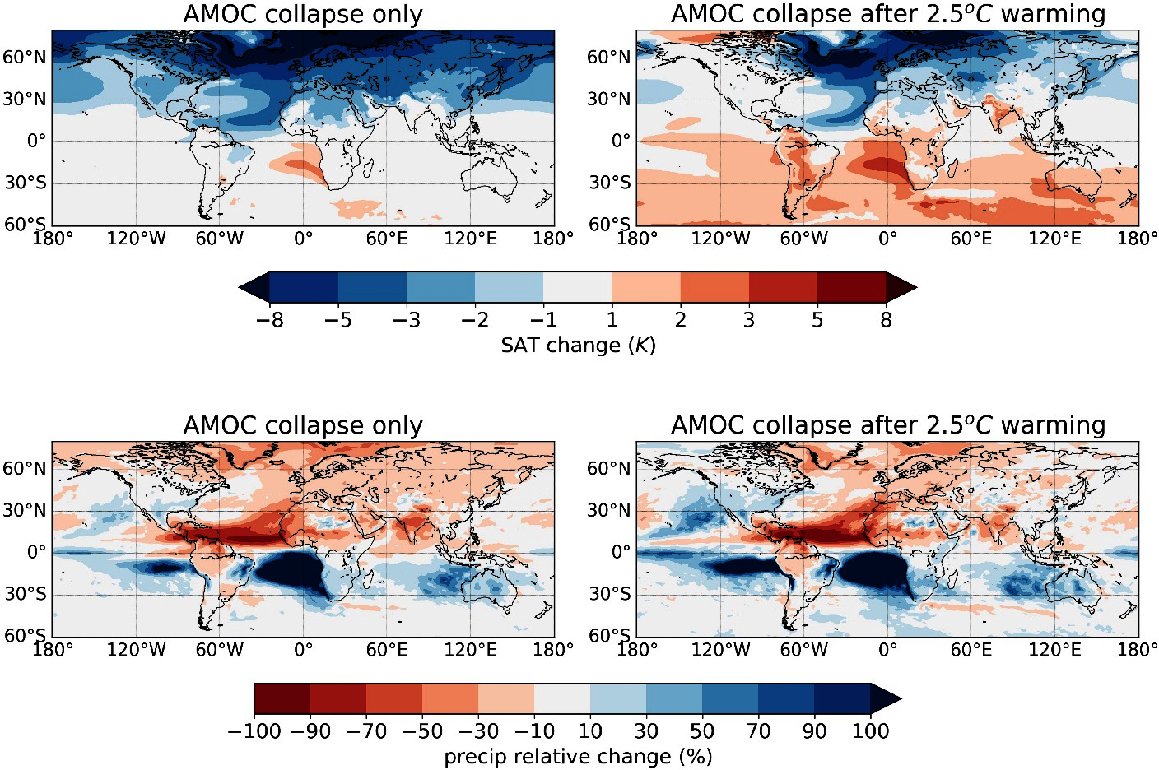
Figure S1. Surface air temperature (SAT, top row) and precipitation (bottom row) response to AMOC-collapse scenarios. Left column, the climatic impacts of just an AMOC collapse without the additional global warming most likely to accompany a collapse in any realistic future scenario is isolated. The isolated impacts of an AMOC collapse are analyzed by taking the difference of 30-year means of the control run and the AMOC- off run, once the simulation is approximately stationary, performed by the HadGEM3-GC2 model. Right column, the analysis is expanded to include the impacts of an AMOC collapse against a more realistic future climate state, accounting for the additional effects of global warming using the future scenario SSP1-2.6 in the model HadGEM3-GC31-MM. The forcing scenario SSP1-2.6 refers to Shared Socio-economic Pathway SSP1 and Regional Concentration Pathway RCP2.6 - a low-emissions pathway with high sustainability. Under the SSP1-2.6 scenario, HadGEM3-GC31-MM reaches a mean global warming of 2.5°C above pre-industrial levels by the end of the century (2071-2100). This warming pattern is overlaid to the impacts of an AMOC collapse to establish the overall impact if the AMOC were to collapse after 2.5°C global warming relative to the present-day climate (2006-35).

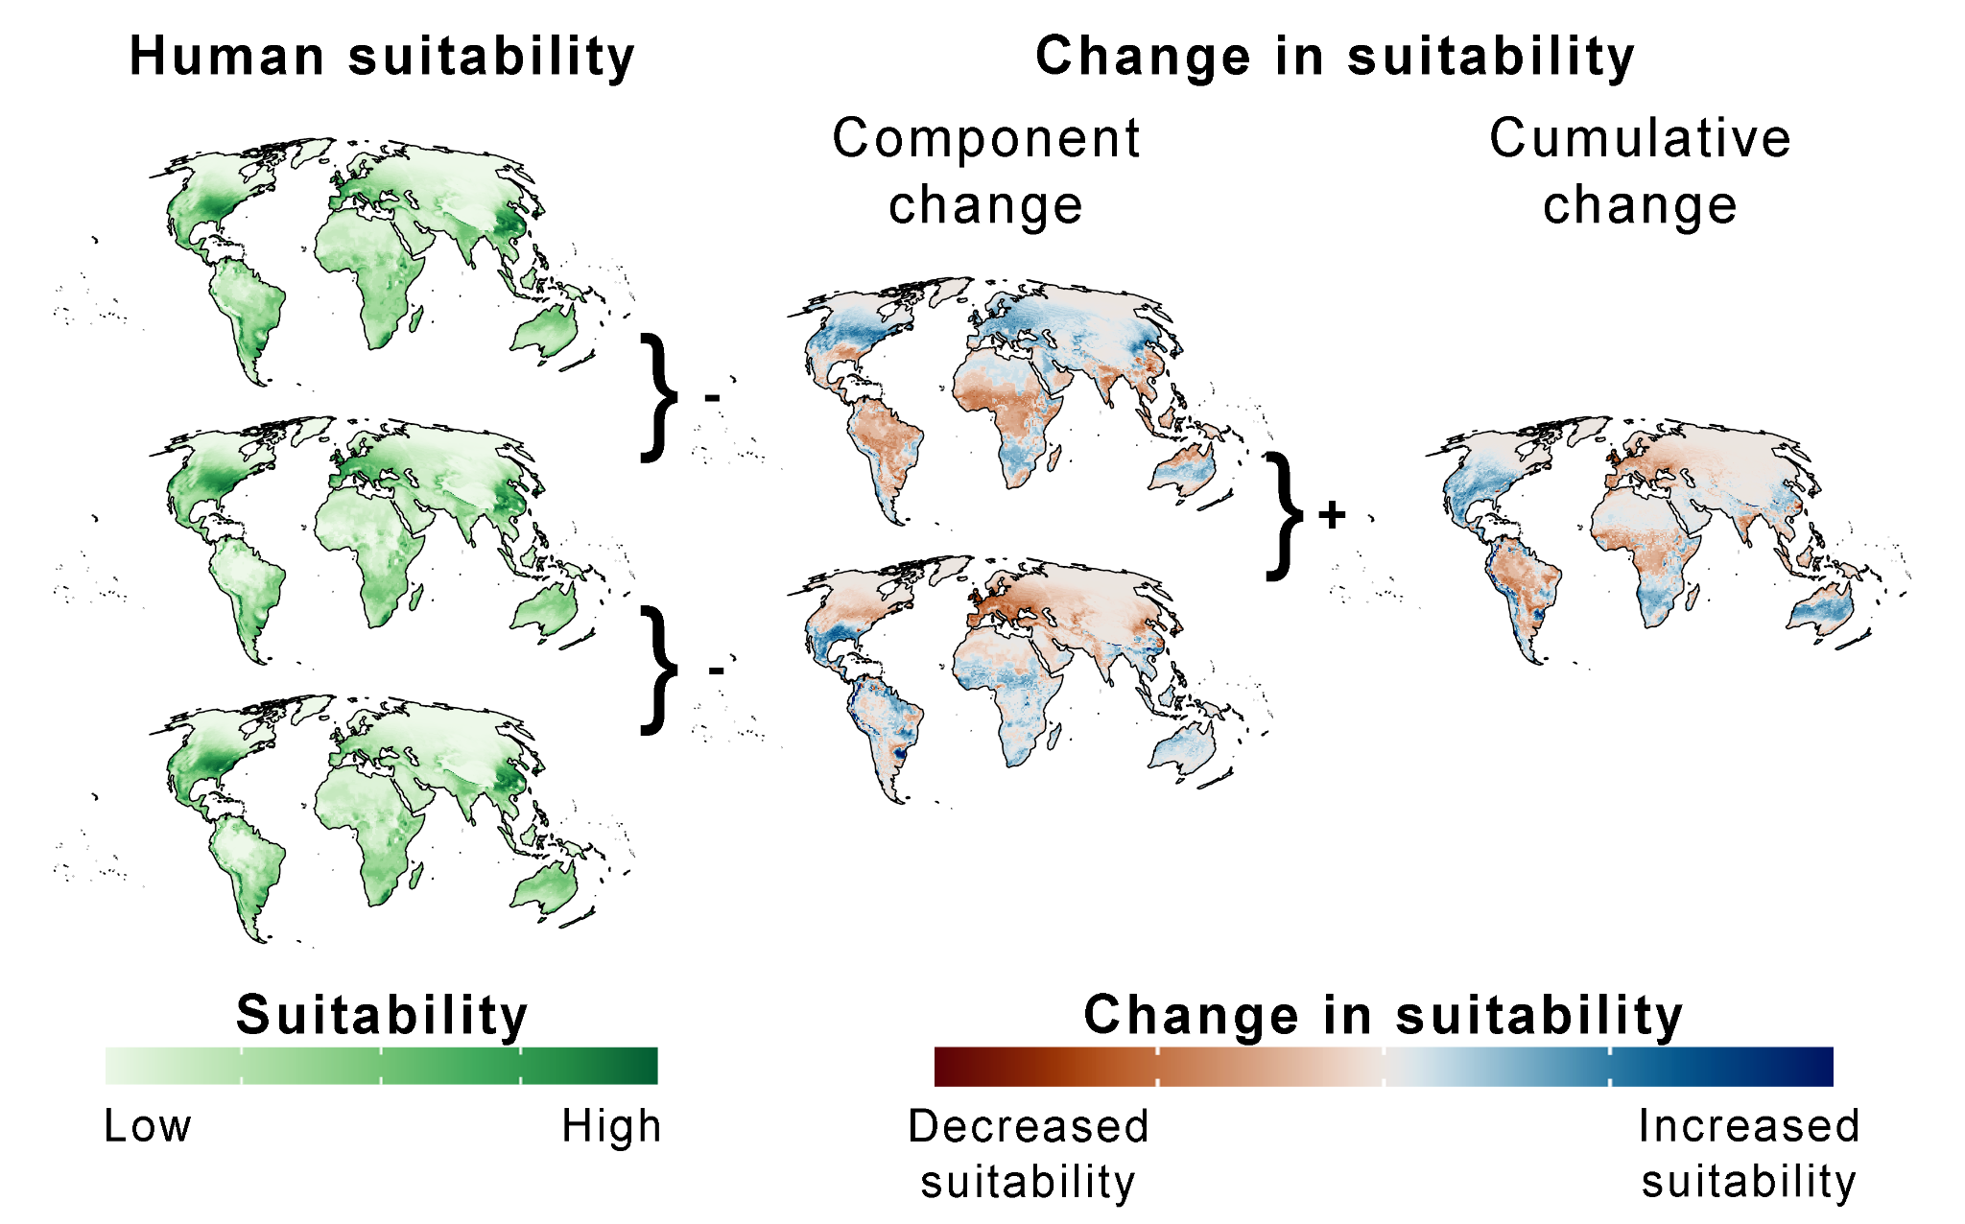
Figure S2. The modeled human MAT-MAP niche. The first column shows human suitability for three scenarios: the mean climate from 1990-2015, 2.5ºC warming above pre-industrial temperatures according to SSP1-2.6, and the simulated collapse of the AMOC. The second column shows the change in human suitability as a result of 2.5ºC warming and AMOC collapse in isolation, while the third column shows the cumulative effect of AMOC collapse following 2.5ºC warming. The climate niches are calculated using 30-year means of the control run and the AMOC-off run, once the simulation is approximately stationary, performed by the HadGEM3-GC2 model. The isolated impacts of the AMOC collapse without any additional warming is a theoretical simulation as additional warming would be necessary to trigger the collapse of the AMOC.

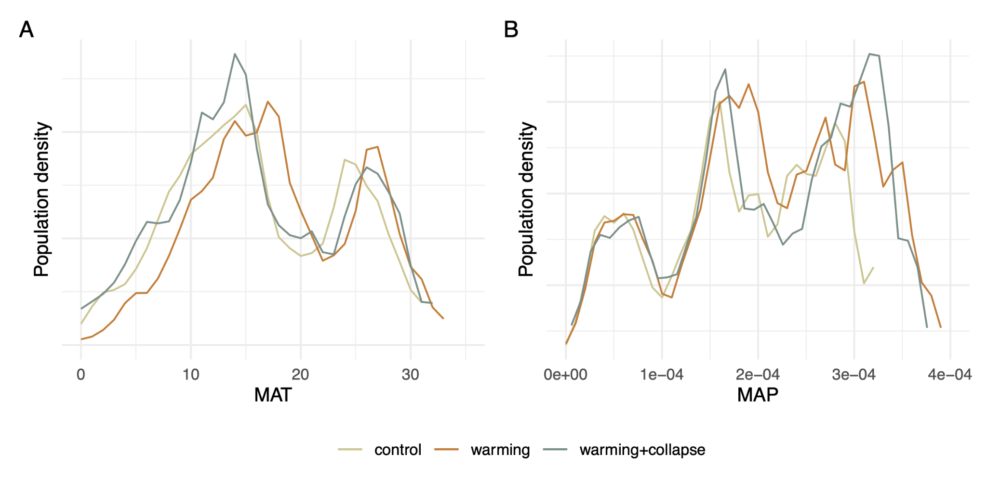
Figure S3. The change in human exposure to different MAT and MAP. Under control conditions human population density had two distinct MAT (panel A) maximums at ~15°C and ~25°C. Under the warming scenario these shift upwards to ~18°C and ~28°C, while under both the AMOC collapse and combined scenarios these shift to colder temperatures. For MAP (panel B), the results are not as clear with a more even distribution across the range of values. However, under all scenarios there is a shift towards a higher percentage of the population being exposed to wetter conditions.

