Supplementary material

1. Model structure
1.1. Overview
The system dynamics model used for the analyses presented in the paper consists of a set of interconnected sub-models, or sectors, that includes: 1) a population sector, capturing changes in population size and structure resulting from births, migration, aging, and mortality; 2) a sector modelling changes in the prevalence of mental health problems; 3) a developmental vulnerability sector, capturing exposure to adverse experiences in childhood that increase the risk of mental health problems in adolescence and adulthood (parental mental health and substance use problems, poverty, family violence, internal displacement); 4) an education sector, modelling secondary and post-secondary education and vocational training enrolment and completion rates; 5) an unemployment and poverty sector, capturing economic participation, unemployment, and informal employment and poverty; 6) a substance use sector, capturing changes in the prevalence of substance use problems; 7) a sector modelling exposure to family violence (physical, sexual, economic, and emotional abuse, abandonment, neglect) and violent crime (i.e., physical assault); 8) an internal displacement sector, capturing the socioeconomic and mental health effects of forced displacement resulting from conflict-related violence; 9) a health services sector, modelling access to mental health services (community-based and hospital) and treatment-dependent recovery; and 10) a suicidal behaviour sector, capturing initial and repeat suicide attempts and suicide mortality. A high-level map of the core model showing the (causal) connections among sectors is presented in Fig. S1.

1.2. Population sector
Fig. S2 presents the structure of the population sector, which models changes in the size and composition of the population of Bogotá due to births, migration, aging, and mortality. The total population is represented as 4 stocks (i.e., state variables), corresponding to numbers of people aged 0−6 years, 7−11 years, 12−17 years, and 18 years and above. Population size increases via births (which flow into the stock of 0−6-year-olds) and immigration and decreases through emigration and mortality. Aging is modelled as a first-order delay, in which people flow out of each stock (except the stock of people aged 18 years and above) at a yearly rate equal to $n/d$, where $n$ is the number of people in the stock at any particular time point and the delay time $d$ is the mean number of years a person spends in the stock. Births and deaths occur at rates $bP$ and $m_{i}P_{i}$, respectively, where
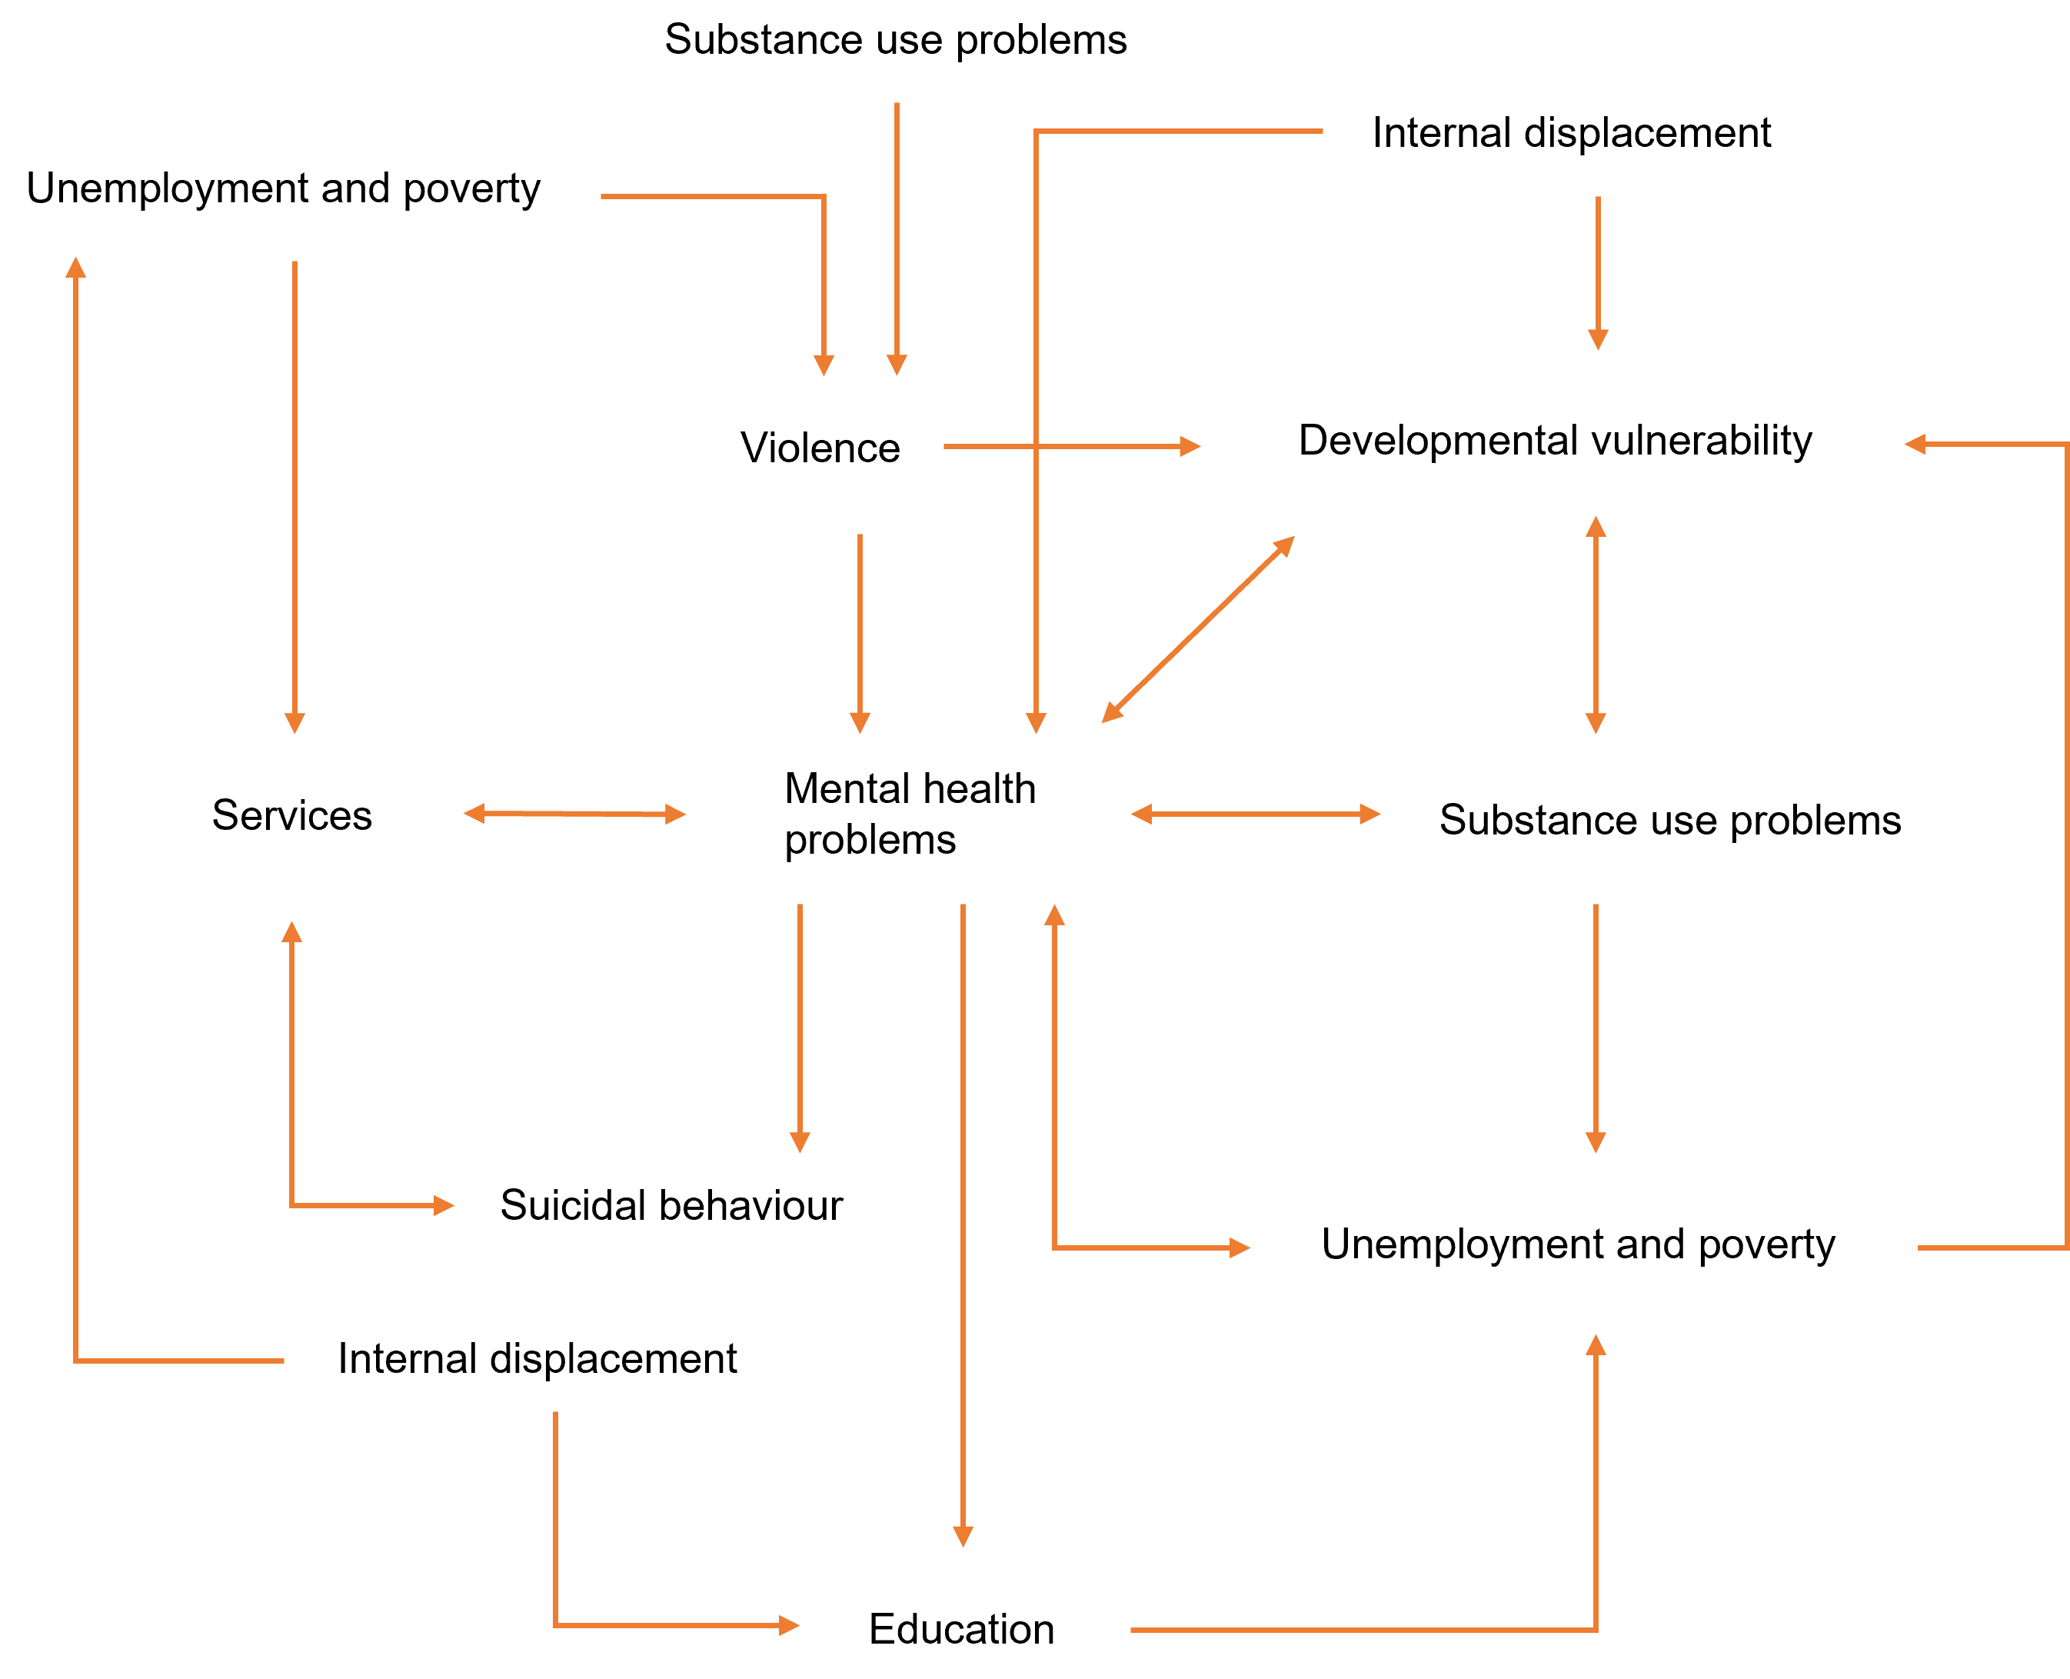
Fig. S1. High-level map of the core system dynamics model showing the causal connections among model sectors. Single-headed arrows indicate unidirectional causal connections; bidirectional causal connections are shown as double-headed arrows.

$P$ is the total population, $P_{i}$ is the population for age group $i$, and the per capita birth rate $b$ and age-specific per capita mortality rates $m_{i}$ decline at constant rates per year. Net migration for age group $i$ is equal to $I_{i}-e_{i}P_{i}$, where $I_{i}$ is age-specific immigration per year and $e_{i}$ is the age-specific per capita emigration rate per year. Population estimates derived from the model are presented together with estimates from the National Population and Housing Census in Fig. S3.

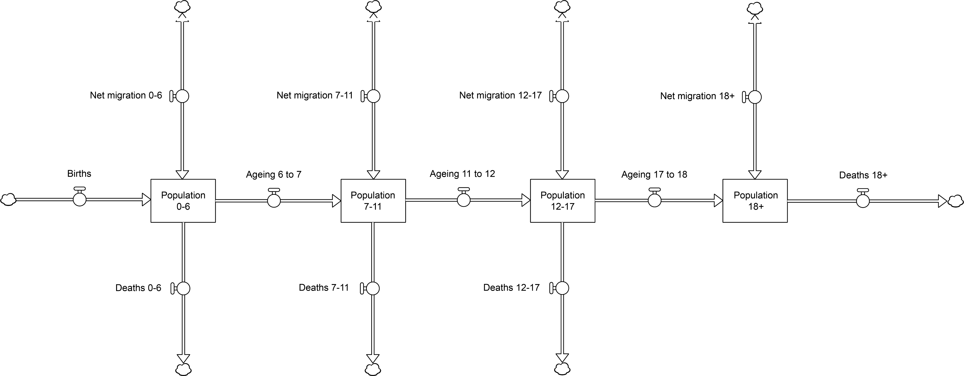
Fig. S2. Stock and flow structure of the population sector.

Fig. S3. Population estimates and projections (all ages and 0−17-year-olds) derived from the system dynamics model and from the National Population and Housing Census (CNPV; available at: https://www.dane.gov.co/).

1.3. Mental health problems sector
Numbers of people aged 7−11 years, 12−17 years, and 18 years and above reporting significant, current mental health problems (8 or more symptoms on the Self Reporting Questionnaire or, for 7−11-year-olds, 2 or more symptoms on the Reporting Questionnaire for Children; see Ministerio de Salud y Protección Social, 2015) are modelled as stocks with inflows corresponding to the incidence of mental health problems and outflows corresponding to recovery (see Fig. S4). The incidence of mental health problems for each age group is equal to $hsL$, where $s$ is the reference (or base) per capita incidence of mental health problems per year (assumed to increase linearly over time, consistent with increasing suicide attempt rates; see section 1.11), $h$ is the product of the effects of developmental vulnerability (Green et al., 2019), unemployment and poverty (Weich and Lewis, 1998), substance use problems (Marmorstein et al., 2010), exposure to family violence and violent crime (Ouellet-Morin et al., 2015; Benjet et al., 2019), and conflict-related internal displacement (Marroquín Rivera et al., 2020) on mental health, and $L$ is the number of people not experiencing significant mental health problems. Age-specific recovery rates are equal to $rH+T$, where $r$ is the per capita spontaneous recovery rate per year, $H$ is the number of people experiencing significant mental health problems, and $T$ is the number of people recovering per year due to effective mental health treatment (see section 1.10 below). Aging of people reporting significant mental health problems is modelled using the same approach described for the population sector (i.e., as a first-order delay; see section 1.2).

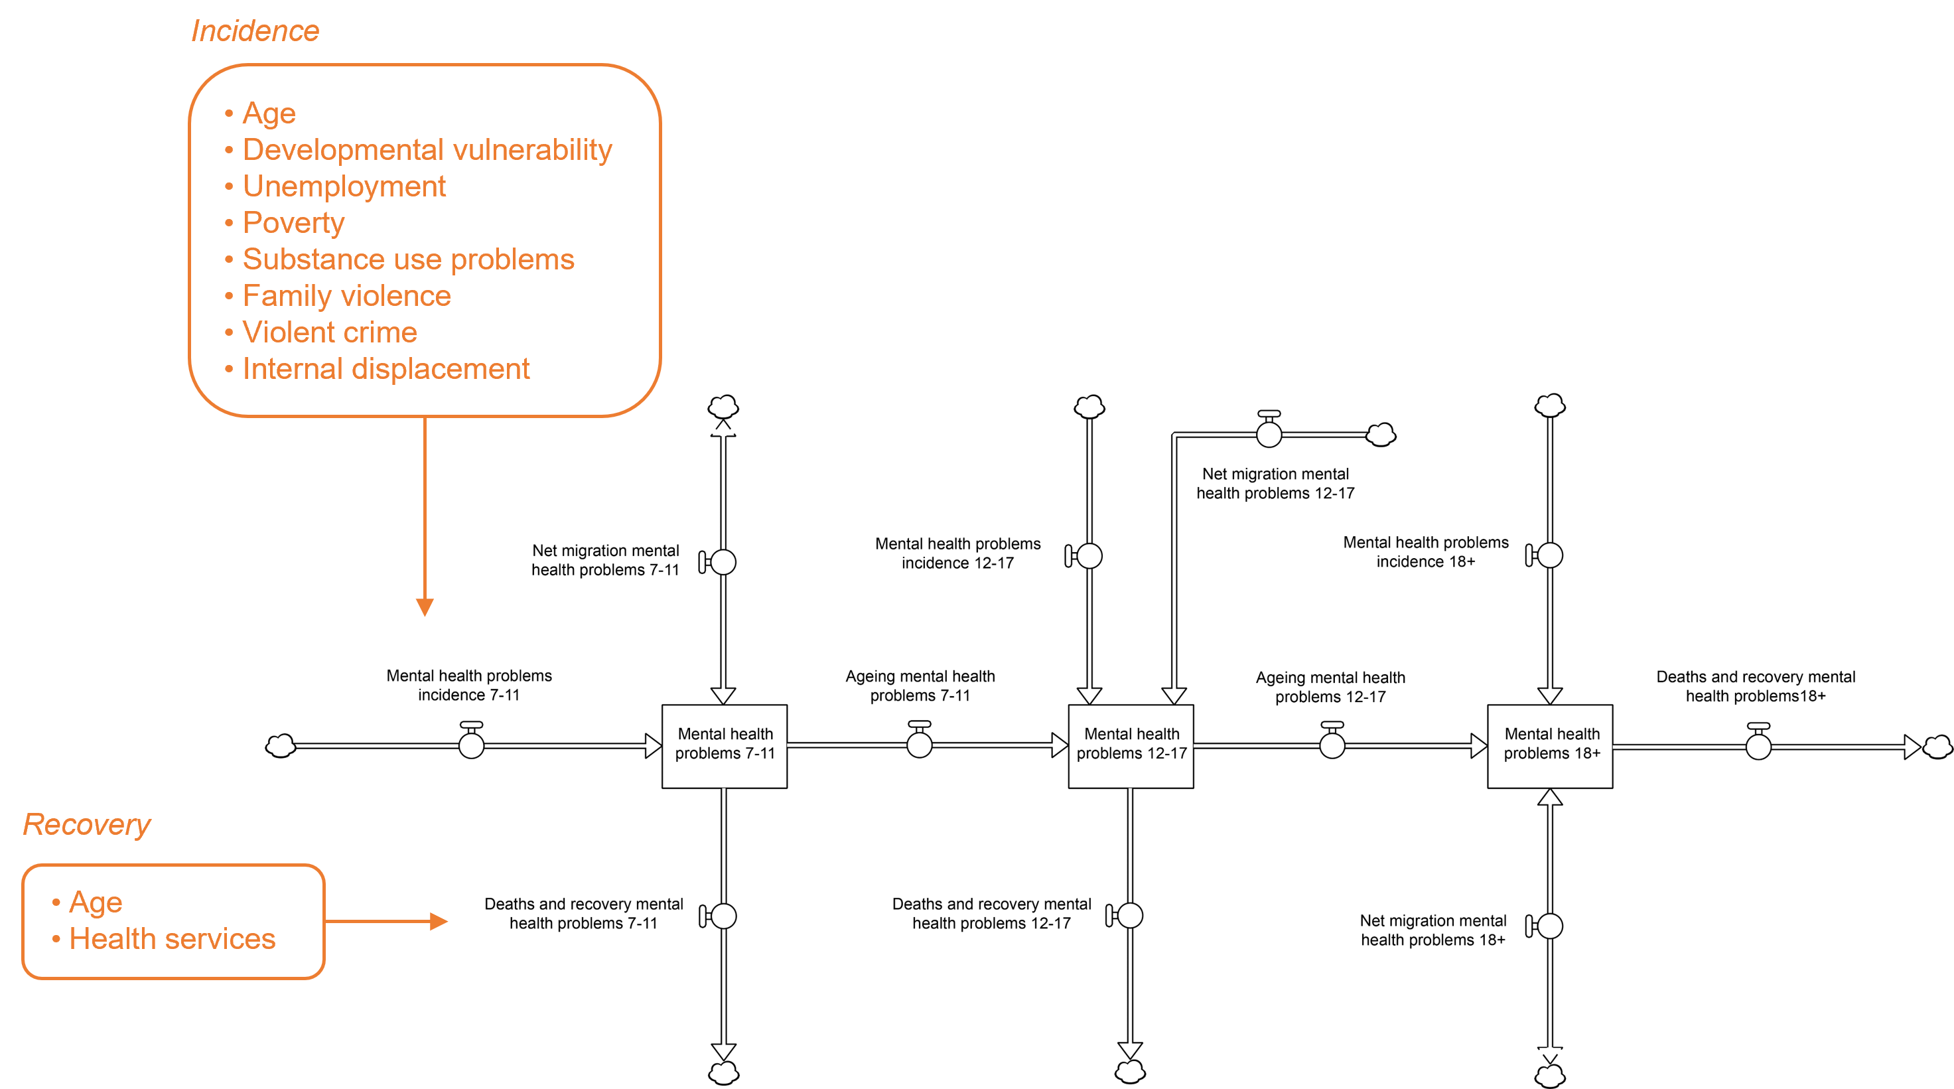
Fig. S4. Structure of the mental health problems sector. Modelled factors that affect the incidence of mental health problems and recovery are listed in the text boxes.

Numbers of people with current mental health problems increase (or decrease) via net migration at age-specific rates $p_{i}I_{i}-q_{i}e_{i}P_{i}$, where $p_{i}$ and $q_{i}$ are the age-specific proportions of people with mental health problems among immigrants and Bogotá residents, respectively, $I_{i}$ is total age-specific immigration per year, $e_{i}$ is the age-specific per capita emigration rate per year, and $P_{i}$ is the number of people in age group $i$ residing in Bogotá. Age-specific per capita mortality among people experiencing significant mental health problems is assumed to be 1.37 times that for people with no significant mental health problems (Russ et al., 2012). Fig. S5 shows estimates of the prevalence of mental health problems derived from the model and the 2015 National Survey of Mental Health.

1.4. Developmental vulnerability sector
The developmental vulnerability sector models exposure to adverse experiences during childhood and its effect on the risk of developing mental health problems in adolescence and adulthood (Fig. S6). The number of developmentally vulnerable children aged 0−11 years is modelled as a stock that increases as children at low risk of psychopathology transition to a state of higher risk; we assume that the onset of developmental vulnerability depends on cumulative exposure to adverse experiences (parental mental health and substance use problems, poverty, family violence, internal displacement) and is irreversible. The incidence of developmental
Fig. S5. Estimates of the prevalence of mental health problems (12−17 years and 18 years and above) derived from the system dynamics model and the 2015 National Survey of Mental Health (ENSM; available at: https://www.minsalud.gov.co/salud/publica/epidemiologia/Paginas/Estudios-y-encuestas.aspx). The error bars for the ENSM estimates correspond to 95% confidence intervals.

vulnerability is equal to $hsR$, where $s$ is the reference (or base) per capita rate at which children at low risk of later psychopathology transition to a state of higher risk per year, $h$ is the product of the effects of parental mental health problems (Dean et al., 2018), poverty (Costello et al., 2003), family violence (Kernic et al., 2003), parental substance use problems (Lynskey et al., 1994), and internal displacement (Marroquín Rivera et al., 2020) on the risk of later psychopathology, and $R$ is the number of lower-risk 0−11-year-olds in the population. The rate $s$ was set so that the prevalence of developmental vulnerability among children turning 12 years aligned with the proportion of 12−17-year-olds reporting mental health problems in the 2015 National Mental Health Survey (see section 1.3).

As developmentally vulnerable children turn 12, they flow into an aging chain that provides a means of tracking numbers of people aged 12−17 years, and 18 years and above at higher risk of developing mental health problems due to adverse experiences in childhood. A person’s level of risk (either high or low) at the time they reach 12 years is assumed to remain unchanged (people are removed from the aging chain only through mortality and emigration; see Fig. S6) and influences the probability that they will experience significant mental health problems throughout their life. Age-specific per capita mortality rates for people with a high risk of developing mental health problems are assumed to be 1.37 times those for people with a low level of risk (Russ et al., 2012). Net migration adds to (or subtracts from) the numbers of people at high risk of developing mental health problems at age-specific rates $p_{i}I_{i}-q_{i}e_{i}P_{i}$, where $p_{i}$ and $q_{i}$ are the age-specific proportions of people with an increased risk of psychopathology among immigrants and Bogotá residents, respectively, $I_{i}$ is total age-specific immigration per year, $e_{i}$ is the age-specific per capita emigration rate per year, and $P_{i}$ is the number of people in age group $i$ residing in Bogotá.

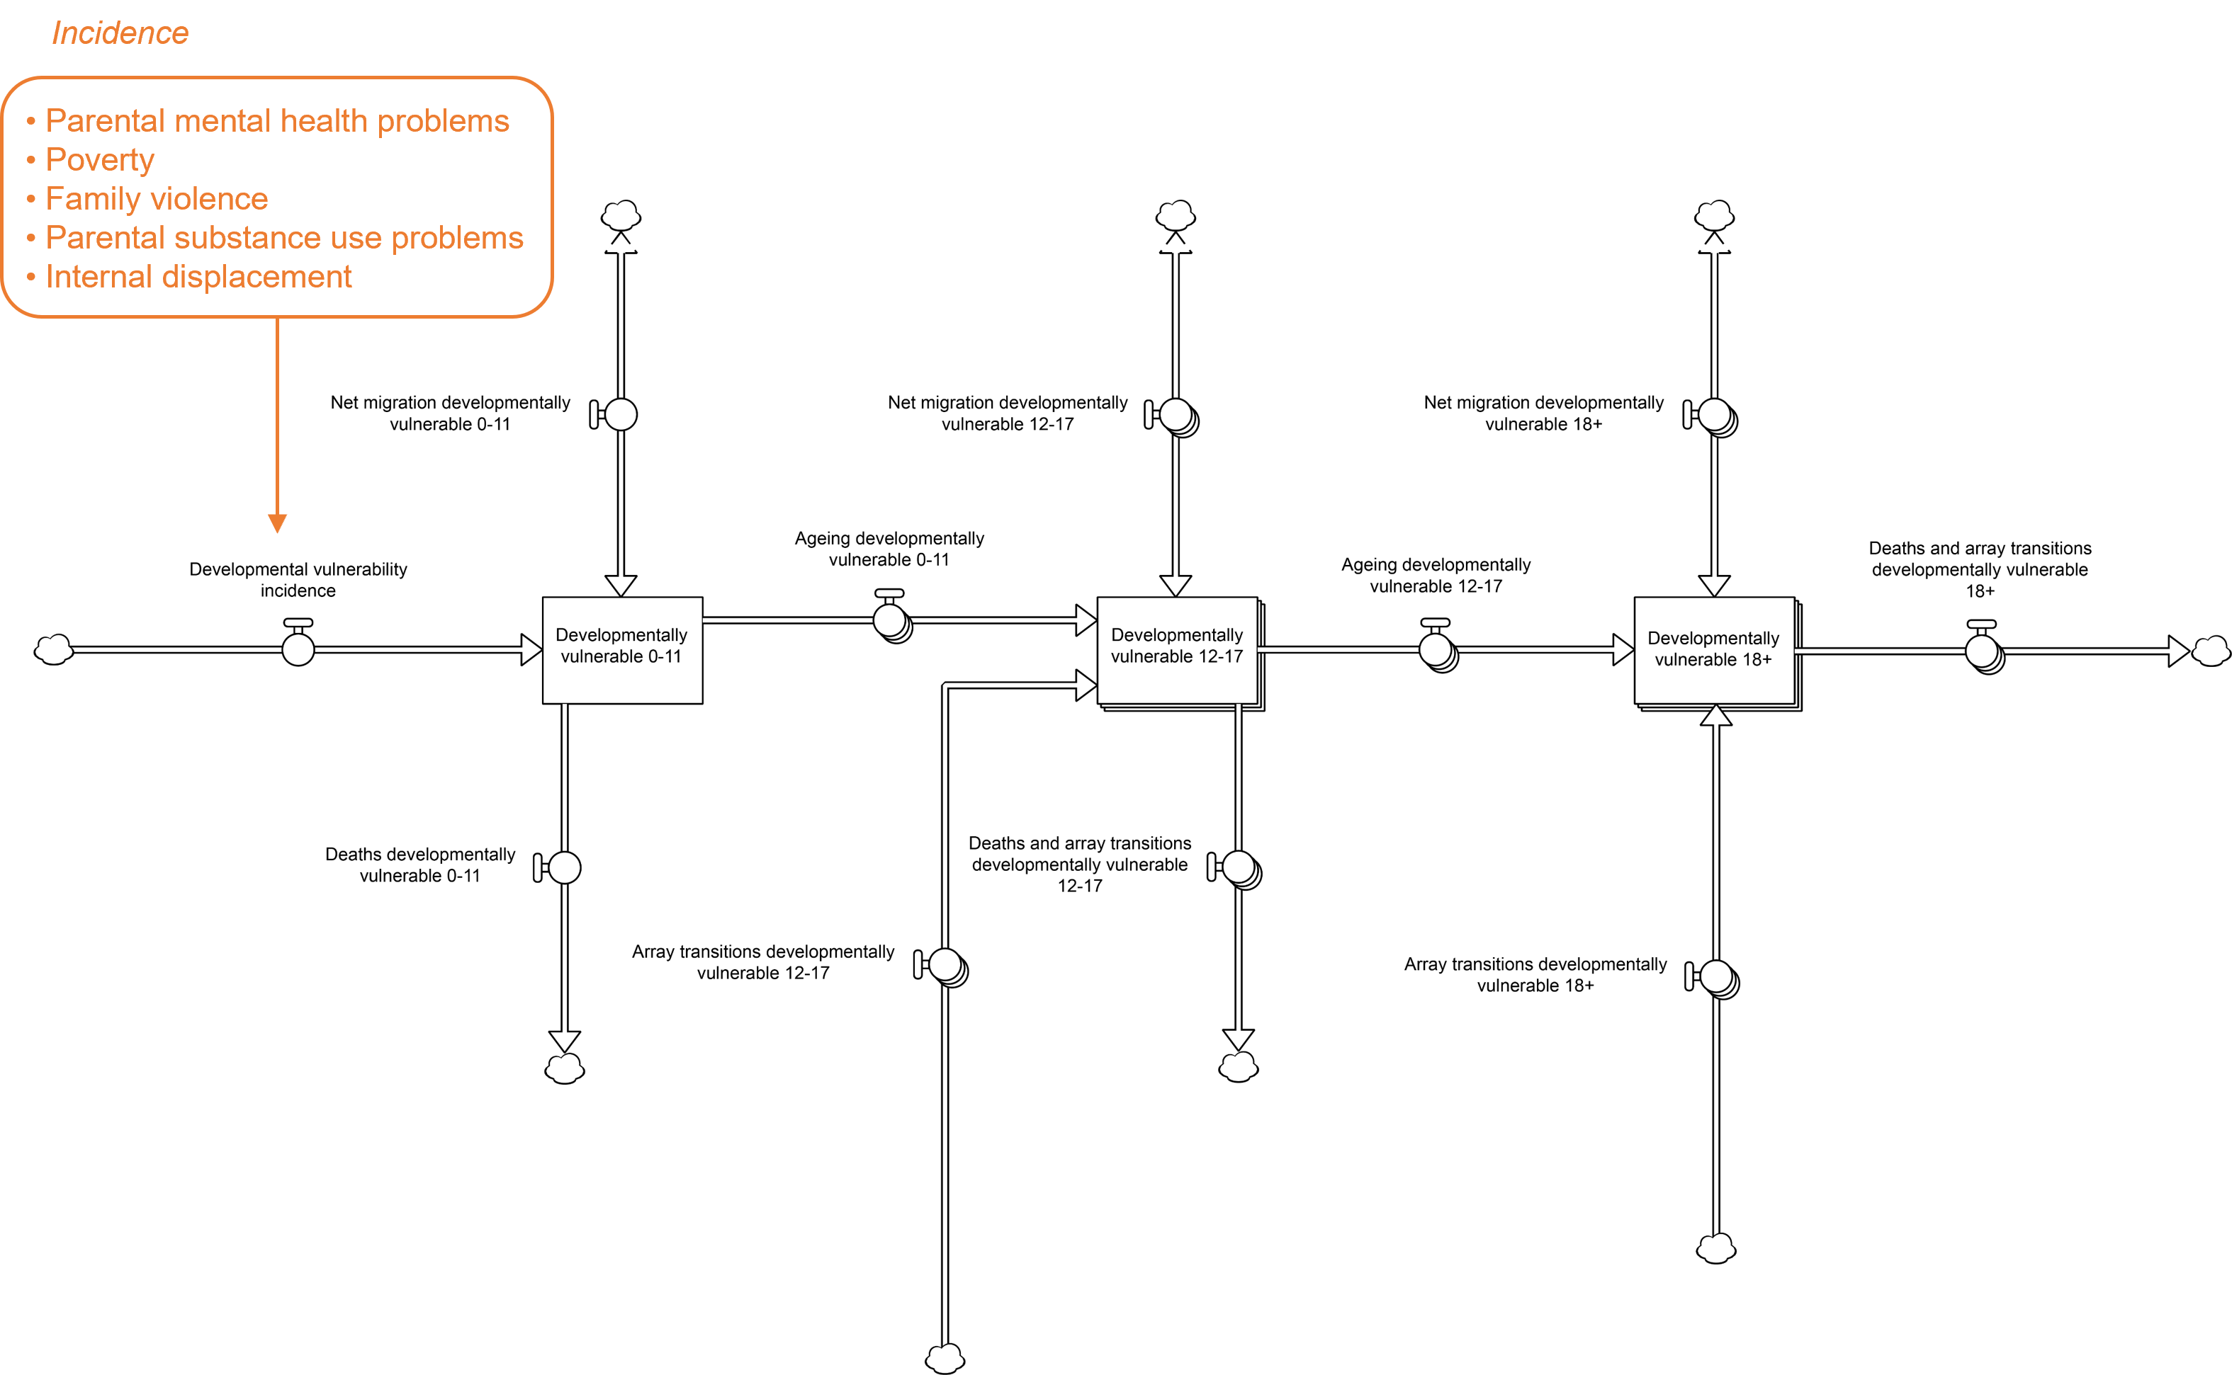
Fig. S6. Structure of the developmental vulnerability sector. Modelled factors that affect the incidence of developmental vulnerability are listed in the text box.

1.5. Education sector
Fig. S7 presents the structure of the education sector, which captures numbers of people enrolled in elementary, secondary, and post-secondary education, and upper secondary (grades 10−11) and post-secondary education completion rates. Nearly all children turning 7 years (96.8%) and the majority of school-age immigrants flow into stocks of 7−11-year-olds and 12−17-year-olds who are currently studying. After completing secondary education (either basic secondary or upper secondary education), adolescents aged 12−17 years may progress to post-secondary education, in which case they enter a stock of students aged 18 years or more as they age (via the flow labelled ‘Ageing studying 12−17’ in Fig. S7), or they discontinue their formal education, where the discontinuation rate per year, $hdS$, is equal to the product of the reference per capita discontinuation rate $d$, the effect $h$ of mental health problems on the discontinuation rate (Lee et al., 2009), and the number of 12−17-year-olds currently studying, $S$. Adults (aged over 17 years) who are not currently studying may enrol in post-secondary (or possibly upper secondary) education at any time, while those currently studying either complete their qualification or drop out prior to completion, where the discontinuation rate depends on the proportion of adults studying who have mental health problems (as for 12−17-year-olds); the flow labelled ‘Net post-secondary study enrolments 18+’ in Fig. S7 is equal to the number of adults commencing study per year minus the number of adults completing or discontinuing study per year. People currently enrolled in elementary, secondary, or post-secondary education are assumed to experience the same age-specific per capita mortality as people not currently studying.

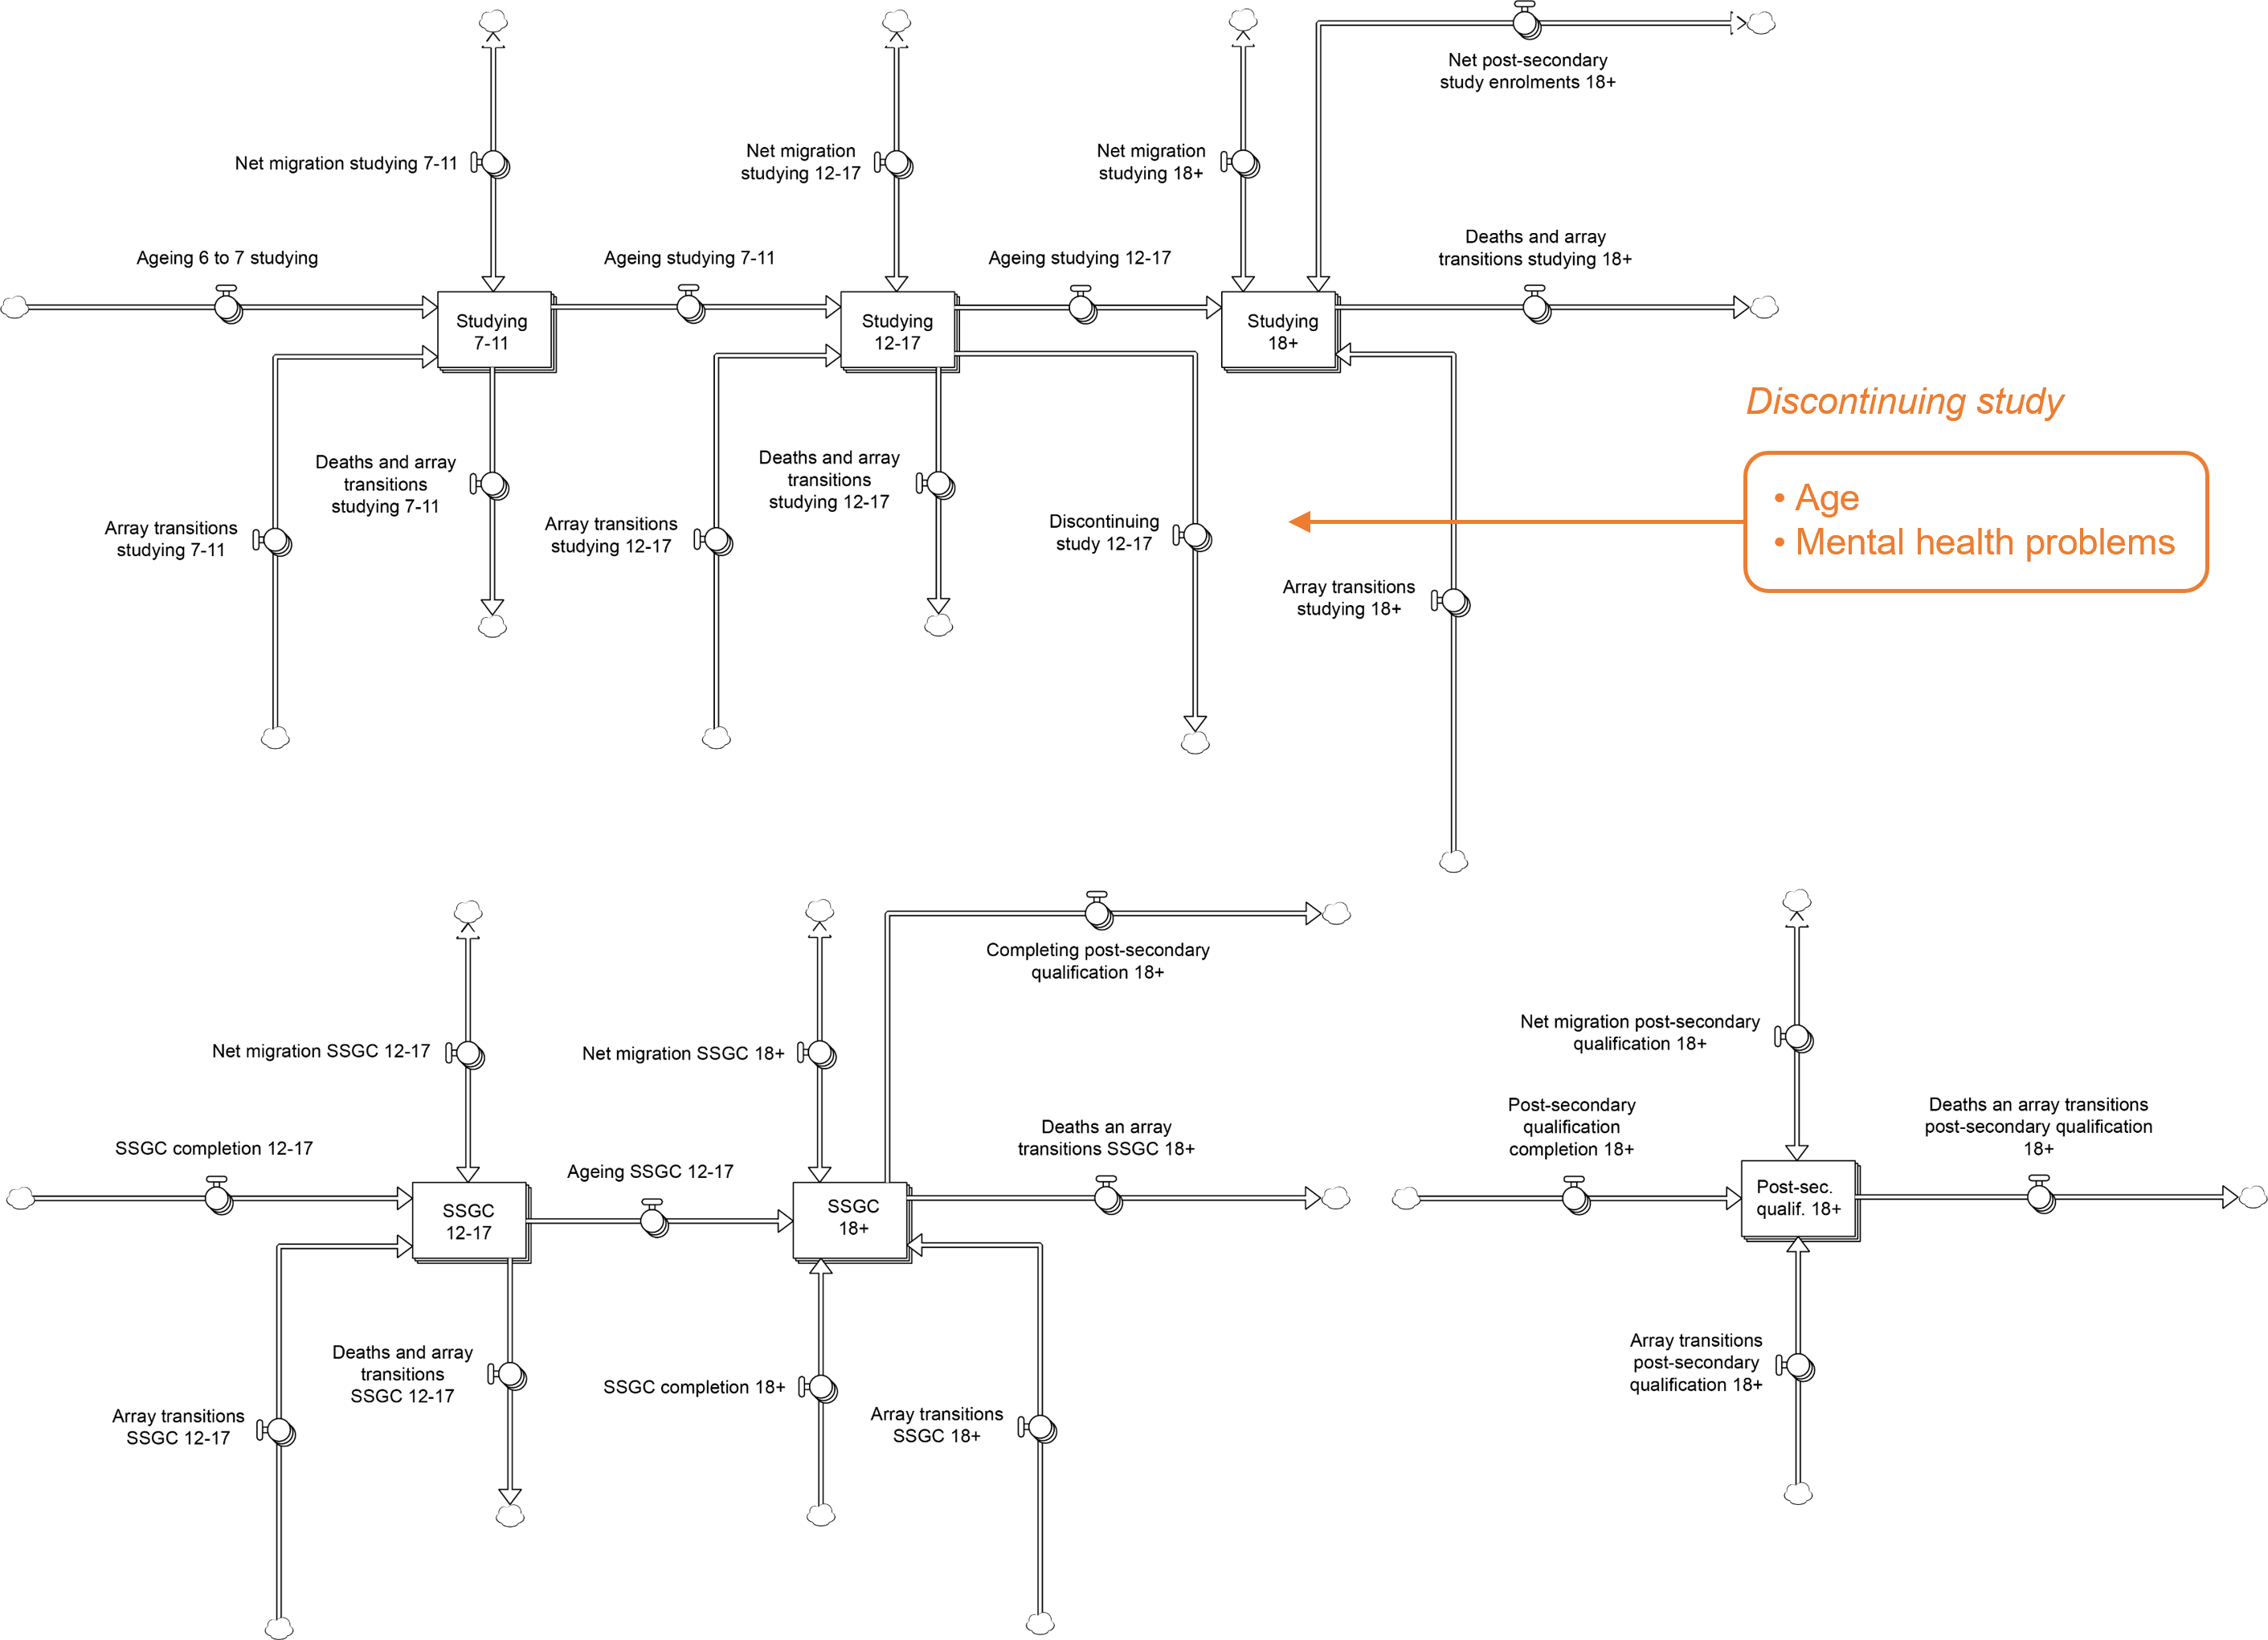
Fig. S7. Structure of the education sector. Modelled factors that affect the discontinuation rate are listed in the text box. SSGC = secondary school graduation certificate.
People completing upper secondary (grades 10−11) and post-secondary education flow into stocks of 12−17-year-olds and adults aged 18 years and above holding a secondary school graduation certificate (Bachiller Académico, Bachiller Técnico, etc.) or post-secondary qualification (Fig. S7). Prior completion of upper secondary education is a pre-requisite for enrolment in post-secondary education, so all adults completing post-secondary education are assumed to hold a secondary school graduation certificate; the outflow labelled ‘Completing post-secondary education 18+’ in Fig. S7 removes adults currently enrolled in post-secondary education from the stock of upper secondary school graduates as they complete their (post-secondary) qualification, so that the stock ‘SSGC 18+’ corresponds to the number of adults holding a secondary school graduation certificate only. Numbers of people holding a secondary school graduation certificate/post-secondary qualification increase (or decrease) due to net migration at rates equal to $p_{i}I_{i}-q_{i}e_{i}P_{i}$, where $p_{i}$ and $q_{i}$ are the age-specific proportions of people who have completed upper secondary school/post-secondary education among immigrants and Bogotá residents, respectively, $I_{i}$ is total age-specific immigration per year, $e_{i}$ is the age-specific per capita emigration rate per year, and $P_{i}$ is the number of people in age group $i$ who currently reside in Bogotá. Per capita mortality rates for people who have a post-secondary qualification are assumed to be 0.74 times those for people without a post-secondary qualification, including people with a secondary school graduation certificate (see Backlund et al., 1999). Model-based estimates of the proportion of people with a secondary school graduation certificate and the proportion of people with a post-secondary qualification are presented together with corresponding estimates derived from the Large Integrated Household Survey in Fig. S8.

1.6. Unemployment and poverty sector
Fig. S9 presents the structure of the unemployment and poverty sector, which models economic participation, unemployment, and informal employment and poverty. The total labour force is represented as four stocks, corresponding to the numbers of employed (including informally employed) and unemployed people aged 12−17 years and 18 years and above. Adolescents turning 12 years are assumed to enter the population of those not in the labour force, i.e., people who are neither employed nor seeking employment (12-year-olds are required to attend school full-time in Colombia, and the vast majority will not be in the labour force). People not in the labour force may decide to seek employment, at which point they enter the stocks of unemployed people, while those seeking employment (i.e., the unemployed) may leave the labour force. Age-specific net flows from the unemployed population to the population of people not in the labour force are calculated as $frU-gsN$, where $U$ and $N$ are, respectively, the numbers of unemployed people and people not in the labour force, $r$ is the reference (or base) per capita rate at which unemployed people leave the labour force per year, $f$ is the product of the effects of mental health problems (Frijters et al., 2014) and the unemployment rate on labour force participation ($f$ is an increasing function of the unemployment rate, so that participation declines as unemployment increases; Mitchell et al., 2019), $s$ is the base per capita rate at which people enter the labour force per year, and $g$ is the product of the effects of upper secondary education and post-secondary education on the labour force entry rate.

Fig. S8. Estimated proportions of people aged 12 years and above who have completed upper secondary (grades 10−11) and post-secondary education derived from the system dynamics model and the Large Integrated Household Survey (GEIH; available at: https://www.dane.gov.co/). Note that people who have completed post-secondary education were excluded in estimating the proportion of people who have completed upper secondary education (i.e., the proportions are for highest educational attainment).

Employed people become unemployed at age-specific rates equal to $vE$, where $E$ is the employed population and $v$ is the per capita rate of job loss per year, while unemployed people secure employment at age-specific rates $hwU$, where $U$ is the unemployed population, $w$ is the reference per capita rate of employment initiation per year, and $h$ is the product of the effects of mental health problems (Frijters et al., 2014), substance use problems (Zabkiewicz and Schmidt, 2007), upper secondary education, and post-secondary education, on the employment initiation rate; the net yearly flow from employment to unemployment is therefore $vE-hwU$. People in employment leave the labour force (e.g., due to retirement, parenting responsibilities, or disability) at
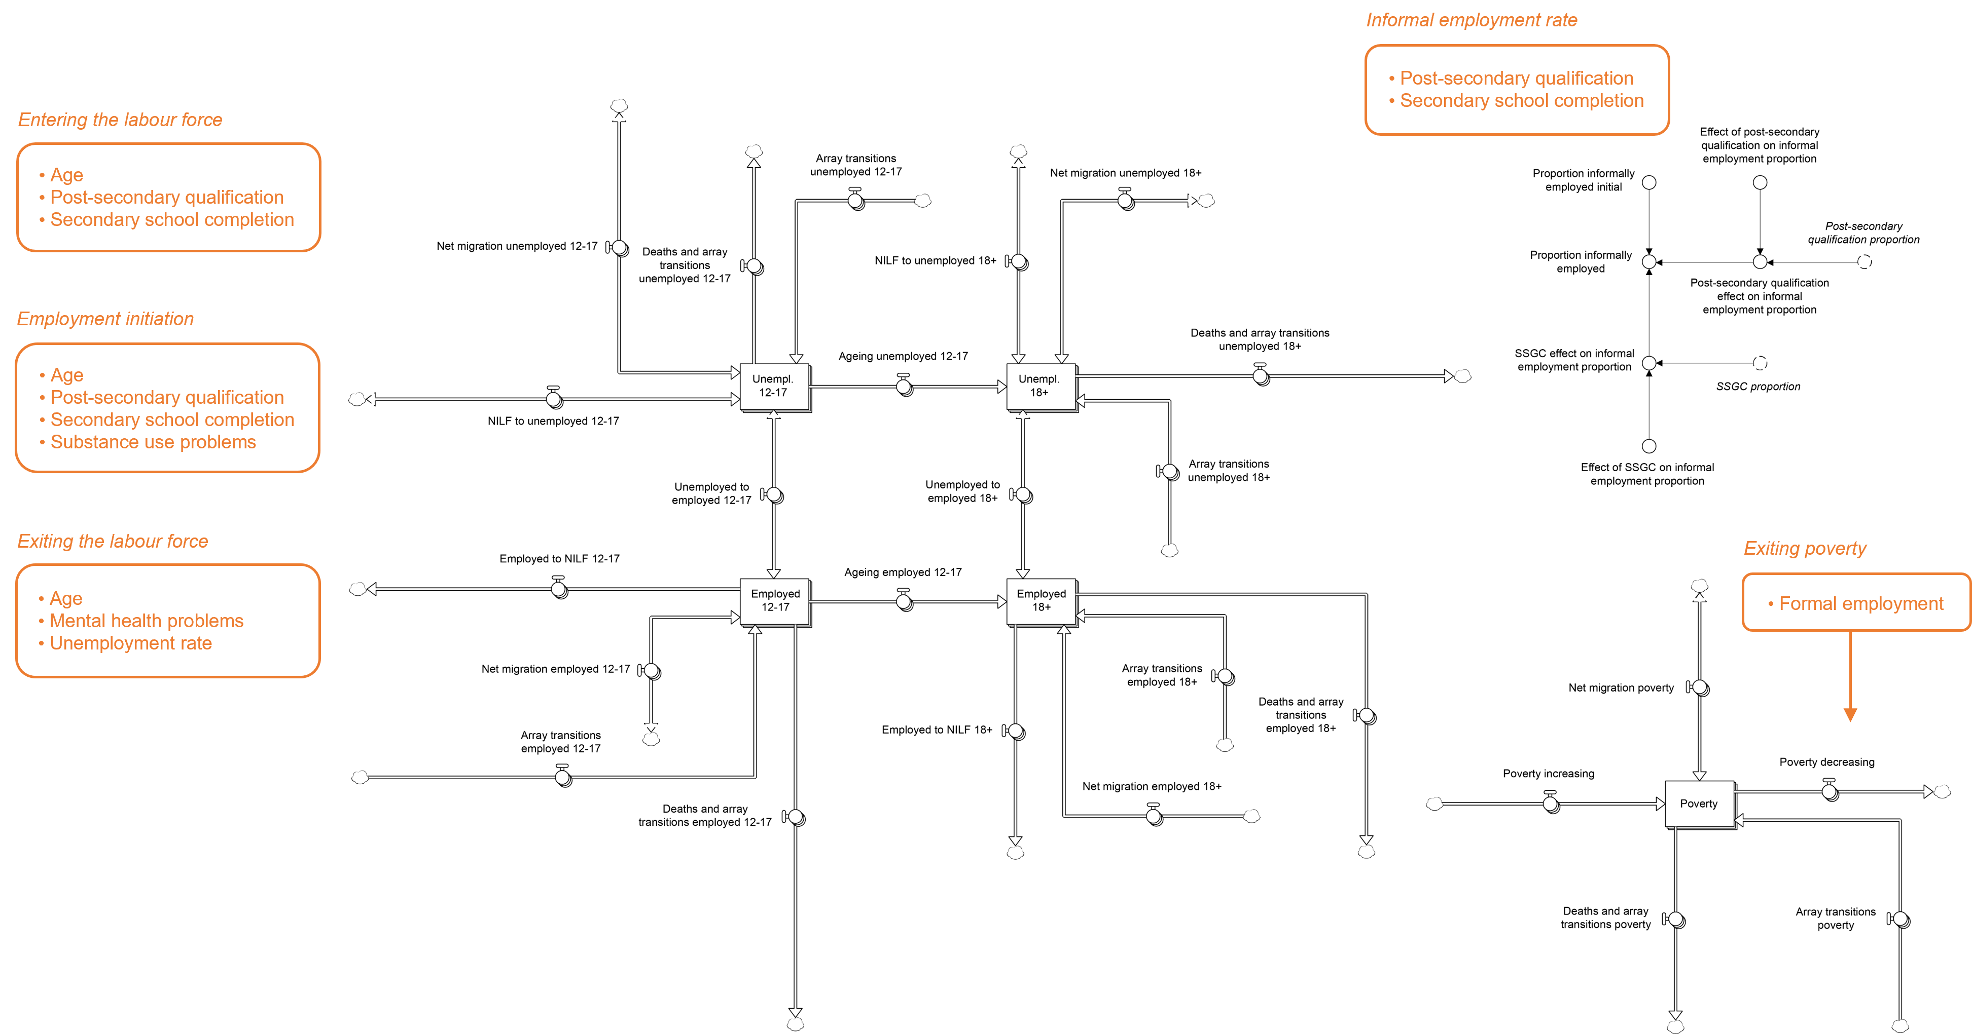
Fig. S9. Structure of the unemployment and poverty sector. Modelled factors that affect economic participation, employment initiation, the informal employment rate, and transitions out of poverty are listed in the text boxes. NILF = not in the labour force; SSGC = secondary school graduation certificate.

age-specific rates $γ_{i}zE_{i}$, where $E_{i}$ is the number of employed people in age group $i$, $z$ is the per capita rate at which employed adults aged 18 years and above leave the labour force per year, and $γ_{i}$ is the effect of being in age group $i$ on the labour force exit rate (equal to 1 for people aged 18 years and above). Net migration increases (or depletes) the employed population at age-specific rates equal to $p_{i}I_{i}-q_{i}e_{i}P_{i}$, where $p_{i}$ and $q_{i}$ are the age-specific proportions of people employed among immigrants and Bogotá residents, respectively, $I_{i}$ is total age-specific immigration per year, $e_{i}$ is the age-specific per capita emigration rate per year, and $P_{i}$ is the number of people in age group $i$ residing in Bogotá (the effect of net migration on the unemployed population is modelled in the same way). Per capita mortality rates for people seeking employment (the unemployed) are assumed to be 1.22 times those for people who are employed or not in the labour force (Sorlie and Rogot, 1990).

Age-specific numbers of people employed informally are equal to $\left(a+b_{i}+c_{i}\right)E_{i}$, where $E_{i}$ is the number of employed people in age group $i$, $a$ is the reference proportion of employed people in informal employment, and $b_{i}$ and $c_{i}$ are the age-specific effects of upper secondary education and post-secondary education, respectively, on the informal employment rate. Multidimensional poverty (https://www.dane.gov.co/index.php/estadisticas-por-tema/pobreza-y-condiciones-de-vida/pobreza-multidimensional/pobreza-multidimensional-2021) is modelled via a stock (arrayed by age group) that increases as people enter poverty at a constant per capita rate per year and decreases as people move out of poverty at age-specific rates $kdM_{i}$ per year, where $M_{i}$ is the number of people in age group $i$ experiencing poverty, $d$ is the base per capita rate at which people transition out of poverty per year, and $k$ is the effect of formal employment on the poverty exit rate (more people are assumed to transition out of poverty per year as formal employment increases). The effect of net migration on the (age-specific) numbers of people experiencing multidimensional poverty is modelled using the same approach described for the employed population above (see previous paragraph), and we assume that transitions into poverty are associated with significantly increased per capita mortality (mortality hazard ratio 1.78; Waitzman and Smith, 1998). Unemployment rate estimates and estimates of the proportion of employed people in informal employment and the prevalence of multidimensional poverty derived from the model are presented alongside empirical estimates in Fig. S10.

1.7. Substance use sector
The structure of the substance use sector, which captures changes in the prevalence of substance use problems and numbers of intoxication-related presentations to health services, is presented in Fig. S11. Numbers of
Fig. S10. Unemployment rate estimates (12 years and over and 12−17 years) and estimates of the proportion of employed people in informal employment and the prevalence of multidimensional poverty derived from the model and from the Large Integrated Household Survey (GEIH) and the National Quality of Life Survey (ECV) (the GEIH and ECV data are available at: https://www.dane.gov.co/).

people aged 12−17 years and 18 years and above with significant substance use problems (for model calibration, we used data on harmful alcohol consumption as a proxy for significant substance use problems; see Departamento Administrativo Nacional de Estadística, 2019) are modelled as stocks with inflows corresponding to the age-specific incidence of substance use problems, equal to $hsG$, where $s$ is the age-specific reference (base) per capita incidence of substance use problems per year, $h$ is the product of the effects of developmental vulnerability (Crum et al., 2008) and mental health problems (Marmorstein et al., 2010) on problematic substance use, and $G$ is the number of people in the population reporting no substance use problems. Recovery, including both spontaneous and treatment-dependent recovery, occurs at a constant per capita rate that is assumed to be identical for both age groups (note that we have not modelled access to treatment explicitly, due principally to data availability constraints); the bi-flows labelled ‘Net substance use incidence’ in Fig. S11 are equal to the number of people developing substance use problems per year minus the number of people recovering per year. Intoxication-related services presentation rates are calculated as $r_{i}D_{i}$, where $r_{i}$ is the per capita presentation rate per year for age group $i$ and $D_{i}$ is the number of people in age group $i$ with significant substance use problems.

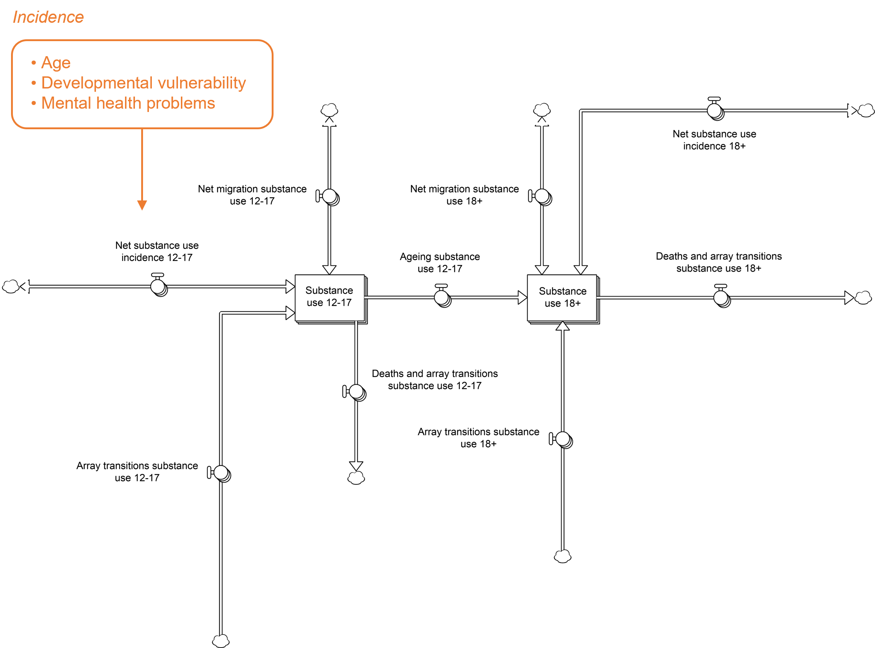
Fig. S11. Structure of the substance use sector. Modelled factors that affect the incidence of substance use problems are listed in the text box.

Net migration adds to (or subtracts from) the stocks of people with substance use problems at age-specific rates $p_{i}I_{i}-q_{i}e_{i}P_{i}$, where $p_{i}$ and $q_{i}$ are the age-specific proportions of people with substance use problems among immigrants and Bogotá residents, respectively, $I_{i}$ is total age-specific immigration per year, $e_{i}$ is the age-specific per capita emigration rate per year, and $P_{i}$ is the number of people in age group $i$ residing in Bogotá. Age-specific per capita mortality rates for people reporting significant substance use problems are assumed to be 1.95 times those for people without substance use problems (see Roerecke and Rehm, 2013). Fig. S12 presents model-based estimates of intoxication-related services presentation rates for 12−17-year-olds and adults aged 18 years and above, together with corresponding estimates derived from the National Public Health Surveillance System (SIVIGILA).

Fig. S12. Intoxication-related health services presentation rate estimates (12−17 years and 18 years and above) derived from the system dynamics model and the National Public Health Surveillance System (SIVIGILA).

1.8. Family violence and violent crime sector
Fig. S13 presents the structure of the family violence and violent crime sector, which models exposure to family violence (physical, sexual, economic, and emotional abuse, abandonment, and neglect) and violent crime (i.e., physical assault). Age-specific base rates of family violence exposure (reported incidents per person per year) are modelled as stocks that increase (7−11 years) or decrease (0−6 years, 12−17 years, and 18+ years) at constant fractional rates per year (note that the stock labelled ‘Family violence base rate’ in Fig. S13 is arrayed by age group). The incidence of family violence exposure in age group $i$ is equal to $fv_{i}P_{i}$, where $v_{i}$ is the base exposure rate, $f$ is the product of the effects of substance use problems and unemployment on family violence exposure (Kyriacou et al., 1999), and $P_{i}$ is the number of people in age group $i$ in the total population. Similarly, the age-specific incidence of violent crime exposure is calculated as $gcP_{i}$, where $c$ is the overall base exposure rate (assumed to decrease at a constant fractional rate per year), $g$ is the product of the effects of substance use problems (Norström and Pape, 2010) and unemployment (Juárez et al., 2020) on violent crime exposure, and $P_{i}$ is the number of people in age group $i$ in the population. Fractional rates of increase (or decrease) in the base exposure rates $v_{i}$ and $c$ are set so that the incidence of family violence exposure for each age group and the total incidence of violent crime exposure align with empirical estimates derived from the epidemiological surveillance system for intrafamily violence, child abuse, and sexual violence (SIVIM) and the Survey of Coexistence and Citizen Security (see Fig. S14).

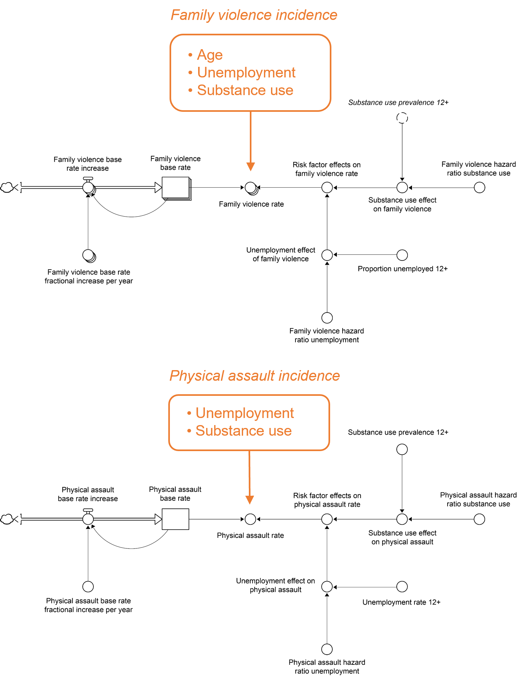
Fig. S13. Structure of the family violence and violent crime (i.e., physical assault) sector. Modelled factors that affect the incidence of family violence and physical assault are listed in the text boxes.

1.9. Internal displacement sector
Numbers of people aged 0−6 years, 7−11 years, 12−17 years, and 18 years or more displaced by conflict-related violence are modelled as stocks with inflows corresponding to displacement-related immigration (i.e., the movement of displaced people from regions affected by armed conflict into Bogotá) and outflows corresponding to repatriation (people returning to regions from which they were displaced) and mortality (see Fig. S15; the bi-
Fig. S14. Estimates of exposure to family violence and violent crime (physical assault) derived from the model and from the epidemiological surveillance system for intrafamily violence, child abuse, and sexual violence (SIVIM) and the Survey of Coexistence and Citizen Security (ECSC; available at: https://www.dane.gov.co/).

flows labelled ‘Net displacement’ are calculated by subtracting the repatriation rate per year from displacement-related immigration per year). Age-specific displacement-related immigration per year is equal to $p_{i}D$, where total displacement-related immigration per year, $D$, is assumed to decrease at a constant fractional rate per year (consistent with available data; Fig. S16), and $p_{i}$ is the proportion of displaced immigrants in age group $i$. Repatriation occurs at a constant per capita rate that is assumed to be identical for all age groups, and we assume that age-specific per capita mortality is 2.5 times higher in the internally displaced population than in the non-displaced population (Heudtlass et al., 2016). Mental health problems, developmental vulnerability, lower levels of education (no secondary school graduation certificate or higher qualification), and unemployment and poverty are assumed to be more prevalent among displaced people than among those not displaced by armed conflict (see Aysa-Lastra, 2005; Marroquín Rivera et al., 2020), and therefore tend to increase as displacement-related immigration increases. Internal displacement is also assumed to increase the risk of developmental vulnerability in children (0−11-year-olds; see section 1.4 above) and the incidence of mental health problems in children, adolescents, and adults (section 1.3). Model-based estimates of the displaced population and the displacement-related immigration rate are presented alongside estimates derived from the Internal Displacement Monitoring Centre (IDMC) in Fig. S16.

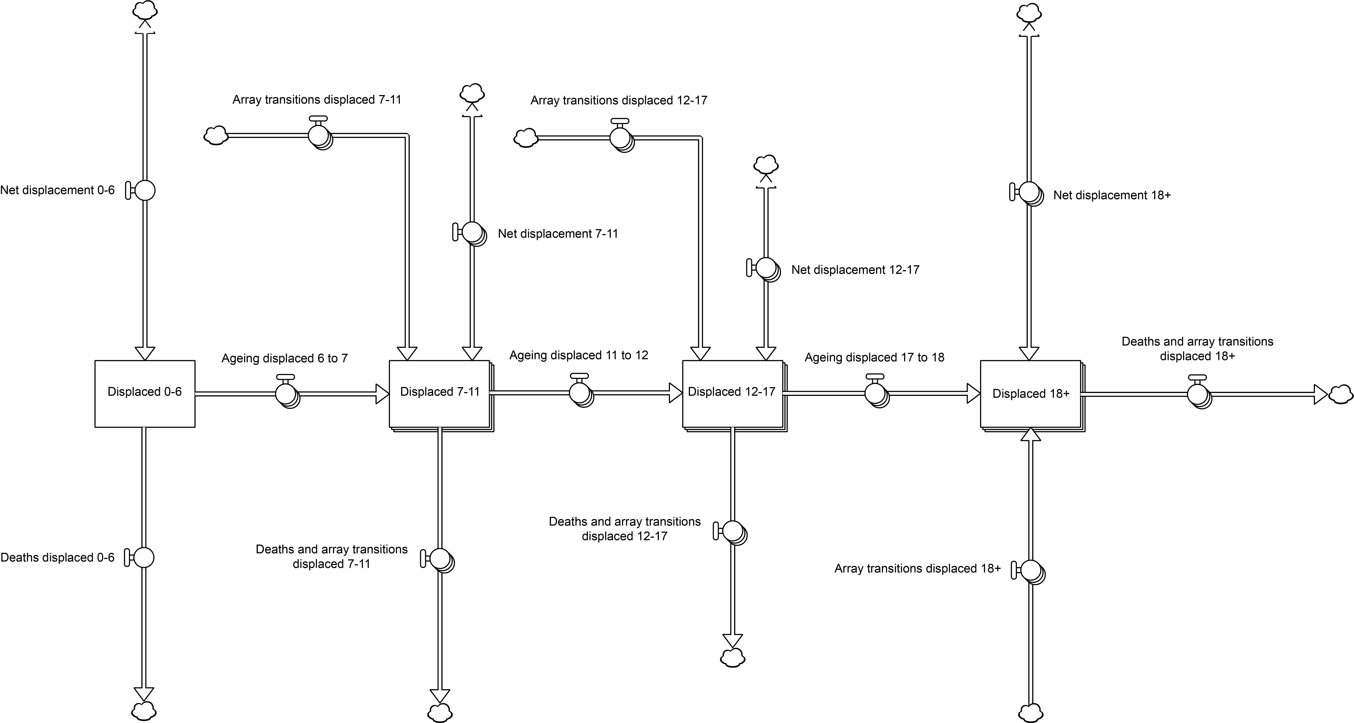
Fig. S15. Structure of the internal displacement sector.

1.10. Mental health services sector
Fig. S17 shows the structure of the mental health services sector, which captures the flow of patients aged 7−11 years, 12−17 years, and 18 years and above through the private and public mental health care systems. People in the general population who are not currently considering engaging with mental health treatment perceive a need for services at age-specific rates equal to $\sum_{i}{θ_{i}pD_{i}}$, where $D_{i}$ is the number of people with symptom level $i$ (significant mental health problems or less severe mental health problems) not currently considering care, $p$ is the age-specific per capita rate at which people without significant mental health problems perceive a need for treatment per year, and the rate ratio $θ_{i}$ is equal to 1 for people without significant mental health problems and substantially more than 1 for people with more severe mental health problems (i.e., people with significant mental health problems are assumed to perceive a need for care at substantially higher per capita rates than those with less severe mental health problems). The age-specific per capita rates $p$ are assumed to increase at a constant yearly rate due to increasing public awareness of mental illness and available treatment options. After perceiving a need for treatment, people engage with either private or public services at per capita rates that depend on their age, symptom severity, and whether they are affiliated with the contributive health care regime or the subsidised health care regime (see Gaviria et al., 2006; people affiliated with the contributive regime are assumed to access private services, while those affiliated with the subsidised regime access public services). The proportion of people affiliated with the subsidised health care regime is directly related to the prevalence of multidimensional poverty, increasing linearly as the proportion of the population experiencing multidimensional poverty increases (see section 1.6).

Fig. S16. Estimates of the total displaced population of Bogotá and the displacement-related immigration rate derived from the system dynamics model and from the Internal Displacement Monitoring Centre (IDMC; data available at: https://www.internal-displacement.org/countries/colombia).

Prior to receiving treatment, people engaging with private or public mental health services wait for a period of time that depends on services capacity and the number of people waiting for care. Total child and adolescent services capacity (i.e., the total number of private and public consultations that can be provided to 7−17-year-olds per year) and total adult services capacity (the total yearly number of consultations that can be provided to patients aged over 17 years) are assumed to increase at constant rates per year (estimated from Individual Registries for Health Services Provision data), and we assume that the proportions of total child and adolescent services capacity and total adult services capacity available to patients affiliated with the subsidised health care regime (i.e., via the public services system) remain constant. People waiting for mental health treatment disengage from the services system, returning to the population of those with no perceived need for care, at age-specific rates equal to $qE+aW$, where $E$ is the number of people engaging with services per year, $q$ is the proportion of people disengaging immediately after engaging due to overly long waiting times, $W$ is the number of people waiting for treatment, and $a$ is the yearly per capita attrition rate, assumed to be constant (Tyrer et al., 1995). Whenever demand for mental health services exceeds services capacity (i.e., when more people are engaging with services than can be treated), the number of people waiting for care increases, increasing waiting
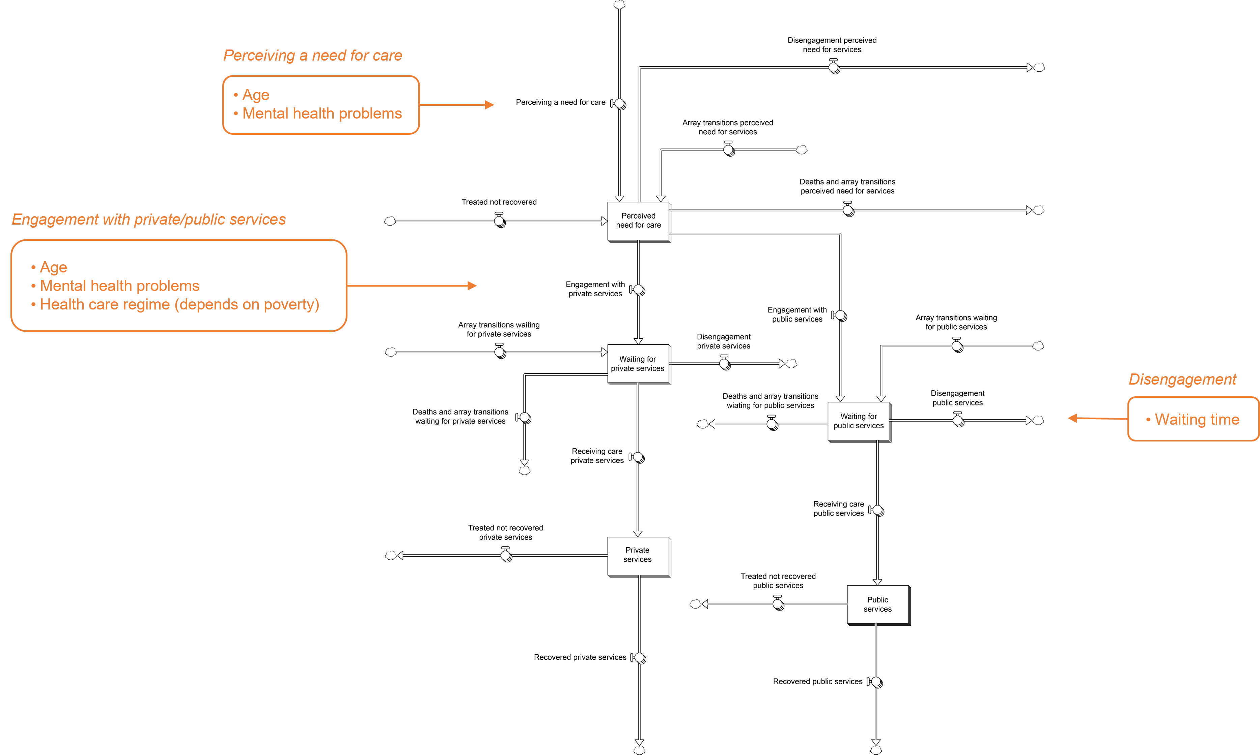
Fig. S17. Structure of the mental health services sector. Modelled factors that affect help-seeking (perceiving a need for care, engagement with services) and disengagement are listed in the text boxes.

times and the values of $q$ and $aW$, so that insufficient services capacity results in increased disengagement and a concomitant increase in the number of people engaging with services who receive either inadequate care or no care at all (the stocks labelled ‘Waiting for services’ in Fig. S17 include patients who have attended one or more consultations but have not recovered, as well as people who have engaged with services but are yet to attend an initial consultation; see below).

Age-specific recovery rates among patients receiving treatment are equal to $rT_{i}$, where $r$ is the per-consultation recovery rate (the proportion of patients recovering when treated divided by the minimally adequate number of consultations per treatment episode; see Thase et al., 1997; Wang et al., 2007) and $T_{i}$ is the number of consultations attended by patients in age group $i$ per year (note that patients entering the stocks labelled ‘Private services’ and ‘Public services’ in Fig. S17 leave after completing a single consultation and will usually flow through these stocks multiple times before recovering). Patients receiving treatment who recover return to the general population of people with no significant mental health problems and no perceived need for services, while those who do not recover flow back into the stock labelled ‘Perceived need for care’ (see Fig. S17; typically, these patients will re-enter the waiting stocks and then flow into the services stocks again at their next consultation). Mental health-related emergency presentation and hospital admission rates for each age group are calculated as $e_{i}\left(P_{i}-M_{i}\right)+ϕe_{i}M_{i}$ and $h_{i}\left(P_{i}-M_{i}\right)+ψh_{i}M_{i}$, respectively, where $P_{i}$ is the total number of people in age group $i$ in the population, $M_{i}$ is the number of people in age group $i$ with significant mental health problems, $e_{i}$ and $h_{i}$ are, respectively, the age-specific per capita emergency presentation rate and the age-specific per capita hospitalisation rate for people without significant mental health problems, and the rate ratios $ϕ$ and $ψ$ are substantially greater than 1 (i.e., people with significant mental health problems are assumed to have substantially higher per capita emergency presentation and hospitalisation rates than people with no mental health problems). Model-based estimates of selected health services outcomes are presented in Fig. S18, together with empirical estimates derived from the National Quality of Life Survey and Individual Registries for Health Service Provision data.

1.11. Suicidal behaviour sector
Fig. S19 presents the structure of the suicidal behaviour sector, which models initial and repeat suicide attempts and suicide mortality. Age-specific numbers of suicide attempts per year are calculated as $\sum_{i}{θ_{i}s\left(D_{i}-R_{i}\right)+λ\sum_{i}{R_{i}}}$, where $D_{i}$ is the number of people with symptom level $i$ (either significant mental health problems or no
Fig. S18. Estimates of selected health services outcomes derived from the system dynamics model and from the National Quality of Life Survey (ECV; available at: https://www.dane.gov.co/) and the Individual Registries for Health Service Provision (RIPS).

significant mental health problems) in the population, $R_{i}$ is the number of people with symptom level $i$ who have made a recent suicide attempt (within the past year), $λ$ is the per capita repeat suicide attempt rate per year, $s$ is the per capita suicide attempt rate per year for people with no significant mental health problems and no history of recent (past-year) suicidal behaviour, and the rate ratio $θ_{i}$ is equal to 1 for people with no significant mental health problems and substantially more than 1 for people experiencing significant mental health problems (people with significant mental health problems are assumed to have a substantially higher per capita initial attempt rate than those with no significant mental health problems; Too et al., 2019). The number of suicide deaths per year in each age group is equal to $γa$, where $a$ is the age-specific suicide attempt rate per year (initial attempts and repeat attempts per year) and $γ$ is age-specific attempt lethality (i.e., the proportion of
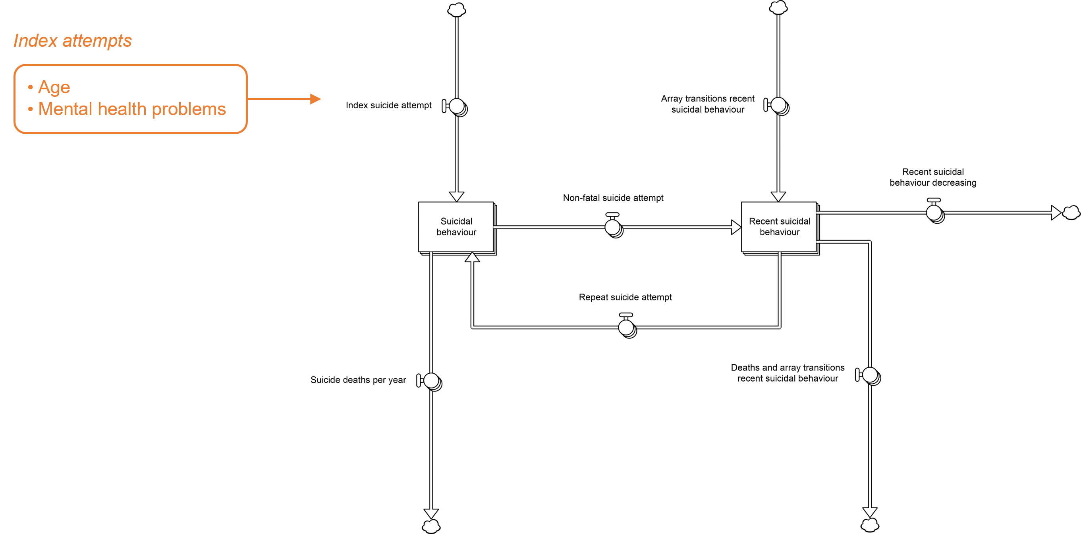
Fig. S19. Structure of the suicidal behaviour sector. Modelled factors that influence the index suicide attempt rate are listed in the text box.

suicide attempts that are fatal). Suicide mortality and attempt rate estimates derived from the model and from National Institute of Legal Medicine and Forensic Sciences data and the Suicidal Behaviour Epidemiological Surveillance Subsystem are presented in Fig. S20.

Fig. S20. Suicide mortality (per 10⁵ population) and suicide attempt rate estimates (all ages) derived from the system dynamics model and from National Institute of Legal Medicine and Forensic Sciences (INMLCF) data and the Suicidal Behaviour Epidemiological Surveillance Subsystem (SISVECOS).

References
Aysa-Lastra, M., 2005. Selection, adaptation and vulnerability of internal forced migrants: a case study in Bogota, Colombia. Doctoral dissertation, University of Pennsylvania.

Backlund, E., Sorlie, P. D., Johnson, N. J., 1999. A comparison of the relationships of education and income with mortality: the national longitudinal mortality study. Soc. Sci. Med. 49, 1373−1384.

Benjet, C., Sampson, L., Yu, S., Kessler, R. C., Zaslavsky, A., Evans-Lacko, S., Martins, S. S., Andrade, L. H., Aguilar-Gaxiola, S., Cía, A., Medina-Mora, M. E., Stagnaro, J. C., Torres de Galvez, M. Y., Viana, M. C., Galea, S., 2019. Associations between neighbourhood-level violence and individual mental disorders: results from the World Mental Health surveys in five Latin American cities. Psychiatry Res. 282, 112607.

Costello, E. J., Compton, S. N., Keeler, G., Angold, A., 2003. Relationships between poverty and psychopathology: a natural experiment. J. Am. Med. Assoc. 290, 2023−2029.

Crum, R. M., Storr, C. L., Ialongo, N., Anthony, J. C., 2008. Is depressed mood in childhood associated with an increased risk for initiation of alcohol use during early adolescence? Addict. Behav. 33, 24−40.

Dean, K., Green, M. J., Laurens, K. R., Kariuki, M., Tzoumakis, S., Sprague, T., Lenroot, R., Carr, V. J., 2018. The impact of parental mental illness across the full diagnostic spectrum on externalising and internalising vulnerabilities in young offspring. Psychol. Med. 48, 2257−2263.

Departamento Administrativo Nacional de Estadística (DANE), 2019. Boletín Técnico. Encuesta Nacional de Consumo de Sustancias Psicoactivas (ENCSPA). Periodo de referencia 2019. Available at: https://www.dane.gov.co/files/investigaciones/boletines/encspa/bt-encspa-2019.pdf.

Frijters, P., Johnston, D. W., Shields, M. A., 2014. The effect of mental health on employment: evidence from Australian panel data. Health Econ. 23, 1058−1071.

Gaviria, A., Medina, C., Mejía, C., 2006. Assessing health reform in Colombia: from theory to practice. Economía 7, 29−72.

Green, M. J., Tzoumakis, S., Laurens, K. R., Dean, K., Kariuki, M., Harris, F., Brinkman, S. A., Carr, V. J., 2019. Early developmental risk for subsequent childhood mental disorders in an Australian population cohort. Aust. N. Z. J. Psychiatry 53, 304−315.

Heudtlass, P., Speybroeck, N., Guha-Sapir, D., 2016. Excess mortality in refugees, internally displaced persons and resident populations in complex humanitarian emergencies (1998−2012) – insights from operational data. Confl. Health 10, 15.

Juárez, N. C., Urdal, H., Vadlamannati, K. C., 2020. The significance of age structure, education, and youth unemployment for explaining subnational variation in violent youth crime in Mexico. Confl. Manag. Peace Sci. 39, 49−73.

Kernic, M. A., Wolf, M. E., Holt, V. L., McKnight, B., Huebner, C. E., Rivara, F. P., 2003. Behavioural problems among children whose mothers are abused by an intimate partner. Child Abuse Negl. 27, 1231−1246.

Kyriacou, D. N., Anglin, D., Taliaferro, E., Stone, S., Tubb, T., Linden, J. A., Muelleman, R., Barton, E., Kraus, J. F., 1999. Risk factors for injury to women from domestic violence. N. Engl. J. Med. 341, 1892−1898.

Lee, S., Tsang, A., Breslau, J., Aguilar-Gaxiola, S., Angermeyer, M., Borges, G., Bromet, E., Bruffaerts, R., de Girolamo, G., Fayyad, J., Gureje, O., Haro, J. M., Kawakami, N., Levinson, D., Oakley Browne, M. A., Ormel, J., Posada-Villa, J., Williams, D. R., Kessler, R. C., 2009. Mental disorders and termination of education in high-income and low- and middle-income countries: epidemiological study. Br. J. Psychiatry 194, 411−417.

Lynskey, M. T., Fergusson, D. M., Horwood, L. J., 1994. The effect of parental alcohol problems on rates of adolescent psychiatric disorders. Addiction 89, 1277−1286.

Marmorstein, N. R., Iacono, W. G., Malone, S. M., 2010. Longitudinal associations between depression and substance dependence from adolescence through early adulthood. Drug Alcohol Depend. 107, 154−160.

Marroquín Rivera, A., Rodríguez, C. J. R., Padilla-Muñoz, A., Gómez-Restrepo, C., 2020. Mental health in adolescents displaced by the armed conflict: findings from the Colombian national mental health survey. Child Adolesc. Psychiatry Ment. Health 14, 23.

Ministerio de Salud y Protección Social, 2015. Encuesta Nacional de Salud Mental 2015. Available at: https://www.minsalud.gov.co/salud/publica/epidemiologia/Paginas/Estudios-y-encuestas.aspx.

Mitchell, W., Wray, L. R., Watts, M., 2019. Macroeconomics. Red Globe Press, London.

Norström, T., Pape, H., 2010. Alcohol, suppressed anger and violence. Addiction 105, 1580−1586.

Ouellet-Morin, I., Fisher, H. L., York-Smith, M., Fincham-Campbell, S., Moffitt, T. E., Arseneault, L., 2015. Intimate partner violence and new-onset depression: a longitudinal study of women’s childhood and adult histories of abuse. Depress. Anxiety 32, 316−324.

Roerecke, M., Rehm, J., 2013. Alcohol use disorders and mortality: a systematic review and meta-analysis. Addiction 108, 1562−1578.

Russ, T. C., Stamatakis, E., Hamer, M., Starr, J. M., Kivimäki, M., Batty, G. D., 2012. Association between psychological distress and mortality: individual participant pooled analysis of 10 prospective cohort studies. Br. Med. J. 345, e4933.

Sorlie, P. D., Rogot, E., 1990. Mortality by employment status in the National Longitudinal Mortality Study. Am. J. Epidemiol. 132, 983−992.

Thase, M. E., Greenhouse, J. B., Frank, E., Reynolds, C. F., Pilkonis, P. A., Hurley, K., Grochocinski, V., Kupfer, D. J., 1997. Treatment of major depression with psychotherapy or psychotherapy-pharmacotherapy combinations. Arch. Gen. Psychiatry 54, 1009−1015.

Too, L. S., Spittal, M. J., Bugeja, L., Reifels, L., Butterworth, P., Pirkis, J., 2019. The association between mental disorders and suicide: a systematic review and meta-analysis of record linkage studies. J. Affect. Disord. 259, 302−313.

Tyrer, P., Morgan, J., Van Horn, E., Jayakody, M., Evans, K., Brummell, R., White, T., Baldwin, D., Harrison-Read, P., Johnson, T., 1995. A randomised controlled study of close monitoring of vulnerable psychiatric patients. Lancet 345, 756−759.

Waitzman, N. J., Smith, K. R., 1998. Phantom of the area: poverty-area residence and mortality in the United States. Am. J. Public Health 88, 973−976.

Wang, P. S., Aguilar-Gaxiola, S., Alonso, J., Angermeyer, M. C., Borges, G., Bromet, E. J., Bruffaerts, R., de Girolamo, G., de Graaf, R., Gureje, O., Haro, J. M., Karam, E. G., Kessler, R. C., Kovess, V., Lane, M. C., Lee, S., Levinson, D., Ono, Y., Petukhova, M., Posada-Villa, J., Seedat, S., Wells, J. E., 2007. Use of mental health services for anxiety, mood, and substance disorders in 17 countries in the WHO world mental health surveys. Lancet 370, 841−850.

Weich, S., Lewis, G., 1998. Poverty, unemployment, and common mental disorders: population based cohort study. Br. Med. J. 317, 115−119.

Zabkiewicz, D., Schmidt, L. A., 2007. Behavioral health problems as barriers to work: results from a 6-year panel study of welfare recipients. J. Behav. Health Serv. Res. 34, 168−185.

2. Intervention definitions and parameter assumptions
Table S1. Intervention definitions and parameter assumptions. Parameters determining the direct effects of each intervention can be modified via an interactive model interface, enabling users to assess the impact of parameter assumptions on model outputs.
Intervention | Description
a. School-based suicide prevention programs | Based on the Signs of Suicide (SOS) program (see Aseltine et al., 2007, BMC Public Health 7, 161), this intervention incorporates curriculum-embedded mental health education aimed at increasing awareness of suicide and brief screening for depression and other risk factors associated with suicidal behaviour. Parameters that can be modified include:  Effect on suicidal behaviour — the multiplicative effect of school-based mental health programs on the per capita suicide attempt rate. The default value (0.625), derived from Aseltine et al. (2007, BMC Public Health 7, 161), implies that school-based mental health programs reduce the incidence of suicidal behaviour by 37.5%.  Effect on mental health — the multiplicative effect of school-based mental health programs on the per capita rate at which adolescents develop significant mental health problems. The default value (1), based on Sheffield et al. (2006, J. Consult. Clin. Psychol. 74, 66−79), implies that school-based mental health programs have no impact on the per capita incidence of mental health problems.  Effect on substance use — the multiplicative effect of school-based mental health programs on the per capita rate at which adolescents develop substance use problems. The default value (0.79), derived from Newton et al. (2022, J. Am. Acad. Child Adolesc. Psychiatry 61, 520−532), implies that school-based mental health programs reduce the incidence of substance use problems by 21%.  Effect on services engagement — the multiplicative effect of school-based mental health programs on the per capita rates that adolescents perceive a need for care and engage with mental health services. The default value (1.81) is derived from Lubman et al. (2020, EClinicalMedicine 18, 100225).
b. Anti-bullying programs | School-based programs aimed at reducing exposure to bullying and cyberbullying. Parameters that can be modified include:  Effect on mental health — the multiplicative effect of anti-bullying programs on the per capita rate at which children and adolescents (aged 7−17 years) develop significant mental health problems. The default value (0.689), derived from Fraguas et al. (2021, JAMA Pediatr. 175, 44−55), implies that school-based anti-bulling programs reduce the per capita incidence of mental health problems by 31.1%.
c. Gatekeeper suicide prevention training | Programs providing suicide prevention training to community gatekeepers (educators, community mothers, young leaders, etc.) with the aim of reducing suicidal behaviour among children and adolescents (aged 7−17 years). Parameters that can be modified include:  Effect on suicidal behaviour — the multiplicative effect of gatekeeper training on the per capita suicide attempt rate. The default value (0.806), derived from Hegerl et al. (2006, Psychol. Med. 36, 1225−1233), implies that gatekeeper training reduces the incidence of suicidal behaviour by 19.4%.  Effect decay rate per year — the fractional rate per year at which the effect on suicidal behaviour declines to a value of 1 (i.e., no effect) after gatekeeper training programs end. The default value (1) implies that the effect on suicidal behaviour would decrease to a value of 1 in 1 year given the initial rate of decline (i.e., the rate immediately after gatekeeper training programs end). Note that the rate of decline in the effect of gatekeeper training itself declines as the effect approaches a value of 1, so the actual time required for the effect to decay completely will generally be greater than the inverse of the decay rate specified.
d. Suicide helplines | Increased investment in helpline services for people experiencing suicidal crisis. Parameters that can be modified include:  Additional callers target — the maximum proportion of people contemplating suicide who could be expected to call a helpline as a direct result of the intervention. The default value (0.2) assumes that increased investment in helpline services could result in 20% of people at risk of self-harm accessing a service when they would not have otherwise. Note that people who would have called a helpline given current levels of investment are assumed to still access services at the same rate (i.e., the total proportion of people calling a helpline is equal to 0.2 plus the proportion who would have called without the intervention).  Effect on suicidal behaviour — the multiplicative effect of accessing suicide helpline services on the risk of suicidal behaviour. The default value (0.822), derived from Gould et al. (2007, Suicide Life Threat. Behav. 37, 338−352), implies that calling a suicide helpline reduces the risk of a suicide attempt by 17.8%.
e. GP mental health training | Programs and policies aimed at enhancing the capability of general practitioners and other health professionals to provide effective clinical support to patients with mental disorders, including: 1) comprehensive mental health training programs for primary care providers; 2) improving the quality of mental health education in undergraduate medical curricula; and 3) providing incentives to encourage specialisation in psychiatry. Parameters that can be modified include:  Proportion completing training — the proportion of general practitioners completing mental health training (the default value is 0.2).  Services provision rate ratio — the mean number of mental health services provided by a general practitioner per year divided by the mean number of services provided by a specialised mental health provider. The default value (0.543) is derived from data on the provision of government-subsidised mental health services in Australia and implies that a general practitioner will provide approximately half the number of mental health services provided by a specialised mental health professional in any given year.  Per service recovery rate ratio — the per service recovery rate for patients treated by a general practitioner divided by the per service recovery rate for patients treated by a specialised mental health professional. The default value (0.463) is derived from Cuijpers et al. (2009, Br. J. Gen. Pract., doi: 10.3399/bjgp09X395139).
f. Community connectedness programs | Community programs and services for adolescents (aged 12−17 years) that increase social connectedness, reducing isolation and enhancing resilience in the face of adversity. Parameters that can be modified include:  Maximum population reach — the maximum proportion of adolescents benefiting from community connectedness programs and services. The default value (0.2) assumes that when fully implemented, community connectedness programs will reach 20% of the adolescent population.  Effect on mental health — the multiplicative effect of community connectedness programs on the per capita rate at which adolescents develop significant mental health problems. The default value (0.787), derived from Bond et al. (2007, J. Adolesc. Health 40, 357.e9−357.e18), implies that increased community connectedness reduces the per capita incidence of mental health problems by 21.3%.  Effect on substance use — the multiplicative effect of community connectedness programs on the per capita rate at which adolescents develop substance use problems. The default value (0.676) is derived from Bond et al. (2007, J. Adolesc. Health 40, 357.e9−357.e18), and implies that increased community connectedness reduces the per capita incidence of substance use problems by 32.4%.  Effect decay rate per year — the fractional rate per year at which the effects of increased connectedness decline to a value of 1 (i.e., no effect) after community connectedness programs end. The default value (1) implies that the effects of increased connectedness would decrease to a value of 1 in 1 year given the initial rate of decline (i.e., the rate immediately after community connectedness programs end). Note that the rate of decline in the effects of community connectedness programs decline as the effects approach a value of 1, so the actual time required for the effects to decay completely will generally be greater than the inverse of the decay rate specified.

3. Numerical inputs and data sources
Table S2. Numerical inputs and data sources. See sections 1.2−1.11 above for descriptions of all model sectors.
Input label | Value | Notes
Population sector
Birth rate increase per year | -7.3171E-05 | Per capita birth rate increase per year. Estimated via constrained optimisation.
Birth rate per year initial | 0.012238273 | Initial per capita birth rate per year. Estimated via constrained optimisation.
Death rate increase per year 0-6 | -6.9645E-05 | Per capita mortality rate increase per year. Estimated via constrained optimisation.
Death rate per year 7-11 | 0.000177648 | Per capita mortality rate per year. Estimated via constrained optimisation.
Death rate per year 12-17 | 0.000421315 | Per capita mortality rate per year. Estimated via constrained optimisation.
Death rate per year 18+ | 0.005411411 | Per capita mortality rate per year. Estimated via constrained optimisation.
Death rate per year initial 0-6 | 0.002069644 | Initial per capita mortality rate per year. Estimated via constrained optimisation.
Emigration rate 0-6 | 0.00010291 | Per capita emigration rate per year. Estimated via constrained optimisation.
Emigration rate 7-11 | 0.000198974 | Per capita emigration rate per year. Estimated via constrained optimisation.
Emigration rate 12-17 | 0.000134317 | Per capita emigration rate per year. Estimated via constrained optimisation.
Emigration rate 18+ | 4.72641E-05 | Per capita emigration rate per year. Estimated via constrained optimisation.
Immigration 0-6 | 1277.133631 | Number of people immigrating per year. Estimated via constrained optimisation.
Immigration 7-11 | 848.1291059 | Number of people immigrating per year. Estimated via constrained optimisation.
Immigration 12-17 | 2717.973235 | Number of people immigrating per year. Estimated via constrained optimisation.
Immigration 18+ | 10980.31726 | Number of people immigrating per year. Estimated via constrained optimisation.
Mental health problems sector
Mental health problems onset base rate initial 7-11 | 0.008802508 | Initial base per capita rate per year. Estimated via constrained optimisation.
Mental health problems onset base rate initial 12-17 | 0.003506634 | Initial base per capita rate per year. Estimated via constrained optimisation.
Mental health problems onset base rate initial 18+ | 0.005034258 | Initial base per capita rate per year. Estimated via constrained optimisation.
Mental health problems onset rate multiplier increase per year | 0.397342737 | Determines the rate of increase in the base per capita incidence of mental health problems for each age group. Estimated via constrained optimisation.
Mental health problems prevalence initial 7-11 | 0.100993576 | Initial prevalence of mental health problems. Estimated via constrained optimisation.
Mental health problems prevalence initial 12-17 | 0.10284596 | Initial prevalence of mental health problems. Estimated via constrained optimisation.
Mental health problems prevalence initial 18+ | 0.059350936 | Initial prevalence of mental health problems. Estimated via constrained optimisation.
Mortality hazard ratio mental health problems | 1.37 | Derived from Russ et al. (2012, Br. Med. J. 345, e4933)
Spontaneous recovery rate | 0.06833333 | Per capita spontaneous recovery rate per year. Derived from Jokela et al. (2011, J. Affect. Disord. 130, 454-461).
Developmental vulnerability sector
Base developmental vulnerability onset rate 0-11 | 0.005372939 | Base per capita rate per year. Estimated via constrained optimisation.
Developmental vulnerability hazard ratio family violence | 1.4 | Derived from Kernic et al. (2003, Child Abuse Negl. 27, 1231-1246)
Developmental vulnerability hazard ratio parental mental health problems | 1.63 | Derived from Dean et al. (2018, Psychol. Med. 48, 2257-2263)
Developmental vulnerability hazard ratio parental substance use problems | 2.783154 | Derived from Lynskey et al. (1994, Addiction 89, 1277-1286)
Developmental vulnerability hazard ratio poverty | 1.59 | Derived from Costello et al. (2003, J. Am. Med. Assoc. 290, 2023-2029)
Mental health problems hazard ratio developmentally vulnerable | 1.95 | Derived from Green et al. (2019, Aust. N. Z. J. Psychiatry 53, 304-315)
Mortality hazard ratio developmental vulnerability | 1.37 | Derived from Russ et al. (2012, Br. Med. J. 345, e4933)
Proportion developmentally vulnerable initial 0-11 | 0.112234494 | Initial prevalence of developmental vulnerability among children aged 0-11 years. Estimated via constrained optimisation.
Education sector
Base discontinuing study rate increase per year 12-17 | -0.02483572 | Base per capita discontinuation rate increase per year. Estimated via constrained optimisation.
Base discontinuing study rate initial 12-17 | 0.027878569 | Initial base per capita discontinuation rate per year. Estimated via constrained optimisation.
Discontinuing post-secondary study base rate 18+ | 0.090604698 | Base per capita discontinuation rate per year. Estimated via constrained optimisation.
Discontinuing post-secondary study hazard ratio mental health problems | 3.907801 | Derived from Lee et al. (2009, Br. J. Psychiatry 194, 411-417)
Discontinuing study hazard ratio mental health problems | 1.200521 | Derived from Lee et al. (2009, Br. J. Psychiatry 194, 411-417)
Mortality hazard ratio no post-secondary qualification | 1.36 | Derived from Backlund et al. (1999, Soc. Sci. Med 49, 1373-1384)
Per capita enrolment rate 18+ | 0.011451119 | Per capita enrolment rate per year. Estimated via constrained optimisation.
Per capita post-secondary study completion rate 18+ | 0.120504195 | Per capita post-secondary education completion rate per year. Estimated via constrained optimisation.
Per capita SSGC completion rate 18+ | 0.055166057 | Per capita upper secondary education completion rate per year. Estimated via constrained optimisation.
Post-secondary qualification proportion initial 18+ | 0.120849607 | Initial proportion of adults (aged 18 years and above) holding a post-secondary qualification. Derived using national data from the Large Integrated Household Survey (GEIH; available at: https://www.dane.gov.co/).
Proportion ageing 6 to 7 studying | 0.968462681 | Proportion of children turning 7 years enrolled in elementary school. Derived from National Quality of Life Survey (ECV) data (available at: https://www.dane.gov.co/).
Proportion discontinuing study completing SSGC 12-17 | 0.849123722 | Proportion of 12-17-year-olds discontinuing study completing upper secondary education. Derived from National Quality of Life Survey (ECV) data (available at: https://www.dane.gov.co/).
Proportion studying initial 7-11 | 0.967990497 | Initial proportion of 7-11-year-olds enrolled in formal education. Estimated via constrained optimisation.
Proportion studying initial 12-17 | 0.891320328 | Initial proportion of 12-17-year-olds enrolled in formal education. Estimated via constrained optimisation.
Proportion studying initial 18+ | 0.125755959 | Initial proportion of adults (aged 18 years and above) enrolled in formal education. Estimated via constrained optimisation.
SSGC proportion initial 12-17 | 0.156968418 | Initial proportion of 12-17-year-olds holding a secondary school graduation certificate. Derived from National Quality of Life Survey (ECV) data (available at: https://www.dane.gov.co/).
SSGC proportion initial 18+ | 0.248535767 | Initial proportion of adults (aged 18 years and above) holding a secondary school graduation certificate. Derived using national data from the Large Integrated Household Survey (GEIH; available at: https://www.dane.gov.co/).
Unemployment and poverty sector
Effect of employment on poverty decreasing rate | 1.775140387 | Effect of formal employment on the prevalence of multidimensional poverty. Estimated via constrained optimisation.
Effect of post-secondary qualification on informal employment proportion | -0.4117912 | Effect of post-secondary education on the informal employment rate. Estimated via constrained optimisation.
Effect of SSGC on informal employment proportion | -0.25077026 | Effect of upper secondary education on the informal employment rate. Estimated via constrained optimisation.
Effect of unemployment rate on unemployed to NILF rate | 1.1 | Effect of the unemployment rate on economic participation. Default value assumes that a 1 percentage point increase in the unemployment rate produces a 10% increase in the per capita rate at which unemployed people leave the labour force.
Employed to NILF base rate 12-17 | 0.069080903 | Base per capita rate per year. Estimated via constrained optimisation.
Employed to NILF base rate 18+ | 0.017960114 | Base per capita rate per year. Estimated via constrained optimisation.
Employment hazard ratio post-secondary qualification | 8.931132034 | Effect of post-secondary education on employment. Derived using national data from the Large Integrated Household Survey (GEIH; available at: https://www.dane.gov.co/).
Employment hazard ratio SSGC | 6.783864185 | Effect of upper secondary education on employment. Derived using national data from the Large Integrated Household Survey (GEIH; available at: https://www.dane.gov.co/).
Employment hazard ratio substance use problems | 0.31 | Derived from Zabkiewicz and Schmidt (2007, J. Behav. Health Serv. Res. 34, 168-185)
Mental health problems hazard ratio poverty | 1.965312513 | Per capita incidence of mental health problems among people experiencing multidimensional poverty divided by per capita incidence among those not experiencing multidimensional poverty. Estimated via constrained optimisation using a prevalence ratio estimate of 1.86 derived from Weich and Lewis (1998, Br. Med. J. 317, 115-119).
Mental health problems hazard ratio unemployed | 6.036956707 | Per capita incidence of mental health problems among unemployed people divided by per capita incidence among those not unemployed. Estimated via constrained optimisation using a prevalence ratio estimate of 1.86 derived from Weich and Lewis (1998, Br. Med. J. 317, 115-119).
Mental health problems prevalence poverty initial | 0.104145605 | Initial prevalence of mental health problems among people experiencing multidimensional poverty. Estimated via constrained optimisation.
Mental health problems prevalence ratio poverty estimate | 1.86 | Derived from Weich and Lewis (1998, Br. Med. J. 317, 115-119)
Mental health problems prevalence ratio unemployed estimate | 1.86 | Derived from Weich and Lewis (1998, Br. Med. J. 317, 115-119)
Mortality hazard ratio poverty | 1.78 | Derived from Waitzman and Smith (1998, Am. J. Public Health 88, 973-976)
Mortality hazard ratio unemployed | 1.22 | Derived from Sorlie and Rogot (1990, Am. J. Epidemiol. 132, 983-992)
NILF to unemployed base rate 12-17 | 0.005763863 | Base per capita rate per year. Estimated via constrained optimisation.
NILF to unemployed base rate 18+ | 0.094504831 | Base per capita rate per year. Estimated via constrained optimisation.
Non-participation hazard ratio mental health problems | 1.63482 | Derived from Frijters et al. (2014, Health Econ. 23, 1058-1071)
Participation hazard ratio post-secondary qualification | 7.034190699 | Effect of post-secondary education on economic participation. Derived using national data from the Large Integrated Household Survey (GEIH; available at: https://www.dane.gov.co/).
Participation hazard ratio SSGC | 2.908429491 | Effect of upper secondary education on economic participation. Derived using national data from the Large Integrated Household Survey (GEIH; available at: https://www.dane.gov.co/).
Participation rate initial mental health problems 12-17 | 0.629180698 | Initial participation rate among 12-17-year-olds with significant mental health problems. Estimated via constrained optimisation.
Participation rate initial mental health problems 18+ | 0.682379813 | Initial participation rate among adults (aged 18 years and above) with significant mental health problems. Estimated via constrained optimisation.
Participation rate initial no mental health problems 12-17 | 0.406615734 | Initial participation rate among 12-17-year-olds with no mental health problems. Estimated via constrained optimisation.
Participation rate initial no mental health problems 18+ | 0.856112261 | Initial participation rate among adults (aged 18 years and above) with no mental health problems. Estimated via constrained optimisation.
Per capita employed to unemployed rate 12-17 | 0.095000082 | Per capita rate per year. Estimated via constrained optimisation.
Per capita employed to unemployed rate 18+ | 0.039662108 | Per capita rate per year. Estimated via constrained optimisation.
Per capita unemployed to NILF rate 12-17 | 0.281280097 | Per capita rate per year. Estimated via constrained optimisation.
Per capita unemployed to NILF rate 18+ | 0.271740484 | Per capita rate per year. Estimated via constrained optimisation.
Post-secondary qualification proportion ratio NILF | 0.34760169 | Proportion of people not in the labour force holding a post-secondary qualification divided by the proportion of people in the total working-age population holding a post-secondary qualification. Derived using national data from the Large Integrated Household Survey (GEIH; available at: https://www.dane.gov.co/).
Post-secondary qualification proportion ratio unemployed | 1.394626507 | Proportion of unemployed people holding a post-secondary qualification divided by the proportion of people in the total working-age population holding a post-secondary qualification. Derived using national data from the Large Integrated Household Survey (GEIH; available at: https://www.dane.gov.co/).
Poverty decreasing base rate | 0.120188954 | Base per capita rate per year. Estimated via constrained optimisation.
Poverty increasing base rate | 0 | Base per capita rate per year. Estimated via constrained optimisation.
Poverty prevalence initial | 0.126569461 | Initial prevalence of multidimensional poverty. Estimated via constrained optimisation.
Proportion informally employed initial | 0.566663481 | Initial proportion of employed people in informal employment. Estimated via constrained optimisation.
SSGC proportion ratio NILF | 0.711847901 | Proportion of people not in the labour force holding a secondary school graduation certificate divided by the proportion of people in the total working-age population holding a secondary school graduation certificate. Derived using national data from the Large Integrated Household Survey (GEIH; available at: https://www.dane.gov.co/).
SSGC proportion ratio unemployed | 1.516626772 | Proportion of unemployed people holding a secondary school graduation certificate divided by the proportion of people in the total working-age population holding a secondary school graduation certificate. Derived using national data from the Large Integrated Household Survey (GEIH; available at: https://www.dane.gov.co/).
Substance use problems prevalence ratio unemployed | 2.176471 | Derived from Slade et al. (2009, The Mental Health of Australians 2. Report on the 2007 National Survey of Mental Health and Wellbeing. Department of Health and Ageing, Canberra)
Unemployed to employed base rate 12-17 | 0.073902998 | Base per capita rate per year. Estimated via constrained optimisation.
Unemployed to employed base rate 18+ | 0.08115513 | Base per capita rate per year. Estimated via constrained optimisation.
Unemployment rate initial mental health problems 12-17 | 0.263484854 | Initial unemployment rate among 12-17-year-olds with significant mental health problems. Estimated via constrained optimisation.
Unemployment rate initial mental health problems 18+ | 0.223923918 | Initial unemployment rate among adults (aged 18 years and above) with significant mental health problems. Estimated via constrained optimisation.
Unemployment rate initial no mental health problems 12-17 | 0.223101649 | Initial unemployment rate among 12-17-year-olds with no mental health problems. Estimated via constrained optimisation.
Unemployment rate initial no mental health problems 18+ | 0.100941175 | Initial unemployment rate among adults (aged 18 years and above) with no mental health problems. Estimated via constrained optimisation.
Substance use sector
Developmental vulnerability prevalence ratio no substance use problems | 0.8609731 | Prevalence of developmental vulnerability among people with no substance use problems divided by the prevalence of developmental vulnerability in the total population. Derived from Crum et al. (2008, Addict. Behav. 33, 24-40)
Mental health problems hazard ratio substance use problems | 8.09464025 | Per capita incidence of mental health problems among people with substance use problems divided by per capita incidence among those with no substance use problems. Estimated via constrained optimisation using a prevalence ratio estimate of 2.63 derived from Marmorstein et al. (2010, Drug Alcohol Depend. 107, 154-160).
Mental health problems prevalence ratio substance use problems estimate | 2.63 | Derived from Marmorstein et al. (2010, Drug Alcohol Depend. 107, 154-160)
Mortality hazard ratio substance use problems | 1.95 | Derived from Roerecke and Rehm (2013, Addiction 108, 1562-1578)
Per capita intoxication rate substance use problems 12-17 | 0.026396631 | Per capita health services presentation rate per year. Estimated via constrained optimisation.
Per capita intoxication rate substance use problems 18+ | 0.003297745 | Per capita health services presentation rate per year. Estimated via constrained optimisation.
Per capita recovery rate substance use problems | 0.241 | Derived from Miller et al. (2001, J. Stud. Alcohol 62, 211-220)
Substance use problems hazard ratio developmental vulnerability | 1.62 | Derived from Crum et al. (2008, Addict. Behav. 33, 24-40)
Substance use problems hazard ratio mental health problems | 4.216942756 | Derived from Marmorstein et al. (2010, Drug Alcohol Depend. 107, 154-160)
Substance use problems onset base rate 12-17 | 0.008003667 | Base per capita rate per year. Estimated via constrained optimisation.
Substance use problems onset base rate 18+ | 0.020359794 | Base per capita rate per year. Estimated via constrained optimisation.
Substance use problems prevalence initial mental health problems 12-17 | 0.101275786 | Initial prevalence of substance use problems among 12-17-year-olds with significant mental health problems. Estimated via constrained optimisation.
Substance use problems prevalence initial mental health problems 18+ | 0.371099227 | Initial prevalence of substance use problems among adults (aged 18 years and above) with significant mental health problems. Estimated via constrained optimisation.
Substance use problems prevalence initial no mental health problems 12-17 | 0 | Initial prevalence of substance use problems among 12-17-year-olds with no mental health problems. Estimated via constrained optimisation.
Substance use problems prevalence initial no mental health problems 18+ | 0.032252089 | Initial prevalence of substance use problems among adults (aged 18 years and above) with no mental health problems. Estimated via constrained optimisation.
Family violence and violent crime sector
Family violence base rate fractional increase per year 0-6 | -0.00021152 | Base per capita exposure rate increase per year. Estimated via constrained optimisation.
Family violence base rate fractional increase per year 7-11 | 0.000304191 | Base per capita exposure rate increase per year. Estimated via constrained optimisation.
Family violence base rate fractional increase per year 12-17 | -0.00072565 | Base per capita exposure rate increase per year. Estimated via constrained optimisation.
Family violence base rate fractional increase per year 18+ | -0.00013935 | Base per capita exposure rate increase per year. Estimated via constrained optimisation.
Family violence base rate initial 0-6 | 0.008377533 | Initial base per capita exposure rate per year. Estimated via constrained optimisation.
Family violence base rate initial 7-11 | 0.00506505 | Initial base per capita exposure rate per year. Estimated via constrained optimisation.
Family violence base rate initial 12-17 | 0.006921743 | Initial base per capita exposure rate per year. Estimated via constrained optimisation.
Family violence base rate initial 18+ | 0.001526139 | Initial base per capita exposure rate per year. Estimated via constrained optimisation.
Family violence hazard ratio substance use problems | 3.6 | Derived from Kyriacou et al. (1999, N. Engl. J. Med. 341, 1892-1898)
Family violence hazard ratio unemployment | 2.4 | Derived from Kyriacou et al. (1999, N. Engl. J. Med. 341, 1892-1898)
Physical assault base rate fractional increase per year | -0.21985666 | Base per capita exposure rate increase per year. Estimated via constrained optimisation.
Physical assault base rate initial | 0.187349398 | Initial base per capita exposure rate per year. Estimated via constrained optimisation.
Physical assault hazard ratio substance use problems | 0.033 | Derived from Norstrom and Pape (2010, Addiction 105, 1580-1586)
Physical assault hazard ratio unemployment | 1.062368 | Derived from Juarez et al. (2020, Confl. Manag. Peace Sci. 39, 49−73)
Internal displacement sector
Displaced initial 0-6 | 60487.94817 | Initial number of 0-6-year-olds displaced by conflict-related violence. Derived from data published by the Internal Displacement Monitoring Centre (IDMC; available at: https://www.internal-displacement.org/countries/colombia) and Unidad para la Atención y Reparación Integral a las Víctimas (available at: https://www.unidadvictimas.gov.co/es/).
Displaced initial 7-11 | 45853.76716 | Initial number of 7-11-year-olds displaced by conflict-related violence. Derived from data published by the Internal Displacement Monitoring Centre (IDMC; available at: https://www.internal-displacement.org/countries/colombia) and Unidad para la Atención y Reparación Integral a las Víctimas (available at: https://www.unidadvictimas.gov.co/es/).
Displaced initial 12-17 | 45853.76716 | Initial number of 12-17-year-olds displaced by conflict-related violence. Derived from data published by the Internal Displacement Monitoring Centre (IDMC; available at: https://www.internal-displacement.org/countries/colombia) and Unidad para la Atención y Reparación Integral a las Víctimas (available at: https://www.unidadvictimas.gov.co/es/).
Displaced initial 18+ | 238049.3444 | Initial number of adults (18 years and above) displaced by conflict-related violence. Derived from data published by the Internal Displacement Monitoring Centre (IDMC; available at: https://www.internal-displacement.org/countries/colombia) and Unidad para la Atención y Reparación Integral a las Víctimas (available at: https://www.unidadvictimas.gov.co/es/).
Displacement age proportion 7-11 | 0.1175 | Proportion of immigrants displaced by conflict-related violence aged 7-11 years. Derived from data published by Unidad para la Atención y Reparación Integral a las Víctimas (available at: https://www.unidadvictimas.gov.co/es/).
Displacement age proportion 12-17 | 0.1175 | Proportion of immigrants displaced by conflict-related violence aged 12-17 years. Derived from data published by Unidad para la Atención y Reparación Integral a las Víctimas (available at: https://www.unidadvictimas.gov.co/es/).
Displacement age proportion 18+ | 0.61 | Proportion of immigrants displaced by conflict-related violence aged 18 years and above. Derived from data published by Unidad para la Atención y Reparación Integral a las Víctimas (available at: https://www.unidadvictimas.gov.co/es/).
Internal displacement rate increase per year | -0.03509489 | Fractional rate of increase per year. Estimated via constrained optimisation.
Internal displacement rate initial | 14117.87761 | Initial displacement-related immigration per year (all ages). Estimated via constrained optimisation.
Mental health problems hazard ratio displaced | 2.911443493 | Derived from Marroquin Rivera et al. (2020, Child Adolesc. Psychiatry Ment. Health 14, 23)
Mental health problems prevalence ratio displaced estimate | 2.448276 | Derived from Marroquin Rivera et al. (2020, Child Adolesc. Psychiatry Ment. Health 14, 23)
Mortality hazard ratio displaced | 2.5 | Derived from Heudtlass et al. (2016, Confl. Health 10, 15)
Poverty prevalence ratio displaced | 1.631356 | Derived from Marroquin Rivera et al. (2020, Child Adolesc. Psychiatry Ment. Health 14, 23)
Proportion studying ratio displaced | 0.8791715 | Derived from Marroquin Rivera et al. (2020, Child Adolesc. Psychiatry Ment. Health 14, 23)
Proportion unemployed ratio displaced | 1.666063648 | Derived from Aysa-Lastra (2005. Selection, adaptation and vulnerability of internal forced migrants: a case study in Bogota, Colombia. PhD thesis, University of Pennsylvania)
Proportion with SSGC or higher qualification ratio displaced | 0.471580728 | Derived from Aysa-Lastra (2005. Selection, adaptation and vulnerability of internal forced migrants: a case study in Bogota, Colombia. PhD thesis, University of Pennsylvania)
Repatriation rate displaced | 0.004362565 | Per capita rate per year. Estimated via constrained optimisation.
Mental health services sector
Disengagement rate perceived need for services | 0.3095975 | Derived from Goldberg et al. (1998, Br. J. Gen. Pract. 48, 1840-1844)
Effect of disengagement on recovery rate | 0.943196 | Derived from Australian Bureau of Statistics (2012, Information paper. Use of the Kessler psychological distress scale in ABS health surveys, Australia, 2007-08. Cat. no. 4817.0.55.001. Australian Bureau of Statistics, Canberra)
Effect of poverty on subsidised regime proportion | 1.101172748 | Effect of multidimensional poverty on the proportion of people affiliated with the subsidised health care regime. Estimated via constrained optimisation.
Effect of waiting time on disengagement rate 7-17 | 7.693296261 | Effect of waiting time on the proportion of people engaging with services disengaging immediately. Estimated via constrained optimisation.
Effect of waiting time on disengagement rate 18+ | 9.491460989 | Effect of waiting time on the proportion of people engaging with services disengaging immediately. Estimated via constrained optimisation.
Emergency presentation rate multiplier increase per year | 0.004503678 | Determines the rate of increase in the base per capita presentation rate for each age group. Estimated via constrained optimisation.
Emergency presentation rate no mental health problems initial 7-11 | 4.9838E-05 | Initial per capita presentation rate per year for 7-11-year-olds without significant mental health problems. Estimated via constrained optimisation.
Emergency presentation rate no mental health problems initial 12-17 | 0.00039448 | Initial per capita presentation rate per year for 12-17-year-olds without significant mental health problems. Estimated via constrained optimisation.
Emergency presentation rate no mental health problems initial 18+ | 0.000454892 | Initial per capita presentation rate per year for adults (aged 18 years and above) without significant mental health problems. Estimated via constrained optimisation.
Emergency presentation rate ratio mental health problems | 9.090351924 | Derived from Australian Bureau of Statistics (2012, Information paper. Use of the Kessler psychological distress scale in ABS health surveys, Australia, 2007-08. Cat. no. 4817.0.55.001. Australian Bureau of Statistics, Canberra)
Hospitalisation rate multiplier increase per year | 0.225987327 | Determines the rate of increase in the base per capita hospitalisation rate for each age group. Estimated via constrained optimisation.
Hospitalisation rate no mental health problems initial 7-11 | 2.48891E-05 | Initial per capita hospitalisation rate per year for 7-11-year-olds without significant mental health problems. Estimated via constrained optimisation.
Hospitalisation rate no mental health problems initial 12-17 | 0.000321432 | Initial per capita hospitalisation rate per year for 12-17-year-olds without significant mental health problems. Estimated via constrained optimisation.
Hospitalisation rate no mental health problems initial 18+ | 0.000305055 | Initial per capita hospitalisation rate per year for adults (aged 18 years and above) without significant mental health problems. Estimated via constrained optimisation.
Hospitalisation rate ratio mental health problems | 9.090351924 | Derived from Australian Bureau of Statistics (2012, Information paper. Use of the Kessler psychological distress scale in ABS health surveys, Australia, 2007-08. Cat. no. 4817.0.55.001. Australian Bureau of Statistics, Canberra)
Perceiving need for care base rate initial 7-11 | 0.019362313 | Initial base per capita rate per year. Estimated via constrained optimisation.
Perceiving need for care base rate initial 12-17 | 0.004453998 | Initial base per capita rate per year. Estimated via constrained optimisation.
Perceiving need for care base rate initial 18+ | 0.000331779 | Initial base per capita rate per year. Estimated via constrained optimisation.
Perceiving need for care rate multiplier increase per year 7-11 | 0.101955532 | Determines the rate of increase in the base per capita rate at which 7-11-year-olds transition to perceiving a need for care. Estimated via constrained optimisation.
Perceiving need for care rate multiplier increase per year 12-17 | 0.475071297 | Determines the rate of increase in the base per capita rate at which 12-17-year-olds transition to perceiving a need for care. Estimated via constrained optimisation.
Perceiving need for care rate multiplier increase per year 18+ | 2.618241984 | Determines the rate of increase in the base per capita rate at which adults (aged 18 years and above) transition to perceiving a need for care. Estimated via constrained optimisation.
Perceiving need for care rate ratio mental health problems | 6.967821517 | Effect of mental health problems on the per capita rate at which people transition to perceiving a need for care. Estimated via constrained optimisation.
Per service recovery rate | 0.07433333 | Proportion of patients recovering with treatment (0.446; see Thase et al., 1997, Arch. Gen. Psychiatry 54, 1009−1015) divided by the minimally adequate number of consultations per treatment episode (6; see Wang et al., 2007, Lancet 370, 841-850)
Proportion disengaging immediately with unlimited capacity | 0.001 | Proportion of people engaging with mental health services assumed to disengage immediately when services capacity is unlimited (no waiting time)
Proportion of capacity public initial 7-17 | 0.213635541 | Initial proportion of total child and adolescent mental health services capacity available to patients affiliated with the subsidised health care regime (i.e., via the public services system). Estimated via constrained optimisation.
Proportion of capacity public initial 18+ | 0.196296571 | Initial proportion of total adult mental health services capacity available to patients affiliated with the subsidised health care regime (i.e., via the public services system). Estimated via constrained optimisation.
Services capacity increase per year 7-17 | 2692.767661 | Annual increase in the total number of child and adolescent mental health consultations that can be provided per year. Estimated using workforce and services provision data from the Registry of Human Talent in Health (RETHUS) and the Individual Registries for Health Service Provision (RIPS).
Services capacity increase per year 18+ | 13196.01716 | Annual increase in the total number of adult mental health consultations that can be provided per year. Estimated using workforce and services provision data from the Registry of Human Talent in Health (RETHUS) and the Individual Registries for Health Service Provision (RIPS).
Services capacity initial 7-17 | 13216.42227 | Initial total number of child and adolescent mental health consultations that can be provided per year. Estimated using workforce and services provision data from the Registry of Human Talent in Health (RETHUS) and the Individual Registries for Health Service Provision (RIPS).
Services capacity initial 18+ | 64767.61347 | Initial total number of adult mental health consultations that can be provided per year. Estimated using workforce and services provision data from the Registry of Human Talent in Health (RETHUS) and the Individual Registries for Health Service Provision (RIPS).
Services engagement rate 7-11 | 1.520335023 | Per capita engagement rate per year. Estimated via constrained optimisation.
Services engagement rate 12-17 | 2.823900658 | Per capita engagement rate per year. Estimated via constrained optimisation.
Services engagement rate 18+ | 0.837288471 | Per capita engagement rate per year. Estimated via constrained optimisation.
Subsidised regime proportion initial | 0.264013682 | Initial proportion of the population affiliated with the subsidised health care regime. Estimated via constrained optimisation.
Subsidised regime proportion ratio emergency care 7-11 | 0.335930305 | Proportion of 7-11-year-olds presenting for emergency care affiliated with the subsidised health care regime divided by the total proportion of 7-11-year-olds affiliated with the subsidised health care regime. Estimated via constrained optimisation.
Subsidised regime proportion ratio emergency care 12-17 | 0.647857489 | Proportion of 12-17-year-olds presenting for emergency care affiliated with the subsidised health care regime divided by the total proportion of 12-17-year-olds affiliated with the subsidised health care regime. Estimated via constrained optimisation.
Subsidised regime proportion ratio emergency care 18+ | 0.673955269 | Proportion of adults (aged 18 years and above) presenting for emergency care affiliated with the subsidised health care regime divided by the total proportion of adults affiliated with the subsidised health care regime. Estimated via constrained optimisation.
Subsidised regime proportion ratio hospital care 7-11 | 0.600444141 | Proportion of 7-11-year-olds admitted to hospital affiliated with the subsidised health care regime divided by the total proportion of 7-11-year-olds affiliated with the subsidised health care regime. Estimated via constrained optimisation.
Subsidised regime proportion ratio hospital care 12-17 | 0.739756633 | Proportion of 12-17-year-olds admitted to hospital affiliated with the subsidised health care regime divided by the total proportion of 12-17-year-olds affiliated with the subsidised health care regime. Estimated via constrained optimisation.
Subsidised regime proportion ratio hospital care 18+ | 1.646377268 | Proportion of adults (aged 18 years and above) admitted to hospital affiliated with the subsidised health care regime divided by the total proportion of adults affiliated with the subsidised health care regime. Estimated via constrained optimisation.
Suicidal behaviour sector
Initial suicide attempt rate 18+ no mental health problems | 9.02272E-05 | Per capita initial suicide attempt rate per year for adults (aged 18 years and above) with no significant mental health problems. Estimated via constrained optimisation.
Initial suicide attempt rate ratio 7-11 | 0.320598541 | Per capita initial suicide attempt rate ratio. Estimated via constrained optimisation.
Initial suicide attempt rate ratio 12-17 | 3.33856926 | Per capita initial suicide attempt rate ratio. Estimated via constrained optimisation.
Recent suicidal behaviour duration | 1 | Mean duration (in years) of increased risk of suicidal behaviour after an initial suicide attempt
Repeat suicide attempt rate per year | 0.823055578 | Per capita suicide attempt rate per year among people with a history of recent (past-year) suicidal behaviour. Estimated via constrained optimisation.
Suicide attempt lethality 7-17 | 0.052038678 | Proportion of suicide attempts that are fatal. Estimated via constrained optimisation.
Suicide attempt lethality 18+ | 0.18716155 | Proportion of suicide attempts that are fatal. Estimated via constrained optimisation.
Suicide attempt rate ratio mental health problems | 7.5 | Per capita initial suicide attempt rate ratio. Derived from Too et al. (2019, J. Affect. Disord. 259, 302-313).

Elementary and basic secondary education (grades 1−9, ages 6−15 years) are compulsory. According to data from the National Quality of Life Survey (ECV; available at: https://www.dane.gov.co/), 97.3% of 5−11-year-olds and 92.1% of 12−17-year-olds were attending school in 2013.

