Definition 1: The $ϕ$ coefficient

The $ϕ$ coefficient is an association measure between two binary variables. To calculate it is necessary to use the contingency table between those binary variables, suppose $q_{i}$ and $q_{j}$, as shown at the Definition Table 1, where $n_{00}$, $n_{01}$, $n_{10}$ and $n_{11}$ are the counting of number of observation whose sum is $n$. Beside $n_{●0}=n_{00}+n_{10}$, $n_{●1}=n_{01}+n_{11}$, $n_{0●}=n_{00}+n_{01}$ and $n_{1●}=n_{10}+n_{11}$.

Definition Table 1: Contingency table between two variables $q_{i}$ and $q_{j}$.
 | q_{i} = 0 | q_{i} = 1 | TOTAL
q_{i} = 0 | n₀₀ | n₀₁ | n_{0●}
q_{i} = 1 | n₁₀ | n₁₁ | n_{1●}
TOTAL | n_{●0} | n_{●1} | n

Finally, with those values from the Definition Table 1, one uses Eq. 1 to calculate the $ϕ$ coefficient. The interval of possible values for this coefficient is [-1,1] where -1 means total disagreement between the two variables, 1 means total agreement and 0 means no relation between them.

 | $$ϕ_{ij}=\frac{n_{11}n_{00}-n_{10}n_{01}}{\sqrt{n_{1●}n_{0●}n_{●0}n_{●1}}}$$ | (1)

Description 1: Boruta method

Boruta (means attack in Polish) is a feature selection algorithm. This method follows the same idea as the Random Forest classifier. A Random Forest creates decision trees with around 67% of the samples in the dataset. The 33% left out are called out-of-bag instances (OOB). Boruta uses these OOB instances to and the trained random forest to estimate the features importance. Besides, to add more randomness to the system, Boruta creates shadow variables. The shadows are new variables created from the original ones, but randomly shuffled. If the original variable presents a better statistical performance than every shadow variable it is considered important. After $n$ randomizations, if the original variable falls in the superior threshold of a binomial distribution ($α>0.95$), that variable is accepted. If the original variable falls in an intermediate region of the distribution ($0.05<α<0.95$), it is considered a tentative. Otherwise, the variable is rejected.

Tables mentioned in the text

Supplementary Table 1: Version of the LSQ applied in J, CPP, FPRP and PC.
id | Question
q1 | Do you fell numbness in your hands and/or feet?
q2 | Tingling (pricking)?
q3 | Anesthetized areas in the skin?
q4 | Spots on the skin?
q5 | Stinging sensation?
q6 | Nodules in the skin?
q7 | Pain in the nerves?
q8 | Swelling of hands and feet?
q9 | Swelling of face?
q10 | Weakness in hands?
q11 | Hard to button shirt? Wear glasses? Write? Hold pans?
q12 | Weakness in feet? Difficulty wearing sandals,slippers?
q13 | Loss of eyelashes?
q14 | Loss of eyebrows?

Supplementary Table 2: Version of the LSQ applied in PTLD.
id | Question
q1 | Do you fell numbness in your hands and/or feet?
q2 | Tingling?
q3 | Stinging sensation?
q4 | Muscle cramps?
q5 | Anesthetized areas in the skin?
q6 | Spots on the skin?
q7 | Nodules on the skin?
q8 | Pain in the nerves?
q9 | Swelling of hands and feet?
q10 | Swelling of face?
q11 | Weakness in hands or feet?
q12 | Hard to button shirt? Write?
q13 | Difficulty wearing shoes?
q14 | Loss of eyelashes? Loss of eyebrows?
q15 | Is it a birth alteration?
q16 | Does anyone in your family have or have had leprosy?

Supplementary Table 3: Description of the hyperparameters for each classifier.
Hyperparameter | Description
Support Vectors Machine
C■ | Penalty parameter for each misclassified data point.
Kernel■ | It can be linear, polynomial, radial, sigmoid or precomputed. It maps the observation into a feature space.
Logistic Regression
C□ | Controls the penalty strength.
Penalty□ | Regularization penalty. It can be L1, L2, or none.
Random Forest
n_estimators▲ | Number of trees in the forest.
max_depth▲ | Maximum depth of trees.
min_samples_split► | Minimum amount of sample to split a node.
max_features► | Maximum number of variables used in each tree.
max_samples▼ | Maximum number of bootstrap samples.
min_samples_leaf▼ | Minimum number samples of samples in each leaf.
max_leaf_nodes | Maximum number of leaves in each tree.
XGBoost
learning_rate♣ | Contribution of each tree to the learning process.
n_estimators♣ | Number of trees.
max_depth♥ | Maximum depth of each tree.
min_child_weight♥ | Minimum summing of the weights in child nodes.
subsample♠ | Subsample ratio of training instances
colsample_bytree♠ | Number of variables to build each tree.
gamma♦ | Minimum split loss.
lambda♦ | L1 regularization.
alpha | L2 regularization.
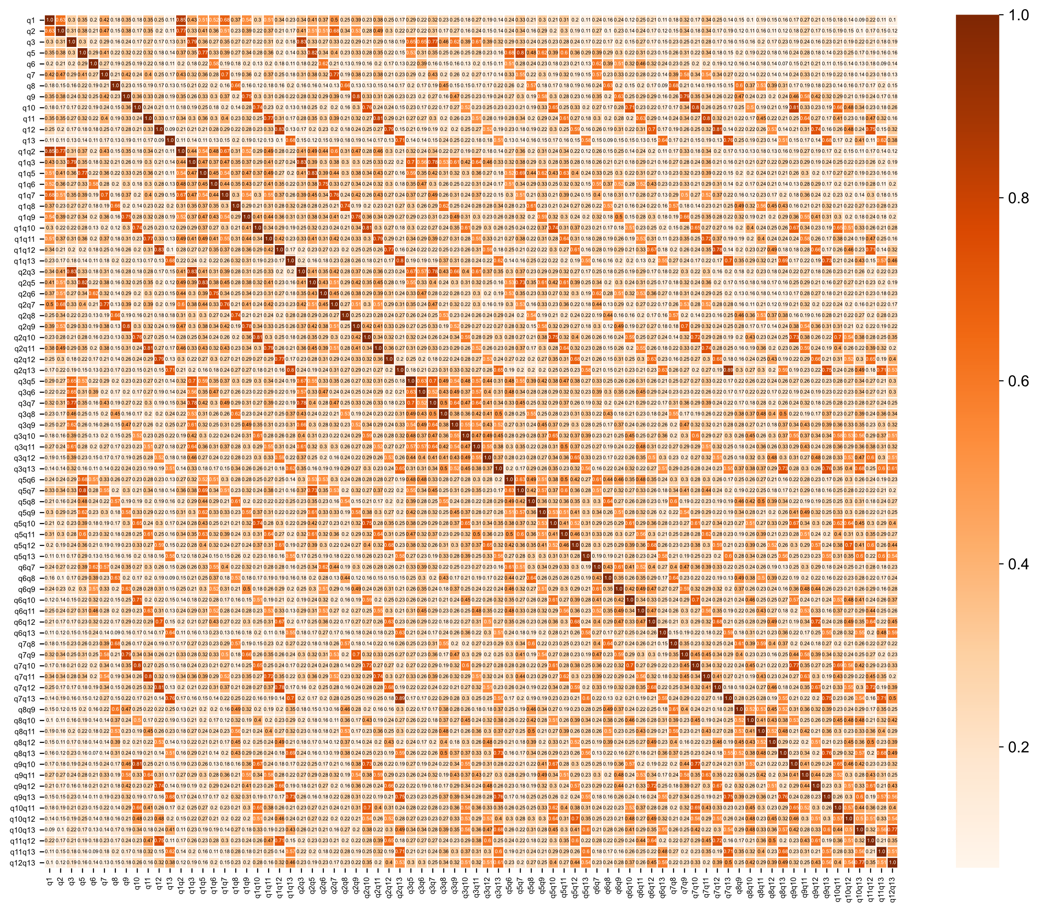
Supplementary Figure 1: Association among variables within the training set given by Matthews’s correlation coefficient.

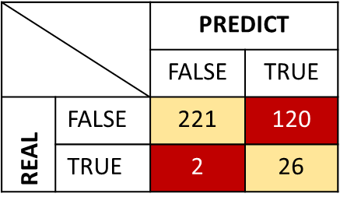  (a) | 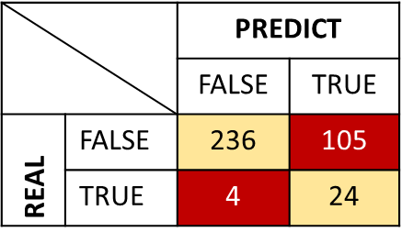  (b)
Supplementary Figure 2: The confusion matrix compares the real clinical leprosy diagnosis (gold standard) with the predicted one from a model or a protocol. In (a) is the confusion matrix comparing the clinical diagnosis of leprosy with predicting the outcome only classifying as LSQ+ if at least one question was marked on the LSQ. Whereas in (b) we compare de gold standard with predictions given by MaLeSQs. Only 2 more subjects were false negatives, but MaLeSQs decreased in 15 the quantity of subjects that would not be evaluated by clinicians.

