Table of Contents
Additional File 1 - Collaborators in the IMPALA study team………………………..…………………….…2
Additional File 2 - Definition data-driven algorithms and connection with AI………………………4
Additional File 3 – Floor plan of the HDUs in QECH and ZCH….…………………………………………….5
Additional File 4 – Observation manual………………………………………………………………………………7
Additional File 5 – Interview guide…..…………………………………………………………………………………8
Additional File 6 – Consolidated criteria for reporting qualitative studies (COREQ)……….…..11
Additional File 7 – Co-design sessions questionnaire………………………………………………………….13
Additional File 8 – Codebook……………………………………………………………………………………………..17
Additional File 9 – Final design proposal ..…….……………………………………………………….………...18

Additional File 1 - Collaborators in the IMPALA study team
Collaborators in the IMPALA study team include: Job Calis MD PhD, Amsterdam Institute for Global Health and Development, Amsterdam, The Netherlands; Christopher Pell PhD, Amsterdam Institute for Global Health and Development, Amsterdam, The Netherlands; Wendy Janssens PhD Prof, Amsterdam Institute for Global Health and Development, The Netherlands; Ângela Jornada Ben MD PhD, Amsterdam Institute for Global Health and Development, The Netherlands; Daniella Brals PhD, Amsterdam Institute for Global Health and Development,The Netherlands; Mark Hoogendoorn PhD Prof, Amsterdam Institute for Global Health and Development, The Netherlands; Michaël Boele van Hensbroek MD PhD Prof, Amsterdam Institute for Global Health and Development,The Netherlands; Job van Woensel MD PhD Prof, Emma Childrens’ Hospital of the Amsterdam University Medical Centers, The Netherlands; Natacha Berbers MSc, Amsterdam Institute for Global Health and Development, The Netherlands; Nina Meels MSc, Amsterdam Institute for Global Health and Development, The Netherlands; Valeria Cristofoli MSc, Amsterdam Institute for Global Health and Development, The Netherlands; Keerthana Raghavan MSc, Amsterdam Institute for Global Health and Development, The Netherlands; Niek Versteegde MD, GOAL 3 B.V., ’s-Hertogenbosch, The Netherlands; Bart Bierling MSc, GOAL 3 B.V., ’s-Hertogenbosch, The Netherlands; Eline Pieck-KleinJan MSc, GOAL 3 B.V., ’s-Hertogenbosch, The Netherlands; Eveline Geubbels PhD, GOAL 3 B.V., ’s-Hertogenbosch, The Netherlands; Lieke de Mare MSc, GOAL 3 B.V., ’s-Hertogenbosch, The Netherlands; Lennart Blom MD PhD, GOAL 3 B.V., ’s-Hertogenbosch, The Netherlands; Michael Levin MD PhD Prof, Section of Paediatric Infectious Disease, Imperial College London, London W2 1PG, UK; Aubrey Cunnington MD PhD, Section of Paediatric Infectious Disease, Imperial College London, London W2 1PG, UK; Myrsini Kaforou PhD; Section of Paediatric Infectious Disease, Imperial College London, London W2 1PG, UK; Clare Wilson MD, Section of Paediatric Infectious Disease, Imperial College London, London W2 1PG, UK; Diego Estrada-Rivadeneyra PhD, Section of Paediatric Infectious Disease, Imperial College London, London W2 1PG, UK; Shea Hamilton PhD, Section of Paediatric Infectious Disease, Imperial College London, London W2 1PG, UK; Victoria Wright PhD, Section of Paediatric Infectious Disease, Imperial College London, London W2 1PG, UK; Jonathan Sturgeon PhD, Section of Paediatric Infectious Disease, Imperial College London, Norfolk Place, London W2 1PG, UK; Grieves Mang’anda Jr MPH, Kamuzu University of Health Sciences, Malawi; Marrianne Kasiya MPH, Kamuzu University of Health Sciences, Malawi; Arox W. Kamng’ona PhD Prof, Kamuzu University of Health Sciences, School of Life Sciences and Allied Health Professions, Blantyre, Malawi; Daniel Mwale MSc, Kamuzu University of Health Sciences, Malawi; David Chaima PhD, Kamuzu University of Health Sciences, Malawi; Jenala Njirammadzi - Maleta MD, Kamuzu University of Health Sciences, Malawi; Josephine Langton MBChB Ass Prof, Kamuzu University of Health Sciences, Malawi; Jacquline Msefula MSc, Kamuzu University of Health Sciences, Malawi; James Makina MD, Kamuzu University of Health Sciences, Malawi; Jobiba Chinkhumba PhD, Kamuzu University of Health Sciences, Malawi; Lucinda Manda Taylor PhD; Kamuzu University of Health Sciences, Malawi; William Nkhono MSc, Kamuzu University of Health Sciences, Malawi; Margret Havara BSc, Kamuzu University of Health Sciences, Malawi; Alick Vweza PhD, Malawi University of Business and Applied Sciences, Malawi; Brenald Dzonzi BSc, Malawi University of Business and Applied Sciences, Malawi; Chimwemwe Msosa PhD, Malawi University of Business and Applied Sciences, Malawi; Christina Chiziwa BSc, Malawi University of Business and Applied Sciences, Malawi; Lezzie Chirambo BSc, Malawi University of Business and Applied Sciences, Malawi; Theresa Mkandawiri PhD Prof, Malawi University of Business and Applied Sciences, Malawi; María Villalobos-Quesada PhD, National eHealth Living Lab, Public Health and Primary Care Department, Leiden University Medical Center, The Netherlands; Margot Rakers MD, National eHealth Living Lab, Public Health and Primary Care Department, Leiden University Medical Center, The Netherlands; Foteini Klapsaki Bach, National eHealth Living Lab, Public Health and Primary Care Department, Leiden University Medical Center, The Netherlands; Kamija Phiri MD PhD Prof, Training Research Unit of Excellence, Malawi; Alice Likumbo BSc, Training Research Unit of Excellence, Malawi; Jessica Chikwana MD, Department of Paediatrics, Zomba Central Hospital, Malawi; Glory Mzembe MD, Training Research Unit of Excellence, Malawi; Mary Magoya MSc, Training Research Unit of Excellence, Malawi; Timothy Rambiki MD, Training Research Unit of Excellence, Malawi; Martin Mwangi PhD, Training Research Unit of Excellence, Malawi; Owen Mtambo PhD, Training Research Unit of Excellence, Malawi; Christopher Nkhata, Training Research Unit of Excellence, Malawi; Patrick Chalira, Training Research Unit of Excellence, Malawi.

Additional File 2 – Definition data-driven algorithms and connection with AI
We define data-driven algorithms as a “set of rules that precisely define a sequence of operations” (Stone, 1971), which use digital data as input and are executed by a computer. The rules draw value from existing data. In some cases, rules can be immutable, as in the case of rule-based AI and traditional algorithms. In other cases, rules can be mutable and transform with time, based on the interaction with the data, as in the case of machine learning systems. This definition allows us to focus on algorithms that can be applied in critical care, whether or not they incorporate AI. Data-driven algorithms can draw data directly from a precise data analysis, or it may involve assessing how well the rules align with the data.

Additional File 3 – Floor plan of the high-dependency units at Queen Elizabeth Central Hospital and Zomba Central Hospital.
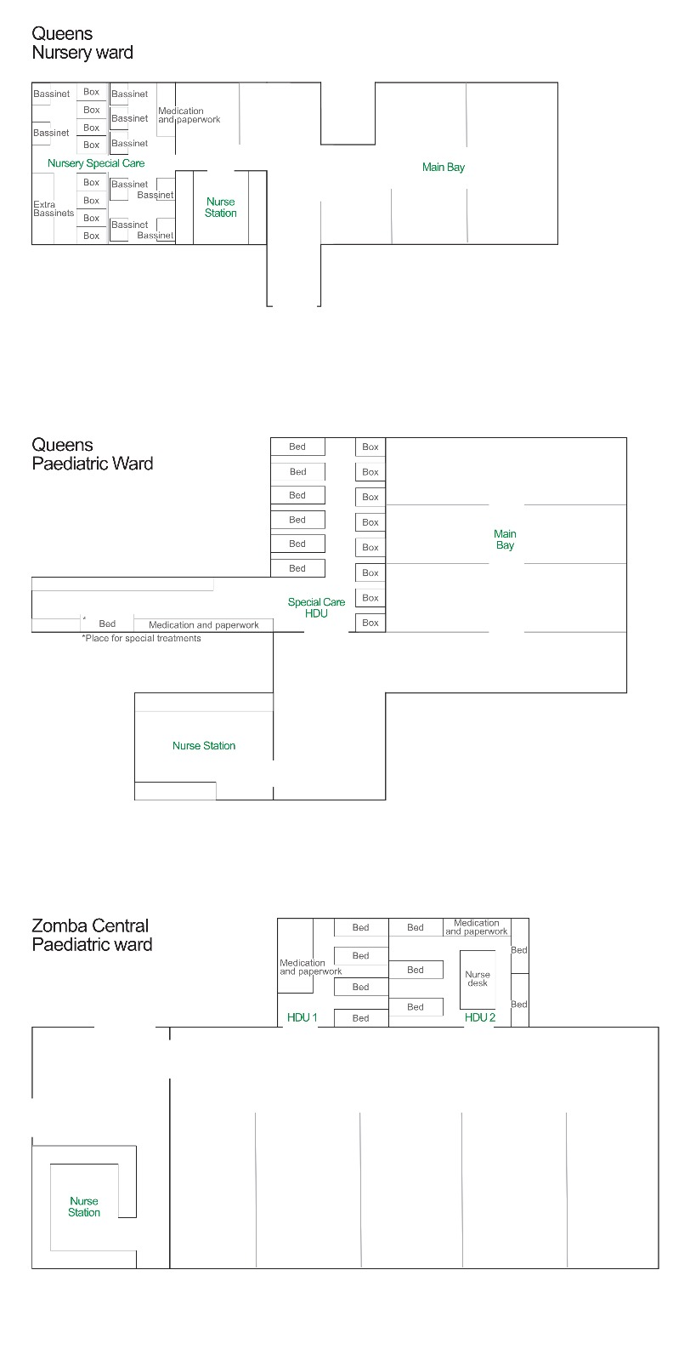
Figure S1. Floor plan of the paediatric high-dependency units at Queen Elizabeth Central Hospital.
A box can host up to three patients. A bassinet contains room for one to two patients. In the nursery ward, the focus is on providing medical care to newborns and young infants. The paediatrics ward is a dedicated area within a hospital that provides medical care to children and adolescents.
Figure S2. Floor plan of the high-dependency unit, part of the paediatrics department, at Zomba Central Hospital. Although meant for one patient, a single bed can accommodate up to three patients according to the needs of the ward.

Additional File 4 – Observation manual
Date |  |  | Start time | End time
 | 27-03 |  | 10.30 | 15.00 | Number | Comment
Staff | Nurses | Day shift |  |  | 4
 |  | Night shift
Patients | At ICU/HDU at 8am
 | Reason for admission

Nurse details
Job title
Gender
Years of experience (range 1-5, 5-10, >10 years)
Years at ward (range 1-5, 5-10, >10 years)

Measuring vitals | Frequency | Action taken
Blood pressure
Heart rate

Respiratory rate

Oxygen saturations
FiO2
GCS
Daily fluid balance

Time period | Situation outline | Interaction with documents/ technologies (type of information) | Examination | Response to perturbations (who responds to alarm or other indications of deterioration, decision-making process). | Communication with others | Other
07:30
08:00
(…)

Additional File 5 – Interview guide
Theme | Statements/questions
Background | Tell me about yourself:  Name , Age (range in decades)  Profession and Experience  - How long have you worked in your current role? (Give ranges)  - Have you done any other jobs as well?c  - What professional training have you done in the past?  Place of work?  - Type of hospital, capacity, amount of children per department
Workflow and workload | Can you elaborate on your work?  Describe your typical work day? (how long is a shift?)  How many other nurses are working with you in the same shift?  What type of patients do you take care of? What type of diseases/conditions are most common?  In your current role, how many patients are you typically responsible for at the same time?  How are these patients distributed between nurses during a shift? Who is taking care of the patients the most? Are there guardians present?  What tasks could take most of your time? What tasks could be organized more efficiently?  What is the total number of patients in your ward? How many of them are critical, how many are relatively healthy/stable?  How do you get an overview of your patients and the ward?
Monitors | Do you use the monitors? If not, why not?  Do you feel confident using the monitors?  Did you ever receive training using the monitors?  How do you decide which child should be attached to a monitor?

Theme | Statements/questions
Team work and handover | What is the total number of patients in your ward? How many of them are critical, how many are relatively healthy/stable?  How do you get an overview of your patients and the ward?
Identifying deterioration and responding to deterioration | How do you decide who to go to first? (To which patient are you going first?) / How do you decide which patients to take care of first?  How do you know if someone is getting more sick? What information do you use to decide which patients to take care of first? (Monitor, experience, nurse worry, other nurses?)  Can you explain your feelings about using a tool that predicts when a patient may need your help? What impact could it have on you, your colleagues and the patients?  Can you tell me about a time when you had to choose which patient to help first? How was that for you? Was there anything you needed but wasn’t there?  Do you get help from the parents/guardians? Do you get help from other staff? How do they let you know if someone is getting sicker?  Do you ever feel unaware of or uncertain about the situation of the patients in your care? Are there situations when you are not sure if a patient needs attention immediately, or when you doubt how to prioritise between patients that need care?  What other information would you like on the children’s condition? What if the information is presented that predicts if a patient is deteriorating?  According to your experience at the HDU, which predictions do you think are most useful clinically?  What are your thoughts on using a tool that predicts patients’ clinical deterioration, and in what ways do you think it could potentially assist you in your work?  Do you think the prediction can be wrong at one point? How would you handle this? How do you (want to) check if the prediction is correct?
Vital sign monitoring | What vital signs do you monitor?  Do you know about prediction tools?  -They use current data to tell you what might happen in the future, like how Netflix or YouTube suggests videos you might enjoy. In healthcare, these tools can help predict patient outcomes, like the chances of a problem happening or the likelihood of developing a certain illness.  According to your experience at the HDU, what should such a tool predict?  Have you ever heard of the Paediatric Early Warning Score?  - The Paediatric Early Warning Score (PEWS) is a tool used to assess the clinical status of a paediatric patient and identify any signs of deterioration or potential medical emergencies. As a starting nurse, understanding PEWS is important for recognizing when a patient may require urgent medical attention.  - The score should be calculated manually every few hours, although it does require some input from the monitor automatically. Mention that the higher the PEWS score the worse the patient is doing, with a score of 3 or higher the nurse should contact a doctor-  - The idea with the IMPALA system is the integration of a similar score (using the same type of information) in the monitoring system.  What are your thoughts on using a tool that predicts patients’ clinical deterioration, and in what ways do you think it could potentially assist you in your work?  Can you explain what you feel about using a tool that predicts when a patient may need your help? What impact could it have on you, your colleagues and the patients?  Do you think you would have sufficient time in your workday to examine the predictions generated by this tool?  Would you want the prediction tool to tell you which patient is at risk of getting worse, or do you also want the predictive tool to tell you why?  Do you think the prediction can be wrong at one point? How would you handle this? How do you (want to) check if the prediction is correct?

Additional File 6 – Consolidated criteria for reporting qualitative studies (COREQ): 32-item checklist
Developed from:
Tong A, Sainsbury P, Craig J. Consolidated criteria for reporting qualitative research (COREQ): a 32-item checklist for interviews and focus groups. International Journal for Quality in Health Care. 2007. Volume 19, Number 6: pp. 349 – 357

Item No |  | Guide Questions/Description | Reported on Page #
Domain 1: Research team and reflexivity
Personal Characteristics
1. Interviewer/ facilitator |  | Which author/s conducted the interview or focus group? | Pg 8/9
2. Credentials |  | What were the researcher’s credentials? E.g., PhD, MD | Pg 8/9
3. Occupation |  | What was their occupation at the time of the study? | Pg 8/9
4. Gender |  | Was the researcher male or female? | Pg 1
5. Experience and training |  | What experience or training did the researcher have? | Pg 8/9
Relationship with participants
6. Relationship established |  | Was a relationship established prior to study commencement? | N/A
7. Participant knowledge of the interviewer |  | What did the participants know about the researcher? e.g. personal goals, reasons for doing the research? | N/A
8. Interviewer characteristics |  | What characteristics were reported about the interviewer/facilitator? e.g. Bias, assumptions, reasons and interests in the research topic | Pg 8/9
 | Domain 2: study design
 | Theoretical framework
 | 9. Methodological orientation and Theory | What methodological orientation was stated to underpin the study? e.g. grounded theory, discourse analysis, ethnography, phenomenology, content analysis | Pg 7-9
 | Participant selection
 | 10. Sampling | How were participants selected? e.g., purposive, convenience, consecutive, snowball | Pg 6
 | 11. Method of approach | How were participants approached? e.g., face-to-face, telephone, mail, email | Pg 6
 | 12. Sample size | How many participants were in the study? | Pg 10-13
 | 13. Non-participation Setting | How many people refused to participate or dropped out? Reasons? | N/A
 | 14. Setting of data collection | Where was the data collected? e.g., home, clinic, workplace | Pg 5
 | 15. Presence of nonparticipants | Was anyone else present besides the participants and researchers? | N/A
 | 16. Description of sample | What are the important characteristics of the sample? e.g. demographic data, date | Table 1
 | Data collection |  |  |  | No
 | 17. Interview guide | Were questions, prompts, and guides provided by the authors? Was it pilot tested? | Supp. 5
 | 18. Repeat interviews | Were repeat interviews carried out? If yes, how many? | N/A
 | 19. Audio/visual recording | Did the research use audio or visual recording to collect the data? | Pg 8/9
 | 20. Field notes | Were field notes made during and/or after the interview or focus group? | N/A
 | 21. Duration | What was the duration of the interviews or focus group? | Pg. 8
 | 22. Data saturation | Was data saturation discussed? | Pg. 8
 | 23. Transcripts returned | Were transcripts returned to participants for comment and/or correction? | N/A
 | Domain 3: analysis and findings
 | Data analysis
 | 24. Number of data coders | How many data coders coded the data? | Pg. 8/9
 | 25. Description of the coding tree | Did the authors provide a description of the coding tree? | N/A
 | 26. Derivation of themes | Were themes identified in advance or derived from the data? | Pg. 8/9
 | 27. Software | What software, if applicable, was used to manage the data? | Pg. 8
 | 28. Participant checking | Did participants provide feedback on the findings? | N/A
 | Reporting
 | 29. Quotations presented | Were participant quotations presented to illustrate the themes/findings? Was each quotation identified? e.g., participant number | Table 2
 | 30. Data and findings consistent | Was there consistency between the data presented and the findings? | Pg 10-13
 | 31. Clarity of major themes | Were major themes clearly presented in the findings? | Pg 10-13
 | 32. Clarity of minor themes | Is there a description of diverse cases or a discussion of minor themes? | Pg 10-13

Additional File 7 – Co-design questionnaire
Risk representation
Explanation of risk prediction:
Predictive monitoring is a technique used to anticipate and prevent potential health issues or complications before they happen. It involves collecting and analysing patient data to make predictions about their future health conditions.
For each visualization, please rank 1 to 4, with 1 being the most desirable and 4 being the least desirable. Please also fill in points you would give the visual, ranging from 10 when you like it, to 1, when you don’t like it at all.
If you have further remarks, please mention them, this can be done either in English or Chichewa.
 | Ranking | Point | Remarks


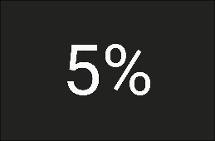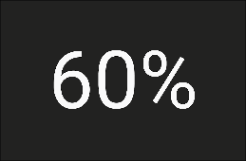



Explainability
Explanation of scoring:
The early warning score should be calculated manually every few hours, although it does require some input from the monitor automatically. The scores assigned to each criterion are added up to generate an overall score, which can help healthcare providers identify children who may be deteriorating and require more intensive monitoring or interventions.
The higher the score, the greater the concern for the patient's condition. Max score = 10.
For each visualization, please rank 1 to 4, with 1 being the most desirable and 4 being the least desirable. Please also fill in points you would give the visual, ranging from 10 when you like it, to 1, when you don’t like it at all.
If you have further remarks, please mention them, this can be done either in English or Chichewa.
 | Ranking | Point | Remarks

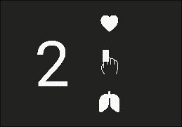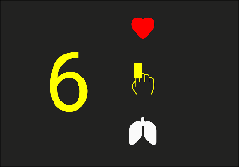
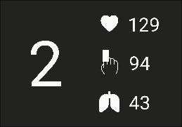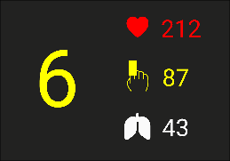
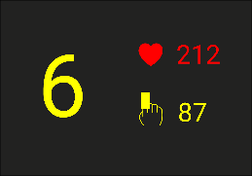

Representation of changes in the score
Explanation of change of score:
The change in score is a way to see if a patient's health is getting better or worse over time. The examples below all represent a patient whose score went from 4 to 6, so an increase of 2. This increase in score means that the patient is deteriorating.
For each visualization, please rank 1 to 4, with 1 being the most desirable and 4 being the least desirable. Please also fill in points you would give the visual, ranging from 10 when you like it, to 1, when you don’t like it at all.
If you have further remarks, please mention them, this can be done either in English or Chichewa.
 | Ranking | Point | Remarks






Prediction options
For each option, please rank 1 to 4, with 1 being the most desirable and 4 being the least desirable. Please also fill in points you would give the visual, ranging from 10 when you like it, to 1, when you don’t like it at all.
If you have further remarks, please mention them, this can be done either in English or Chichewa.
 | Ranking | Point | Remarks
Discharge Algorithms
These algorithms are designed to assist healthcare providers in determining when a patient is ready to be discharged from the ward/hospital.
Treatment Algorithms
These algorithms are used to monitor patients for signs of clinical deterioration or worsening health.
Deterioration Algorithms
These algorithms provide step-by-step guidance on the selection and management of treatment options for specific medical conditions or diseases.
Diagnostic Algorithms
These algorithms help healthcare providers in screening patients for specific conditions or diseases and determining the most likely diagnosis.

Additional File 8 – Codebook
Theme | Code | Code Definition
Workflow and workload | Nurse to patient ratio | The ratio of nurses to patients within the ward.
Workflow and workload | Tasks and responsibilities | The duties and obligations assigned to nurses, including patient care, administration, and communication tasks.
Workflow and workload | Staff shortages | The insufficient availability of nursing staff to meet patient care demands.
Prioritisation | Clinical experience | The level of practical knowledge and experience that informs nurses' ability to determine patient care priorities.
Prioritisation | Prioritisation elements | Factors considered by nurses when prioritising patient care, such as patient condition and available resources.
Prioritisation | Clinical judgement | Nurses’ ability to assess and make decisions based on clinical knowledge, experience, and patient-specific information.
Interaction with guardians | Guardian’s involvement in care | The extent to which guardians (family or caregivers) are included in the patient’s care by nurses.
Interaction with guardians | Guardian’s knowledge | The level of understanding that guardians have about the patient’s condition and care, as assessed or communicated by nurses.
Perspective on predictive algorithms | Baseline knowledge | Nurses’ initial understanding and familiarity with predictive algorithms and their potential uses in patient care.
Perspective on predictive algorithms | Support clinical decision-making | The extent to which predictive algorithms assist nurses in making informed care decisions, such as identifying at-risk patients.
Perspective on predictive algorithms | Preventive intervention and early detection | Using predictive algorithms to help nurses anticipate potential health issues early for timely intervention.
Perspective on predictive algorithms | Trust, transparency and traceability | Ensuring that predictive algorithms used in nursing are understandable, transparent, and inspire trust among nursing staff.
Perspective on predictive algorithms | Preferences - prediction option | Nurses' preferences regarding the type and format of predictive information provided for patient care.
Perspective on predictive algorithms | Preferences - location | Nurses' preferences on where predictive algorithm interventions or monitoring should be implemented (e.g., at bedside, in clinics).
Perspective on predictive algorithms | Guardians’ involvement | The ways nurses want guardians’ to be involved in the use of predictive tools or data-driven insights.

Additional File 9 – Final design proposal
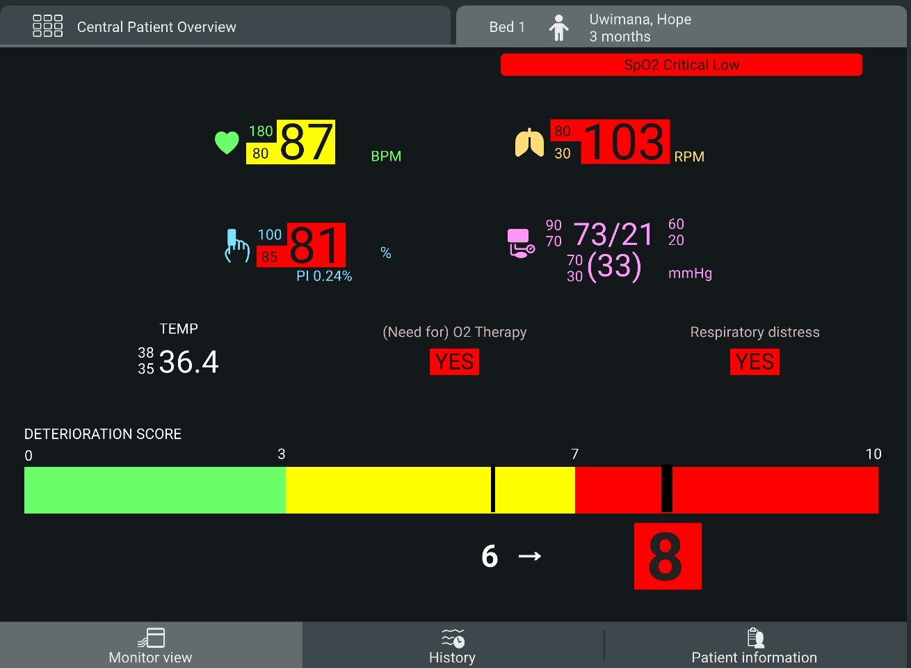
  - Risk representation
Nurses expressed a preference for a color code that included not only red and green but also intermediate colors. Additionally, we opted to display the numbers on the bar ranging from 0 to 10.
  - Representation of score input
We decided to color the score input when values exceed the threshold. This allows for easy identification of areas where scores have increased, providing insight into the factors influencing the algorithm.
  - Representation of changes in the score
Nurses reported a greater understanding of the arrow that indicated the previous score and the current score.

Harold S. Stone. Introduction to Computer Organization and Data Structures. McGraw-Hill, Inc.Professional Book Group; 1971.

