Supplementary
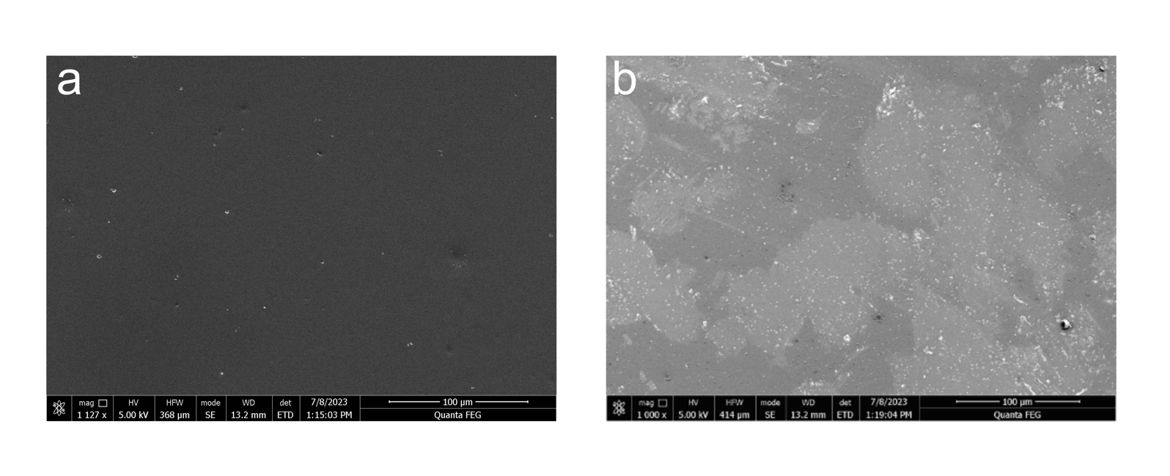

Supplementary Figure S1. SEM Surface Microscopy (a) Bare Nafion NR-211 surface showing no distinguishing features on surface (b) Nafion NR-211 surface immediately after 10 nm BN deposition showing islands on surface, showing surface roughening caused by pulsed laser deposition plasma plume. The surface is also observed to be markedly lighter, suggesting successful deposition of insulating BN layer. Differences in contrast on surface are attributed to inhomogeneities of deposition on the surface.
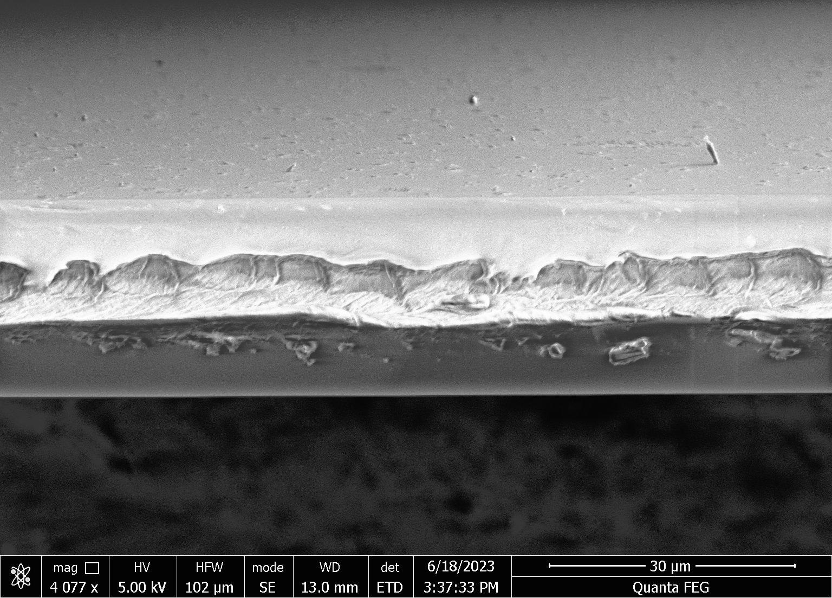

Supplementary Figure S2. X-Section SEM Image of Nafion surface after 10nm BN deposition. The surface of the Nafion post-deposition is seen to be roughened due to the plasma plume of the BN deposition system. This effect is purely on the deposition surface- the backside, also visible in this image, does not show similar morphology.
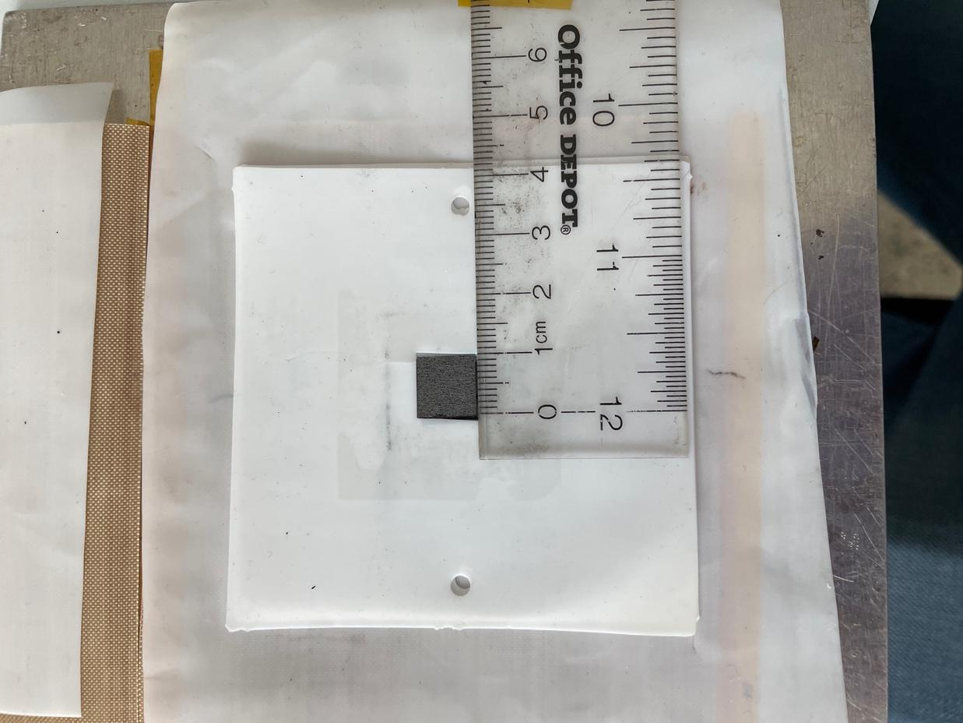
Supplementary Figure S3. Photograph of 1cm² pressed cell.

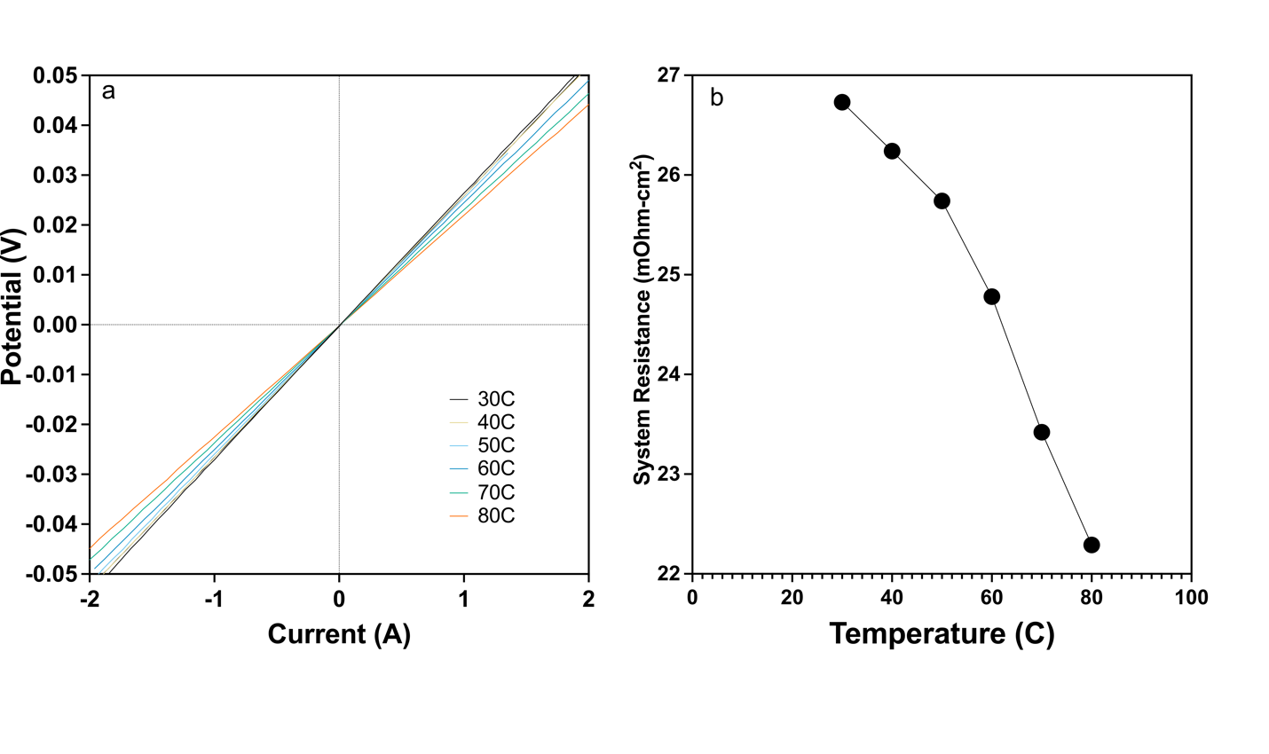
Supplementary Figure S4. System Resistances by Temperature. The fuel cell tester was set up with all components except the membrane, under constant N₂ flow (0.125 lpm anode and cathode) and tested to extract the system resistance. (a) The I-V curves of the fuel cell tester with all lead resistances, and GDE resistances. (b) Resistance extracted from each curve, to then be subtracted from the cell resistance from electrochemical testing.

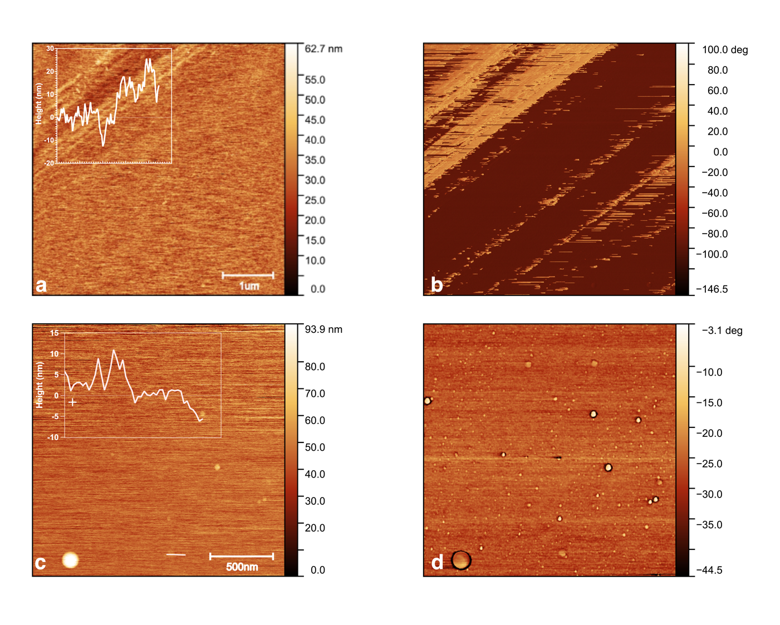
Supplementary Figure S5. AFM and Phase Contrast Image of 10 nm (a/b) and 2nm (c/d) BN on Si.

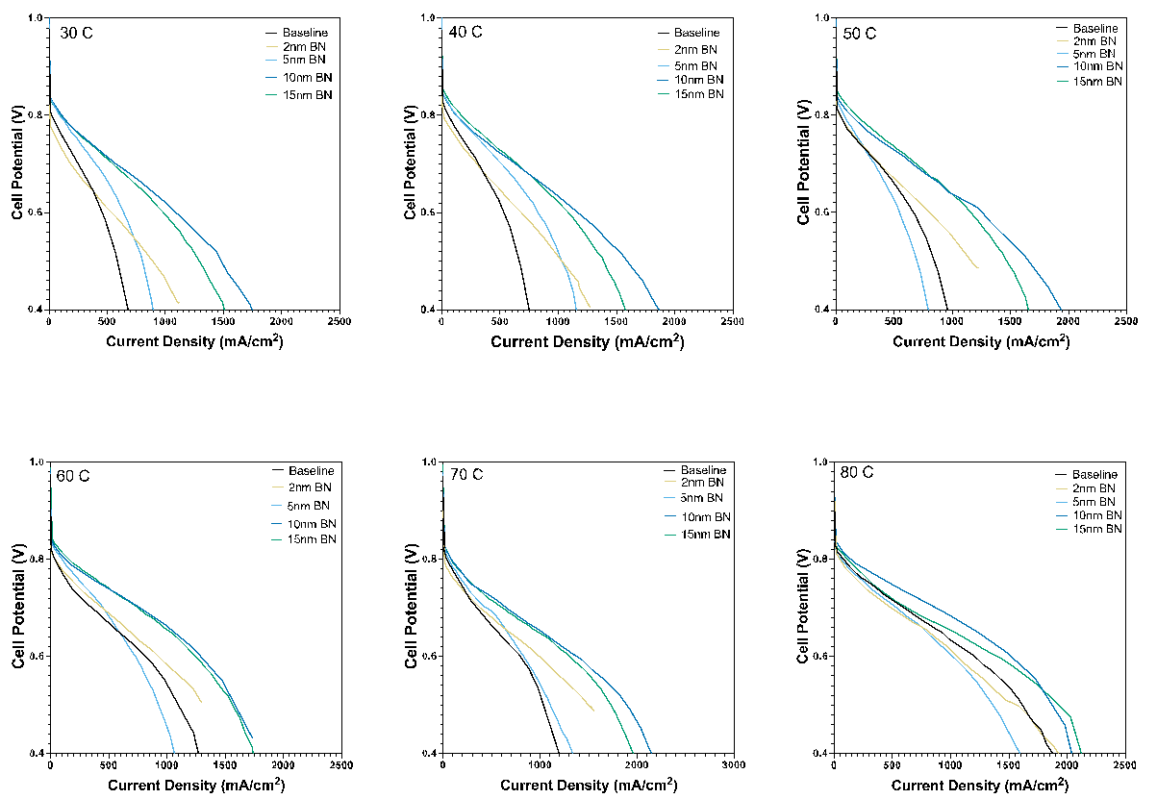
Supplementary Figure S6. Polarization Curves at Varying Temperatures.
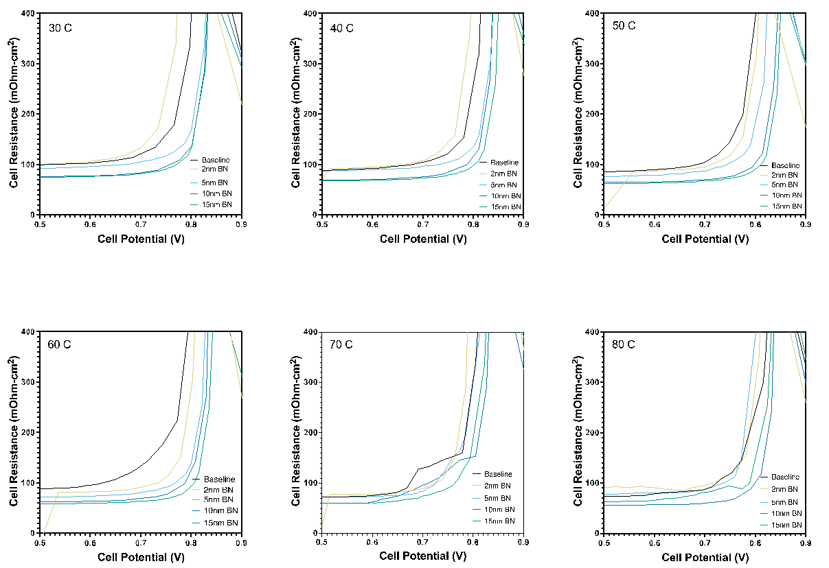
Supplementary Figure S7. Cell Resistance by Potential

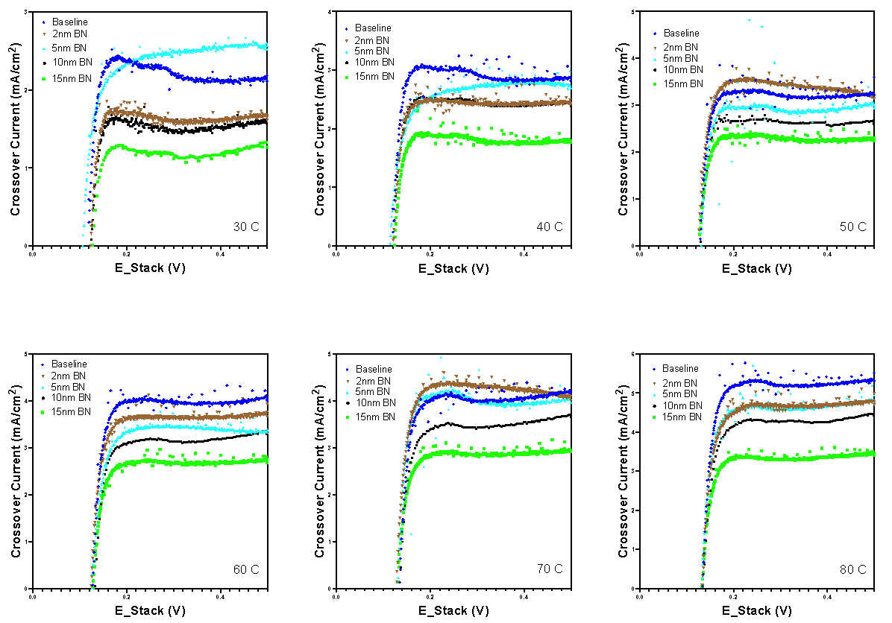
Supplementary Figure S8. Linear Sweep Voltammetry Crossover Data.

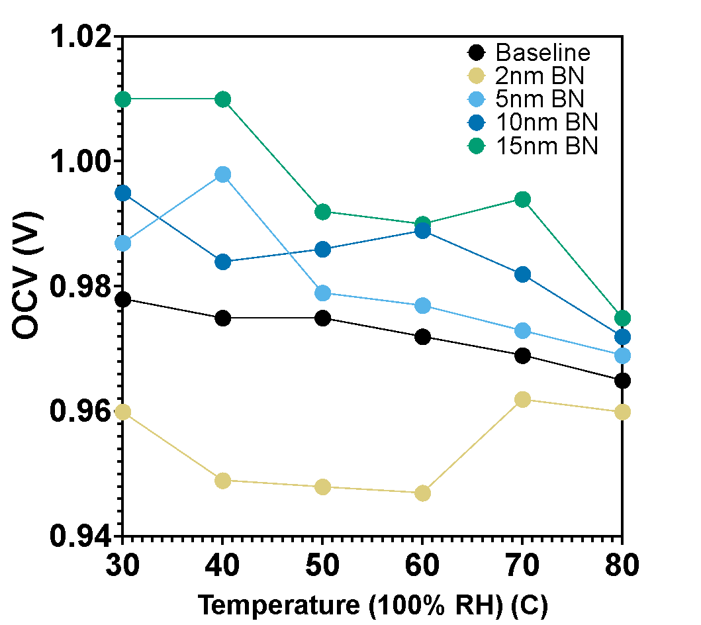
Supplementary Figure S9. OCV Trends. The OCV increases steadily from the baseline values across temperatures for the 5nm, 10nm, and 15nm layers, another indicator of crossover reduction. The 2nm layer consistently showed a decrease in OCV across temperatures, likely due to the incomplete layer showing heterogeneous contact between electrodes and the membrane surface.

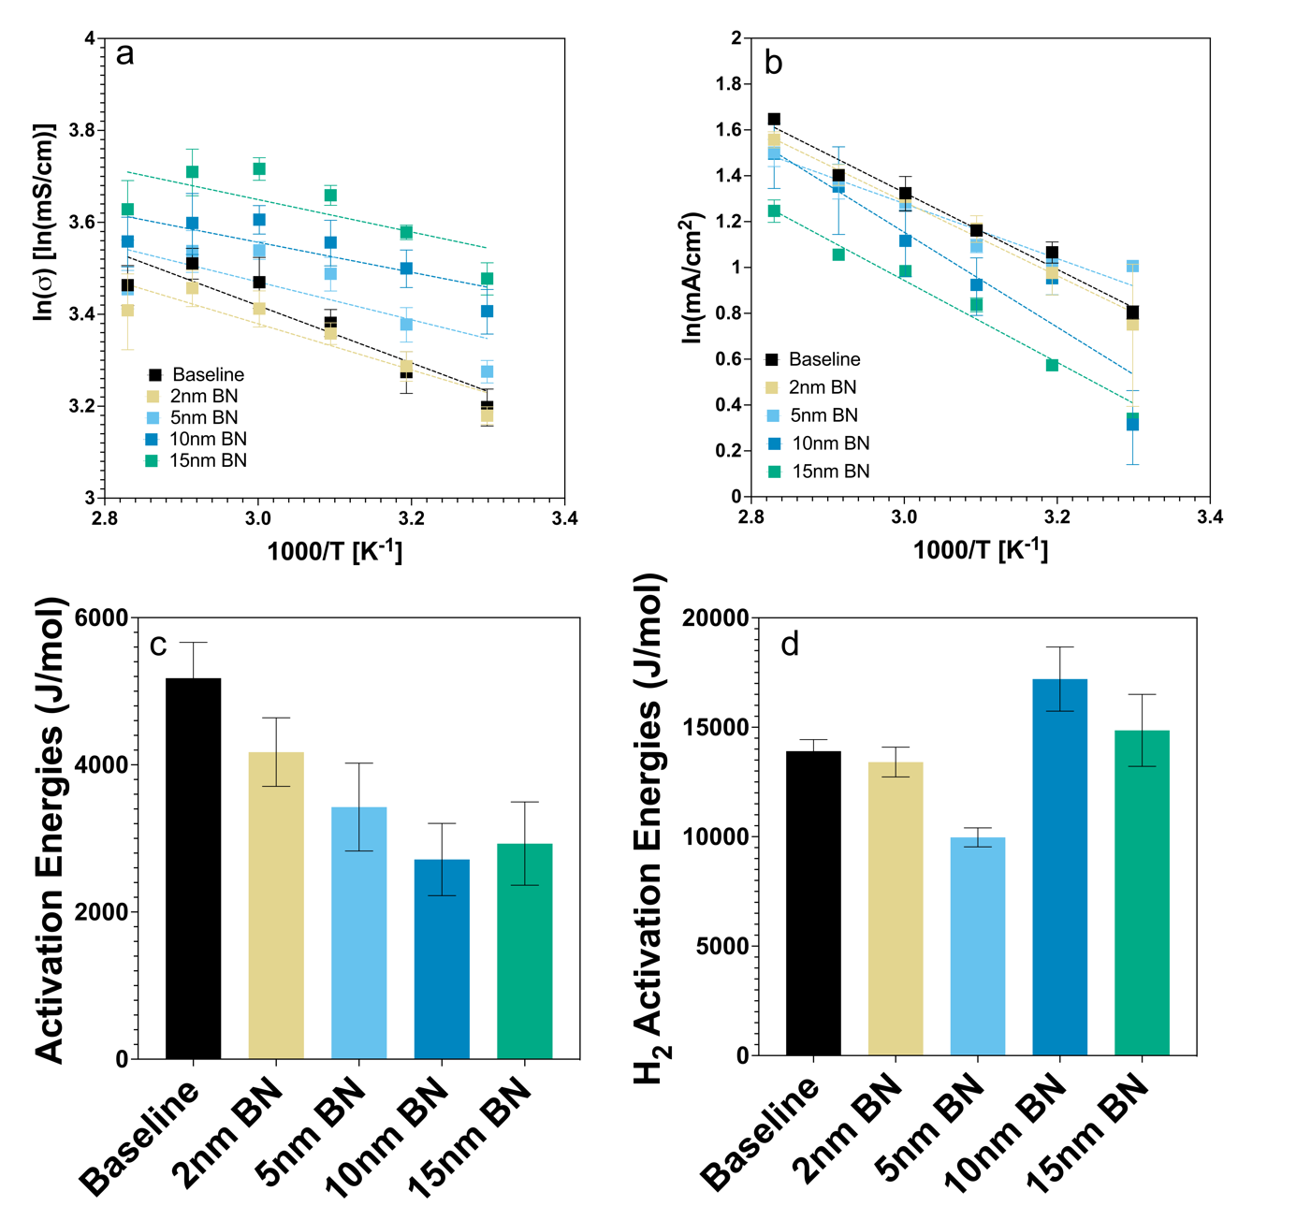

Supplementary Figure S10. Estimation of Activation Energies. Arrhenius fits of the (a) conductivity and (b) crossover values are provided. An estimation of activation energies for (c) proton and (d) H₂ transport are provided, showing the significantly larger barrier to H₂ transport with the PLD BN, while facilitating proton transport.

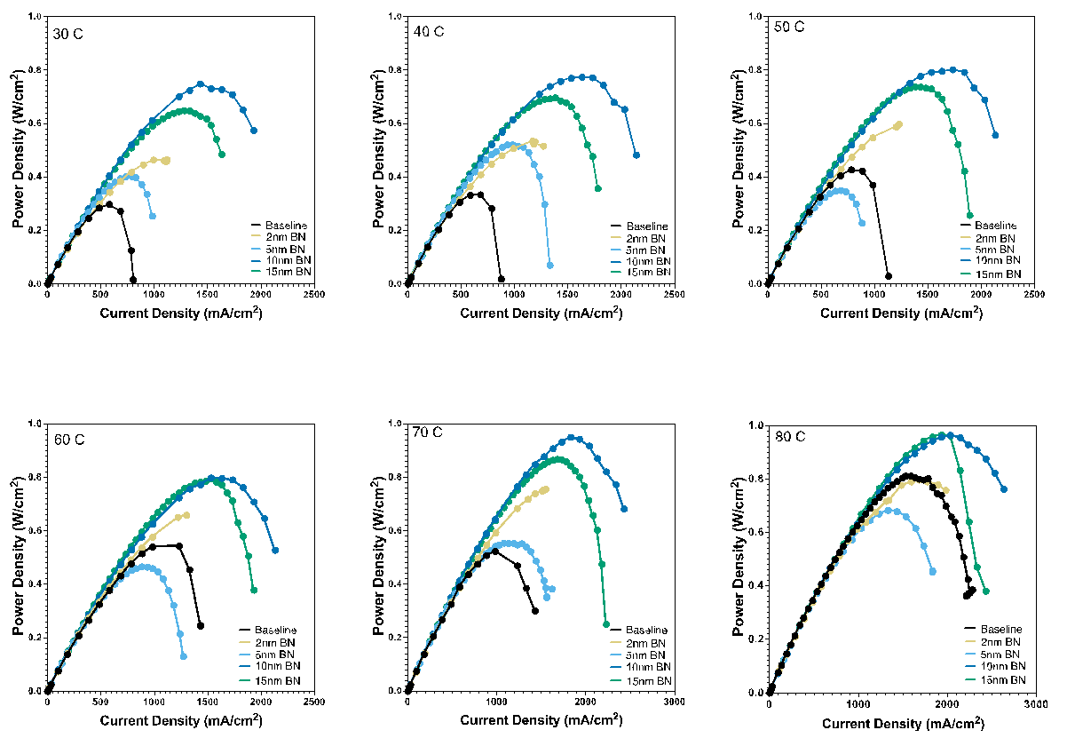
Supplementary Figure S11. Cell Power Density Output

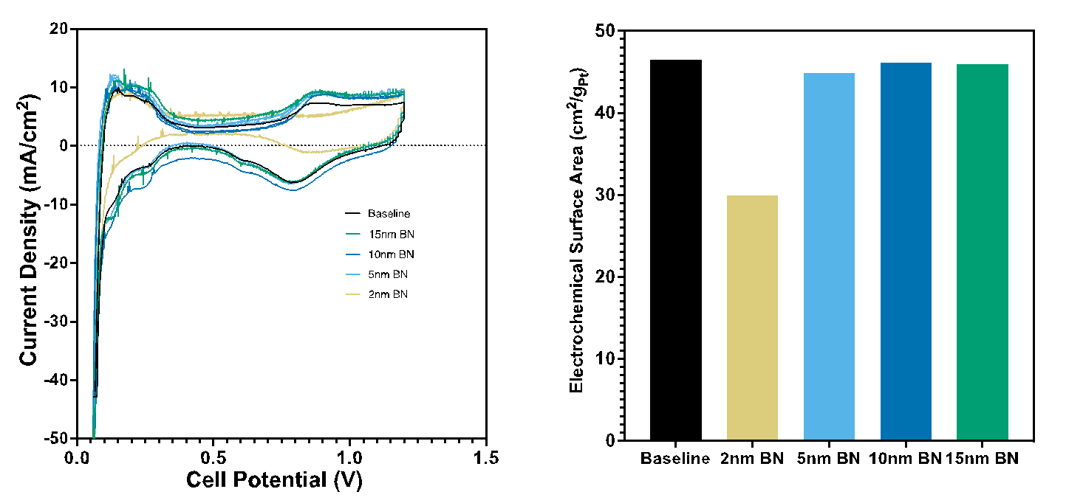
Supplementary Figure S12. Electrochemically Available Surface Area (ECSA). The 2nm layer, likely due to its incomplete and heterogeneous coverage, shows lower catalyst accessibility. The thicker layers show no appreciable ECSA differences.

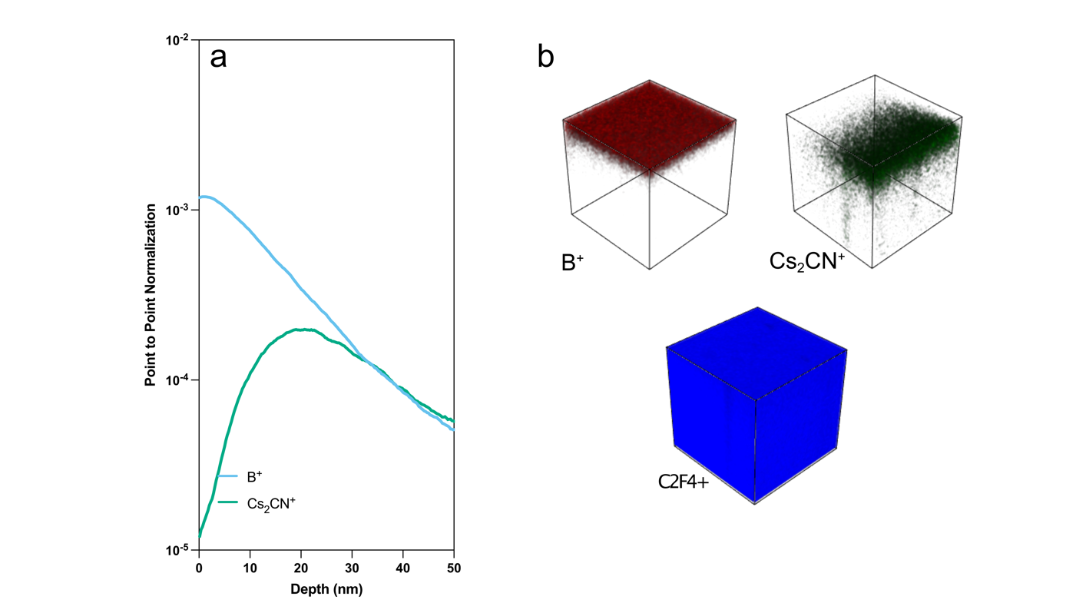
Supplementary Figure S13. ToF-SIMS Data for 2nm BN. (a)The depth of nitrogen implantation is seen to be over 20nm into the Nafion, while the boron remains at the surface as BN up to 2nm. (b) The surface coverage is observed as an incomplete layer. The nitrogen is seen to be noncomplete coverage, suggesting that the source of the 2nm BN MEA’s poor performance is a heterogenous sample surface after pressing as compared to the thicker layers.

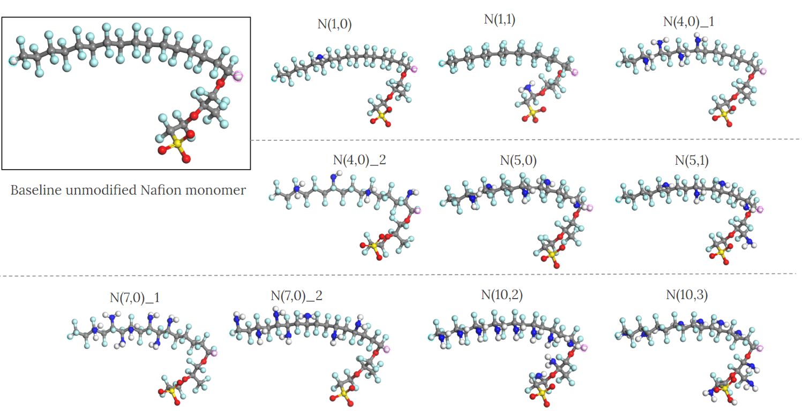

Supplementary Figure S14. The monomers of the nitrogen functionalized Nafion polymer variants simulated in this study.

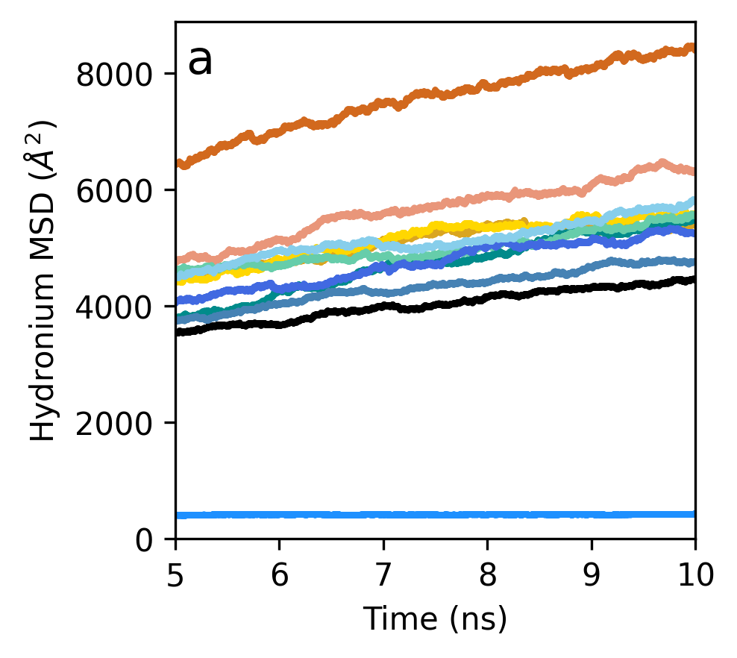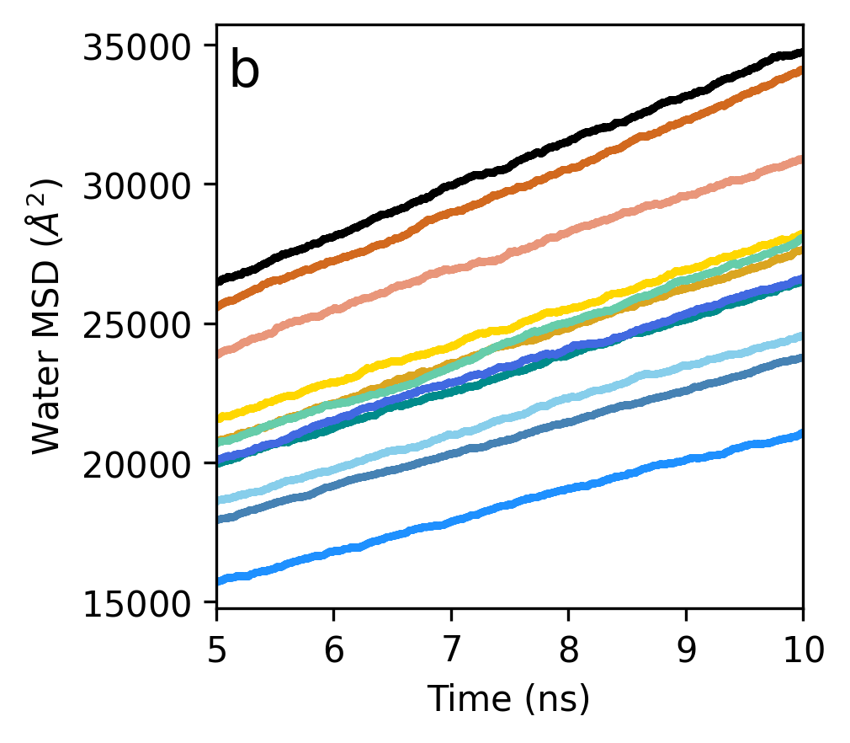
Supplementary Figure S15. Mean-squared displacement (MSD) of a) hydronium ion and b) water molecule for last 5ns of production run.
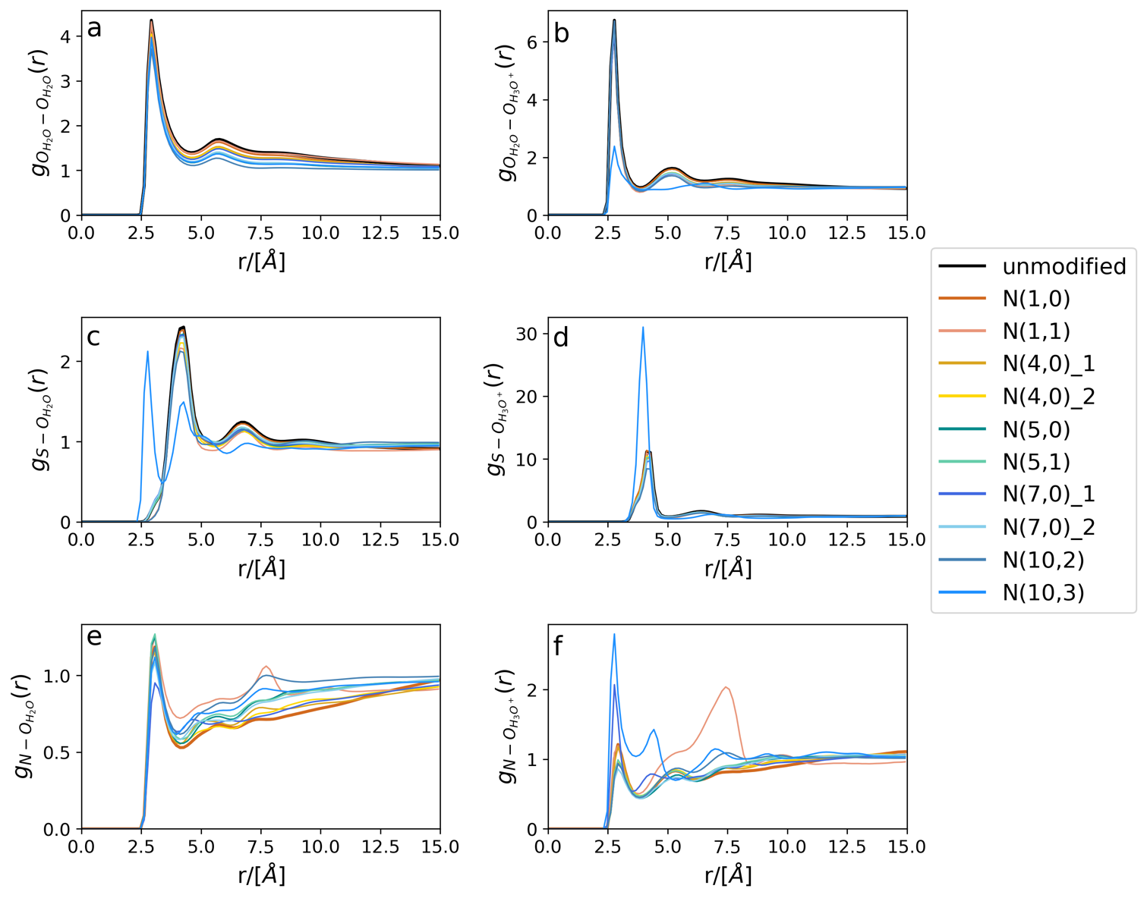
Supplementary Figure S16. Radial distribution function plots. a) water - water b) water - hydronium c) sulfur - water d) sulfur – hydronium e) nitrogen – water f) nitrogen – hydronium.

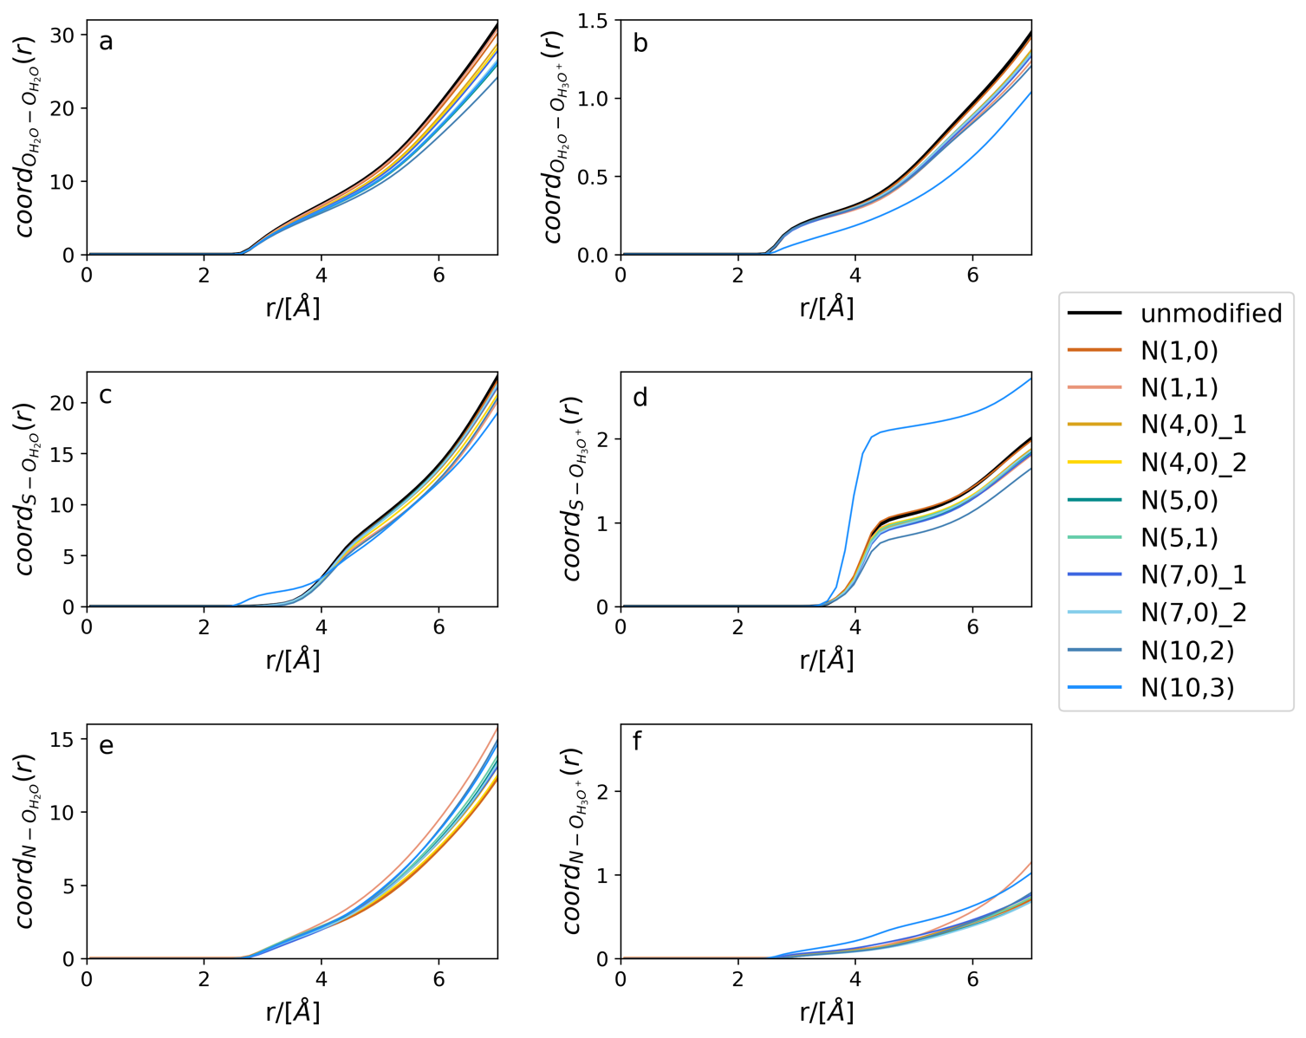
Supplementary Figure S17. Coordination number plots. a) water - water b) water - hydronium c) sulfur - water d) sulfur – hydronium e) nitrogen – water f) nitrogen – hydronium.

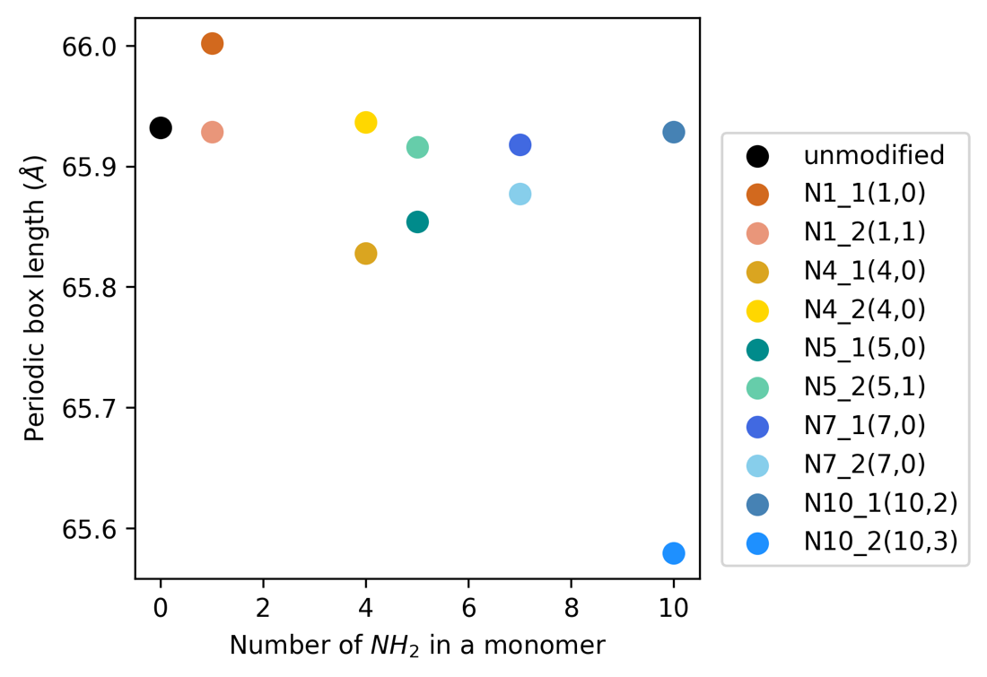
Supplementary Figure S18. Simulation box length at the end of the equilibration step.

