Supplementary Material

High Costs of GHG Abatement with Electrifying the Light-Duty Vehicle Fleet with Heterogeneous Preferences of Vehicle Consumers

Jia Zhong, Madhu Khanna, Kalai Ramea

BEPAM-V is a partial equilibrium, open economy, multi-period model of the agricultural, transportation and electricity sectors with a vehicle choice module. The green boxes below describe exogenously specified determinants of demand in the three sectors. The agricultural and electricity sectors assume a nationally representative consumer with a downward-sloping demand curve. The transportation sector (including the fuel sector and vehicle choice module) considers heterogeneous consumers that differ in their driving characteristics, vehicle stock ages, geographical location, access to charging stations and idiosyncratic preferences. The yellow boxes indicate the costs of production (or the supply side of the model) in the three sectors. We assume that existing policies in the fuel and electricity sector (the Renewable Fuel Standard and the Renewable Portfolio Standard) prevail and analyze the effects of alternative policy scenarios related to EVs in the transportation sector. The model endogenously determines the equilibrium prices and quantities in the three sectors, the mix of vehicles in new sales and in the vehicle stock that maximize the present value of the social welfare in the three sectors subject to technology, material balance and policy constraint in each policy scenario. We compare the change in social welfare and greenhouse gas emissions in each policy scenario relative to the baseline scenario and determine the welfare cost of abatement.
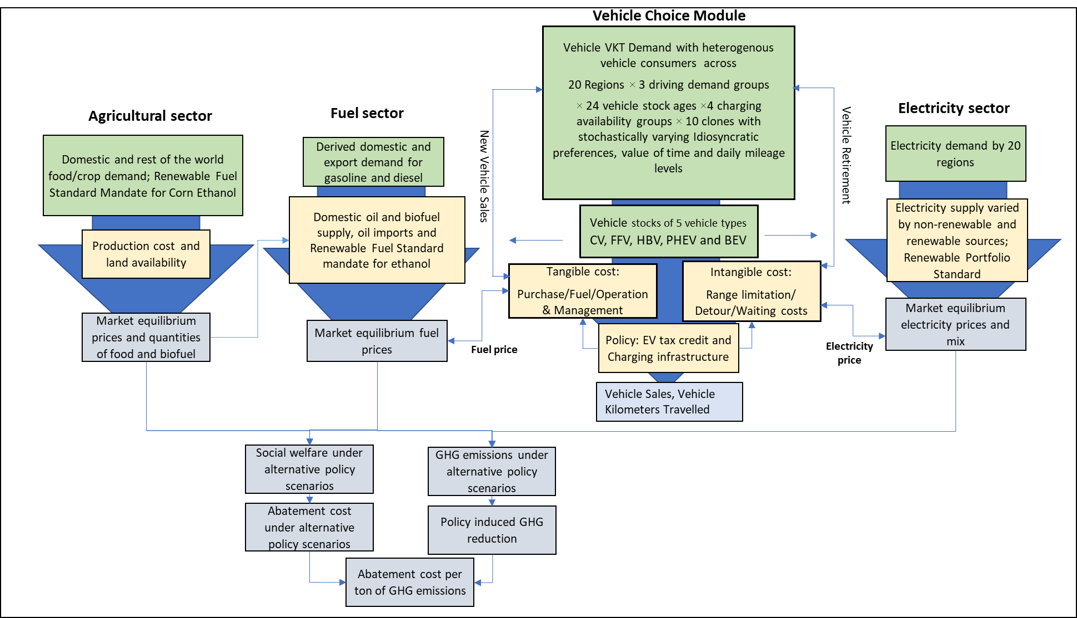
Figure A1: Biofuel and Environmental Policy Analysis Model with Vehicle Choice (BEPAM-V)

The four scenarios simulated here are listed in Table A2 to examine the policy effectiveness of two policies independently and jointly relative to the baseline scenario: 1) Clean Vehicle (EV) Tax Credit and 2) increased access to public charging stations.
Table A2: Policy Scenarios
Scenarios | Description
Baseline Scenario | - Phase out of EV tax credit since 2016 (A.3)  - Number of charging stations increase at 2% annually without policy support (EIA 2019)
Policy Scenario 1 | - Phase out of EV tax credit since 2016 (A.3)  - Increasing availability of public charging to 0.5 million charging stations nationwide by 2030
Policy Scenario 2 | - EV Tax Credit increased to $7500  - Number of charging stations increase at 2% annually without policy support (EIA 2019)
Policy Scenario 3 | - EV Tax Credit increased to $7500  - Increasing availability of public charging to 0.5 million charging stations nationwide by 2030

Benchmark case assumptions underlying in BEPAM model: Corn ethanol mandate maintained at 54 billion liters (15 B gallons) over 2022-2030; Binding state RPSs over 2022-2030 in all states; Intangible costs and idiosyncratic preferences included
Alternative cases for sensitivity analysis:
Case 1: Similar assumptions as in the Benchmark case but corn ethanol mandate maintained at 10% blend rate over 2022-2030 instead of the volumetric level of 54 billion liters of corn ethanol;
Case 2: Similar assumptions as in the Benchmark case but only tangible costs of vehicles were included without considering the intangible costs.

A.1 Mathematical Representation of the Biofuel and Environmental Policy Analysis Model with Vehicle Choice (BEPAM-V)
We describe the mathematical representation of the model objective function below. For convenience, we use lowercase symbols to denote the exogenous parameters and uppercase symbols to represent endogenously determined variables. We first describe the objective function to maximize social welfare in Section A.1.1 subject to the constraints in Section A.1.2. The transportation sector module is specified for 5,760 heterogeneous consumers by vehicle age groups by driving demand with different availability of chargers by regions, and the vehicle owners/buyers are subject to representative costs of vehicle kilometer traveled (VKT) of different fuel types and mix that vary spatially for battery electric vehicles. We apply Monte Carlo methods to generate ten clones of each of the 5,760 types of consumers that differ in the intangible costs. Model runs are conducted for each clone of the 5760 types of consumers separately and the model is run ten times for each policy scenario to determine vehicle choices by each clone. These choices are averaged over the ten clones and used to determine derived demand for fuel and VKT in each of the 20 regions and then aggregated to the national level. The electricity sector has exogenously given downward sloping demand for electricity in each of the 20 electricity marketing regions in the US. The agricultural sector has downward sloping demand curves for major field crops, secondary agricultural products, and livestock products. We now describe the objective function and constraints, the intangible and tangible costs of BEVs, and the methods for randomly generating clones.
- Objective Function
The objective function is the sum of discounted consumers’ and producers’ surpluses obtained from production, consumption and international trade in the transportation fuel, electric power, and agriculture sectors over a planning horizon of T years with w representing the social discount rate, and the terminal values of vehicles and land in year T. The algebraic expression is given in equation (1). The first six lines in equation (1) include the consumer and producer surpluses of the transportation sector; the next four lines from line 7 to 10 show consumer and producer surpluses of the electricity sector developed in Oliver and Khanna (2017); the lines 11 to 15 describe the welfare of the agriculture sector (as in Ferin et al. 2021; Chen et al., 2021). The last two terms are the terminal values of vehicle and land at the end of study period in year T. The notation for variables, parameters, and subscripts. is described in Table A.8.
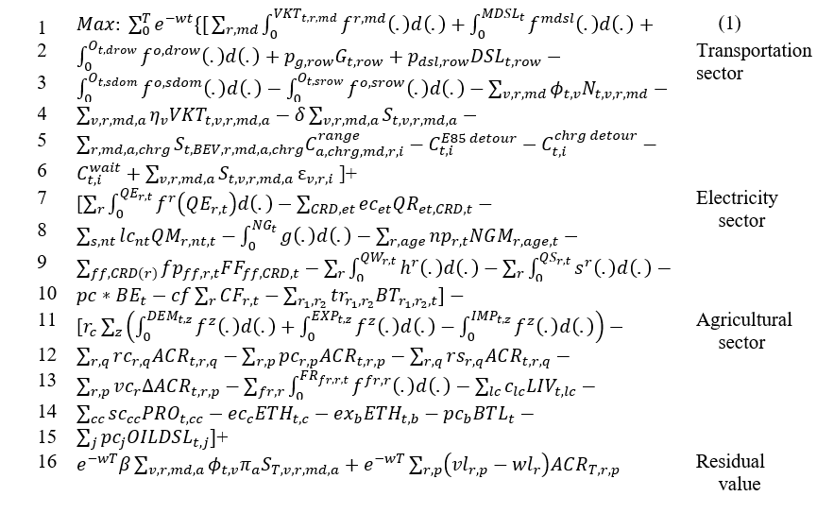

A.1.1.1 Transportation Sector
The first integral term in the first line of (1) represents the area under the inverse demand function for aggregated kilometers traveled (VKT) from which consumers’ surplus is derived. Each integral is associated with a region and driving demand group. ${VKT}_{t,r,md}$ denotes the endogenous variable of vehicle kilometers traveled by driving demand groups denoted as md= {high, medium, low} of region r in year t; $f^{r,md}(.)$ denotes the inverse demand function for the VKT in each region r and driving demand group md; and d(.) denotes the integration variable. We construct the VKT demand functions $f^{r,md}(.)$ for light-duty vehicles by disaggregating the total national VKT demand defined in the BEPAM (Chen et al. 2021) into twenty regions (r) defined by Khanna et al. (2021) each with its own distinct demand and supply conditions based on the Highway Statistics. The regions are aggregations of states that are part of 20 electricity market regions (EMR) in the US (as defined in Oliver and Khanna (2017). The three driving demand groups (md) are identified based on their annual driving behavior from the 2017 National Household Travel Survey (NHTS). The low driving demand group includes the vehicles driving less than 8,000 miles per year; the vehicles in the medium group drive on average between 8,000 and 16,000 miles per year; and the high driving demand group has yearly demand of more than 16,000 miles.
The medium- or heavy-duty trucks consume diesel and have a separate VKT demand function $f^{mdsl}(.)$ in the second integral term of the first line, which denotes the area under the inverse demand function for VKT for diesel vehicles (denoted by $MDSL_{t}$). We do not consider alternative fuel options for heavy-duty truck sectors because there is limited alternative powertrain option available currently in the medium- or heavy-duty vehicle market. The demand functions for kilometers traveled and rest of the equation (1) are all characterized by linear demand functions, but other functional forms, such as constant elasticity demand functions, can be incorporated without difficulty.
The first integral term in the second line represents the area under the inverse demand function $f^{o,drow}\left(.\right)$ for crude oil consumed ($O_{t,drow}$) by the rest of the world (drow denotes the demand for the rest of the world) . The next two items in the second line show the economic benefit from exporting the liquid petroleum product of gasoline G and diesel DSL to the rest of the world (ROW). The parameters $p_{g,row}$ and $p_{d,row}$denote the world price of gasoline and diesel.

The first integral term in line 3 denotes the area under the inverse supply function of the domestic crude oil (denoted by $O_{t,sdom}$), where sdom is domestic supply. The second term is the ROW oil producer surplus with the area under the inverse supply function for crude oil domestically produced (denoted by $O_{t,srow}$), where srow is ROW supply. Then the next term is the sum of vehicle purchase cost by multiplying the newly purchased vehicle $N_{t,v,r,md}$ at year t of vehicle type v in region r with driving demand group md and the vehicle prices $ϕ$ are in unit of $ per vehicle. Consumers have choices of five vehicle engine types: Conventional vehicles (CVs), Flex-fuel vehicles (FFVs), Hybrid vehicles (HBVs), Plug-in-hybrid electric vehicles (PHEVs) and Battery electric vehicles (BEVs). CV, HBV, and PHEV (under charge-sustaining mode) drive on conventional fuel (currently with 10% ethanol blend E10); BEV and PHEV that partially run under charge-depleting mode on electricity; FFV is capable of using any mix of ethanol-gasoline blends of E10 and E85 (higher ethanol blend of 53% to 74%).

The first term in the fourth line is the operation and maintenance cost (η_{v} $ per mile varying by vehicle type) and multiplied by the miles driven${VKT}_{t,v,r,md,a}$ of vehicle type v at age a of driving demand group md in region r at year t. The second term is the annual vehicle registration cost by multiplying δ $ per year per vehicle with the vehicle stock of vehicle type v at age a of driving demand group md in region r at time t ($S_{t,v,r,md,a}$).

In the fifth line, we define two types of inconvenience costs: range limitation ($C_{t,a, chrg, md,r,i}^{range}$) for each BEV in use in region r of driving demand group md with vehicle age a, with charging type chrg (with four choices of home, work, both chargers or none) ($S_{t,BEV,r,md,a, chrg}$) and detour costs for FFV and BEV ($C_{t,i}^{E85 detour}$, $C_{t,i}^{chrg detour}$). We calculate the range limitation cost $C_{t,a, chrg, md,r,i}^{range}$ as extra cost of reaching destination when battery dies to meet an individual’s driving demand for each driving demand group md , vehicle age a, region r at time t with probabilistic choice of daily VKT drawn from a daily kilometers distribution with subscript i denoting each clone i. The details are given in A.1.4.1. The detour cost with FFV and BEV ($C_{t,i}^{E85 detour}$ and $C_{t,i}^{chrg detour}$) in the fifth line is defined as the time cost needed to reach to the nearest station for charging or fueling E85 fuels for BEV and FFV, which is further discussed in A.1.4.3. We draw random number for each clone i from a distribution of income to represent value of time for transportation and multiply it with the time needed for the detour to quantify the monetary value of time for each clone.
The first term in the last line of the transportation sector bracket is the waiting cost ($C_{t,i}^{wait}$) defined as the time spent at charging stations waiting for a BEV to recharge, which is further discussed in A.1.4.2. We use the randomly drawn value from the distribution of income to calculate the monetary value of the waiting cost for clone i each year. Lastly, we represent the idiosyncratic preference of each clone for each of the vehicle fuel types by constructing and calibrating the error terms that reflect the unobserved variable that affects the preferences or purchase decision in the random utility framework. The constructed stochastic terms $ε_{v,r,i}$ represent the idiosyncratic heterogeneity in the consumers’ preference of each unit of vehicle type v of each region r and is obtained by a random draw i from the calibrated Gumble distribution derived from standard error terms by Ramea et al. (2018). They are included in the welfare function after being multiplied by the total amount of vehicles in stock. We discuss the source and calibration of the terms considering the substitution pattern across the fuel types and the spatial variation considered over the region by using the Google trend data in section A.1.5.

A.1.1.2 Electricity Sector
Lines 7 to 10 in Equation 1 represent the consumer and producer surplus in the electricity sector module (as in Oliver and Khanna 2017 for details). The first integral term in the seventh line represents the area under the inverse demand curve for electricity. The choice variable $QE_{er,t}$ is the quantity of electricity consumed in electricity market regions (EMR) r in year t from all energy sources. $f^{r}\left(.\right)$ is the inverse demand function for electricity in EMR r. The next term is a summation that represents the variable operation and maintenance (O&M) cost for electricity generation from existing coal and natural gas power plants and co-firing biomass with coal. The parameter $ec_{et}$ is the O&M cost for electricity generated from technology type et and the variable $QR_{et,CRD,t}$ represents the electricity generated from technology type et in year t. The supply of electricity resources is represented at a crop reporting districts (CRD) level; with each CRD representing an aggregation of multiple counties The technology types used for electricity generation include coal, natural gas, oil, nuclear, and renewable sources of hydro-electricity, wind, solar, and bioelectricity. The model generates electricity from existing power plants and allows new power plants to be established using natural gas as well as renewable sources.
The first term in the eighth line represents the levelized cost of electricity generation from new power plants. The parameter $lc_{nt}$ is the levelized cost of generating electricity from a new power plant with technology type nt (nt is a subset of et) and the choice variable $QM_{r,nt,t}$ is the quantity of electricity generated in region r from a new power plant with technology type nt in year t. The next term in the eighth line represents the area under the national supply curve for natural gas. The endogenous variable $NG_{t}$ is the quantity of natural gas used to produce electricity for all regions in year t and the function $g\left(.\right)$ represents the supply curve for natural gas. The next term is the regional transmission and distribution costs of natural gas for electric power region. The parameter $np_{r,t}$ is the transmission and distribution cost per unit of natural gas by region $r$ in year $t$ and the endogenous variable $NGM_{r,age,t}$ is the quantity of natural gas used in region $r$ for power plants with type $age∈\left\{exisitng,new\right\}$ in year t.
The first term in the ninth line is the fuel cost of power plants that consume coal or fuel oil to generate electricity. The parameter $fp_{ff,r,t}$ denotes the fuel cost for fuel type $ff∈\left\{coal,fuel oil\right\}$, in region r, year t, and the variable $FF_{ff,CRD,t}$ is the quantity of fuel type ff used for electricity generation in CRD , year t. The second term represents the area under the supply curve for electricity generated from new wind capacity. The choice variable $QW_{r,t}$ is the quantity of electricity generated from new wind capacity in region r in year t. The functions $h^{r}\left(.\right)$ are the supply curves for new wind generation in region r. The third term calculates the area under the supply curve for electricity generated from new solar capacity. The choice variable $QS_{r,t}$ is the quantity of electricity generated from new solar capacity in region r in year t. The functions $s^{r}\left(.\right)$ are the supply curves for new solar generation in region r.
The first term in the tenth line represents the processing costs of cellulosic biomass for power generation at either a dedicated biomass-based power plant or co-fired at a coal power plant. The parameter pc is the unit processing cost and the variable $BE_{t}$ is the quantity of biomass used to generate electricity in year t. The next term represents the cost of retrofitting a coal power plant for co-firing. The parameter cf is the cost of retrofitting a MW of coal plant capacity for co-firing and the variable $CF_{r,t}$ is the amount of capacity converted for co-firing in region r. The very last term of the electricity sector represents the transportation cost of biomass for electricity generation. The parameter $tr_{r_{1},r_{2}}$ is the per-metric ton cost of transporting biomass from CRD $r_{1}$ to CRD $r_{2}$ and the variable $BT_{r_{1},r_{2},t}$ is the quantity of biomass transported from CRD $r_{1}$ to CRD $r_{2}$ in year $t$.

A.1.1.3 Agriculture Sector
Lines 11 to 15 in Equation 1 represent the consumer and producer surplus in the various crop and livestock, processed commodity markets in the agricultural sector (as in Chen et al. 2021). The first integral term in the eleventh line of (1) represents the areas under the demand functions from which consumers’ surplus is derived. Each integral is associated with a crop, livestock, or processed commodity for which domestic market demand is considered: $DEM_{t,z}$ denotes the endogenous domestic demand variable in year t; z =(cc,j,lc) denotes the index set for crop commodities (cc), processed products from crops (j), and livestock commodities (lc); $f^{z}(.)$ denotes the inverse demand function for the associated commodity. The next two integral terms account for the areas under the inverse demand functions for exports, $EXP_{t,z}$ and the areas under the import supply functions, $IMP_{t,z}$ (such as sugar).

In the twelfth line, the first two terms include the production costs of row crops, perennial crops, and collecting crop and forest residues for biofuel and electricity production. The land allocated to row crops and perennial crops (acreage) in region r and year t is denoted by $ACR_{t,r,q}$ and $ACR_{t,r,p}$, respectively. The production of row crops may use one of various production practices, denoted by q, which differ by crop rotation, tillage, and irrigation. Parameters denoting the production costs of row and perennial crops are ${rc}_{r,q}$ and $pc_{r,p}$. Leontief production functions are assumed for both row crops and perennial crops production. The next term represents the cost of collecting crop residues, such as corn stover and wheat straw, and we use $rs_{r,q}$ to denote the collection costs of crop residues.

The first term in the thirteenth line denotes the costs of converting marginal lands (such as idle land and crop pasture land) for producing perennial crops, which include costs of land clearing, wind rowing and any necessary activities for seedbed preparation. The amount of marginal lands converted for perennial grasses are denoted by $ΔACR_{t,r,p}$ and $vc_{r}$ represents the conversion cost per unit of marginal land. The second term represents the area underneath the regional-specific supply functions of forest residues and pulpwood $(FR_{fr,r,t})$, where fr is a set consisting of forest residues and pulpwood. The last term in thirteenth line includes the costs associated with livestock activities, where $c_{lc}$ denotes the cost per unit of livestock category lc (again employing Leontief production functions), which is assumed to be the same across all regions. Variable $LIV_{t,lc}$ represents the quantity of livestock lc processed in year t.

The first term of the fourteenth line represents the total cost of converting primary crops (corn, soybeans, sugarcane and sugar beet) to secondary (processed) commodities (oils, soymeal, refined sugar, and HFCS). The amount of processed primary crop cc in year t is denoted by $P{RO}_{t,cc}$, and $sc_{cc}$ denotes the processing cost per unit. The next two terms represent the processing costs of corn and cellulosic ethanol in the refinery, namely $E{TH}_{t,c}$ and $E{TH}_{t,b}$, followed by two terms representing the processing costs of biodiesel produced from biomass (denoted by $BTL_{t}$) and vegetable oils (denoted by $OILDSL_{t,j}$).

A.1.1.4 Terminal Value of Vehicles and Land
Finally, the last two terms of equation 1 in line 16 represent the depreciated scrappage value of the vehicles still drivable before reaching the assumed age span of 24 years and by the end of the simulation period T, as well as the remaining economic life of standing perennial grasses. In terms of the scrappage value of vehicles, the coefficient β represents the vehicle market value loss once the vehicle leaves the dealer lot (85% in this study). The depreciation factor 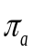 is caused by aging problems after a years of wear and tear (National Automobile Dealers Association, 2014). These multipliers are applied to the original purchase price at $ϕ_{t,v}$ of each powertrain v at year t. The very last term of the last line reflects the value of the remaining economic life of standing perennial grasses beyond the planning period T, denoted by ${vl}_{r,p}$, net of the return from the most profitable cropping alternative in region r, denoted by ${wl}_{r}$. The latter is used to account for the opportunity cost of land.

- Constraints
The demand for vehicle kilometers driven (VK$T_{t,v,r,md,a}$) of liquid fuel-based vehicles type v with driving demand group of md of vehicle age a in region r at time t is met by driving and consuming fuels of blended fuel of gasoline and ethanol formulated in equation 2 below, where $E_{t,v}$ and $G_{t,v}$ represent the consumption of ethanol and gasoline for each type of vehicle and $γ_{t,v,a}$ is the fuel efficiency (kilometers per liter). Ethanol is assumed to be substitutes of gasoline, with per liter of ethanol providing two-thirds energy of per liter of gasoline. $κ_{v}$ ($≤100\%)$is the utility factor of a duel-fuel plug-in hybrid vehicle, representing the percentage of kilometers driven on liquid fuels. Similarly, in equation 3, the number of kilometers driven by electrified vehicles ($VKT_{t,v,r,md,a})$ depends on electricity consumption $QEV_{t,v,r,a}$ and fuel economy $γ_{t,v,a}$ as well as the percentage of vehicle running on the electricity $\left(1-κ_{v}\right)$ of electric vehicles type v with driving demand group of md of vehicle age a in region r at time t. We use a multiplier of 40% for $κ_{v}$, representing the VKT driven in the charging-depleting mode for the PHEV based on Bradley and Davis (2011). Finally, in equation 4, the total driving demand of each region and driving behavior group can be met by the driving choices among five vehicle powertrains across all ages.

$$κ_{v}\sum_{r,md}{VKT_{t,v,r,md,a}}=γ_{t,v,a}\left[\frac{2}{3}{ETH}_{t,v}+G_{t,v}\right]$$
$$∀t,a, v∈\{CV,FFV,HEV,PHEV\}$$
$$\left(1-κ_{v}\right)\sum_{md}{{VKT}_{t,v,r,md,a}}=γ_{t,v,a}QEV_{t,v,r,a} ∀t, v∈\{PHEV, BEV\}$$
$$\sum_{v,a}{{VKT}_{t,v,r,md,a}}= {VKT}_{t,r,md} ∀t, r,md$$

The vehicle stocks ($S_{t,v,r,md,a}$) for each powertrain at age a and time t determine the maximum kilometers the fleet capable of running with the assumption of maximum annual kilometers ($m_{a,md}^{cap}$) displayed in Figure A2 in equation 5. Equation 6 defines the turnover of the existing vehicle fleet (age greater than 1) should be greater than the amount of vehicle stock from the previous year t-1 at age a-1 discount at the functional retirement rate (z_{a}) considering the possible early retirement. We follow the vehicle scrappage rate by age (z_{a}) (Belzowski et al. 2010) to let vehicles retire at a rate of z due to functional reasons of wear and tear for all five powertrains. The numbers of new vehicle purchases (N), existing vehicle fleet (S), and yearly kilometers driven (${VKT}_{t,v,r,md,a}$) are endogenously determined by the model. The vehicle fleet dynamics enables the update of the age distribution simultaneously with the solution of newly purchased vehicles and retired vehicles.
$$S_{t,v,r,md,a}×m_{a,md}^{cap}≥{VKT}_{t,v,r,md,a} ∀t,v,md,a$$
$$S_{t,v,r,md,a}≥S_{t-1,v,r,md,a-1}×z_{a-1} ∀ 2≤a≤24,T≥t≥2$$
- Data

A.1.3.1: Vehicle and Driving Demand
The annual kilometers driven per vehicle ($m_{a,md}^{cap}$ in equation 5) by vehicle age and the vehicle count by vehicle age are shown in Figure A1 and Figure A2. Due to the lack of driving information for alternative vehicles and for simplicity, we assume that the maximum annual mileage driven by alternative vehicles (FFV, PHEV, HEV, and BEV) are the same as the majority of vehicle owners represented in the NHTS.

Figure A2a The Annual Kilometers Demand by each Driving Group Across Vehicle Ages (NHTS, 2017)

Figure A2b Vehicle Count Probability Distribution in Age and Driving Demand group (NHTS, 2017)

We quantify vehicle stocks by fuel types v, driving behavior group md, vehicle age a in each region r in 2016 as the starting point of the study period. The count of vehicle stock by fuel type is obtained from EIA (2019). The age distribution of the conventional vehicle (CV) is from NHTS (FHA, 2017); and those of other alternative fuel vehicles are from Transportation Energy Data Book (Davis and Boundy 2018). The spatial distribution by state of current vehicle stock, primary CV, is from Highway Statistics Series (Federal Highway Administration 2016). We assume HBV spatial distribution is proportionally the same as CV. The spatial distribution of FFVs is from IHS; and PHEV and BEV distributions are assumed to be the same with each other across states based on the vehicle registration reported by NREL (2016). We assume that vehicle age and spatial distributions are independent, and thus the multiplication of the above distribution provides the joint distribution by fuel type, age, and region. We then aggregate the vehicle stocks of the 55 states to the 20 electricity market regions (EMR) modeled in the BEPAM (Oliver et al. 2017).

A.1.3.2: Vehicle Ownership Cost
The purchase price (denoted as $ϕ_{t,v}$ in equation 1) of new vehicles of each of the five types is obtained from Annual Energy Outlook (EIA, 2019) and is calculated by weighing the market share estimated by AEO of each vehicle class defined by AEO from 2016 to 2050. AEO developed the National Energy Modeling System (NEM) to forecast future transportation energy consumption. The data in Figure A3 showed that except for BEVs whose price is expected to decline with reduced battery costs (BloombergNEF 2019), the prices for the other vehicles are projected to slightly increase mainly due to the inflation.

Figure A3 Vehicle Purchase Costs in 2016 Dollars.
The annual operating and maintenance costs per mile (denoted by $η_{v}$) are from Alternative Fuels Data Center (2020) for each powertrain separately. We assume FFV has the same operational cost as CV, and PHEV has the same operational cost as HBV. Other operating costs (denoted as $δ$) including the yearly vehicle registration, insurance, and license costs are summed up at $1,616 per vehicle and assumed to be same across vehicles from the American Automobile Association (AAA).
We construct the fuel economy (denoted by $γ_{t,v,a}$ in equation 2) of each vehicle type v at age a at time t. The first-year fuel economy of the existing conventional vehicle is calibrated based on the data from (Federal Highway Administration 2016a) in 2016. We use the fuel efficiencies from the alternative fuel data center (DOE 2017) for alternative fuel vehicles (FFV, HBV, PHEV, and BEV). The efficiency of PHEV is defined separately for charge-depleting mode (all-electric) and charge-sustaining mode (only on gasoline). The efficiencies of the future vehicles from 2020 onward are from the AEO 2021, in which all vehicles comply with the Corporate Fuel Efficiency Standard (US Energy Information Administration 2019). We apply a discount rate of 70% to the future fuel economy $γ_{t,v,a}$ based on the EPA report (US EPA, 2016) that the realized fuel economy of the fleet is 70% of the CAFE standard specified numbers.
Table A3 Specification of Light-Duty Vehicle in 2016.
Vehicle type | Energy sources | Fuel efficiency  (miles per gasoline equivalent gallon) | Average purchase price  ($) | Operational and  maintenance costs  ($ per mile) | Carbon intensity (g CO₂ per mile)
CV | E10 | 20 | 25,720 | 0.068 | 370
FFV | E10, E85 | 19 | 25,750 | 0.068 | 310
HBV | E10 | 33 | 32,400 | 0.070 | 254
PHEV | E10, Electricity | 35, 85 | 39,700 | 0.070 | 117
BEV | Electricity | 90 | 51,500 | 0.066 | 0.002

- Intangible Cost
We now elaborate on the construction of inconvenience costs of range limitation cost, waiting cost, and detour costs of lines 5 and 6 of equation 1 in this section.

A.1.4.1 Range Limitation Cost
The total range limitation cost at the national level ($\sum_{r,md,a,chrg}{S_{t,BEV,r,md,a,chrg}C_{a, chrg, md,r,i}^{range}}$ in line 5 of the objective function of equation 1) is the total cost per vehicle ($C_{a, chrg, md,r,i}^{range}$) times the total stock of the vehicles by demand group, region, vehicle age, and charging groups. The $C_{a, chrg, md,r,i}^{range}$ is quantified by the cost of using alternative transportation plans to meet an individual’s driving demand (or to reach their destination) when BEV runs out of battery (Lin et al. 2012).
The total range limitation cost is quantified by multiplying a conservative $20 per day that could cover the costs of ride-hailing service or car rental to reach the destination to the estimated number of days in a year (${Days}_{a, chrg, md,r,i}$) an EV owner will run out of battery that driving demand exceeds the range provided by the available chargers from a stochastic process (in equation 7). The number of days (${Days}_{a, chrg, md,r,i}$) is counted when randomly drawn VKT driving demand X_{days,md,i,t} from the daily kilometers demand distribution (shown in Figure A4) exceeds the effective battery range supported by the available charger in equation 9. We generate the daily VKT driving demand distribution with Gamma distributions for each of the three driving demand groups with the mean and variance of the annual kilometers driven for each group obtained from NHTS (2017). The Gamma distributions (in Figure A4) show that peaks of the distribution cluster to the left and the probability of driving more than 50 miles is relatively low (Lin et al. 2012; Ramea et al. 2018). The difference in driving behaviors between workday and weekend is not captured in this study.
$C_{range,a, chrg, md,r,i,t}={Days}_{a, chrg, md,r,i,t}×\$20/day$ ($/veh) chrg= {HW,H,W, Public}
${Days}_{a, chrg, md,r,i,t}=\sum_{day=1}^{365}{1(X_{day, md,i,t}>eVKT_{t,r})}$

Figure A4 The Gamma Distribution of the Daily Mileage Driven
The effective VKT of a vehicle (eVKT_{t,r} in equation 8) is defined as the sum of total VKT that can be achieved by charging the BEV at home (H) and/or at work (W) if available, and from public charging (k=regular L2 charger, fast charging) in region r at time t (equation 8). It sums up the effective range a vehicle can get from all possible charging options (at home, work, and public stops) and provides a conservative estimate of the total effective range of BEV in region r at time t.
$${eVKT}_{t,r}=\min\left(e_{H}{tc}_{H}Q_{H}/γ_{BEV,t},{ R}_{t}^{max}\right)+\min\left(e_{W}{tc}_{W}Q_{W}/γ_{BEV},{ R}_{t}^{max}\right) te +\min\left(\sum_{k}{e_{k}Q_{P,k,r}{tc}_{r,t}/γ_{BEV,t}},{ R}_{t}^{max}\right)$$
${tc}_{r,t}=(2×q_{r,t}^{P,L2}+min⁡(2,\frac{{ R}_{t}^{max}}{γ_{t}^{BEV}×50})×q_{r,t}^{P,DC})/(q_{r,t}^{P,L2}+q_{r,t}^{P,DC})$
The first term on the right-hand side of equation 9 of eVKT is the effective range obtained at home, in which e_{H} is the charging capacity of 6.6 kW for L2 charging portal for most home chargers, tc_{H} is the hours spent at the charging location (assuming 8 hours at home), and Q_{H} is the binary variable to decide whether or not to buy a home charger. The multiplication of the above term ($e_{H}{tc}_{H}Q_{H}$) is the total capacity (in kWh) of a BEV charged at home; this is then divided by $γ_{BEV,t}$ (kilometer per kWh) to get the effective VKT. We then take the minimum of the VKT that can be obtained from being charged at home and the range capacity ($R_{t}^{max}$) of a BEV since the BEV can not run beyond its charging capacity with a single charge. The maximum range with a full charge ($R_{t}^{max}$) is obtained from the sales-weighted average of BEVs options with ranges of 100 miles, 200 miles, and 300 miles from AEO (2019). The second term on the right-hand side of equation 9 is the effective range obtained at work, similarly from the charging capacity e_{W} (6.6 kW for L2 charging portal), charging time tc_{W} (assuming 8 hours at work), and Q_{W} binary input parameter of work charger ownership, and finally divided by $γ_{BEV,t}$ and then set a maximum to be at battery range capacity (${ R}_{t}^{max}$). Four possible charging availability combinations are considered besides the public charging: Home and Work (Q_{H}= Q_{W} =1), Home only (Q_{H}=1, Q_{W}=0), Work only (Q_{H}=0, Q_{W}=1), and none of the above (Q_{H}= Q_{W} =0). We assume as in Ramea et al. (2018) that of all BEV owners in 2016, 52% have home chargers and 5% have work chargers. Home chargers cost an extra $2,500 for consumers and the choice of installing a home charger after 2016 is endogenously determined and affects the eVKT of a BEV and home charger share in the year 2016 and onwards.
The third term on the right-hand side of equation 9 is the effective range obtained at public charging available, whose availability depends on the region r. Two types of public chargers are considered (denoted as k): regular charger L2 with 6.6 kW of charging capacity, and DC fast charger with 50 kW fast charging. Q_{P,t,r} is the public charger availability in percentage relative to gasoline stations, measured by the ratio of the numbers of public charging to the gasoline stations in each region r at time t based on Alternative Fuel Data Center and North American Industry Classification System(Figure A5). We assume that if the density is the same as gasoline stations, the charging option is always approachable and ready to obtain VKT from the public charging. The public stations and portals are assumed to increase at 2% annually without policy support, according to the AEO outlook (EIA 2019). The time spent at the charging station is the availability-weighted (Q) average of time required for regular Level 2 charger portal and DC fast-charging given in equation 10. It is assumed to be limited to a 2-hour duration for simplicity generally for both two types of public charging. Fast DC charging needs less time to fully charge an electric vehicle with a power capacity of 50 kW. Assuming the vehicle owner will most likely need charging when the battery state-of-charge (SOC) is 20% of full charge ($R_{t}^{max}$/$γ_{BEV}$ in kWh) and will stop charging at 80% of $R_{t}^{max}$, the time required in hours to get 60% of $R_{t}^{max}$ from fast charging is then divided by 50kW capacity of fast charger and becomes $min⁡(2,\frac{60\%{×R}^{max}/γ_{BEV}}{50})$, where the maximum charging hours are assumed cannot surpass 2 hours that reaches to the limit of patience waiting in the public.
We want to highlight the stochastic process in the quantification of range limitation to capture the behavioral characteristics, specifically pictured in Figure A4. Unlike the deterministic range limitation cost used by Kubendran (2016), we randomly pick daily kilometers ($VKT_{day,a, chrg, md,r,i}$ in equation 8) from the Gamma distribution of daily VKT for each day for 10 times, for each BEV owner i from daily VKT demand distribution by groups (md with low, medium, high driving demand) for vehicle aged a given different charge availability chrg (with 4 combination of home and work chargers) in 20 electric market regions r for 365 days every year (day). By randomly drawing the VKT from the distribution, we believe we generate a representative daily driving behavior for vehicle consumers in each region.

A.1.4.2 Waiting Cost
We define the waiting cost as the time spent at charging stations waiting for a BEV to charge, which is at the cost of the consumer surplus in the objective function (1) in line 6. The value of the waiting cost is obtained by multiplying the total number of visits, the probability of needing public charging ($P_{fix,chrg,t}$), the average time spent at the charging station (${tc}_{r,t}$) identical to the term defined in equation 10, and the value of time ($V_{i}^{t}$) defined in equation 11. We quantify the number of visits to the public charging needed by taking the total annual driving demand (VKT) divided by the range capacity of the vehicle ($R_{t}^{max}$). We calculate the probability of needing the public charging ($P_{fix,chrg,t}$) by using the daily VKT driving demand distribution when driving demand $X_{day, md,i,t}$ exceeds the effective VKT only obtained at home or work ${eVMT}_{chrg,t}^{fix}$ in equation 12. The effective VKT in equation 13 is different from equation 9 that the obtained VKT excludes those from public charging. That is because the effective VKT is now the VKT obtained from existing chargers other than public charging to determine the need for public charging.
$$C_{t,i}^{wait}=\sum_{r,md,a,chrg}{\frac{{VKT}_{t,BEV,r,md,a,chrg}}{R_{t}^{max}}}×P_{fix,chrg,t}×{tc}_{r,t}×V_{i,r,md,a,chrg,t}^{t}$$
$$P_{fix,chrg,t}\left(X_{day, md,i,t}>{eVKT}_{chrg,t}^{fix}\right)=1-\int_{0}^{{eVKT}_{chrg,t}^{fix}}{p\left(x\right)}dx$$
$${eVKT}_{t}^{fix}=\min\left(R_{t}^{max},e_{H}{tc}_{H}q_{H})+min⁡(R_{t}^{max},e_{W}{tc}_{W}q_{W}\right)$$
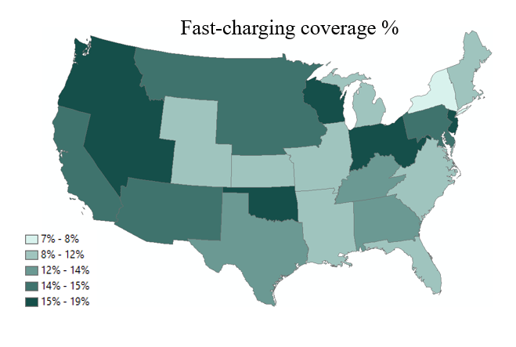 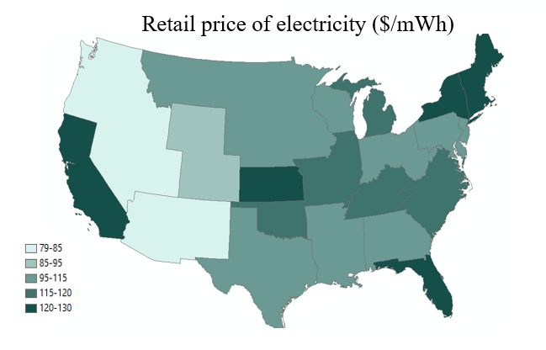Figure A5 The DC Fast-Charging Coverage Relative to Gasoline Station and Retail Price of Electricity Across the US in 2020
The value of time ($V_{i,r,md,a,chrg,t}^{t}$) is the opportunity cost of time spent on the road, which is found to be half of the income based on the DOT study (2015). The income distribution of the US population is from the Census Bureau (Semega, Fontenot and Kollar 2017), and we draw 10 clones or representative consumers (denotes as i) with driving demand group md, vehicle age a, with charging availability chrg, of time t in region r to represent the value of time across the US as part of Monte Carlo process. Though there are only 10 clones, the cloning strategy applied to the segmentation of the vehicle age, region, and charging availability for BEV enlarges the number of total drawings from the income distribution and should result in a reasonable representation of the US population.
We assume the plug-in hybrid vehicle (PHEV) owner has the option to use gasoline and thus will not spend any extra time in the public charging station or in making detours and that they have an accessible chargers either at home or at work for use on the charge-depleting mode. We, therefore, exclude the waiting costs from the PHEV ownership costs.

A.1.4.3 Detour Cost
Detour cost is defined as the time cost to find the nearest station to charge BEV or to add E85 fuels for FFV, which is included as cost of the consumer surplus in the objective function (1) in line 5. It is a function of the random draw of value of time ($V_{i,r,md,a,chrg,t}^{t}$ in $/hour) just discussed above in A.1.4.2, kilometers driven ($VKT$ in kilometers) , fuel efficiency (${ R}_{t,v}^{max}$ in mile per gallon), detour distance (${d_{detour}}_{r}$ in kilometers), probability of using public charging ($P_{fix,chrg,t}$) and average driving speed (32 mile per hour) used in Pouliot and Babcock (2014). We applied the linear form of the detour cost with respect to the detour distance.
$$C_{detour} =\sum_{v,r,md,a,chrg}{V_{i,r,md,a,chrg,t}^{t}}\frac{{VKT}_{t,v,r,md,a,chrg}}{{ R}_{t,v}^{max}}{d_{detour}}_{r}P_{fix,chrg,t}\frac{2×1.3 Euclidean coefficient}{32 mph}$$
$$=0.082×\sum_{v,r,md,a,chrg}{V_{i,r,md,a,chrg,t}^{t}}\frac{{VKT}_{t,v,r,md,a,chrg}}{{ R}_{t}^{max}}{d_{detour}}_{r}P_{fix,chrg,t}$$

where the $V_{i,r,md,a,chrg,t}^{t}$ is the value of the time defined in A.1.4.2; ${VKT}_{t,v,r,md,a,chrg}$ is the total yearly VKT driven of vehicle v of driving demand group md, vehicle age a, with charging availability chrg, of time t of region r that are endogenously determined by the model, divided by the maximum range of FFV with a full tank or BEV (${ R}_{t,v}^{max}$) to obtain the number of visits to public charging stations. $d_{detour,r}$ is the detour distance varying across region r. $P_{fix,chrg,t}$ is the same probability of visiting the public charging for BEV drivers defined in A.1.4.2, which is the probability of exceeding the effective VKT gained at home or work charging. Same as Pouliot (2014), we assume a representative car with a running speed of 32 miles per hour and 1.3 Euclidean coefficient for the round trip (multiplied by 2), and that will reduce the detour cost for BEV to be equation 15. Whereas the range capacity of FFV is the full tank of fuel (assumed to be 16.2 gallons as Pouliot (2014) times the fuel efficiency $γ_{FFV}$, and the probability of needing a public charging is always 1. The total detour price of E85 is then reduced to equation 16. Equations 15 and 16 roughly show that the detour cost would be more expensive for FFV E85 refueling than BEV when the range capacity of BEV exceeds the range of FFV with a one-time refill, whereas FFV will always need to rely on the public charging to refill E85.
$C_{i}^{chrg detour} =0.082×\sum_{v,r,md,a,chrg}{V_{i,r,md,a,chrg,t}^{t}}\frac{{VKT}_{t,FFV,r,md,a,chrg}}{{ R}_{t}^{max}}d_{r,charging}P_{fix,chrg,t}$
$$C_{i}^{E85 detour} =0.082\sum_{v,r,md,a,chrg}{V_{i,r,md,a,chrg,t}^{t}}\frac{{VKT}_{t,FFV,r,md,a,chrg}^{E85}}{γ_{FFV}×16.2}d_{r,E85}$$

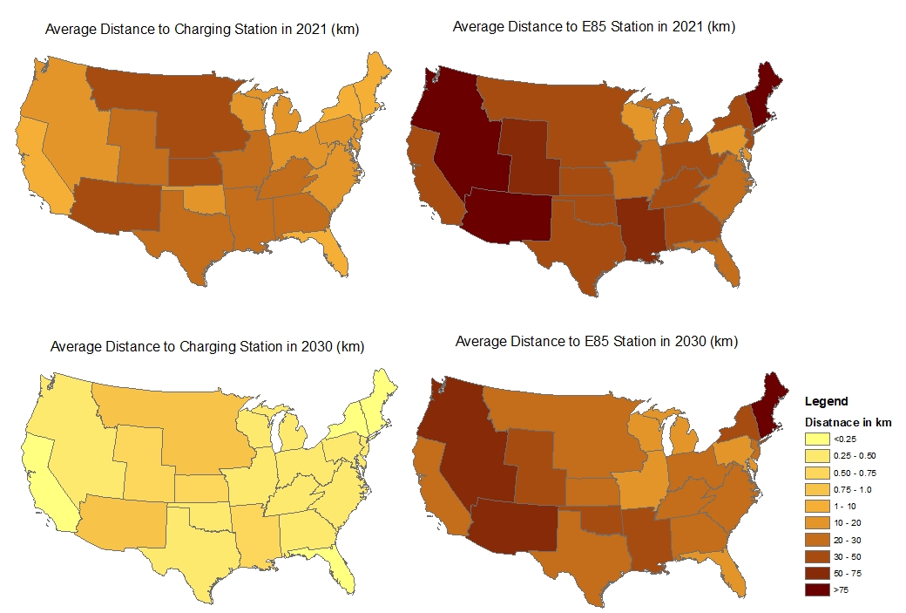
Figure A6 Regional Average VKT Distance to the Nearest Station in the US in 2016 and 2030

We obtain the detour distance (denoted as d in the unit of a mile) by measuring the distance from the centroid of the zip code zone to the nearest refueling station for E85 or BEV charging stations. The dataset is available from NREL. The state-level detour distance in 2016 is shown in Figure A6 and averaged to the electricity market region. The distances in 2030 are extrapolated based on the scenario assumptions.

A.1.5 Idiosyncratic Preferences
We capture the idiosyncratic preference towards the vehicle fuel type by building and calibrating the error terms that reflect the unobserved variable that affect the preferences or

Figure A7 The Histogram of the Error Terms for Each Vehicle Type

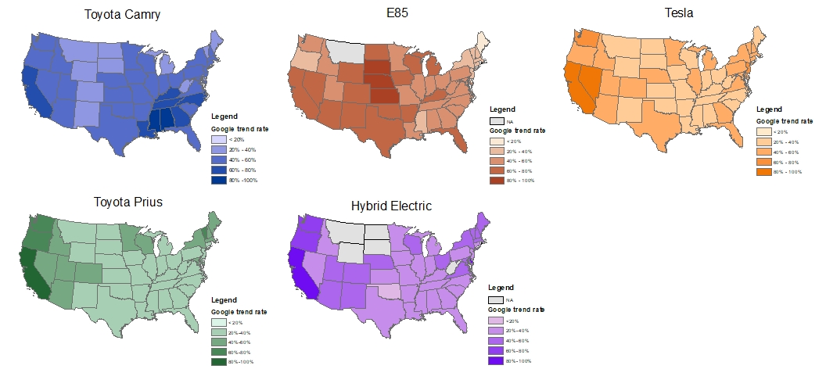
Figure A8 The Normalized Cross-Sectional Data of Search Interest Relative to the Highest Count of the State in the US for Five Keywords in 2020 Provided by Google Trend Data

purchase decision in the random utility framework. The idiosyncratic preference could vary based on different reasons, including positive belief in technological improvement, environmental consciousness, or negative fear of battery life, safety concerns, and so on. Briefly speaking, we first build upon the standard error terms of Gumble distribution that represents the nested correlation for five powertrains; we then apply the regional distribution in interest for each fuel type over time from Google trend to capture the spatial variation, and finally calibrate them to monetary value ($ε_{v,r,i}$) from 2016 to 2019 to validate transportation sector in the objective function 1 for all the vehicles in stock ($S_{t,v,r,md,a}$) in line 6 as part of the consumer surplus $\sum_{v,r,md,a}{S_{t,v,r,md,a}}ε_{v,r,i}$. The distribution of established monetary value of idiosyncratic preference term ($ε_{v,r,i}$) by vehicle type v is provided in Figure A.7 and across the region in Figure A. 8. We elaborate each step in the following paragraphs.
First as shown in equation 17, the fundamental concept of the random error term is from the discrete choice model that the probability of choosing between two alternatives is determined by relative difference between error terms, which also defines the relative correlation between alternative options (Train 2003). For example, the probability of BEV being chosen over other vehicles depends on the differences of the error term of BEV and other vehicle j and the probability distributions of the error term $f\left(ε\right)$.
$$Prob\left(U_{BEV}>U_{j}, ∀j≠BEV\right)=\int{I\left(ε_{j}-ε_{BEV}<V_{BEV}-V_{j}, ∀j≠i\right) f\left(ε\right)dε}$$
Where $U_{j}$ can be simplified as the observed utility plus the error term $V_{j}+ε_{j}$, where $V_{j}$ is the observable utility and $ε_{j}$ is the unobservable error terms. We use the error terms provided by Ramea et al. (2018) that represent the vehicle choices of US market under a similar nested multinomial logit model (Figure A9), which has correlated error terms within the same nest of the engine type but independent across the different drivetrain nests (Bunch and Rocke 2016). The error terms follow a standard Gumbel distribution with a location parameter of 0 and scale parameter of 1 for each vehicle type and are correlated within the nests (as shown in the top left of Figure A10).
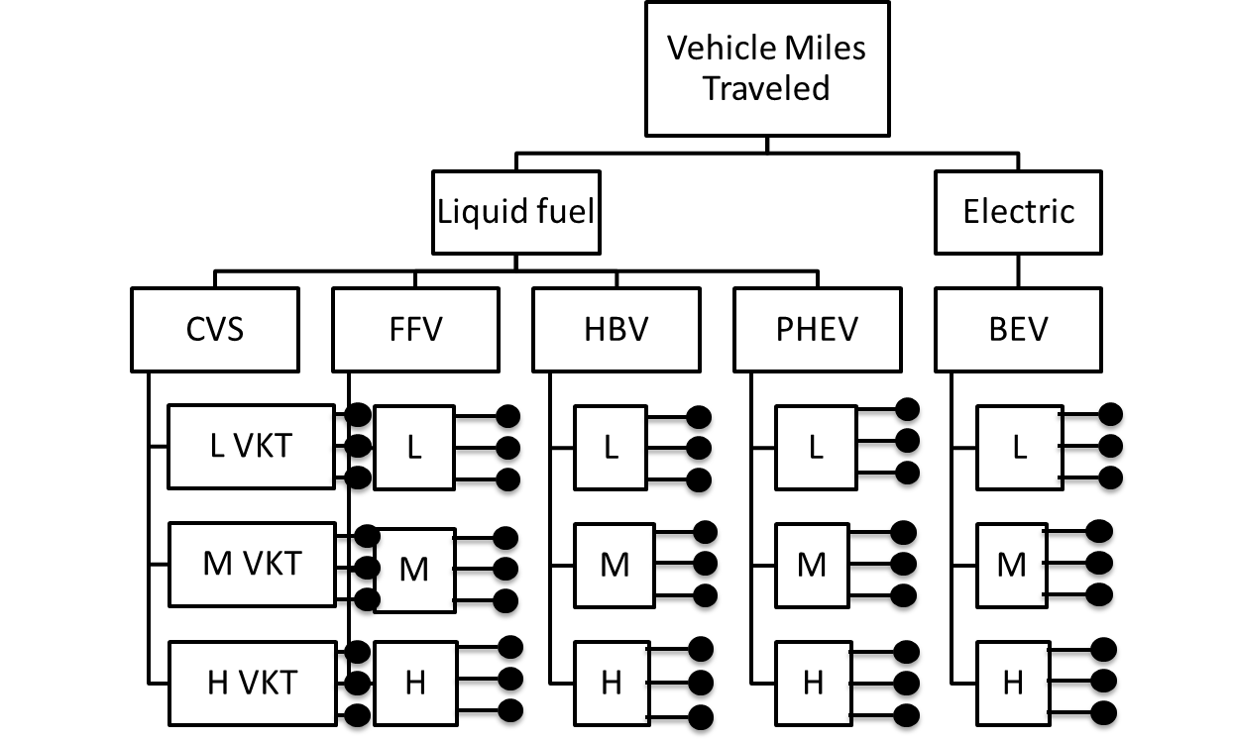Figure A9 Nested Structure Applied in This Model. Black dots represent random preference terms; only three of ten clones are shown here due to limited space.
In order to show the spatial variations in different fuel types of the vehicle, we apply the regional multipliers from Google Trend data. The Google trend data are used to monitor the real-time and archived information on Google queries that reveal preferences or interests over time and across regions (Mavragani and Ochoa 2019; Challet, Bel and Ayed 2014). Google Trend provides the normalized metrics of search requests relative to the highest search count in a given time frame (can be daily, monthly, yearly) across the region. The normalization of the regional search interest done by Google Trend is to divide the search count of region r of vehicle v at time t (Search Count_{v,t,r}) by the highest search volume of the state in the US (max_{r}(Search Count_{v,t,r}) in equation 18), so that the measurement of search interests are all in the scale of 0 to 1. We first use representative car models or brands as the keywords for three vehicle types: “Toyota Camry” for the conventional vehicle (CV), “Tesla” for battery electric vehicle (BEV), and “Toyota Prius” for Plug-in Hybrid Electric Vehicle (PHEV). To represent the search interest for the flex-fuel vehicle (FFV) and hybrid electric vehicle (HBV) that do not have a representative vehicle model in the US market, we use “E85” and “Hybrid Electric” as the search keyword. The spatial variation of search interest across the state is shown in Figure A8.
Search Interest_{v,t,r}= Search Count_{v,t,r} / ×100% $∀ v,t$
For example, the highest search interest of Toyota Camry is in the state of Mississippi and so California only has a search interest of 50%, meaning it only has 50% of the search count in Mississippi; whereas the searches of electric vehicles (Tesla, Toyota Prius, and hybrid electric) are primarily concentrated in California with values of 100%; and search interest for E85 cluster in the Midwest area. We collect the data for each fuel type of vehicle from 2016 to 2019 across 51 states and average these 20 electricity market regions (Search Interest_{v,t,r}).
After multiplying the spatial variation by the standard error terms, we then calibrate the alternative-specific constant c and the scaling multiplier α to emulate the heteroskedastic errors (Train 2003) by region. α and c are calibrated iteratively. The idiosyncratic preference calibration follows the function below:
$ε_{v,t,r,md,i}$ = α×Search Interest_{v,t,r}×(ε_{v}+c).
The systematic differentiation of monetized preferences across vehicle type v, region r ($ε_{v,t,r,md,i}$) is then multiplied by the vehicle stocks and added to the objective function value that represents the monetary value of the unobserved psychological preference (utility/disutility) per unit of the vehicle still in use under the nested multinomial logit model framework (Train 2003). It help validate the model from 2016 to 2019 so that the observed vehicle stock at the national level would be close to the simulated outcome from the model.
Figure A10 (second row) shows the correlation between the error terms and the variance-covariance matrix of the error difference terms. The results show that after the adjustment the correlation coefficient matrix of the error terms and the variance-covariance matrix has a similar pattern as the original nested error terms.
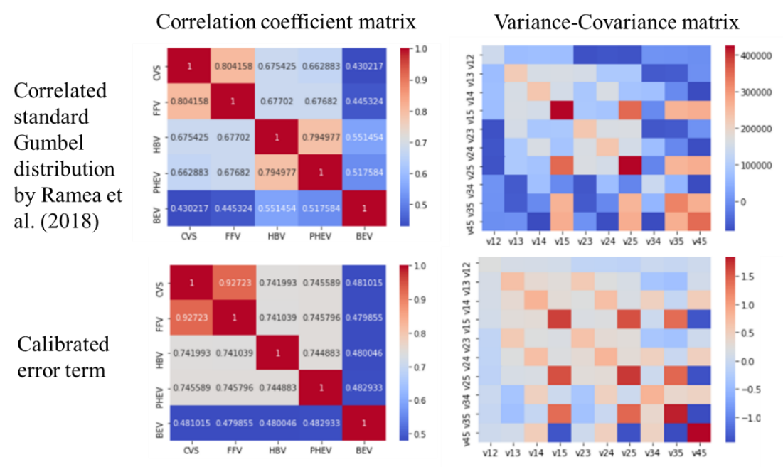
Figure A10 The Heatmap of the Correlation Coefficient Matrix and Variance-Covariance Matrix Compared to the Nested Error Terms by Ramea et al. (2018)

A.2 Monte Carlo Cloning Approach
We discussed the stochastic procedures separately in each intangible cost section. We now elaborate dedicatedly in this section the Monte Carlo cloning strategy applied to generate heterogeneous vehicle consumer behaviors related with intangible costs in the US vehicle market.
Besides the consumer heterogeneity in the dimensions of ownership of vehicles (with 24 vehicle age groups having 3 varying driving demands with 4 possible combinations of charger availabilities in 20 regions), we also include three elements of behavioral variability: daily miles driven, value of time, and idiosyncratic preferences. These distributional attributes would help to represent the population base to quantify the range limitation costs related to driving behaviors (A.1.4.1), waiting time for detours and charging (A.1.4.2 and A.1.4.3), as well as the idiosyncratic preferences (A.1.5). We parameterize the Gamma distributions for daily miles driven by low, medium, and high driving demand group from the mean and variance of VKT from NHTS to represent the daily activity of drivers with different overall yearly driving demand, and borrow the income distribution from Census Bureau (Semega et al. 2017) to represent the value of time, as well as construct the monetary valuation of preference for vehicles by region calibrated by Google trend.
Following the Monte Carlo simulation procedure, we define 10 individuals (also known as clones from (Ramea et al. 2018)) and denoted as i in equation 1 in each representative vehicle ownership segmented by vehicle age (24 vehicle ages), varying VKT driving behavior (among 3 driving demand groups) and equipped with different availabilities of the charger (4 possible availabilities) in 20 regions across US. We then draw values for each clone from the above-mentioned three distributions (Daily VKT distribution, value of time distribution, and the idiosyncratic preferences) independently (for 10 times) to represent their distributional behaviors. We then feed each clone (denoted as i in equation 1) into the model to solve endogenously for the best vehicle choice for these 5,760 customers. We lastly take the average of the vehicle choices output over 10 clones to represent the choice of each heterogenous group considering behavioral, economic, and geological features. We limit the random draw to only 10 clones due to the limitation of the computational capabilities of the model.

A.3 Clean Vehicle (EV) Tax Credit

A.3.1 Phasing-Out Tax Credit Before 2023
From 2010 to 2023, the federal Clean Vehicle (EV) tax credit program offers a tax credit to individuals who purchase new qualifying BEV and PHEV ($7,500 for BEV and $2,500 for PHEV). The eligible EV should also be manufactured by automakers that have sold fewer than 200,000 qualifying electrified vehicles in the US. It began to phase out for Tesla in 2018 and then Toyota in 2019 after they sold more than 200,000 qualifying electric vehicles. The phase-out period is gradual in reducing tax credit amount from $7,500 to $3,750 and then to $1,875, and that takes place over quarters. As more EV producers reach the 200,000 BEV sales level, fewer EVs sold in the market will be eligible for EV tax credit, and thus the weighted tax credit to all EV buyers declines. We follow the same assumption of the declining EV tax credit from 2022 to 2030 as in Annual Energy Outlook (AEO) for the Phase-out tax credit scenario (Figure A11).

Figure A11 The Phasing-Out of Tax Credit for BEV and PHEV Consumers

A.3.2 Extended EV Tax Credit by Inflation Reduction Act
The Inflation Reduction Act reestablished the federal tax credit for EV purchases and took effect on Jan 1st, 2023. It eliminates the 200,000 EV threshold for manufacturers and all BEVs are eligible for $7,500 tax credit. However, the tax credit is subject to income eligibility criteria. Specifically, the modified adjusted gross income of buyers eligible for tax credit may not exceed $300,000 for married couples filing jointly, $225,000 for heads of households, and $150,000 for all other filers. Other complications for eligible vehicles include the vehicle price cap, place of the assembly plant, and source of battery material. For simplicity, they are not considered in this study.
Under the Inflation Reduction Act, these income thresholds are adjusted for inflation every three years beginning in 2025. We collect the income distribution of new vehicle buyers from market research company MaritzCX and find that the population that qualified for EV tax credit among existing 2021 BEV buyers and overall new vehicle buyers is 80% and 92% of the buyers, respectively. That is because the current EV buyers have higher income on average. We then propose a population-weighted tax credit to incorporate the income factor in our study. First, starting from a share of current EV buyers of 80%, the population qualified for tax credits will linearly increase to 92% in 2030. This is based on the assumption that the future BEV buyers will be no different from the majority overall all-new vehicle buyers in 2030, specifically if the BEVs become cheaper, more acceptance of the BEV technology, and more available public chargers. Admittedly, it could also be possible that less population will qualify for the tax credit over time and will drop in 2030, especially when market acceptance of BEV weakens among the majority of vehicle buyers who have lower incomes or the inflation rises faster than the acceptance rate (as shown in Figure A12). In this paper, we discussed the most optimistic case when acceptance of BEV and qualification of tax credit rise.

Figure A12 Two Scenarios of the Population Qualified for EV Tax Credit as Weight

A.4 Model Validation
We validate the model by comparing the model outcomes for many key endogenous variables from 2016 to 2019 with observed data. The 2020 to 2022 are considered abnormal in fuel consumption and production due to the pandemic; thus, we do not include the most recent years for validation. We calibrate the elasticity for the crude oil market for US supply and the rest of the world supply to 1.5 and 0.8 and keep the demand function of the rest of the world at -4, as in Chen et al. (2020). The model outcomes compared to the observed prices and quantities are shown in Table A4a. We find that fuel consumption and production both in the US and the rest of the world generally deviate by less than 2%. The fuel prices are within a 12% deviation. We calibrate the vehicle stocks by incorporating the behavioral factors as well as the idiosyncratic preference by scaling the error term universally (See details in A.1.4). The vehicle stocks are within a 9% deviation from the observed level from 2016 to 2019. The deviation of 9% could be explained by the smaller scales of alternative fuel vehicle stocks compared to conventional vehicles. The deviations of the simulated outcomes of the updated BEPAM from their observed values over the 2016–2019 period are generally within a similar level of tolerance as in previous studies applying BEPAM (Chen et al. 2021; Hudiburg et al. 2016; Oliver and Khanna 2017). We also examine the effect of excluding intangible costs and idiosyncratic preferences in Table A4b. We find that the average deviation in observed and model outcomes of vehicle stocks worsens with the exclusion of intangible costs and idiosyncratic preferences.

Figure A13 The Ownership Cost Breakdown for Each Fuel Type across Driving Demand
We calculate the annualized ownership cost of five vehicle types for buyers with low, medium, and high driving demand. The total ownership cost includes purchase cost, maintenance cost, fuel cost, range limitation, waiting cost, and detour cost, as shown in the Figure A13. The error bars show the range of idiosyncratic preference that is from the sample of the distribution. In 2016, conventional vehicles (CV) are the cheapest option for consumers of low- and medium-driving demand groups and are very close to the cheapest HBVs in the high-driving demand group. That is because of the higher driving cost savings obtained by alternative fuel vehicles are enough to offset the high upfront purchase cost. In 2030 in Figure 13b, the advantage of CV diminishes when tax credit is applied to the PHEV and BEV reduces the purchase cost meanwhile the BEV price reduces, and the improved charging availability cuts the other inconvenience costs. BEV becomes the cheapest vehicle type in both middle and high driving demand groups with annualized costs ranging from $4k to $5.5k per year. We noticed that the intangible costs of detour, waiting, and range limitation do not have a significant impact on the ownership costs of BEV as the buyers would choose to buy home chargers to avoid the range limitation and detour costs.
Table A4 (a) Model Validation Including Intangible Costs and Idiosyncratic Preferences
 | Observed |  |  |  | Model outcome |  |  |  | Source | Avg. % difference
 | 2016 | 2017 | 2018 | 2019 | 2016 | 2017 | 2018 | 2019
Fuel gallons (billion liters)
US oil consumption | 942 | 961 | 984 | 961 | 984 | 1003 | 969 | 992 | DOE | 2%
US oil supply | 515 | 545 | 636 | 712 | 545 | 545 | 700 | 662 | DOE | 2%
ROW oil use | 4254 | 4285 | 4451 | 4527 | 4247 | 4254 | 4508 | 4466 | DOE | 0%
ROW oil supply | 4686 | 4705 | 4799 | 4777 | 4690 | 4709 | 4777 | 4796 | DOE | 0%
E10 | 541 | 541 | 541 | 541 | 541 | 541 | 530 | 534 | EIA | -1%
Blended diesel | 193 | 197 | 208 | 204 | 201 | 201 | 201 | 201 | EIA | 0%
Prices ($ per liter)
US oil price | 0.27 | 0.32 | 0.41 | 0.36 | 0.27 | 0.30 | 0.39 | 0.36 | WTI | -2%
ROW oil price | 0.27 | 0.34 | 0.45 | 0.40 | 0.27 | 0.30 | 0.39 | 0.36 | Brent | -9%
US wholesale ethanol | 0.41 | 0.38 | 0.32 | 0.33 | 0.42 | 0.39 | 0.39 | 0.39 | NEO price | 10%
US retail E10 ($/gge) | 0.56 | 0.62 | 0.72 | 0.69 | 0.64 | 0.67 | 0.84 | 0.75 | AFDC | 12%
US retail diesel | 0.51 | 0.54 | 0.63 | 0.61 | 0.64 | 0.67 | 0.84 | 0.75 | AFDC | 0%
Vehicle kilometer traveled (billion km)
Gasoline vehicle | 4395 | 4538 | 4613 | 4667 | 4395 | 4459 | 4536 | 4752 | EIA | 0%
Diesel vehicle | 656 | 664 | 699 | 693 | 694 | 710 | 710 | 718 | EIA | 4%
Vehicle stocks (million)
CV | 215 | 228 | 228 | 229 | 216 | 212 | 214 | 224 | AEO | -4%
FFV | 19.8 | 19.4 | 19.7 | 20.2 | 20.0 | 19.2 | 18.7 | 18.2 | AEO | -4%
HBV | 4.07 | 4.21 | 4.68 | 4.69 | 4.17 | 3.93 | 3.86 | 4.16 | AEO | -9%
PHEV | 0.32 | 0.36 | 0.53 | 0.64 | 0.32 | 0.30 | 0.34 | 0.84 | AEO | -2%
BEV | 0.29 | 0.37 | 0.57 | 0.87 | 0.31 | 0.30 | 0.55 | 1.15 | AEO | 9%
Total | 239 | 252 | 254 | 255 | 241 | 235 | 238 | 248 | AEO | -4%
Electricity Sector
Consumption (MmWh) | 3762 | 3723 | 3859 | 3811 | 3958 | 3979 | 4007 | 4043 | EIA | -5%
Natural Gas % | 34% | 32% | 36% | 39% | 37% | 37% | 37% | 37% | EIA | -5%
Coal% | 30% | 30% | 28% | 23% | 29% | 29% | 29% | 29% | EIA | -5%
Nuclear% | 20% | 20% | 20% | 20% | 18% | 18% | 18% | 18% | EIA | 9%
Hydroelectricity% | 7% | 7% | 7% | 7% | 6% | 6% | 6% | 7% | EIA | -10%
Wind electricity% | 6% | 6% | 7% | 7% | 7% | 7% | 7% | 7% | EIA | 10%
Solar electricity% | 0.9% | 1.3% | 1.5% | 1.7% | 0.6% | 1.0% | 1.5% | 1.9% | EIA | -11%
Total renewable% | 15% | 17% | 17% | 18% | 15% | 15% | 16% | 17% | EIA | -6%
GHG Emissions (million metric tons of CO₂)
Transportation | 1,869 | 1,887 | 1,918 | 1,924 | 2,182 | 2,169 | 2,163 | 2,160 | EIA | 14%
Electricity | 2,845 | 2,789 | 2,890 | 2,763 | 2,273 | 2,272 | 2,208 | 2,220 | EIA | -10%
*The observed actual GHG emissions of 2016 to 2019 from the electricity sector are from US EIA report of 2021, where the emission from the electricity sector can be indirectly referred from the Figure 4 of energy-related carbon dioxide emission by fossil fuel and are the sum of emission from the sources of coal and natural gas.
Table A4 (b) Model Validation Without Considering Intangible Costs and Preferences
 | Observed |  |  |  | Model outcome |  |  |  | Source | Average %difference
 | 2016 | 2017 | 2018 | 2019 | 2016 | 2017 | 2018 | 2019
Fuel gallons (billion liters)

Consumption | 942 | 961 | 984 | 961 | 980 | 1003 | 973 | 992 | DOE | 3%
US oil supply | 515 | 545 | 636 | 712 | 545 | 545 | 700 | 662 | DOE | 2%
ROW oil use | 4254 | 4285 | 4451 | 4527 | 4251 | 4254 | 4508 | 4466 | DOE | 0%
ROW oil supply | 4686 | 4705 | 4799 | 4777 | 4690 | 4709 | 4780 | 4796 | DOE | 0%
E10 | 541 | 541 | 541 | 541 | 484 | 484 | 481 | 477 | EIA | -11%
Blended diesel | 193 | 197 | 208 | 204 | 201 | 202 | 201 | 201 | EIA | 0%
Prices ($ per liter)
US oil price | 0.27 | 0.32 | 0.41 | 0.36 | 0.27 | 0.30 | 0.40 | 0.36 | WTI | -2%
ROW oil price | 0.27 | 0.34 | 0.45 | 0.40 | 0.27 | 0.30 | 0.40 | 0.36 | Brent | -8%
US wholesale ethanol | 0.41 | 0.38 | 0.32 | 0.33 | 0.42 | 0.39 | 0.39 | 0.39 | NEO price | 10%
US retail E10 ($/gge) | 0.56 | 0.62 | 0.72 | 0.69 | 0.61 | 0.67 | 0.81 | 0.75 | AFDC | 9%
US retail diesel | 0.51 | 0.54 | 0.63 | 0.61 | 0.47 | 0.52 | 0.51 | 0.57 | AFDC | -9%
Vehicle kilometer traveled (billion km)
Gasoline vehicle | 4395 | 4538 | 4613 | 4667 | 4366 | 4416 | 4557 | 4,722 | EIA | -1%
Diesel vehicle | 656 | 664 | 699 | 693 | 696 | 710 | 715 | 723 | EIA | 5%
Vehicle stocks (million)
CV | 215 | 228 | 228 | 229 | 207 | 190 | 173 | 177 | AEO | -17%
FFV | 19.8 | 19.4 | 19.7 | 20.2 | 24.7 | 37.7 | 61.6 | 60.5 | AEO | 133%
HBV | 4.07 | 4.21 | 4.68 | 4.69 | 4.06 | 3.82 | 3.56 | 7.54 | AEO | 7%
PHEV | 0.32 | 0.36 | 0.53 | 0.64 | 0.32 | 0.30 | 0.29 | 0.27 | AEO | -30%
BEV | 0.29 | 0.37 | 0.57 | 0.87 | 0.29 | 0.28 | 1.35 | 1.32 | AEO | 41%
Total | 239 | 252 | 254 | 255 | 237 | 232 | 239 | 247 | AEO | -4%
Electricity Sector
Consumption (MmWh) | 3,762 | 3,723 | 3,859 | 3,811 | 3,958 | 3,979 | 4,007 | 4,043 | EIA | 5%
Natural Gas% | 34% | 32% | 36% | 39% | 37% | 37% | 37% | 37% | EIA | 5%
Coal% | 30% | 30% | 28% | 23% | 29% | 29% | 29% | 29% | EIA | 5%
Nuclear% | 20% | 20% | 20% | 20% | 18% | 18% | 18% | 18% | EIA | -8%
Hydroelectricity% | 7% | 7% | 7% | 7% | 6% | 6% | 6% | 7% | EIA | -5%
Wind electricity% | 6% | 6% | 7% | 7% | 7% | 7% | 7% | 7% | EIA | 13%
Solar electricity% | 0.9% | 1.3% | 1.5% | 1.7% | 0.6% | 1.0% | 1.5% | 1.9% | EIA | -7%
Total renewable% | 15% | 17% | 17% | 18% | 15% | 15% | 16% | 17% | EIA | -5%
GHG Emissions (million metric tons of CO₂)
Transportation | 1,869 | 1,887 | 1,918 | 1,924 | 2,278 | 2,278 | 2,265 | 2,257 | EIA | 20%
Electricity | 2,845 | 2,789 | 2,890 | 2,763 | 2,178 | 2,166 | 2,157 | 2,153 | EIA | -23%

A.5 Electricity Sector Outcomes
The total electricity generation increased under three policy scenarios with greater BEV adoption which causes the cumulative GHG emission from electricity sector going up. The fuel sources of the electricity generated remain relatively constant with slightly more renewable and natural gas, but less coal and nuclear. Overall intensity remains relatively the same.
Table A5 Electricity Generation by Sources of Each Policy Scenarios in 2030
 | Baseline Scenario | Scenario 1: Increased Public Charging | Scenario 2: Clean Vehicle (EV) Tax Credit | Scenario 3: Clean Vehicle (EV) Tax Credit & Increased Charging
Total power (M mWh) | 4,221 | 4,240 | 4,343 | 4,361
Coal % | 26% | 26% | 26% | 26%
Natural Gas % | 31% | 32% | 33% | 33%
Nuclear % | 18% | 18% | 18% | 17%
Renewable % | 24% | 24% | 24% | 24%
Average electricity price ($/mWh) | 106 | 107 | 110 | 110
Cumulative GHG emission from electricity sector (B Mg CO₂) | 18.5 | 18.7 | 18.8 | 19.1

We tested the sensitivity of an aggressive Renewable Portfolio Standard policy and cheaper solar and wind energy on the results of the paper by targeting at 40% of renewable energy in 2030 projected by AEO. The total mix of solar and wind mix of benchmark scenario discussed in the main paper and the aggressive RPS scenario falls in the range from 21% to 37% that are observed or reported in EIA or AEO (Table A6). The forecasted levelized cost of electricity of solar and wind are calibrated to align the projections of solar and wind energy from EIA till 2030 (US Energy Information Administration 2022). In 2030, the total share of renewable energy is forecasted to be 39% close to the AEO projections.

Table A6 Electricity Generation by Source in 2030 under Benchmark and Aggressive RPS Scenario
 | Benchmark | Aggressive RPS |  | AEO 2023 database for year 2030ª
Coal % | 26% | 22% |  | 9%
Natural Gas % | 33% | 24% |  | 43%
Nuclear % | 17% | 16% |  | 6%
Solar % | 8% | 17% |  | 22%
Wind % | 8% | 13% |  | 19%
Other Renewable % | 8% | 9% |  | 0%
Total Renewable % | 24% | 39% |  | 41%
Total Power MmWh | 4,361 | 4,636
Average electricity price ($/Mwh) | 110 | 90
ª Annual Energy Outlook 2023 - U.S. Energy Information Administration (EIA)

Figure A14 Effect of Behavioral Preferences on Share of Alternative Vehicles in New Sales under Various Policy Scenarios

Figure A15 Effect of Behavioral Preferences on Share of Alternative Vehicles in Vehicle Stock under Various Policy Scenarios

Table A7 Social Welfare Effects of Alternative Policy Scenarios over 2022-2030 ($ billion)
 | Including Intangible and behavioral preferences |  |  |  | Including tangible costs only
 | Baseline Scenario | Scenario 1: Increased Public Charging | Scenario 2: Clean Vehicle (EV) Tax Credit | Scenario 3 Clean Vehicle (EV) Tax Credit & Better Charging | Baseline Scenario | Scenario 1: Increased Public Charging | Scenario 2: Clean Vehicle (EV) Tax Credit | Scenario 3 Clean Vehicle (EV) Tax Credit & Better Charging
Transportation sector | 74,401 | -57 | -143 | -166 | 73,623 | -108 | -329 | -281
VKT consumers | 67,857 | -7 | -125 | -127 | 67,045 | -22 | -177 | -178
CV | 55,361 | -1,095 | -5,713 | -6,745 | 40,093 | -957 | -7,792 | -8,214
FFV | 4,977 | 81 | 1,079 | 1,055 | 12,092 | 1,032 | 872 | 639
HBV | 2,643 | -157 | -511 | -600 | 10,424 | -5,762 | -6,316 | -6,587
PHEV | 1,277 | -33 | 2 | -55 | 238 | -9 | 49 | -201
BEV | 3,598 | 1,198 | 5,018 | 6,218 | 4,198 | 5,674 | 13,010 | 14,184
VKT diesel consumers | 6,002 | -50 | -17 | -38 | 6,036 | -86 | -151 | -102
Fuel producer | 542 | 0 | 0 | -1 | 542 | -1 | -1 | -1
Electricity sector | 5,817 | 5 | 30 | 36 | 5,812 | 28 | 80 | 88
Electricity consumers | 3,887 | -14 | -51 | -62 | 3,884 | -56 | -116 | -123
Electricity producers | 1,930 | 19 | 81 | 98 | 1,928 | 83 | 196 | 211
Agricultural sector | 1,709 | 0 | 0 | 0 | 1,708 | 1 | -1 | -1
Government revenue | 484 | -17 | -231 | -269 | 457 | -47 | -496 | -526
Fuel tax | 488 | -6 | -23 | -28 | 476 | -18 | -52 | -55
Vehicle tax credit | -12 | -5 | -226 | -246 | -16 | -25 | -451 | -466
Infrastructure investment | 0 | -7 | 0 | -7 | 0 | -7 | 0 | -7
Economic surplus | 80,694 | -70 | -362 | -411 | 79,895 | -130 | -752 | -722
Cumulative GHG emissions 2022-2030 (B Mg CO₂) | 36.9 | -0.20 | -0.73 | -0.90 | 36.4 | -0.52 | -1.58 | -1.65
 |  | Relative to Baseline |  |  | Relative to Baseline
Taxpayer cost of abatement($/Mg CO₂-eq) |  | 91 | 341 | 313 |  | 95 | 319 | 320
Welfare Cost of Abatement ($/Mg CO₂-eq) |  | 359 | 495 | 458 |  | 250 | 477 | 438

Figure A16 Sales Share of Alternative Vehicles Across Different Clones and Mean Values of Alternative Vehicle Types under Policy Scenarios 3 from 2022 to 2030: (a) Share of BEVs (b) Share of conventional vehicles (CVs), and (b) Share of other vehicle types (Flex fuel vehicles (FFVs), Hybrid vehicles (HBVs), and Plug-in hybrid vehicles PHEVs). C labels the outcome of each clone.

Figure A17 The Vehicle Stock Share With Different Clones and Mean Values of Alternative Vehicle Types under Policy Scenarios 3 from 2022 to 2030: (a) Share of BEVs (b) Share of conventional vehicles (CVs), and (b) Share of other vehicle types (Flex fuel vehicles (FFVs), Hybrid vehicles (HBVs), and Plug-in hybrid vehicles PHEVs). C labels the outcome of each clone.

Table A8 Effects of Alternative Levels of Biofuel Mandate on the Transportation Energy over 2022-2030
Scenarios | Volumetric Mandate for 54 B liters of corn ethanol |  |  |  | Blend Mandate for 10% ethanol blend
Scenarios | Baseline Scenario | Scenario 1: Increased Public Charging | Scenario 2: Clean Vehicle (EV) Tax Credit | Scenario 3 Clean Vehicle (EV) Tax Credit & Increased Charging | Scenario 1: Increased Public Charging | Scenario 2: Clean Vehicle (EV) Tax Credit | Scenario 3 Clean Vehicle (EV) Tax Credit & Increased Charging
Total Energy (B gge liter) | 659 | 650 | 607 | 598 | 656 | 610 | 602
Gasoline | 343 | 330 | 272 | 262 | 343 | 286 | 276
Blended diesel | 253 | 253 | 253 | 252 | 259 | 259 | 259
Ethanol (B liters) | 54 | 54 | 53 | 53 | 39 | 34 | 33
in E10 | 38 | 36 | 29 | 28 | 38 | 32 | 31
in E85 | 16 | 18 | 24 | 25 | 1 | 2 | 2

Figure A18 The FFV Sales Share with a Mandate of 54 Billion Liters of Ethanol (Plot a) and Mandate of 10% Ethanol Blend (Plot b). The FFV sales shares in plot (a) rise is caused by the volumetric mandate that requires capacity to increase consumption of ethanol as gasoline and E10 consumption declines due to BEV adoption. In plot (b) with the corn ethanol mandate reduced to 10% blend, FFV sales share remains at 2% by 2030 under the different policy scenarios.

Figure A19 The BEV Sales Share Under Mandate of 54 B liters of Ethanol (Plot a) and Mandate of 10% Ethanol Blend (Plot b). The EV sales shares across two alternative specifications of the ethanol mandate do not change much. With the reduced corn ethanol mandate, there is a slight increase in the EV share (by less than 1%) by 2030 under different policy scenarios.

Table A9 Social Welfare and GHG Effects of Alternative Policy Scenarios over 2022-2030 with Aggressive RPS with Reduced Cost of Solar and Wind Electricity
 | Baseline Scenario | Policy Scenario 1: Increased Public Charging | Policy Scenario 2: Clean Vehicle (EV) Tax Credit | Policy Scenario 3 Clean Vehicle (EV) Tax Credit & Better Charging
 |  | Relative to Baseline Scenario
Transportation sector ($B) (a) | 74,376 | -52 | -42 | -69
Electricity sector ($B) (b) | 5,741 | 3 | 17 | 22
Agriculture sector ($B) (c) | 1,711 | -1 | -1 | 0
Government revenue ($B) (d) | 469 | -20 | -269 | -300
Net Economic surplus ($B) (e=a+b+c+d) | 80,585 | -69 | -294 | -347
Cumulative GHG emissions 2022-2030 (B Mg CO₂) (f) | 35 | -0.22 | -0.82 | -0.98
% Change in Cumulative GHG Emissions Relative to Baseline |  | -1% | -2% | -3%
Transportation (B Mg CO₂) | 18.2 | -1% | -6% | -7%
Electricity (B Mg CO₂) | 16.7 | 0.3% | 1.1% | 1.4%
GHG Emissions from Transportation and Electricity in 2030 (B Mg CO₂) | 3.64 | -0.03 | -0.18 | -0.21
% Change in GHG Emissions from Transportation and Electricity in 2030 |  | -1% | -5% | -6%
GHG Emissions from Transportation in 2030 | 1.89 | -2% | -12% | -14%
GHG Emissions from Electricity in 2030 | 1.74 | 0% | 3% | 3%
Taxpayer Cost of Abatement  ($ per Mg CO₂-eq) (d/f) |  | 91 | 329 | 305
Welfare Cost of Abatement  ($ per Mg CO₂-eq) (e/f) |  | 319 | 359 | 352

Table A.9 Notation
Notation | Unit | Description
Endogenous Variable
U | $ | Utility
C | $ | Cost
S | unit | Vehicle stock
O | gallon | Crude oil
N | unit | New vehicle purchased
VKT | kilometers | Total kilometers driven by gasoline vehicles
MDSL | kilometers | Total kilometers driven by diesel vehicles
ETH | gallon | Ethanol gallons
G | gallon | Gasoline gallons
DSL | gallon | Diesel gallons
QE | mWh | Electricity consumption
QR | mWh | Electricity generated
QM | mWh | Electricity generated from new power plant
NG | M mmbtu | Quantity of natural gas used to produce electricity
NGM | M mmbtu | Quantity of natural gas used to produce electricity
FF | M mmbtu | Quantity of fuel type used for electricity generation
QW | mWh | Quantity of electricity generated from new wind capacity
QS | mWh | Quantity of electricity generated from new solar capacity
BE | Metric ton | Quantity of biomass used to generate electricity
CF | mW | Amount of capacity converted for co-firing
BT | Metric ton | Quantity of biomass transported
DEM | Vary by commodity | Domestic demand
EXP | Vary by commodity | Demand for exports
IMP | Vary by commodity | Import supply
ACR | acre | The land allocated to row crops and perennial crops
FR | Metric ton | Supply of forest residues and pulpwood
LIV | head | quantity of livestock
PRO | Vary by commodity | primary crop
BTL | gallon | biodiesel produced from biomass
OILDSL | gallon | biodiesel produced from vegetable oils
Q | % | Availability of home and work chargers
X | kilometers | Random kilometers drawn from the distribution of daily miles driven
V^{t} | $ per hour | Random value drawn from the distribution of time value
V | $ | Observed utility
Exogenous Parameter
$$ϕ$$ | $ per vehicle | Purchase price
$$η$$ | $ per kilometers | Operational and maintenance cost
δ | $ per vehicle | Annual registration cost
Ε | $ per vehicle | Error term of the random utility
$π$ |  | depreciation factor
ec | $ per mWh | O&M cost for electricity generated
fp | $ per mmbtu | Fuel cost of coal, fuel oil for electricity production
lc | $ per mWh | Levelized cost of generating electricity
np | $ per mmbtu | Transmission and distribution cost per unit of natural gas
cf | $ per MW | Cost of retrofitting a MW of coal plant capacity for co-firing
tr | $ per metric ton | Cost of transporting biomass
rc | $ per acre | production costs of row crops
pc | $ per acre | production costs of perennial crops
rs | $ per acre | collection costs of crop residues
vc | $ per acre | conversion cost per unit of marginal land
sc | Units vary according to crops | processing cost per unit
ec | $ per gallon | processing cost of corn ethanol
ex | $ per gallon | processing cost of cellulosic ethanol
vl | $ per acre | value of the remaining economic life of standing perennial grasses
wl | $ per acre | return from the most profitable cropping alternative
z | % | Scrappage rate
m | kilometers | Yearly kilometers driven cap
eVKT | kilometers | Effective kilometers
e | kW | Charging output
tc | hour | Charging time needed
Q | % | Charger availability
$$γ$$ | miles per kWh | Fuel efficiency
p | % | Probability of running out of power
d | miles | Detour distance
α |  | Scalars for idiosyncratic preference
c |  | Scalars for error term
$$β$$ | % | Vehicle discount
$$κ$$ | % | Percentage of mileage driven on fuels for electrified vehicles
$$π$$ | % | Aging factor
R^{max} | miles | BEV range
w |  | Interest rate
Superscript
drow |  | Rest of world demand
sdom |  | Domestic supply
row |  | Rest of world
g |  | Gasoline
dsl |  | Diesel
mdsl |  | Driving demand for diesel vehicles
o |  | Crude oil
CRD |  | Agricultural region
et |  | Electricity technology type
nt |  | New power plant with technology type
ff |  | fuel type$∈\left\{coal,fuel oil\right\}$
fr |  | Set of consisting forest residues and pulpwood
i |  | Clones for stochastic process
a |  | Vehicle age
t |  | Year
v |  | Five vehicle powertrain
chrg |  | Charging groups: H for home, W for work, P for public
k |  | Two types of public charging: L2 for Level 2, DC for DC fast charging
md |  | Driving demand: Low, Medium, High
r |  | Electric market region
cc |  | Crop commodities
lc |  | Livestock commodities
j |  | Other vehicles than BEV

References
Alternative Fuels Data Center, D. 2020. “Vehicle Cost Calculator Assumptions and Methodology.” Available at: https://afdc.energy.gov/calc/cost_calculator_methodology.html [Accessed June 11, 2019].
American Automobile Association (AAA). 2016. “Your driving costs.” Available at: http://newsroom.aaa.com/auto/your-driving-costs/.
Baik, Y., R. Hertzke, H. Patrick, and S. Knupfer. 2019. “Making electric vehicles profitable.” McKinsey. Available at: https://www.mckinsey.com/industries/automotive-and-assembly/our-insights/making-electric-vehicles-profitable [Accessed January 22, 2020].
BloombergNEF. 2019. “A Behind the Scenes Take on Lithium-ion Battery Prices.” Available at: https://about.bnef.com/blog/behind-scenes-take-lithium-ion-battery-prices/ [Accessed January 22, 2020].
Challet, D., A. Bel, and H. Ayed. 2014. “Do Google Trend data contain more predictability than price returns?”
Chen, L., D. Debnath, J. Zhong, K. Ferin, A. VanLoocke, and M. Khanna. 2021. “The economic and environmental costs and benefits of the renewable fuel standard.” Environmental Research Letters 16(3):034021. Available at: https://iopscience.iop.org/article/10.1088/1748-9326/abd7af.
DOE. 2021a. “Alternative Fueling Station Locator.” Available at: https://afdc.energy.gov/stations/#/find/nearest.
DOT. 2015. “Revised Value of Travel Time Guidance.” Available at: https://www.transportation.gov/sites/dot.gov/files/docs/2015 Revised Value of Travel Time Guidance.pdf [Accessed May 5, 2020].
EIA. 2019. “Annual Energy Outlook 2019 with projections to 2050.” Available at: https://www.eia.gov/outlooks/aeo/ [Accessed May 23, 2019].

EIA. 2021. “Light-Duty Vehicle Stock by Technology Type.” Annual Energy Outlook 2019. Available at: https://www.eia.gov/outlooks/aeo/data/browser/#/?id=49-AEO2019&cases=ref2019&sourcekey=0 [Accessed June 17, 2019].
Federal Highway Administration. 2016. “Highway Statistics 2016.” Highway Statistics 2016. Available at: https://www.fhwa.dot.gov/policyinformation/statistics/2016/ [Accessed June 12, 2019].
Federal Highway Administration. 2017. “National Household Travel Survey.” Available at: https://nhts.ornl.gov/ [Accessed July 26, 2019]
Ferin, K. M. et al. Water Quality Effects of Economically Viable Land Use Change in the Mississippi River Basin under the Renewable Fuel Standard. Environ. Sci. Technol. (2021). doi:10.1021/acs.est.0c04358
Greenspan, A., and D. Cohen. 1996. “Motor Vehicle Stocks, Scrappage, and Sales.”
Lade, G.E., and J. Bushnell. 2019. “Fuel Subsidy Pass-Through and Market Structure: Evidence from the Renewable Fuel Standard.” Available at: http://www.card.iastate.edu/products/publications/pdf/16wp570.pdf [Accessed May 22, 2017].
Hudiburg, T.W., W. Wang, M. Khanna, S.P. Long, P. Dwivedi, W.J. Parton, M. Hartman, and E.H. Delucia. 2016. “Impacts of a 32-billion-gallon bioenergy landscape on land and fossil fuel use in the US.” Nature Energy 1. Available at: https://www.nature.com/articles/nenergy20155.pdf [Accessed November 17, 2017].
Hu, L., J. Dong, and Z. Lin. 2019. “Modeling charging behavior of battery electric vehicle drivers: A cumulative prospect theory based approach.” Transportation Research Part C: Emerging Technologies 102:474–489.
Lin, Z., J. Dong, C. Liu, and D.L. Greene. 2012. “PHEV Energy Use Estimation: Validating the Gamma Distribution for Representing the Random Daily Driving Distance.” Transportation Research Record 2287:37–43. Available at: https://www.ornl.gov/publication/phev-energy-use-estimation-validating-gamma-distribution-representing-random-daily-0 [Accessed September 16, 2020]
Mavragani, A., and G. Ochoa. 2019. “Google Trends in Infodemiology and Infoveillance: Methodology Framework.” JMIR Public Health and Surveillance 5(2):e13439. Available at: http://publichealth.jmir.org/2019/2/e13439/.
National Automobile Dealers Association. 2014. “Volatility in Used Vehicle Depreciation : Historical Trends & Future Outlook.” Available at: kansasdealers.org/wp-content/uploads/2019/05/NADA-Report-Volatility-in-Used-Vehicle-Depreciation.pdf
NREL. 2021. “Alternative Fuel Stations API.” Developer Network. Available at: https://developer.nrel.gov/docs/transportation/alt-fuel-stations-v1/ [Accessed April 20, 2021].
Oliver, A., and M. Khanna. 2017. “What Is the Cost of a Renewable Energy-Based Approach to Greenhouse Gas Mitigation?” Land Economics 93(3):437–458.
Pouliot, S., and B.A. Babcock. 2014. “The demand for E85: Geographical location and retail capacity constraints.” Energy Economics 45:134–143. Available at: http://www.sciencedirect.com/science/article/pii/S0140988314001558 [Accessed May 18, 2016].
Semega, J.L., K.R. Fontenot, and M.A. Kollar. 2017. “Income and Poverty in the United States: 2016.” Available at: https://www.census.gov/library/publications/2017/demo/p60-259.html [Accessed March 19, 2021].
Ramea, K., D.S. Bunch, C. Yang, S. Yeh, and J.M. Ogden. 2018. “Integration of behavioral effects from vehicle choice models into long-term energy systems optimization models.” Energy Economics 74:663–676. Available at: https://www.sciencedirect.com/science/article/pii/S0140988318302573 [Accessed August 13, 2018].
Train, K.E. 2003. Discrete choice methods with simulation. Cambridge University Press, 2003, ISBN: 0-521-81696-3
US Energy Information Administration. 2019. “Assumptions to the Annual Energy Outlook 2019: Transportation Demand Module.” (February):1–29. Available at: https://www.eia.gov/outlooks/aeo/assumptions/pdf/transportation.pdf
US EPA, and NTHSA. 2018. “The Safer Affordable Fuel-Efficient (SAFE) Vehicles Rule for Model Years 2021-2026 Passenger Cars and Light Trucks.”
US Energy Information Administration. 2021 “U.S. Energy-Related Carbon Dioxide Emissions, 2021” Available at: https://www.eia.gov/environment/emissions/carbon/archive/2021/

Source: Highway Statistics Series - Policy | Federal Highway Administration (dot.gov).We use the actual VKT by regions and demand preference group in 2016 and the interceptions of aggregated national demand function (defined as in Chen et al. (2021)) to construct the demand functions by 20 regions and 3 demand preference groups.
This cost does not apply to electricity generated as a co-product at cellulosic ethanol refineries.
We use the full age range of the vehicle up to age 24 to describe the whole picture of the vehicle still in use and consume the energy that is observed from the National Household Transportation Survey.
U.S. Energy Information Administration - EIA - Independent Statistics and Analysis
Level 2 chargers are most common in the US for charging options at home, at work, and in public charging with a charging rates up to 25 miles of range per hour; DC fast charging provides 8 time faster charging rate but typically found in major highways with higher volumes and for longer trip conveniences.
Alternative Fuels Data Center: Alternative Fueling Station Locator (energy.gov): https://afdc.energy.gov/stations/#/find/nearest
North American Industry Classification System (NAICS) U.S. Census Bureau: https://www.census.gov/naics/
DC fast charging is from: https://developer.nrel.gov/docs/transportation/alt-fuel-stations-v1/. Electricity price is from: https://www.eia.gov/electricity/
https://developer.nrel.gov/docs/transportation/alt-fuel-stations-v1/

