Supplementary Material

Content

- Topology for TIO residue
- Force parameters for TIO
- Topology file for LHP residue
- Force field for LHP
- RDF graphics
- WOR graphics
- References

General

The simulated systems are composed from different concentrations of three residues : TIO, LHP and TIP3P. We have used CHARMM force fields for the simulations with NAMD. TIP3P is the standard water model (Mark and Nilsson, 2001) and the force field parameters are taken from the CHARMM22 file par_all27_prot_lipid.inp. For the other two residues we have used the topology and force fields reported in section 1)–4).

1) Topology file for TIO residue

* All comments to maria@crs4.it
*
27 1

! +++++++++++++++++++++++++++++++++++++++++++++++++++++++++++++++++++++++++++++
! + Maria Valentini, Rutile TiO2 Unit Cell topology +
! +++++++++++++++++++++++++++++++++++++++++++++++++++++++++++++++++++++++++++++

MASS 1 OT2 15.99900 O !
MASS 2 OT3 15.99900 O !
MASS 3 TI6 47.88000 Ti !
MASS 4 TI5 47.88000 Ti !

RESI TIO +0.000 !Rutile Titanium Crystal Ti2O4
GROUP
ATOM O0 OT2 -1.1200 ! O1
ATOM O1 OT3 -0.7165 ! |
ATOM T5 TI6 +1.4330 ! O2---T5---O3
ATOM O2 OT3 -0.7165 ! |
ATOM O3 OT3 -0.7165 ! O0
ATOM T4 TI5 +1.8365 ! |
! T4

BOND T5 O1 T5 O2 T5 O3 T5 O0
BOND T4 O0
ANGLE O0 T5 O2 O0 T5 O3 O0 T5 O1
ANGLE O1 T5 O2 O3 T5 O1
ANGLE T4 O0 T5
!DIHED O2 T5 O0 T4 O3 T5 O0 T4
!DIHED O1 T5 O0 T4

PATCHING FIRST NONE LAST NONE

END

2) Force field for TIO residue

! Parameters for TIO2 Bonded model from Brandt and Lyubartsev 2015
! to simulate Tio2-water interfaces
BONDS
!
!V(bond) = Kb(b - b0)**2
!
!Kb: kcal/mole/A**2
!b0: A
!
!atom type Kb b0
!
TI5 OT2 504.60 1.9598
TI6 OT3 504.60 1.9598
TI6 OT2 504.60 1.9598
ANGLES
!
!V(angle) = Ktheta(Theta - Theta0)**2
!
!V(Urey-Bradley) = Kub(S - S0)**2
!
!Ktheta: kcal/mole/rad**2
!Theta0: degrees
!Kub: kcal/mole/A**2 (Urey-Bradley)
!S0: A
!
!atom types Ktheta Theta0 Kub S0
!
OT3 TI6 OT2 0.000 74.38 ! Ktheta=0 no angular restraint
OT3 TI6 OT3 0.000 90.00 ! Ktheta=0 no angular restraint
TI6 OT2 TI5 0.000 127.19 ! Ktheta=0 no angular restraint
DIHEDRALS
!
!V(dihedral) = Kchi(1 + cos(n(chi) - delta))
!
!Kchi: kcal/mole
!n: multiplicity
!delta: degrees
!
!atom types Kchi n delta
!
TI5 OT2 TI6 OT3 0.000 1 180.00 ! Kchi=0 No dihedral restraint!
IMPROPER
!
!V(improper) = Kpsi(psi - psi0)**2
!
!Kpsi: kcal/mole/rad**2
!psi0: degrees
!note that the second column of numbers (0) is ignored
!
!atom types Kpsi 0 psi0
!
NONBONDED nbxmod 5 atom cdiel fshift vatom vdistance vfswitch -
cutnb 14.0 ctofnb 12.0 ctonnb 10.0 eps 1.0 e14fac 1.0 wmin 1.5
!
!V(Lennard-Jones) = Eps,i,j[(Rmin,i,j/ri,j)**12 - 2(Rmin,i,j/ri,j)**6]
!
!epsilon: kcal/mole, Eps,i,j = sqrt(eps,i * eps,j)
!Rmin/2: A, Rmin,i,j = Rmin/2,i + Rmin/2,j
!
!atom ignored epsilon Rmin/2 ignored eps,1-4 Rmin/2,1-4
!
!oxygen
OT2 0.000000 -0.6190888 1.34750 !Oxygen O0 coordinated with two titanium
OT3 0.000000 -0.6190888 1.66500 !Oxygen 3-coordinated
!titanium
TI5 0.000000 -1.7349773 2.34900 ! Titanium 6 - coordinated
TI6 0.000000 -1.7349773 2.61550 ! Titanium 5-coordinated
! water
!HT 0.000000 -0.0000000 0.00000 ! TIP3P Hydrogen
!OT 0.000000 -0.6079968 1.57550 ! TIP3P Oxygen

END

3) Topology file for LHP residue

* Topology File.
*
99 1
MASS 1 oh 16.000000
MASS 2 c3 12.010000
MASS 3 n3 14.010000
MASS 4 c 12.010000
MASS 5 o 16.000000
MASS 6 ho 1.008000
MASS 7 h1 1.008000
MASS 8 hn 1.008000
MASS 9 hc 1.008000

RESI LHP 0.0000 ! it was -0.001
GROUP
ATOM OD oh -0.595600
ATOM CG c3 0.114100
ATOM CD c3 0.112800
ATOM N n3 -0.811100
ATOM CA c3 0.069500
ATOM CB c3 -0.093300
ATOM C c 0.631200
ATOM O oh -0.574100
ATOM OXT o -0.505000
ATOM HD ho 0.404000
ATOM HG h1 0.054800
ATOM HD1 h1 0.061300
ATOM HD2 h1 0.061300
ATOM H hn 0.369900
ATOM HA h1 0.083800
ATOM HB1 hc 0.085700
ATOM HB2 hc 0.085700
ATOM H1 ho 0.445000

BOND OD CG ! dist 1.4287
BOND OD HD ! dist 0.9753
BOND CG CD ! dist 1.5223
BOND CG CB ! dist 1.5145
BOND CG HG ! dist 1.0945
BOND CD N ! dist 1.4765
BOND CD HD1 ! dist 1.0960
BOND CD HD2 ! dist 1.0952
BOND N CA ! dist 1.4917
BOND N H ! dist 1.0181
BOND CA CB ! dist 1.5253
BOND CA C ! dist 1.5380
BOND CA HA ! dist 1.0967
BOND CB HB1 ! dist 1.0941
BOND CB HB2 ! dist 1.0976
BOND C O ! dist 1.3578
BOND C OXT ! dist 1.2261
BOND O H1 ! dist 0.9742

ANGL OD CG CD ! angle 110.2559
ANGL OD CG CB ! angle 109.7353
ANGL OD CG HG ! angle 108.3332
ANGL CG OD HD ! angle 106.8319
ANGL CG CD N ! angle 106.2791
ANGL CG CD HD1 ! angle 110.3435
ANGL CG CD HD2 ! angle 112.2270
ANGL CG CB CA ! angle 103.1482
ANGL CG CB HB1 ! angle 112.5956
ANGL CG CB HB2 ! angle 109.7067
ANGL CD CG CB ! angle 102.5335
ANGL CD CG HG ! angle 113.3607
ANGL CD N CA ! angle 107.3683
ANGL CD N H ! angle 108.7770
ANGL N CD HD1 ! angle 109.0911
ANGL N CD HD2 ! angle 110.3903
ANGL N CA CB ! angle 106.2466
ANGL N CA C ! angle 110.6667
ANGL N CA HA ! angle 108.4237
ANGL CA N H ! angle 108.5512
ANGL CA CB HB1 ! angle 111.6681
ANGL CA CB HB2 ! angle 111.1248
ANGL CA C O ! angle 114.6562
ANGL CA C OXT ! angle 124.5559
ANGL CB CG HG ! angle 112.5234
ANGL CB CA C ! angle 111.7663
ANGL CB CA HA ! angle 109.6926
ANGL C CA HA ! angle 109.9320
ANGL C O H1 ! angle 116.0987
ANGL O C OXT ! angle 120.7764
ANGL HD1 CD HD2 ! angle 108.4687
ANGL HB1 CB HB2 ! angle 108.5466

DIHE HD OD CG CD ! dihe 66.0817
DIHE HD OD CG CB ! dihe 178.3002
DIHE HD OD CG HG ! dihe -58.4972
DIHE OD CG CD N ! dihe 83.4056
DIHE CB CG CD N ! dihe -33.3869
DIHE HG CG CD N ! dihe -154.9523
DIHE OD CG CD HD1 ! dihe -158.4514
DIHE CB CG CD HD1 ! dihe 84.7561
DIHE HG CG CD HD1 ! dihe -36.8093
DIHE OD CG CD HD2 ! dihe -37.3539
DIHE CB CG CD HD2 ! dihe -154.1464
DIHE HG CG CD HD2 ! dihe 84.2882
DIHE OD CG CB CA ! dihe -79.5826
DIHE CD CG CB CA ! dihe 37.5820
DIHE HG CG CB CA ! dihe 159.7179
DIHE OD CG CB HB1 ! dihe 40.9421
DIHE CD CG CB HB1 ! dihe 158.1068
DIHE HG CG CB HB1 ! dihe -79.7573
DIHE OD CG CB HB2 ! dihe 161.9409
DIHE CD CG CB HB2 ! dihe -80.8944
DIHE HG CG CB HB2 ! dihe 41.2414
DIHE CG CD N CA ! dihe 15.6522
DIHE HD1 CD N CA ! dihe -103.3157
DIHE HD2 CD N CA ! dihe 137.5879
DIHE CG CD N H ! dihe -101.6334
DIHE HD1 CD N H ! dihe 139.3988
DIHE HD2 CD N H ! dihe 20.3023
DIHE CD N CA CB ! dihe 8.2712
DIHE H N CA CB ! dihe 125.7041
DIHE CD N CA C ! dihe 129.7869
DIHE H N CA C ! dihe -112.7802
DIHE CD N CA HA ! dihe -109.5701
DIHE H N CA HA ! dihe 7.8628
DIHE N CA CB CG ! dihe -28.8617
DIHE C CA CB CG ! dihe -149.6714
DIHE HA CA CB CG ! dihe 88.1347
DIHE N CA CB HB1 ! dihe -150.0182
DIHE C CA CB HB1 ! dihe 89.1721
DIHE HA CA CB HB1 ! dihe -33.0219
DIHE N CA CB HB2 ! dihe 88.6212
DIHE C CA CB HB2 ! dihe -32.1885
DIHE HA CA CB HB2 ! dihe -154.3824
DIHE N CA C O ! dihe 120.5345
DIHE CB CA C O ! dihe -121.2634
DIHE HA CA C O ! dihe 0.7931
DIHE N CA C OXT ! dihe -60.6976
DIHE CB CA C OXT ! dihe 57.5045
DIHE HA CA C OXT ! dihe 179.5611
DIHE CA C O H1 ! dihe -2.1577
DIHE OXT C O H1 ! dihe 179.0234

IMPH CA OXT C O

4) Force Field parameters for LHP

* Force Field Parameter File.
*

BONDS
c3 oh 316.70 1.423
ho oh 371.40 0.973
c3 c3 300.90 1.538
c3 h1 330.60 1.097
c3 n3 325.90 1.465
hn n3 392.40 1.019
c c3 313.00 1.524
c3 hc 330.60 1.097
c oh 400.10 1.351
c o 637.70 1.218

ANGLES
oh c3 c3 67.500 110.190
oh c3 h1 50.900 110.260
c3 oh ho 47.400 107.260
c3 c3 n3 66.000 111.040
c3 c3 h1 46.400 109.560
c3 c3 c3 62.900 111.510
c3 c3 hc 46.300 109.800
c3 n3 c3 63.800 112.350
c3 n3 hn 47.400 109.290
n3 c3 h1 49.500 109.880
n3 c3 c 66.300 111.140
c3 c oh 68.400 112.730
c3 c o 67.400 123.200
c3 c3 c 63.300 111.040
c c3 h1 47.000 108.220
c oh ho 49.900 106.550
oh c o 75.900 122.100
h1 c3 h1 39.200 108.460
hc c3 hc 39.400 107.580

DIHEDRALS
ho oh c3 c3 0.160 3 0.0
ho oh c3 c3 0.250 1 0.0
X c3 oh X 0.167 3 0.0
X c3 c3 X 0.156 3 0.0
h1 c3 c3 oh 0.000 3 0.0
h1 c3 c3 oh 0.250 1 0.0
c3 c3 c3 c3 0.180 3 0.0
c3 c3 c3 c3 0.250 2 180.0
c3 c3 c3 c3 0.200 1 180.0
hc c3 c3 oh 0.000 3 0.0
hc c3 c3 oh 0.250 1 0.0
hc c3 c3 c3 0.160 3 0.0
c3 c3 n3 c3 0.300 3 0.0
c3 c3 n3 c3 0.480 2 180.0
X c3 n3 X 0.300 3 0.0
X c c3 X 0.000 2 180.0
h1 c3 c o 0.800 1 0.0
h1 c3 c o 0.000 2 0.0
h1 c3 c o 0.080 3 180.0
X c oh X 2.300 2 180.0
ho oh c o 2.300 2 180.0
ho oh c o 1.900 1 0.0

IMPHI
c3 o c oh 1.100 2 180.0
c3 o c ho 0.000 2 180.0
ho ho ho ho 0.000 2 0.0

NONBONDED NBXMOD 5 GROUP SWITCH CDIEL -
CUTNB 14.0 CTOFNB 12.0 CTONNB 10.0 EPS 1.0 E14FAC 0.83333333 WMIN 1.4
! Emin Rmin/2 Emin/2 Rmin (for 1-4's)
! (kcal/mol) (A)
oh 0.00 -0.2104 1.7210 0.00 -0.1052 1.7210
c3 0.00 -0.1094 1.9080 0.00 -0.0547 1.9080
n3 0.00 -0.1700 1.8240 0.00 -0.0850 1.8240
c 0.00 -0.0860 1.9080 0.00 -0.0430 1.9080
o 0.00 -0.2100 1.6612 0.00 -0.1050 1.6612
ho 0.00 -0.0000 0.0000 0.00 -0.0000 0.0000
h1 0.00 -0.0157 1.3870 0.00 -0.0078 1.3870
hn 0.00 -0.0157 0.6000 0.00 -0.0078 0.6000
hc 0.00 -0.0157 1.4870 0.00 -0.0078 1.4870

5) RDF graphics

Lattice structure (Ti–Ti, Ti–O, O–O)

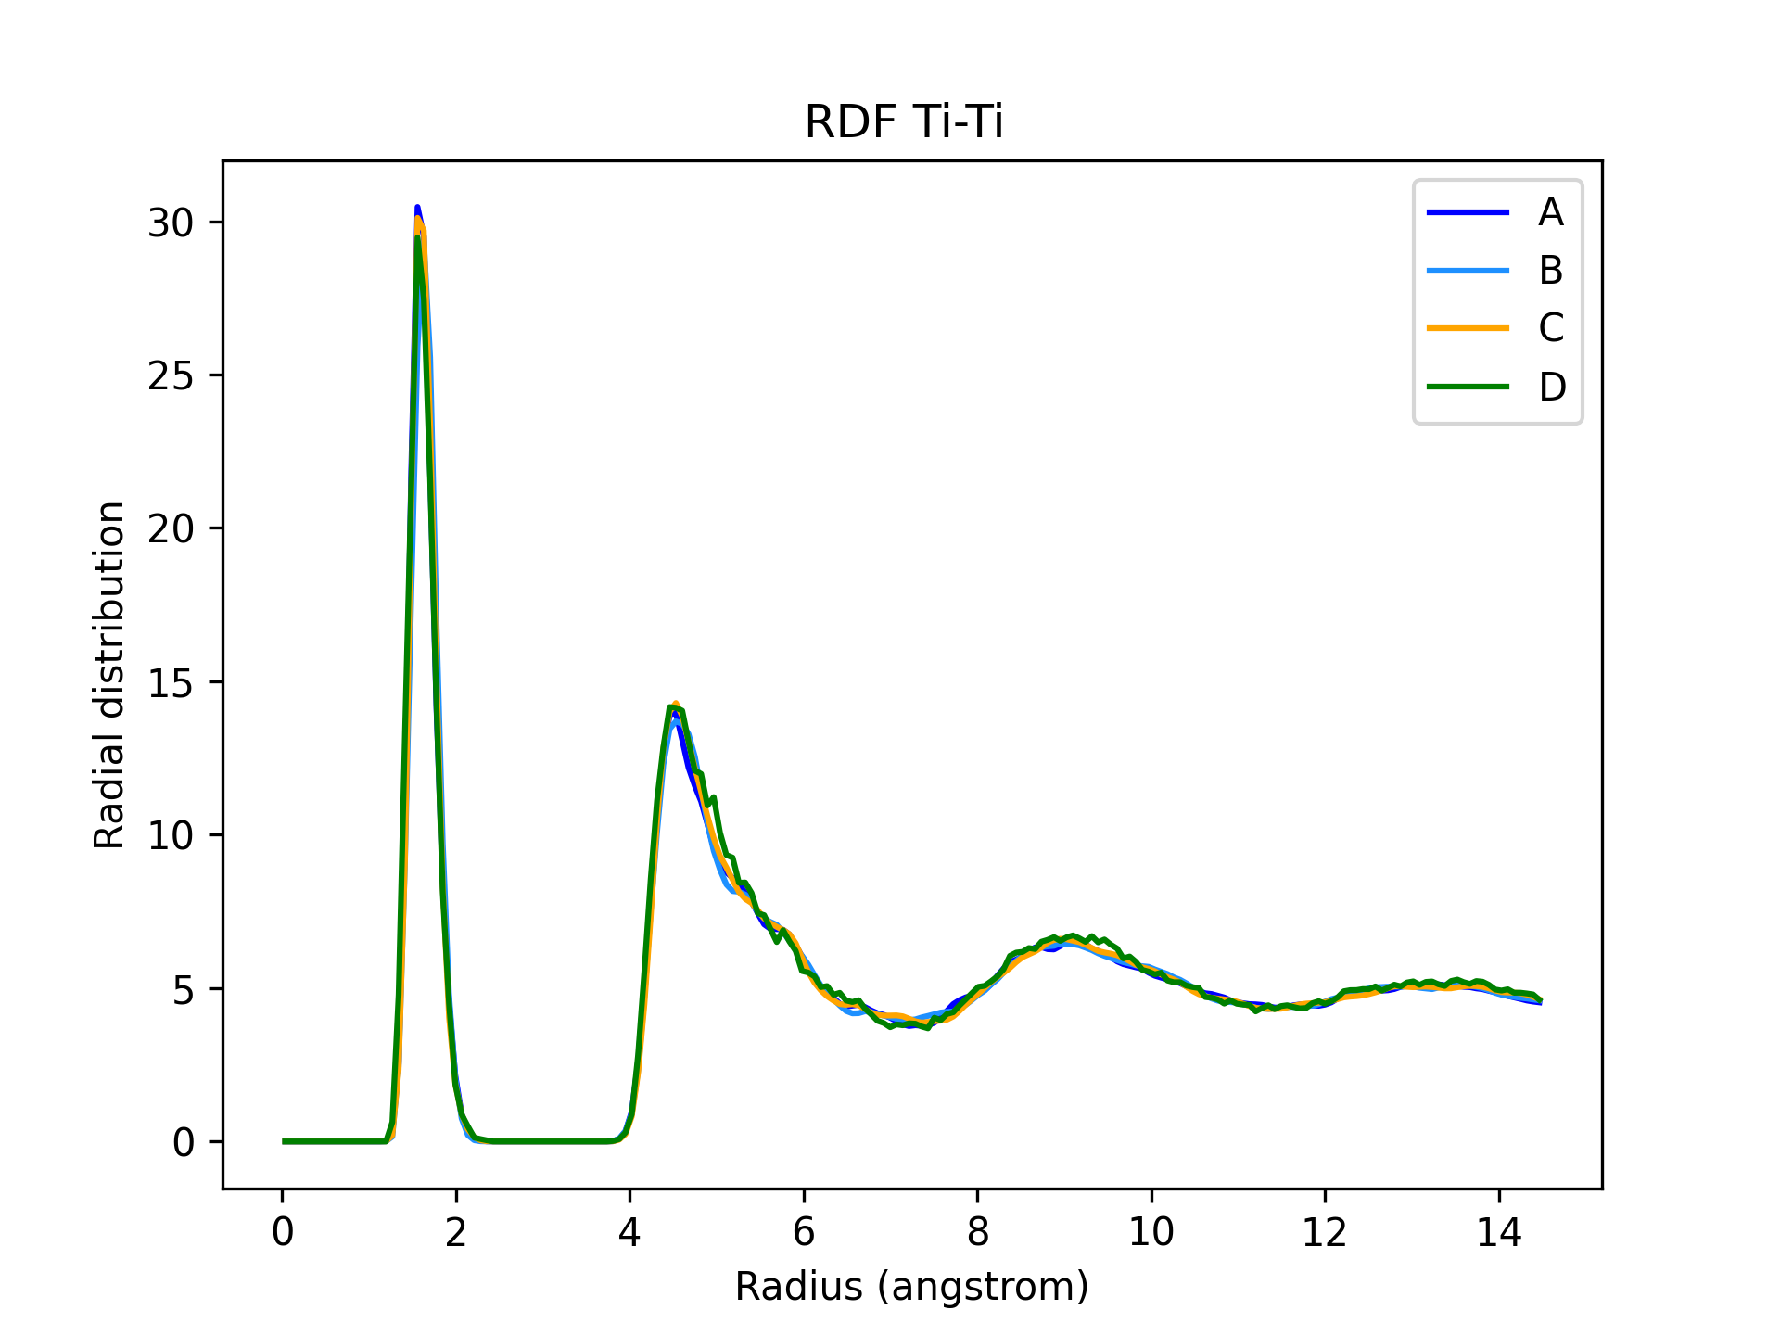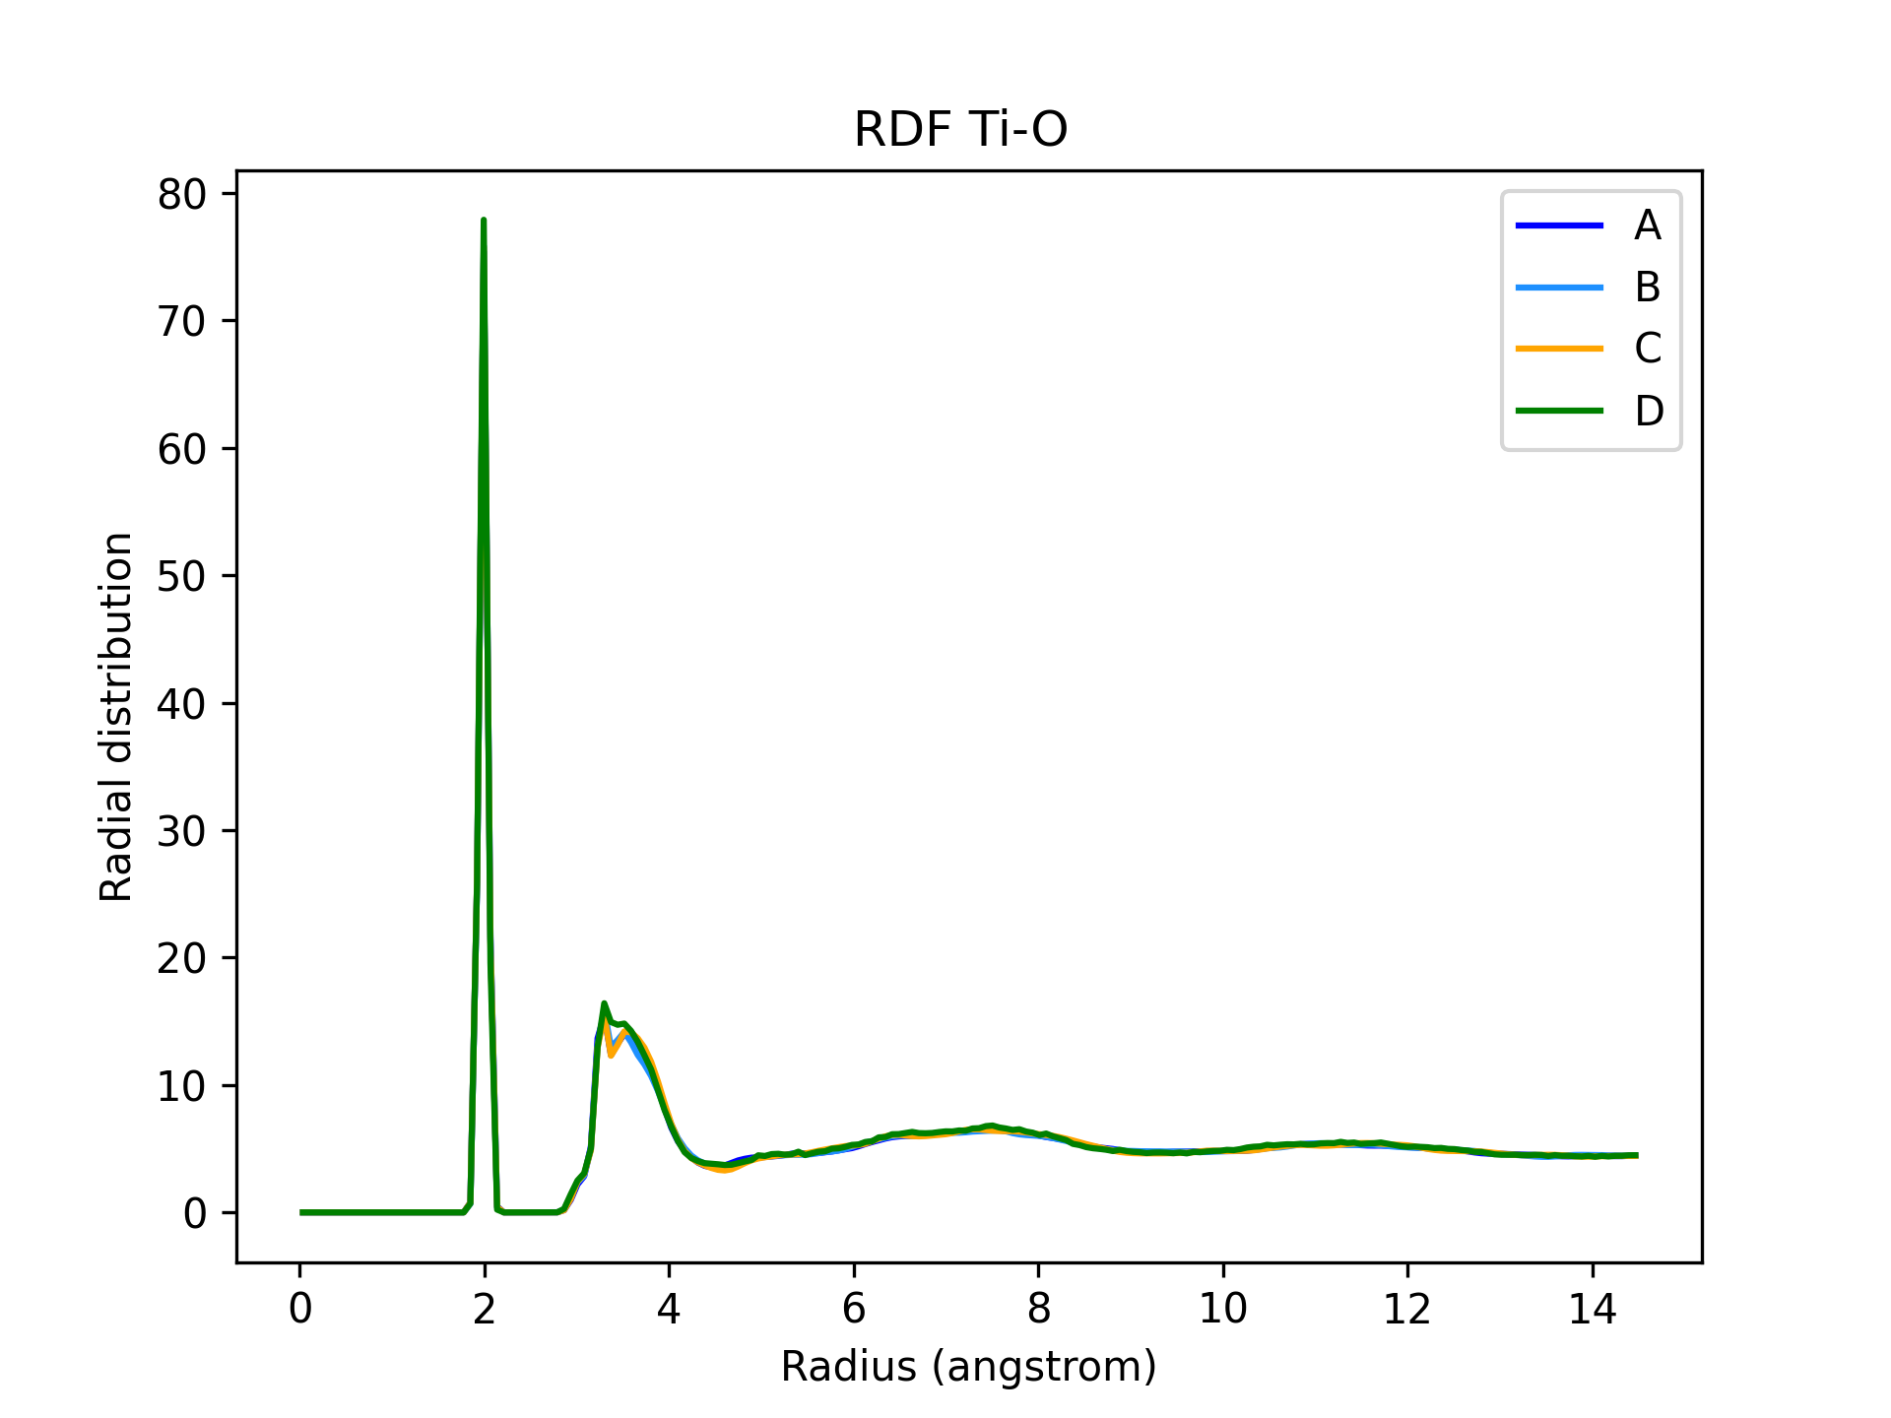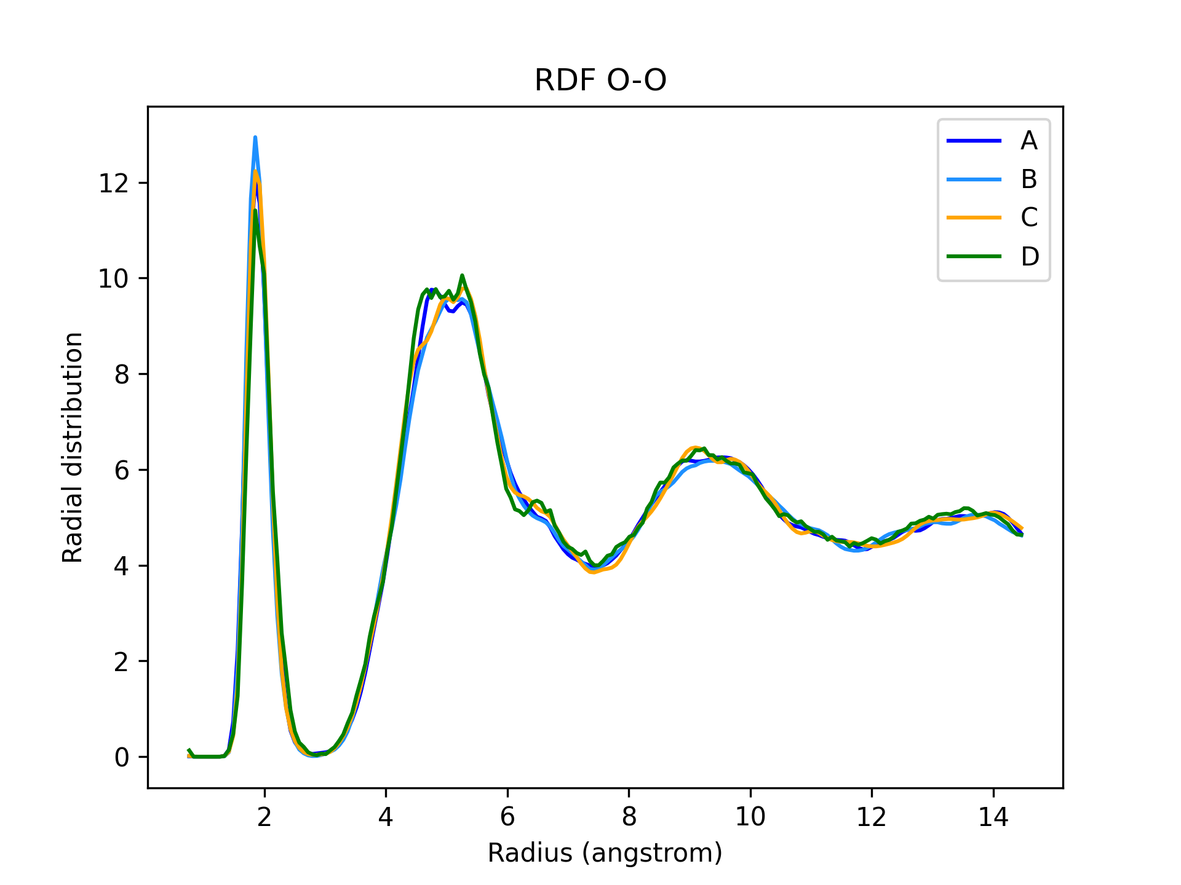
Figure 1S. RDF for a) Ti–Ti, b) Ti–O and c) O–O

In Fig. 1S is shown the RDF for the Ti–Ti atomic pair, where it is evident the distance pattern that characterizes the TiO₂ unitary cell. More precisely, a sequence of titanium shells is visible. The first sharp shell is about at 1.6 Å, while two others, wider shells are evident at 4.5 Å and 9 Å. The last shell is quite widespread because of the fluctuations due to lattice vibrations. This is also evidence that the titanium dioxide lattice loses the perfectly crystalline structure in favor of a less regular but still periodic pattern. Similarly, Fig. 1S also reports the RDF for the titanium and lattice oxygen pair, with two main oxygen shells at about 2 Å (very sharp) and 3.4 Å (wide), in accord with the unit cell pattern distances. Finally, in Fig. 1S is also plotted the RDF for the pair of lattice oxygens, with peaks at about 2, 5 and 9 Å, confirming again unitary cell coordination pattern. Overall, there are no differences among the four systems A, B, C and D, as expected, concerning lattice–lattice interactions. These four RDFs thus provide a re–validation of the correctness of the adopted force field: unitary cell pattern is correct and consistently maintained during simulations.

Water structure (Ow–Ow, Ow–Hw, Hw–Hw)

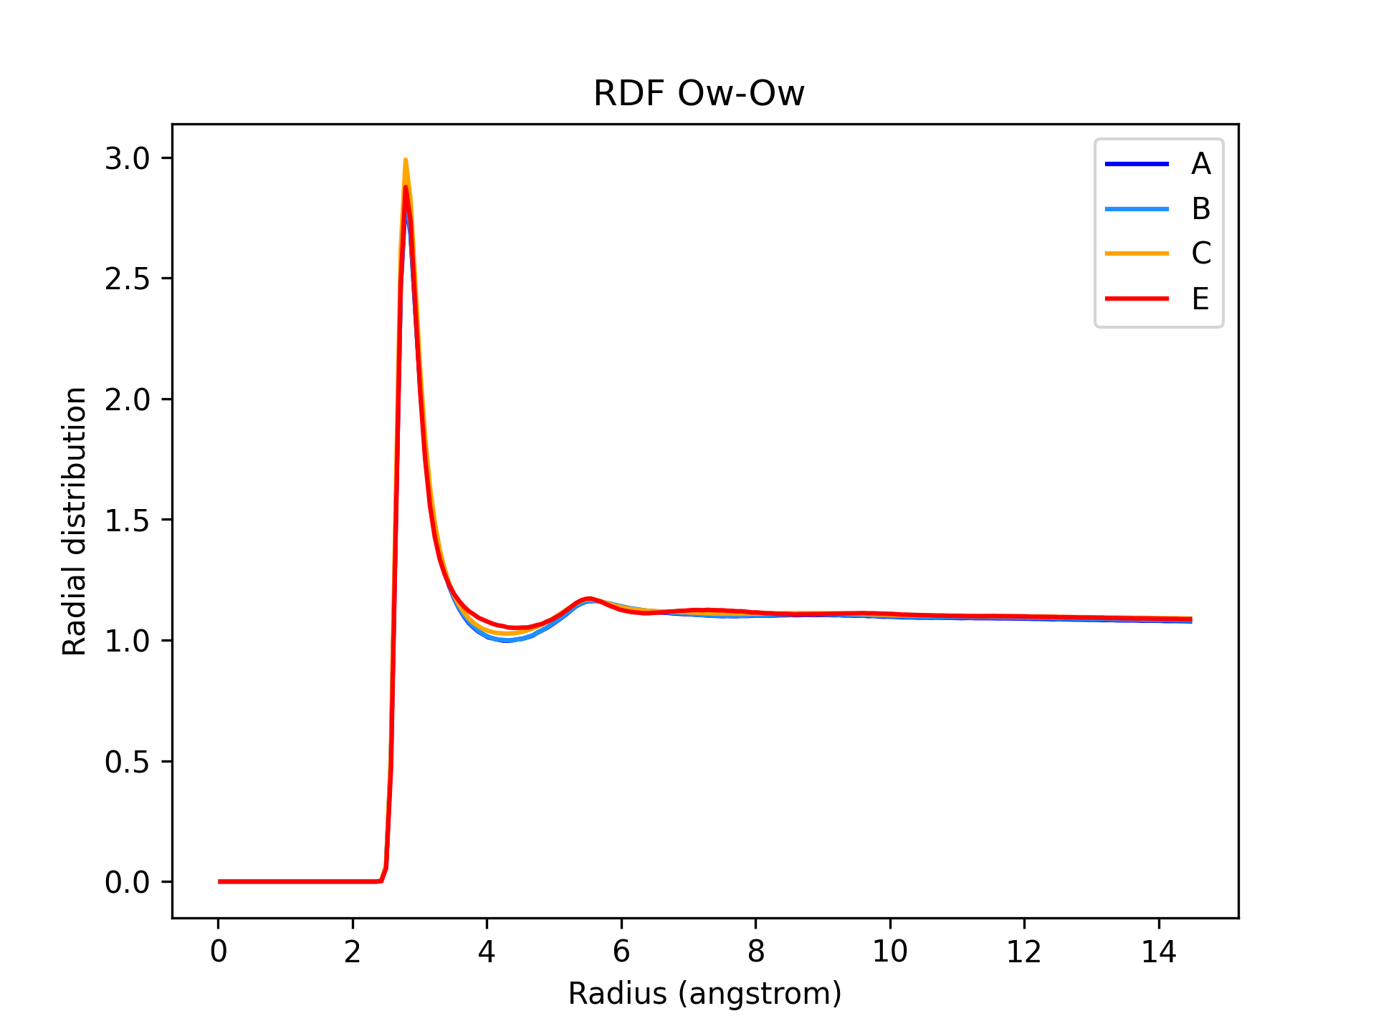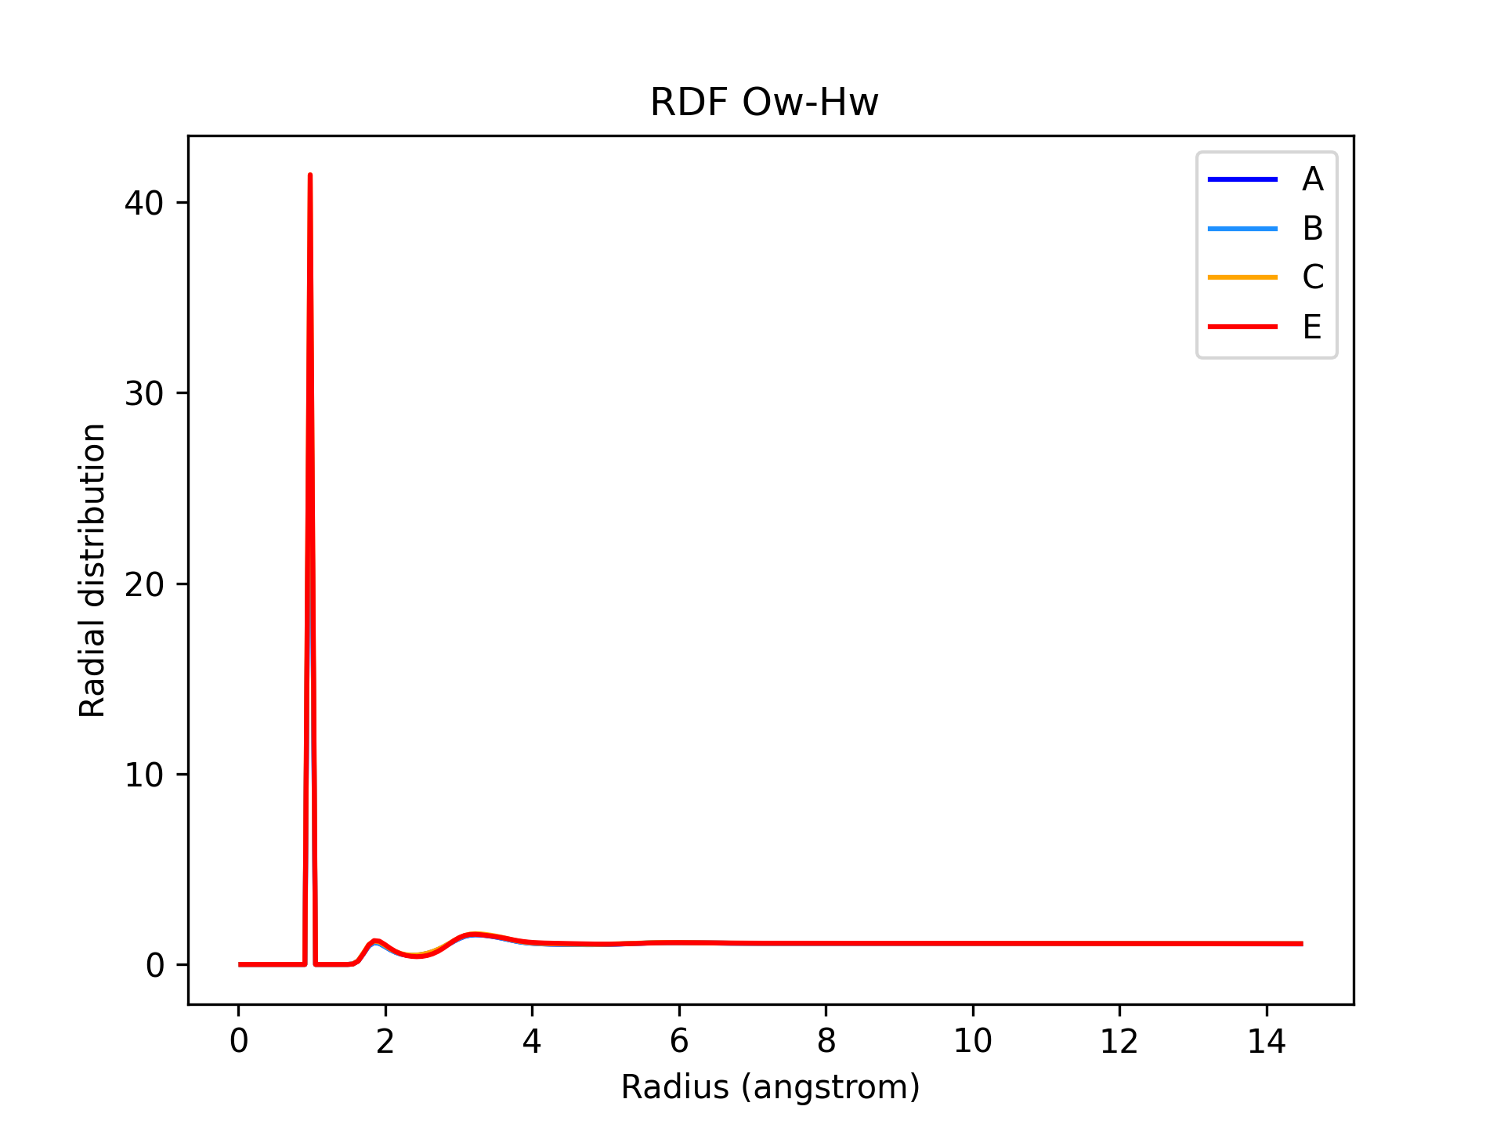
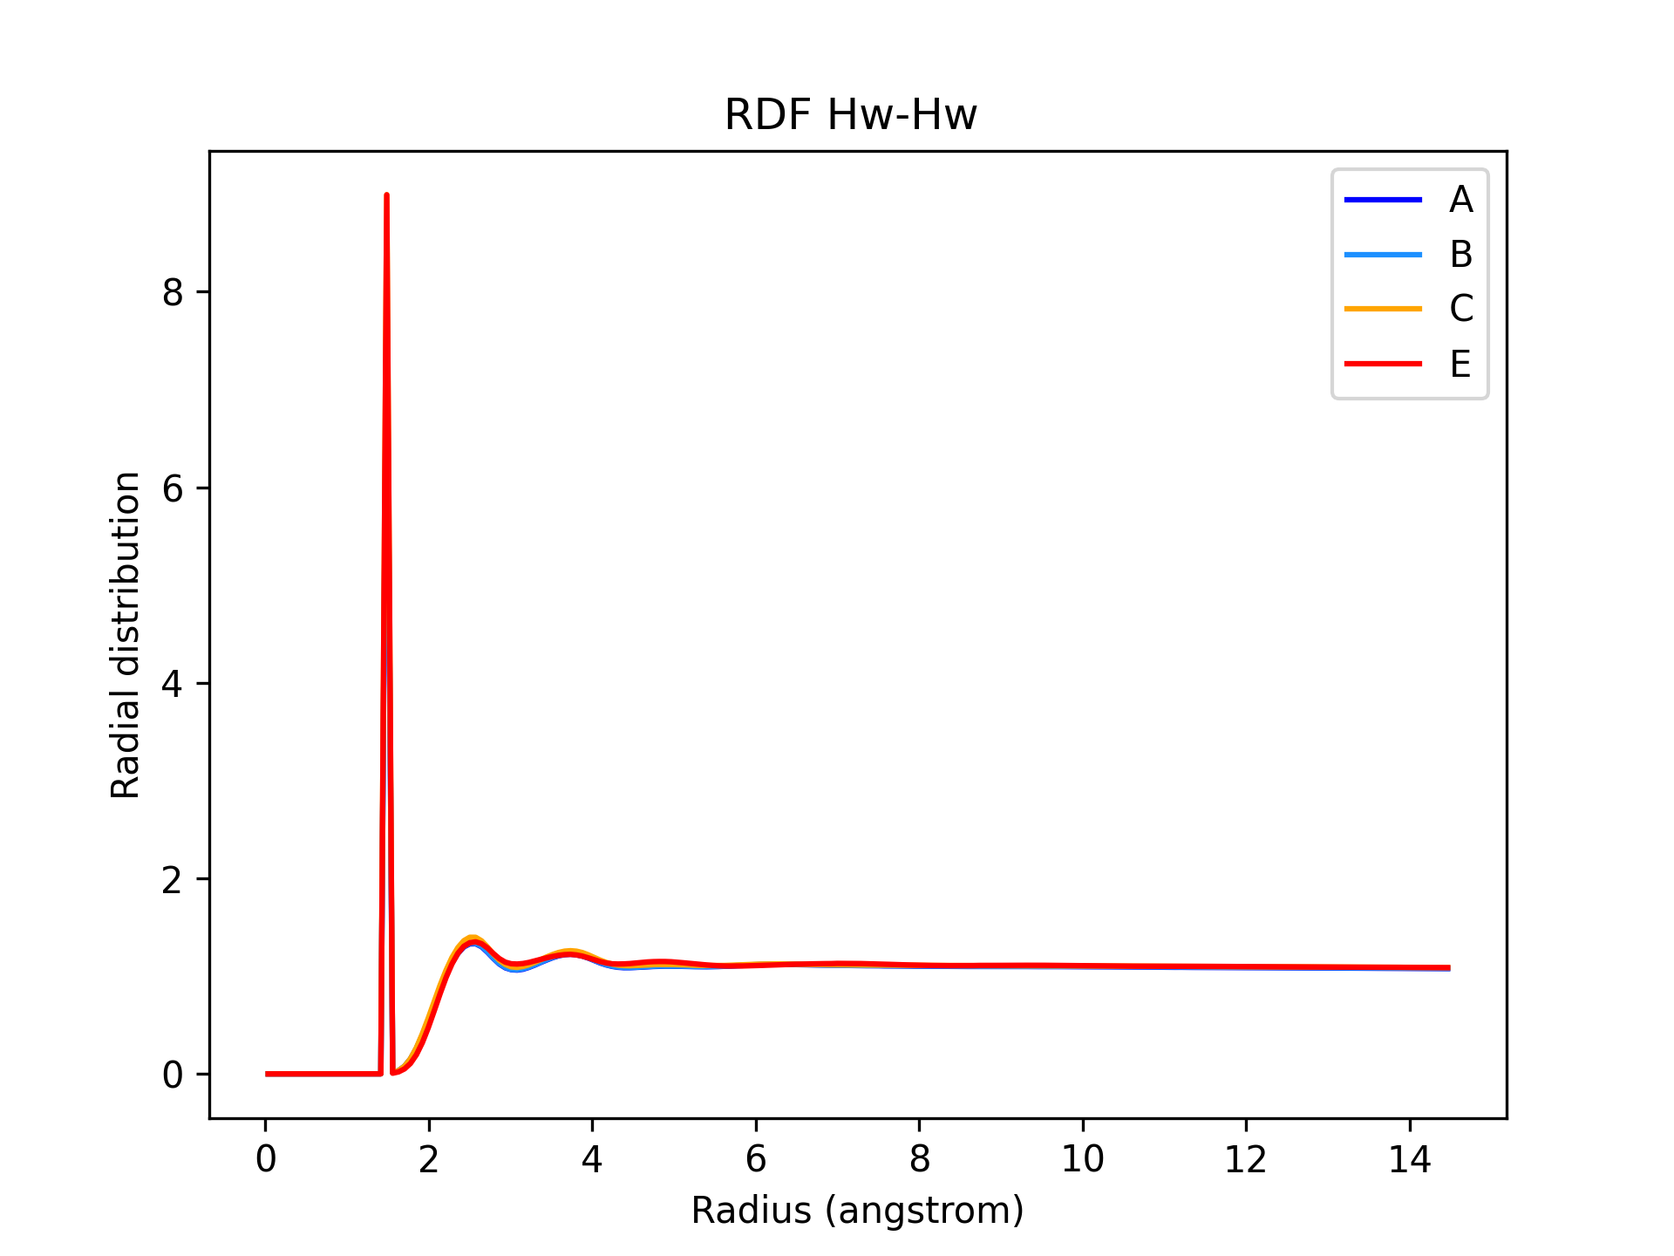

Figure 2S. RDF for the pairs a) Ow–Ow, b) Ow–Hw and c) Hw–Hw

For the case of the water–water RDF, there is no surprise, as can be seen in Fig. 2S, that confirms the standard facts about water structure and organization.

6) Water Orientational Relaxation Graphs

We have evaluated the water orientational relaxation by using the MDAnalysis WaterOrientationalRelaxation routine (Yeh et al, 1999) to analyze “how fast” water molecules are rotating/changing direction. We have evaluated WOR OH, WOR HH and WOR dip respectively representing the orientational relaxation around the OH axis of the water molecule, around the HH axis and around the charge dipole axis of the TIP3P molecule present in the systems.

System A
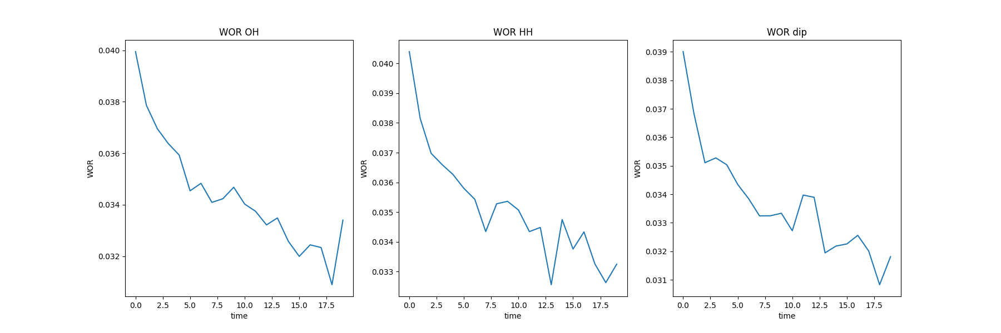
System B
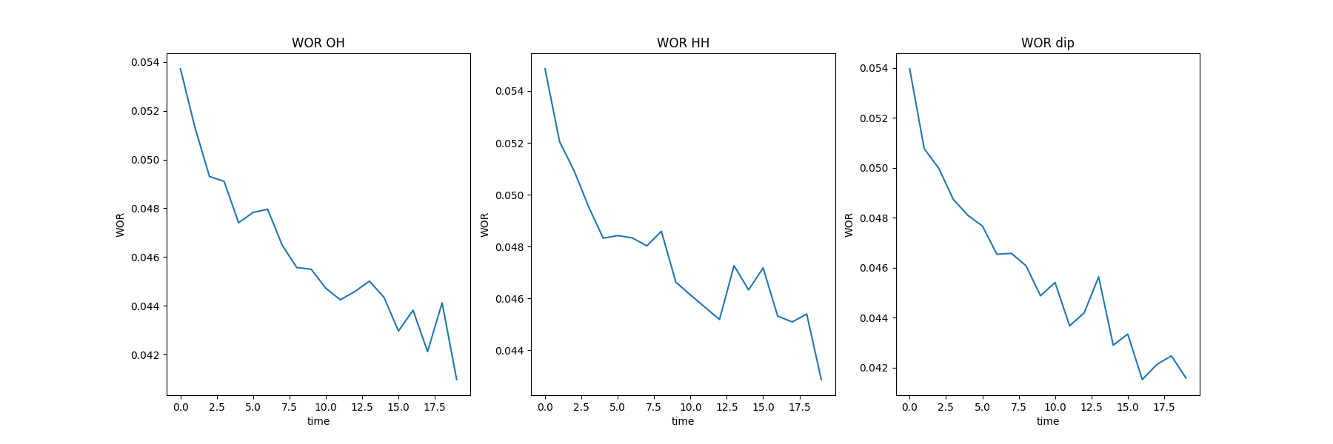
System C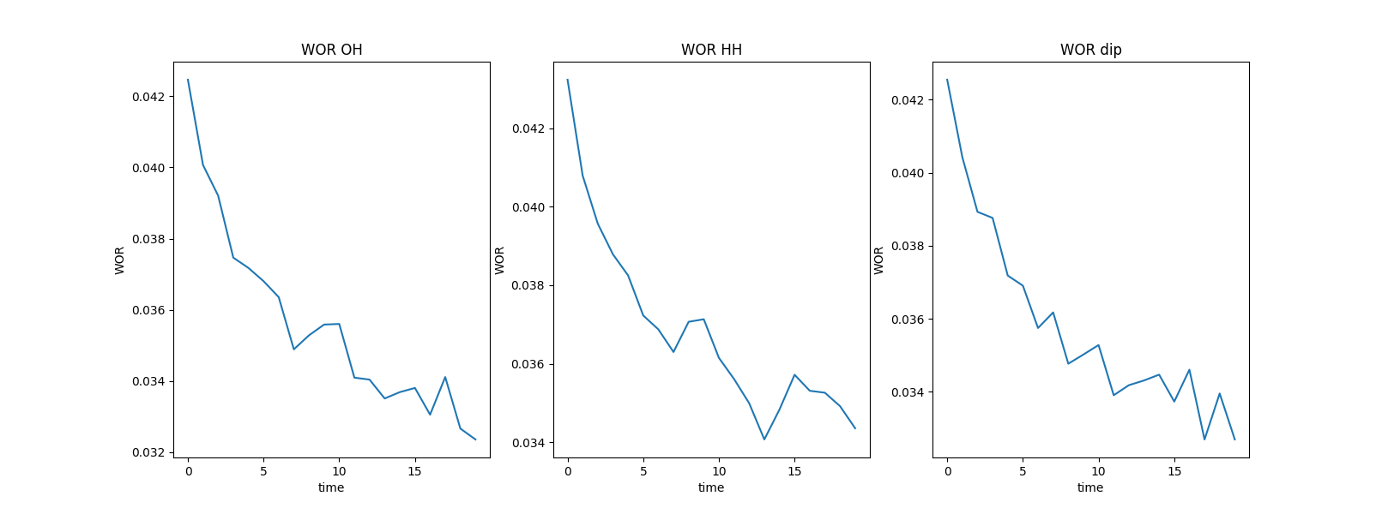Figure 3S. Water Orientation Relaxation Pictures for the systems A, B, C

7) References

Mark P, Nilsson L (2001). Structure and Dynamics of the TIP3P, SPC, and SPC/E Water Models at 298 K. J. Phys. Chem. A 105(43):9954–9960. https://doi.org/10.1021/jp003020w.

Yeh YL, and Chung-Yuan Mou CY (1999). Orientational Relaxation Dynamics of Liquid Water Studied by Molecular Dynamics Simulation, J. Phys. Chem. B, 103:3699-3705. https://doi.org/10.1021/jp984584r.

