Table 1: Comparison of VAS, PCS, and WOMAC in HP and NHWP populations, as well as comparisons of demographic information such as Age, Height, CCI, and SES. Bolded values indicate significance.
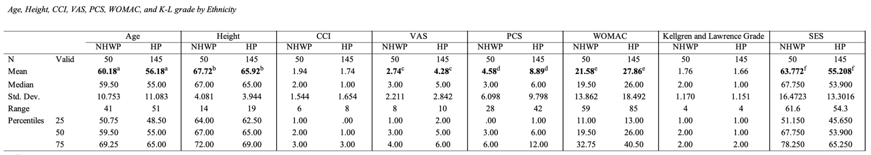

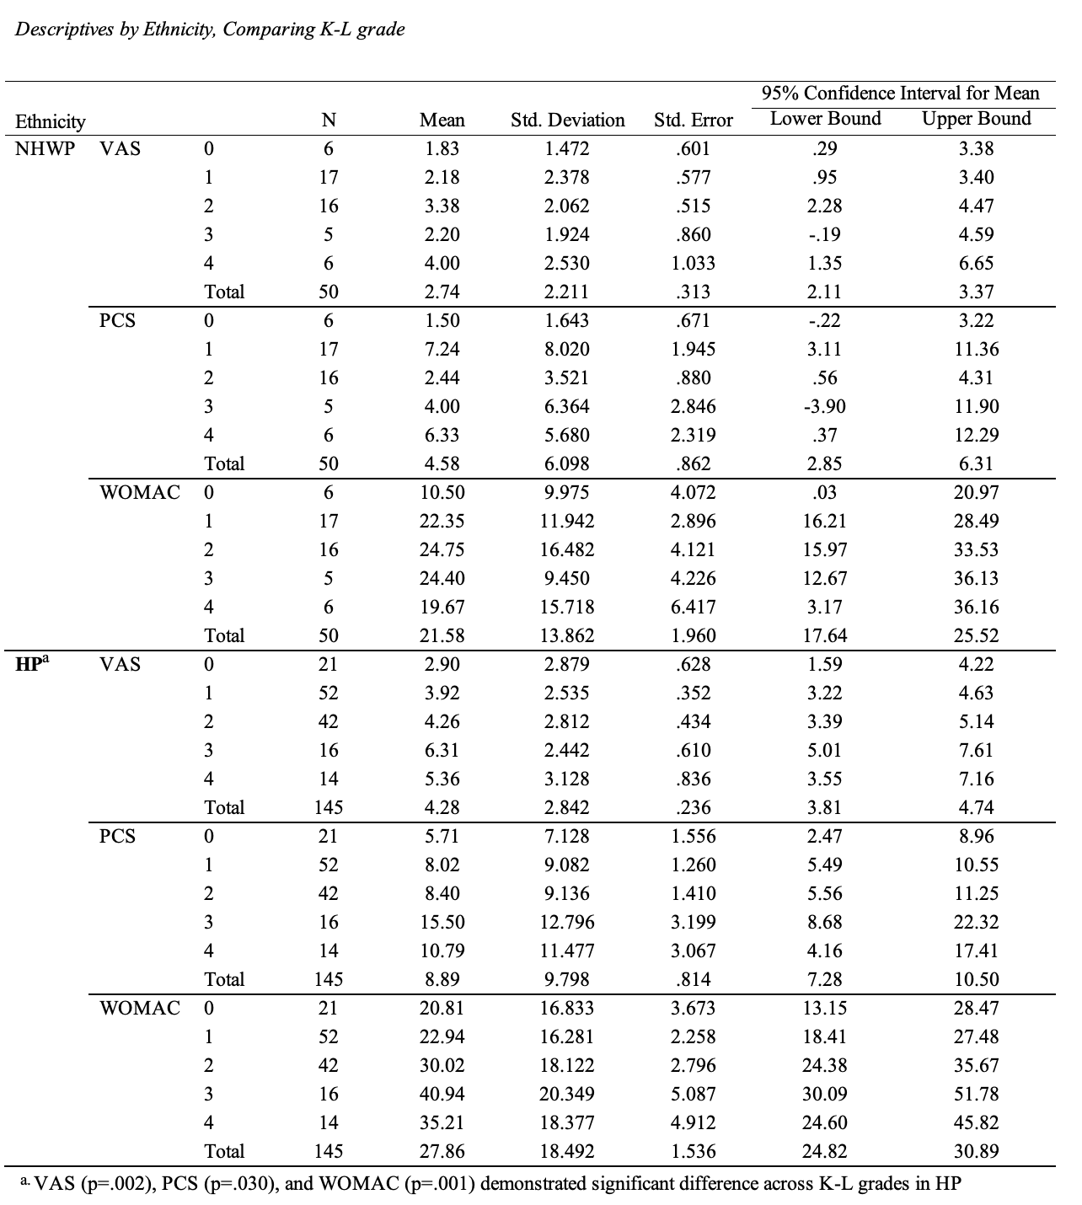
Table 2: Comparison of VAS, PCS, and WOMAC by K-L grade, stratified by Ethnicity.

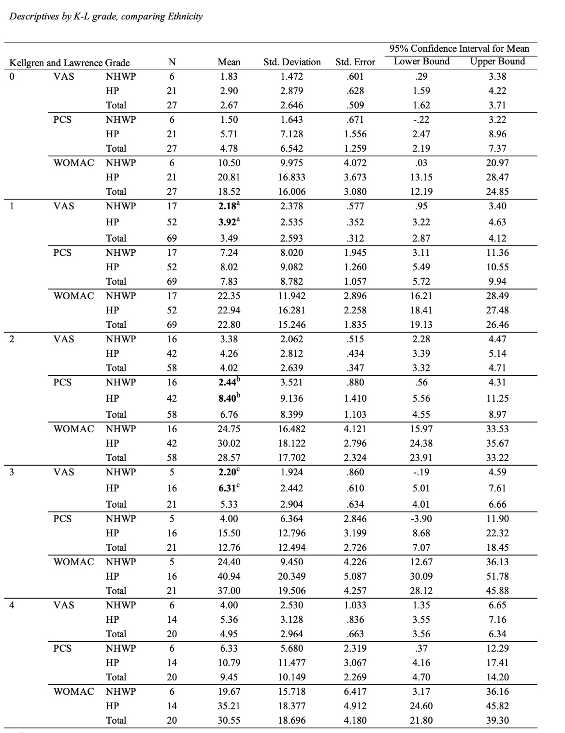
Table 3. Comparison of outcomes VAS, PCS, and WOMAC between HP and NHWP, stratified by K-L grade.

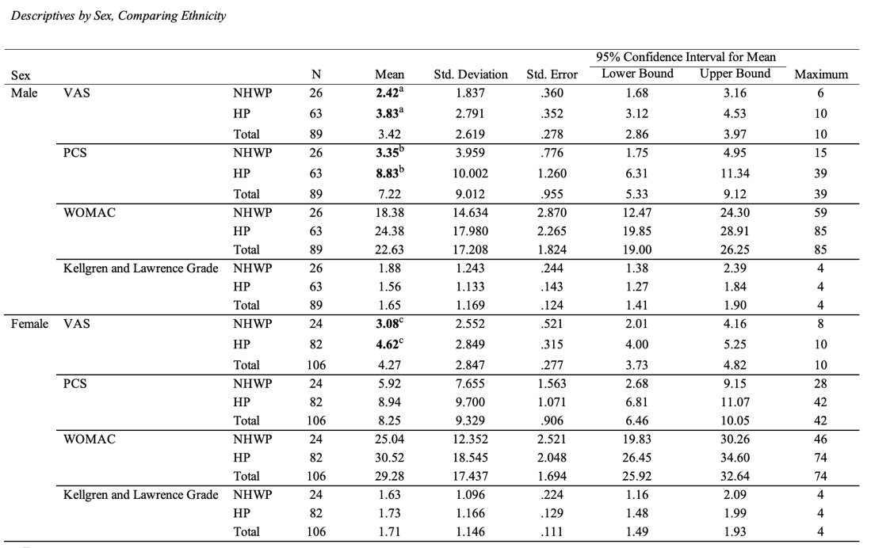

Table 4: Comparison of outcomes VAS, PCS, WOMAC between HP and NHWP, stratified by sex.

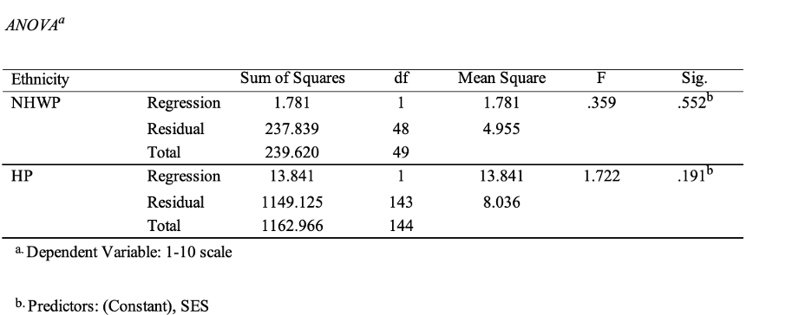

Table 5: ANOVA testing evaluating the effect of SES on VAS between HP and NHWP.
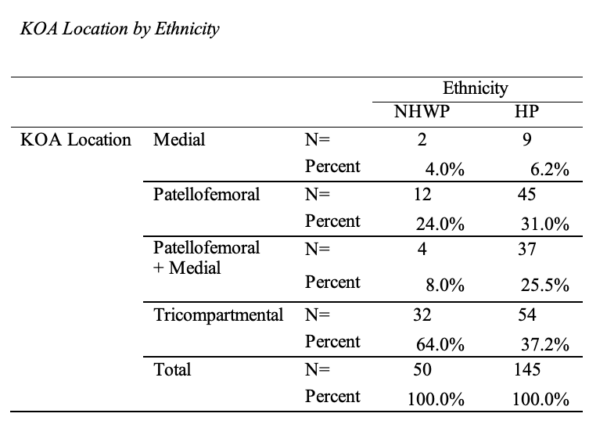
Table 6: Experimental data of Hispanic and Non-Hispanic White subjects included in the study. Measurements are reported as % (n).

