SUPPLEMENTAL FIGURES

Supplemental Figure 1

Supplemental Figure 2
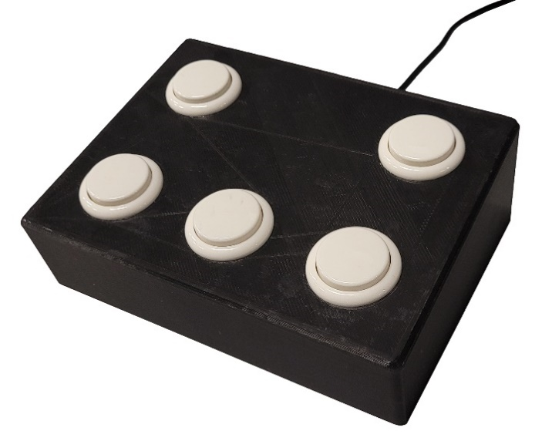
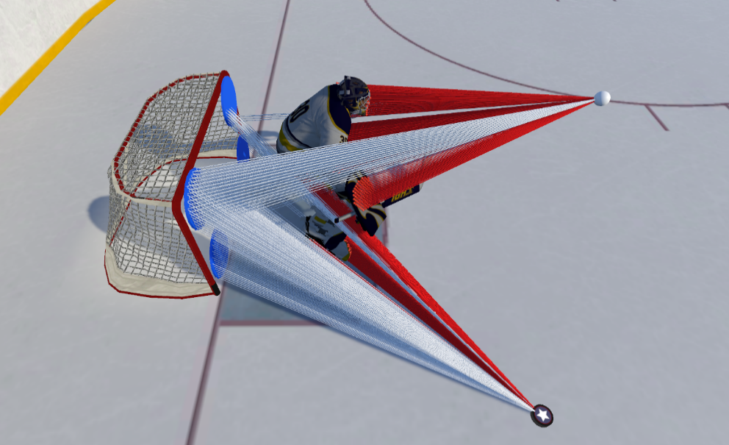
Supplemental Figure 3.

