Supplementary Materials for
Durable All Inorganic Perovskite Tandem Photovoltaics
Chenghao Duan et al.
*Corresponding author. E-mail: kyyan@scut.edu.cn

The PDF file includes:
Figs. S1 to S47
Tables S1 to S8
References (46–71)

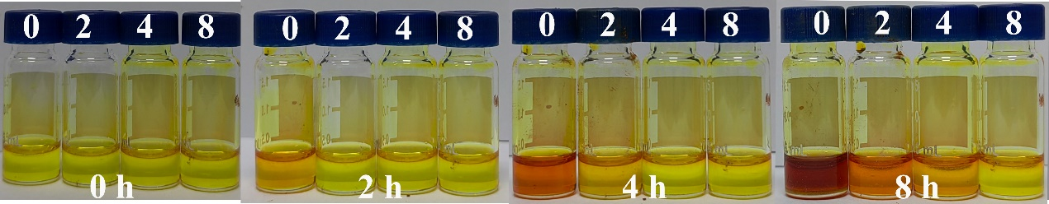
Fig. S1 Photographs of color change with the aging time of CsPb_{1-x}Sn_{x}I₃ perovskite precursor solution with different concentrations of PTSH in the air (mg/mL). The coordination of PTSH with Sn²⁺ ions can enhance the electron cloud density to surround Sn²⁺ ions and inhibit oxidation⁴⁶.

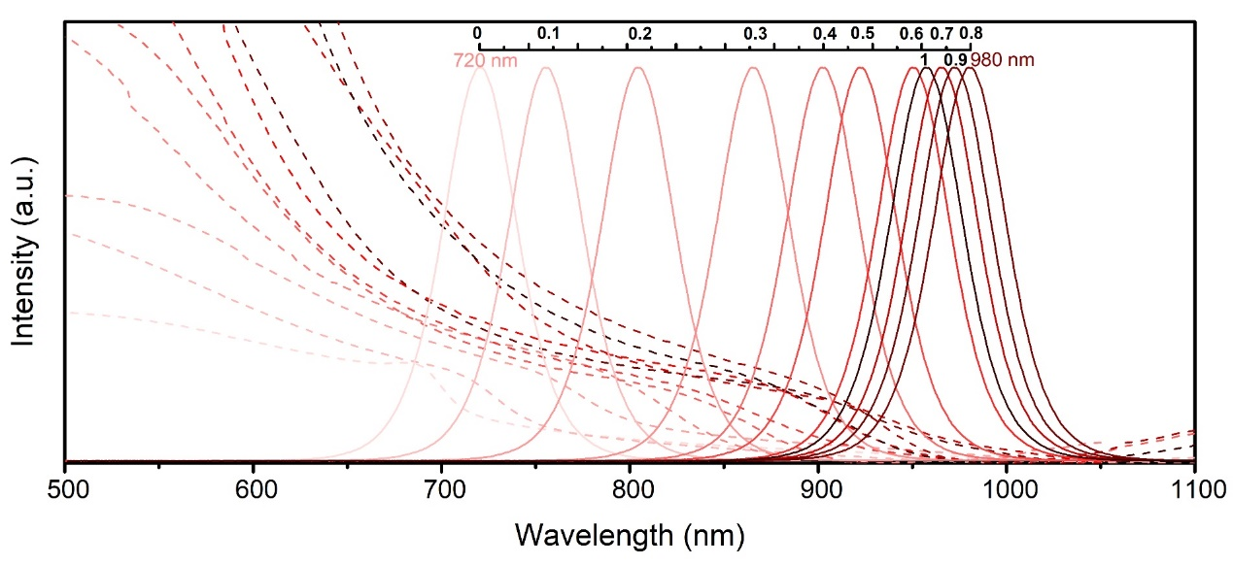
Fig. S2 The UV–vis absorption and Photoluminescence (PL) spectra of CsPb_{1-x}Sn_{x}I₃ (x = 0, 0.1, 0.2, 0.3, 0.4, 0.5, 0.6, 0.7, 0.8, 0.9, and 1.0) inorganic perovskites. Notably, when x=0.8, the PL emission spectrum of CsPb_{0.2}Sn_{0.8}I₃ manifests an exciting wavelength of approximately 980 nm.
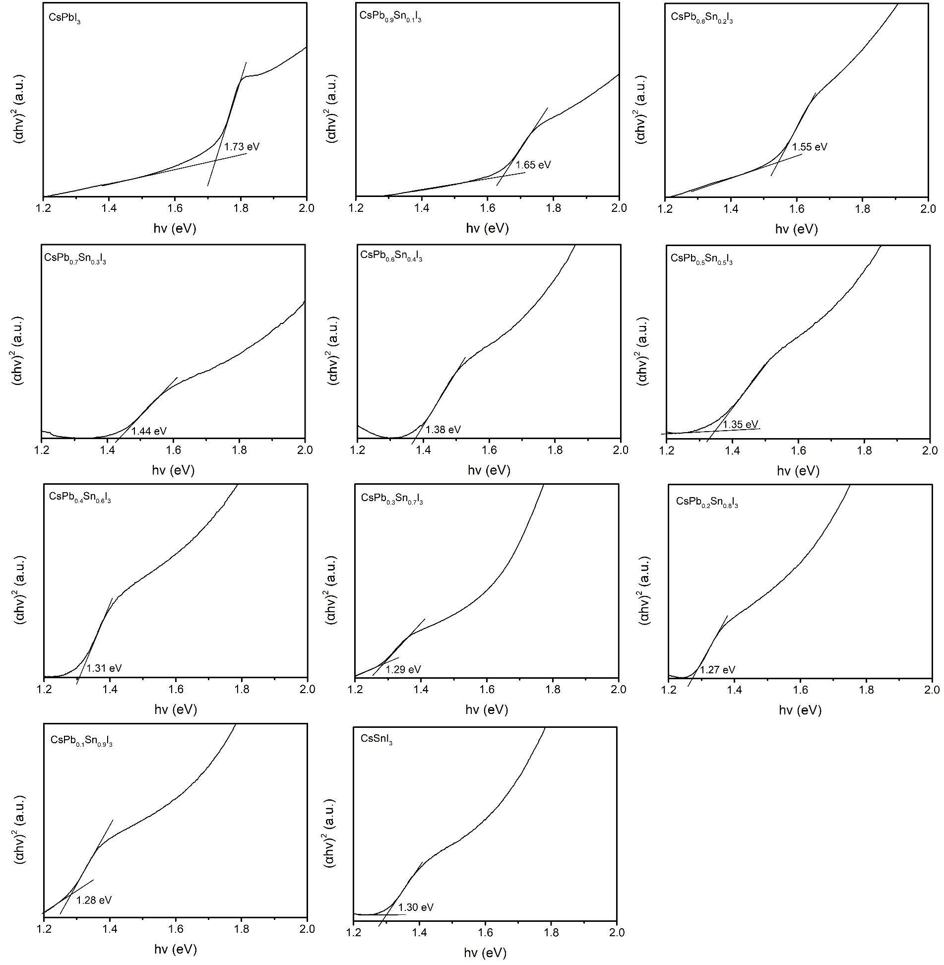
Fig. S3 Tauc plots of the CsPb_{1-x}Sn_{x}I₃ films. Due to the bandgap bowing effect of Sn−Pb alloyed perovskites, CsPb_{1-x}Sn_{x}I₃ (1>x≥0.7) perovskite demonstrated lower bandgap compared to CsPbI₃ or CsSnI₃.

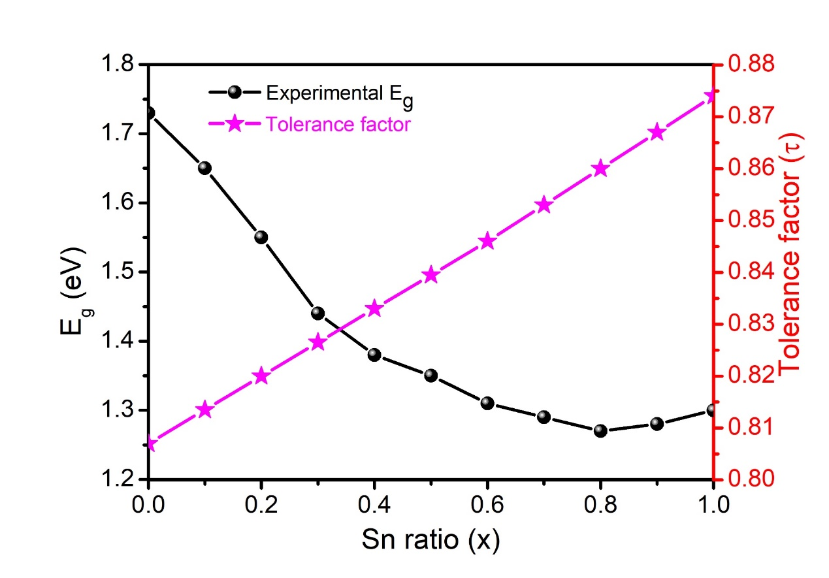
Fig. S4 Variation of experimental bandgaps and tolerance factors as a function of x in CsPb_{1-x}Sn_{x}I₃. Geometric stability analysis was conducted by evaluating the tolerance factor (τ) and formation energy of CsPb_{1-x}Sn_{x}I₃ perovskites. With an increase in Sn content, τ gradually increases from 0.807 to 0.875. This can be attributed to the smaller ionic radius of Sn²⁺ (0.93 Å) compared to Pb²⁺ (1.19 Å), which means that replacing Pb with Sn can improve the stability of the perovskite structure⁴⁷.

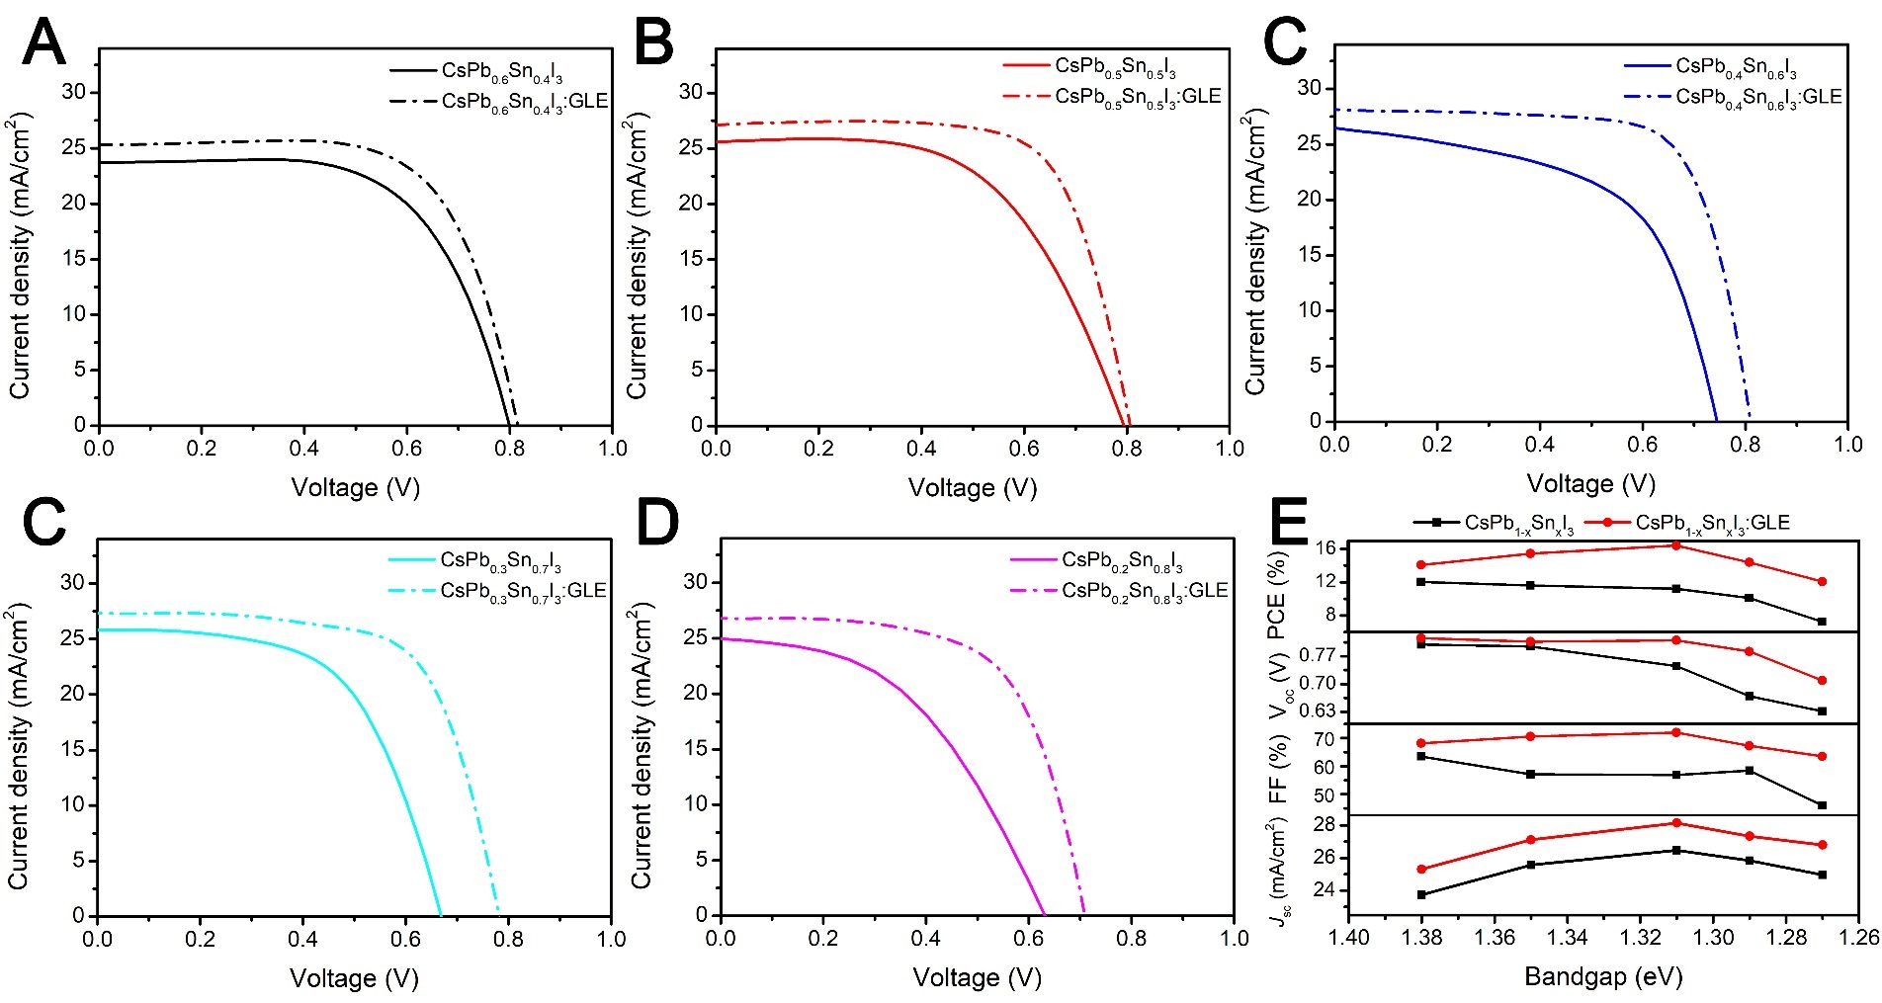
Fig. S5 (A-D) J-V characteristic curves of the CsPb_{1-x}Sn_{x}I₃ (0.8≥x≥0.4) PSCs without and with GLE under AM 1.5G 100 mW/cm² simulated solar light. (E) Performance changes of CsPb_{1-x}Sn_{x}I₃ (0.8≥x≥0.4) PSCs without and with GLE. By comparing the J-V curves of different CsPb_{1-x}Sn_{x}I₃ (0.8≥x≥0.4) PSC systems, it can be found that the efficiency of CsPb_{1-x}Sn_{x}I₃ devices decreases with the increase of Sn content, mainly due to inferior film formation and serious defect state density of obtained perovskite films. The performance of all devices using the GEL strategy has increased, especially in the CsPb_{0.4}Sn_{0.6}I₃ system, which means that the strategy has good universality. Compared with the performance parameters of other NBG CsPb_{1-x}Sn_{x}I₃:GLE (x=0.4, 0.5, 0.7, or 0.8) PSCs, CsPb_{0.4}Sn_{0.6}I₃:GLE device presents a more promising prospect, especially in the application of tandem devices.

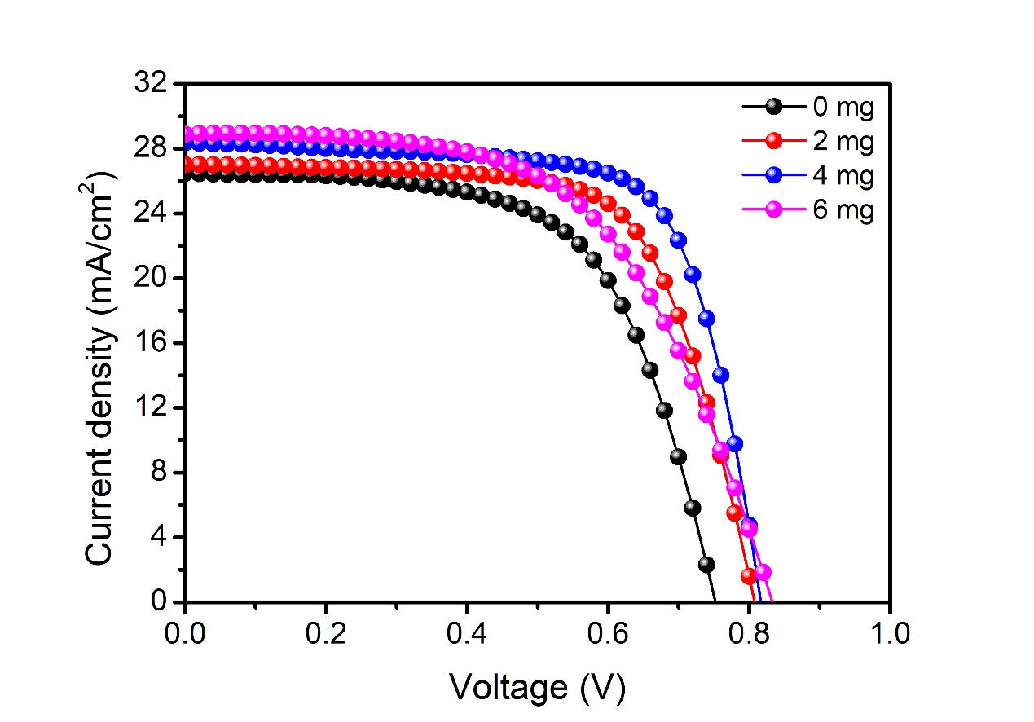
Fig. S6 J-V characteristic curves of the devices with different concentrations of PTSH under AM 1.5G 100 mW/cm² simulated solar light.
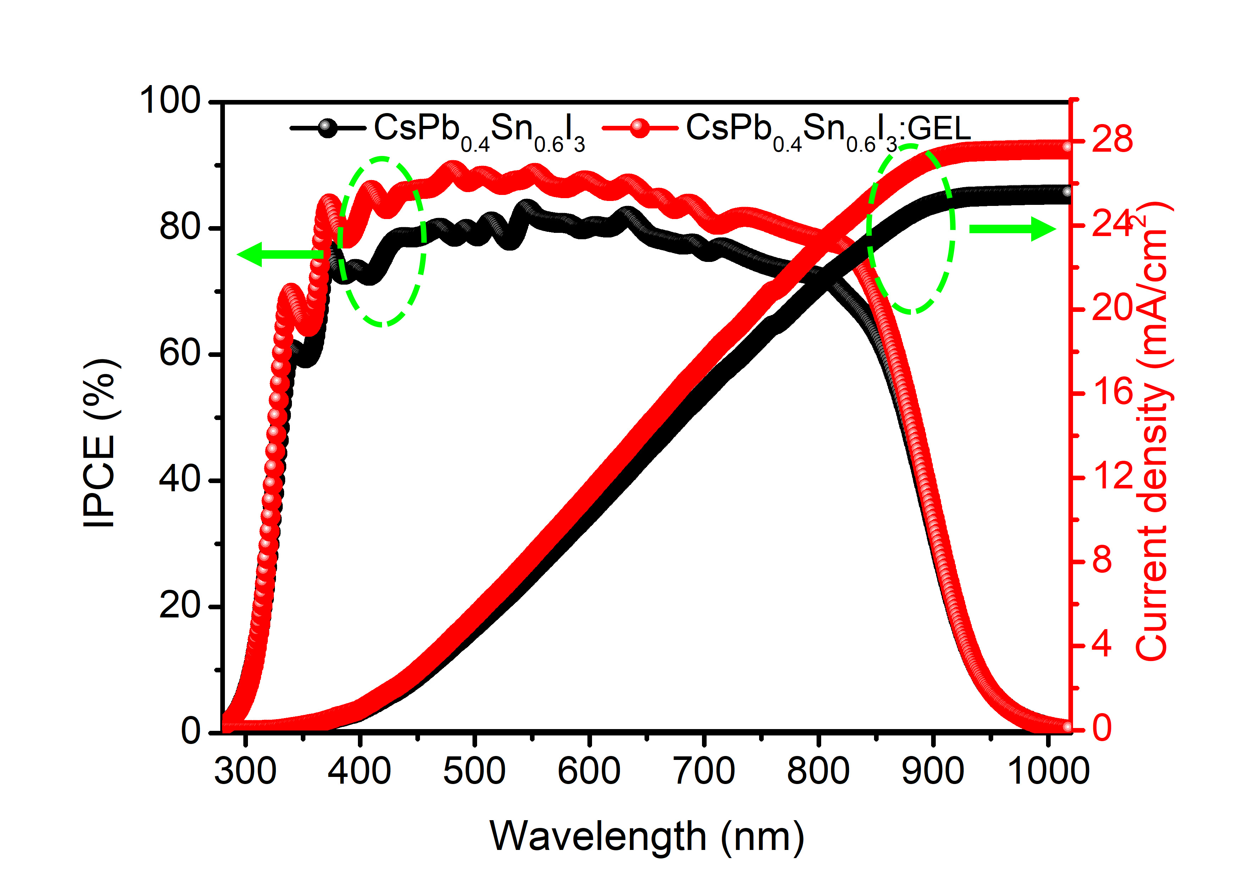
Fig. S7 IPCE spectra for the devices based on CsPb_{0.4}Sn_{0.6}I₃ and CsPb_{0.4}Sn_{0.6}I₃:GLE.
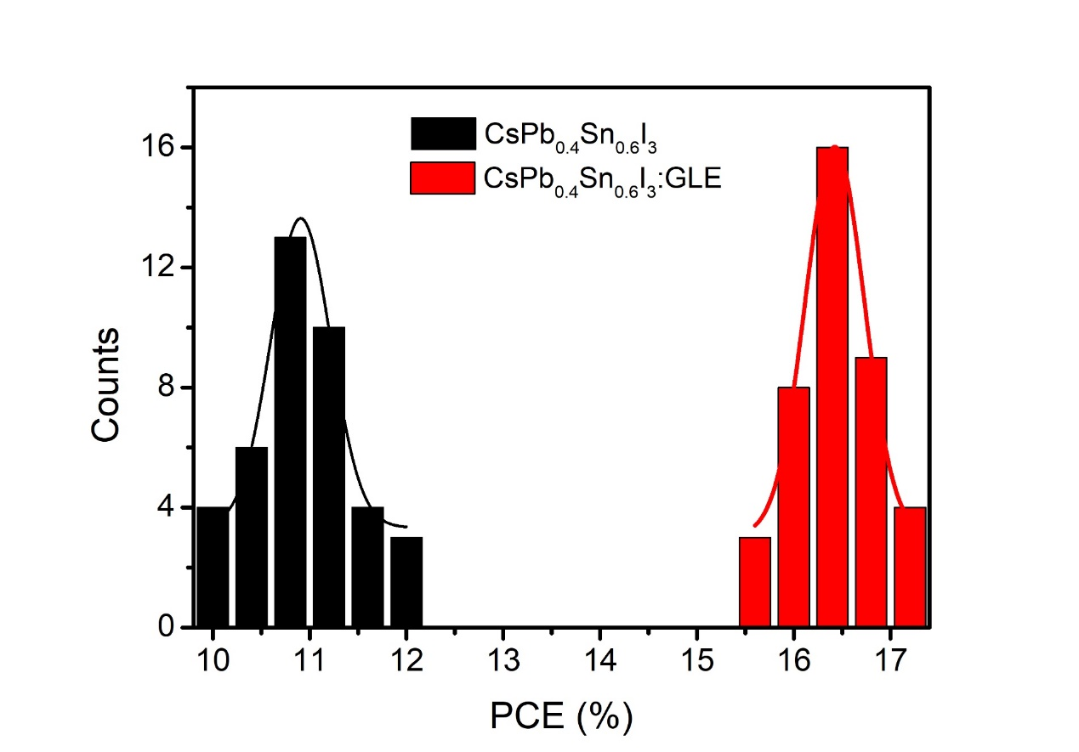
Fig. S8 Histograms for PCE of the devices based on CsPb_{0.4}Sn_{0.6}I₃ and CsPb_{0.4}Sn_{0.6}I₃:GLE. Error values represent S.D. calculated from 40 devices prepared at the same conditions.
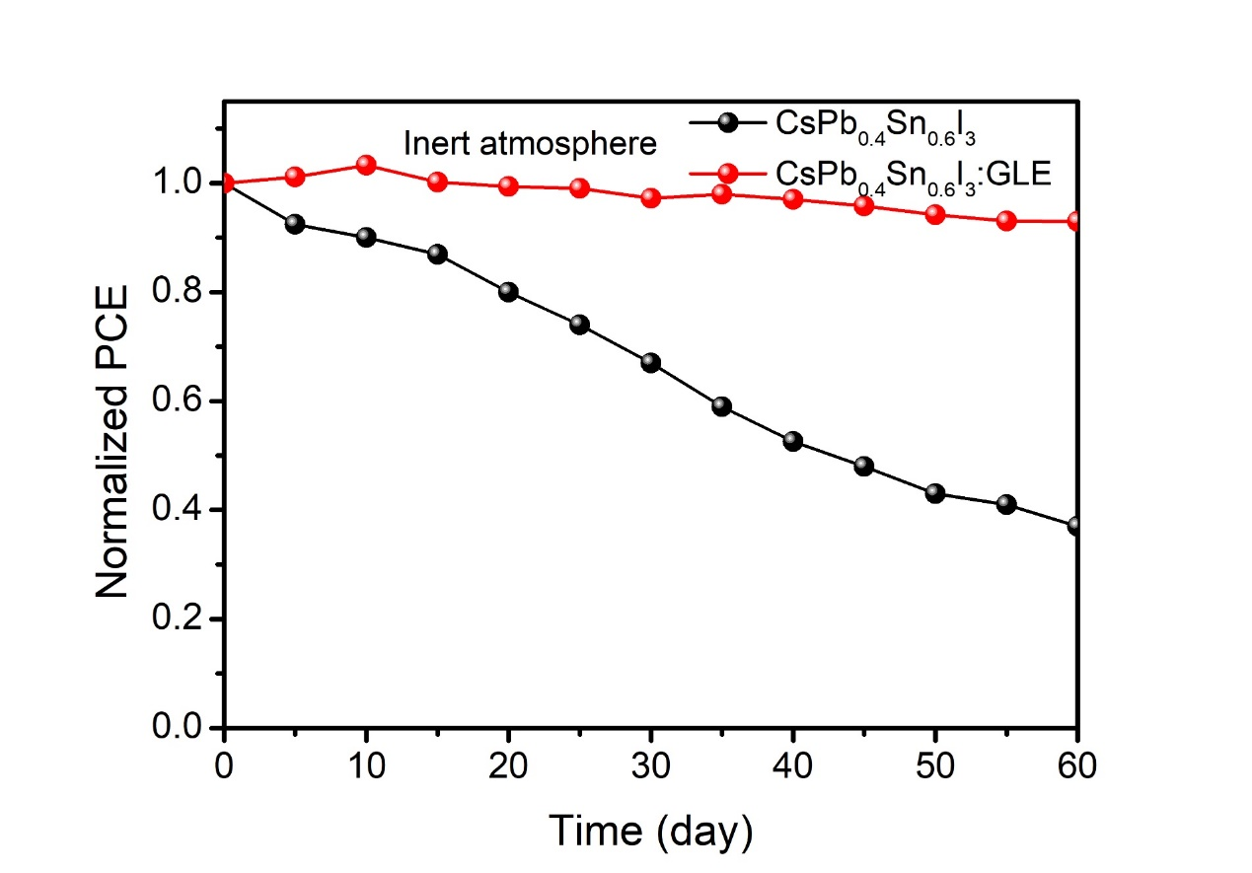
Fig. S9 PCE decays in an inert atmosphere for the devices based on CsPb_{0.4}Sn_{0.6}I₃ and CsPb_{0.4}Sn_{0.6}I₃:GLE.
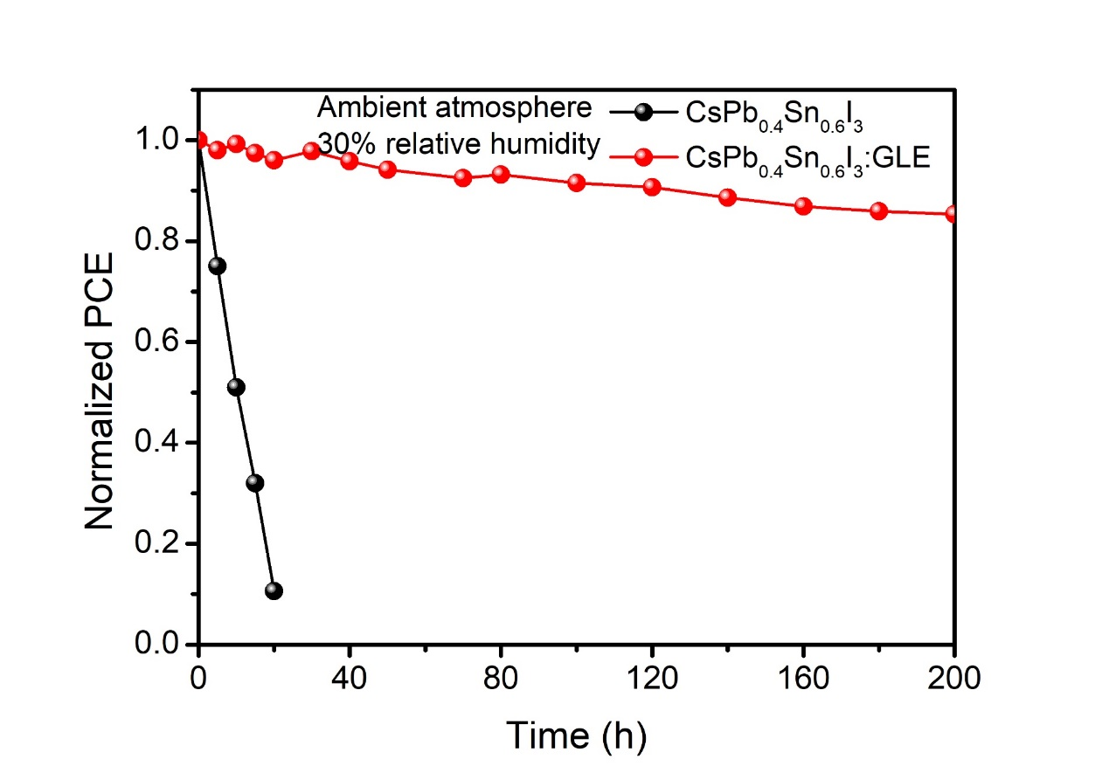
Fig. S10 Normalized PCE changes of the devices based on CsPb_{0.4}Sn_{0.6}I₃ and CsPb_{0.4}Sn_{0.6}I₃:GLE films in an ambient atmosphere with 30% relative humidity.

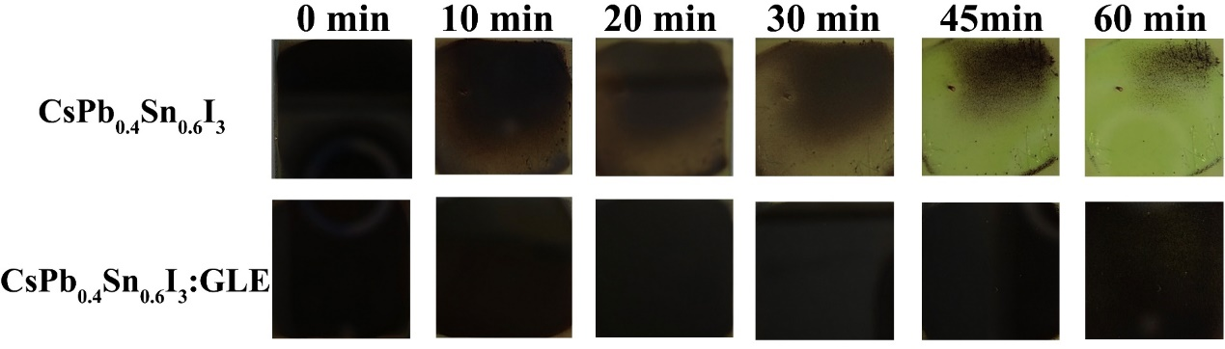
Fig. S11 The changes of CsPb_{0.4}Sn_{0.6}I₃ and CsPb_{0.4}Sn_{0.6}I₃:GLE perovskite films in the air with 50% relative humidity.

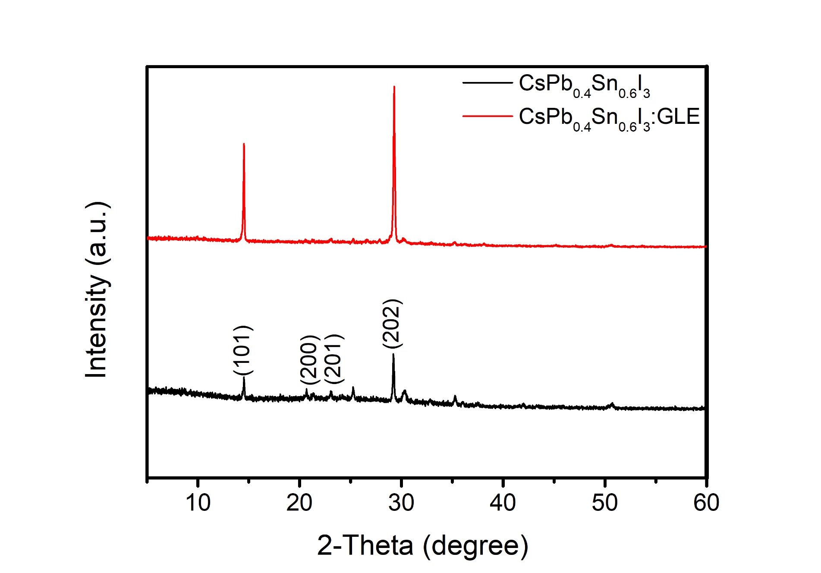
Fig. S12 XRD patterns of the CsPb_{0.4}Sn_{0.6}I₃ and CsPb_{0.4}Sn_{0.6}I₃:GLE films. The XRD spectra at approximately 14.5°, 20.7°, 23.1°, and 29.1°, is corresponding to the (101), (200), (201), and (202) crystal planes of perovskite, respectively.

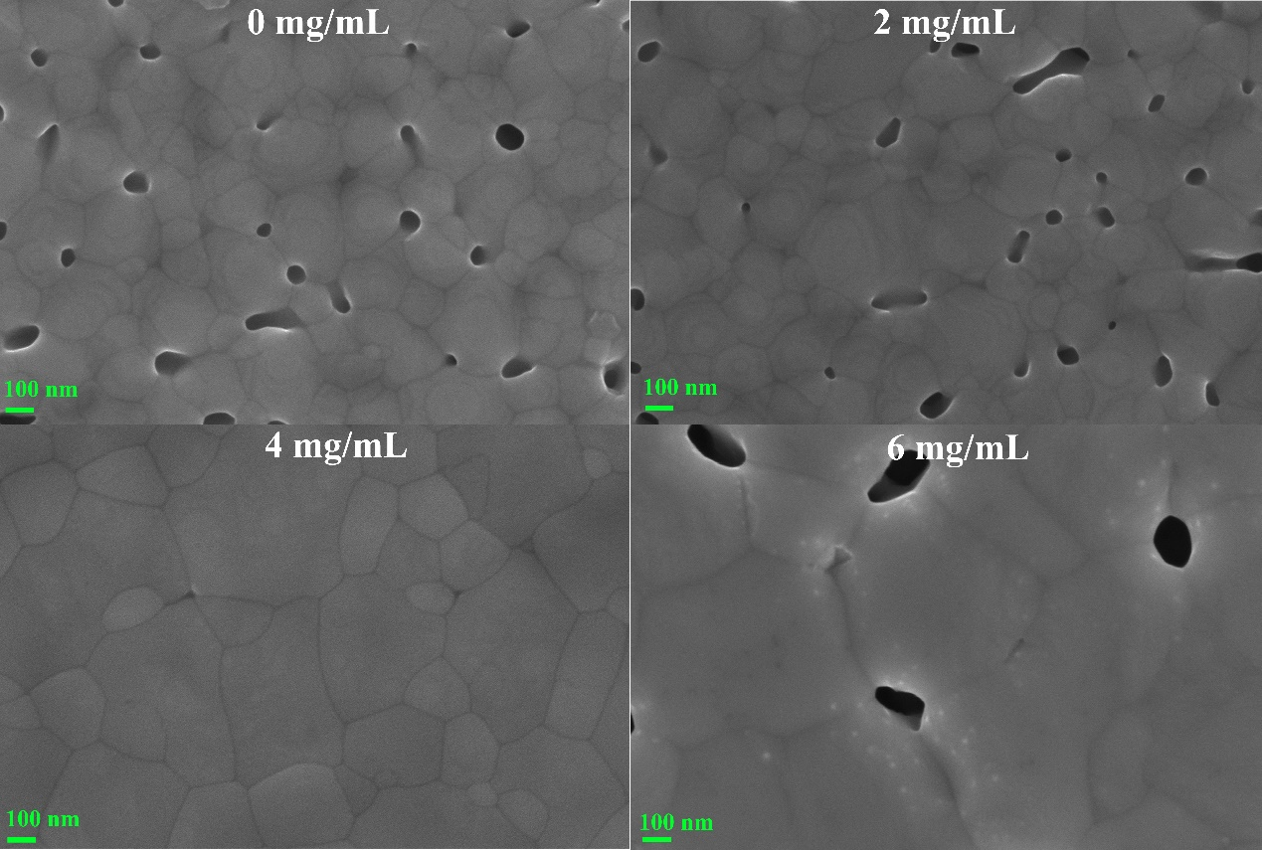
Fig. S13 SEM images of the CsPb_{0.4}Sn_{0.6}I₃ films with different concentrations PTSH (0, 2, 4, and 6 mg/mL).
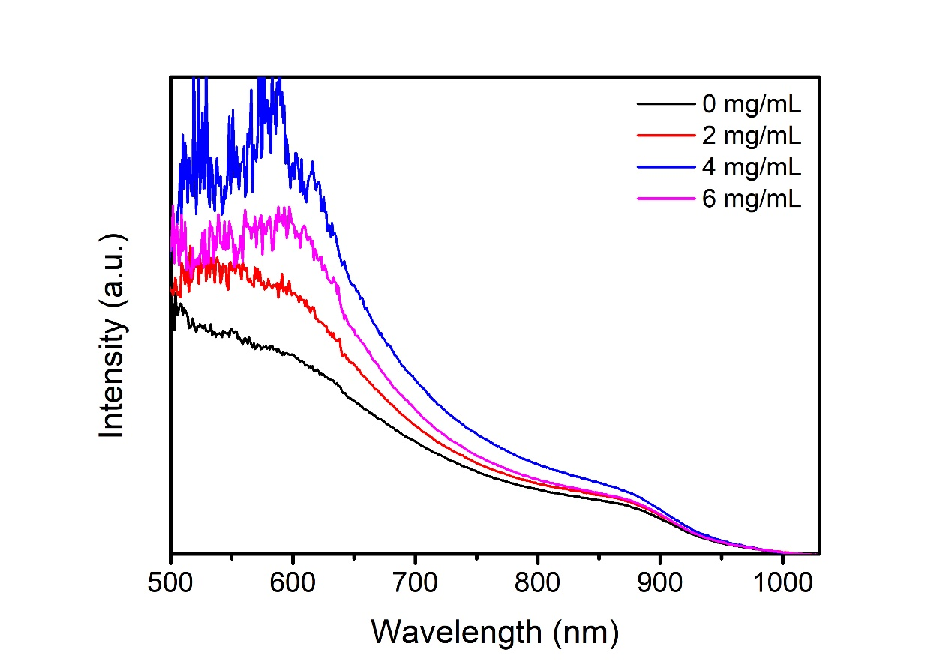
Fig. S14 UV-vis patterns of the CsPb_{0.4}Sn_{0.6}I₃:GLE films with different concentration PTSH.
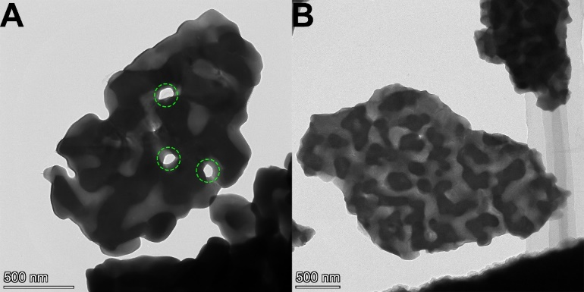
Fig. S15 HRTEM images of the stripped CsPb_{0.4}Sn_{0.6}I₃ and CsPb_{0.4}Sn_{0.6}I₃:GLE crystals.

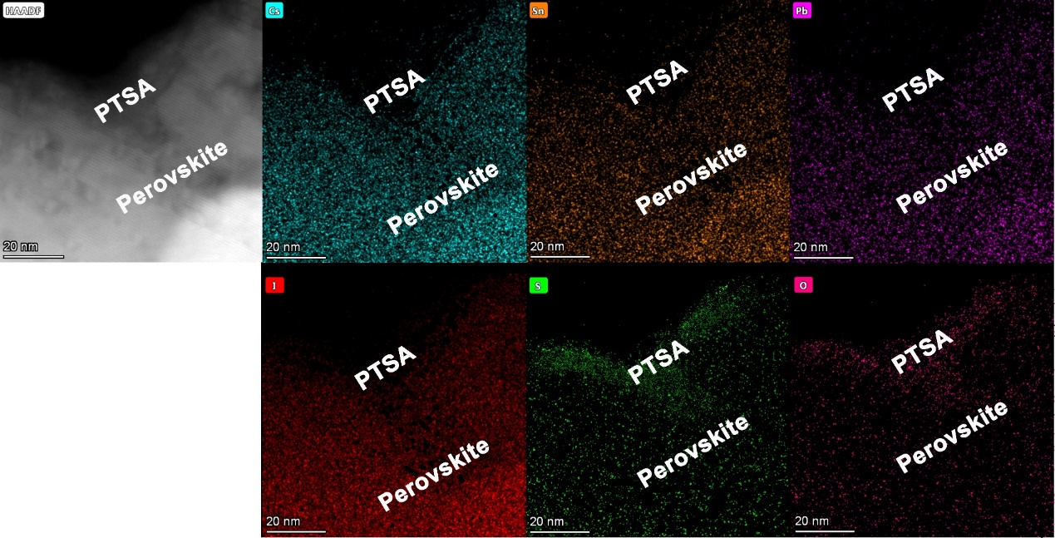
Fig. S16 High-angle annular dark-field (HAADF)-STEM and EDS element mapping results (Cs, Sn, Pb, I, S, and O) of CsPb_{0.4}Sn_{0.6}I₃:GLE sample. It can be clearly observed that Cs, Sn, Pb, and I elements are mainly distributed in the perovskite region in Fig. S15, while S and O elements are distributed in the PTSA region, indicating the formation of PTSA film on the surface of perovskite grains.
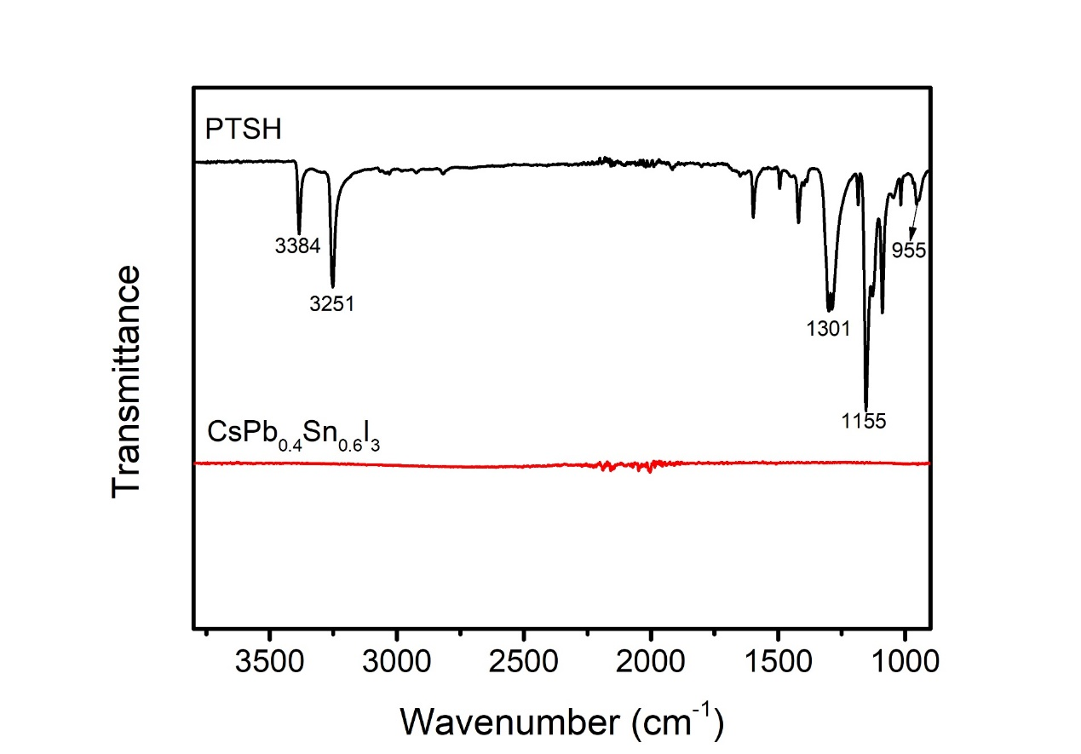
Fig. S17 FTIR spectra of PTSH and CsPb_{0.4}Sn_{0.6}I₃ samples.

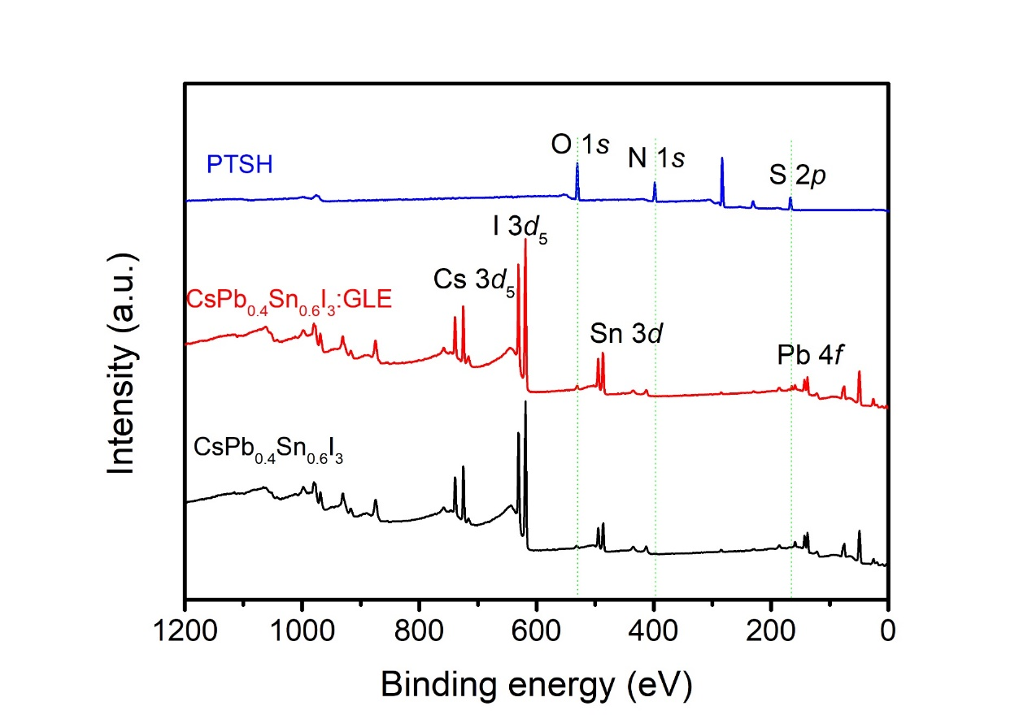
Fig. S18 XPS spectra of the full survey for PTSH, CsPb_{0.4}Sn_{0.6}I₃, and CsPb_{0.4}Sn_{0.6}I₃:GLE samples.
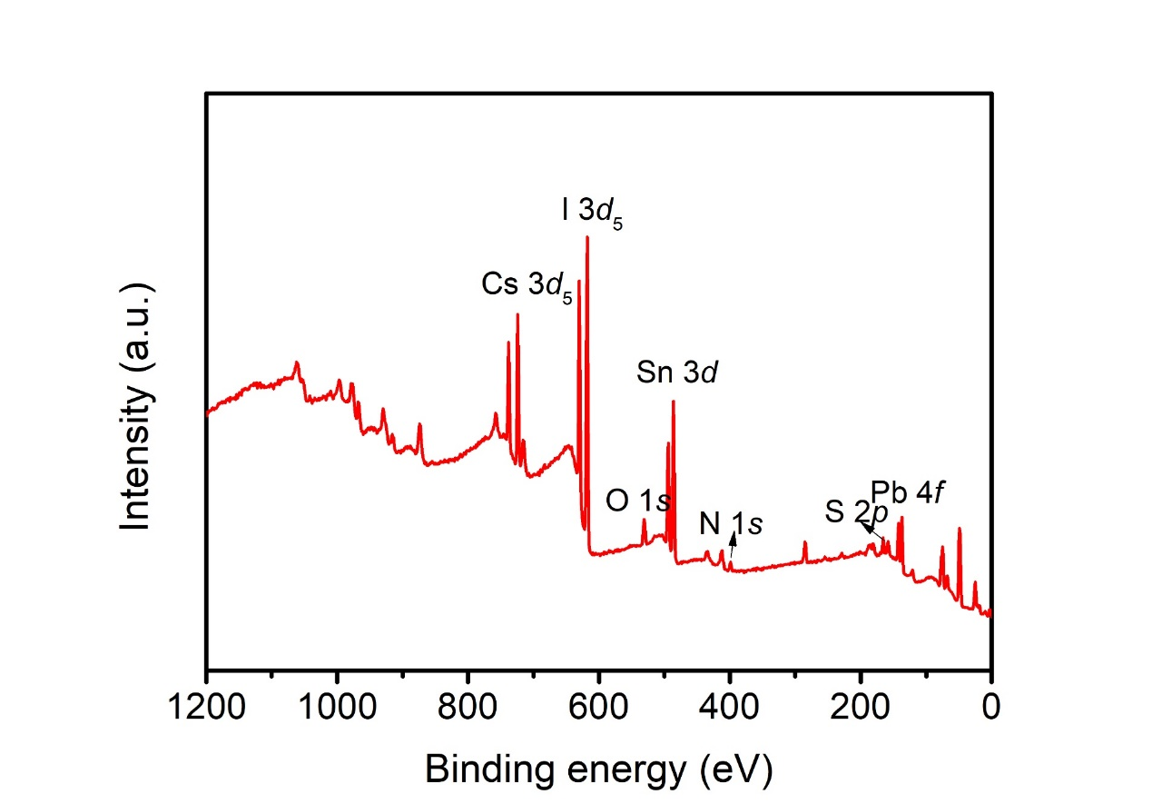
Fig. S19 XPS spectrum of the full survey for CsPb_{0.4}Sn_{0.6}I₃:GLE sample annealing at 70 ºC.

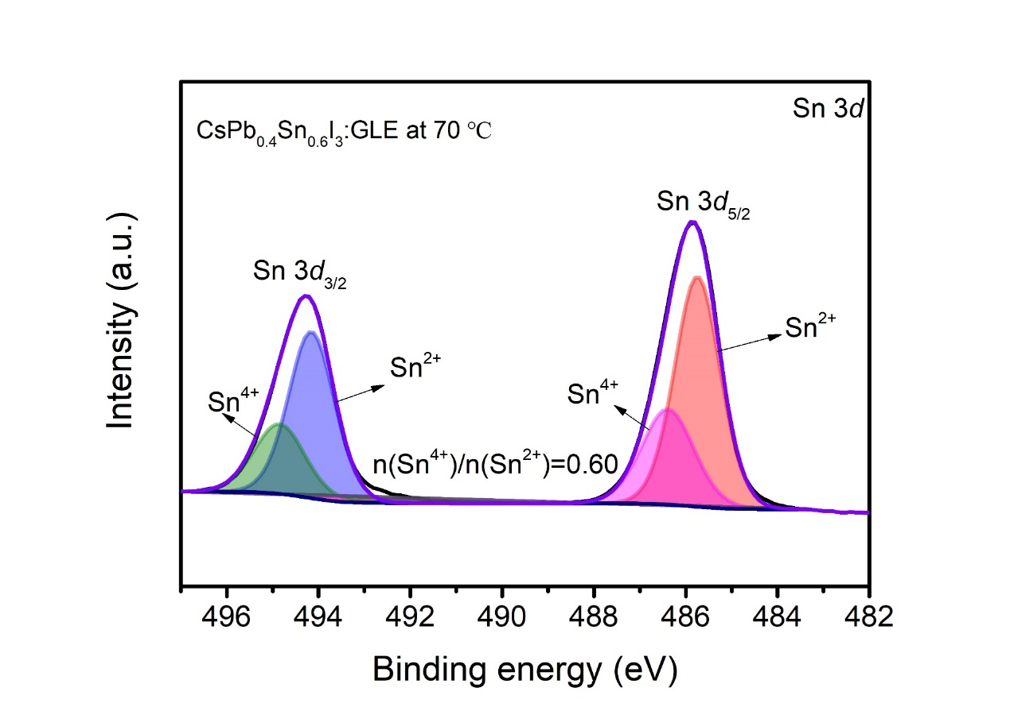
Fig. S20 Sn 3d XPS spectrum of the CsPb_{0.4}Sn_{0.6}I₃:GLE sample annealing at 70 ℃. The Sn⁴⁺ content in the Sn 3d XPS spectrum of the sample prepared at 70 ℃ also exhibited a reduction, primarily attributed to the NH₂ functional group coordinating with Sn²⁺ to inhibit its oxidation¹⁴.

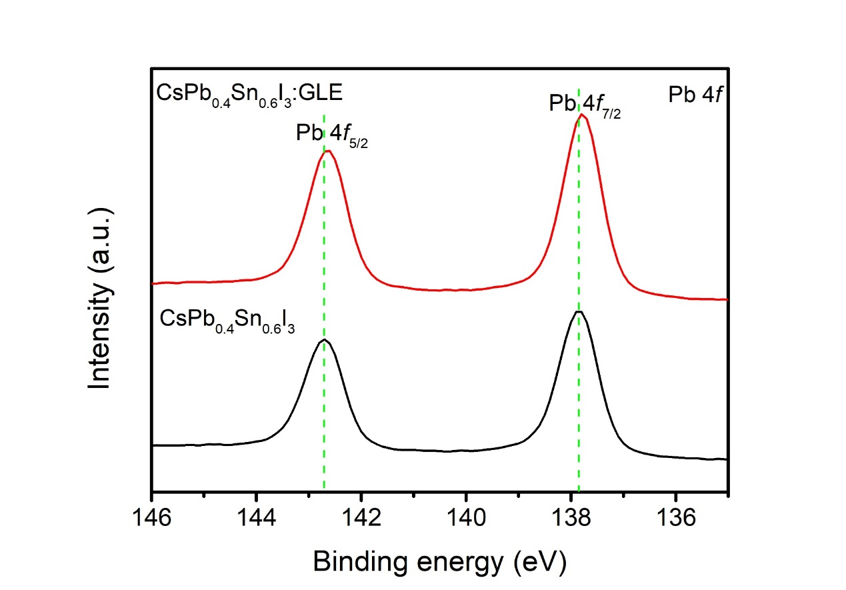
Fig. S21 Pb 4f XPS spectra of CsPb_{0.4}Sn_{0.6}I₃ and CsPb_{0.4}Sn_{0.6}I₃:GLE films.

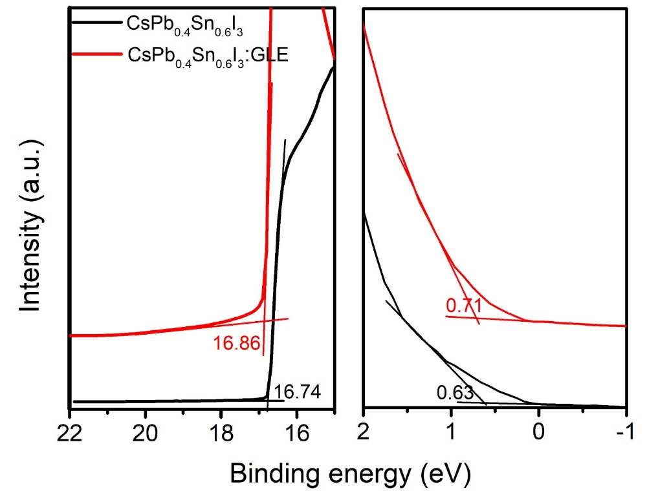
Fig. S22 UPS spectra of CsPb_{0.4}Sn_{0.6}I_{3,} and CsPb_{0.4}Sn_{0.6}I₃:GLE films.

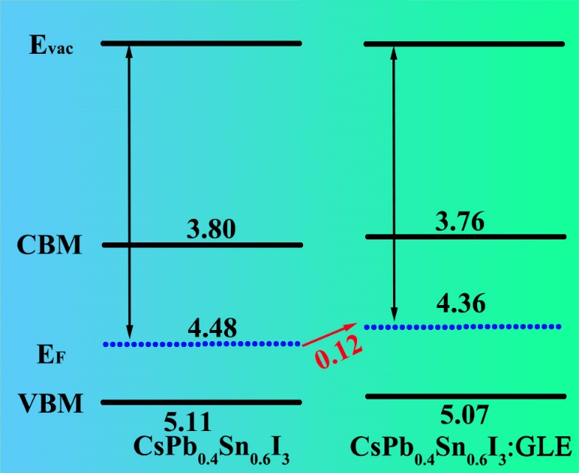
Fig. S23 Perovskite energy level diagram constructed from UPS results, where Evac stands for vacuum energy level, CBM is conduction band minimum, E_{F} is fermi level of perovskite film, and VBM is valence band maximum. Due to the easy oxidation of Sn²⁺ to Sn⁴⁺, the CsPb_{0.4}Sn_{0.6}I₃ film exhibits severe p-type self-doping^{35,36}.

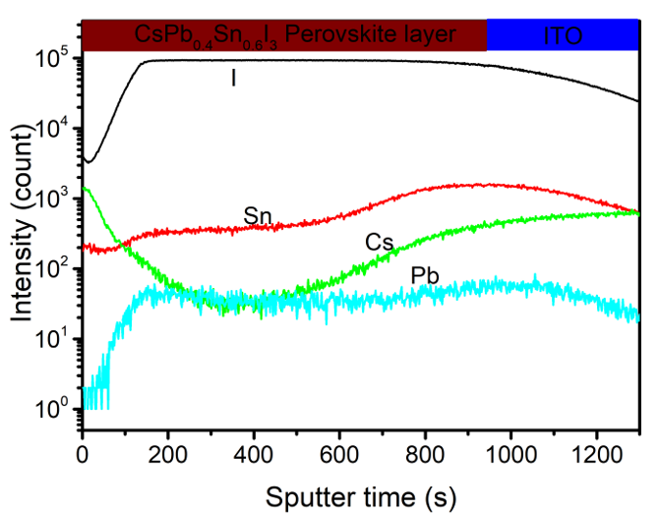
Fig. S24 ToF-SIMS of depth profiles of anion distribution within CsPb_{0.4}Sn_{0.6}I₃ film.
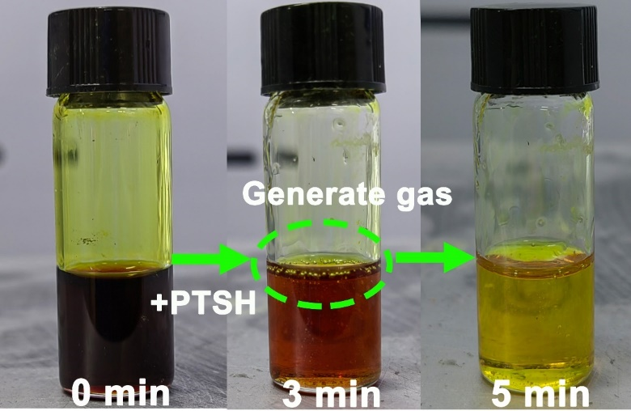
Fig. S25 Photographs of oxidized CsPb_{1-x}Sn_{x}I₃ precursor solution reduced by PTSH at 105 ℃.

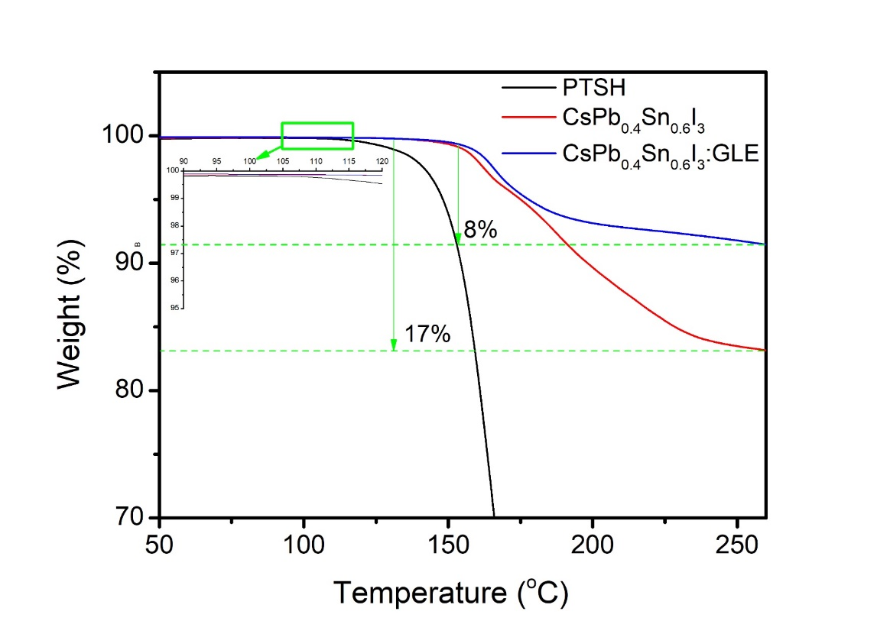
Fig. S26 TG results for the PTSH, CsPb_{0.4}Sn_{0.6}I₃, and CsPb_{0.4}Sn_{0.6}I₃:GLE samples. Upon heating to 105 ℃, PTSH gradually decomposes and releases N₂. The CsPb_{0.4}Sn_{0.6}I₃ and CsPb_{0.4}Sn_{0.6}I₃:GLE samples began to lose weight at approximately 160 ℃, mainly due to the sublimation of SnI₄ formed by a substantial presence of Sn⁴⁺ in the film¹³. According to the previous experimental characterization, it can be inferred that the possible reactions of CsPb_{0.4}Sn_{0.6}I₃:GLE film during the preparation process are as follows:
SnI₂+DMSO→SnO₂+(CH₃)₂S+SnI₄ (1)
SnI₂+O₂→SnO₂+SnI₄ (2)
C₇H₁₀SO₂N₂+SnI₄→SnI₂+ C₇H₇SO₂H+HI↑+N₂↑ (3)
C₇H₇SO₂H+SnO₂→Sn²⁺+ C₇H₇SO₃⁻+H₂O↑ (4)
C₇H₁₀SO₂N₂+SnO₂→C₇H₇SO₃⁻+Sn²⁺+H₂O↑+N₂↑ (5)

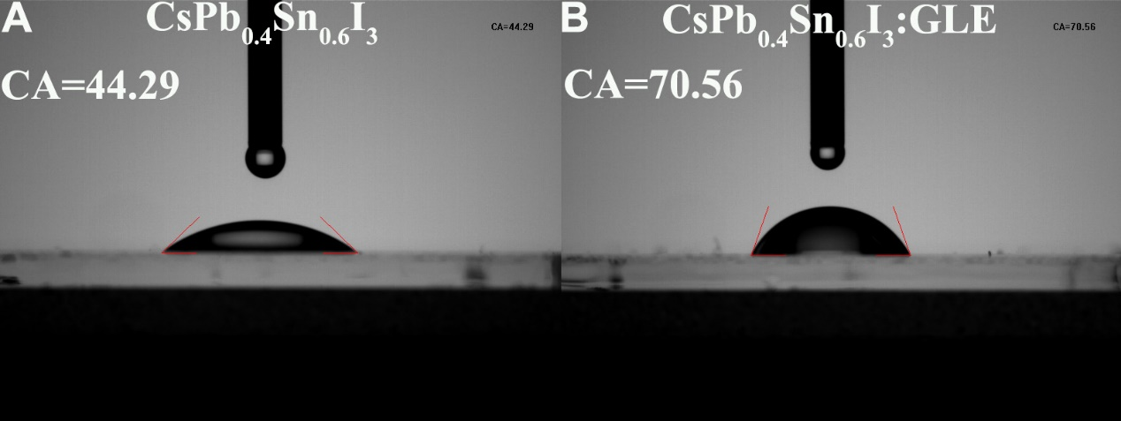
Fig. S27 The contact angles for the CsPb_{0.4}Sn_{0.6}I₃ and CsPb_{0.4}Sn_{0.6}I₃:GLE samples.

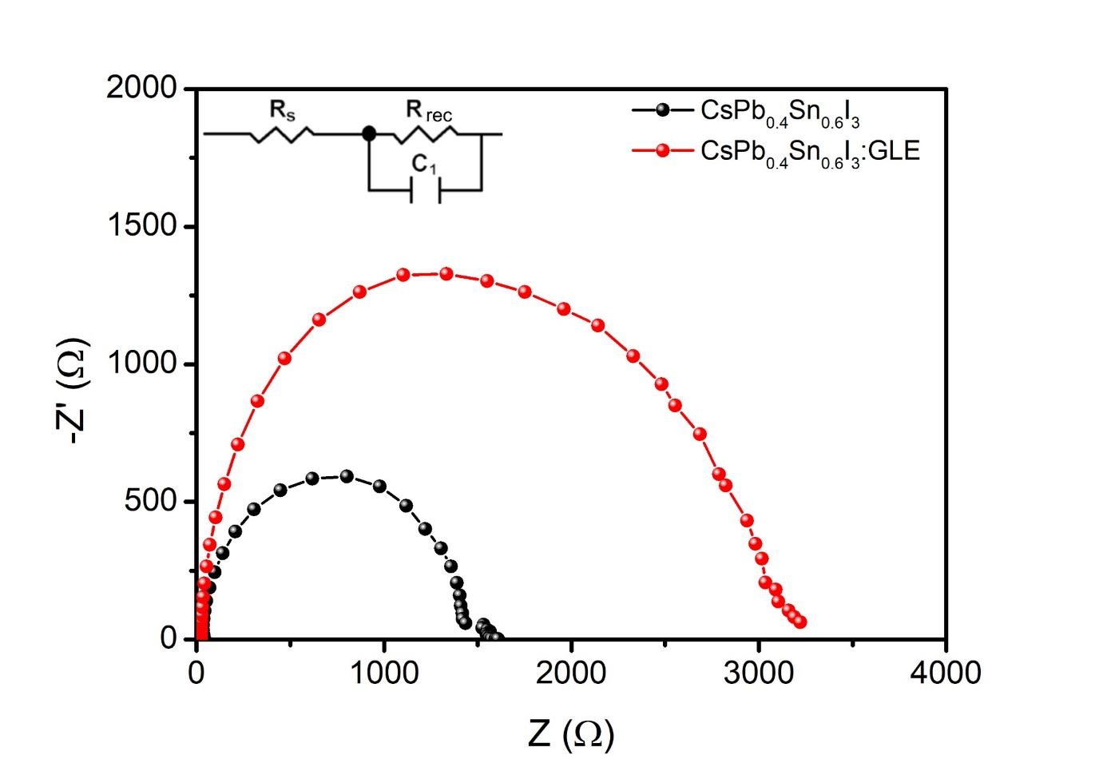
Fig. S28 Nyquist plots for the CsPb_{0.4}Sn_{0.6}I₃ devices based on without or with GLE. The semicircle observed in the Nyquist plot represents the recombination resistance (R_{rec}).

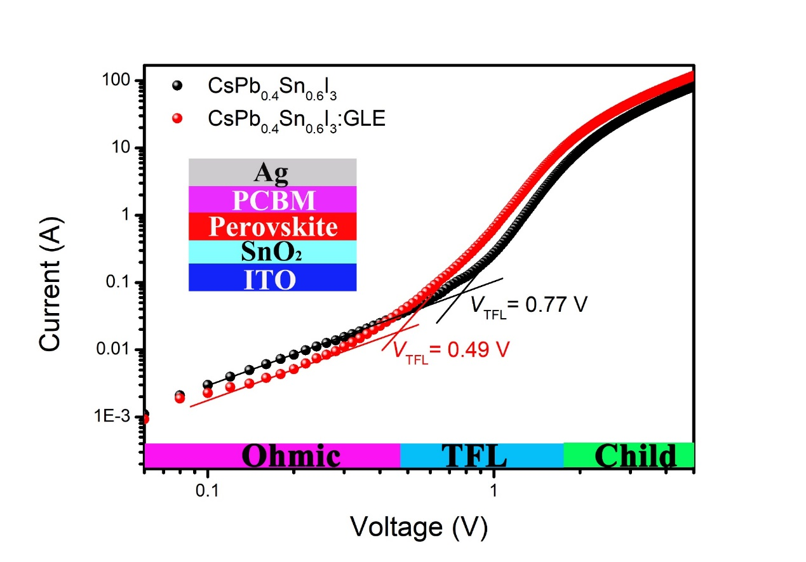
Fig. S29 The space-charge-limited current versus voltage of devices (ITO/SnO₂/perovskite/ PC₆₁BM/Ag) based on without or with GLE. They can be divided into the ohmic region, trap filling limit (TFL) region, and Child region. Among them, the density of trapped states (N_{trap}) can be obtained from the TFL region using the following formula³⁸:
$$N_{trap}=\frac{2V_{TFL}εε_{}}{qL^{2}}$$
In the equation, ε_{θ} and ε are the vacuum dielectric constant and relative dielectric constant, respectively. V_{TFL} and q denote the starting voltage in the TFL region and elementary charge, while L represents the thickness of the perovskite film, respectively³⁹.

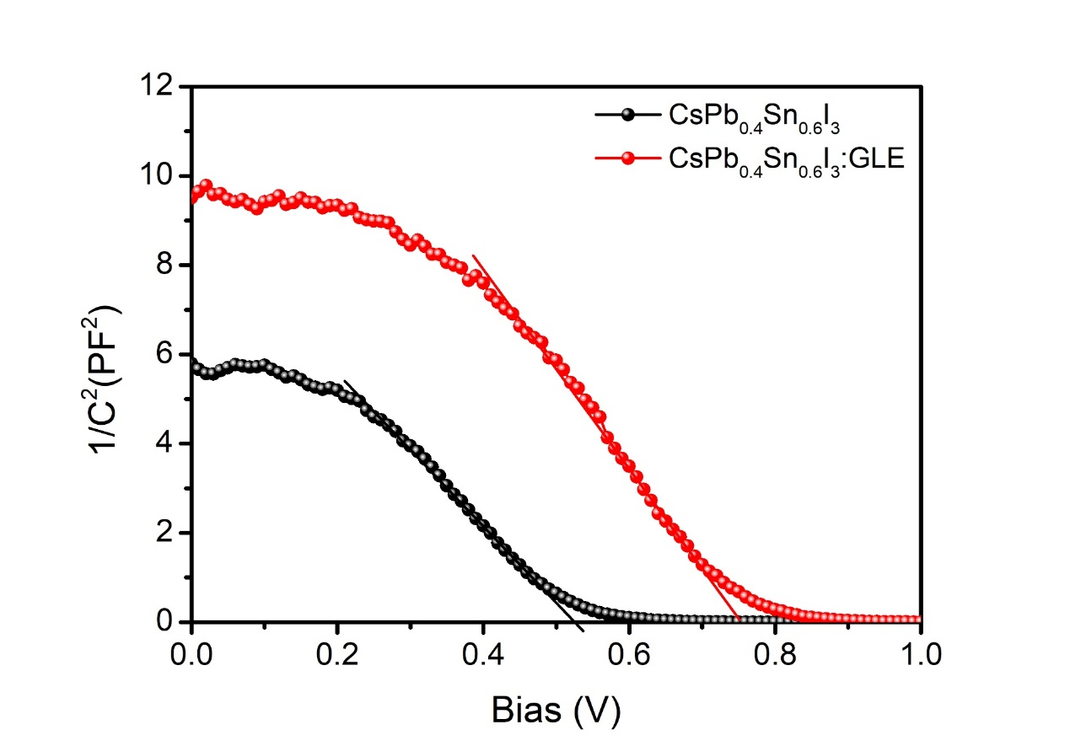
Fig. S30 Mott-Schottky measurement for CsPb_{0.4}Sn_{0.6}I₃ and CsPb_{0.4}Sn_{0.6}I₃:GLE PSCs. The built-in potential (V_{bi}) of the corresponding device can be determined by analyzing the Mott-Schottky equation, as follows:
$$C^{-2}= \frac{(2V_{bi}-V)}{A^{2}qε_{0}εN}$$
Here, C represents the depletion region capacitance, V and A denote the applied voltage and area of the device, respectively³⁹.

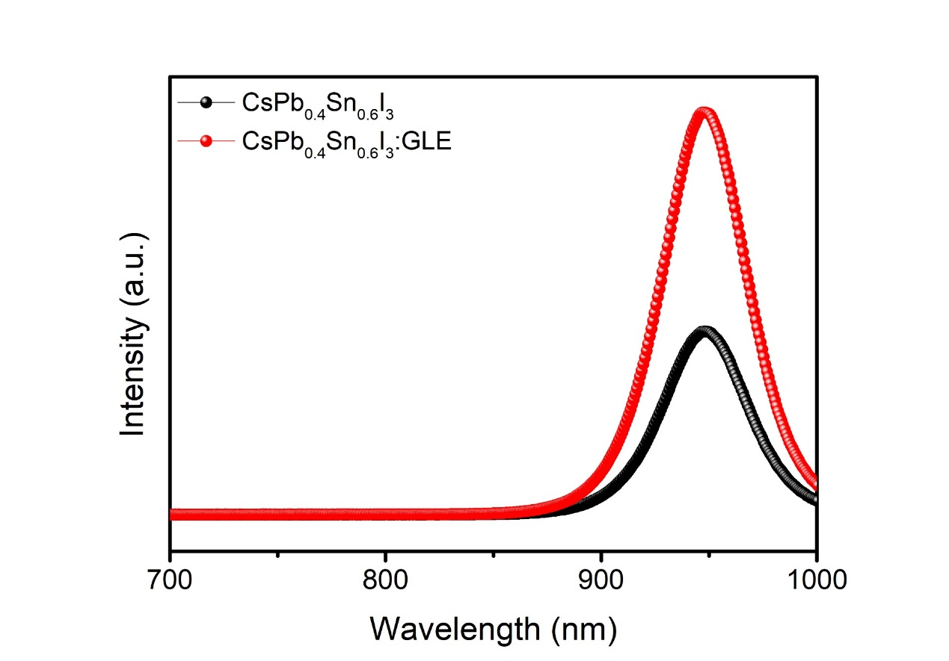
Fig. S31 Steady-state PL spectra for pristine CsPb_{0.4}Sn_{0.6}I₃ and CsPb_{0.4}Sn_{0.6}I₃:GLE films.

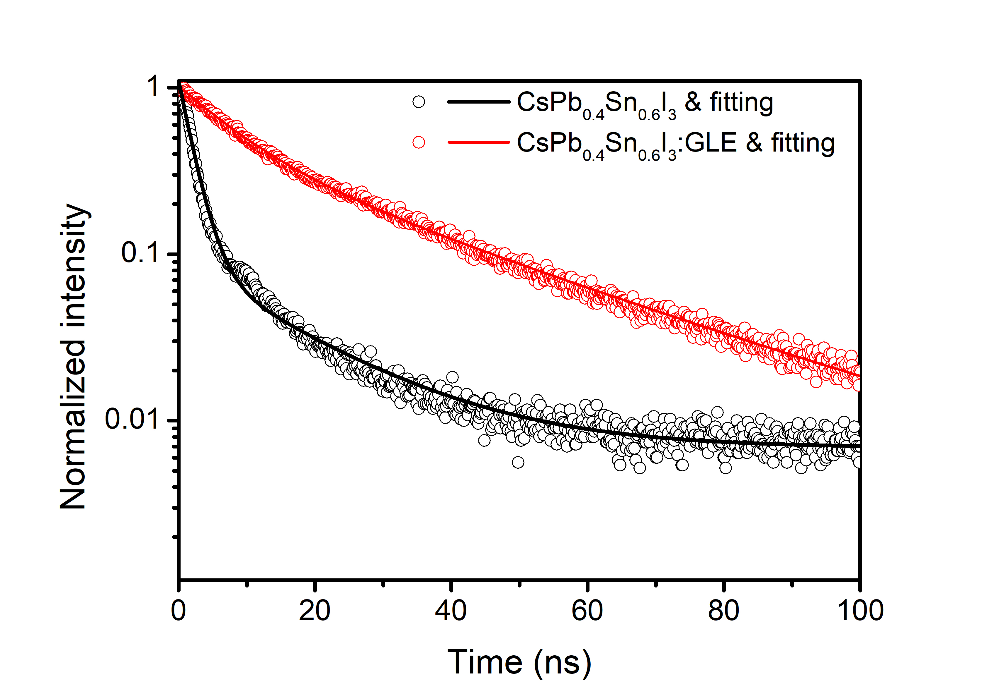
Fig. S32 TRPL spectra for pristine CsPb_{0.4}Sn_{0.6}I₃ and CsPb_{0.4}Sn_{0.6}I₃:GLE films. All curves were fitted using a bi-exponential decay model based on the formula: (f(t) = A₁exp(-t/τ₁) + A₂exp(-t/τ₂)). Subsequently, using the formula: τ_{ave} = (A₁τ₁² + A₂τ₂²)/(A₁τ₁ + A₂τ₂) can calculate the average decay time (τ_{ave})⁶⁰.

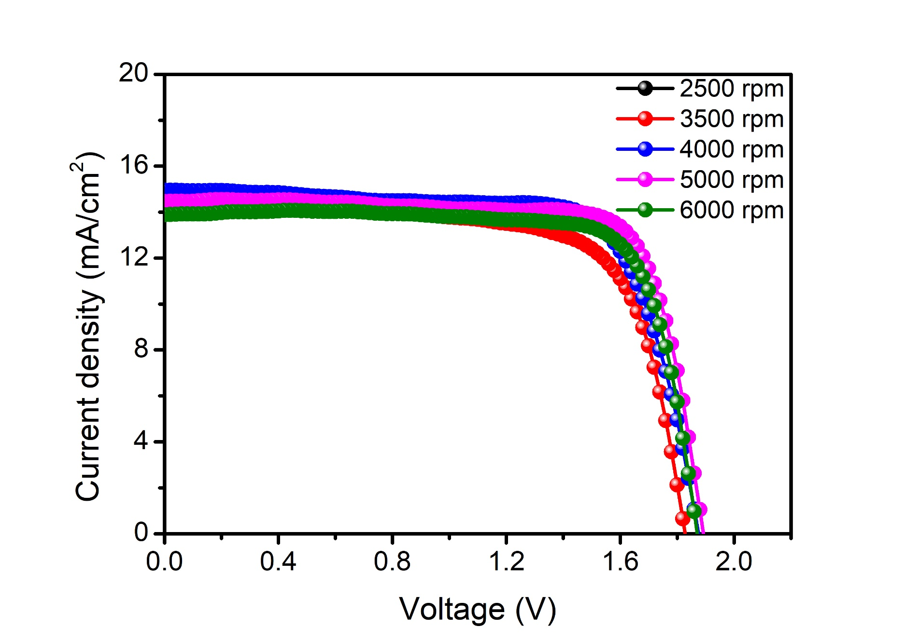
Fig. S33 J-V characteristic curves of the IPTSCs with different thicknesses of NBG perovskite layers under AM 1.5G 100 mW/cm² simulated solar light. By changing the spin-coating speed (2500-6000 rpm), different thicknesses of NBG active layers were obtained. The thickness of the NBG active layer was negatively correlated with the spin-coating speed. By comparing the J-V curves of IPTSCs based on different thicknesses of NBG perovskite layers, it can be found that the J_{sc} of prepared IPTSC does not increase with the increase of NBG perovskite layer thickness, which is due to the poor quality of the NBG perovskite film prepared at lower spin-coating speed, resulting in the deterioration of device performance. With the increase in spin-coating speed, the quality of NBG perovskite film is improved, accompanied by the increase in IPTSC performance. When the spin-coating speed reached 6000 rpm, the J_{sc} of the obtained IPTSC decreased significantly due to the thin thickness of the NBG perovskite film obtained at a high spin-coating speed.

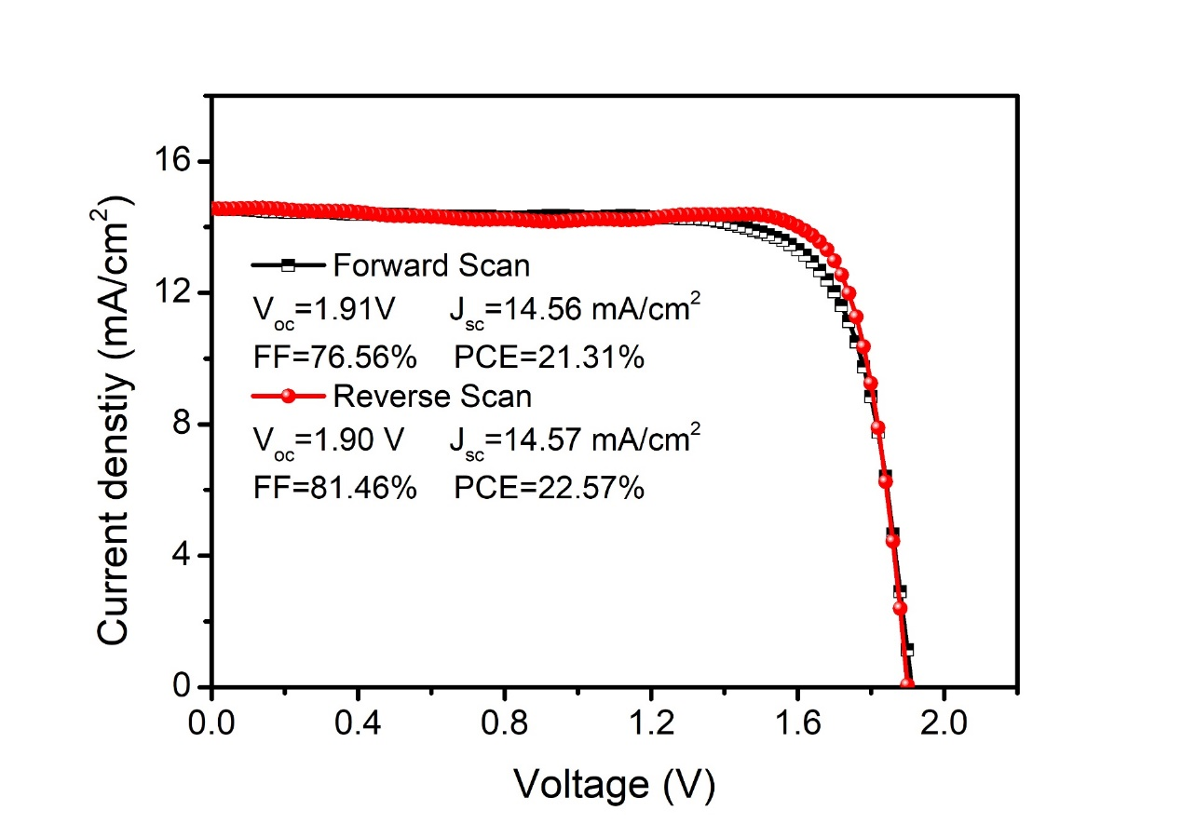
Fig. S34 The J–V curve of a champion IPTSC under forward and reverse scans.

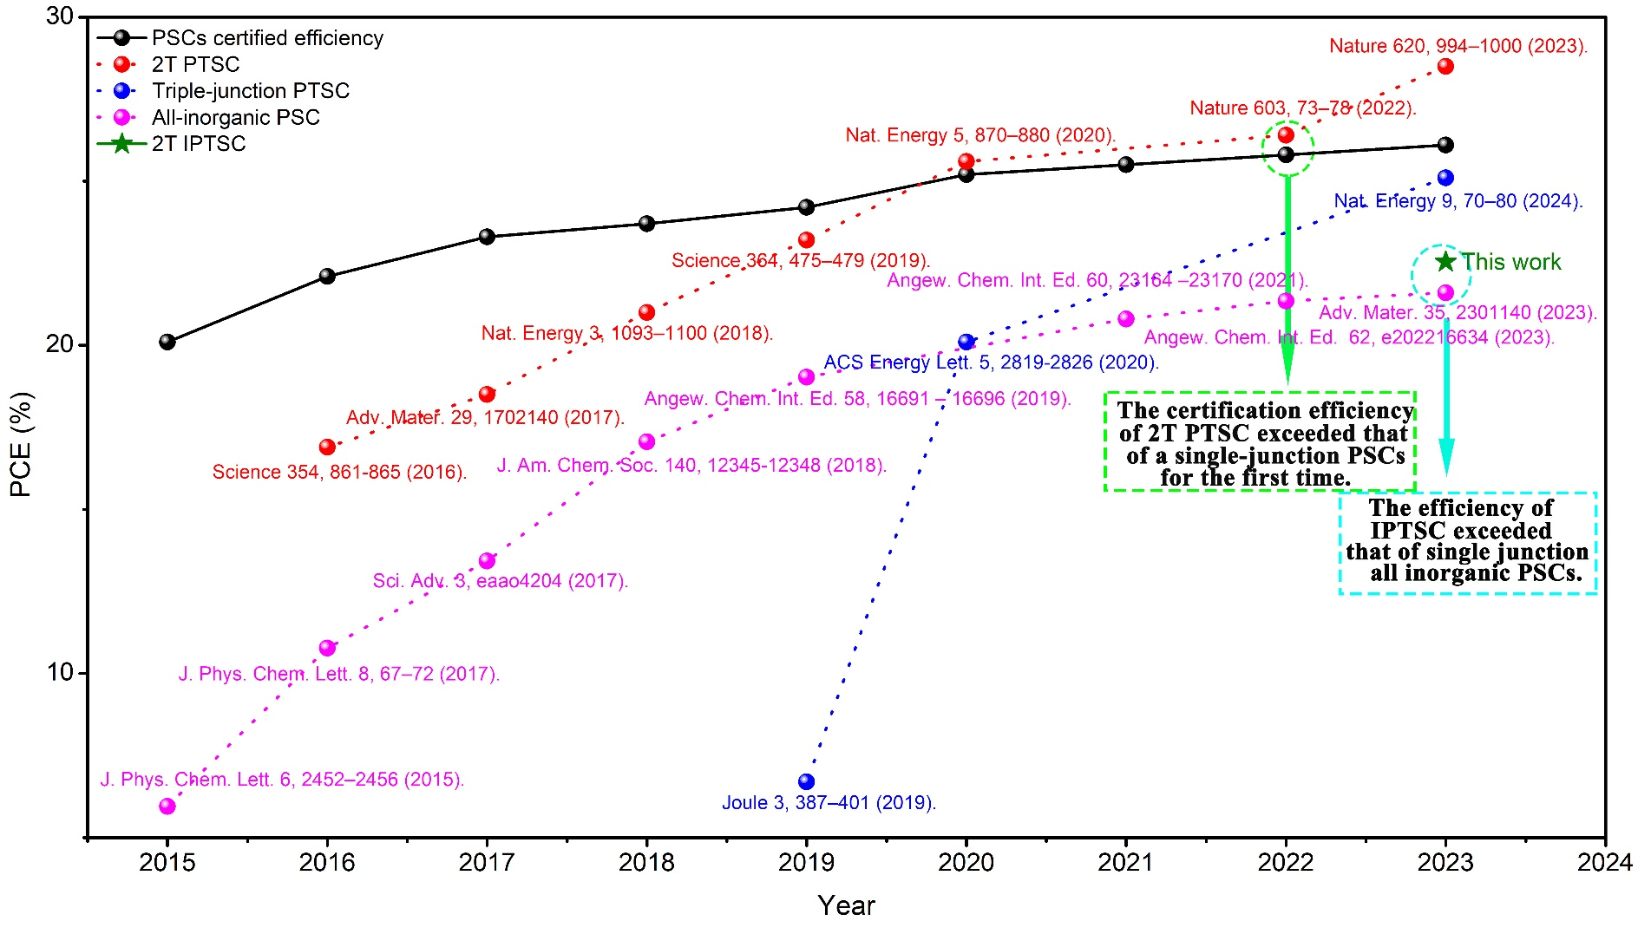
Fig. S35 The PCE development of single-junction PSCs, 2T PTSCs, triple-junction PTSCs, all-inorganic PSCs, and 2T IPTSCs. From Fig. S35 and Table S7, it can be seen that the initially reported efficiency of PTSCs was only 16.9%⁴² and 9.6% (triple-junction)⁴³, respectively, far lower than the corresponding organic-inorganic hybrid single-junction PSCs. After 7 years of effort, the certification efficiency of PTSCs surpassed that of single-junction PSCs⁶¹. It is precisely because researchers have put in a lot of effort to achieve breakthroughs. Even, the efficiency of triple-junction PTSCs has not surpassed that of single-junction PSCs after years of development^{62,63}.
Currently, the highest reported efficiency of inverted inorganic PSCs is 20.6%, and the planar device efficiency is 21.8%^{6,44}. As inorganic perovskites, the efficiency of the first reported IPTSCs in this work exceeds 22.54%, surpassing the single-junction inorganic PSCs. We believe that with the development of IPTSC in the future, its efficiency will surpass that of single-junction organic-inorganic hybrid PSCs. All the progress needs some time to overcome the technology issues.

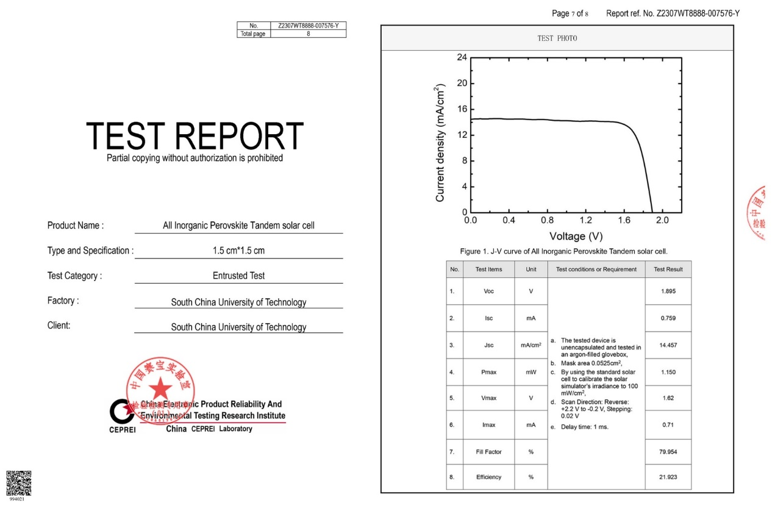
Fig. S36 The certified result of an IPTSC measured by China CEPREI Laboratory. The device achieved a PCE of 21.923% with a V_{oc} of 1.895 V, a J_{sc} of 14.457 mA/cm², and an FF of 79.954%.
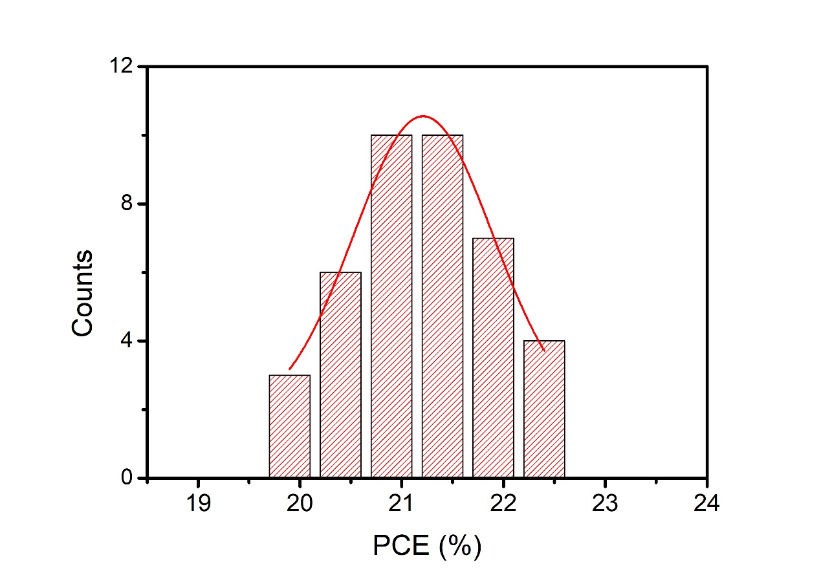
Fig. S37 Histograms for PCE of all inorganic 2T devices, with an average PCE of 21.21 ± 1.36%. Error values represent S.D. calculated from 40 devices prepared at the same conditions.
.
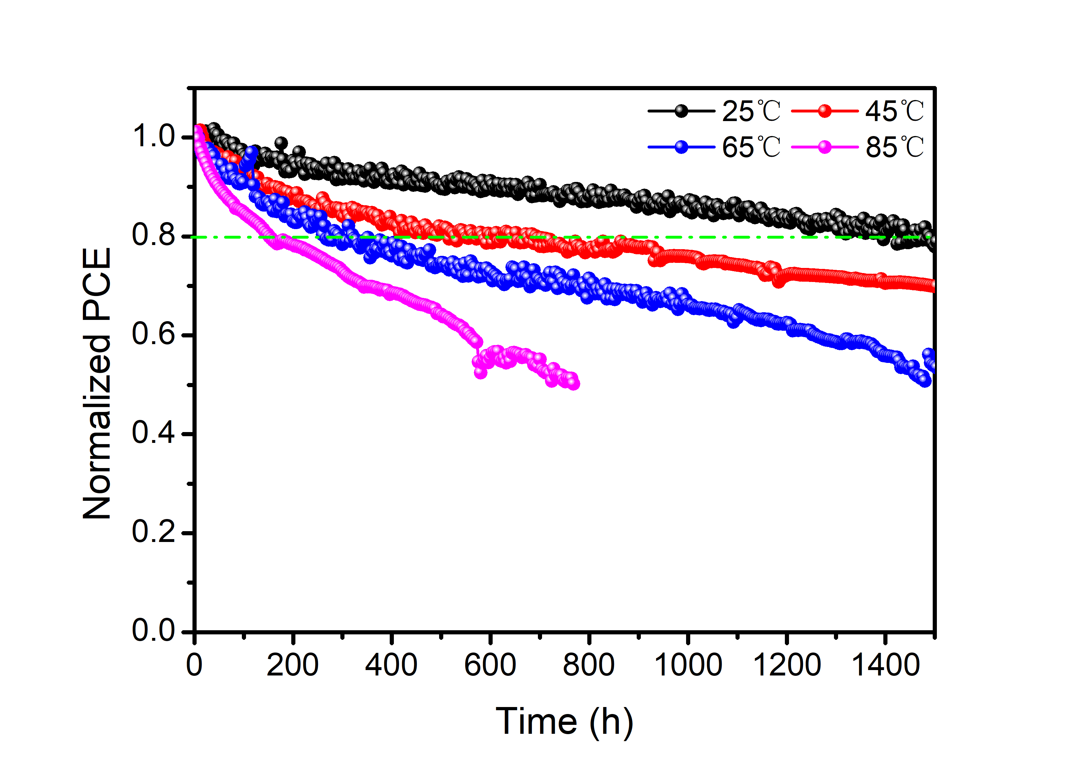
Fig. S38 Operational stability of 2T IPTSC under continuous 1 sun in N₂ glovebox at 25, 45, 65, and 85 °C, respectively.
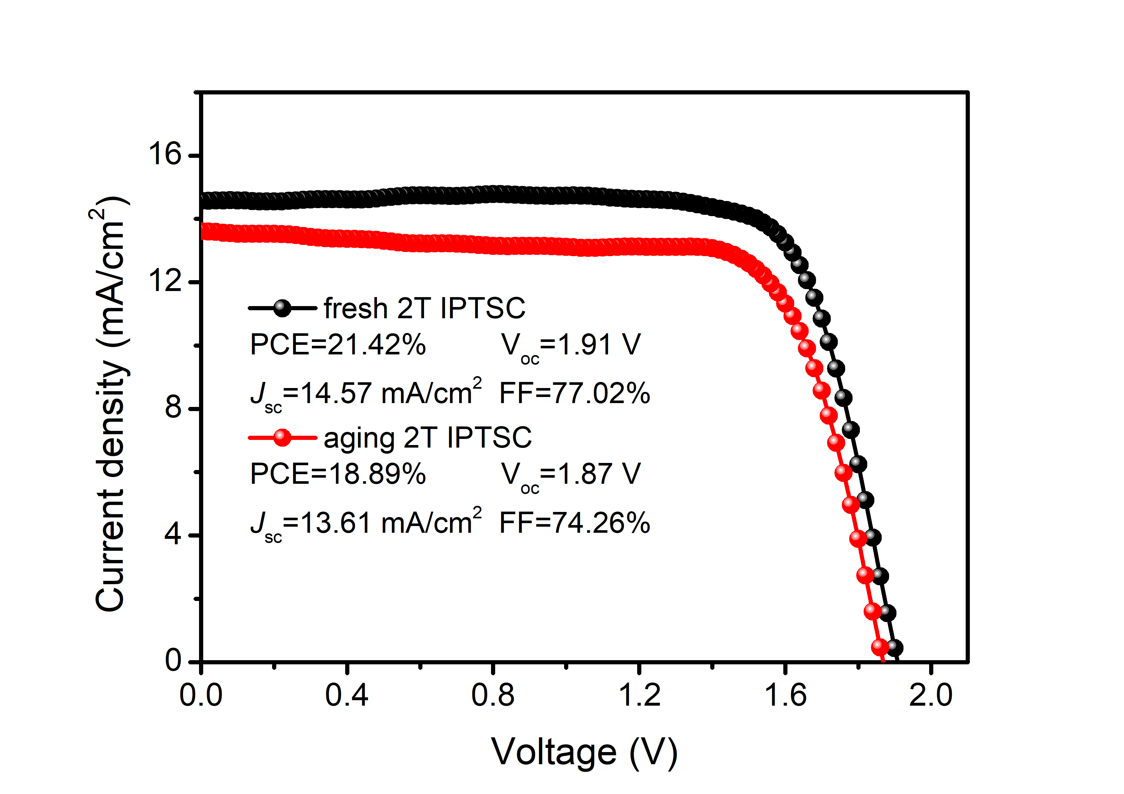
Fig. S39 The J-V curve of fresh and aging (under MPP at 85 ℃ for 5 days) 2T IPTSCs. By comparing the devices before and after aging, V_{oc} loss at 2%, while the major losses are Jsc (6.6%) and FF (3.6%)
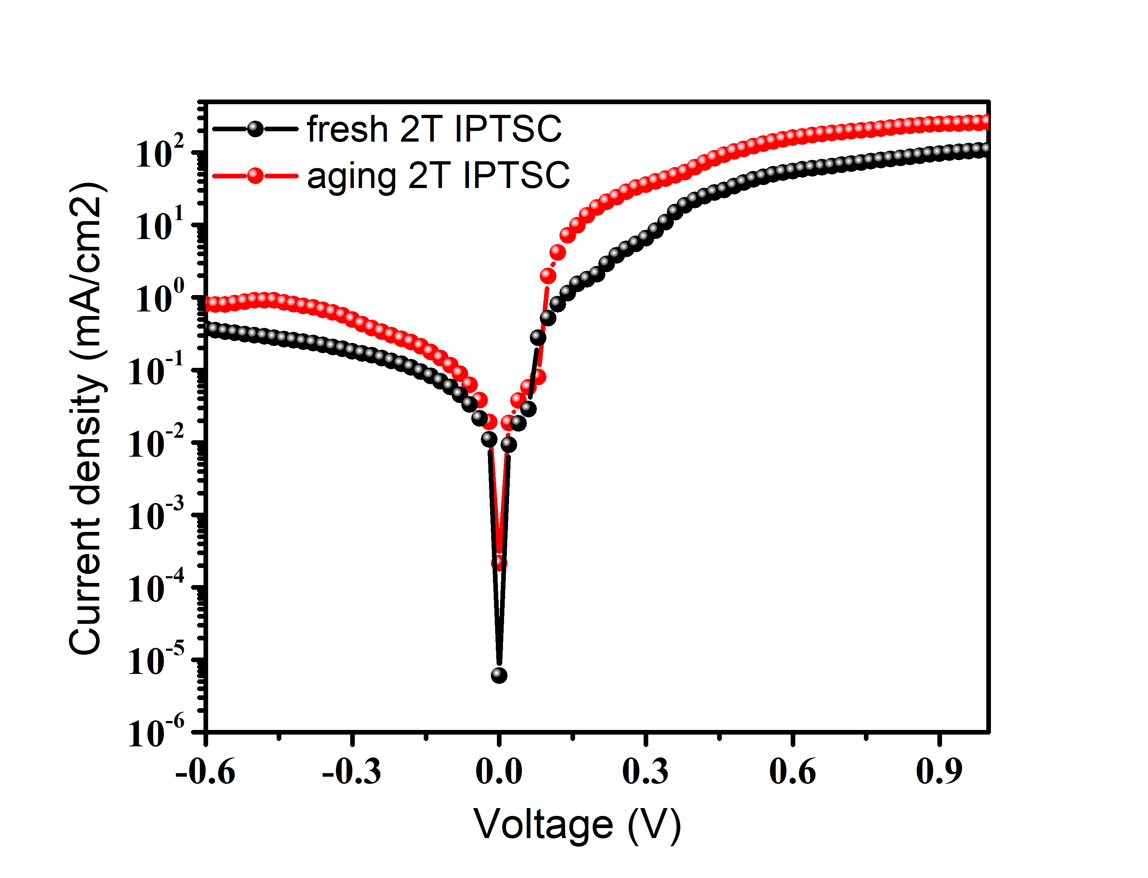
Fig. S40 Corresponding dark currents of fresh and aging (under MPP at 85 ℃ for 5 days) 2T IPTSCs.
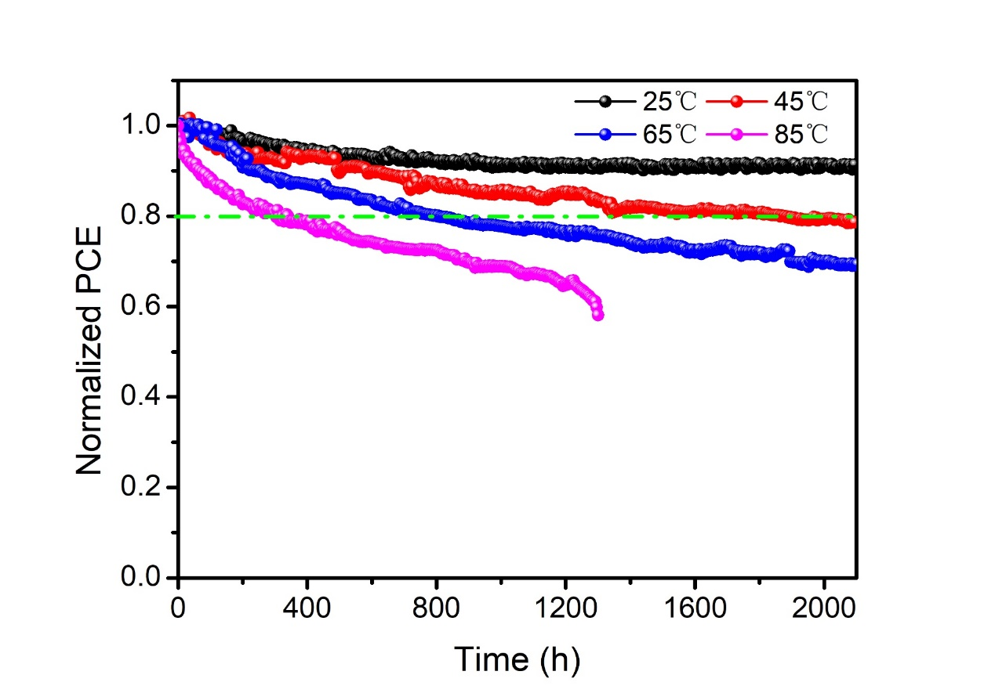
Fig. S41 Operational stability of WBG subcell under continuous 1 sun in N₂ glovebox at 25, 45, 65, and 85 °C, respectively.

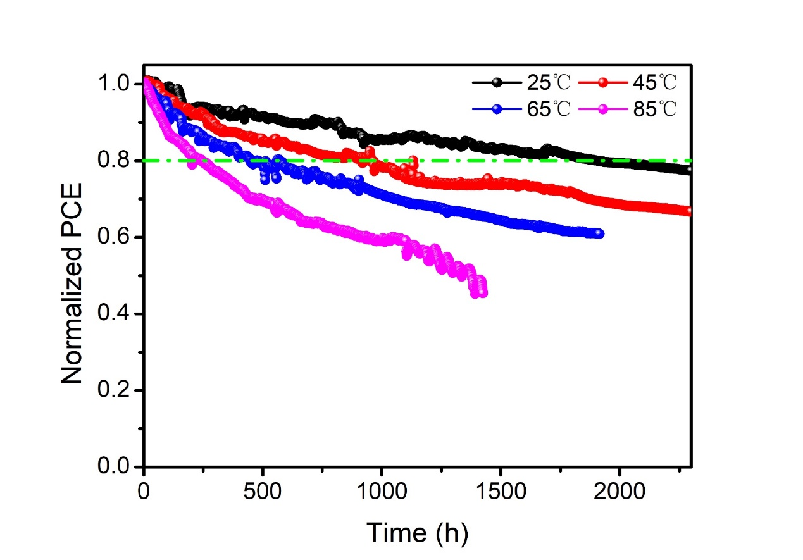
Fig. S42 Operational stability of NBG subcell based on PEDOT:PSS HTL under continuous 1 sun in N₂ glovebox at 25, 45, 65, and 85 °C, respectively. To more realistically reflect the temperature-dependent efficiency of NBG subcells in IPTSC, PEDOT:PSS replaced NiO_{x} as HTL to prepare independent NBG subcells. Compared with the NiO_{x}-based subcell (as shown in Fig. 1e), the efficiency of the device based on PEDOT:PSS significantly decreases under MPP tracking at 65 ℃, mainly because the acidity of PEDOT:PSS affects the stability of the device. This is also one of the issues that need to be addressed in the future of tandem devices.
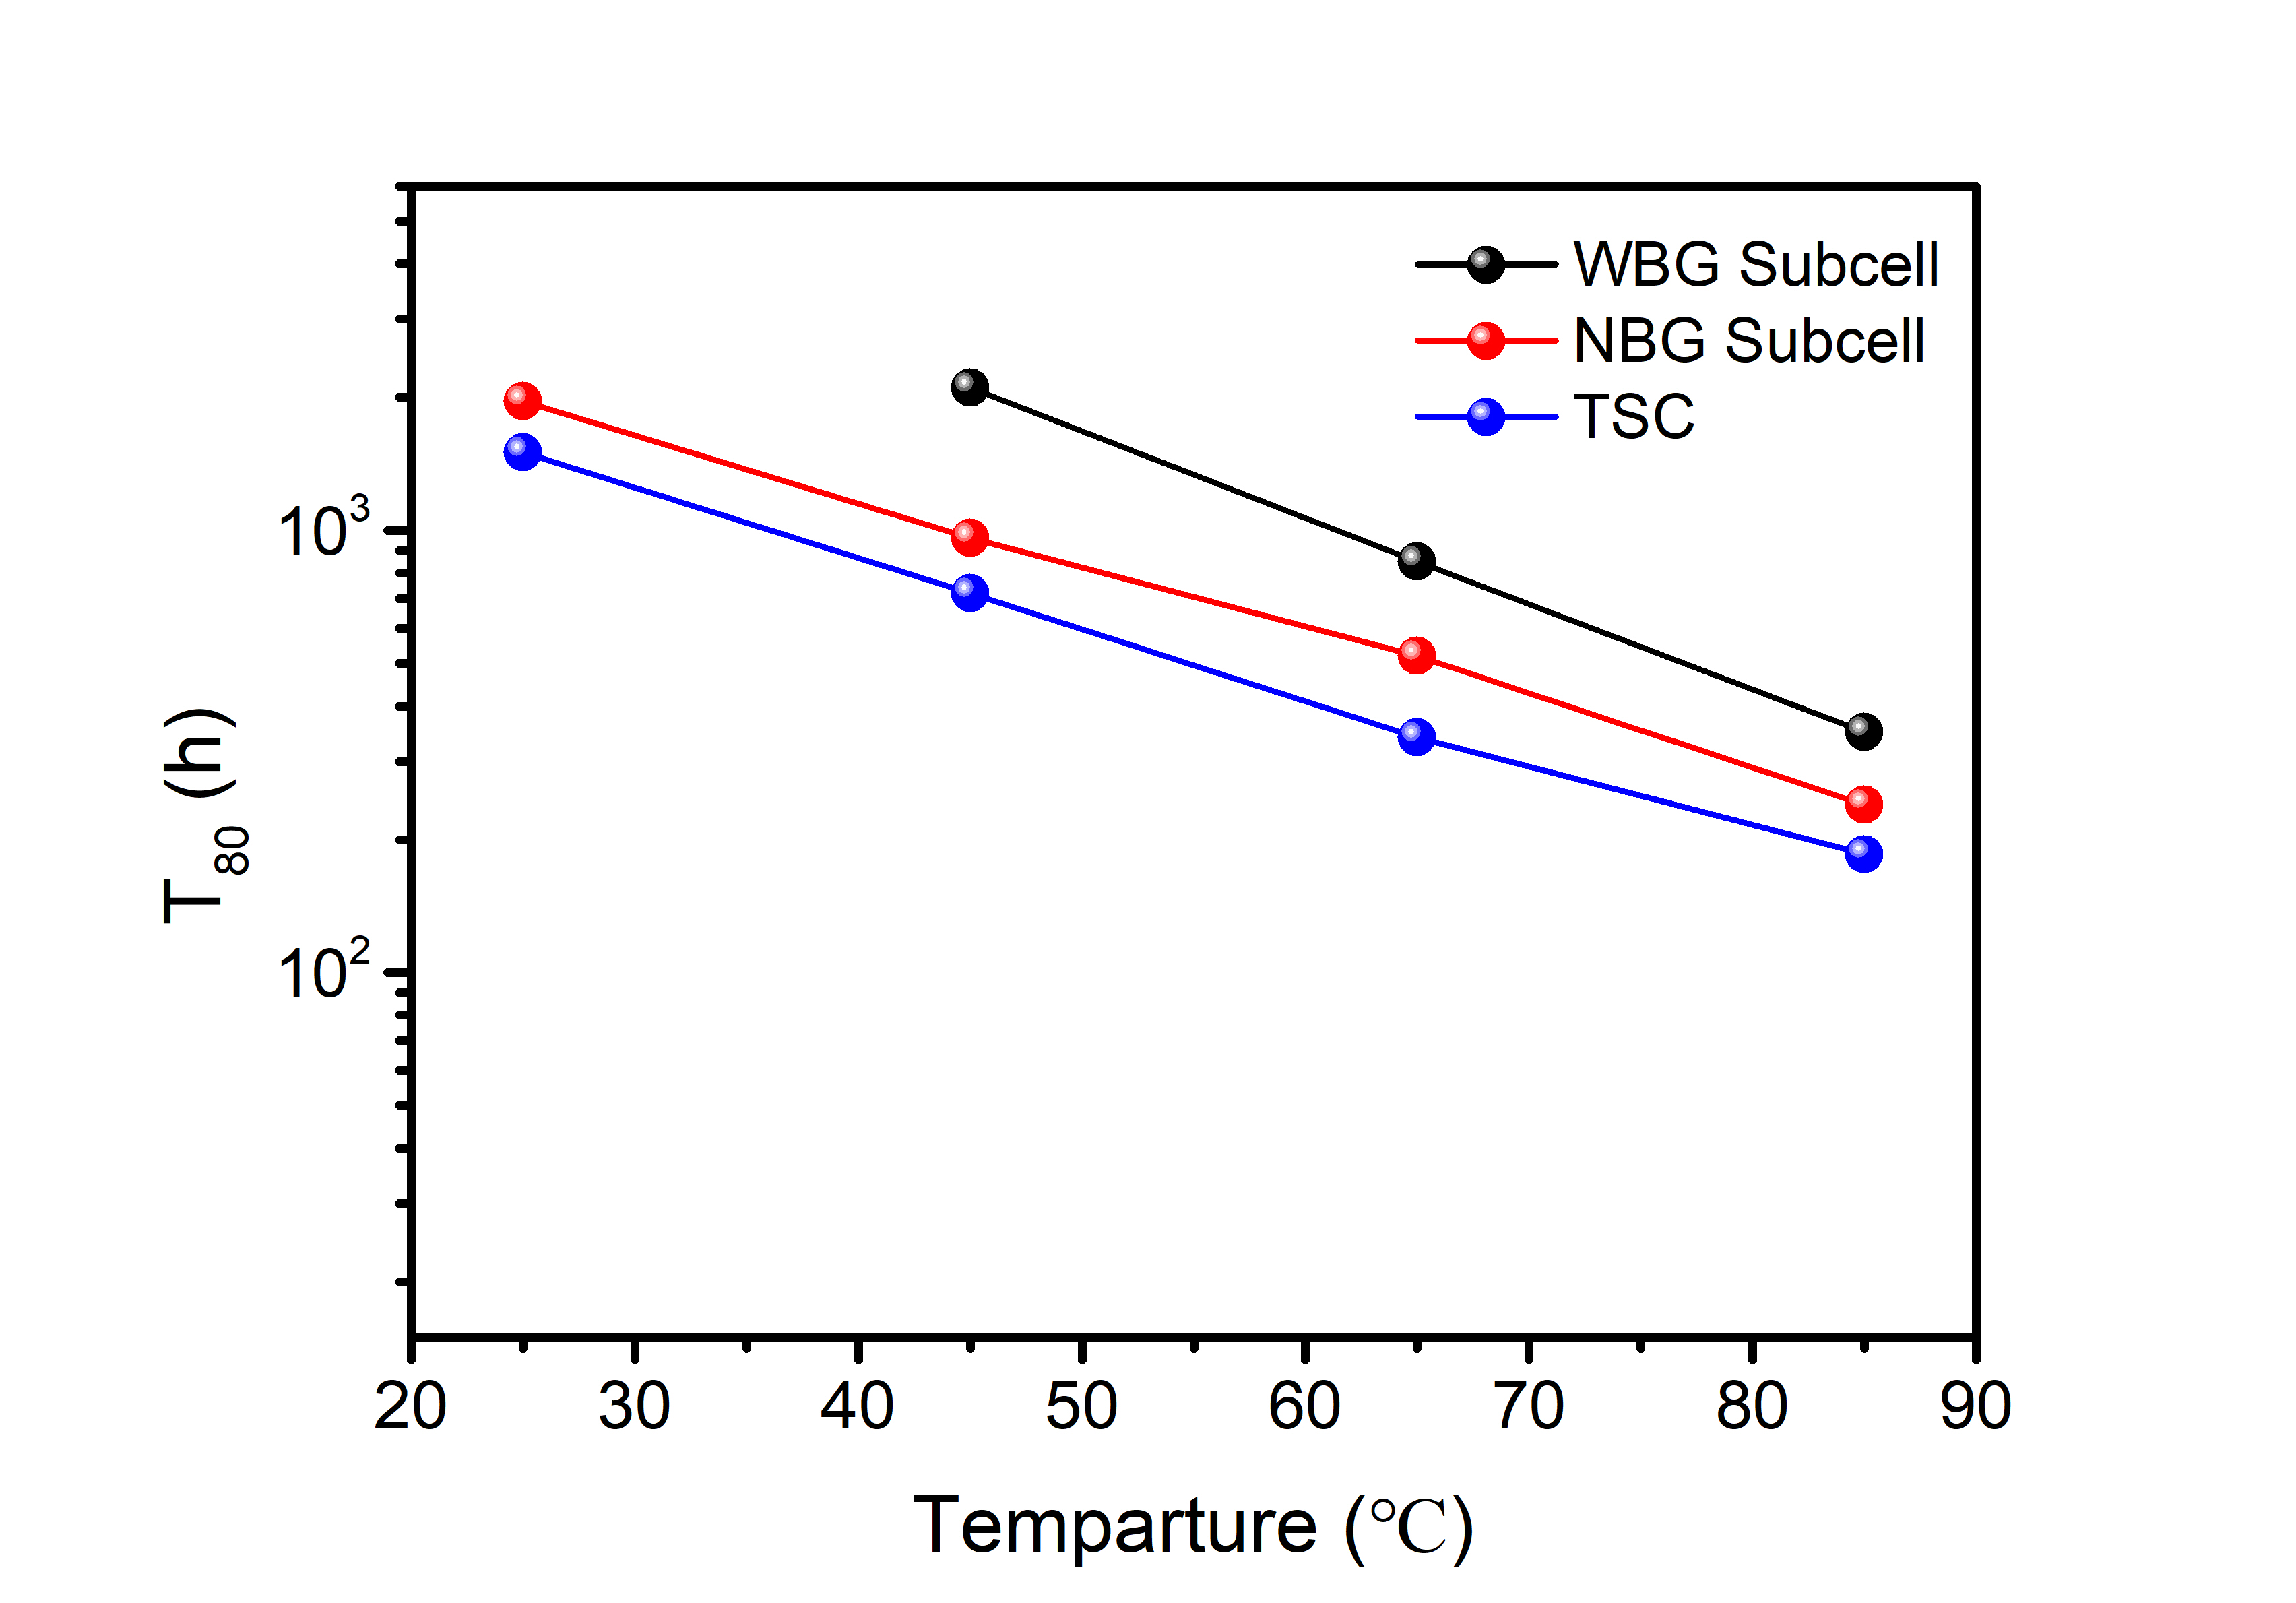
Fig. S43 T₈₀ values of corresponding devices at different temperatures.
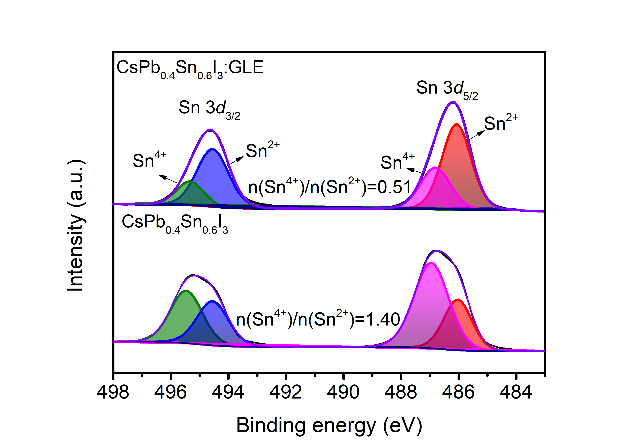
Fig. S44 XPS Sn 3d spectra of CsPb_{0.4}Sn_{0.6}I₃ and CsPb_{0.4}Sn_{0.6}I₃:GLE films with continuous illumination at 85 °C for 10 days in N₂ glovebox. One possible pathway for the formation of Sn⁴⁺ defects is through oxidation-reduction reactions with I₀ interstitials or I₂ molecules, which are caused by the oxidation of iodides through photoelectrochemical reactions or partial decomposition at high temperatures⁶⁴. The I₂ generated by photothermal conditions will escape from the film, accelerating the decomposition of the perovskite film. The use of packaging layers can suppress this process.
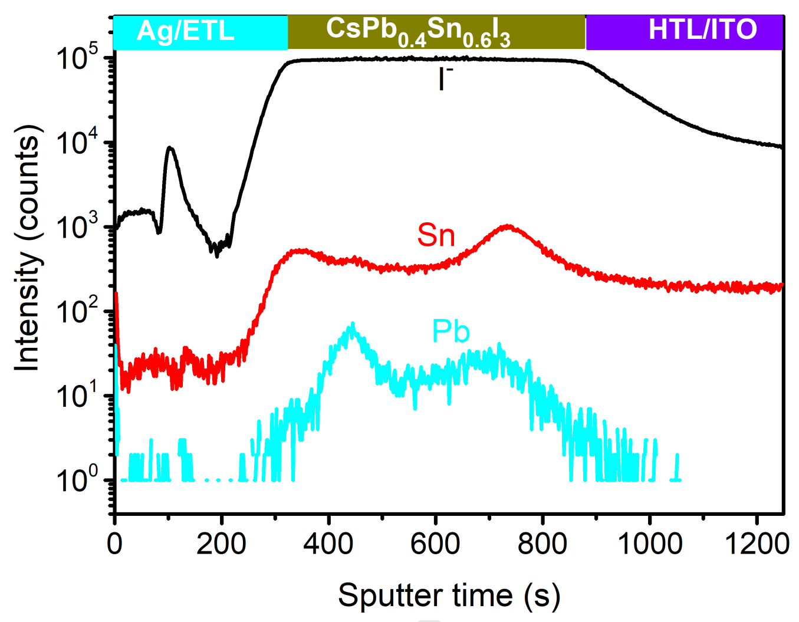
Fig. S45 ToF-SIMS of depth profiles of anion distribution in inorganic CsPb_{0.4}Sn_{0.6}I₃ PSC with continuous illumination at 85 °C for 10 days in N₂ glovebox.

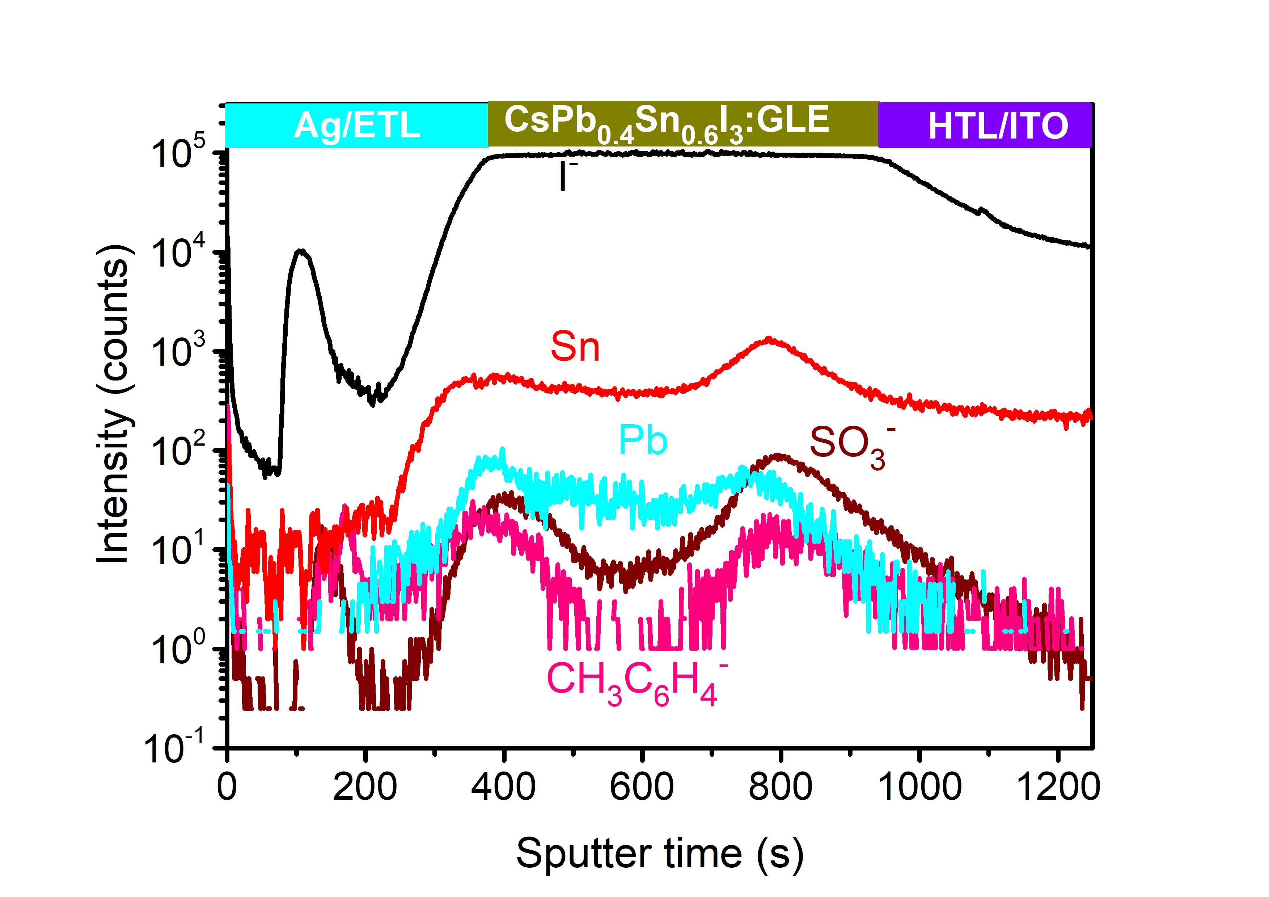
Fig. S46 ToF-SIMS of depth profiles of anion distribution in inorganic CsPb_{0.4}Sn_{0.6}I₃:GLE PSC with continuous illumination at 85 °C for 10 days in N₂ glovebox.

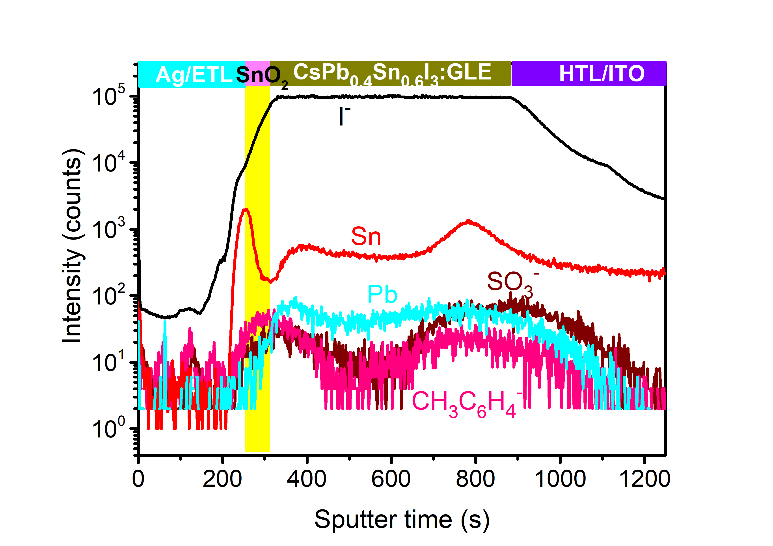
Fig. S47 ToF-SIMS of depth profiles of anion distribution in inorganic CsPb_{0.4}Sn_{0.6}I₃:GLE PSC based on ALD-SnO₂ with continuous illumination at 85 °C for 10 days in N₂ glovebox. The thinner ALD-SnO₂ layer does not affect the efficiency of NBG PSC and 2T IPTSC.
Table S1 Device parameters of CsPb_{1-x}Sn_{x}I₃ (0.8≥x≥0.4) solar cells without and with GLE.
Samples | V_{oc}(V) | J_{sc}(mA/cm²) | FF(%) | PCE(%)
CsPb_{0.6}Sn_{0.4}I₃ | 0.799 | 23.73 | 63.47 | 12.04
CsPb_{0.6}Sn_{0.4}I₃:GLE | 0.815 | 25.31 | 68.17 | 14.07
CsPb_{0.5}Sn_{0.5}I₃ | 0.794 | 25.57 | 57.11 | 11.60
CsPb_{0.5}Sn_{0.5}I₃:GLE | 0.806 | 27.11 | 70.60 | 15.44
CsPb_{0.4}Sn_{0.6}I₃ | 0.745 | 26.47 | 56.87 | 11.21
CsPb_{0.4}Sn_{0.6}I₃:GLE | 0.810 | 28.14 | 71.98 | 16.41
CsPb_{0.3}Sn_{0.7}I₃ | 0.669 | 25.84 | 58.40 | 10.10
CsPb_{0.3}Sn_{0.7}I₃:GLE | 0.782 | 27.33 | 67.26 | 14.38
CsPb_{0.2}Sn_{0.8}I₃ | 0.632 | 24.96 | 46.03 | 7.26
CsPb_{0.2}Sn_{0.8}I₃:GLE | 0.709 | 26.79 | 63.54 | 12.07

Table S2 Device parameters of CsPb_{0.4}Sn_{0.6}I₃ solar cells with different concentrations of PTSH.
Samples | V_{oc}(V) |  | J_{sc}(mA/cm²) | FF(%) | PCE(%)
control | 0.752 | 26.46 |  | 62.12 | 12.36
2 mg | 0.808 | 27.02 |  | 67.86 | 14.81
4 mg | 0.817 | 28.35 |  | 71.01 | 16.44
6 mg | 0.833 | 28.89 |  | 57.09 | 13.74

Table S3 Device parameters of inorganic Sn/Pb binary perovskite solar cells.
Perovskite |  | Device structure | V_{oc} (V) | J_{sc} (mA/cm²) | FF (%) | PCE (%) | Ref.
CsPb_{0.9}Sn_{0.1}IBr₂ |  | FTO/c-TiO₂/m-TiO₂/perovskite/carbon | 1.26 | 14.30 | 63 | 11.33 | 48
CsPb_{0.75}Sn_{0.25}IBr₂ |  | ITO/SnO₂/C₆₀/perovskite/Spiro-OMeTAD/Au | 1.21 | 12.57 | 75.8 | 11.53 | 49
CsPb_{0.6}Sn_{0.4}I₂Br |  | ITO/NiO_{x}/perovskite/ZnO/PC₆₁BM/Ag | 0.84 | 22.99 | 69.34 | 13.40 | 21
CsPb_{0.55}Sn_{0.45}I₂Br | ITO/PEDOT:PSS/perovskite/PC₆₁BM/Ag |  | 0.70 | 20.55 | 71.67 | 10.32 | 50
CsPb_{0.5}Sn_{0.5}I₂Br |  | FTO/c-TiO₂/m-TiO₂/perovskite /Al₂O₃/NiO/carbon | 0.62 | 20.1 | 65 | 8.10 | 51
CsPb_{0.7}Sn_{0.3}I₃ |  | ITO/PEDOT:PSS/perovskite/C₆₀/BCP/Ag | 0.83 | 24.77 | 71.29 | 14.61 | 52
CsPb_{0.7}Sn_{0.3}I₃ |  | ITO/PEDOT:PSS/perovskite/PCBM/PEI/Ag | 0.921 | 24.637 | 75.8 | 17.19 | 53
NBG
CsPb_{0.6}Sn_{0.4}I₃ |  | FTO/NiO_{x}/perovskite/PC₆₁BM/BCP/Ag | 0.874 | 25.74 | 74.6 | 16.79 | 9
CsPb_{0.6}Sn_{0.4}I₃ |  | FTO/NiO_{x}/perovskite/PC₆₁BM/ZrACA/Ag | 0.83 | 26.9 | 76.7 | 17.12 | 54
CsPb_{0.5}Sn_{0.5}I_{2.7}Br_{0.3} |  | ITO/PEDOT:PSS/perovskite/PC₆₁BM/BCP/Ag | 0.86 | 22.11 | 72.7 | 13.82 | 55
CsPb_{0.4}Sn_{0.6}I_{2.4}Br_{0.6} |  | ITO/PEDOT:PSS/perovskite/PC₆₁BM/GeO_{x}/Ag | 0.86 | 19.02 | 75.1 | 12.34 | 12
CsPb_{0.4}Sn_{0.6}I₃ |  | ITO/NiO_{x}/perovskite/ZnO/PC₆₁BM/Ag | 0.82 | 28.86 | 73.66 | 17.41 | This work
Table S4 Summary of photothermal stability of the state-of-the-art NBG PSCs.
Device structure | MPP tracking Stability (%) |  | Ref.
Device structure | Room temperature | High temperature | Ref.
ITO/PEDOT/SnOCl/Cs_{0.2}FA_{0.8}Pb_{0.5}Sn_{0.5}I₃/C60/BCP/Cu | in N₂, encapsulated, T₈₇=1200 h | in N₂, encapsulated  T=50 ℃, T₈₁=850 h | 56
ITO/PEDOT:PSS/Cs_{0.05}FA_{0.7}MA_{0.25}Pb_{0.5}Sn_{0.5}I₃/C60/BCP/Ag | in N₂, unencapsulated, T₈₈=1200 h | NA | 57
ITO/PEDOT:PSS/ FA_{0.6}MA_{0.4}Pb_{0.4}Sn_{0.6}I₃/C60/BCP/Ag | in N₂, unencapsulated, T₈₂=1830 h | NA | 58
ITO/PEDOT/Cs_{0.2}FA_{0.8}Pb_{0.5}Sn_{0.5}I₃/C60/BCP/ALD-SnO₂/Cu | in N₂, unencapsulated, T₉₀=906 h  T₈₈=1000 h | NA | 59
FTO/NiO_{x}/CsPb_{0.6}Sn_{0.4}I₃/PCBM/BCP/Ag | in N₂, unencapsulated, T₉₀=958 h | NA | 9
ITO/NiO_{x}/CsPb_{0.4}Sn_{0.6}I₃/ZnO/PCBM/Ag | in N₂, unencapsulated, T₈₀>1900 h | in N₂, unencapsulated  T=65 ℃, T₈₃=1000 h | This work

Table S5 The values of decay amplitude constants and decay time.
Films | A₁ | τ₁ (ns) | A₂ | τ₂ (ns) | τ_{ave} (ns)
CsPb_{0.4}Sn_{0.6}I₃ | 0.08 | 16.10 | 1.01 | 1.99 | 7.50
CsPb_{0.4}Sn_{0.6}I₃:GLE | 0.43 | 30.35 | 0.59 | 8.38 | 24.31

Table S6 Device parameters of IPTSCs with different thicknesses of NBG perovskite layers.
Samples | V_{oc}(V) |  | J_{sc}(mA/cm²) | FF(%) | PCE(%)
2500 rpm | 1.80 | 14.20 |  | 66.45 | 17.03
3500 rpm | 1.83 | 14.47 |  | 70.37 | 18.63
4000 rpm | 1.87 | 14.95 |  | 73.36 | 20.58
5000 rpm | 1.89 | 14.46 |  | 78.23 | 21.41
6000 rpm | 1.87 | 13.88 |  | 78.04 | 20.28

Table S7 Development of different system PSCs.
Year | Single-junction PSCs | 2T PTSCs | Triple-junction PTSCs | All-inorganic PSCs | 2T IPTSCs
2015 | 20.1% |  |  | 5.95%  J. Phys. Chem. Lett. 6, 2452–2456 (2015).
2016 | 22.1% | 16.9%  Science 354, 861-865 (2016). |  | 10.77%  J. Phys. Chem. Lett. 8, 67–72 (2017).
2017 | 23.3% | 18.5%  Adv. Mater. 29, 1702140 (2017). |  | 13.43%  Sci. Adv. 3, eaao4204 (2017).
2018 | 23.7% | 21%  Nat. Energy 3, 1093–1100 (2018). |  | 17.06%  J. Am. Chem. Soc. 140, 12345-12348 (2018).
2019 | 24.2% | 23.2%  Science 364, 475–479 (2019). | 6.7%  Joule 3, 387–401 (2019). | 19.03%  Angew. Chem. Int. Ed. 58, 16691 – 16696 (2019).
2020 | 25.2% | 25.6%  Nat. Energy 5, 870–880 (2020). | 20.1%  ACS Energy Lett. 5, 2819-2826 (2020).
2021 | 25.5% |  |  | 20.8%  Angew. Chem. Int. Ed. 60, 23164 –23170 (2021).
2022 | 25.8% | 26.4%  Nature 603, 73–78 (2022). |  | 21.35%  Angew. Chem. Int. Ed. 62, e202216634 (2023).
2023 | 26.1 | 28.5%  Nature 620, 994–1000 (2023). | 25.1%  Nat. Energy 9, 70–80 (2024). | 21.8%  Adv. Mater. 35, 2301140 (2023). | 22.54%  This work

Table S8 Summary of photothermal stability of the state-of-the-art all perovskite TSCs.
Device structure | MPP tracking Stability (%) |  | Ref.
Device structure | Room temperature | High temperature | Ref.
ITO/NiO/SAM/FA_{0.8}Cs_{0.2}Pb(I_{0.62}Br_{0.38})₃/C60/ALD-SnO₂/Au/PEDOT:PSS/ FA_{0.7}MA_{0.3}Pb_{0.5}Sn_{0.5}I₃/C60/BCP/Cu | in air, encapsulated, T₉₃=600 h | in air, encapsulated  T=60 ℃, T₈₀<200 h | 15
ITO/NiO/SAM/FA_{0.8}Cs_{0.2}Pb(I_{0.6}Br_{0.4})₃/C60/ALD-SnO₂/Au/PEDOT:PSS/ Cs_{0.05}FA_{0.7}MA_{0.25}Pb_{0.5}Sn_{0.5}I₃/C60/BCP/Cu | in air, encapsulated, T₈₆=500 h | NA | 65
ITO/SAM/FA_{0.8}Cs_{0.2}Pb(I_{0.6}Br_{0.4})₃/C60/ ALD-SnO₂/IZO/PEDOT:PSS/ Cs_{0.1}FA_{0.6}MA_{0.3}Pb_{0.5}Sn_{0.5}I₃/C60/SnO₂/Cu | in air, encapsulated, T₈₀=415 h | NA | 16
ITO/NiO/SAM/CsPbI_{3-x}Br_{x}/C60/ALD-SnO₂/Au/PEDOT:PSS/ FA_{0.7}MA_{0.3}Pb_{0.5}Sn_{0.5}I₃/C60/BCP/Cu | in air, encapsulated, T₉₆=1000 h | NA | 66
ITO/SAM/FA_{0.8}Cs_{0.2}Pb(I_{0.6}Br_{0.4})₃/C60/ ALD-SnO₂/IZO/PEDOT:PSS/ Cs_{0.1}FA_{0.6}MA_{0.3}Pb_{0.5}Sn_{0.5}I₃/C60/SnO₂/Cu | in air, encapsulated, T₈₀=301 h | NA | 67
ITO/NiO/VNPB/FA_{0.8}Cs_{0.2}PbI_{1.86}Br_{1.14}/C60/ALD-SnO₂/Au/PEDOT:PSS/ FA_{0.7}MA_{0.3}Pb_{0.5}Sn_{0.5}I₃/C60/BCP/Cu | in air, encapsulated, T₉₀=600 h | NA | 68
ITO/ NiOx-SAM/DMA_{0.1}Cs_{0.4}FA_{0.5}Pb(I_{0.72}Br_{0.24}Cl_{0.04})₃/C60/ALD-SnO₂/ITO NCs/ FAPb_{0.5}Sn_{0.5}I₃/C60/ALD-SnO₂/Cu | in air, encapsulated, T₉₀=855 h | NA | 69
ITO/Meo-2PACz/FA_{0.7}Cs_{0.3}PbI_{2.1}Br_{0.9}/ LiF/C60/ALD-SnO₂/Au/PEDOT:PSS/ FA_{0.6}MA_{0.4}Pb_{0.4}Sn_{0.6}I₃/C60/BCP/Ag | in N₂, T₈₀=1500 h | NA | 70
ITO/PTAA/FA_{0.6}Cs_{0.4}PbI_{1.95}Br_{1.05}/C60/ALD-SnO₂/Cs_{0.05}FA_{0.5}MA_{0.45}Pb_{0.5}Sn_{0.5}I₃ /C60/BCP/Ag | encapsulated, T₉₄=1000 h | NA | 19
Cu/ITO/PEDOT:PSS/FA_{0.7}MA_{0.3}Pb_{0.5}Sn_{0.5}I₃/C60/ALD-SnO₂/ITO/NiOx-SAM/FA_{0.8}Cs_{0.2}PbI_{1.8}Br_{1.2}/C60/ALD-SnO₂/IZO | encapsulated, T₁₀₀=600 h | NA | 71
ITO/NiO/CsPbI₂Br/ZnO/PCBM/ALD-SnO₂/Au/PEDOT:PSS/ CsPb_{0.4}Sn_{0.6}I₃/ZnO/PCBM/Ag |  | in N₂, unpackaged,  T=65 ℃, T₈₀=1510 h  T=85 ℃, T₈₀=800 h | This work

References
1 Tumen-Ulzii G. et al. Detrimental Effect of Unreacted PbI₂ on the Long-Term Stability of Perovskite Solar Cells. Adv. Mater. 32, 1905035 (2020).
2 Bai S. et al. Planar Perovskite Solar Cells with Long-Term Stability using Ionic Liquid Additives. Nature 571, 245–250 (2019).
3 Li Z. Z. et al. Approaches for Thermodynamically Stabilized CsPbI₃ Solar Cells, Nano Energy 71, 104634 (2020).
4 Wang Y. et al. Thermodynamically Stabilized β-CsPbI₃-Based Perovskite Solar Cells with Efficiencies >18%. Science 365, 591-595 (2019).
5 Chu X. et al. Surface in situ reconstruction of inorganic perovskite films enabling long carrier lifetimes and solar cells with 21% efficiency. Nat. Energy 8, 372–380 (2023).
6 Zhang H. et al. Tailored Cysteine-Derived Molecular Structures towards Efficient and Stable Inorganic Perovskite Solar Cells. Adv. Mater. 35, 202301140 (2023).
7 Liu C. et al. Soft Template-Controlled Growth of High-Quality CsPbI3Films for Efficient and Stable Solar Cells. Adv. Energy Mater. 10, 1903751 (2020).
8 Sun Q. et al. Integrated 4‑terminal all-inorganic perovskite tandem solar cell with open-circuit voltage exceeding 2.1 V for water splitting. ACS Energy Lett. 7, 4215−4223 (2022).
9 Hu M. et al. Surface Sn(IV) hydrolysis improves inorganic Sn−Pb perovskite solar cells. ACS Energy Lett. 8, 1035−1041 (2023).
10 Wang C. et al. Low‐Bandgap Mixed Tin‐Lead Perovskites and Their Applications in All‐Perovskite Tandem Solar Cells. Adv. Funct. Mater. 29, 1808801 (2019).
11 Gu S. et al. Tin and Mixed Lead-Tin Halide Perovskite Solar Cells: Progress and their Application in Tandem Solar Cells. Adv. Mater. 32, 1907392 (2020).
12. Lee, S. et al. Inorganic narrow bandgap CsPb_{0.4}Sn_{0.6}I_{2.4}Br_{0.6} perovskite solar cells with exceptional efficiency. Nano Energy 77, 105309 (2020).
13. Ye, T. et al. Localized electron density engineering for stabilized B-γ CsSnI₃-based perovskite solar cells with efficiencies >10%. ACS Energy Lett. 6, 1480-1489 (2021).
14. Duan, C. et al. A Bifunctional Carbazide Additive for Durable CsSnI₃ Perovskite Solar Cells. Adv. Mater. 35, 2300503 (2023).
15. Lin, R. et al. All-perovskite tandem solar cells with 3D/3D bilayer perovskite heterojunction. Nature 620, 994–1000 (2023).
16. He, R. et al. All-perovskite tandem 1 cm² cells with improved interface quality. Nature 618, 80–86 (2023).
17. Wang, Z. et al. Suppressed phase segregation for triple-junction perovskite solar cells. Nature 618, 74–79 (2023).
18. Wen, Q. et al. All-inorganic CsPb_{1-x}Sn_{x}I₂Br perovskites mediated by dicyandiamide additive for efficient 4-terminal tandem solar cell. Chem. Eng. J. 452, 139697 (2023).
19. Yu, Z. et al. Simplified interconnection structure based on C60/SnO_{2-x} for all-perovskite tandem solar cells. Nat. Energy 5, 657–665 (2020).
20. Hu, M. et al. Antioxidative solution processing yields exceptional Sn(II) stability for sub-1.4 eV bandgap inorganic perovskite solar cells. J. Energy Chem. 72, 487-494 (2022).
21. Yeom, K.-W. Lee, D.-K. & Park, N.-G. Hard and Soft Acid and Base (HSAB) Engineering for Efficient and Stable Sn-Pb Perovskite Solar Cells. Adv. Energy Mater. 12, 2202496 (2022).
22. Zhang, T. et al. Efficient CsSnI₃-based inorganic perovskite solar cells based on a mesoscopic metal oxide framework via incorporating a donor element. J. Mater. Chem. A 8, 4118 (2020).
23. Song, T.-B. et al. Importance of Reducing Vapor Atmosphere in the Fabrication of Tin-Based Perovskite Solar Cells. J. Am. Chem. Soc. 139, 836−842 (2017).
24. Savill, K. Ulatowski, A. & Herz, L. Optoelectronic properties of tin-lead halide perovskites. ACS Energy Lett. 6, 2413−2426 (2021).
25. Zhang, J. Hodes, G. Jin, Z. & Liu, S. All-inorganic CsPbX₃ perovskite solar cells: progress and prospects. Angew. Chem. Int. Ed. 58, 15596−15618 (2019).
26. Zhang, Z. et al. Perovskite-based tandem solar cells: get the most out of the sun, Adv. Funct. Mater. 30, 2001904 (2020).
27. Sutton, R. et al. Cubic or orthorhombic? Revealing the crystal structure of metastable black-phase CsPbI₃ by theory and experiment. ACS Energy Lett. 3, 1787−1794 (2018).
28. Wang, K.-L. et al. Tailored Phase Transformation of CsPbI₂Br Films by Copper(II) Bromide for High-Performance All-Inorganic Perovskite Solar Cells, Nano Lett. 19, 5176−5184 (2019).
29. Chen, B. et al. In Situ Observing and Tuning the Crystal Orientation of Two-Dimensional Layered Perovskite via the Chlorine Additive. Nano Lett. 22, 7826−7833 (2022).
30. Wang, J. et al. Controlling the Crystallization Kinetics of Lead-Free Tin Halide Perovskites for High Performance Green Photovoltaics. Adv. Energy Mater. 11, 2102131 (2021).
31. Liu, J. et al. Mechanistic investigation of the enhanced NH₃-SCR on cobalt-decorated Ce-Ti mixed oxide: In situ FTIR analysis for structure-activity correlation. Appl. Catal. B: Environ. 200, 297–308 (2017).
32. Diaz, J. R. A. et al. A substituted sulfonamide and its Co (II), Cu (II), and Zn (II) complexes as potential antifungal agents. J. Enzyme Inhib. Med. Chem. 31, 51–62 (2016).
33. Wang, J. et al. Novel RO membranes fabricated by grafting sulfonamide group: Improving water permeability, fouling resistance and chlorine resistant performance. J. Membrane Sci. 641, 119919 (2022).
34. Lin, Z. et al. Preparation of efficient inverted tin-based perovskite solar cells via the bidentate coordination effect of 8-hydroxyquinoline. Chem. Commun. 56, 4007 (2020).
35. Lee, S. J. et al. Fabrication of Efficient Formamidinium Tin Iodide Perovskite Solar Cells through SnF₂–Pyrazine Complex. J. Am. Chem. Soc. 138, 3974−3977 (2016).
36. Wang, Y. et al. Convenient preparation of CsSnI₃ quantum dots, excellent stability, and the highest performance of lead-free inorganic perovskite solar cells so far. J. Mater. Chem. A 7, 7683−7690 (2019).
37. Duan, C. et al. Improving the stability and scalability of all-inorganic inverted CsPbI₂Br perovskite solar cell. J. Energy Chem. 68, 176–183 (2022).
38. Akman, E. & Akin, S. Poly(N,N′-bis-4-butylphenyl-N,N′-bisphenyl)benzidine-Based Interfacial Passivation Strategy Promoting Efficiency and Operational Stability of Perovskite Solar Cells in Regular Architecture. Adv. Mater. 33, 2006087 (2021).
39. Laban, W. A. & Etgar, L. Depleted hole conductor-free lead halide iodide heterojunction solar cells. Energy Environ. Sci. 6, 3249 (2013).
40. Zhu, L. et al. Trap State Passivation by Rational Ligand Molecule Engineering toward Efficient and Stable Perovskite Solar Cells Exceeding 23% Efficiency. Adv. Energy Mater. 11, 2100529 (2021).
41. Chen, Y. et al. Self-sacrifice alkali acetate seed layer for efficient four-terminal perovskite/silicon tandem solar cells. Nano Energy 100, 107529 (2022).
42. Eperon, G. E. et al. Perovskite-perovskite tandem photovoltaics with optimized band gaps. Science 354, 861-865 (2016).
43. McMeekin, D. P. et al. Solution-processed all-perovskite multi-junction solar cells. Joule 3, 387-401 (2019).
44. Xu, T. et al. Interface Modification for Efficient and Stable Inverted Inorganic Perovskite Solar Cells, Adv. Mater. 35, 2303346 (2023).
45. Zhao, X. et al. Accelerated aging of all-inorganic, interface-stabilized perovskite solar cells, Science 377, 307–310 (2022).
46. Su, Y. et al. Acetic Acid-Assisted Synergistic Modulation of Crystallization Kinetics and Inhibition of Sn²⁺ Oxidation in Tin-Based Perovskite Solar Cells. Adv. Funct. Mater. 32, 2109631 (2022).
47. Chen, Q. et al. Under the spotlight: the organic-inorganic hybrid halide perovskite for optoelectronic applications. Nano Today 10, 355−396 (2015).
48. Liang, J. et al. CsPb_{0.9}Sn_{0.1}IBr₂ Based All-Inorganic Perovskite Solar Cells with Exceptional Efficiency and Stability. J. Am. Chem. Soc. 139, 14009-14012 (2017).
49. Li, N. et al. Inorganic CsPb_{1−x}Sn_{x}IBr₂ for Efficient Wide-Bandgap Perovskite Solar Cells. Adv. Energy Mater. 8, 1800525 (2018).
50. Chen, G. et al. Design of Low Bandgap CsPb_{1-x}Sn_{x}I₂Br Perovskite Solar Cells with Excellent Phase Stability. Small 17, e2101380 (2021).
51. Ban, H. et al. Stabilization of Inorganic CsPb_{0.5}Sn_{0.5}I₂Br Perovskite Compounds by Antioxidant Tea Polyphenol. Solar RRL 4, 1900457 (2020).
52. Huang, S. et al. Efficient Ideal-Bandgap Tin–Lead Alloyed Inorganic Perovskite Solar Cells Enabled by Structural Dimension Engineering. Adv. Optical Mater. 10, 2200891 (2022).
53. Zhang, T. et al. Critical role of post-treatment induced surface reconstruction for high performance inorganic tin-lead perovskite solar cells. Chem. Eng. J. 479, 147554 (2024).
54. Zhang, W. et al. B‐Site Co‐Doping Coupled with Additive Passivation Pushes the Efficiency of Pb–Sn Mixed Inorganic Perovskite Solar Cells to Over 17%. Adv. Mater. 2309193 (2023).
55. Sun, Q. et al. Integrated 4-Terminal All-Inorganic Perovskite Tandem Solar Cell with Open-Circuit Voltage Exceeding 2.1 V for Water Splitting. ACS Energy Lett. 7, 4215–4223 (2022).
56. Yu, Z. et al. Solution-Processed Ternary Tin (II) Alloy as Hole-Transport Layer of Sn–Pb Perovskite Solar Cells for Enhanced Efficiency and Stability. Adv. Mater. 34, 2205769 (2022).
57. Jiang, X. et al. Multifunctional Regulation of Highly Orientated Tin−Lead Alloyed Perovskite Solar Cells. ACS Energy Lett. 8, 1068−1075 (2023).
58. Tong, J. et al. Carrier control in Sn–Pb perovskites via 2D cation engineering for all-perovskite tandem solar cells with improved efficiency and stability. Nat. Energy 7, 642–651 (2022).
59. Wang, J. et al. Enhancing Photostability of Sn-Pb Perovskite Solar Cells by an Alkylammonium Pseudo-Halogen Additive. Adv. Energy Mater. 13, 2204115 (2023).
60. Duan, C. H. et al. PEDOT:PSS-Metal Oxide Composite Electrode with Regulated Wettability and Work Function for High-Performance Inverted Perovskite Solar Cells. Adv. Optical Mater. 8, 2000216 (2020).
61. Lin, R. et al. All-perovskite tandem solar cells with improved grain surface passivation. Nature 603, 73-78 (2022).
62. Wang, Z. et al. Suppressed phase segregation for triple-junction perovskite solar cells. Nature 618, 74-79 (2023).
63. Wang, J. et al. Halide homogenization for low energy loss in 2-eV-bandgap perovskites and increased efficiency in all-perovskite triple-junction solar cells. Nature Energy 9, 70-80 (2024).
64. Chen, L. et al. Incorporating Potassium Citrate to Improve the Performance of Tin-Lead Perovskite Solar Cells. Adv. Energy Mater. 13, 2301218 (2023).
65. Chen, H. et al. Regulating surface potential maximizes voltage in all-perovskite tandems. Nature 613, 676–681 (2023).
66. Li, T. et al. Inorganic wide-bandgap perovskite subcells with dipole bridge for all-perovskite tandems. Nat. Energy 8, 610–620 (2023).
67. Zhu, J. et al. A donor–acceptor-type hole-selective contact reducing non-radiative recombination losses in both subcells towards efficient all-perovskite tandems. Nat. Energy 8, 714–724 (2023).
68. Lin, R. et al. All-perovskite tandem solar cells with improved grain surface passivation. Nature 603, 73–78 (2022).
69. Wen, J. et al. Heterojunction formed via 3D-to-2D perovskite conversion for photostable wide-bandgap perovskite solar cells. Nat. Commun. 14, 7118 (2023).
70. Tong, J. et al. Carrier control in Sn–Pb perovskites via 2D cation engineering for all-perovskite tandem solar cells with improved efficiency and stability. Nat. Energy 7, 642–651 (2022).
71. Wang, Y. et al. Oxidation-resistant all-perovskite tandem solar cells in substrate configuration. Nat. Commun. 14, 1819 (2023).

