NRT2Quit Trial Supplementary Materials 2-5

Supplementary Materials 2 - Changes to protocol and rationale

- The original protocol included a 7-month follow-up. Due to slow recruitment it was judged an inappropriate use of resources to follow-up such a small sample.
- The initial eligibility criteria specified that smokers had to purchase at least one NRT product OTC, as it was assumed that Rx users have already received behavioural support that could impact on cessation NRT use. Among our sample of otherwise eligible participants, almost a third obtained their NRT on prescription. However, there was no indication that Rx users obtained more support with medication use than OTC users from HPCs (OTC only: 30.0%, Rx only: 21.4%, and OTC and RX users: 13.3%, p=.60). Therefore, participants using only Rx NRT were included in the trial, but were excluded in sensitivity analyses (exploratory analysis).

Supplementary Materials 3 – Recruitment materials

Figure S1: Leaflets distributed to community pharmacies in the UK



Figure S2: Slides with advertisement for display near the till in few of the pharmacies

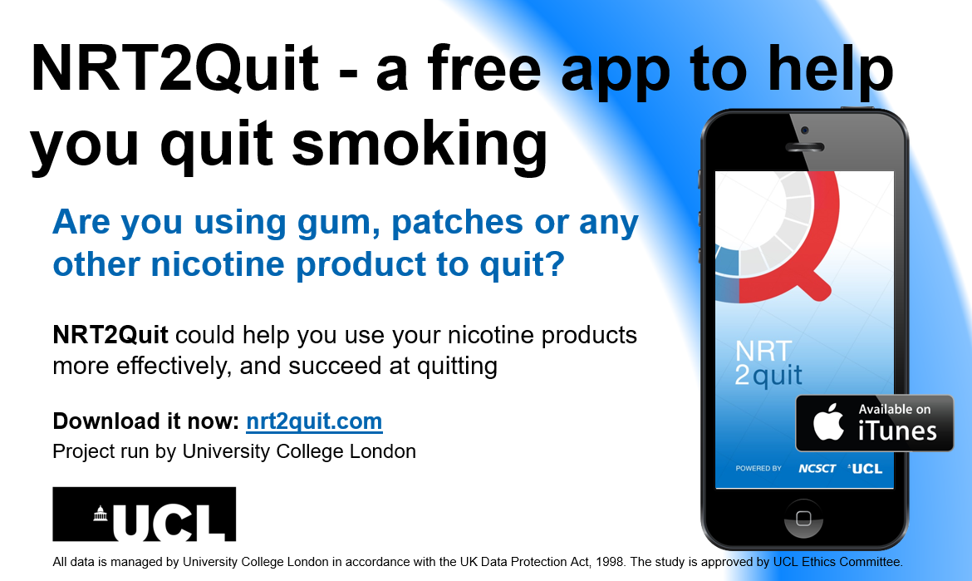

Supplementary Material 4: Functionality and screenshots of NRT2Quit (Intervention and control)

Table S.4.1: Comparison between intervention and control versions of NRT2Quit (greyed out cells = not provided)
Feature and content supporting NRT use | Intervention |  |  | Control
 | BCT Smoking Taxonomy | BCTs  V1 Taxonomy | BCT Smoking Taxonomy |  | BCTs  V1 Taxonomy
Registration and Setting of the Quit Date
Setting up of the quit date | BS4 | - 1.3 | BS4 |  | 1.1, 1.3
Reassuring feedback on NRT purchased | BM7, RC10 | 2.2, 3.1, 10.4, 15.1 | - |  | -
Making a pledge for not-smoking and NRT use | BM6 | 1.8 , 13.5, | - |  | -
Features to update the quit date and NRT use | BS4, RC4 | 1.1, 1.3 | BS4 |  | 1.1, 1.3
Support with NRT Use
Brief advice on NRT use | A1 | 4.1 | - |  | -
Comprehensive advice on NRT and its use | A1, BM5, RC6 | 4.1, 4.2, 4.3, 4.4, 5.1, 5.3, 5.6, 6.2, 7.1, 8.1, 8.3, 12.1 | - |  | -
Monitoring and feedback of NRT use (Dashboard, daily diary and additional tailored sessions) | A4, BM7, BS6, RD1, R14 | 1.6, 2.2, 2.3, 3.1, 15.1 | - |  | -
General cessation advice and other information | -
Monitoring of smoking status (daily diary) | BS6, R14 | 2.2., 2.3, 2.4, 2.7, 15.1, | - |  | -
Feedback on smoking status | BM7 | 1.6, 10.4, 15.1 | - |  | -
Pre- and post-quit daily tips | A2, BM1, BM2, BM8 BM10, BS2, BS3, BS7, BS8, BS10, BS11, RC10, | 5.1, 5.3, 5.5, 5.6, 6.2, 7.1, 8.2, 9.1, 11.1, 11.2, 12.1, 12.2, 12.3, 12.4, 13.5, 15.1, | -
Generic advice on quitting | BS2, BM8, BM1, BM2, BM5, RC6 | 4.1, 4.2, 4.3, 5.1, 5.3, 5.6, 6.2, 7.1, 8.2, 9.1, 11.1, 11.2, 12.1, 12.2, 12.3, 12.4, 13.5, 15.1 | BS2*, BM1*, BM2*, BM5*, RC6* |  | 5.1*, 6.2*, 10.4*, 11.1*
Information on stop smoking medications | A1, RD2 | 5.1, 5.6, 11.1 | -
Information about the app, study and the team | RC4 | 9.1 | A1* |  | 9.1*
Calendar / Counting days to and from the quit date
Outline of the quit plan and reminders to obtain NRT | BS3 | 12.5 | - |  | -
Display the date of the follow-up | N/A | N/A | N/A |  | N/A
Displaying days to and since the quit date | BS3 | 12.5 | BS3 |  | 12.5
Daily reminders to engage with the app and advice | BS6 | 7.1 | - |  | -
*=brief and simplified
Figure S.4a: Visual summary of the differences in the architecture and functionality of NRT Control vs. Intervention apps.

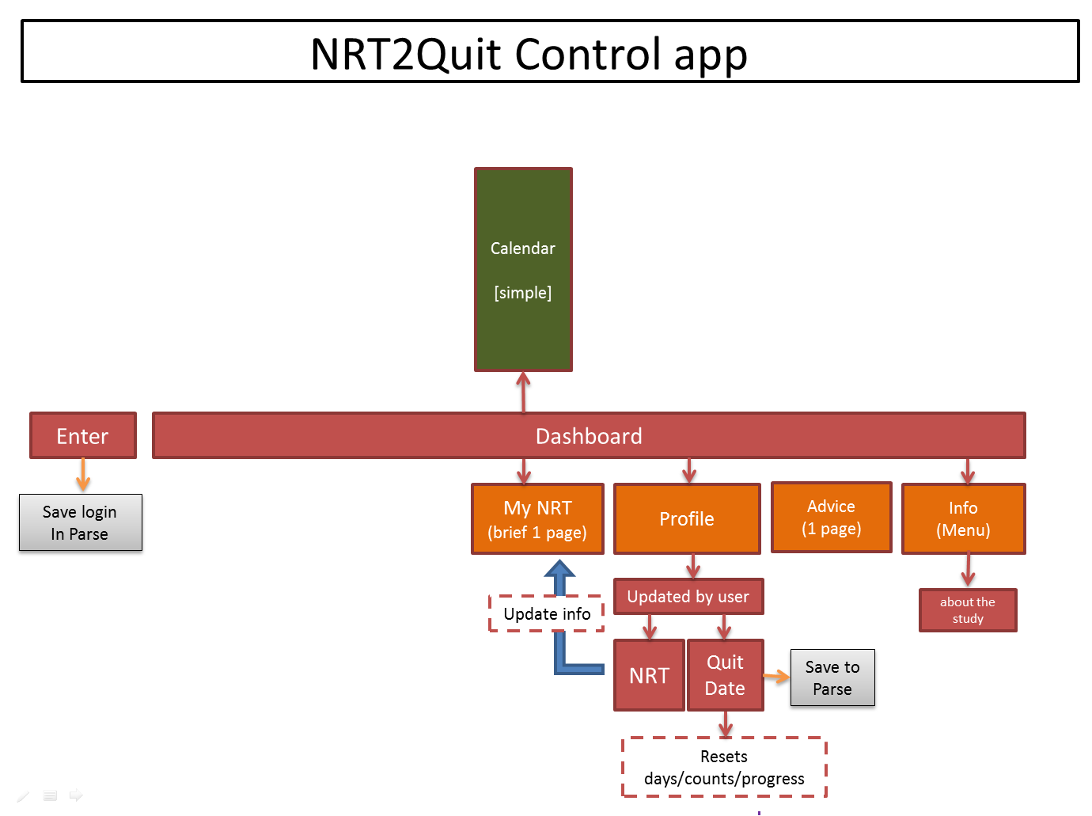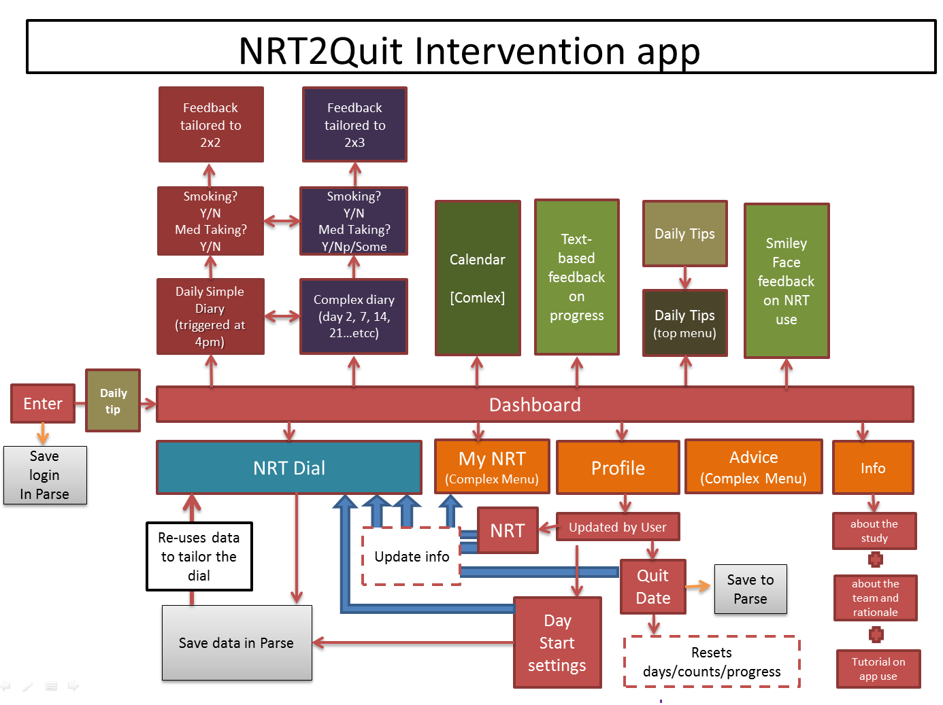

Figure S.4b: Selected Screenshots of NRT2Quit

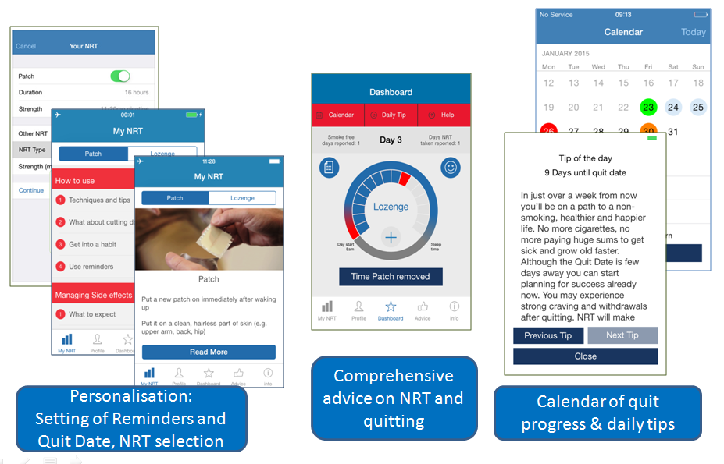

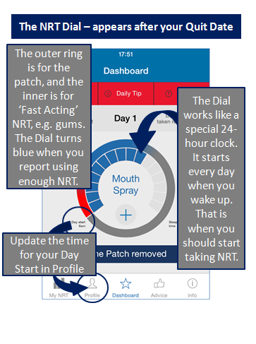
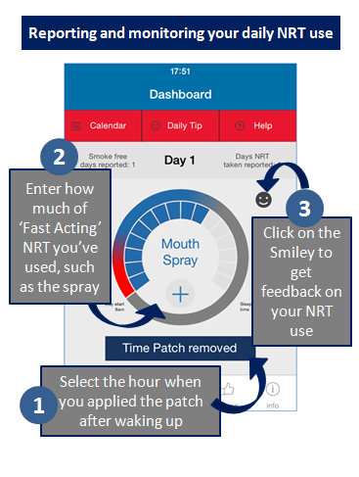
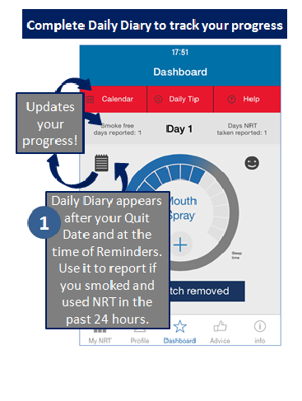
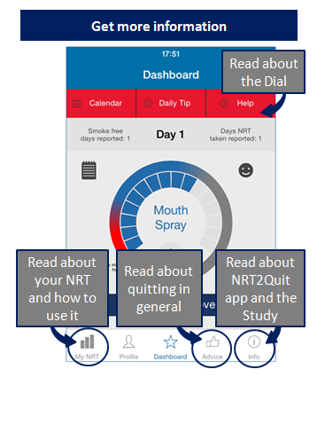
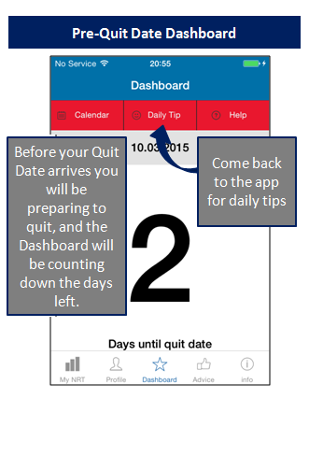
Figure S.4c: NRT2Quit – tutorial for Intervention users about NRT2Quit and the main dashboard

Supplementary Materials 5 – Flow of participants through NRT2Quit app and the trial

Figure S6: Flow of participants through the NRT2Quit app and the trial

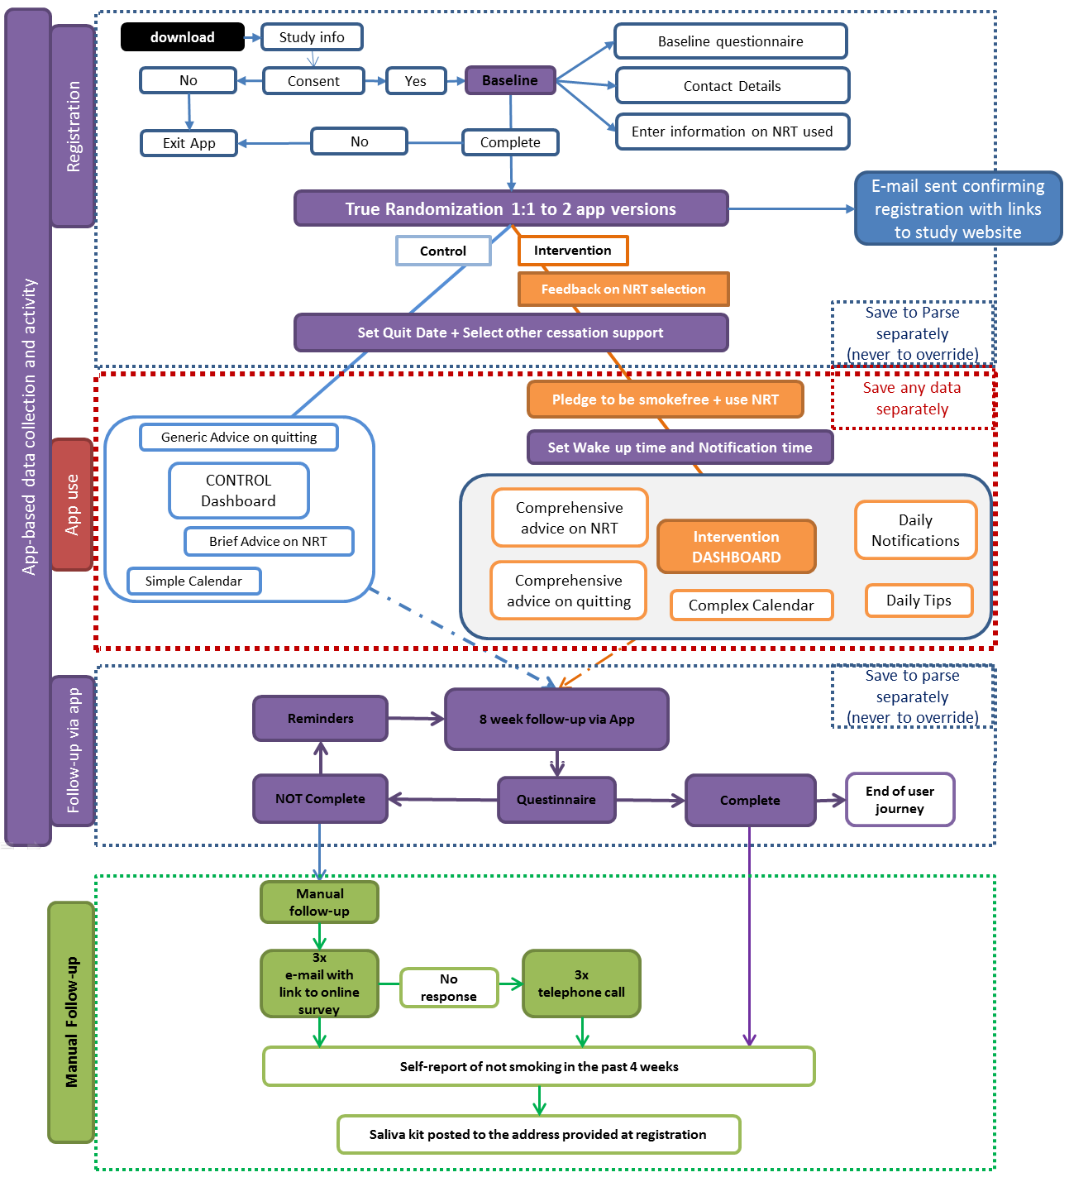

Michie, S., et al. (2011). Development of a taxonomy of behaviour change techniques used in individual behavioural support for smoking cessation. Addictive behaviors, 36(4), 315-319.
Michie, S., et al., (2013). The behavior change technique taxonomy (v1) of 93 hierarchically clustered techniques: building an international consensus for the reporting of behavior change interventions. Annals of behavioral medicine, 46(1), 81-95.

