Supplemental Material

Rapid increase of C/EBPa p42 induces growth arrest of AML cells by Cop1 deletion in Trib1-expressing AML

Yoshitaka Sunami, Seiko Yoshino, Yukari Yamazaki, Takashi Iwamoto, and Takuro Nakamura

Five Supplemental Figures

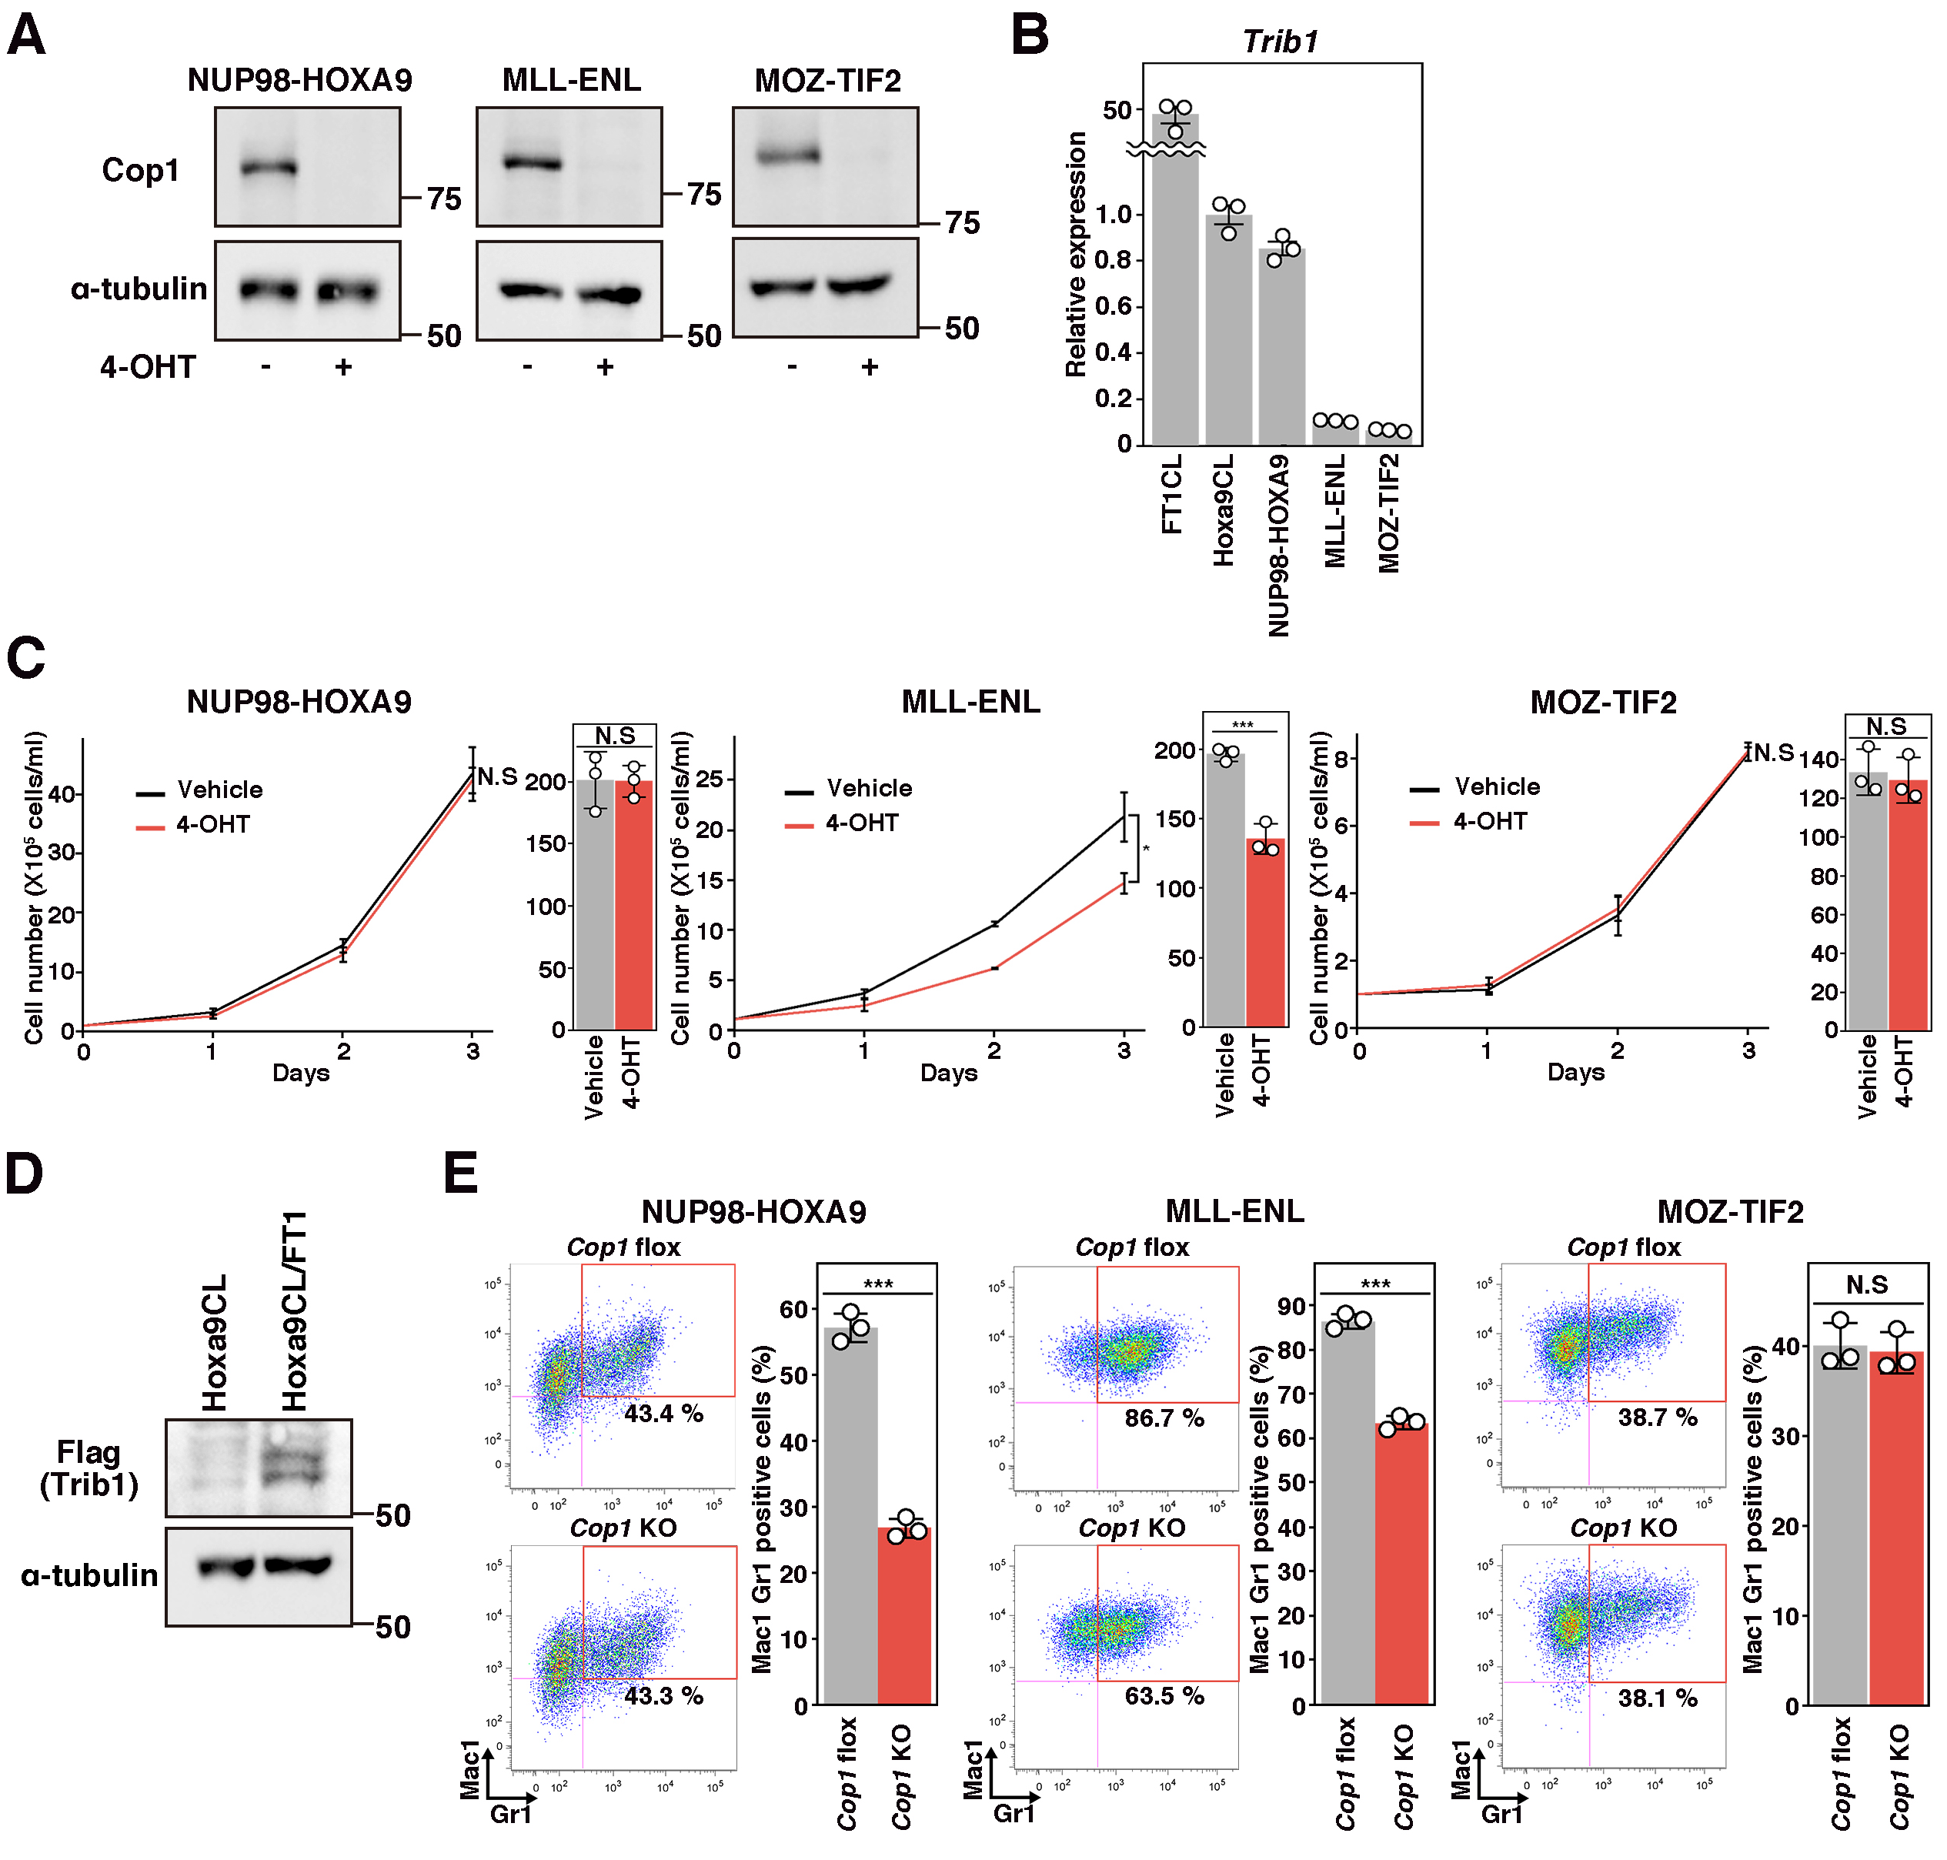
Supplementary Fig. S1. Cop1 is required for proliferation and survival of Trib1-induced AML. A Immunoblotting showing Cop1 loss by 4-hydroxytamoxifen (4-OHT) treatment in indicated cell lines. B Trib1 expression in five cell lines measured by qRT-PCR (n = 3 per group; mean ± SD). C The effect of Cop1 KO on leukemia cell proliferation. The bar graphs show differences on day 3. Statistical analysis was performed by Student t-test and *marks adjusted p-value < 0.05 (n = 3 per group; mean ± SD). D Immunoblotting showing Flag-tagged Trib1 expression in Hoxa9CL/FT1 cells. E Flow cytometry showed no increase of Mac1- and Gr1-positive fractions by Cop1 KO in NUP98-HOXA9, MLL-ENL, and MOZ-TIF2 cells. Frequencies of Mac1- and Gr1-positive cells are indicated in FACS plots and bar graphs.

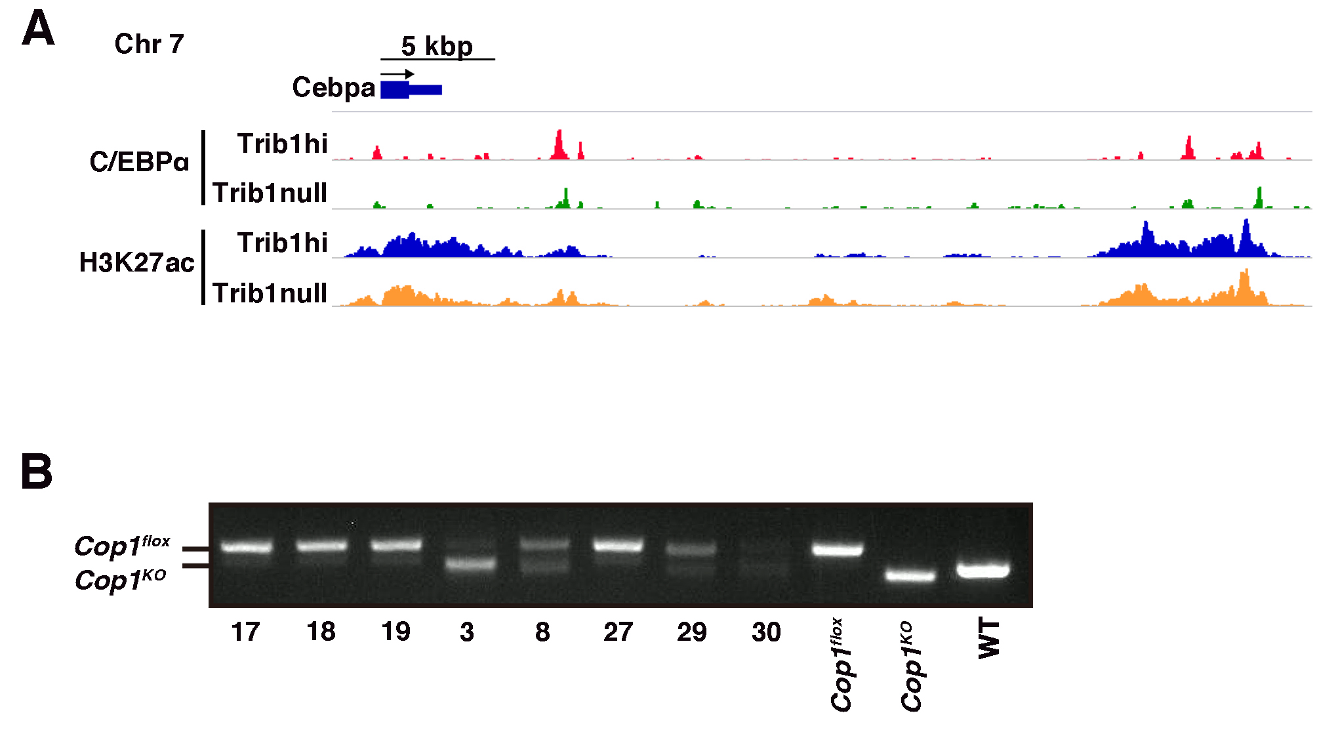Supplementary Fig. S2. Epigenetic landscape of Cebpa and genotype of AML in the bone marrow transplantation experiment. A ChIP-seq for C/EBPα and histone H3K27ac in Trib1-associated AML cells at the Cebpa 3’ enhancers [25]. B Evaluation of Cop1 alleles in AML from the bone marrow transplantation experiment. Tumor DNA samples collected from recipients treated with vehicle (17, 18, and 19) or tamoxifen (3, 8, 27, 29, and 30) were subjected to genomic PCR. Cop1 flox, KO, and wild type (WT) alleles are indicated.

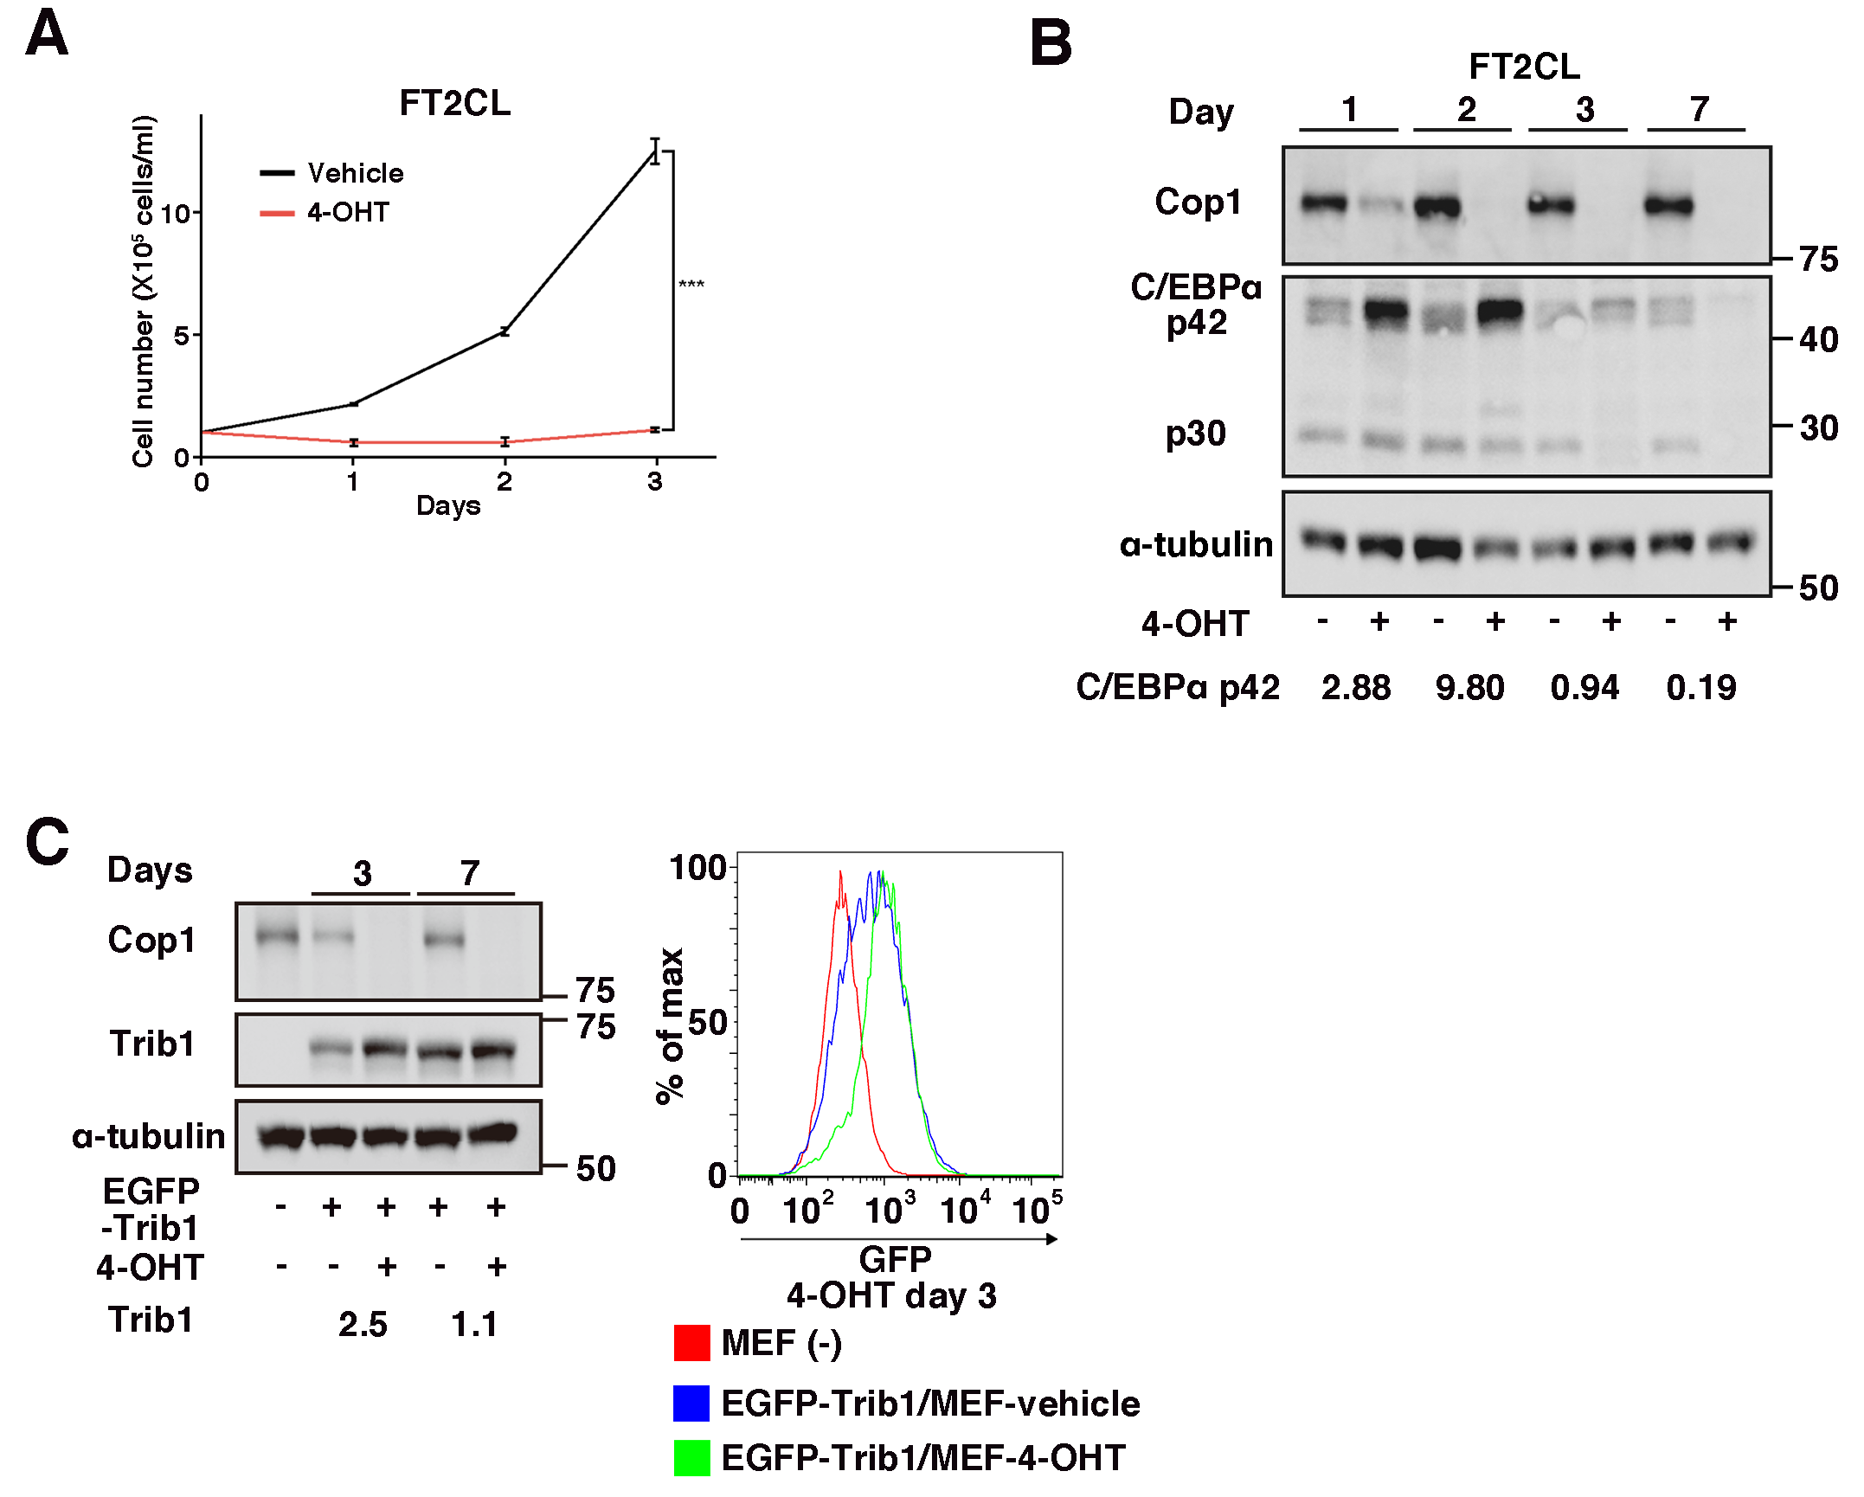
Supplementary Fig. S3. Growth suppression of Trib2-expressing AML and Trib1 protein increase in mouse embryonic fibroblasts by Cop1 KO. A Inhibition of proliferation by Cop1 KO in FT2CL. Statistical analysis was performed by Student t-test and ***marks adjusted p-value < 0.001 (n = 3 per group; mean ± SD). B Immunoblotting showing transient increase of the C/EBPa p42 isoform by Cop1 KO in FT2CL. The p42 expression ratios (KO vs WT) adjusted by α-tubulin are indicated (bottom). C Mild increase of the EGFP-tagged Trib1 protein by Cop1 KO in MEFs. Left: Immunoblotting showing increased Trib1 protein 3 and 7 d after 4-OHT treatment. Right: Flow cytometry showing increased EGFP expression by Cop1 KO. Fold-increase values adjusted by α-tubulin (Cop1 KO vs WT) are indicated (bottom). Representative immunoblots from three independent experiments.

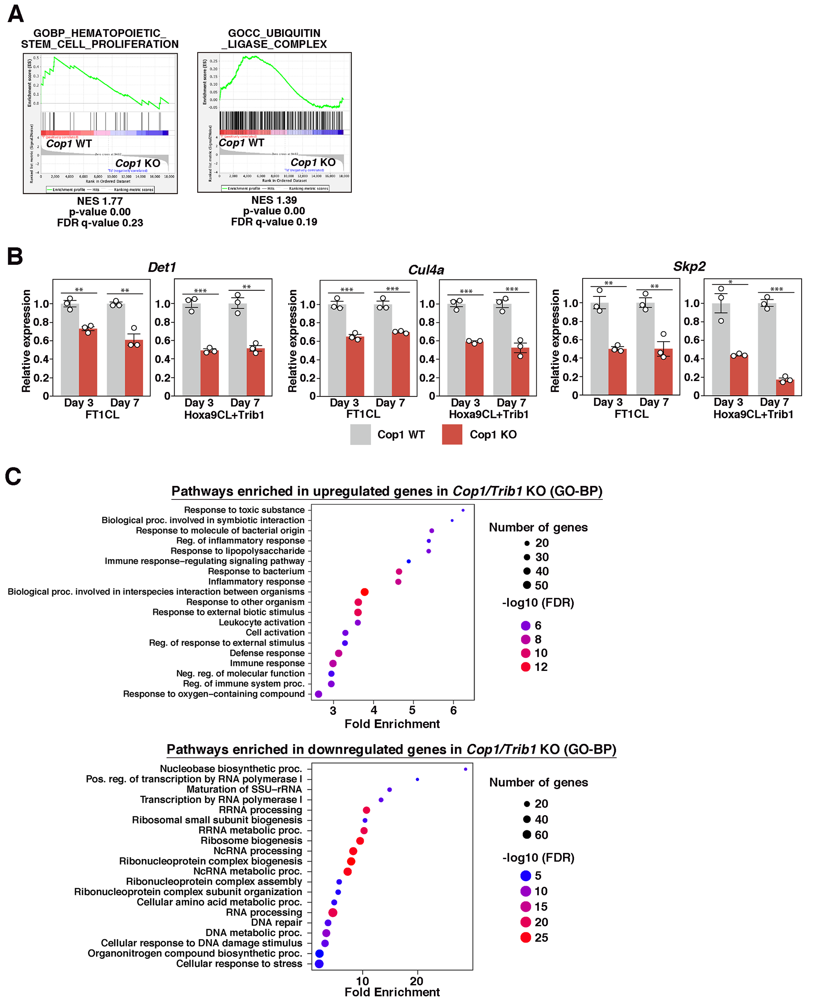
Supplementary Fig. 4. Modulation of gene expression profiles in AML by Cop1 KO. A GSEA showing enrichment of correlated pathways with Cop1 expression. NES, normalized enrichment score; FDR, false discovery rate. B qRT-PCR showing downregulation of Det1, Cul4a, and Skp2 on day 3 and 7 after 4-OHT treatment. Statistical analysis was performed by Student t-test and **marks adjusted p-value < 0.01 and ***marks adjusted p-value < 0.001. C Gene ontology analysis for biological processes showing the enrichment of pathways in overlapping upregulated (top) and downregulated (bottom) genes between Cop1 and Trib1 KO AML.
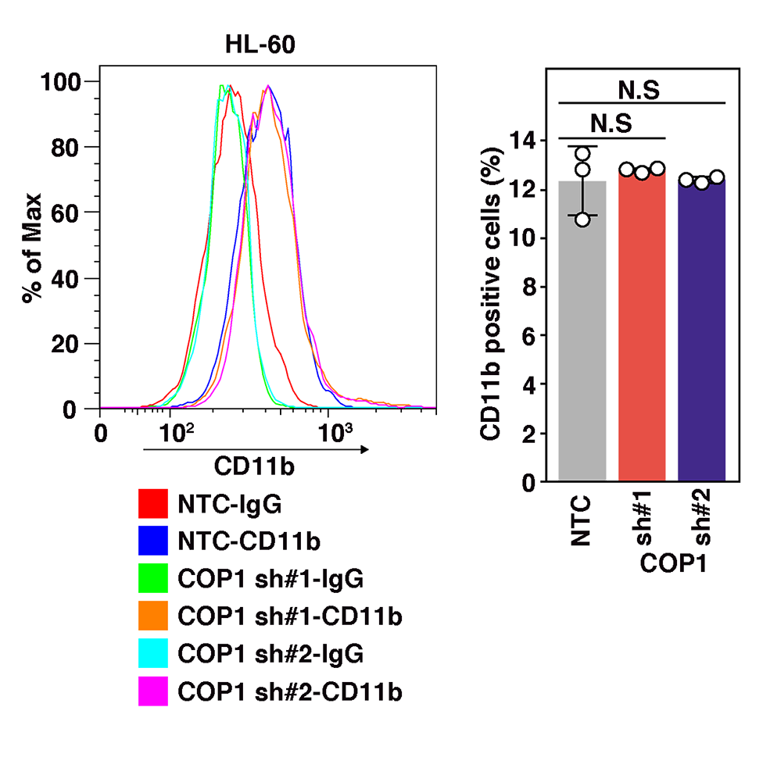
Supplementary Fig. S5. Flow cytometry showing CD11b-positive fractions in HL-60 cells. Left; representative plots of CD11b expression in HL-60. Right; frequencies of CD11b-positive fractions in each group (n = 3 per group; mean ± SD). Statistical analysis was performed by one-way ANOVA.

