Supplementary Materials for

Self-healing Polymer Gel with Cascade-Responsive Properties
Chao Li¹, Chihamo Jike¹, Yan Song¹, Guo Liang Li¹*, Yi Jia², Junbai Li^{2, 3}*
¹State Key Laboratory of Chemical Resource Engineering, College of Materials Science and Engineering, Beijing University of Chemical Technology, 100029 Beijing (China)
²Beijing National Laboratory for Molecular Sciences (BNLMS), CAS Key Lab of Colloid, Interface and Chemical Thermodynamics, Institute of Chemistry, Chinese Academy of Sciences, 100190 Beijing (China)
³University of Chinese Academy of Sciences, 100049 Beijing (China)
*Corresponding author. Email: glli@buct.edu.cn (Guo Liang Li); jbli@iccas.ac.cn (Junbai Li)

The PDF file includes:
Supplementary Fig. 1 to 18
Supplementary Video 1 caption
Other Supplementary Materials for this manuscript include the following:
Supplementary Video 1

Table of content
Supplementary Fig. 1. 2
Supplementary Fig. 2. 3
Supplementary Fig. 3. 4
Supplementary Fig. 4. 5
Supplementary Fig. 5. 6
Supplementary Fig. 6. 7
Supplementary Fig. 7. 8
Supplementary Fig. 8. 9
Supplementary Fig. 9. 10
Supplementary Fig. 10. 11
Supplementary Fig. 11. 12
Supplementary Fig. 12. 13
Supplementary Fig. 13. 14
Supplementary Fig. 14. 15
Supplementary Fig. 15. 16
Supplementary Fig. 16. 17
Supplementary Fig. 17. 18
Supplementary Fig. 18. 19
Supplementary Video 1. 20

Supplementary Fig. 1.
¹H Nuclear magnetic resonance (¹H-NMR) spectrum of the chain extender lysine–dopamine (LDA).

Supplementary Fig. 2.
¹³C Nuclear magnetic resonance (¹³C-NMR) spectrum of the chain extender lysine–dopamine (LDA).

Supplementary Fig. 3.
Fourier-transform infrared (FT-IR) spectra of the cascade-responsive self-healing polymers (CRSP).
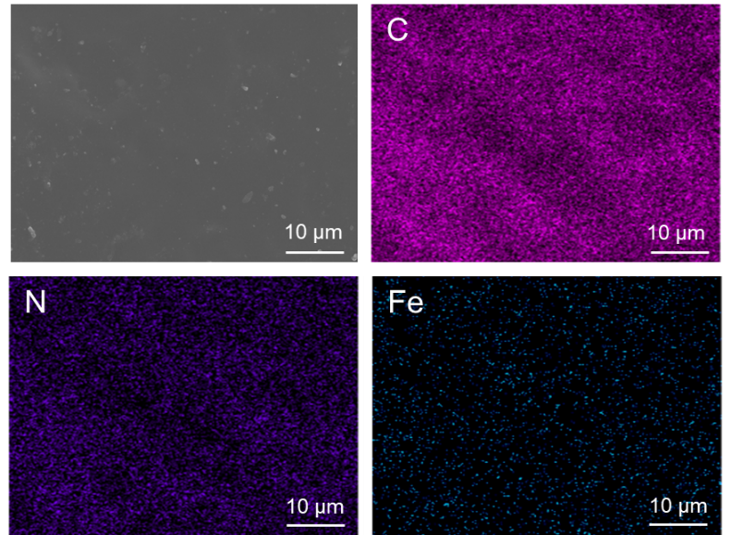

Supplementary Fig. 4.
Scanning electron microscope-Energy Dispersive Spectrometer (SEM-EDS) mapping of the cascade-responsive self-healing polymer-3 (CRSP-3). It shows the uniform distribution of Fe on the surface of sample, which proves the successful incorporation of ferrocene into polymer chain.

Supplementary Fig. 5.
Stress–strain curves of cascade-responsive self-healing polymer-0 (CRSP-0, Fig. 1e). Note that control sample CRSP-0 cannot achieve self-healing.

Supplementary Fig. 6.
Stress–strain curves of cascade-responsive self-healing polymer-1 (CRSP-1, Fig. 1e).

Supplementary Fig. 7.
Stress–strain curves of cascade-responsive self-healing polymer-2 (CRSP-2, Fig. 1e).

Supplementary Fig. 8.
Stress–strain curves of cascade-responsive self-healing polymer-4 (CRSP-4, Fig. 1e).

Supplementary Fig. 9.
Stress–strain curves of cascade-responsive self-healing polymer-5 (CRSP-5, Fig. 1e).

Supplementary Fig. 10.
Stress–strain curves of cascade-responsive self-healing polymer-6 (CRSP-6, Fig. 1e).

Supplementary Fig. 11.
Stress-strain curves of original and self-healing cascade-responsive self-healing polymer-3 (CRSP-3, Fig. 1e) at room temperature for 24 h without mechanical force. The self-healing efficiency is calculated to be only 5 %.

Supplementary Fig. 12.
Master curves of storage (G′) and loss (G′′) moduli for original and compressed control samples (a) cascade-responsive self-healing polymer-0 (CRSP-0, Fig. 1e) at pH 11 and (b) CRSP-3, (Fig. 1e) at pH 7 (50 MPa, 5 min). The storage (G′) and loss (G′′) moduli of control CRSP-0 at pH 11 had no significant change. In addition, the storage (G′) and loss (G′′) moduli of CRSP-3 at pH 7 decreases slightly after compression.

Supplementary Fig. 13.
Atomic force microscope (AFM) modulus histograms for (a) original and (b) compressed control sample cascade-responsive self-healing polymer-0 (CRSP-0, Fig. 1e) at pH 11 (50 MPa, 5 min). The modulus of control sample CRSP-0 at pH 11 showed no significant change after compression.

Supplementary Fig. 14.
Two-dimensional distribution maps of moduli for (a) uncompressed and (b) compressed control sample cascade-responsive self-healing polymer-0 (CRSP-0, Fig. 1e) at pH 11 (50 MPa, 5 min). The modulus of control sample CRSP-0 at pH 11 showed no significant change after compression.

Supplementary Fig. 15.
Two-dimensional distribution maps of moduli for (a) original and (b) compressed cascade-responsive self-healing polymer-3 (CRSP-3, Fig. 1e) at pH 11 (50 MPa, 5 min). The modulus of CRSP-3 at pH 11 increased obviously after compression.

Supplementary Fig. 16.
Ultimate tensile strength of cascade-responsive self-healing polymer-3 (CRSP-3, Fig. 1e) that compressed at different pressure. After compressed, the sample remained at room temperature for 24 h for the next test.

Supplementary Fig. 17.
Ultimate tensile strength of cascade-responsive self-healing polymer-3 (CRSP-3, Fig. 1e), that self-healed for different times in artificial seawater and compressed at 110 MPa.

Supplementary Fig. 18.
Stress-strain curves of cascade-responsive self-healing polymer-3 (CRSP-3, Fig. 1e) that self-healed for different times in artificial seawater and compressed at 110 MPa. Note that each CRSP-3 spline was immersed in artificial seawater for 3 h before the self-healing test. a, Stress-strain curves of original CRSP-3. b, Stress-strain curves of cut CRSP-3 that self-healed for 0 s. c, Stress-strain curves of cut CRSP-3 that self-healed for 30 s. d, Stress-strain curves of cut CRSP-3 that self-healed for 1 min. e, Stress-strain curves of cut CRSP-3 that self-healed for 5 min. f, Stress-strain curves of cut CRSP-3 that self-healed for 30 min. g, Stress-strain curves of cut CRSP-3 that self-healed for 3 h. h, Stress-strain curves of cut CRSP-3 that self-healed for 6 h. i, Stress-strain curves of cut CRSP-3 that self-healed for 12 h.

Supplementary Video 1.
The mechanical-response self-healing process of cascade-responsive self-healing polymer-3 (CRSP-3). The broken control sample CRSP-0 and CRSP-3 were treated under the pressure of 50 MPa for 5 min at room temperature. The as-synthesized CRSP-3 exhibited obvious healing behaviors. In contrast, the control sample CRSP-0 did not show healing behavior under the same conditions.

