Infection pattern of male-killing viruses alters phenotypes in the tea tortrix moth, Homona magnanima

Takumi Takamatsu^{1, #}, Hiroshi Arai^{1,2}, Yoshiyuki Itoh³, Chien-fu Wu¹, Kentaro Kitaura¹, Hiromitsu Moriyama¹, Maki N. Inoue^{1, #}

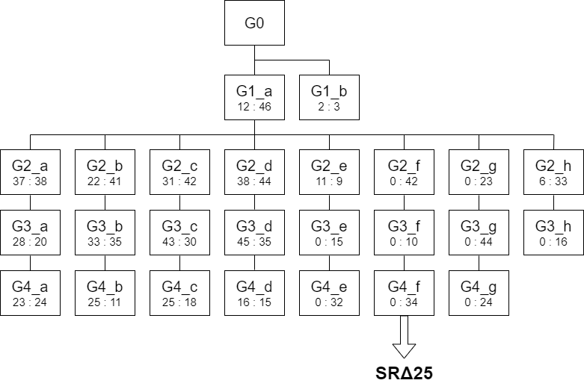
Figure S1. Lineage of the NSR line following injection of homogenate of OGV1 and OGV3 infected H. magnanima.
Each square indicates the generation after injection (G0–G4) andsex ratio (male: female) of each sibling.

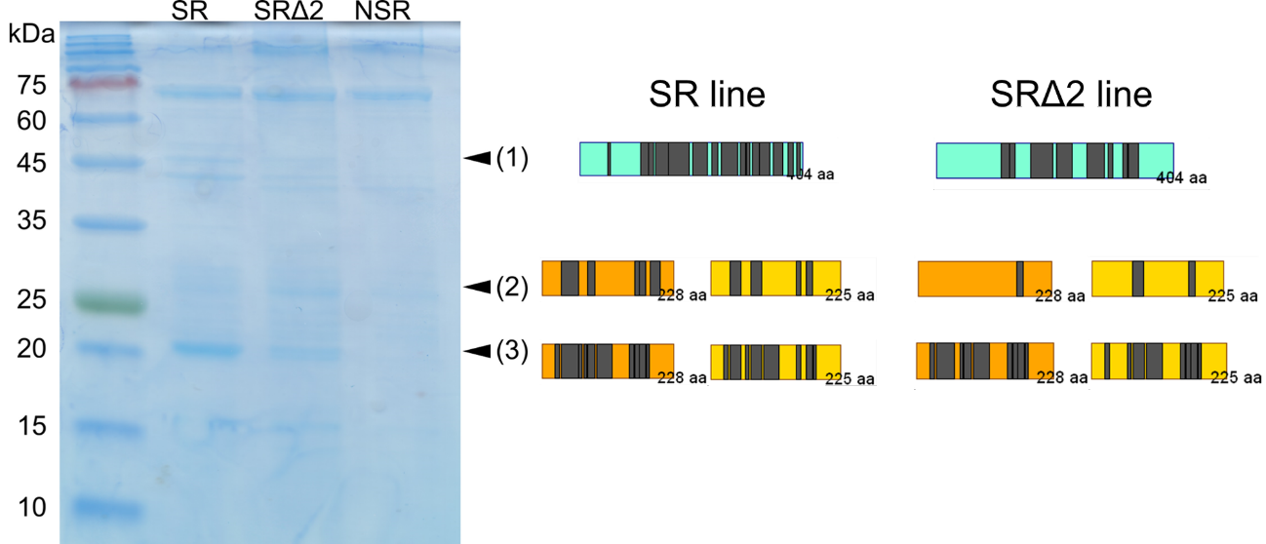
Figure S2. Genome segment assignment of OGVs proteins in the SR line and the SRΔ2 line.
Tryptic peptides identified as OGV proteins were mapped to each ORF. Gray squares indicate peptide fragments analyzed by LC-MS. Cyan, orange, and yellow squares indicate the ORFs of MK6, MK23, and MK24.

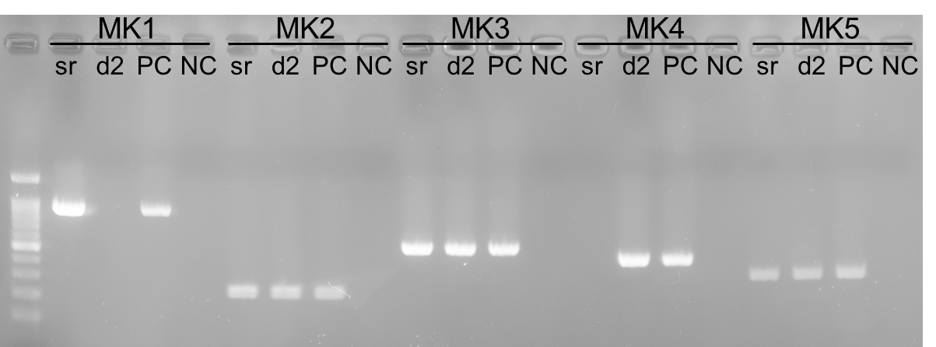
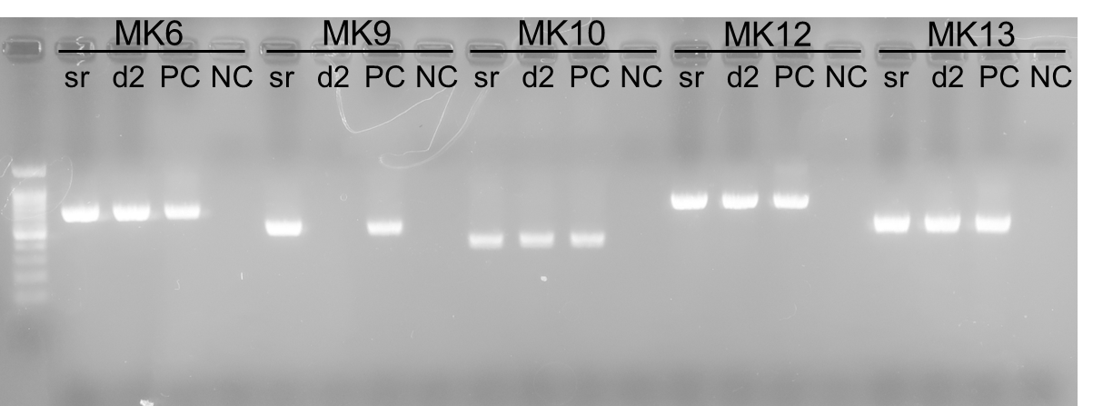
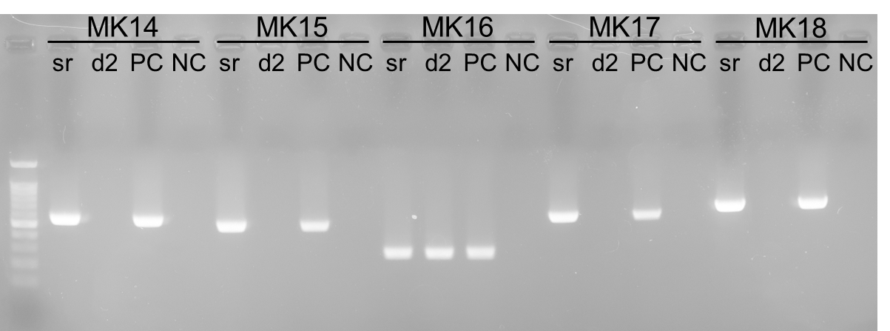
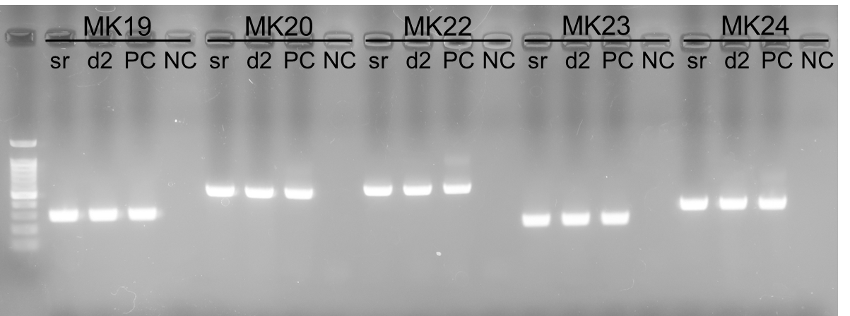
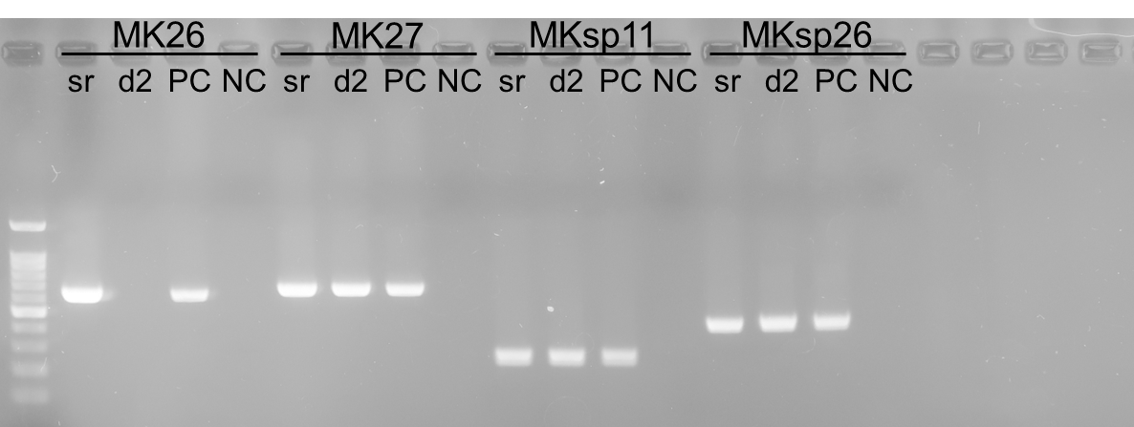
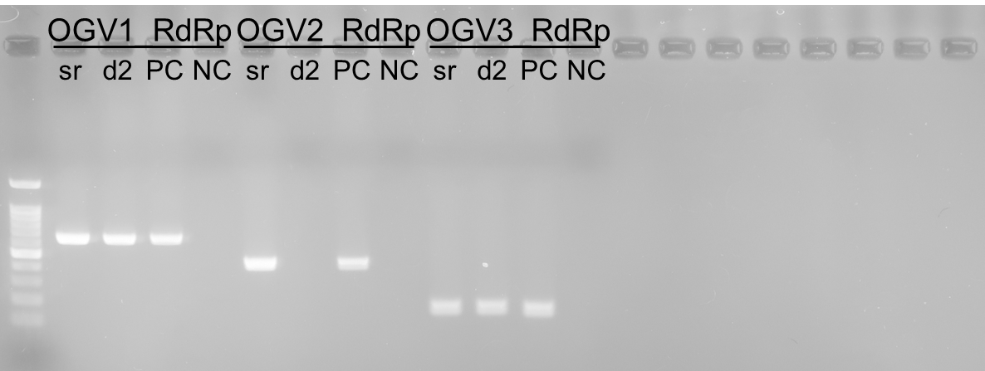

Figure S3. RT-PCR analysis for detection of RNAs extracted from virus particles.
sr: virus particles from SR line; d2: virus particles from SRΔ2 line; PC: positive control; NC: negative control. Primers used in this study are listed in Table S1.

