Supporting Information

Cao et al.,

Contents of this file
- Supplementary Table 1 to 5
- Supplementary Figures 1 to 14
Supplementary Table
Supplementary Table 1. The springtime MDA8 ozone trends in the PRD cities (ppbv a⁻¹) from 2013 to 2022.

City | Aª | B^{b} | C^{c}
Guangzhou | 1.59 | 1.03 | 0.54
Shenzhen | 0.78 | 0.63 | 0.15
Zhuhai | 0.60 | 0.59 | 0.02
Foshan | 1.89 | 1.00 | 0.89
Zhongshan | 1.11 | 0.94 | 0.16
Jiangmen | 2.05 | 1.03 | 1.02
Dongguan | 0.77 | 1.09 | -0.32
Huizhou | 0.50 | 0.80 | -0.30
Zhaoqing | 0.36 | 0.80 | -0.44

ª Observed trends are obtained by ordinary linear regression on spring (MAM) monthly mean MDA8 O₃ anomalies measured at all the national monitoring sites for each city in the PRD.
^{b} Meteorologically driven trends are obtained by fitting the ozone data to a multiple linear regression (MLR) model with the three most important meteorological covariates (see text).
^{c} Anthropogenically driven trends are obtained by ordinary linear regression of the residual ozone after removing the MLR-fitted value.

Supplementary Table 2. The springtime MDA8 ozone trends for 57 sites in the PRD region (ppbv a⁻¹) from 2013 to 2022.

city | Site | Aª | Bª | Cª | Site | Aª | Bª | Cª
Guangzhou | gyzx | 1.92 | 0.93 | 0.98 | hdsf | 0.91 | 1.06 | -0.16
Guangzhou | swz | 2.78 | 1.09 | 1.68 | sjcz | 3.23 | 1.11 | 2.12
Guangzhou | thzy | -1.71 | -0.96 | -0.75 | jlz | 1.09 | 0.88 | 0.21
Guangzhou | gdsxy | 1.86 | 1.11 | 0.75 | lh | 2.03 | 1.01 | 1.02
Guangzhou | s86z | 1.67 | 1.05 | 0.62 | tyx | 2.20 | 0.95 | 1.25
Guangzhou | pyzx | 1.81 | 1.19 | 0.62 | mfsslgy | -0.63 | 0.93 | -1.56
Shenzhen | ly | 1.57 | 0.67 | 0.89 | xx | 1.26 | 0.30 | 0.96
Shenzhen | hh | -0.10 | 0.71 | -0.81 | na | 0.73 | 0.55 | 0.17
Shenzhen | hqc | 1.02 | 0.55 | 0.47 | ky | 1.87 | 0.65 | 1.21
Shenzhen | ny | -0.04 | 0.53 | -0.57 | ms | 1.32 | 0.58 | 0.74
Shenzhen | yt | 0.44 | 0.57 | -0.13 | gl | -0.05 | 0.86 | -0.91
Shenzhen | lg | 1.43 | 0.76 | 0.66
Zhuhai | jd | 0.70 | 0.60 | 0.10 | tj | 2.15 | 0.66 | 1.49
Zhuhai | qs | -0.43 | 0.43 | -0.86 | dm | -0.01 | 0.65 | -0.66
Foshan | wl | 2.02 | 1.07 | 0.95 | rgjdb | 1.71 | 0.96 | 0.76
Foshan | hczz | 2.65 | 1.03 | 1.62 | gmkt | 1.27 | 0.89 | 0.38
Foshan | nhqxj | 2.01 | 1.09 | 0.92 | ssjcz | 1.20 | 0.91 | 0.30
Foshan | sdsg | 2.99 | 1.01 | 1.98 | ssydh | 1.34 | 0.95 | 0.39
Zhongshan | hby | 1.63 | 0.95 | 0.67 | zml | 1.62 | 0.98 | 0.64
Zhongshan | zx | 0.45 | 0.95 | -0.50 | cclyq | 0.74 | 0.89 | -0.15
Jiangmen | bj | 2.82 | 1.03 | 1.79 | gfx | 1.59 | 0.94 | 0.65
Jiangmen | xq | 1.75 | 1.06 | 0.68 | dh | 2.04 | 1.08 | 0.96
Dongguan | ncyl | 0.62 | 1.01 | -0.39 | ncxp | 0.34 | 1.11 | -0.77
Dongguan | gclc | 0.97 | 0.94 | 0.02 | dczs | 1.91 | 0.83 | 1.08
Dongguan | dcsj | 0.65 | 1.15 | -0.50
Huizhou | hnajsh | 0.80 | 0.88 | -0.08 | hyqcxlch | -0.02 | 0.70 | -0.72
Huizhou | xphjsl | 0.66 | 0.87 | -0.21 | dywgwh | 0.25 | 0.62 | -0.37
Huizhou | jbysxl | 0.82 | 0.92 | -0.10
Zhaoqing | mg | 0.22 | 0.76 | -0.54 | kk | 0.22 | 0.82 | -0.60
Zhaoqing | cz | 1.43 | 0.76 | 0.67 | qxy | -0.63 | 0.79 | -1.43
ª Same with Table S1 but for each site in the PRD.

Supplementary Table 3. Key meteorological factors for each city driving the springtime MDA8 ozone trends in the PRD from 2013 to 2022.

City | 1st | 2nd | 3rd
Guangzhou | (+)SSR(100.0%) | (-)V850(91.7%) | (-)U10(41.7%)
Shenzhen | (-)U10 (72.7%) | (-)V850(45.5%) | (+)SSR(54.5%)
Zhuhai | (-)V850 (75.0%) | (-)U10 (75.0%) | (+)SSR(75.0%)
Foshan | (+)SSR(100.0%) | (-)V850(100.0%) | (-)U10(100.0%)
Zhongshan | (-)V850(100.0%) | (+)SSR(50.0%),  (-)U10(50.0%) | (+)SSR(50.0%),  (-)U10(50.0%)
Jiangmen | (-)V850(100.0%) | (+)SSR(75.0%) | (-)U10(75.0%)
Dongguan | (+)SSR (80.0%) | (-)V850(80.0%) | (-)PBLH(40.0%),  (-)U10(40.0%)
Huizhou | (+)SSR(40.0%),  (-)V850(40.0%) | (-)V850(60.0%) | (+)V10(60.0%)
Zhaoqing | (+)SSR(100.0%) | (-)V850(100.0%) | (-)U10(100.0%)

The top three meteorological predictors for each site as determined by the MRL model (see Method), with the most frequent predictor across all sites selected for each corresponding rank, are indicated in the legend. Positive and negative signs indicate a positive and negative correlation between ozone change and meteorological factors.

Supplementary Table 4. Meteorological variables from the ERA5 reanalysis dataset were used in this study.

Variableª names | Definition
Tmax | Daily maximum 2-m air temperature (K)
U10 | 10-m zonal wind ( m s⁻¹)*
V10 | 10-m meridional wind ( m s⁻¹)†
PBLH | Boundary layer height (m)
SLP | Sea level pressure (Pa)
RH | Surface air relative humidity (%)
V850 | 850-hPa meridional wind (m s⁻¹)†
SSR | Surface net solar radiation (J m⁻²)
Variable^{b} names | Definition
MSLP | Mean sea level pressure
U | Eastward component of the wind (m s⁻¹)*
V | Northward component of the wind (m s⁻¹)*

ª Meteorological variable: The following parameters are considered as ozone covariates in the MRL model. T_{max}, U10, V10, and RH are available at a 0.1° × 0.1° resolution, while SLP, PBLH, and V850 come in a 0.25° × 0.25° resolution. The data are averaged over 24 hours for use in the MLR model for ozone, with exceptions for PBLH and SSR, which are averaged over daytime hours (7:00 - 19:00 local time), and T_{max}, which uses the daily maximum.
^{b} Meteorological variables: Hourly MSLP is used in weather type classification; Hourly U, V at 850 hPa are used to analyze the wind field. These data come in 0.25° × 0.25° resolutions.
* Positive westerly
† Positive southerly

Supplementary Table 5. The 27 original classes of LWTs have eight directional types, two types that describe atmospheric rotation (A and C), 16 hybrid-combined types, and one “Unclassified” type representing weak or chaotic flow.

Vorticity | Directional | Hybrid |  | Low flow
Anticyclonic  (A) | Northeasterly  (NE) | Anticyclonic Northeasterly  (ANE) | Cyclonic Northeasterly  (CNE) | Low Flow  (LF)
Cyclonic  (C) | Easterly  (E) | Anticyclonic Easterly  (AE) | Cyclonic Easterly  (CE)
 | Southeasterly  (SE) | Anticyclonic Southeasterly  (ASE) | Cyclonic Southeasterly  (CSE)
 | Southerly  (S) | Anticyclonic Southerly  (AS) | Cyclonic Southerly  (CS)
 | Southwesterly  (SW) | Anticyclonic Southwesterly  (ASW) | Cyclonic Southwesterly  (CSW)
 | Westerly  (W) | Anticyclonic Westerly  (AW) | Cyclonic Westerly  (CW)
 | Northwesterly  (NW) | Anticyclonic Northwesterly  (ANW) | Cyclonic Northwesterly  (CNW)
 | Northerly  (N) | Anticyclonic Northerly  (AN) | Cyclonic Northerly  (CN)
A final set of 11 types is finally retained (bold letters)

Supplementary Figures
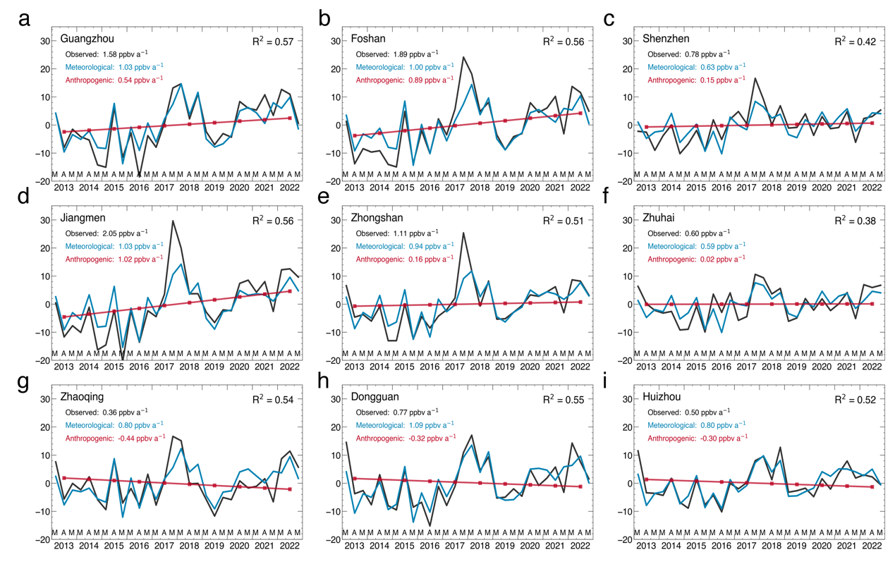
Supplementary Figure 1. Time series of monthly mean MDA8 ozone anomalies in spring (MAM) from 2013 to 2022 for the nine cities in the PRD: a Guangzhou, b Foshan, c Shenzhen, d Jiangmen, e Zhongshan, f Zhuhai, g Zhaoqing, h Dongguan, i Huizhou. For each city, observed trends are compared to the meteorologically driven trends and the residuals which are determined as the anthropogenically driven trend.

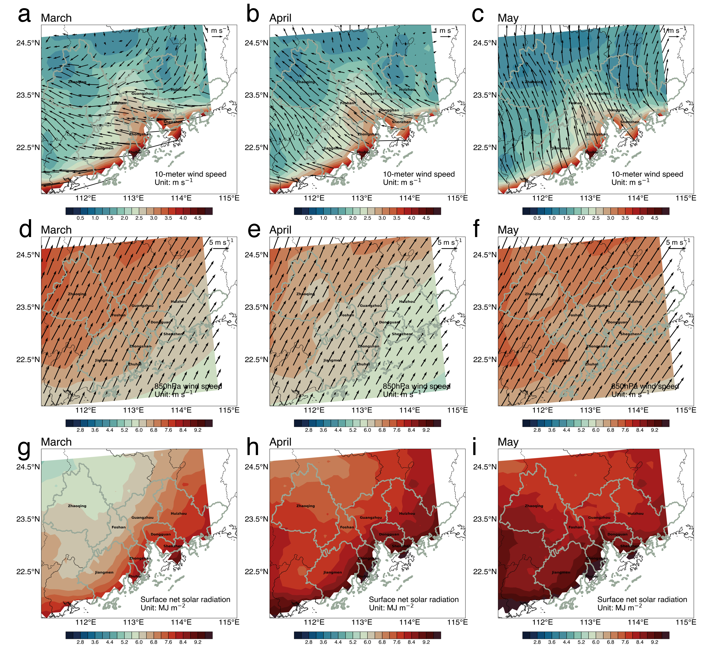
Supplementary Figure 2. Spatial distribution of monthly wind field and SSR for March, April, and May in PRD from 2013-2022. a 10m-meter wind vector in March, b April, and c May. d 850hPa wind vector in March, e April, and f May. g Surface net solar radiation (SSR) in March, h April, and i May. For the 10-meter wind vector, the wind speed of less than 2m s⁻¹ is removed because the direction of that is unclear. The data for wind fields are averaged over 24 hours, with exceptions for SSR, which is averaged over daytime hours (7:00 - 19:00 local time).

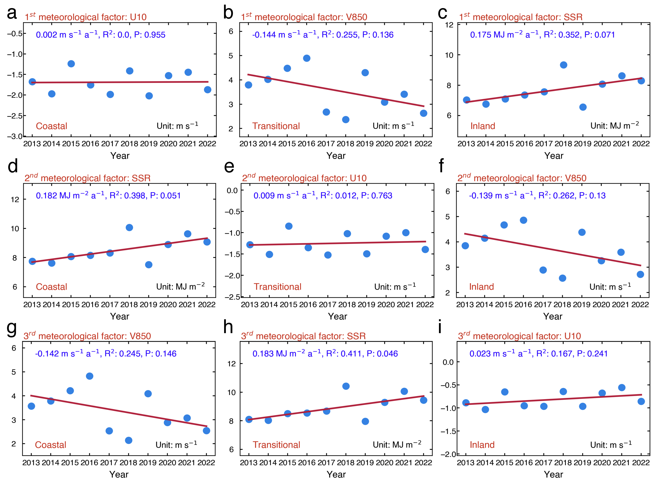
Supplementary Figure 3. Spatial trends of key meteorological factors at coastal, transitional, and inland sites in the Pearl River Delta region. a-c Trends of the primary key meteorological factor U10, V850, SSR (These factors are the ozone covariates in the MRL model. For more details, refer to the “Methods” section) at sites where U10, V850, and SSR are predominantly influential in coastal, transitional, and inland areas respectively (Ref: Fig. 3a). d-f Trends of the secondary key meteorological factor in coastal (SSR), transitional (U10) and Inland (V850) Sites (Ref: Fig. 3b). g-i Trends of the third key meteorological factor in Coastal (V850), transitional (SSR), and inland (U10) sites.
Note: the trends shown in each sub-figure are based on the aggregated data from sites where the specified meteorological factors (U10, V850, SSR) are identified as the primary, secondary, or tertiary key influences. While these trends are categorized into general areas such as coastal, transitional, or inland for a broader regional perspective, the actual calculations use data from the specific sites influenced by these factors. This approach highlights the variations of key meteorological factors at each site rather than categorizing trends based solely on broad geographical areas like coastal, transitional, or inland regions. In presenting sub-regional trends, the method acknowledges some level of generalization or approximation.

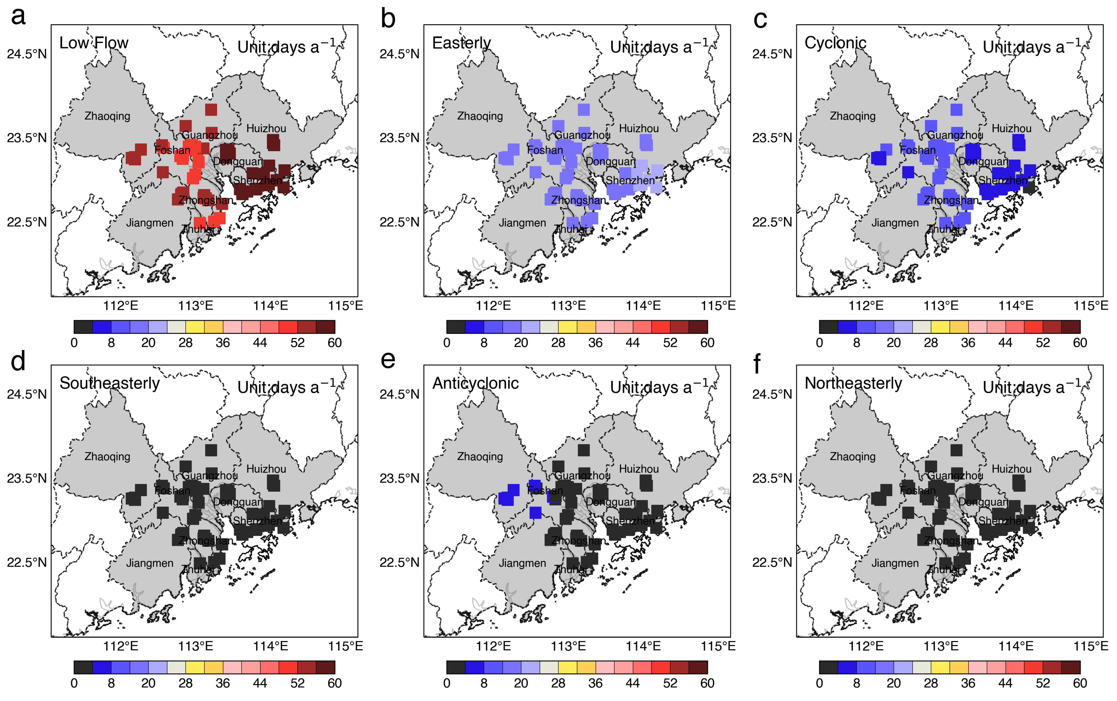
Supplementary Figure 4. Spatial distribution of multi-year averaged occurrences under the following weather types for each site: a Low flow, b Easterly, c Cyclonic, d Southeasterly, e Anticyclonic, and f Northeasterly.

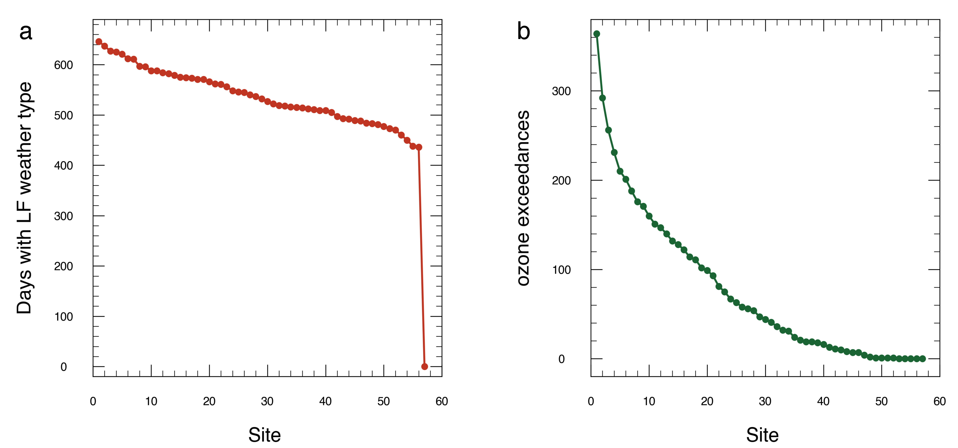
Supplementary Figure 5. Threshold values for defining RLFEs in the Pearl River Delta. a Relationship between the number of days with LF weather type and the number of affected sites in the Pearl River Delta from March to May 2013–2022. The x-axis represents the number of sites experiencing the LF weather type simultaneously, while the y-axis shows the corresponding total number of days. A threshold of 50 sites 5 or more sites concurrently exhibiting the LF weather type was selected to represent the Pearl River Delta region under the control of the LF weather type. This threshold reflects a significant regional influence, ensuring that the LF weather type's substantial control over regional weather is captured while balancing the frequency of occurrence with regional coverage. b Relationship between the number of ozone exceedance and the number of sites recording such exceedance in the Pearl River Delta for the same period. The x-axis indicates the number of sites with ozone exceedance on a given day, up to a maximum of 57 sites, while the y-axis represents the total number of days with that specific number of sites exceeding ozone thresholds. This curve assists in selecting a threshold to indicate widespread ozone exceedance across the region. A threshold of 5 or more sites concurrently exhibiting ozone exceedance was chosen to denote a significant regional ozone exceedance event, reflecting a balanced consideration of both the extent of the area affected and the frequency of such occurrences.

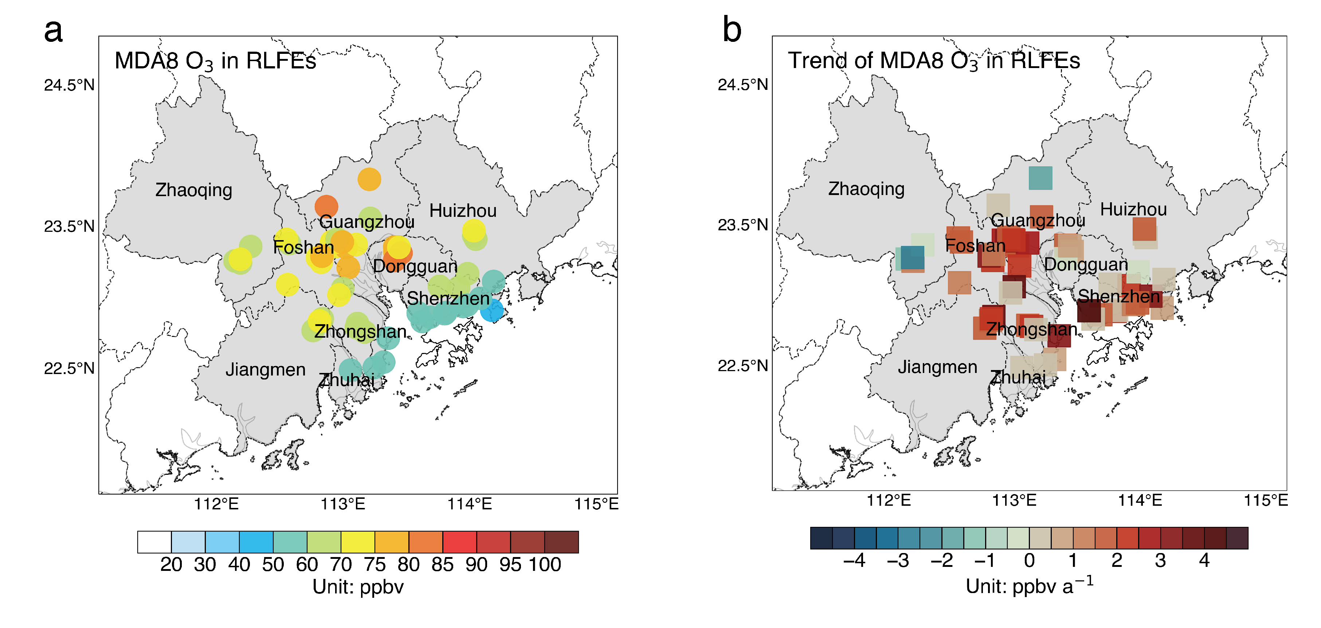
Supplementary Figure 6. The characteristics of ozone concentrations during RLFEs (see text). a Mean MDA8 ozone concentration at each site. b Trends in annual MDA8 ozone concentrations at each site.

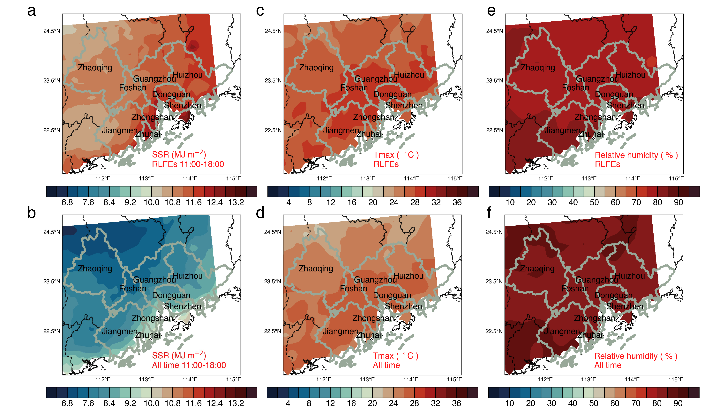
Supplementary Figure 7. Characteristics of the spatial distribution of meteorological factors affecting ozone production reactivity. a-b Show the mean values during RLFEs and the mean values for all times for daytime (11:00-18:00 local time) surface net solar radiation (SSR). c-d Present the same sets of values as in (a-b) but for the daily maximum value of 2-m air temperature (T_{max}). e-f Illustrate the same sets of values as in (a-b) but for daily 24-hour averaged surface air relative humidity (RH).

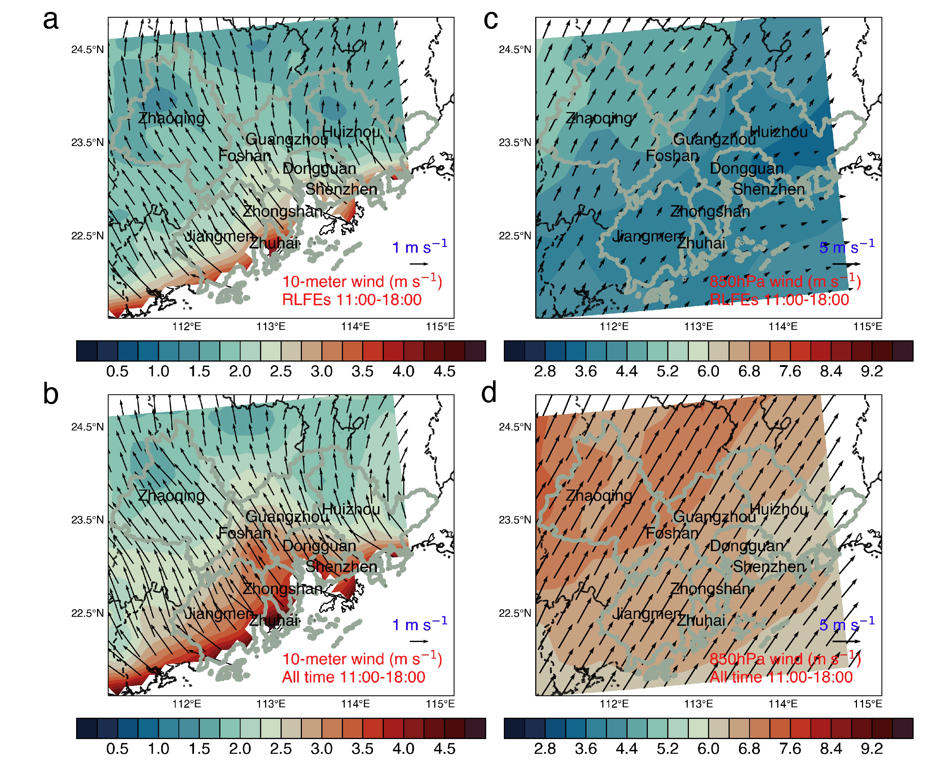
Supplementary Figure 8. Spatial distribution of wind fields (11:00-18:00 local time) at 10-meter and 850hPa heights. a-b Depict the mean values during RLFEs and mean values for all times of the 10-meter wind vector. For all times in (b), the wind vector with the wind speed less than 2 m s⁻¹ is removed, while all the wind speeds are retained. c-d Illustrate the same sets of values as in (a-b) but for the wind field at 850hPa height.

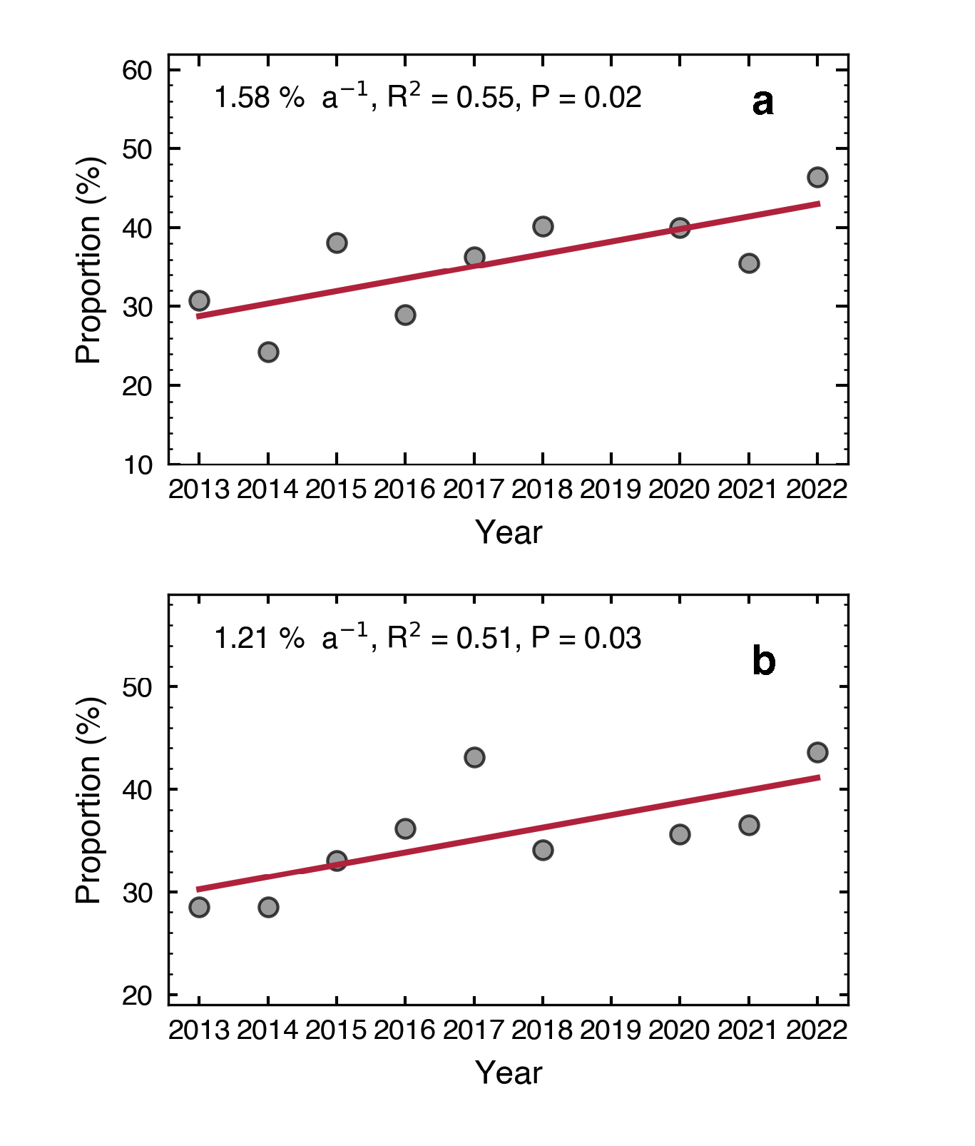
Supplementary Figure 9. The same as Fig. 7 a and b but without the data from 2019.

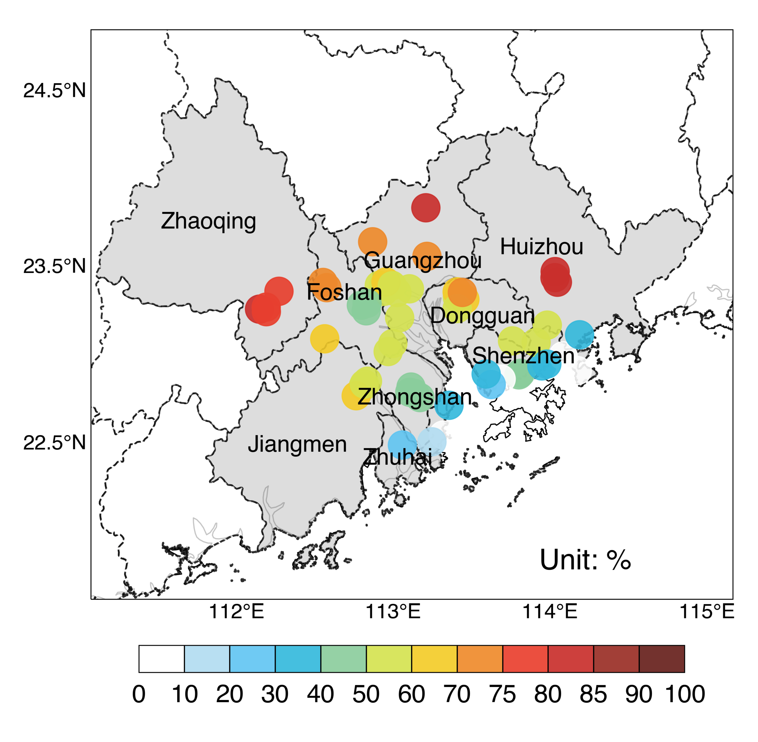
Supplementary Figure 10. The proportion of low wind speed (LWS, less than 2m/s) hours during RLFEs at each site. The proportions are calculated by dividing LWS hours within RLFEs by the total RLFE hours. This reflects the spatial distribution of LWS occurrences during RLFEs.

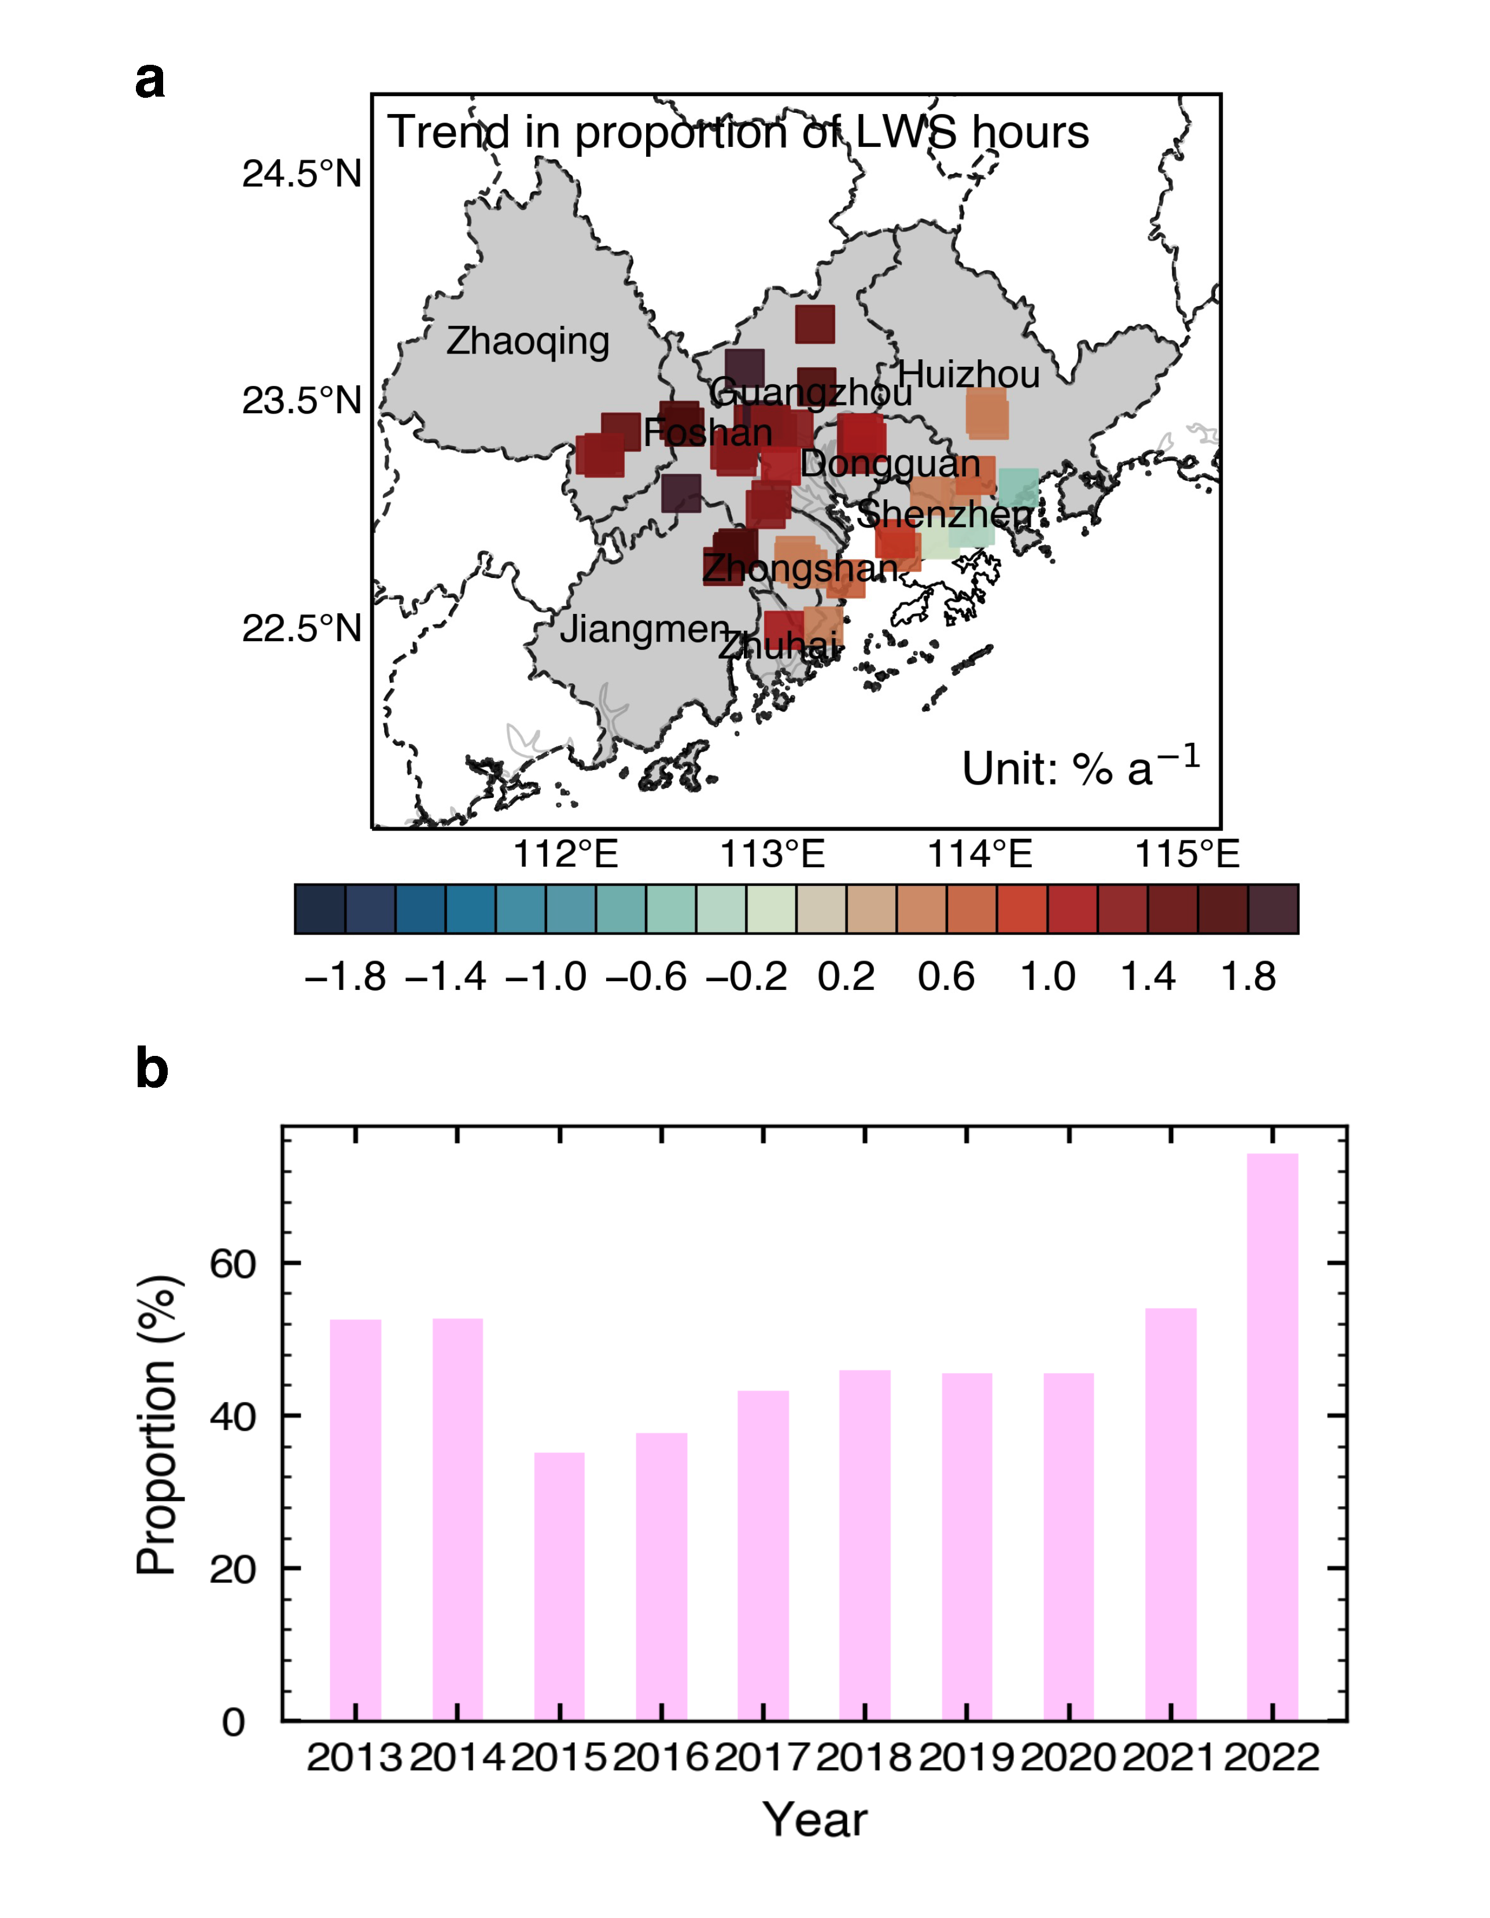
Supplementary Figure 11. The dynamic evolutionary characteristics of the RLFEs from 2013 to 2022. a Trends in the annual proportion of low wind speed (LWS, less than 2m/s) hours during RLFEs at each site, with the proportion calculated by dividing LWS hours within RLFEs by the total annual RLFE hours. This reveals the long-term trend of LWS occurrences during RLFEs. b Annual average proportion of sites experiencing Low Wind Speed Events (LWEs) among the 57 sites during RLFEs. LWEs are defined as days when the average wind speed from 6:00-18:00 local time is less than 2m/s at any of the 57 sites. Specifically, all 153 RLFEs in this study are categorized as LWEs.

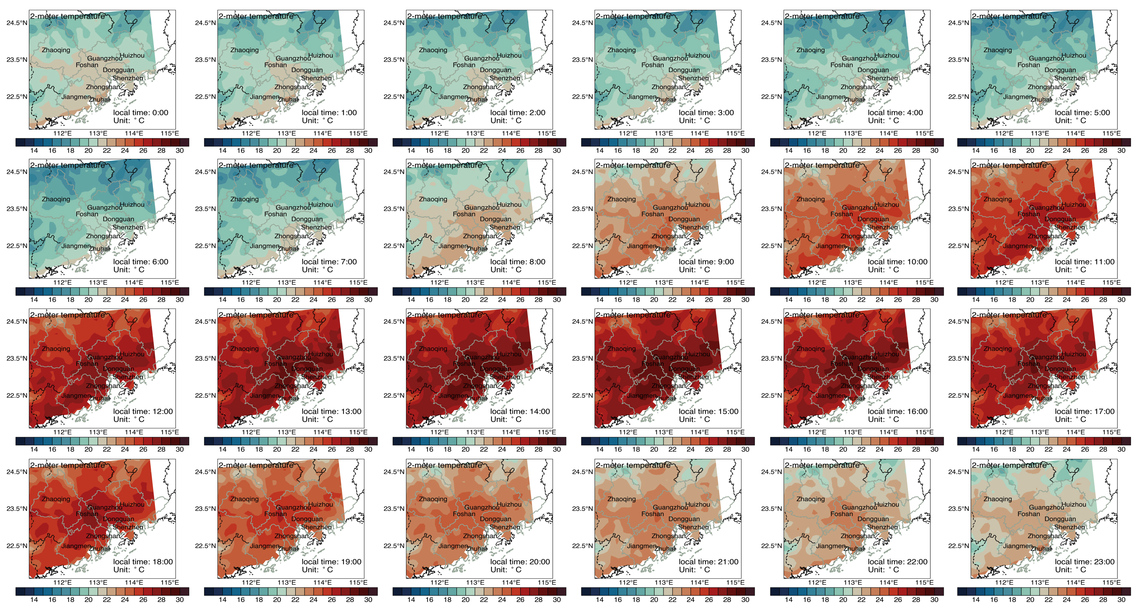
Supplementary Figure 12. Diurnal variation in hourly spatial distribution of 2-m air temperature during Low-Frequency Events (RLFEs). The Urban Heat Island effect commences at 09:00 local time and begins to dissipate at 21:00, with the peak intensity observed between 13:00 and 17:00 hours.

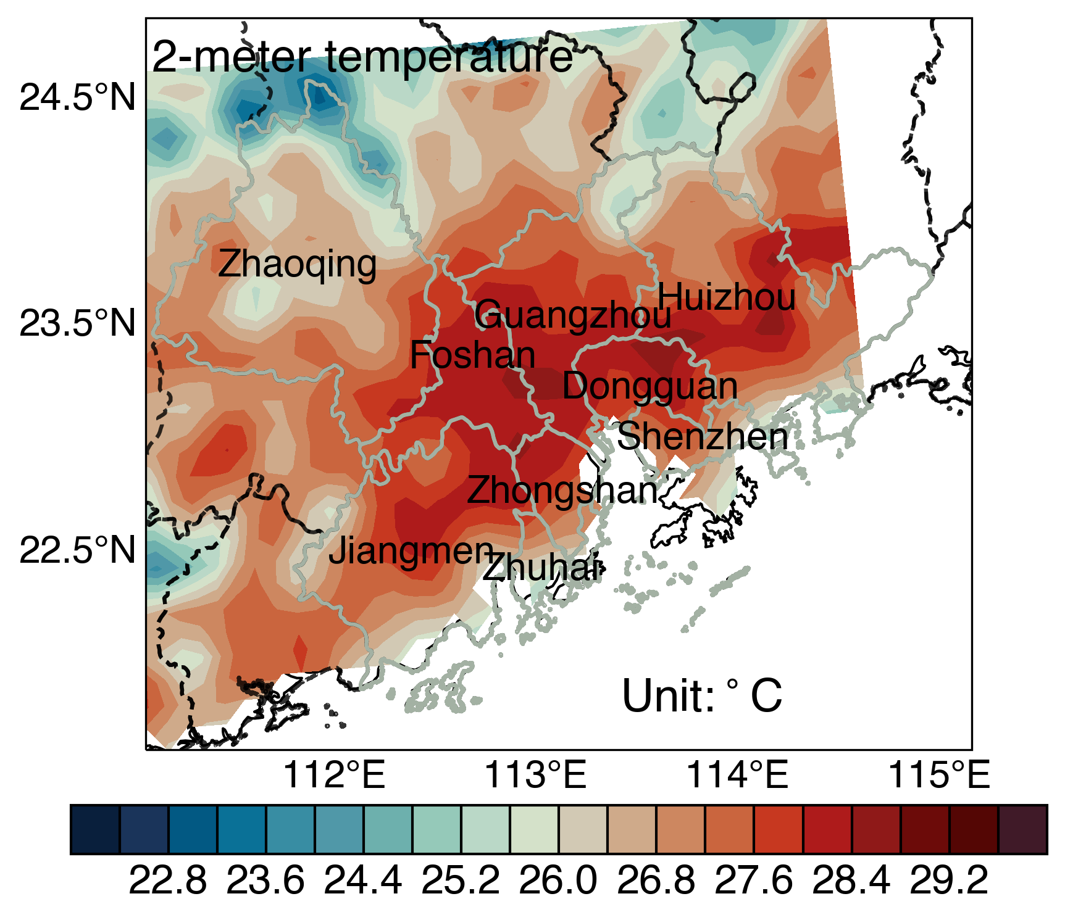
Supplementary Figure 13. Spatial Distribution of 2-m Air Temperature Averages During the Peak Urban Heat Island Hours in RLFEs. Hourly average of 2-m air temperature during the peak Urban Heat Island effect hours (Local Time: 13:00 - 17:00) across RLFEs.

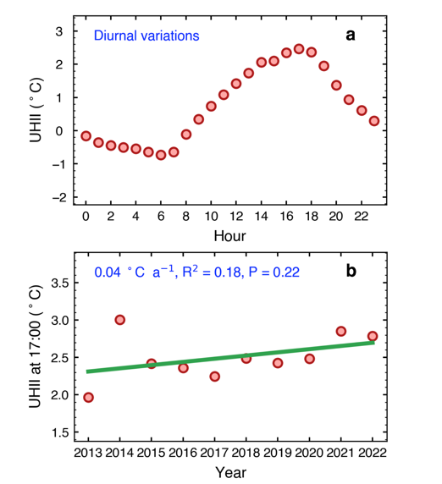
Supplementary Figure 14. The thermal evolutionary characteristics of the RLFEs from 2013 to 2022. a Diurnal variation of the Pearl River Delta's Urban Heat Island Intensity (UHII) index during LFEs. b Trends in the annual mean value of the UHII index at 17:00 during RLFEs.

