Table S1 Characterization of SNPs
Characteristic | SNPs
Size, nm (mean ± standard error) | 39.73 ± 5.21
Hydrodynamic size in reverse osmosis water, nm (mean ± standard error) | 409.50 ± 6.73
Zeta Potential (mV) | -35.17 ± 1.07
Morphology | Amorphous
Purity (%) | 99.99
Endotoxin | Negative

Abbreviations: SiO₂ nanoparticles (SNPs)

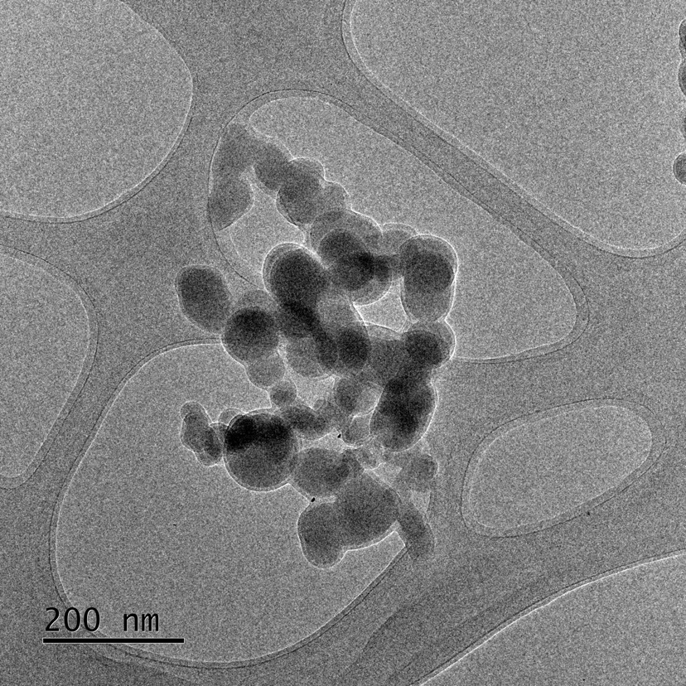
Fig. S1 TEM image of the SiO₂ nanoparticle by field emission transmission electron microscope. Scale bar, 200nm

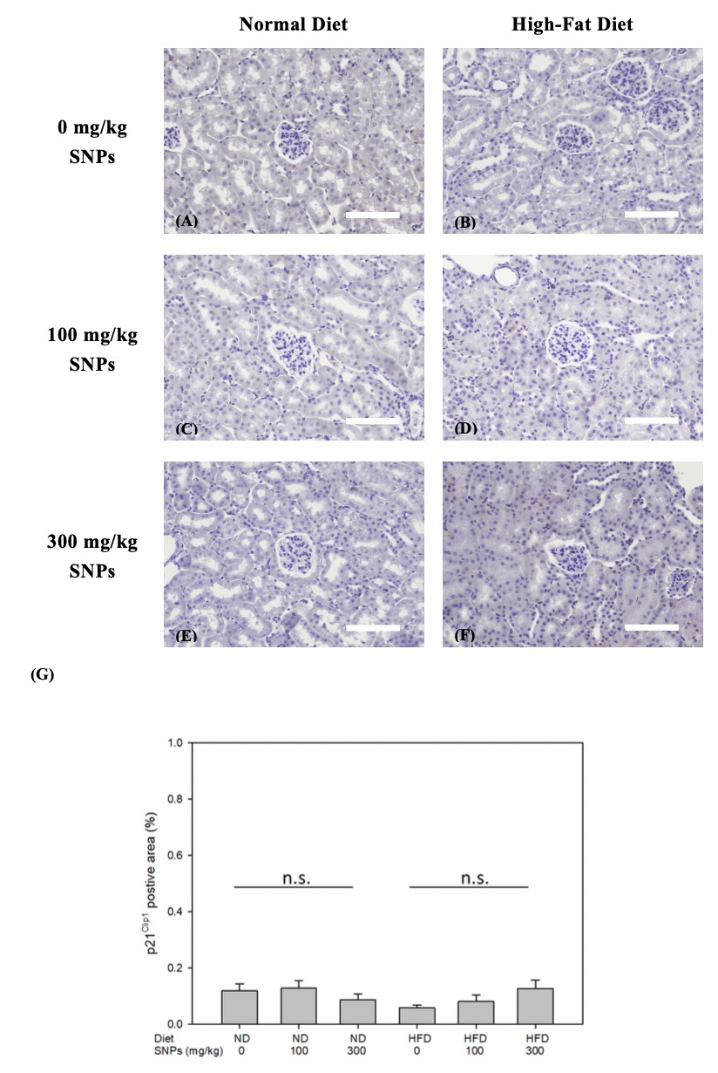

Fig. S2 The degree of aging is shown by staining for p21^{Clip1} using an immunohistochemistry stain. Mice were fed on the ND (A, C, E) or HFD (B, D, F) for 25 weeks. The mice were treated with 0 (A, B), 100 (C, D), and 300 (E, F) mg/kg SNPs twice per week. Scale bars are 100 µm (A-F). The percentage of positive p21 Clip staining/area was analyzed by Image-Pro (G). Data are expressed as the mean ± standard error of the mean (n=6) and analyzed by a paired t-test. No significance (n.s.). Abbreviations: SiO₂ nanoparticles (SNPs), normal diet (ND), and high-fat diet (HFD).

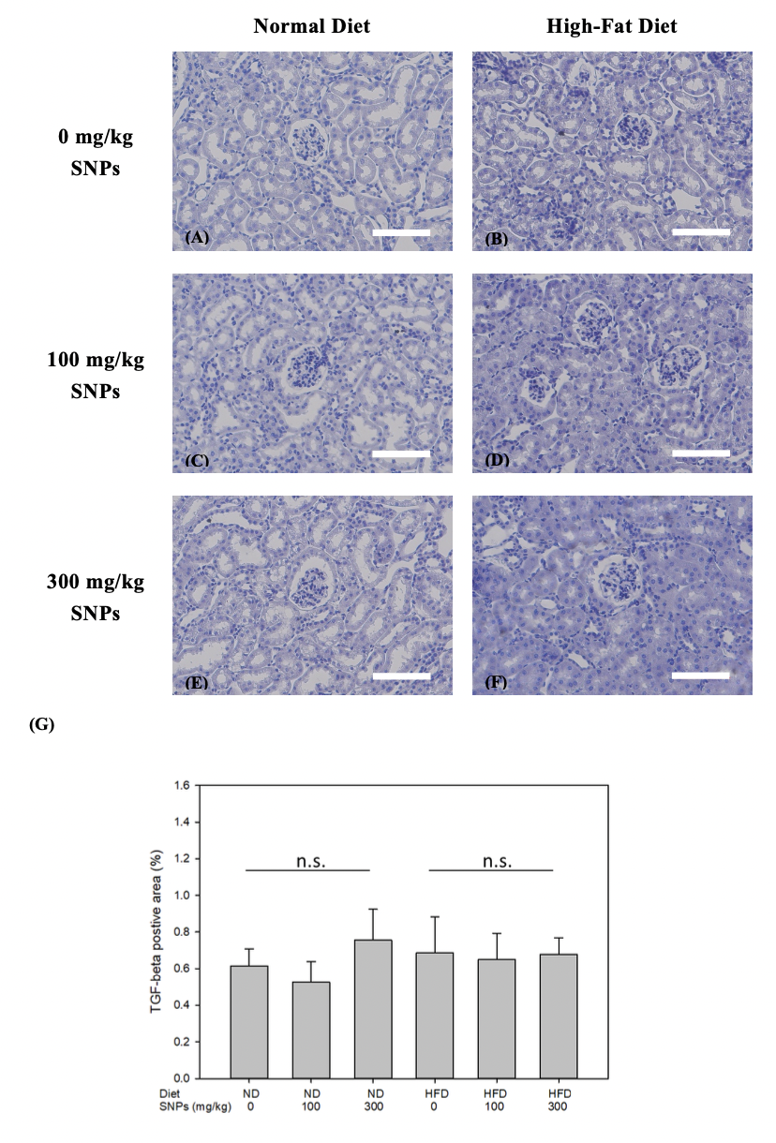

Fig. S3 The degree of TGF-β is shown by using an immunohistochemistry stain. Mice were fed on the ND (A, C, E) or HFD (B, D, F) for 25 weeks. The mice were treated with 0 (A, B), 100 (C, D), and 300 (E, F) mg/kg SNPs twice per week. Scale bars are 100 µm (A-F). The percentage of positive TGF β staining/area was analyzed by Image-Pro (G). Data are expressed as the mean ± standard error of the mean (n=6) and analyzed by a paired t-test. No significance (n.s.). Abbreviations: SiO₂ nanoparticles (SNPs), normal diet (ND), and high-fat diet (HFD).

