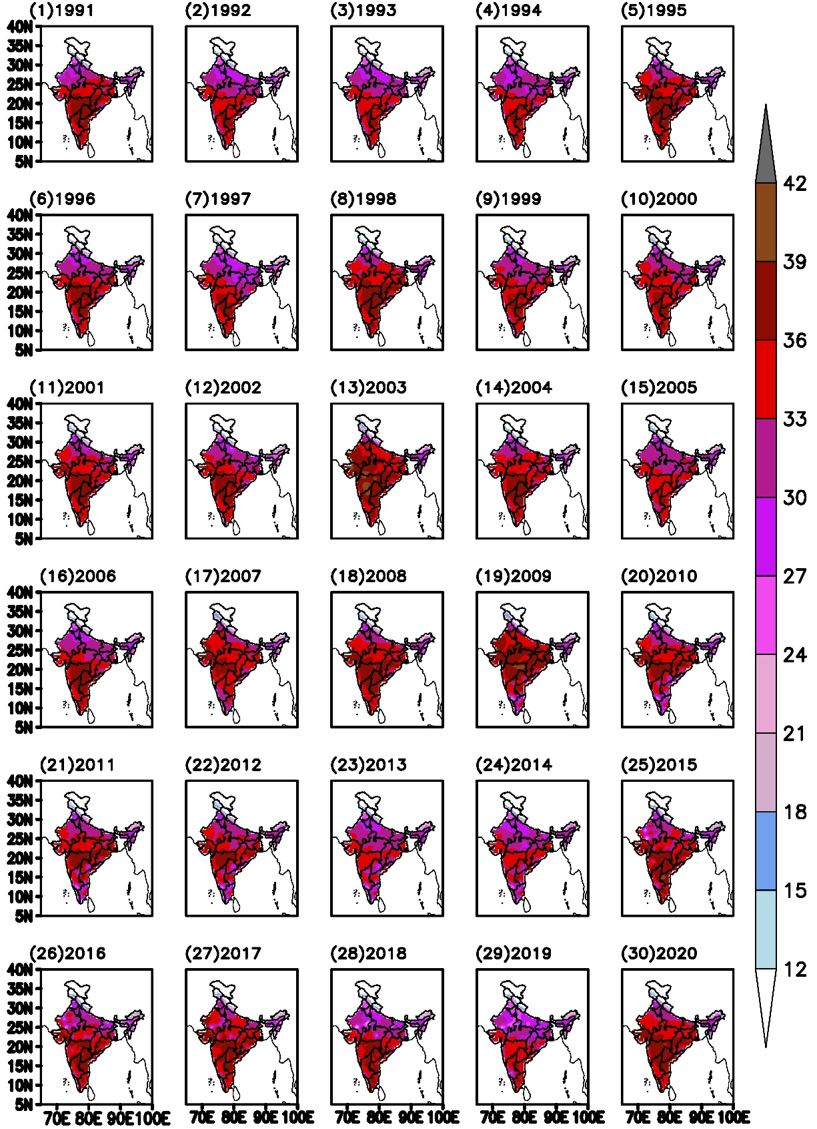
Figure S1. The maximum temperature of the month March for 30 years (from 1991 to 2020).

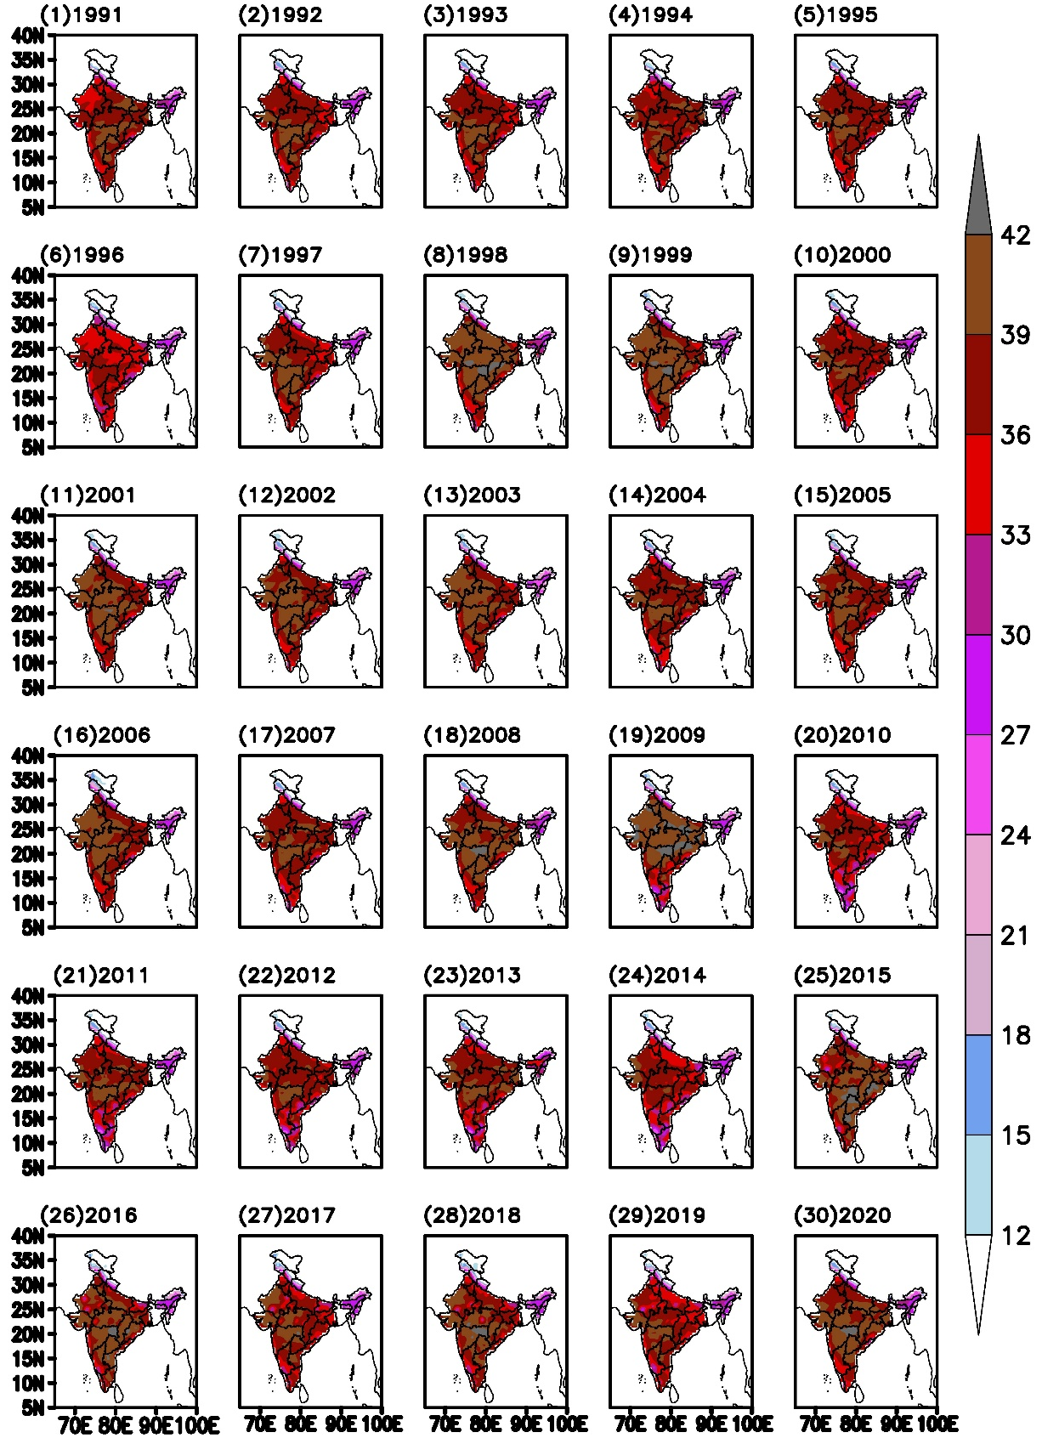
Figure S2. Same as figure S1 but, for April.

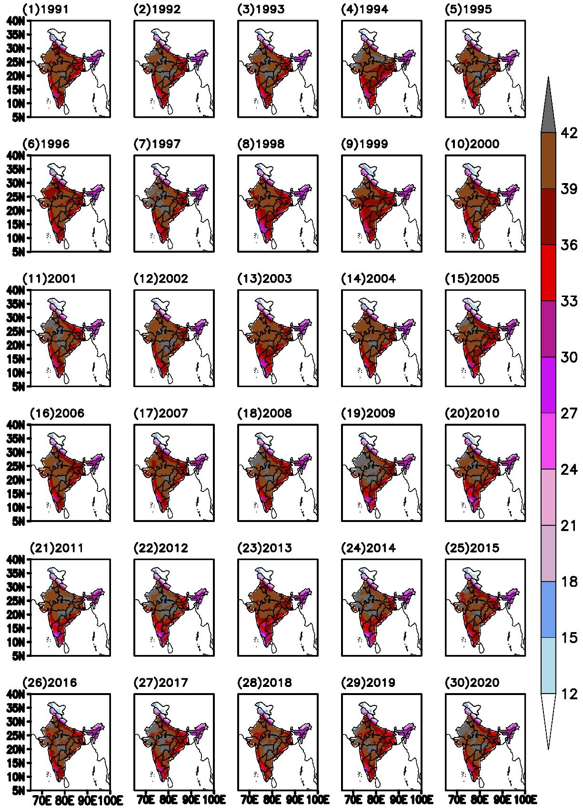

Figure S3. Same as figure S1 but, for May.

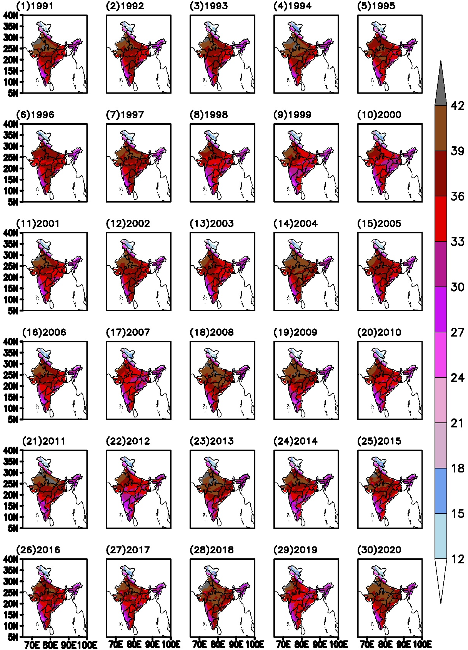
Figure S4. Same as figure S1 but, for June.

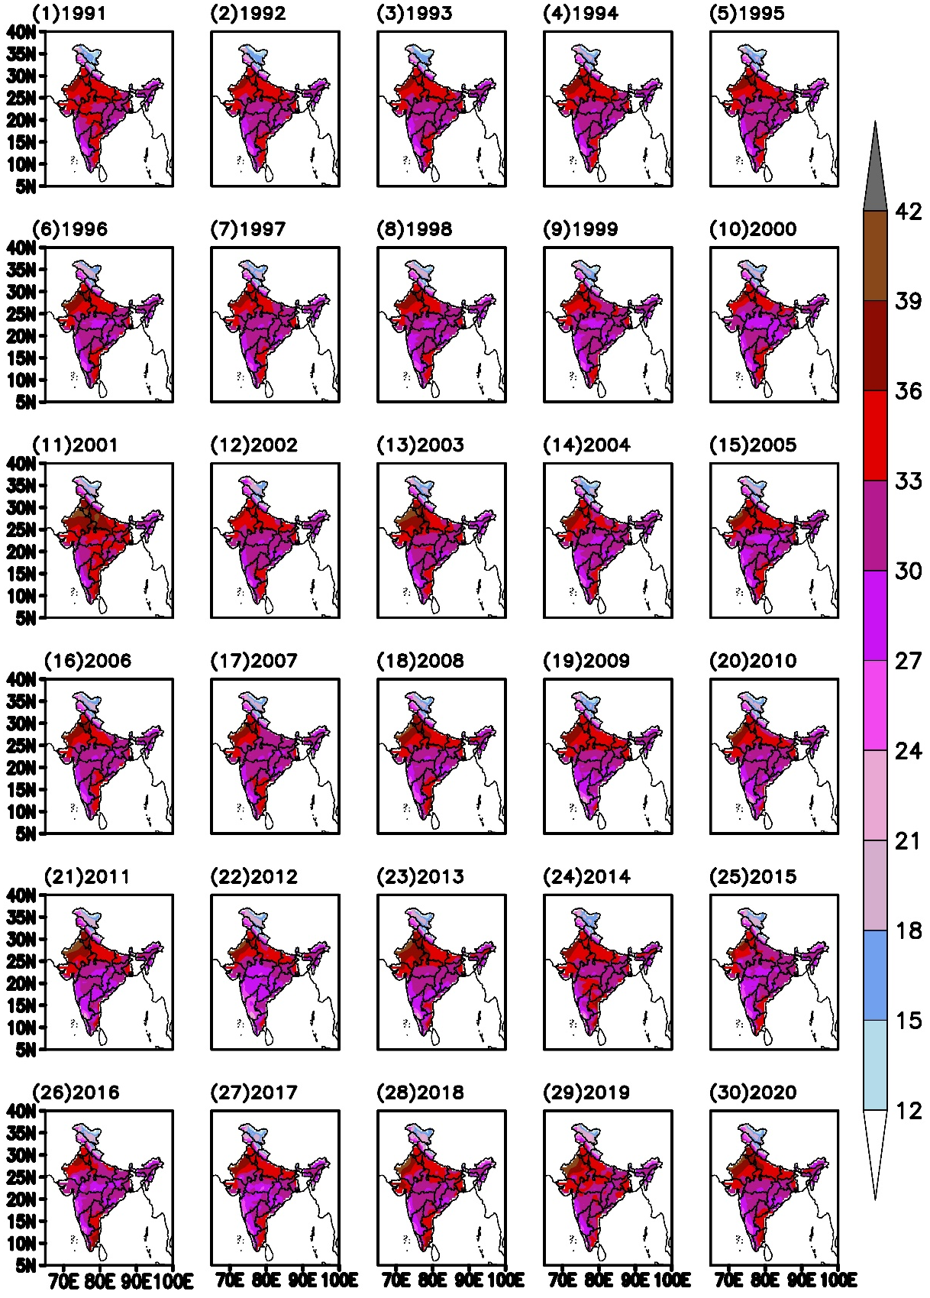

Figure S5. Same as figure S1 but, for July.
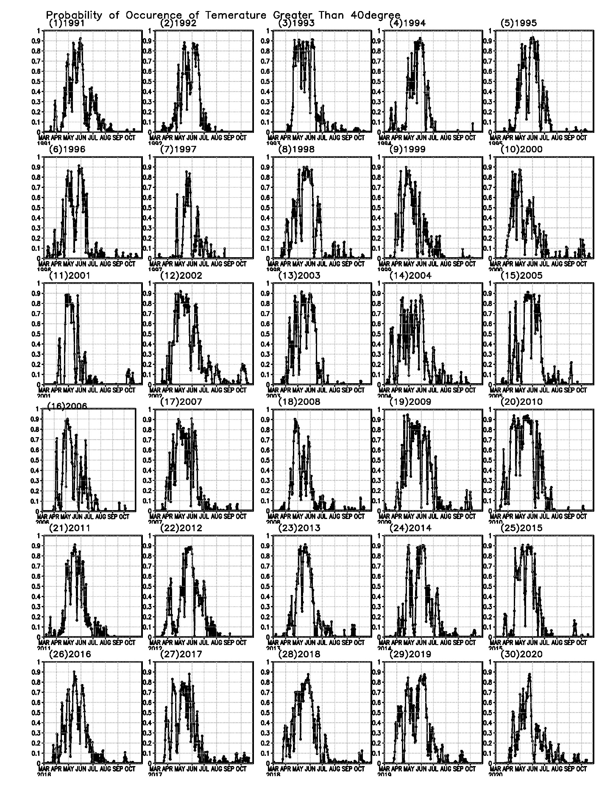
Figure S6. Probability of occurrence of mean temperature greater than 40ᴼC, over 70-90ᴼE; 20-30ᴼN for 1991 to 2020.

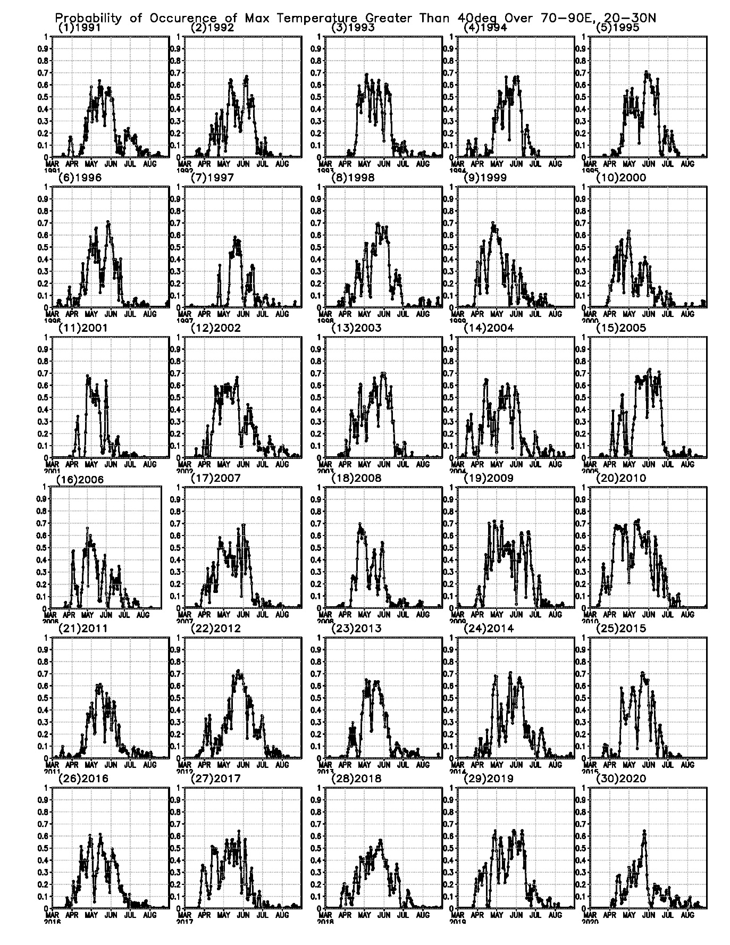
Figure S7. Probability of occurrence of maximum temperature greater than 40ᴼC, over 70-90ᴼE; 20-30ᴼN for 1991 to 2020
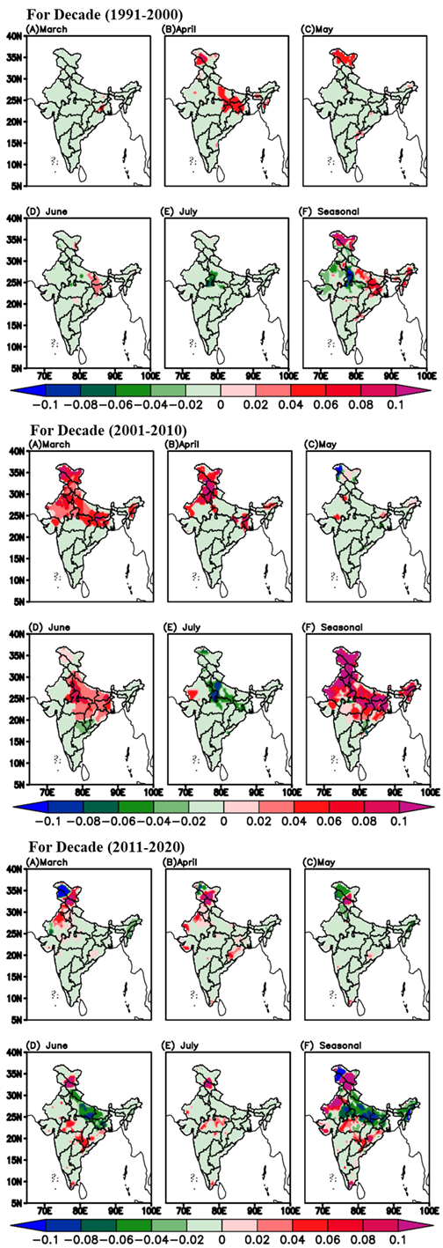

Figure S8. The linear trend (number/year) of HWN for every month of summer and composite seasonal for three decades 1991 to 2000; 2001 to 2010; 2011 to 2020.
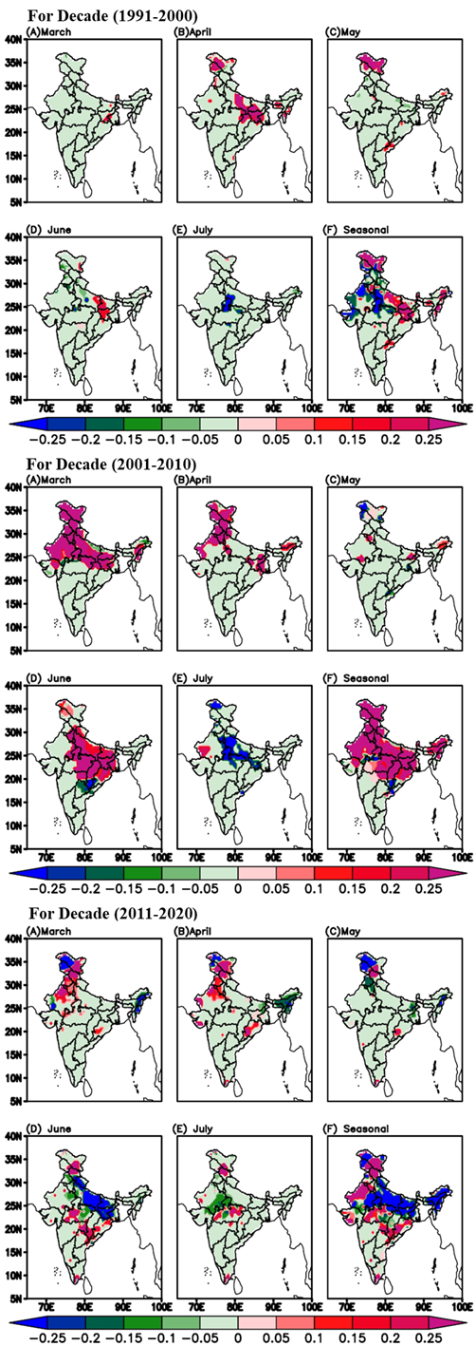
Figure S9. The linear trend (day/year) of HWD for every month of summer and composite seasonal for three decades 1991 to 2000; 2001 to 2010; 2011 to 2020.
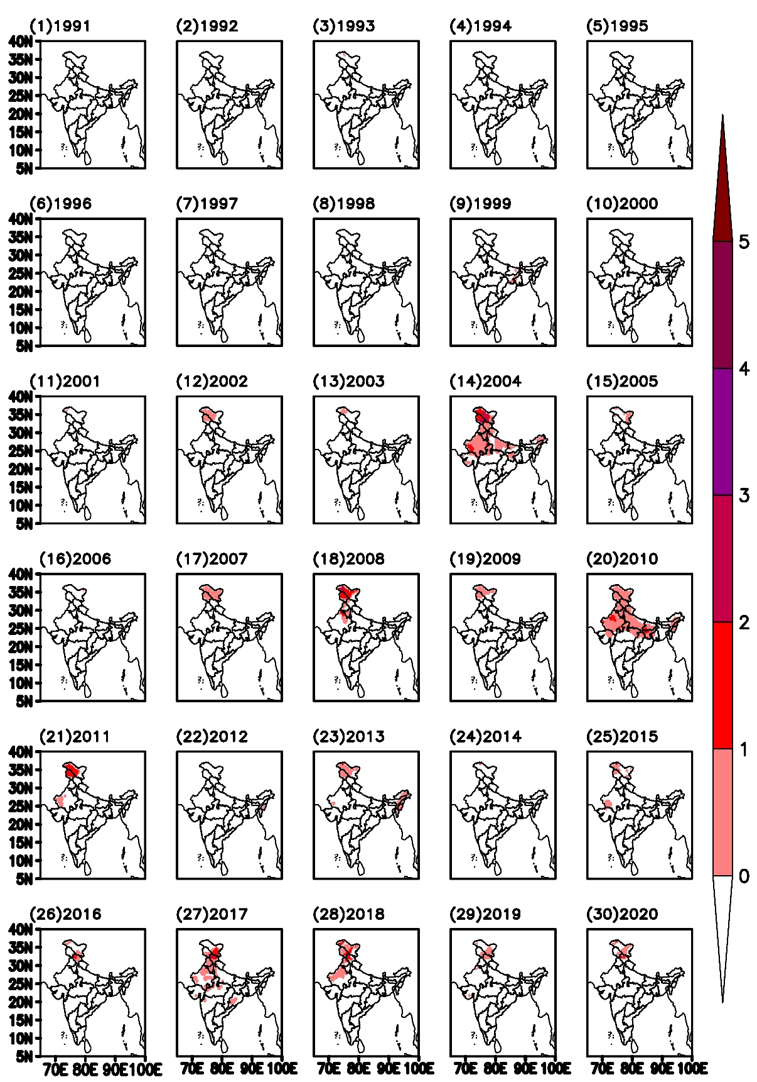
Figure S10a. Spatial distribution of HWN (heat wave number) for month of March from 1991 to 2020.

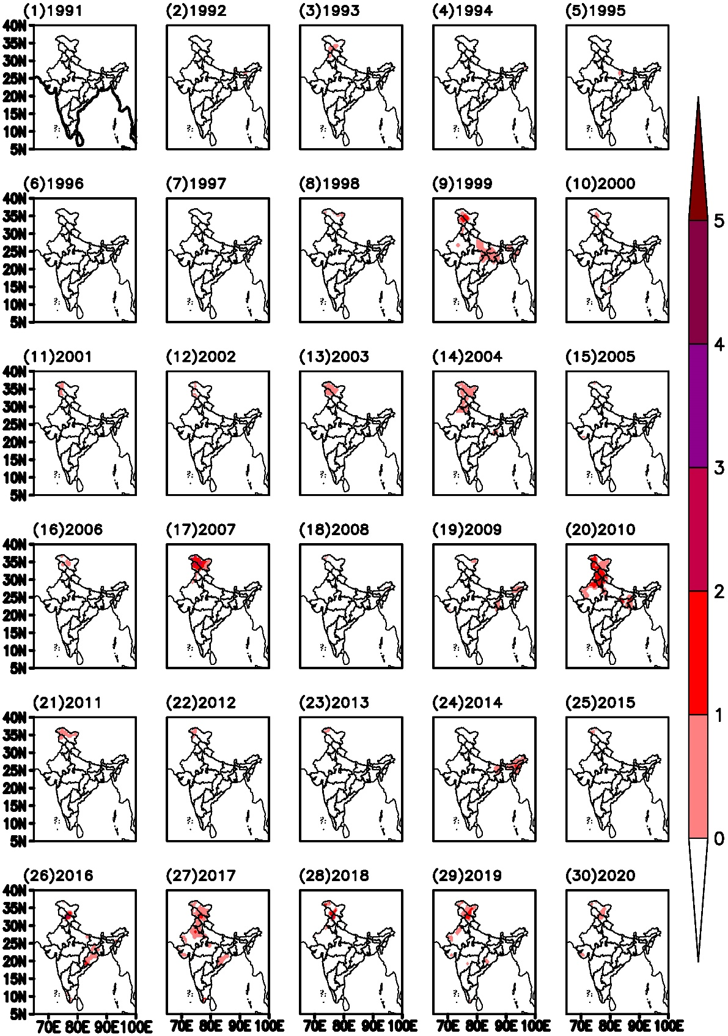
Figure S10b. HWN, same as figure 1a, but for the month of April.

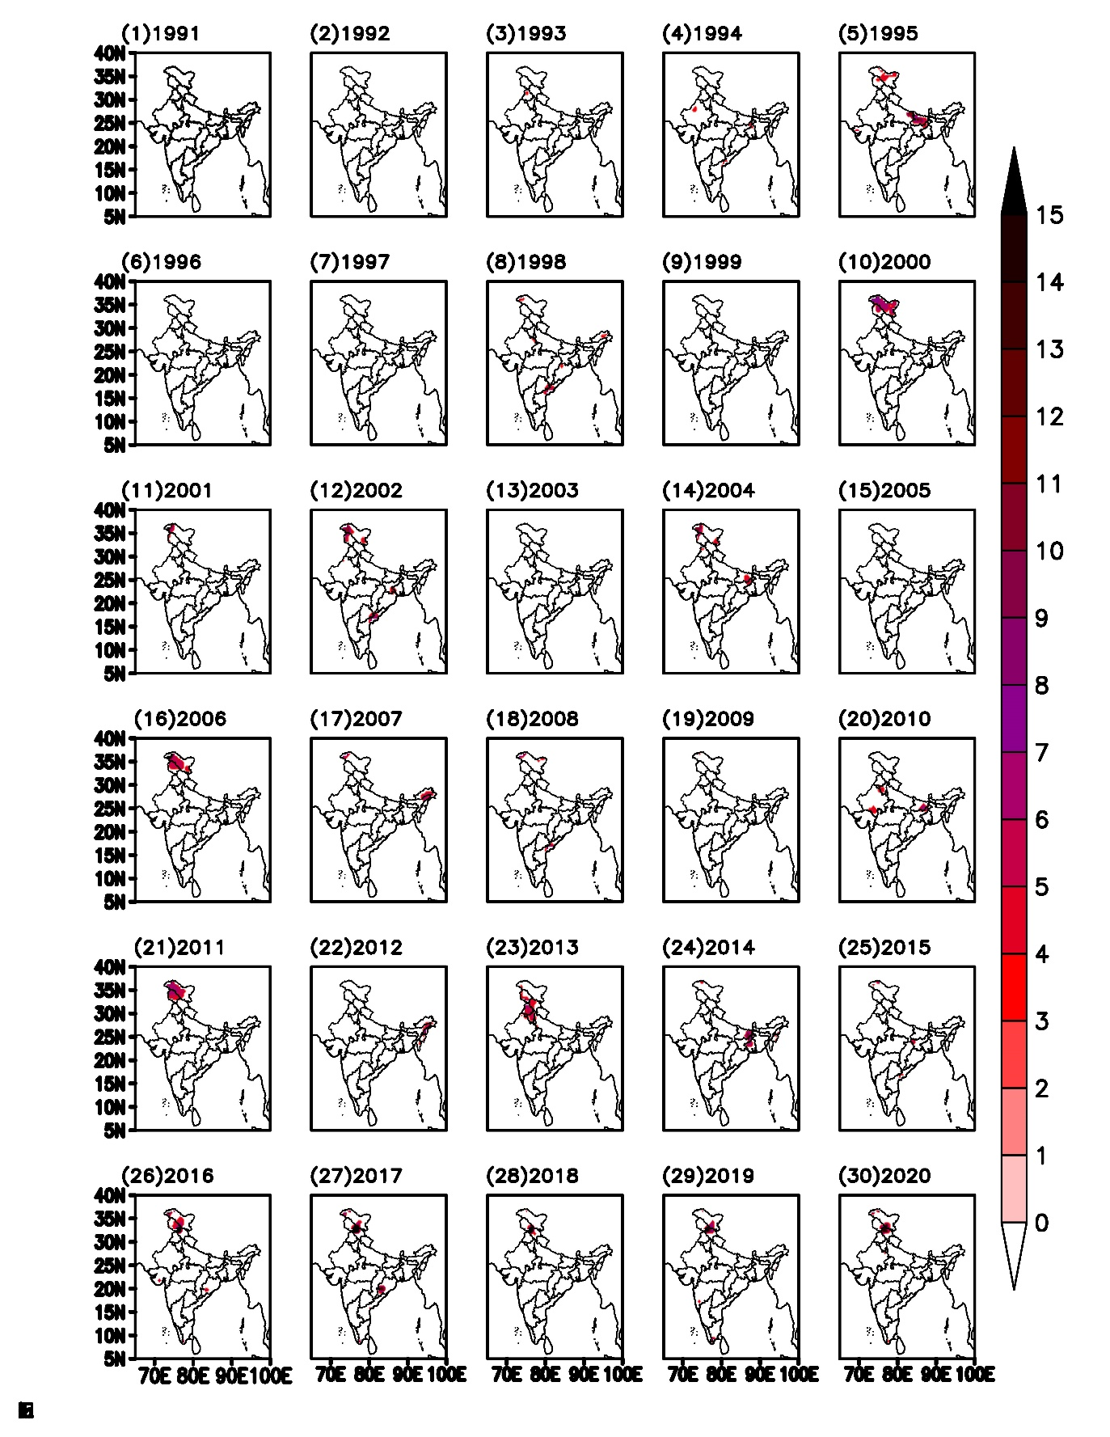
Figure S10c. HWN, same as figure 1a, but for the month of May.

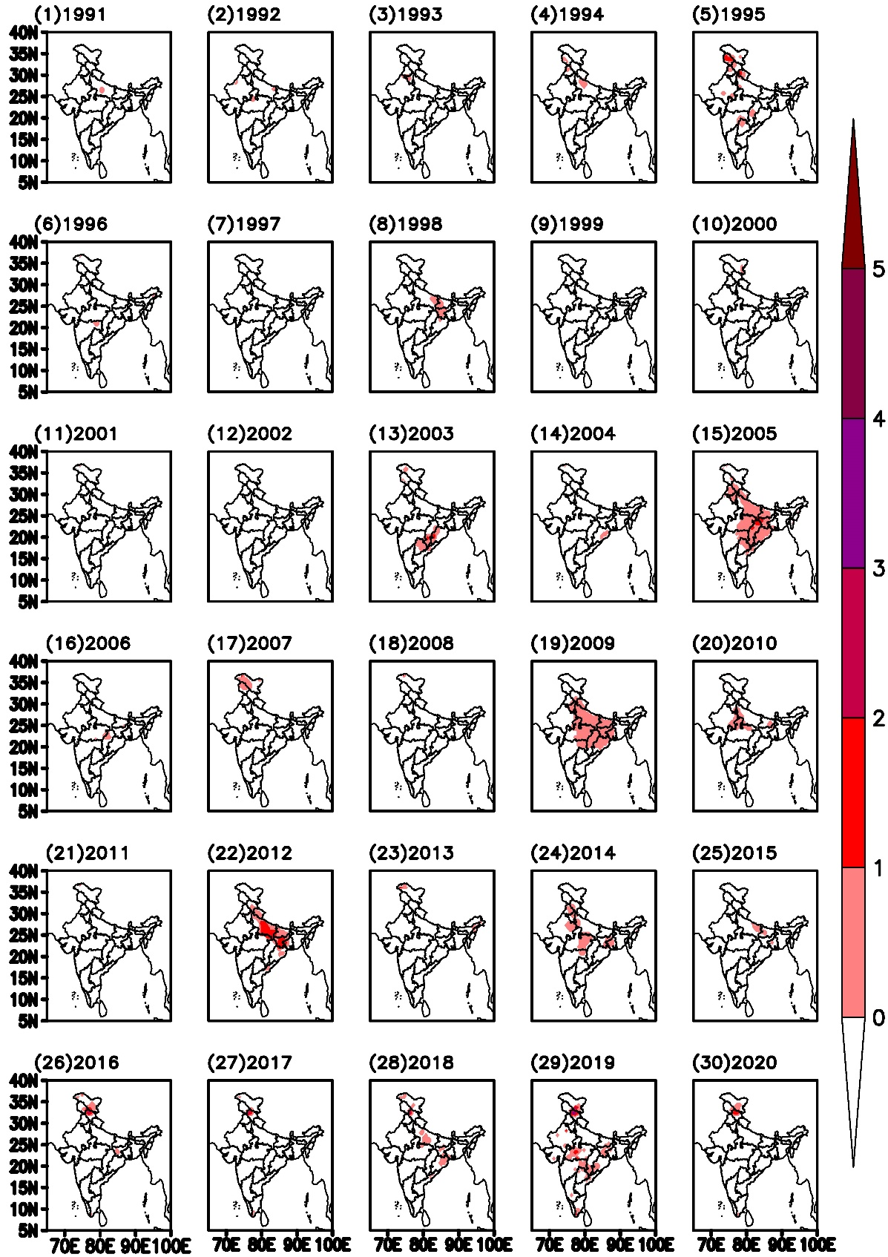
Figure S10d. HWN, same as figure 1a, but for the month of June.

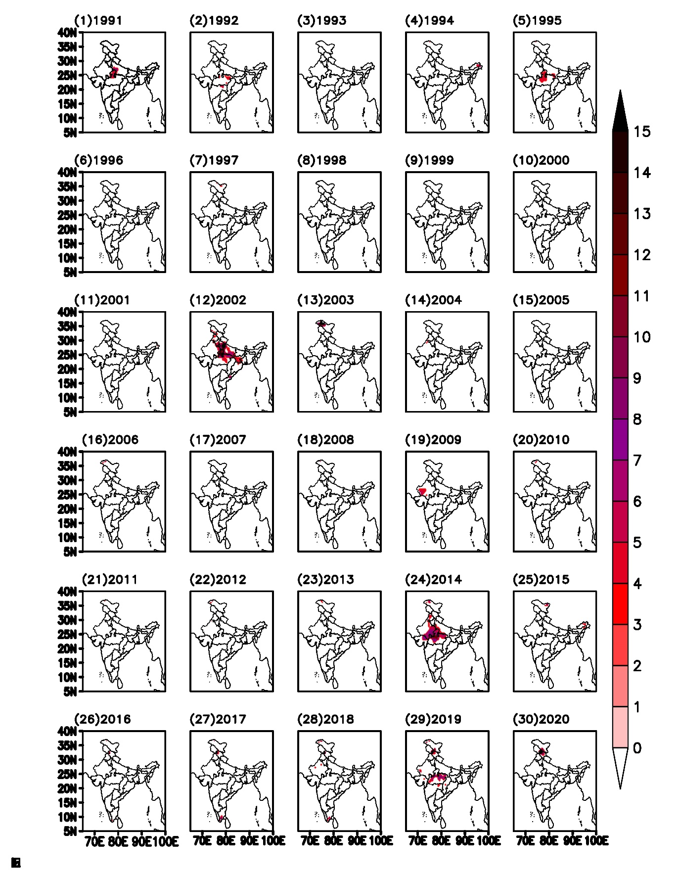
Figure S10e. HWN, same as figure 1a, but for month of July.

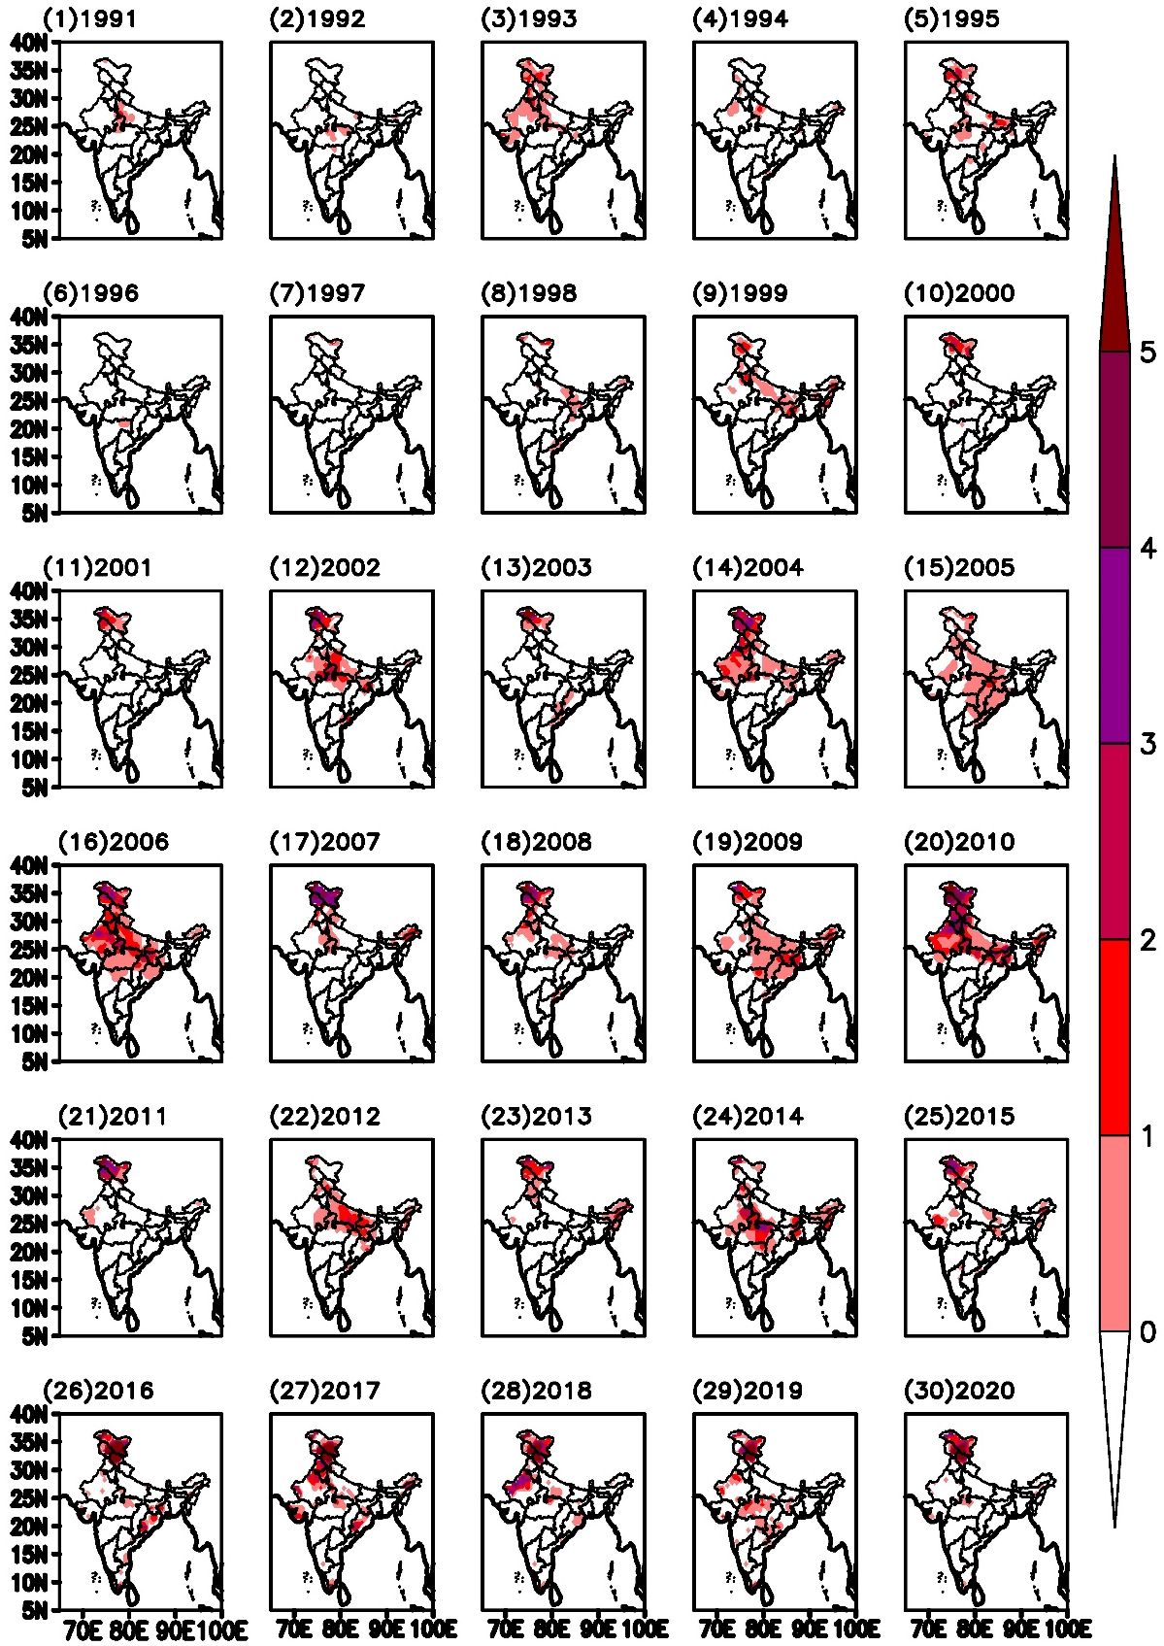
Figure S10f. HWN, same as figure 1a, but for the composite summer months March to July (MAMJJ).

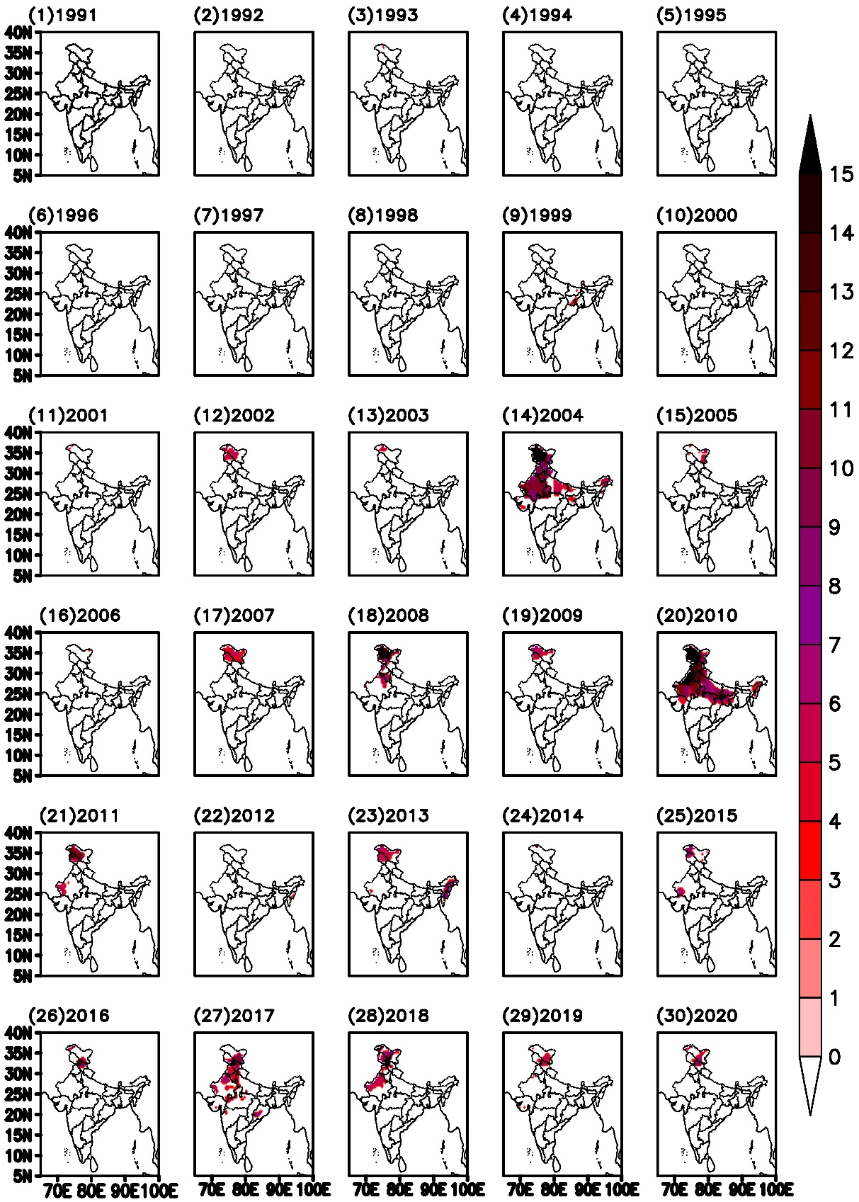
Figure S11a. Spatial distribution of HWD (heat wave duration) for month of March from 1991 to 2020.

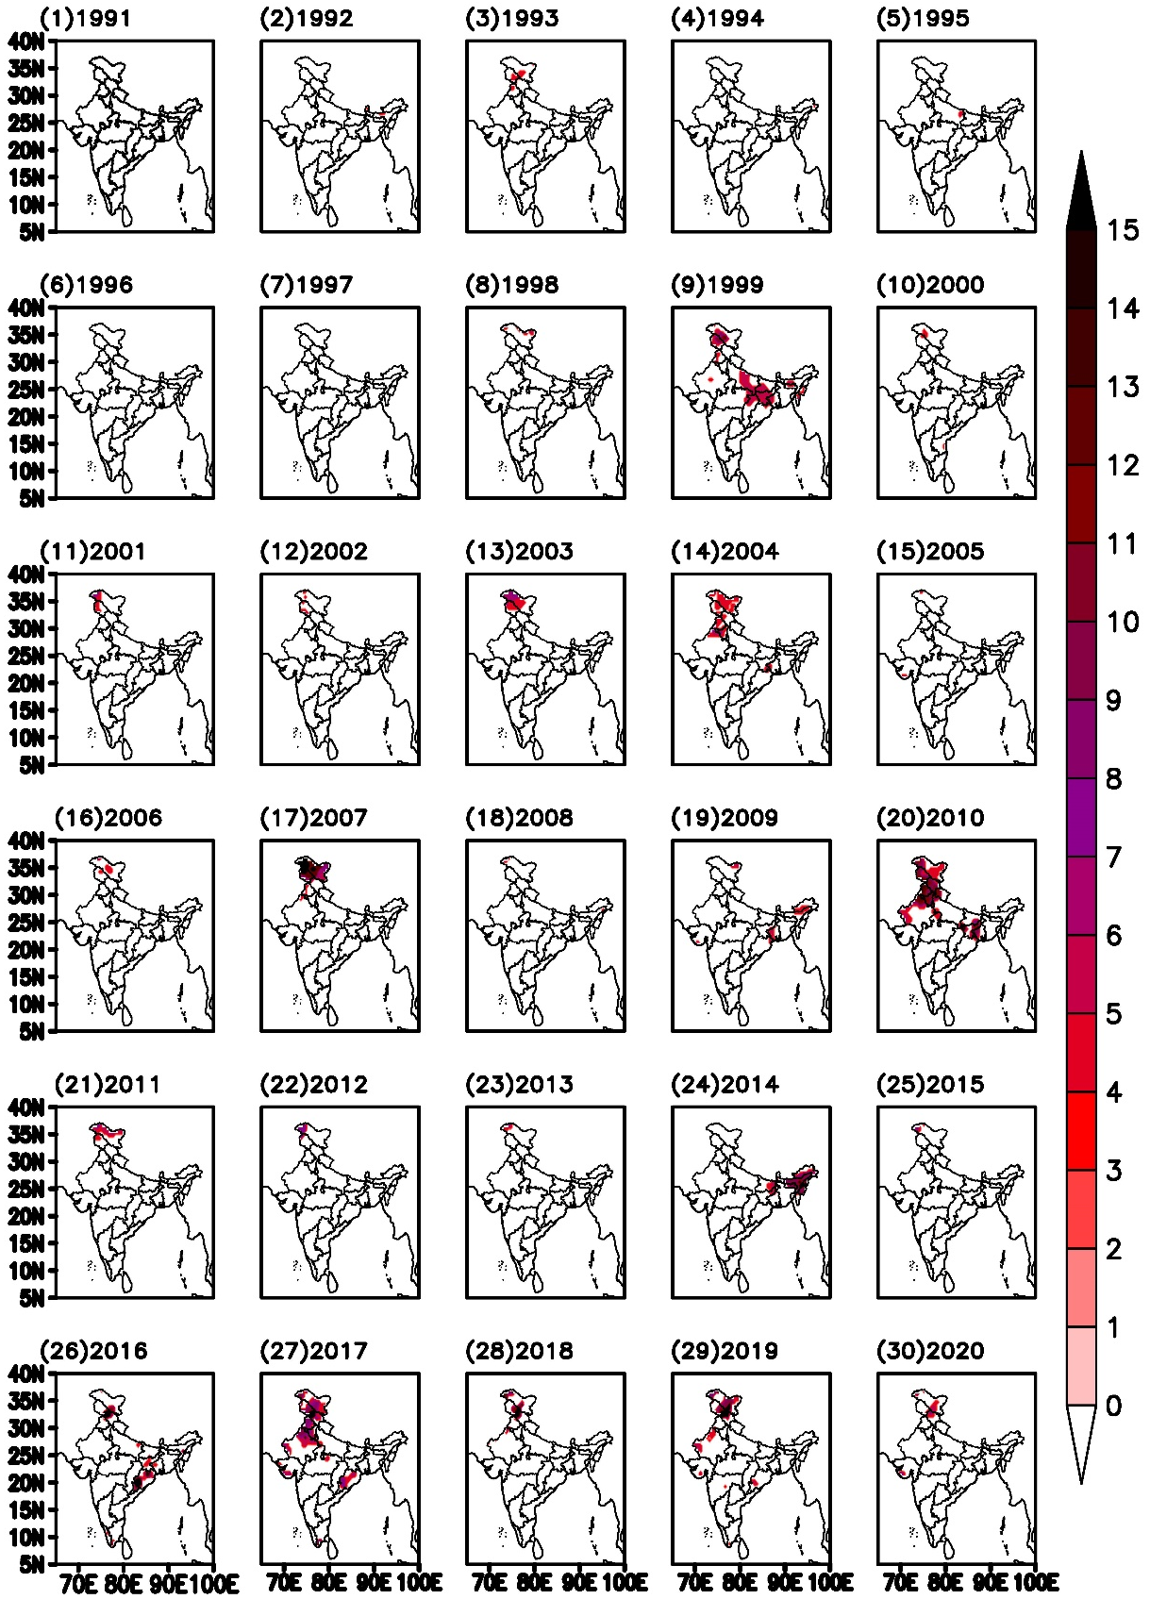
Figure S11b. HWD, same as figure 2a, but for the month of April.

Figure S11c. HWD, same as figure 2a, but for the month of May.

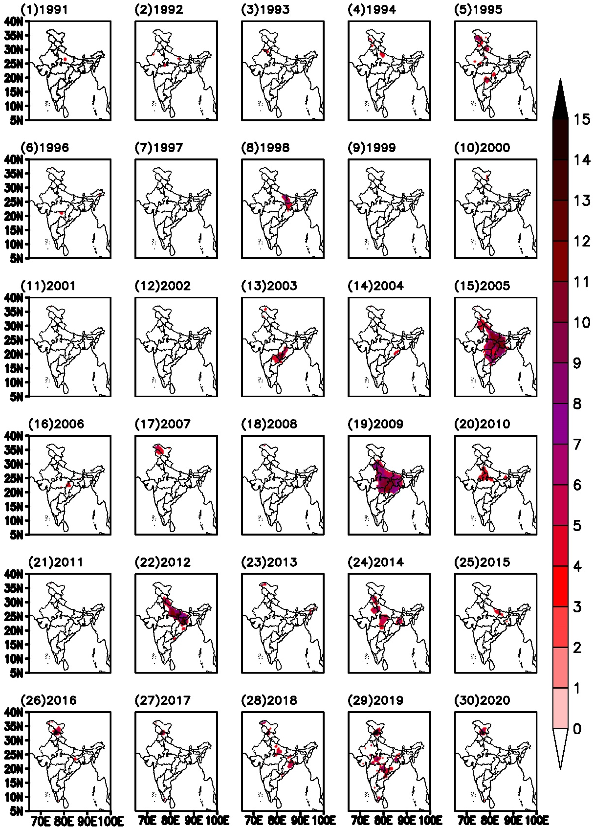
Figure S11d. HWD, same as figure 2a, but for the month of June.

Figure S11e. HWD, same as figure 2a, but for the month of July.

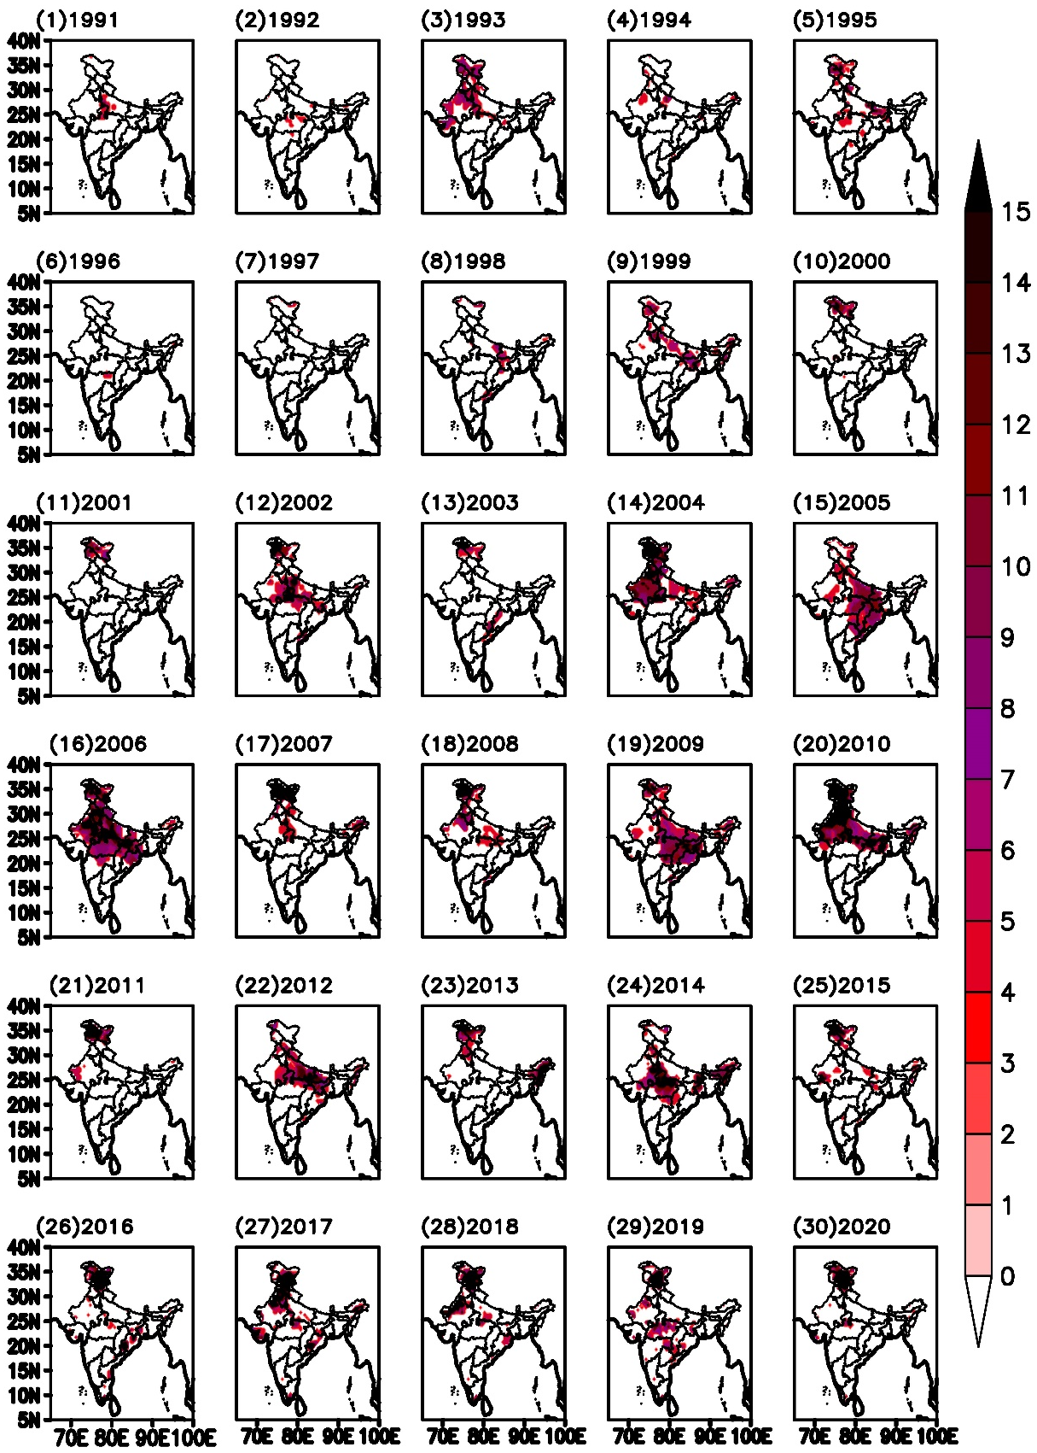
Figure S11f. HWD, same as figure 2a, but for the composite of summer months (MAMJJ).

