supplementary information
Rational Design of Phytovirucide that Inhibits the Nucleocapsid Condensates of Tomato Spotted Wilt Virus

Authors: Ningning Zan, Jiao Li, Jiahui Yao, Shang Wu, Jianzhuan Li, Feifei Chen, Baoan Song*, Runjiang Song*
Affiliations: State Key Laboratory of Green Pesticide, Key Laboratory of Green Pesticide and Agricultural Bioengineering, Ministry of Education, Center for R&D of Fine Chemicals of Guizhou University, Guiyang 550025, PR China

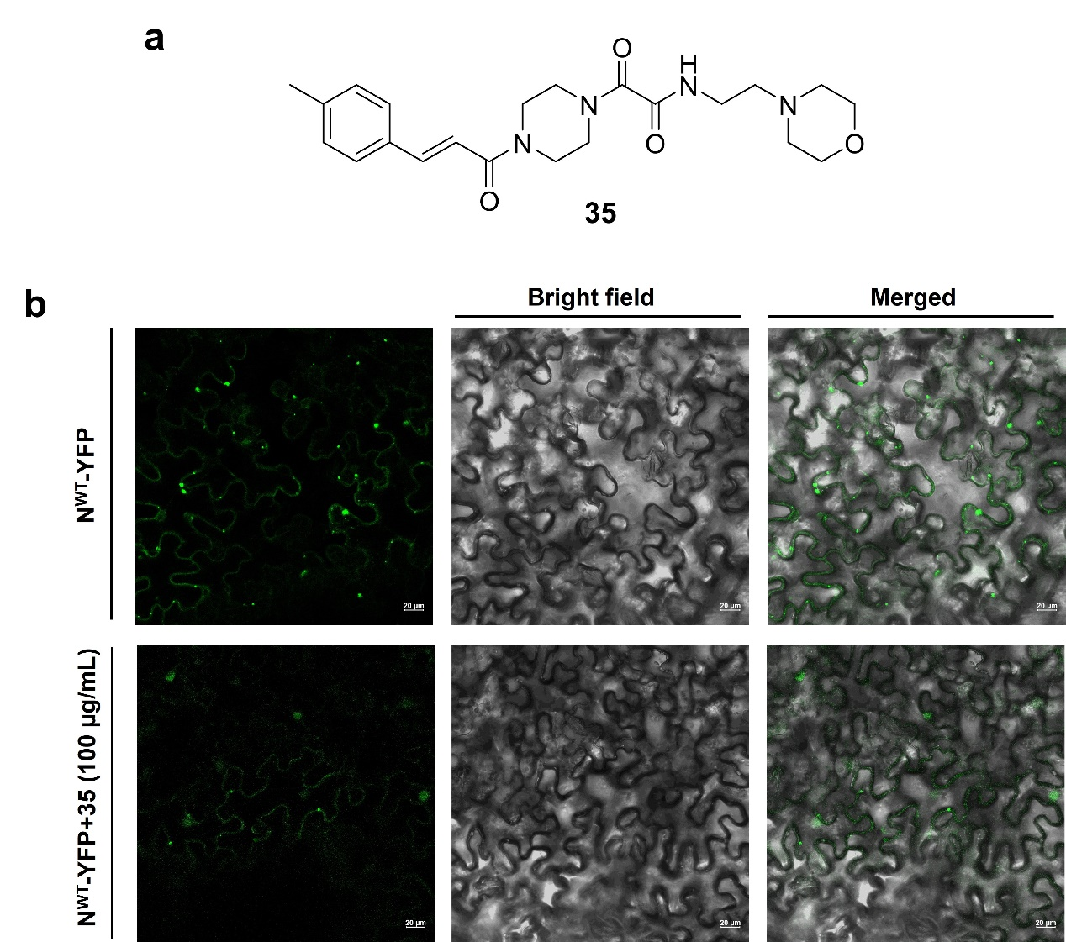
Fig. S1. The effect of compound 35 on N protein condensates. a) The structural formula of compound 35 that we previously reported. b) Compound 35 could reduce the numbers of IBs in vivo. Bars, 20 μm.

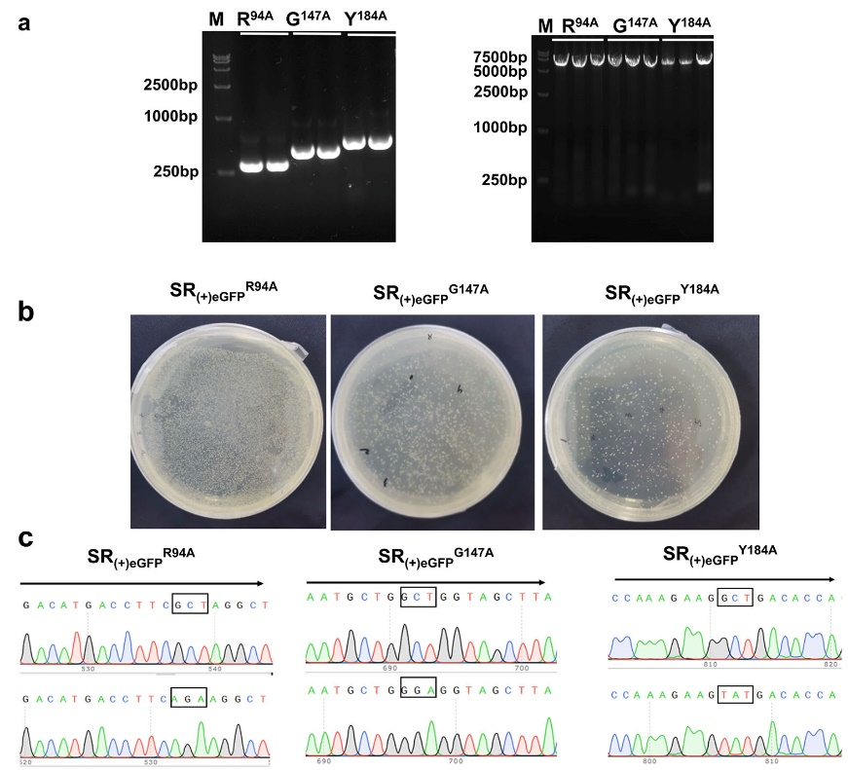
Fig. S2. Construction of mutant-type vectors SR_{(+)eGFP}^{Mut.} a) Gel electrophoresis of the inserted segment and linearized carrier of three mutations (R^{94A}, G^{147A}, and Y^{184A}). b) The recombinant systems were converted to DH5α and cultured overnight. c) Sequence identification of mutant plasmids SR_{(+)eGFP}^{R94A}, SR_{(+)eGFP}^{G147A}, and SR_{(+)eGFP}^{Y184A}.

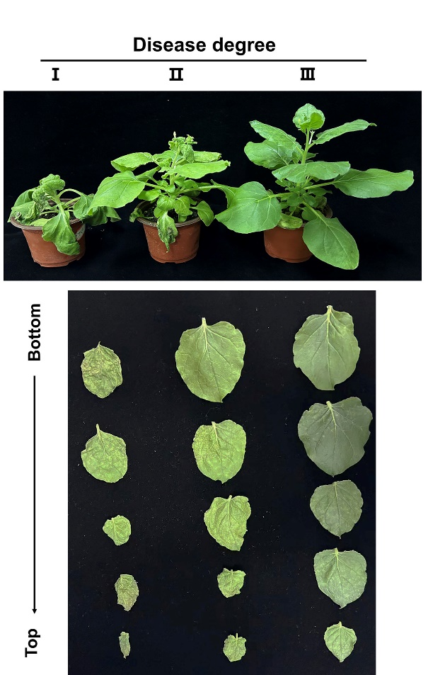
Fig. S3. Photographs of TSWV-infected N. benthamiana plants with different degrees of symptom severity, related to Fig. 4f.

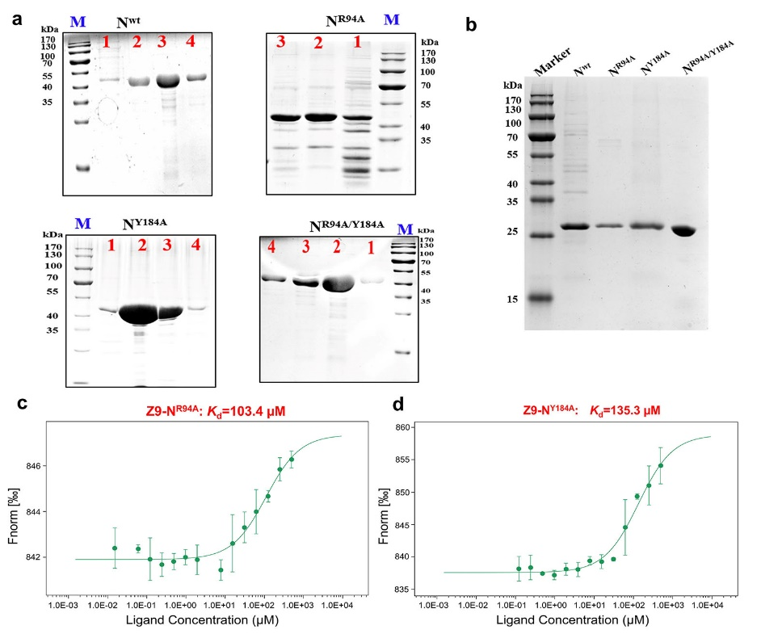
Fig. S4. The binding sites affect the binding ability of compound Z9 to N protein. a) SDS-PAGE identification of the purified N^{WT} and N^{Mut} (N^{R94A}, N^{Y184A}, N^{R94A&Y184A}) with solubilizing label (TRX). b) SDS-PAGE identification of purified N^{WT} and N^{Mut} after TRX was digested by enterokinase. c) The binding ability of compound Z9 with N^{R94A} was determined by MST. d) The binding ability of compound Z9 with N^{Y184A} was determined by MST.

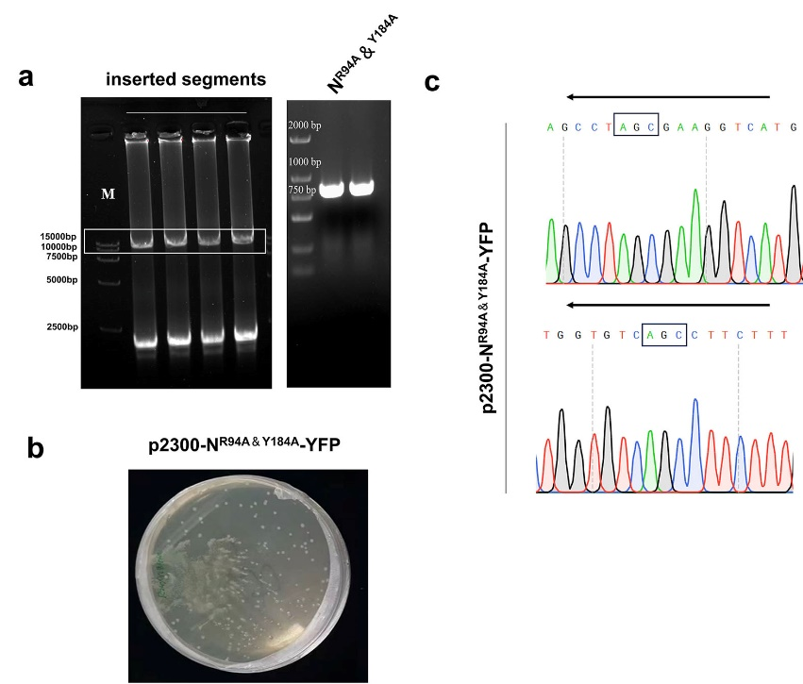
Fig. S5. Construction of mutant-type transient expression vector p2300-N^{R94A&Y184A}-YFP. a) Gel electrophoresis of the linearized carrier and inserted segments of mutation (R^{94A}&Y^{184A}). b) The mutant plasmid was converted to DH5α and cultured overnight; c) Sequence identification of mutant-type transient expression vector p2300-N^{R94A&Y184A}-YFP

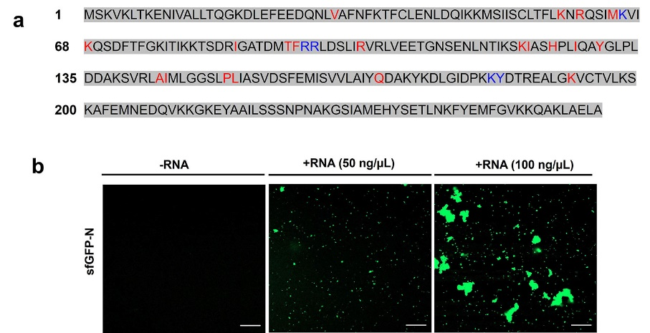
Fig. S6. RNA mediated N protein condensation. a) RNA binding sites in N protein. b) RNA induces phase transition of the N protein. RNA was incubated with 10 μM N protein at 25 °C for 10 min. Scale bars, 20 μm.

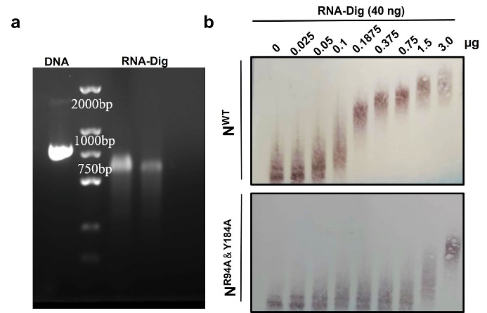
Fig. S7. The effect of binding sites on the binding of N proteins to RNA by EMSA assay. a) Preparation of digoxin labeled RNA probe through in vitro transcription. b) The binding ability of N^{R94A&Y184A} protein to RNA was reduced by EMSA assay. 1 µL RNA probe (40 ng/µL) was added into the PCR tubes and mixed with 9 µL different qualities of the purified N^{WT} or N^{R94A&Y184A} (0.025, 0.05, 0.1, 0.1875, 0.375, 0.75, 1.5, 3.0, and 6.0 µg), respectively. The mixtures were incubated in ice water bath for 10 min.

Table S1. List primers used in the study.
Construct | Primer sequence (5' to 3') | Purpose
pCB301-HH-SR_{(+)eGFP}^{R94A}-RZ-NOS | F: GCATATAACAACTTCTACGATCATCAT  GTCTAAGGTTAAGCTCAC  R: GATCAAGCTATCAAGCCTAGCGAAGG  TCATGTCAGTGGCTC | To amplify the sequence of inserted fragment
pCB301-HH-SR_{(+)eGFP}^{R94A}-RZ-NOS | F: GAGCCACTGACATGACCTTCGCTAGG  CTTGATAGCTTGATC  R: GATGATCGTAGAAGTTGTTATATGC | To amplify the sequence of linearization vector
pCB301-HH-SR_{(+)eGFP}^{G147A}-RZ-NOS | F: GCATATAACAACTTCTACGATCATCA  TGTCTAAGGTTAAGCTCAC  R: GCAATAAGAGGTAAGCTACCAGCCAG  CATTATGGCAAGCCTC | To amplify the sequence of inserted fragment
pCB301-HH-SR_{(+)eGFP}^{G147A}-RZ-NOS | F: GCATATAACAACTTCTACGATCAT  CATGTCTAAGGTTAAGCTCAC  R: GATGATCGTAGAAGTTGTTATATGC | To amplify the sequence of linearization vector
pCB301-HH-SR_{(+)eGFP}^{Y184A}-RZ-NOS | F: GCATATAACAACTTCTACGATCATCAT  GTCTAAGGTTAAGCTCAC  R: CTAAGGCTTCCCTGGTGTCAGCCTTC  TTTGGATCGATCCCGAG | To amplify the sequence of inserted fragment
pCB301-HH-SR_{(+)eGFP}^{Y184A}-RZ-NOS | F: CTCGGGATCGATCCAAAGAAGGCTGA  CACCAGGGAAGCCTTAG  R: GATGATCGTAGAAGTTGTTATATGC | To amplify the sequence of linearization vector
p2300-N^{R94A&Y184A}-YFP | F：CAAAACTTGCAGAACTTGCTTCTAGA  ATGGTGAGCAAGGGCGAGGAG  R：GTGAGCTTAACCTTAGACATGGTAC  CGAGCTCGCGAA | To amplify the sequence of linearization vector
p2300-N^{R94A&Y184A}-YFP | F：CTCGAGCTTTCGCGAGCTCGGTACCA  TGTCTAAGGTTAAGCTCAC  R：CCTCGCCCTTGCTCACCATTCTAGAA  GCAAGTTCTGCAAGTTTTG | To amplify the sequence of inserted fragment

Synthesis steps of the target compounds:
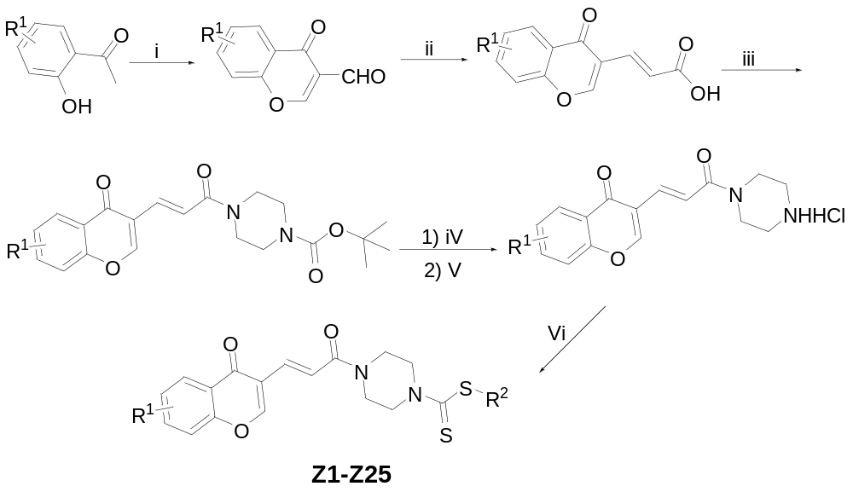
Scheme S1. The synthesis route of compounds Z1-Z25 in the study. Reaction conditions for the synthesis of compounds Z1-Z25. Reagents and conditions: (i) phosphorus oxychloride (3 equiv), anhydrous DMF, 0℃ to 50℃; (ii) propanedioic acid (2 equiv), pyridine, anhydrous EtOH, reflux; (iii) N-Boc-piperazine (1.2 equiv), 1-Ethyl-3-(3-dimethylaminopropyl)carbodiimide hydrochloride (1.1 equiv), 1-Hydroxybenzotriazole (1.2 equiv), triethylamine (3 equiv), anhydrous DMF, rt; (iv) trifluoroacetic acid, anhydrous CH₂Cl₂, rt; (v) HCl, propan-2-ol, EtOAc, rt; (vi) carbon disulfide (2 equiv), halogenated hydrocarbons or tertiary amine substituted halogenated hydrocarbons (1.1 equiv), triethylamine (3 equiv), anhydrous DMF, rt.
The synthesis of methods of intermediates 3-formyl substituted chromone, (E)-3-(substituted chromone-3-yl) acrylic acid, and (E)-4-(3-(substituted chromone-3-yl) acryloyl) piperazine-1-carboxylate were carried out according to the reference literature¹⁻³.
The synthesis of 3- (substituted chromone-3-yl) acryloylpiperazine hydrochloride
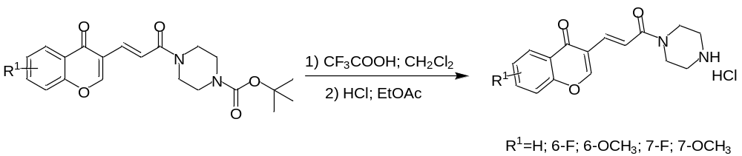
Scheme S2. Synthesis route of 3- (substituted chromone-3-yl) acryloylpiperazine hydrochloride
With the synthesis of the compound that R¹ was H as an example: A solution of (E)-4-(3-(substituted chromone-3-yl) acryloyl) piperazine-1-carboxylate (2.0 g, 5.20 mmol) and 5 mL trifluoroacetic in 20 mL dichloromethane was placed in a 50 mL flask. The reaction mixture was stirred at room temperature. Upon consumption of starting material, the solvent was removed by vacuum concentration. An appropriate amount of ethyl acetate and isopropanol were added to the residue, and 1.0 mL of concentrated hydrochloric acid was then added to the mixture. After being stirred at room temperature for 3 h, the mixture was filtered and dried to obtain a white solid product 3- (substituted chromone-3-yl) acryloylpiperazine hydrochloride in 72% yield.
The synthesis of substituted 3- (substituted chromone-3-yl) acryloylpiperazinyl dithiocarbonate (Z1-Z25)
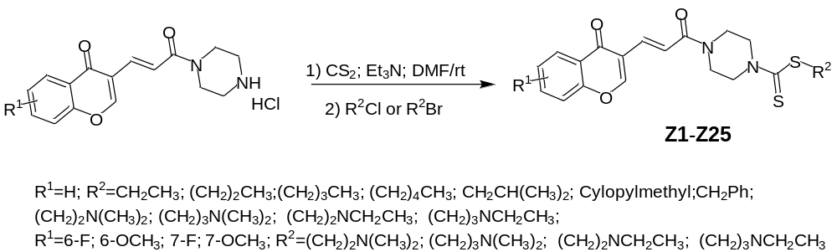
Scheme S3. Synthesis route of the target compounds Z1-Z25
With the synthesis of the compound Z9 that R¹ was H and R² was N,N-dimethylaminopropyl as an example: 3- (chromone-3-yl) acryloylpiperazinyl dithiocarbonate (300 mg, 0.94 mmol, 1.0 equiv) and triethylamine (280 mg, 1.87 mmol, 3.0 equiv) in DMF were added to a 25 mL flask. And carbon disulfide (140 mg, 1.87 mmol) was added and the mixture was reacted at room temperature for 30 minutes. N,N-dimethylamino-3-chloropropane hydrochloride (160 mg, 1.03 mmol, 1.1 equiv) was then added, and the reaction mixture was stirred for another 10 h. The resulting mixture was quenched with water, and the solid was obtained after filtration, washing, and drying. The product was obtained by recrystallization with anhydrous ethanol, with a yield of 55% as a white solid. m.p. 114.2 - 115.6℃; ¹H NMR (400 MHz, CDCl₃) δ 8.28 (dd, J = 8.0, 4.0 Hz, 1H), 8.17 - 8.08 (m, 2H), 7.75 - 7.71 (m, 1H), 7.53 - 7.46 (m, 2H), 7.37 (d, J = 16.0 Hz, 1H), 4.40 - 3.86 (m, 8H), 3.37 (t, J = 8.0 Hz, 2H), 2.40 (t, J = 8.0 Hz, 2H), 2.25 (s, 6H), 1.94 - 1.87 (m, 2H); ¹³C NMR (101 MHz, CDCl₃) δ 198.07, 176.63, 166.22, 158.50, 155.43, 134.79, 134.13, 126.16, 125.96, 124.24, 120.64, 119.27, 118.24, 58.55, 45.48, 44.67, 41.31, 35.03, 26.79; HRMS (ESI) m/z for C₂₂H₂₈O₃N₃S₂ [M+H]⁺ cacld. 446.15666, found. 446.15585.

The spectral data of other compounds were shown as follows:
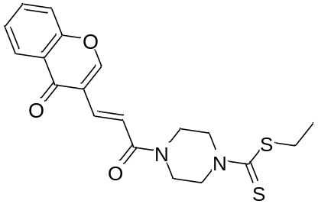
Ethyl (E)-4-(3-(4-oxo-4H-chromen-3-yl)acryloyl)piperazine-1-carbodithioate（Z1）：white solid; yield, 82%; m.p. 154.3 - 156.1℃; ¹H NMR (400 MHz, CDCl₃) δ 8.28 (dd, J = 8.0, 4.0, 1H), 8.16 - 8.07 (m, 2H), 7.76 - 7.70 (m, 1H), 7.54 - 7.45 (m, 2H), 7.37 (d, J = 14.9 Hz, 1H), 4.38 - 3.86 (m, 8H), 3.33 (q, J = 7.4 Hz, 2H), 1.38 (t, J = 7.4 Hz, 3H); ¹³C NMR (101 MHz, CDCl₃) δ 198.14, 176.64, 166.22, 158.49, 155.44, 134.79, 134.13, 126.16, 125.96, 124.25, 120.65, 119.28, 118.24, 44.68, 41.33, 31.59, 13.67; HRMS (ESI) m/z for C₁₉H₂₁O₃N₂S₂ [M+H]⁺ cacld. 389.09881, found. 389.09787.
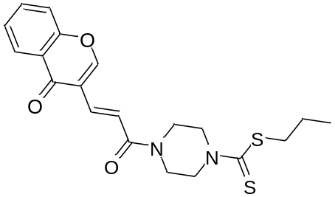
Propyl (E)-4-(3-(4-oxo-4H-chromen-3-yl)acryloyl)piperazine-1-carbodithioate（Z2）：
white solid; yield, 70%; m.p. 145.6 - 147.1℃; ¹H NMR (400 MHz; CDCl₃) δ 8.28 (dd, J = 8.0, 4.0 Hz, 1H), 8.14 - 8.09 (m, 2H), 7.75 - 7.70 (m, 1H), 7.53 - 7.46 (m, 2H), 7.37 (d, J = 12.0 Hz, 1H), 4.40 - 3.86 (m, 8H), 3.31 (t, J = 8.0 Hz, 2H), 1.80 - 1.71 (m, 2H), 1.05 (t, J = 7.8 Hz, 3H); ¹³C NMR (101 MHz, CDCl₃) δ 198.36, 176.63, 166.23, 158.49, 155.43, 134.78, 134.13, 126.16, 125.96, 124.25, 120.66, 119.28, 118.24, 44.68, 41.32, 39.20, 22.03, 13.62; HRMS (ESI) m/z for C₂₀H₂₃O₃N₂S₂ [M+H]⁺ cacld. 403.11446, found. 403.11362.
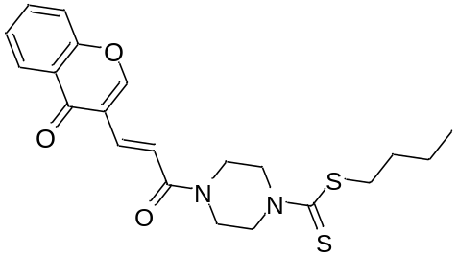
Butyl (E)-4-(3-(4-oxo-4H-chromen-3-yl)acryloyl)piperazine-1-carbodithioate（Z3）：
white solid; yield, 75%; m.p. 131.8 - 132.2℃; ¹H NMR (400 MHz; CDCl₃) δ 8.28 (dd, J = 8.0, 4.0 Hz, 1H), 8.14 - 8.09 (m, 2H), 7.74 - 7.70 (m, 1H), 7.52 - 7.46 (m, 2H), 7.37 (d, J = 12.0 Hz, 1H), 4.39 - 3.86 (m, 8H), 3.33 (t, J = 8.0 Hz, 2H), 1.73 - 1.67 (m, 2H), 1.49 -1.43 (m, 2H), 0.96 (t, J = 7.4 Hz, 3H); ¹³C NMR (101 MHz; CDCl₃) δ 198.39, 176.62, 166.22, 158.49, 155.43, 134.77, 134.13, 126.16, 125.96, 124.24, 120.65, 119.28, 118.24, 44.68, 41.32, 37.09, 30.59, 22.19, 13.75; HRMS (ESI) m/z for C₂₁H₂₅O₃N₂S₂ [M+H]⁺ cacld. 417.13011, found. 417.12906.
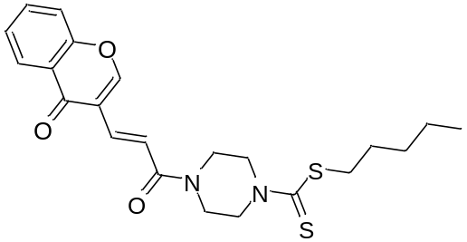
Pentyl (E)-4-(3-(4-oxo-4H-chromen-3-yl)acryloyl)piperazine-1-carbodithioate（Z4）：
white solid; yield, 78%; m.p. 144.4 - 146.1℃; ¹H NMR (400 MHz; CDCl₃) δ 8.25 (dd, J = 8.0, 4.0 Hz, 1H), 8.12 (s, 1H), 8.08 (d, J = 12.0 Hz, 1H), 7.72 - 7.69 (m, 1H), 7.50 - 7.44 (m, 2H), 7.35 (d, J = 12.0 Hz, 1H), 4.39 - 3.84 (m, 8H), 3.30 (t, J = 8.0 Hz, 2H), 1.72 - 1.67 (m, 2H), 1.41 - 1.33 (m, 4H), 0.89 (t, J = 6.0 Hz, 3H); ¹³C NMR (101 MHz, CDCl₃) ) δ 198.46, 176.70, 166.29, 158.56, 155.50, 134.84, 134.20, 126.22, 126.03, 124.31, 120.71, 119.34, 118.31, 44.75, 41.39, 37.42, 31.25, 28.31, 22.39, 14.08; HRMS (ESI) m/z for C₂₂H₂₇O₃N₂S₂ [M+H]⁺ cacld. 431.14576, found. 431.14478.
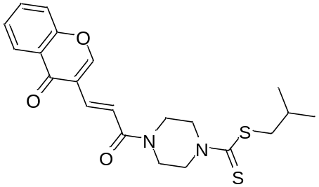
Isobutyl (E)-4-(3-(4-oxo-4H-chromen-3-yl)acryloyl)piperazine-1-carbodithioate (Z5):
white solid; yield, 72%; m.p. 153.4 - 155.9℃; ¹H NMR (400 MHz) δ 8.25 (dd, J = 8.0, 4.0 Hz, 1H), 8.12 - 8.06 (m, 2H), 7.71 - 7.68 (m, 1H), 7.49 - 7.44 (m, 2H), 7.34 (d, J = 12.0 Hz, 1H), 4.39 - 3.84 (m, 8H), 3.21 (d, J = 4.0 Hz, 2H), 2.02 – 1.97 (m, 1H), 1.02 (d, J = 5.6 Hz, 6H); ¹³C NMR (101 MHz, CDCl₃) δ 198.61, 176.68, 166.29, 158.56, 155.49, 134.84, 134.19, 126.22, 126.02, 124.30, 120.71, 119.33, 118.30, 45.98, 44.74, 41.39, 28.10, 22.24; HRMS (ESI) m/z for C₂₁H₂₅O₃N₂S₂ [[M+H]⁺ cacld. 417.13011, found. 417.12906.
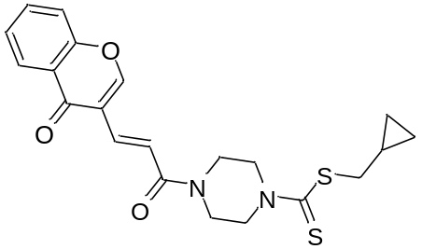
Cyclopropylmethyl (E)-4-(3-(4-oxo-4H-chromen-3-yl)acryloyl)piperazine-1-carbodithioate (Z6): white solid; yield, 85%; m.p. 167.2 - 169.1℃; ¹H NMR (400 MHz; CDCl₃) δ 8.26 (dd, J = 6.0, 2.0 Hz, 1H), 8.12 (s, 1H), 8.08 (d, J = 12.0 Hz, 1H) , 7.72 - 7.69 (m, 1H), 7.50 - 7.45 (m, 2H), 7.35 (d, J = 12.0 Hz, 1H), 4.39 - 3.85 (m, 8H), 3.25 (d, J = 4.0 Hz, 2H), 1.17 - 1.11 (m, 1H), 0.63 - 0.59 (m, 2H), 0.34 - 0.31 (m, 2H); ¹³C NMR (101 MHz, CDCl₃) δ 198.47, 176.71, 166.30, 158.58, 155.50, 134.87, 134.21, 126.22, 126.03, 124.31, 120.70, 119.34, 118.31, 44.76, 43.91, 41.40, 9.50, 6.03; HRMS(ESI) m/z for C₂₁H₂₃O₃N₂S₂ [M+H]⁺ cacld. 415. 11446, found. 415. 11331.
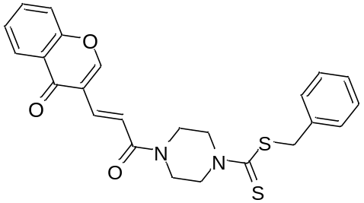
Benzyl (E)-4-(3-(4-oxo-4H-chromen-3-yl)acryloyl)piperazine-1-carbodithioate (Z7): white solid; yield, 90%; m.p. 135.6 - 137.1 ℃; ¹H NMR (400 MHz, CDCl₃) δ 8.26 (dd, J = 6.4, 1.2 Hz, 1H), 8.12 (s, 1H), 8.08 (d, J = 12.0 Hz, 1H), 7.72 - 7.69 (m, 1H), 7.50 - 7.45 (m, 2H), 7.39 - 7.27 (m, 6H), 4.57 (s, 2H), 4.42 - 3.85 (m, 8H); ¹³C NMR (101 MHz, CDCl₃) δ 197.50, 176.71, 166.29, 158.59, 155.50, 135.64, 134.93, 134.21, 129.50, 128.76, 127.78, 126.22, 126.04, 124.31, 120.65, 119.32, 118.31, 44.75, 42.29, 41.40; HRMS(ESI) m/z for C₂₄H₂₃O₃N₂S₂ [M+H]⁺ cacld. 451.11446, found. 451.11349.
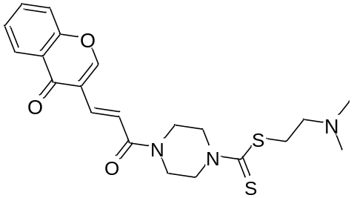
2-(N,N-dimethylamino)ethyl (E)-4-(3-(4-oxo-4H-chromen-3-yl)acryloyl)piperazine-1-carbodithioate (Z8)：
white solid; yield, 75%; m.p. 145.2 - 146.7℃; ¹H NMR (400 MHz, CDCl₃) δ 8.28 (dd, J = 8.0, 4.0 Hz, 1H), 8.15 (s, 1H), 8.10 (d, J = 16.0 Hz, 1H), 7.75 - 7.71 (m, 1H), 7.53 - 7.46 (m, 2H), 7.37 (d, J = 16.0 Hz, 1H), 4.41 - 3.86 (m, 8H), 3.52 (t, J = 6.0 Hz, 2H), 2.68 (t, J = 6.0 Hz, 2H), 2.33 (s, 6H); ¹³C NMR (101 MHz, CDCl₃) δ 197.92, 176.63, 166.21, 158.53, 155.42, 134.83, 134.13, 126.14, 125.96, 124.22, 120.58, 119.25, 118.24, 55.73, 45.28, 44.66, 41.33, 35.21; HRMS (ESI) m/z for C₂₁H₂₆O₃N₃S₂ [M+H]⁺ cacld. 432.14101, found. 432.14075.
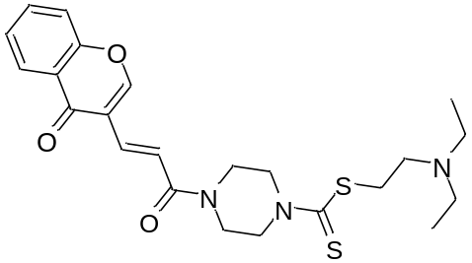
2-(diethylamino)ethyl (E)-4-(3-(4-oxo-4H-chromen-3-yl)acryloyl)piperazine-1-carbodithioate (Z10): white solid; yield, 68%; m.p. 135.7 - 138.0 ℃; ¹H NMR (400 MHz, CDCl₃) δ 8.28 (dd, J = 8.0, 2.0 Hz, 1H), 8.14 (s, 1H), 8.11 (d, J = 16.0 Hz, 1H), 7.75 - 7.70 (m, 1H), 7.53 -7.46 (m, 2H), 7.37 (d, J = 16.0 Hz, 1H), 4.41 - 3.86 (m, 8H), 3.46 (d, J = 8.0 Hz, 2H), 2.79 (d, J = 8.0 Hz, 2H), 2.65 - 2.60 (m, 4H), 1.07 (t, J = 7.0 Hz, 6H); ¹³C NMR (101 MHz, CDCl₃) δ 198.17, 176.63, 166.21, 158.49, 155.43, 134.79, 134.13, 126.16, 125.96, 124.24, 120.63, 119.27, 118.24, 51.25, 47.01, 44.69, 41.34, 34.85, 11.91; HRMS (ESI) m/z for C₂₃H₃₀O₃N₃S₂ [M+H]⁺ cacld. 460.17231, found. 460.17130.
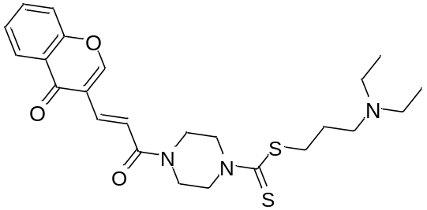
3-(diethylamino)propyl (E)-4-(3-(4-oxo-4H-chromen-3-yl)acryloyl)piperazine-1-carbodithioate (Z11): white solid; yield, 62%; m.p. 129.8 - 131.2 ℃; ¹H NMR (400 MHz, CDCl₃) δ 8.28 (dd, J = 8.0, 2.0 Hz, 1H), 8.14 (s, 1H), 8.11 (d, J = 16.0 Hz, 1H), 7.75 - 7.71 (m, 1H), 7.53 -7.46 (m, 2H), 7.37 (d, J = 16.0 Hz, 1H), 4.40 - 3.86 (m, 8H), 3.35 (t, J = 8.0 Hz, 2H), 2.57 - 2.50 (m, 6H), 1.91 -1.84 (m, 2H), 1.03 (t, J = 8.0 Hz, 6H); ¹³C NMR (101 MHz, CDCl₃) δ 198.25, 176.63, 166.22, 158.49, 155.43, 134.78, 134.13, 126.16, 125.96, 124.25, 120.65, 119.27, 118.24, 51.70, 46.88, 44.68, 41.33, 35.34, 26.12, 11.83; HRMS (ESI) m/z for C₂₄H₃₂O₃N₃S₂ [M+H]⁺ cacld. 474.18796, found. 474.18692.
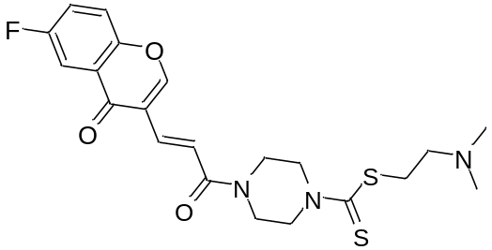
2-(dimethylamino)ethyl (E)-4-(3-(6-fluoro-4-oxo-4H-chromen-3-yl)acryloyl)piperazine-1-carbodithioate (Z12): white solid; yield, 70%; m.p. 172.1 - 174.3 ℃; ¹H NMR (400 MHz, CDCl₃) δ 8.15 (s, 1H), 8.08 (d, J = 16.0 Hz, 1H), 7.91 (dd, J = 8.0, 4.0 Hz, 1H), 7.55 - 7.52 (m, 1H), 7.48 - 7.43 (m, 1H), 7.36 (d, J = 16.0 Hz, 1H), 4.42 - 3.86 (m, 8H), 3.51 (t, J = 8.0 Hz, 2H), 2.66 (t, J = 6.0 Hz, 2H), 2.32 (s, 6H); ¹³C NMR (101 MHz, CDCl₃) δ 198.01, 175.76, 166.04, 161.14, 158.49, 151.62, 134.37, 125.45, 125.37, 122.53, 122.28, 120.91, 120.44, 120.36, 118.62, 111.16, 110.92, 57.72, 45.31, 44.65, 41.33, 35.36; HRMS (ESI) m/z for C₂₁H₂₅O₃N₃FS₂ [M+H]⁺ cacld. 450.13159, found. 450.13080.
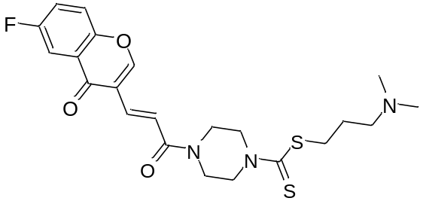
3-(dimethylamino)propyl (E)-4-(3-(6-fluoro-4-oxo-4H-chromen-3-yl)acryloyl)piperazine-1-carbodithioate (Z13): white solid; yield, 75%; m.p. 149.4 - 152.9 ℃; ¹H NMR (400 MHz, CDCl₃) δ 8.15 (s, 1H), 8.08 (d, J = 1.6.0 Hz, 1H), 7.90 (dd, J = 8.0, 3.2 Hz, 1H), 7.55 - 7.52 (m, 1H), 7.47 - 7.42 (m, 1H), 7.36 (d, J = 16.0 Hz, 1H), 4.40 - 3.87 (m, 8H), 3.37 (t, J = 8.0 Hz, 2H), 2.39 (t, J = 8.0 Hz, 2H), 2.24 (s, 6H), 1.94 - 1.86 (m, 2H); ¹³C NMR (101 MHz, CDCl₃) δ 198.16, 175.87, 166.17, 161.00, 159.03, 158.60, 151.74, 134.46, 125.54, 125.48, 122.61, 122.41, 121.03, 120.54, 120.48, 118.72, 111.23, 110.05, 58.60, 45.53, 44.75, 41.40, 35.10, 26.84; HRMS(ESI) m/z for C₂₂H₂₇O₃N₃FS₂ [M+H]⁺ cacld. 464.14724, found. 464.14639.
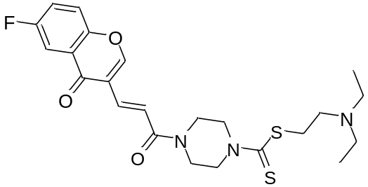
2-(diethylamino)ethyl (E)-4-(3-(6-fluoro-4-oxo-4H-chromen-3-yl)acryloyl)piperazine-1-carbodithioate (Z14): yellow solid; yield, 62%; m.p. 147.8 - 151.2 ℃; ¹H NMR (400 MHz, CDCl₃) 8.15 (s, 1H), 8.08 (d, J = 16.0 Hz, 1H), 7.90 (dd, J = 8.0, 3.2 Hz, 1H), 7.55 - 7.52 (m, 1H), 7.48 - 7.43 (m, 1H), 7.36 (d, J = 16.0 Hz, 1H), 4.41 - 3.86 (m, 8H), 3.48 (t, J = 8.0 Hz, 2H), 2.81 (t, J = 6.0 Hz, 2H), 2.67 - 2.62 (m, 4H), 1.08 (t, J = 8.0 Hz, 6H); ¹³C NMR (101 MHz, CDCl₃) δ 198.15, 175.79, 166.08, 161.18, 158.71, 158.53, 151.66, 134.39, 125.48, 125.41, 122.57, 122.31, 120.96, 120.48, 120.40, 118.66, 111.19, 110.95, 51.22, 46.99, 44.69, 41.36, 34.70, 11.80; HRMS(ESI) m/z for C₂₃H₂₉O₃N₃FS₂ [M+H]⁺ cacld. 478.16289, found. 478.16168.
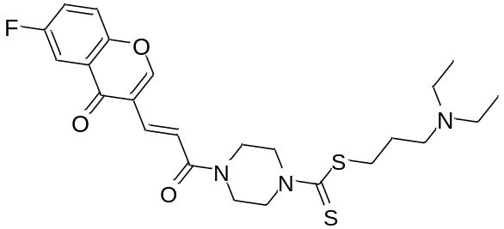
3-(diethylamino)propyl (E)-4-(3-(6-fluoro-4-oxo-4H-chromen-3-yl)acryloyl)piperazine-1-carbodithioate (Z15): yellow solid; yield, 74%; m.p. 127.1 - 128.3 ℃; ¹H NMR (400 MHz, CDCl₃) 8.15 (s, 1H), 8.09 (d, J = 12.0 Hz, 1H), 7.90 (dd, J = 8.0, 3.2 Hz, 1H), 7.55 - 7.52 (m, 1H), 7.48 - 7.43 (m, 1H), 7.36 (d, J = 16.0 Hz, 1H), 4.41 - 3.87 (m, 8H), 3.35 (t, J = 8.0 Hz, 2H), 2.57 - 2.51 (m, 6H), 1.91 - 1.84 (m, 2H), 1.03 (t, J = 8.0 Hz, 6H); ¹³C NMR (101 MHz, CDCl₃) δ 198.28, 175.81, 166.08, 161.17, 158.71, 158.53, 151.67, 134.38, 125.48, 125.41, 122.57, 122.31, 120.97, 120.48, 120.40, 118.66, 111.19, 110.95, 51.68, 46.87, 44.70, 41.33, 35.34, 26.11, 11.82; HRMS(ESI) m/z for C₂₄H₃₁O₃N₃FS₂ [M+H]⁺ cacld. 492.17854, found. 492.17734.
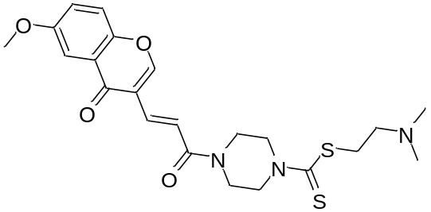
2-(dimethylamino)ethyl (E)-4-(3-(6-methoxy-4-oxo-4H-chromen-3-yl)acryloyl)piperazine-1-carbodithioate (Z16): white solid; yield, 70%; m.p. 138.9 - 140.1 ℃; ¹H NMR (400 MHz, CDCl₃) δ 8.13 - 8.09 (m, 2H), 7.62 (d, J = 3.2 Hz, 1H), 7.45 (d, J = 8.0 Hz, 1H), 7.38 (d, J = 16.0 Hz, 1H), 7.32 -7.29 (m, 1H), 4.41 - 3.87 (m, 8H), 3.92 (s, 3H), 3.51 (t, J = 8.0 Hz, 2H), 2.67 (t, J = 8.0 Hz, 2H), 2.32 (s, 6H), 1.89 - 1.96 (m, 2H); ¹³C NMR (101 MHz, CDCl₃) δ 198.03, 176.48, 166.25, 158.30, 157.49, 150.31, 134.96, 124.88, 124.21, 120.38, 119.67, 118.42, 105.05, 57.77, 55.97, 45.35, 44.66, 41.32, 35.40; HRMS(ESI) m/z for C₂₂H₂₈O₄N₃S₂ [M+H]⁺ cacld. 462.15152, found. 462.15112.
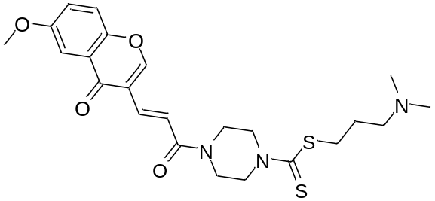
3-(dimethylamino)propyl (E)-4-(3-(6-methoxy-4-oxo-4H-chromen-3-yl)acryloyl)piperazine-1-carbodithioate (Z17): white solid; yield, 68%; m.p. 161.2 - 163.4 ℃; ¹H NMR (400 MHz, CDCl₃) δ 8.13 (s, 1H), 8.12 (d, J = 16.0 Hz, 1H), 7.62 (d, J = 4.0 Hz, 1H), 7.45 (d, J = 8.0 Hz, 1H), 7.38 (d, J = 16.0 Hz, 1H), 7.32 - 7.29 (m, 1H), 4.39 - 3.87 (m, 8H), 3.92 (s, 3H), 3.37 (t, J = 6.0 Hz, 2H), 2.43 (t, J = 6.0 Hz, 2H), 2.28 (s, 6H), 1.96 - 1.89 (m, 2H); ¹³C NMR (101 MHz, CDCl₃) δ 198.03, 176.45, 166.24, 158.27, 157.46, 150.28, 134.90, 124.85, 124.17, 120.38, 119.64, 118.39, 105.02, 58.47, 55.94, 45.38, 44.63, 41.25, 34.95, 26.68; HRMS(ESI) m/z for C₂₃H₃₀O₄N₃S₂ [M+H]⁺ cacld. 476.16722, found. 476.16647.
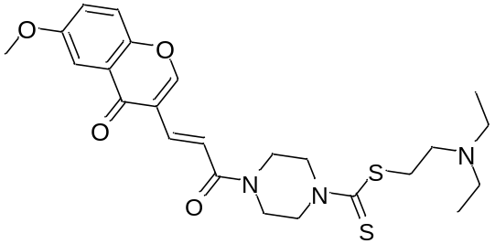
2-(diethylamino)ethyl (E)-4-(3-(6-methoxy-4-oxo-4H-chromen-3-yl)acryloyl)piperazine-1-carbodithioate (Z18): white solid; yield, 58%; m.p. 137.4 - 139.6 ℃; ¹H NMR (400 MHz, CDCl₃) δ 8.13 (s, 1H), 8.12 (d, J = 16.0 Hz, 1H), 7.62 (d, J = 3.2 Hz, 1H), 7.45 (d, J = 8.0 Hz, 1H), 7.38 (d, J = 16.0 Hz, 1H), 7.32 - 7.29 (m, 1H), 4.41 - 3.86 (m, 8H), 3.92 (s, 3H), 3.46 (t, J = 6.0 Hz, 2H), 2.79 (t, J = 8.0 Hz, 2H), 2.65 - 2.60 (m, 4H), 1.07 (t, J = 8.0 Hz, 6H); ¹³C NMR (101 MHz, CDCl₃) δ 198.11, 176.46, 166.27, 158.30, 157.46, 150.28, 134.94, 124.84, 124.18, 120.34, 119.64, 118.38, 105.03, 55.94, 51.23, 46.95, 44.63, 41.30, 34.67, 11.83; HRMS(ESI) m/z for C₂₄H₃₂O₄N₃S₂ [M+H]⁺ cacld. 490.18287, found. 490.18173.
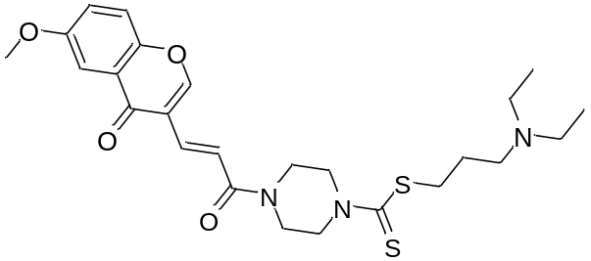
3-(diethylamino)propyl (E)-4-(3-(6-methoxy-4-oxo-4H-chromen-3-yl)acryloyl)piperazine-1-carbodithioate (Z19): yellow solid; yield, 54%; m.p. 120.1 - 122.3 ℃; ¹H NMR (400 MHz, CDCl₃) δ 8.13 (s, 1H), 8.12 (d, J = 16.0 Hz, 1H), 7.62 (d, J = 3.2 Hz, 1H), 7.45 (d, J = 8.0 Hz, 1H), 7.38 (d, J = 16.0 Hz, 1H), 7.32 -7.29 (m, 1H), 4.40 - 3.87 (m, 8H), 3.92 (s, 3H), 3.35 (t, J = 8.0 Hz, 2H), 2.57 - 2.51 (m, 6H), 1.92 - 1.84 (m, 2H), 1.03 (t, J = 6.0 Hz, 6H); ¹³C NMR (101 MHz, CDCl₃) δ 198.26, 176.48, 166.27, 158.29, 157.49, 150.31, 134.92, 124.88, 124.20, 120.42, 119.67, 118.43, 105.06, 55.97, 51.68, 46.88, 44.67, 41.30, 35.32, 26.11, 11.81; HRMS(ESI) m/z for C₂₅H₃₄O₄N₃S₂ [M+H]⁺ cacld. 504.19852, found. 504.19727.
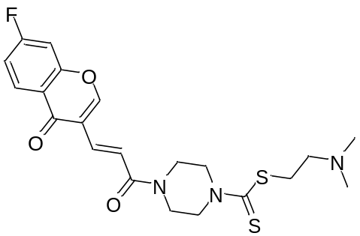
2-(dimethylamino)ethyl (E)-4-(3-(7-fluoro-4-oxo-4H-chromen-3-yl)acryloyl)piperazine-1-carbodithioate (Z20): white solid; yield, 68%; m.p. 176.1 - 178.3 ℃; ¹H NMR (400 MHz, CDCl₃) δ 8.31 -8.27 (m, 1H), 8.12 (s, 1H), 8.07 (d, J = 16.0 Hz, 1H), 7.35 (d, J = 12.0 Hz, 1H), 7.24 - 7.19 (m, 2H), 4.41 - 3.85 (m, 8H), 3.50 (t, J = 6.0 Hz, 2H), 2.66 (t, J = 6.0 Hz, 2H), 2.31 (s, 6H); ¹³C NMR (101 MHz, CDCl₃) δ 198.07, 175.69, 167.05, 166.06, 164.50, 158.41, 156.45, 156.32, 134.35, 128.83, 128.72, 121.10, 119.47, 114.96, 114.73, 105.08, 104.83, 57.77, 45.36, 44.68, 41.35, 35.45; HRMS (ESI) m/z for C₂₁H₂₅O₃N₃FS₂ [M+H]⁺ cacld. 450.13159, found. 450.13055.
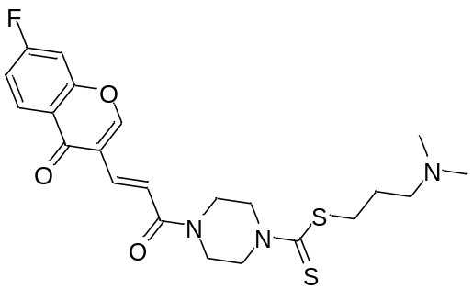
3-(dimethylamino)propyl (E)-4-(3-(7-fluoro-4-oxo-4H-chromen-3-yl)acryloyl)piperazine-1-carbodithioate (Z21): white solid; yield, 72%; m.p. 132.1 - 134.2 ℃; ¹H NMR (400 MHz, CDCl₃) δ 8.31 - 8.27 (m, 1H), 8.12 (s, 1H), 8.07 (d, J = 12.0 Hz, 1H), 7.34 (d, J = 12.0 Hz, 1H), 7.24 - 7.19 (m, 2H), 4.40 -3.86 (m, 8H), 3.36 (t, J = 6.0 Hz, 2H), 2.39 (t, J = 6.0, 2H), 2.24 (s, 6H), 1.94 - 1.88 (m, 2H); ¹³C NMR (101 MHz, CDCl₃) δ 198.08, 175.67, 167.03, 166.07, 164.48, 158.40, 156.43, 156.29, 134.32, 128.80, 128.69, 121.08, 119.43, 114.93, 114.71, 105.05, 104.80, 58.52, 45.44, 44.65, 41.30, 35.02, 26.76; HRMS(ESI) m/z for C₂₂H₂₇O₃N₃FS₂ [M+H]⁺ cacld. 464.14724, found. 464.14624.
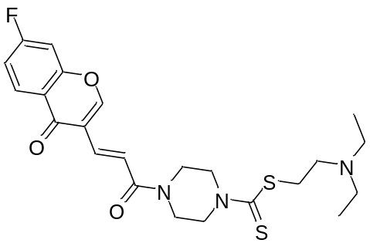
2-(diethylamino)ethyl (E)-4-(3-(7-fluoro-4-oxo-4H-chromen-3-yl)acryloyl)piperazine-1-carbodithioate (Z22): white solid; yield, 63%; m.p. 170.1 - 172.2 ℃; ¹H NMR (400 MHz, CDCl₃) δ 8.31 - 8.27 (m, 1H), 8.12 (s, 1H), 8.07 (d, J = 12.0 Hz, 1H), 7.34 (d, J = 12.0 Hz, 1H), 7.28 - 7.19 (m, 2H), 4.40 - 3.86 (m, 8H), 3.47 (t, J = 6.0 Hz, 2H), 2.79 (t, J = 6.0, 2H), 2.66 - 2.60 (m, 4H), 1.07 (t, J = 8.0 Hz, 2H); ¹³C NMR (101 MHz, CDCl₃) δ 198.16, 175.69, 167.04, 166.07, 164.50, 158.42, 156.45, 156.31, 134.35, 128.82, 128.72, 121.10, 119.45, 114.96, 114.73, 105.08, 104.83, 51.23, 46.99, 44.68, 41.34, 34.75, 11.86; HRMS(ESI) m/z for C₂₈H₂₉O₃N₃FS₂[M+H]⁺ cacld. 478.16289, found. 478.16183.
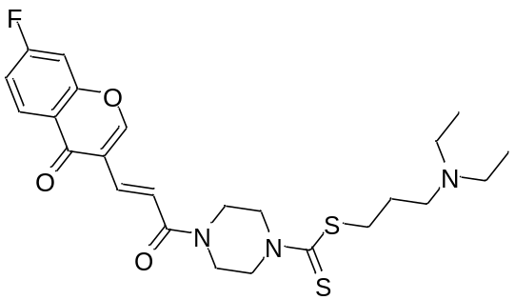
3-(diethylamino)propyl (E)-4-(3-(7-fluoro-4-oxo-4H-chromen-3-yl)acryloyl)piperazine-1-carbodithioate (Z23): yellow solid; yield, 61%; m.p. 120.4 - 122.1℃; ¹H NMR (400 MHz, CDCl₃) δ 8.31 - 8.27 (m, 1H), 8.12 (s, 1H), 8.08 (d, J = 16.0 Hz, 1H), 7.35 (d, J = 12.0 Hz, 1H), 7.24 - 7.19 (m, 2H), 4.40 - 3.86 (m, 8H), 3.35 (t, J = 8.0 Hz, 2H), 2.57 - 2.51 (m, 6H), 1.91 -1.84 (m, 2H), 1.03 (t, J = 8.0 Hz, 2H); ¹³C NMR (101 MHz, CDCl₃) δ 198.27, 175.69, 167.05, 166.07, 164.50, 158.41, 156.45, 156.32, 134.33, 128.83, 128.72, 121.12, 119.46, 114.96, 114.73, 105.08, 104.83, 51.67, 46.87, 44.69, 41.33, 35.33, 26.09, 11.80; HRMS(ESI) m/z for C₂₄H₃₁O₃N₃FS₂ [M+H]⁺ cacld. 492.17854, found. 492.17728.
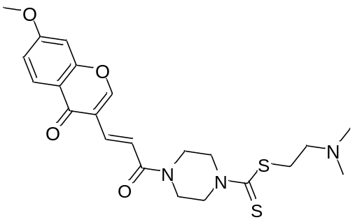
2-(dimethylamino)ethyl (E)-4-(3-(7-methoxy-4-oxo-4H-chromen-3-yl)acryloyl)piperazine-1-carbodithioate (Z24): white solid; yield, 72%; m.p. 170.8 - 173.2 ℃; ¹H NMR (400 MHz, CDCl₃) δ 8.17 (d, J = 8.0 Hz, 1H), 8.10 (d, J = 16.0 Hz, 1H), 8.07 (s, 1H), 7.34 (d, J = 16.0 Hz, 1H), 7.05 - 7.02 (m, 1H), 6.88 (d, J = 4.0 Hz, 1H), 4.40 - 3.86 (m, 8H), 3.93 (s, 3H), 3.51 (t, J = 6.0 Hz, 2H), 2.68 (t, J = 8.0 Hz, 2H), 2.33 (s, 6H); ¹³C NMR (101 MHz, CDCl₃) δ 197.88, 176.01, 166.26, 164.36, 158.08, 157.20, 134.95, 127.48, 120.44, 119.14, 118.06, 115.29, 100.26, 57.71, 55.96, 45.25, 44.63, 41.30, 35.16; HRMS(ESI) m/z for C₂₂H₂₈O₄N₃S₂ [M+H]⁺ cacld. 462.15157, found. 462.15060.
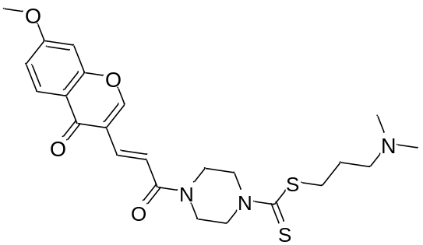
3-(dimethylamino)propyl (E)-4-(3-(7-methoxy-4-oxo-4H-chromen-3-yl)acryloyl)piperazine-1-carbodithioate (Z25): white solid; yield, 69%; m.p. 162.9 - 164.7 ℃; ¹H NMR (400 MHz, CDCl₃) δ 8.17 (d, J = 8.0 Hz, 1H), 8.10 (d, J = 16.0 Hz, 1H), 8.07 (s, 1H), 7.34 (d, J = 16.0 Hz, 1H), 7.05 - 7.02 (m, 1H), 6.88 (d, J = 4.0 Hz, 1H), 4.39 - 3.87 (m, 8H), 3.93 (s, 3H), 3.36 (t, J = 8.0 Hz, 2H), 2.40 (t, J = 6.0 Hz, 2H), 2.24 (s, 6H), 1.90 - 1.87 (m, 2H); ¹³C NMR (101 MHz, CDCl₃) δ 198.02, 176.01, 166.28, 164.35, 158.09, 157.19, 134.93, 127.47, 120.45, 119.13, 118.06, 115.29, 100.26, 58.52, 55.96, 45.44, 44.62, 41.28, 35.01, 26.75; HRMS(ESI) m/z for C₂₃H₃₀O₄N₃S₂ [M+H]⁺ cacld. 476.16722, found. 476.16693.

Structure identification spectrum of the compounds:
Fig. S8. ¹H NMR of the compound Z1
Fig. S9. ¹³C NMR of the compound Z1

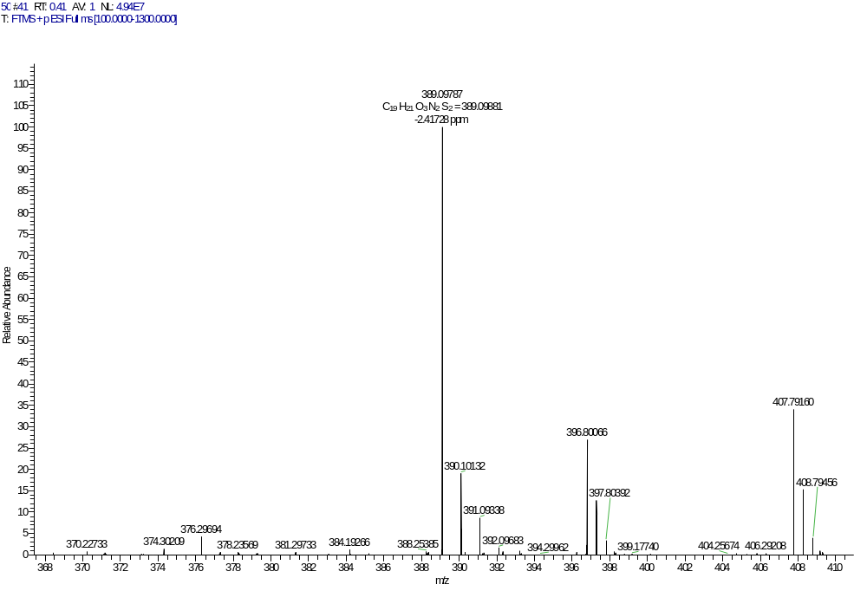
Fig. S10. HRMS of the compound Z1
Fig. S11. ¹H NMR of the compound Z2

Fig. S12. ¹³C NMR of the compound Z2

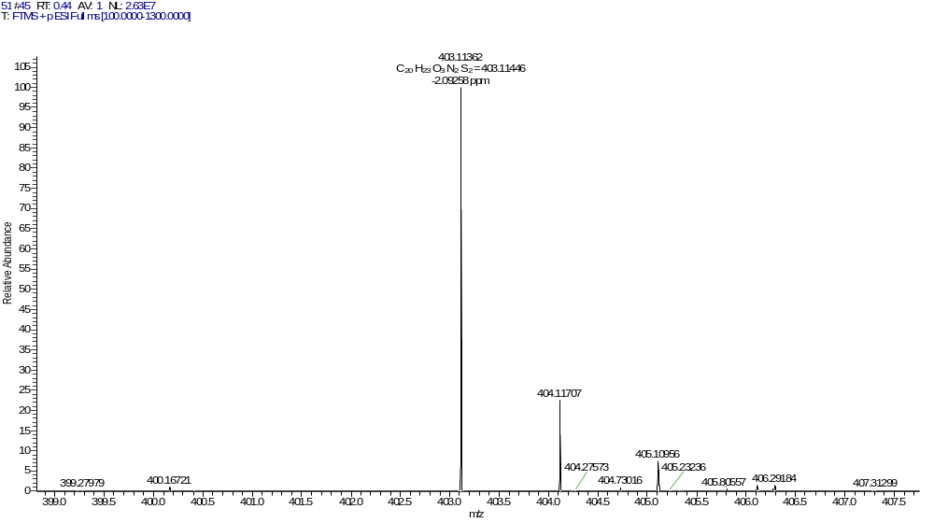
Fig. S13. HRMS of the compound Z2

Fig. S14. ¹H NMR of the compound Z3
Fig. S15. ¹³C NMR of the compound Z3

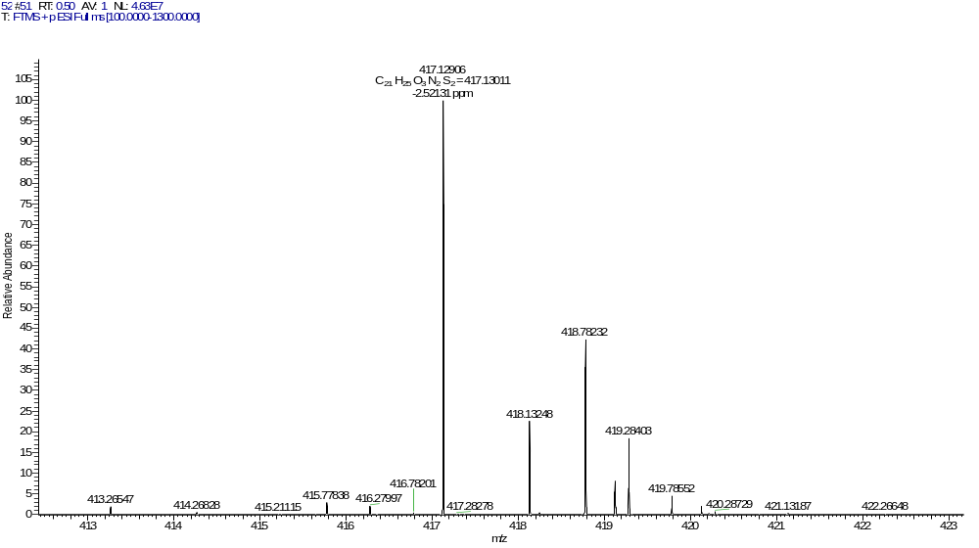
Fig. S16. HRMS of the compound Z3
Fig. S17. ¹H NMR of the compound Z4

Fig. S18. ¹³C NMR of the compound Z4

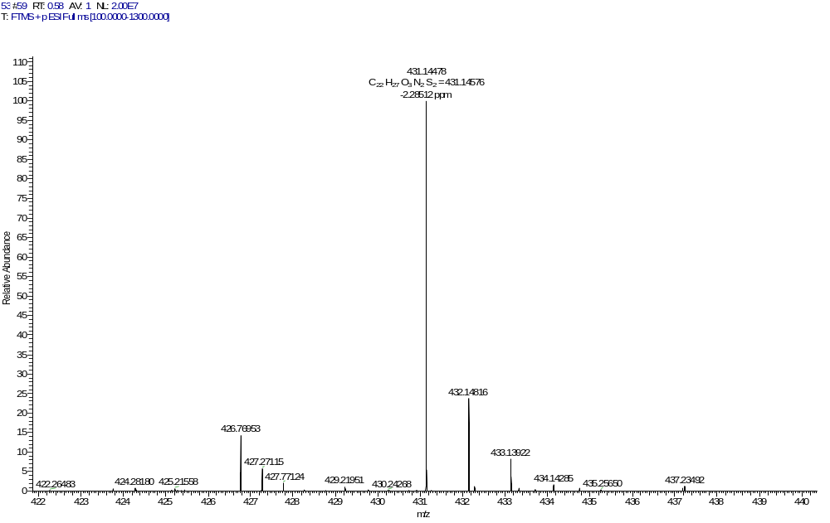
Fig. S19. HRMS of the compound Z4

Fig. S20. ¹H NMR of the compound Z5

Fig. S21. ¹³C NMR of the compound Z5

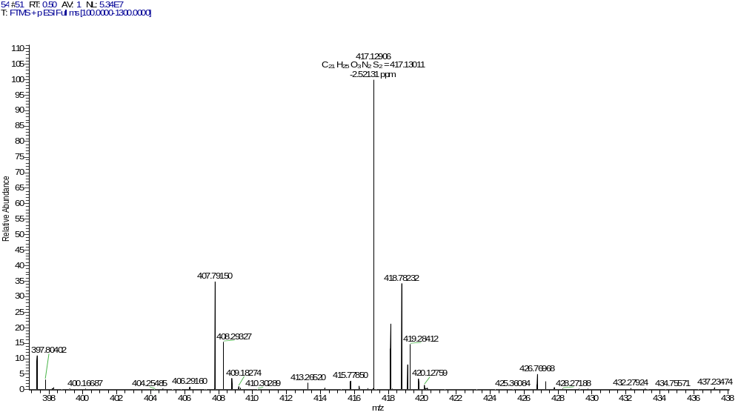
Fig. S22. HRMS of the compound Z5
Fig. S23. ¹H NMR of the compound Z6

Fig. S24. ¹³C NMR of the compound Z6
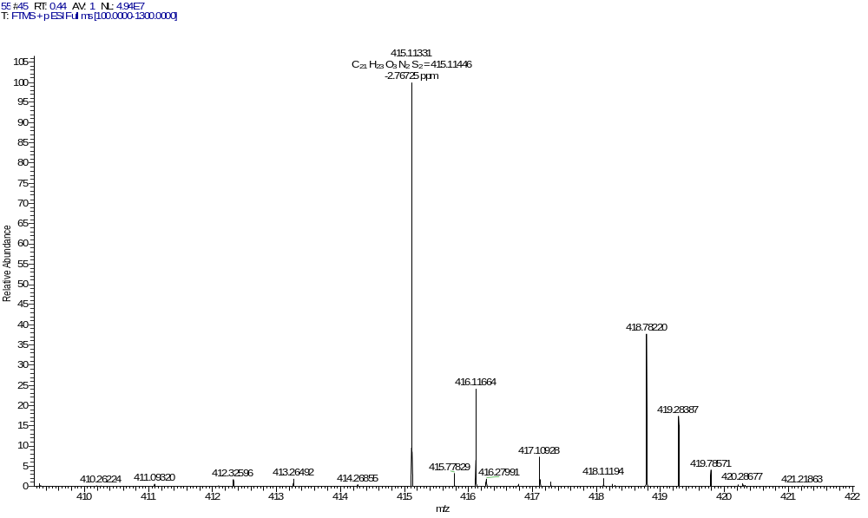
Fig. S25. HRMS of the compound Z6

Fig. S26. ¹H NMR of the compound Z7
Fig. S27. ¹³C NMR of the compound Z7
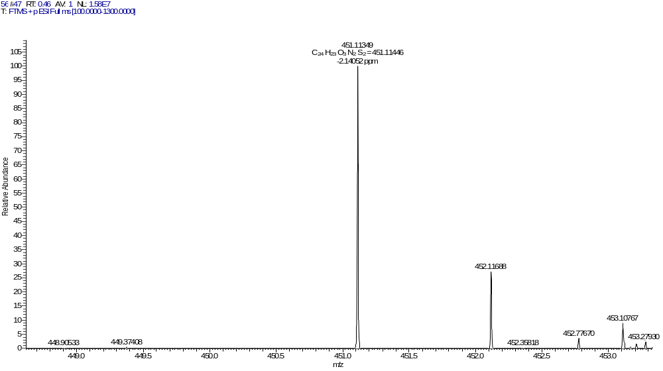
Fig. S28. HRMS of the compound Z7

Fig. S29. ¹H NMR of the compound Z8

Fig. S30. ¹³C NMR of the compound Z8
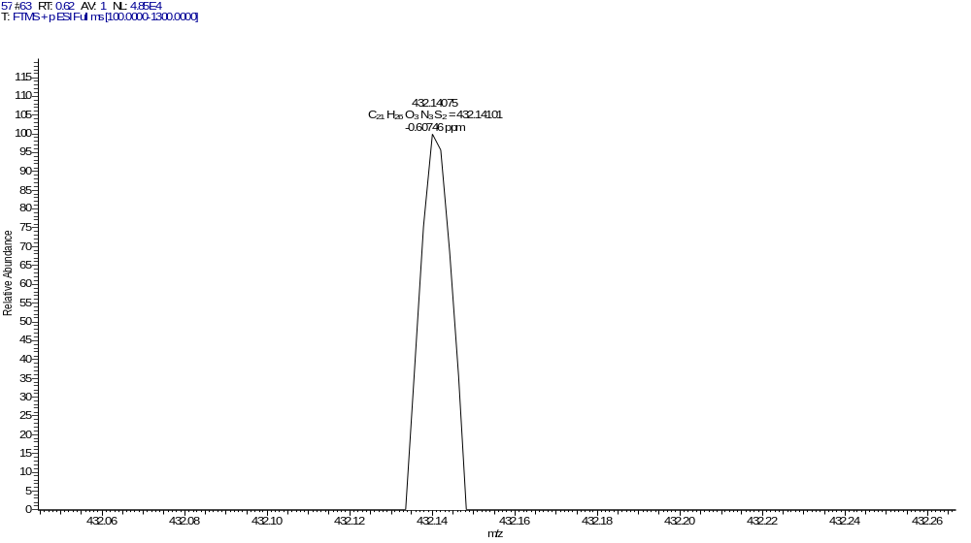
Fig. S31. HRMS of the compound Z8

Fig. S32. ¹H NMR of the compound Z9

Fig. S33. ¹³C NMR of the compound Z9
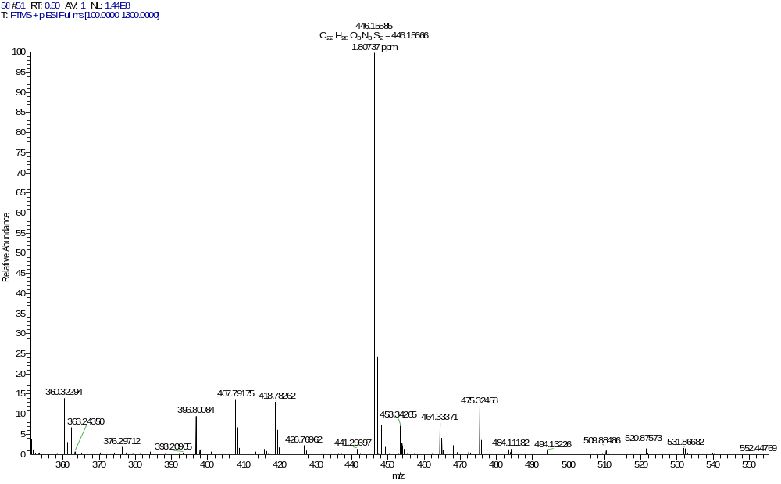
Fig. S34. HRMS of the compound Z9
Fig. S35. ¹H NMR of the compound Z10

Fig. S36. ¹³C NMR of the compound Z10
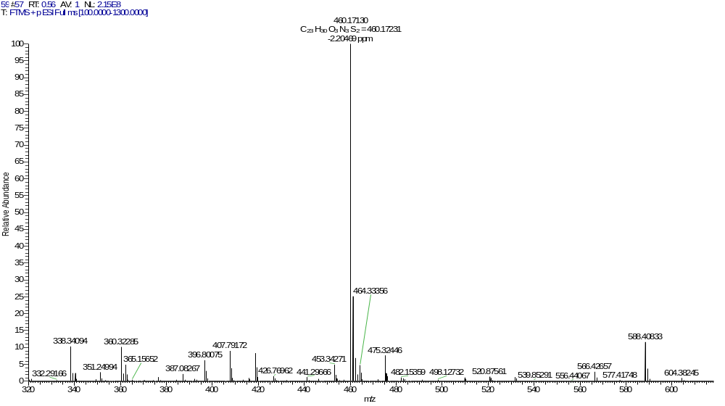
Fig. S37. HRMS of the compound Z10

Fig. S38. ¹H NMR of the compound Z11

Fig. S39. ¹³C NMR of the compound Z11

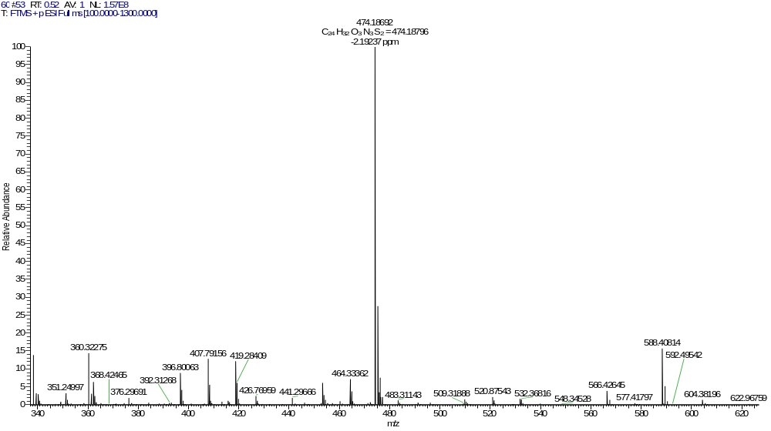
Fig. S40. HRMS of the compound Z11
Fig. S41. ¹H NMR of the compound Z12

Fig. S42. ¹³C NMR of the compound Z12

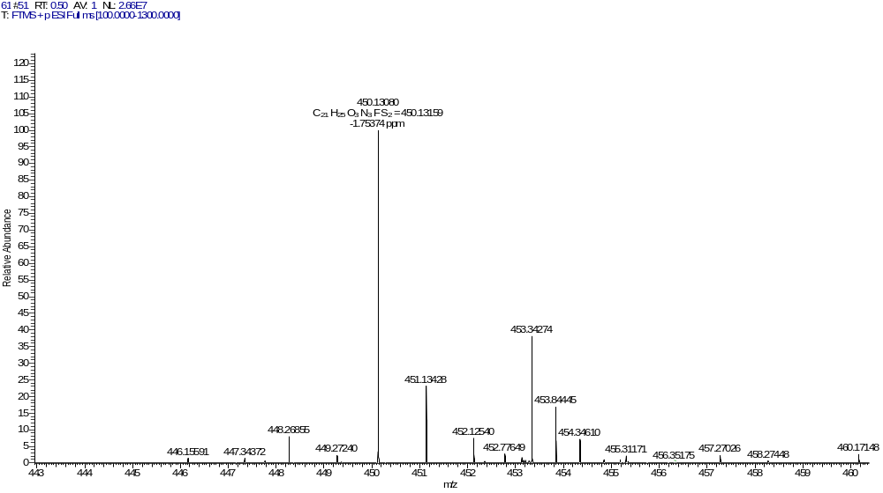
Fig. S43. HRMS of the compound Z12

Fig. S44. ¹H NMR of the compound Z13

Fig. S45. ¹³C NMR of the compound Z13

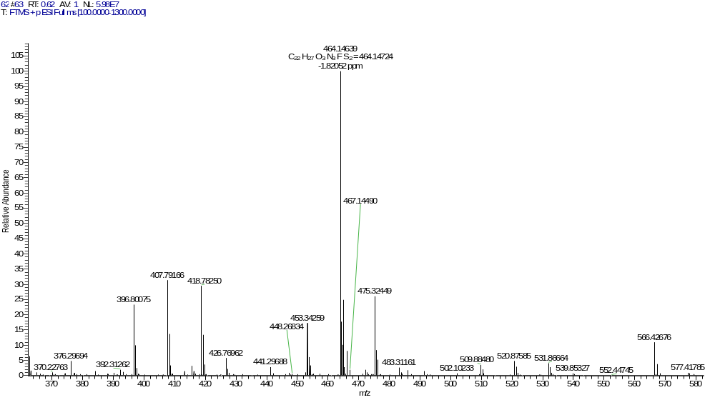
Fig. S46. HRMS of the compound Z13

Fig. S47. ¹H NMR of the compound Z14

Fig. S48. ¹³C NMR of the compound Z14

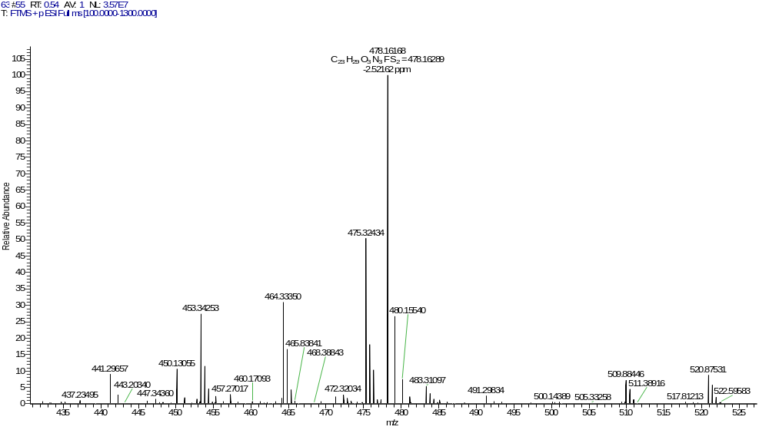
Fig. S49. HRMS of the compound Z14

Fig. S50. ¹H NMR of the compound Z15

Fig. S51. ¹³C NMR of the compound Z15

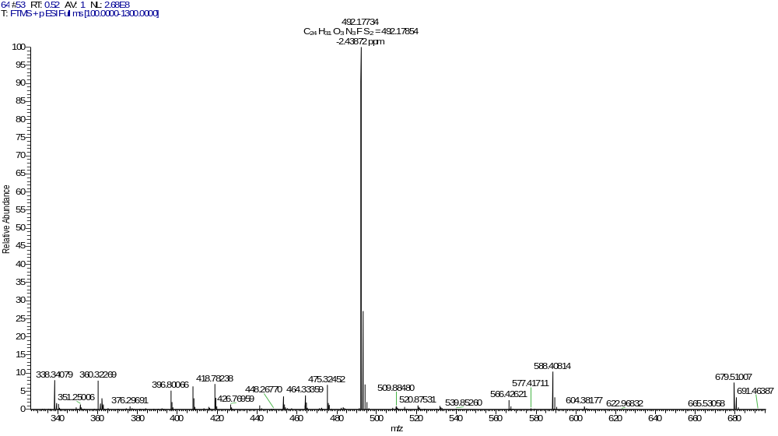
Fig. S52. HRMS of the compound Z15

Fig. S53. ¹H NMR of the compound Z16

Fig. S54. ¹³C NMR of the compound Z16
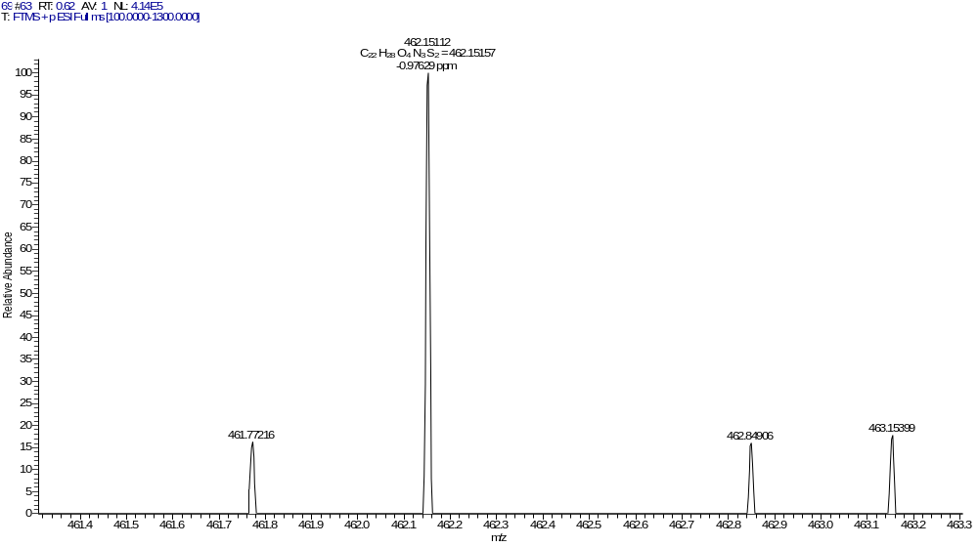
Fig. S55. HRMS of the compound Z16

Fig. S56. ¹H NMR of the compound Z17

Fig. S57. ¹³C NMR of the compound Z17

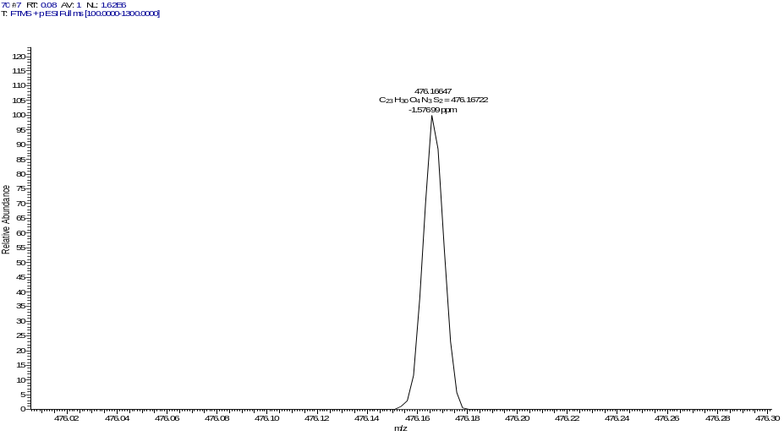
Fig. S58. HRMS of the compound Z17

Fig. S59. ¹H NMR of the compound Z18
Fig. S60. ¹³C NMR of the compound Z18
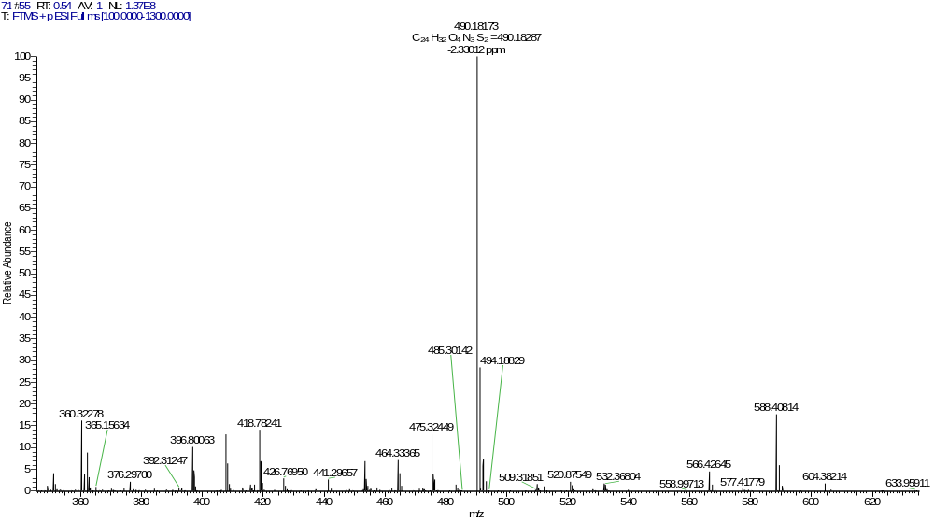
Fig. S61. HRMS of the compound Z18

Fig. S62. ¹H NMR of the compound Z19

Fig. S63. ¹³C NMR of the compound Z19

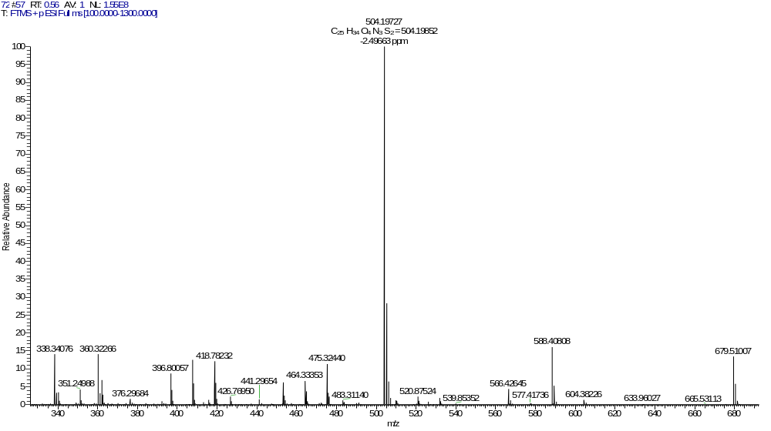
Fig. S64. HRMS of the compound Z19

Fig. S65. ¹H NMR of the compound Z20

Fig. S66. ¹³C NMR of the compound Z20
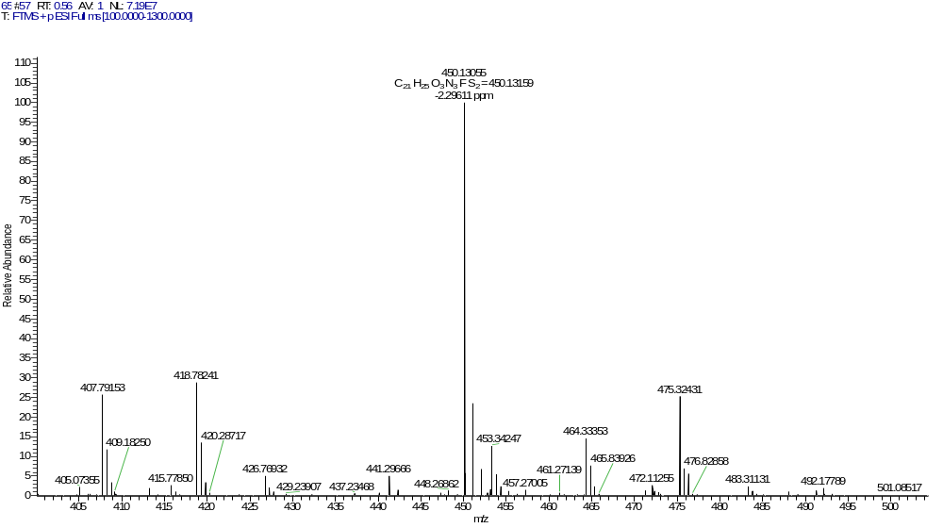
Fig. S67. HRMS of the compound Z20

Fig. S68. ¹H NMR of the compound Z21

Fig. S69. ¹³C NMR of the compound Z21

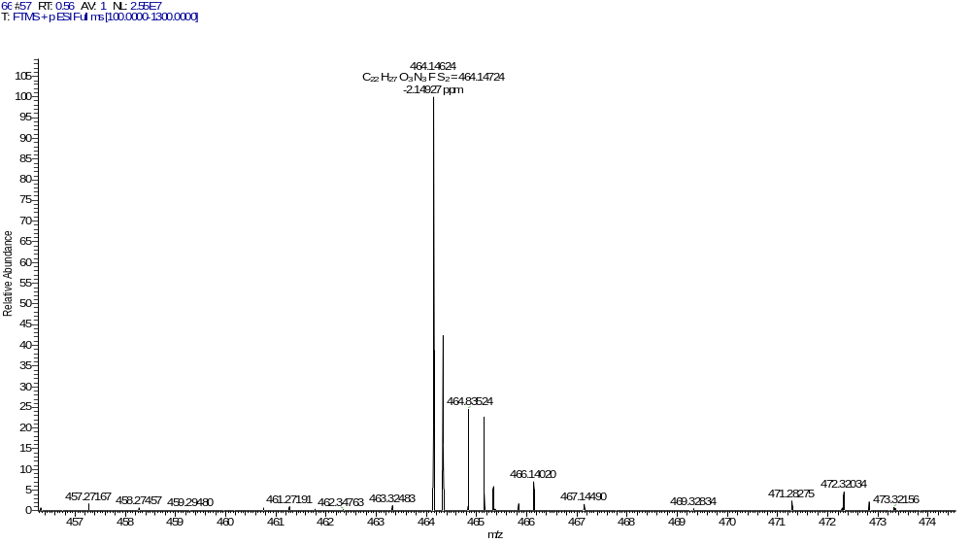
Fig. S70. HRMS of the compound Z21

Fig. S71. ¹H NMR of the compound Z22

Fig. S72. ¹³C NMR of the compound Z22

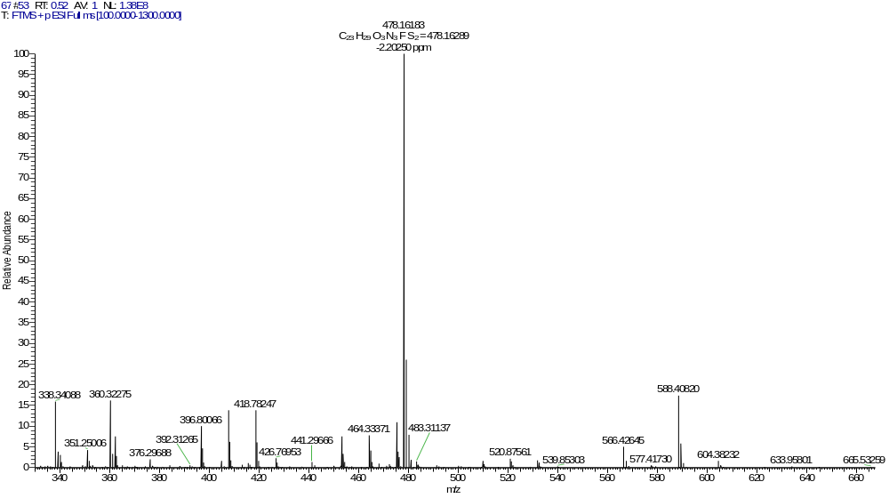
Fig. S73. HRMS of the compound Z22

Fig. S74. ¹H NMR of the compound Z23

Fig. S75. ¹³C NMR of the compound Z23

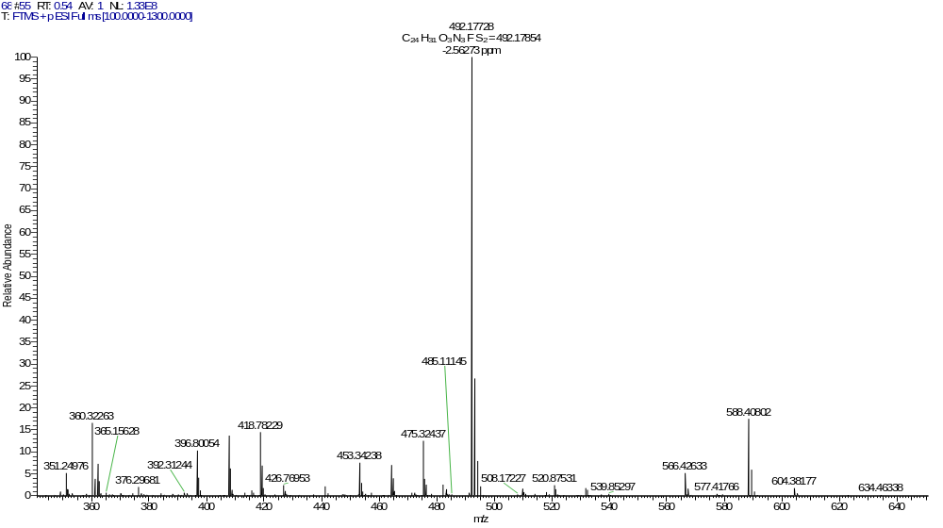
Fig. S76. HRMS of the compound Z23

Fig. S77. ¹H NMR of the compound Z24

Fig. S78. ¹³C NMR of the compound Z24

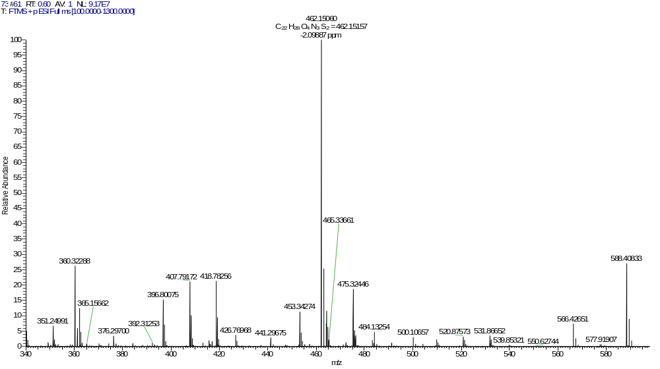
Fig. S79. HRMS of the compound Z24

Fig. S80. ¹H NMR of the compound Z25

Fig. S81. ¹³C NMR of the compound Z25

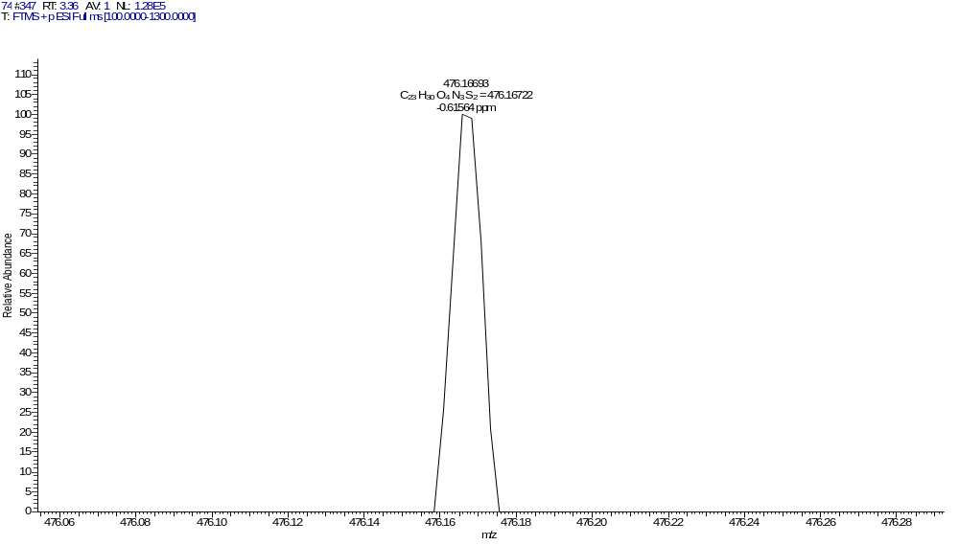
Fig. S82. HRMS of the compound Z25

References
- Khan, D. & Parveen, I. Chroman-4-one-based amino bidentate ligand: an efficient ligand for suzuki-miyaura and mizoroki-heck coupling reactions in aqueous medium. Eur. J. Org. Chem. 35, 4946-4957 (2021).
- Yu, Y. F. et al. Discovery and optimization of chromone derivatives as novel selective phosphodiesterase 10 inhibitors. ACS Chem. Neurosci. 11, 1058-1071 (2020).
- Jiang, D., Chen, J., Zan, N., Li, C., Hu, D. & Song, B. A. Discovery of novel chromone derivatives containing a sulfonamide moiety as anti-ToCV agents through the tomato chlorosis virus coat protein-oriented screening method. J. Agric. Food Chem. 69, 12126-12134 (2021).

