Supplementary Figure and Table
Supplementary Table S1. STR profiling. The genetic profile of established organoid lines (tumor/normal) shows that their short tandem repeat patterns are identical to parental tissues.

Supplementary Figure S1. Relative abundance of 6 strains between normal and tumorous stool samples (N=40, each Normal and Tumor); Blautia producta, Bifidobacterium adolescentis, Parabacteroides distasonis, Bacteroides ovatus, Bacteroides fragilis, and Bifidobacterium longum.
Supplementary Table S1.

NO | KCLB NO | Amelogenin | D3S1358 | D1S1656 | D2S441 | D13S317 | D16S539 | D18S51 | D2S1338 | CSF1PO | Penta D | TH01 | Vwa | D21S11 | D7S820 | TPOX | D8S1179 | D19S433
1 | SNU-7237T | X | 15 | 11,13 | 9,9.1 | 11,12 | 10,11,12 | 13,19 | 25,27 | 10,12 | 9,11 | 7,9 | 14 | 29,30 | 11.3,12 | 11 | 10 | 13,14,15.2
2 | SNU-7237N | X | 15 | 11,13 | 9.1 | 11,12 | 10,11,12 | 13,19 | 25,27 | 10,12 | 9,11 | 7,9 | 14 | 29,30 | 12 | 11 | 10 | 14,15.2
3 | SNU-7237-TO | X | 15 | 11,13 | 9,9.1 | 11,12 | 10,11,12 | 12,13,19 | 25,27 | 10,13 | 9,11 | 7,9 | 14 | 29,30 | 11.3,12 | 11 | 10 | 13,15.2
4 | SNU-7237N-NO | X | 15 | 11,13 | 9,9.1 | 11,12 | 10,11,12 | 12,13,19 | 25,27 | 10,13 | 9,11 | 7,9 | 14 | 29,30 | 11.3,12 | 11 | 10 | 13,15.2
6 | SNU-7293N | X,Y | 16 | 13,15 | 10,13 | 8,10 | 9,11,12 | 17 | 20,23 | 11,13 | 9,12 | 6 | 18,19 | 30,31 | 10,12 | 11 | 10,14 | 13,14
7 | SNU-7293-TO | X,Y | 16 | 13,15 | 10,13 | 8,10 | 9,11 | 17 | 20,23 | 11,13 | 912 | 6 | 18,19 | 30,31 | 10,12 | 11 | 10,13 | 13,14
8 | SNU-7293N-NO | X,Y | 16 | 13,15 | 10,13 | 8,10 | 9,11 | 17 | 20,23 | 11,13 | 9,12 | 6 | 18,19 | 30,31 | 10,12 | 11 | 10,13 | 13,14
11 | SNU-7390N | X,Y | 16,17 | 13,17.3 | 12,14 | 11,12 | 10,13 | 12,13 | 20,23 | 9,10 | 9,11 | 9 | 17 | 30,31.2 | 8,12 | 8,11 | 13,14 | 13,14.2
12 | SNU-7390S3-TO | X,Y | 16,17 | 13,17.3 | 12,14 | 11,12 | 10,13 | 12,13 | 20,23 | 9,10 | 9,11 | 9 | 17 | 30,31.2 | 8,12 | 8,11 | 13,14 | 13,14.2
13 | SNU-7390N-NO | X,Y | 16,17 | 13,17.3 | 12,14 | 11,12 | 10,13 | 12,13 | 20,23 | 9,10 | 9,11 | 9 | 17 | 30,31.2 | 8,12 | 8,11 | 13,14 | 13,14.2

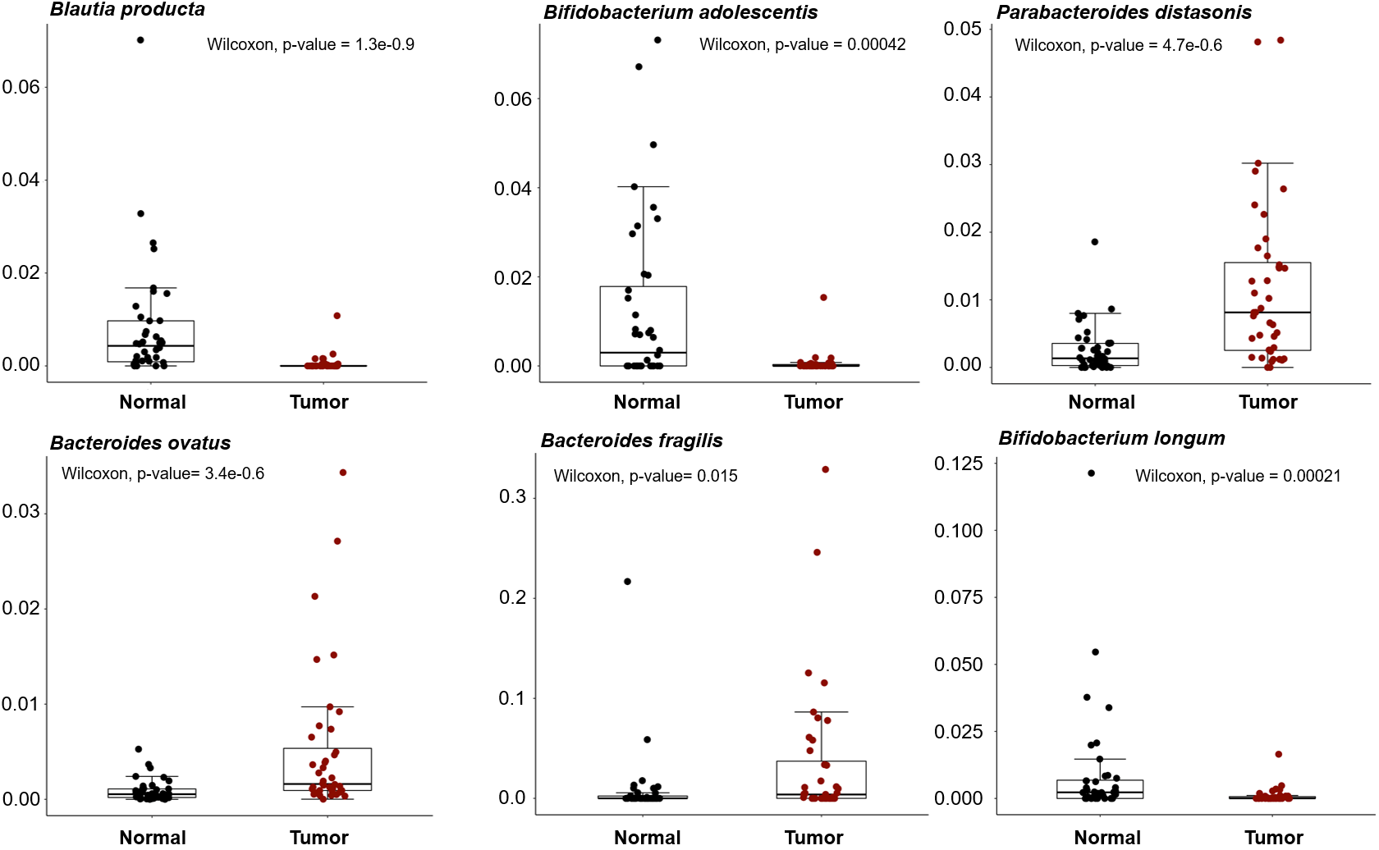
Supplementary Figure S1.

