Supporting Information
Anchoring mechanism of low-coordination terminal hydroxyls in Pt atomic clusters
Xing Yuanª, Wenzhe Siª, Xiao Zhuª, Bin Zhouª, Junhua Liª, Yue Peng^{*a}
ª State Key Joint Laboratory of Environment Simulation and Pollution Control, School of Environment, Tsinghua University, Beijing 100084, China

Contents
45 Pages, 6 Tables, 32 Figures
Figure S1. Optimized periodic models: (a) TiO₂ (001) surface and (b) dehydrated Al₂O₃ (100) surface. Page S7
Figure S2. Model structures of (a) hydroxylation TiO₂ (101) and (b) hydroxylation Al₂O₃ (100) slabs. Page S8
Figure S3. The optimized structures of adsorption of Pt species on hydroxylation TiO₂ (101) and hydroxylation Al₂O₃ (100) slabs: (a) Pt single atoms, (b) Pt₃ ACs, (c) Pt₄ ACs, (d) Pt₅ ACs. Page S9
Figure S4. NH₃ adsorbed energy of the (a) Pt/TiO₂ and (b) Pt/Al₂O₃ slabs. Page S10
Figure S5. Model structures of (a) Pt/TiO₂ and (b) Pt/Al₂O₃ slabs. Page S11
Figure S6. XRD patterns of Pt/TiO₂ and Pt/Al₂O₃. Page S12
Figure S7. STEM-EDS elemental mapping of Pt/TiO₂. Page S13
Figure S8. (a) Nitrogen adsorption-desorption isotherms and (b) pore distributions of Pt/TiO₂ and Pt/Al₂O₃ catalysts. Page S14
Figure S9. EXAFS curves between the experimental and fit results of (a) Pt/TiO₂ and (b) Pt/Al₂O₃. Page S15
Figure S10. Normalized ²⁷Al MAS NMR spectra of Al₂O₃ and 1 wt% Pt/Al₂O₃. Page S16
Figure S11. Projected density of states (PDOS) of the (a) Pt/TiO₂ and (b) Pt/Al₂O₃ slabs. Page S17
Figure S12. XPS spectra and results of Pt/TiO₂ and Pt/Al₂O₃. Page S18
Figure S13. H₂-TPR of Pt/TiO₂ and Pt/Al₂O₃. Page S19
Figure S14. EPR of Pt/TiO₂ and Pt/Al₂O₃. Page S20
Figure S15. NH₃ oxidation performance of the Pt/TiO₂ and Pt/Al₂O₃ catalysts with moisture: (a) N₂O selectivity, (b) NO selectivity, and (c) NO₂ selectivity, and (d) N₂O selectivity without moisture. Reaction conditions: O₂ = 2 %, NH₃ = 500 ppm, H₂O = 4 % (if used), N₂ as the balance gas, GHSV = 60,000 mL·g⁻¹·h⁻¹. Page S21
Figure S16. Catalytic performance of Pt/TiO₂ and Pt/Al₂O₃ catalysts in the purification of NH₃: TOF of NH₃ oxidation. Reaction conditions: O₂ =2 %, NH₃ = 500 ppm, N₂ as the balance gas, GHSV = 60,000 mL g⁻¹ h⁻¹. Page S22
Figure S17. Py-IR of Pt/TiO₂ and Pt/Al₂O₃. Page S23
Figure S18. In situ DRIFTS of NH₃ adsorption at 50 °C on Pt/TiO₂ and Pt/Al₂O₃.. Page S24
Figure S19. (a) adsorbed energy of NH₃ and ICOHP on Pt₃O₅ ACs/TiO₂ (101) and Pt₃O₈ ACs/Al₂O₃ (100) slabs, Crystal orbital Hamilton population (COHP) on (b) Pt/TiO₂ and (c) Pt/Al₂O₃ slab. Page S25
Figure S20. Projected density of states (PDOS) of NH₃ on (a) Pt/TiO₂ and (b) Pt/Al₂O₃ slabs. Page S26
Figure S21. Charge density difference and the corresponding planar-average charge density analyses of Pt ACs loading and NH₃ adsorption on (a-b) Pt/TiO₂ and (c-d) Pt/Al₂O₃ slabs. Page S27
Figure S22. Bader charge of (a) single-atom Pt/TiO₂, (b) single-atom Pt/Al₂O₃, (c) Pt₃ ACs/TiO₂, (d) Pt₃ ACs/Al₂O₃ slab. Page S28
Figure S23. NH₃ dehydrogenation via hydrogen spillover on Pt/TiO₂ (101) slab. Page S29
Figure S24. NH₃ dehydrogenation via hydrogen spillover on Pt/Al₂O₃ (100) slab. Page S30
Figure S25. (a) NH₃ and (b) NH₂ dehydrogenation via hydrogen spillover on single-atom Pt/TiO₂ (101) and single-atom Pt/Al₂O₃ (100) slabs, (c) the optimized structures of intermediates, transition states, and final states of NH species formation on single-atom Pt/TiO₂ and single-atom Pt/Al₂O₃ slab. Page S31
Figure S26. The optimized structures of intermediates, transition states, and final states of NH₂ and NH species formation on Pt ACs/TiO₂ and Pt ACs/Al₂O₃ slabs. Page S32
Figure S27. In-situ NAP-XPS of N 1s on the (a) Pt/TiO₂ and (b) Pt/Al₂O₃, Pt 4f on the (c) Pt/TiO₂ and Pt 4d (d) Pt/Al₂O₃, O 1s on the (e) Pt/TiO₂ and (f) Pt/Al₂O₃, is pretreated with 500 ppm NH₃ at 30 °C, exposed to 1 mbar of O₂ at 30 °C, at 150 °C, at 250 °C. Page S33
Figure S28. The optimized structures of intermediates, transition states, and final states of N₂ formation on Pt/TiO₂ slab. Page S34
Figure S29. The optimized structures of intermediates, transition states, and final states of N₂ formation on Pt/Al₂O₃ slab. Page S35
Figure S30. The optimized structures of intermediates, transition states, and final states of N₂O formation on Pt/TiO₂ slab. Page S36
Figure S31. The optimized structures of intermediates, transition states, and final states of N₂O formation on Pt/Al₂O₃ slab. Page S37
Figure S32. NH₃ oxidation mechanisms to (a) NH₃ dehydrogenation, formation of (b)H₂O and NHO*, (c) N₂O on the Pt₃O₅/TiO₂ (101) and Pt₃O₈/Al₂O₃ (100) slabs. Page S38
Figure S33. Plausible oxidation mechanism of the single-layer Pt ACs catalyst under the NH₃ oxidation.
Page S39
Table S1. EXAFS fitting parameters at the Pt L-edge various samples (S₀²=0.92) Page S40
Table S2. Element analyses of fresh and used catalysts. Page S41
Table S3. Formation energy of oxygen vacancy. Page S42
Table S4. Acidity from NH₃-TPD Page S43
Table S5. Comparison of NH₃-SCO performance of Pt-based catalysts reported by other literatures.
Page S44
Table S6. Acidity from Py-IR. Page S45

Reference. Page S46

Experimental and Computational methods
1. Materials
Titanium dioxide (TiO₂, anatase, Macklin, AR), Aluminium oxide (γ-Al₂O₃, anatase, Macklin, AR), Hydrogen hexachloroplatinate (IV) (H₂PtCl₆·xH₂O, Macklin, AR) were purchased from Shanghai Macklin Biochemical Co., Ltd and analytical grade.
2. Catalyst synthesis
The Pt modified Ti or Al-based catalysts with various loading were produced by the impregnation method. Firstly, a certain amount of H₂PtCl₆·xH₂O were totally dissolved into deionized water. Afterwards, 5 g of the commercial TiO₂ or Al₂O₃ catalysts (40-60 mesh) were added into the clear mixed solution, and then the solution in 80 ℃ water bath was evaporated dry after magnetic stirring. The solid residue was further dehydrated for overnight in an oven at 100 ℃. Ultimately, the ground powder was calcined at 500 ℃ for 5 h in a muffle furnace to obtain the target catalyst sample. These different loading samples were marked as TiO₂, Pt/TiO₂, Al₂O₃, Pt/Al₂O₃, which include 0 wt.%, 1 wt.%, 0 wt.%, 1 wt.% Pt, respectively. The contents of 1 wt.% Pt elements in TiO₂ and Al₂O₃ catalysts were almost consistent with the theoretical value by ICP-AES.
3. Characterization
A Bruker D8/Advance diffractometer was used for X-ray diffraction (XRD) patterns via a monochromatic Cu Kα source (λ = 0.15418 nm). The record angle 2θ was from 10 to 90° with the scan of 5 °/min.
A Thermo Scientific Escalab 250XI photoelectron spectrometer was used to record X-ray photoelectron spectroscopy (XPS) under an ultra-vacuum atmosphere through the Al Kα (1486.6 eV) excitation source. The calibrated binding energy was C1s peak at 284.6 eV.
A FEI Tecnai G2 F30 microscope was used to observe High resolution transmission electron microscope (HRTEM).
The radiation was carried out by a Si (111) doublecrystal monochromator. XANES and EXAFS results were analyzed by Athena software.
a Bruker A300 detector was proposed to gain electron paramagnetic resonance (EPR) for the oxygen vacancies of fresh catalyst, with frequency modulation of 100 kHz and amplitude modulation of 10 G under room temperature.
Micromeritics AutoChem II 2920 chemical adsorption analyzer was utilized to conduct Hydrogen temperature programmed reduction (H₂-TPR), with the thermal conductivity detector (TCD). Initially, 100 mg fresh sample was preprocessed at 300 ℃ under 50 mL/min Ar gas flow for 1h. Then, after the sample cooled down to room temperature, it was switched to 50 mL/min 5% H₂/Ar gas flow. Ultimately, after the TCD baseline held steady, the H₂ TCD signal was recorded with a 10 ℃/min heating rate from 50 ℃ to 1000 ℃.
Micromeritics AutoChem II 2920 chemical adsorption analyzer was also utilized to conduct oxygen temperature programmed desorption (O₂-TPD), with the thermal conductivity detector (TCD). Initially, 100 mg fresh sample was preprocessed at 300 ℃ under 50 mL/min pure Ar gas flow for 1h. Then, after the sample cooled down to room temperature, it was switched to 50 mL/min 5% O₂/Ar gas flow. Ultimately, after the TCD baseline held steady, the O₂ TCD signal was recorded with a heating rate of 10 ℃/min from 50 ℃ to 1000 ℃.
A Gasmet DX-4000 FTIR analyzer was utilized to conduct ammonia temperature programmed desorption (NH₃-TPD) for the acid center on the catalyst surface. Initially, 100 mg fresh sample was pretreated at 400 ℃ by 100 mL/min N₂ flow for 1h. Then, after the sample cooled down to room temperature, it was switched to 100 mL/min 500 ppm NH₃/N₂ gas flow, and ammonia was fully adsorbed by the sample under 30 ℃ for 1 h. Ultimately, it was switched to 100 mL/min N₂ flow for cleaning weakly adsorbed NH₃, and then the desorbed NH₃ concentration was recorded from 30 ℃ to 900 ℃ under the heating rate of 10 ℃/min.
A Fourier transform infrared spectrometer (Nicolet Magna-IR 560) was used to conduct Pyridine adsorption infrared spectroscopy (Py-IR) with a resolution of 4 cm⁻¹ under vacuum conditions.
A Thermo Fisher Nicolet 6700 FTIR spectrometer was used to perform in-situ diffuse reflectance infrared Fourier transform spectroscopy (In-situ DRIFTS) with an MCT detector. Initially, fresh catalyst powder in a sample cell with a CaF₂ window, was preprocessed in a 50 mL/min He gas flow under 400 ℃ for 1 h. Then, the sample was cooled to the setting temperature to collect background spectra. Afterwards, it was switched to 50 mL/min 500 ppm NH₃/He. Ultimately, the infrared spectra were recorded with a resolution of 4 cm⁻¹ by 32 scans.
4. Activity and byproduct analysis
A fixed-bed reactor was used to evaluate the NH₃ purifying capacity. The reaction temperature of 100 mg fresh catalyst (40-60 mesh) in the quartz tube reactor was measured by a thermocouple. The 100 mL/min mixed flue gas included 500 ppm NH₃, 2% O₂ and balanced by N₂ with 60,000 mL·g⁻¹·h⁻¹ mass space velocity. A GASMET DX-4000 infrared gas analyzer was used to determine inlet and outlet component concentrations of NO, NH₃, NO₂, N₂O, and O₂.
The NH₃ conversion, NO_{x} selectivity, and N₂ selectivity were determined by the following equation:
$${NH}_{3} conversion (\%)=\frac{C_{{NH}_{3},inlet}-C_{{NH}_{3},outlet}}{C_{{NH}_{3},inlet}}×100\%$$ | (1)
$${NO}_{x} selectivity (\%)=\frac{C_{{NO}_{x},outlet}}{C_{{NH}_{3},inlet}-C_{{NH}_{3},outlet}}×100\%$$ | (2)
$$N_{2}O selectivity (\%)=\frac{{{2C}_{N_{2}O}}_{,outlet}}{C_{{NH}_{3},inlet}-C_{{NH}_{3},outlet}}×100\%$$ | (3)
$$N_{2} selectivity \left(\%\right)=(1-\frac{{{2C}_{N_{2}O}}_{,outlet}+C_{{NO}_{x},outlet}+C_{{NH}_{3},outlet}}{C_{{NH}_{3},inlet}})×100\%$$ | (4)
where $C_{{NO}_{x},inlet}$ and $C_{{NH}_{3},inlet}$ represent the inlet concentrations of NO_{x} and NH₃, respectively. Besides, $C_{{NO}_{x},outlet}$ and $C_{{NH}_{3},outlet }$represent the outlet concentrations of NO_{x} and NH₃, respectively.
Turnover frequency (TOF) based on V species was determined by the following equation:
$$TOF=\frac{Flow rate×{NH}_{3} inlet concentration×conversion}{22.4×60×V content}×100\%$$ | (5)
where the V content was determined as the following equation:
$$V content=\frac{m_{catalyst}×V wt.\%}{M_{V}}$$ | (6)
where Pt wt.% were determined by ICP-OES, m_{catalyst} represented the weight of the catalyst, and M_{V} represented the molecular mass of Pt.
5. DFT calculation
Vienna Ab-initio Simulation Package (VASP 5.4.4) was utilized to accomplish all the first-principles calculations in this paper. The interaction between ions and electrons was described by the projection augmented wave (PAW) approach. There was a 400 eV cutoff energy and the functional of generalized gradient approximation with Perdew Burke Ernzerh (GGA-PBE). Hubbard U was used to modify the strong on-site Coulombic interaction between the f and d orbits of the transition elements, where the U_{eff} (U-J) of Pt, and Ti were 9 and 4.5 eV, respectively.¹ The climbing image-nudged elastic band (CI-NEB) approach was used to search Transition states (TS) in the elementary reaction process. The most common dimer Pt species and the most stable TiO₂ (101) surface were chosen to establish the slab model of the Pt supported Ti-based catalyst. The 3 × 3 periodical supercell slab model possesses twelve atomic layers with 64 Ti atoms and 128 O atoms, where the lower six layers kept the fixed coordinates in Figure S1. A 20 Å vacuum layer was set in the Z direction of the surface model. Besides, the most common dimer Pt species and the most stable dehydrated Al₂O₃ (100) surface were chosen to establish the slab model of the Pt supported Al-based catalyst. The 2 × 2 periodical supercell slab model possesses twelve atomic layers with 60 Al atoms and 96 O atoms, where the lower six layers kept the fixed coordinates. A 20 Å vacuum layer was set in the Z direction of the surface model.
Pt/Al₂O₃ and Pt/TiO₂ with different coordination to surface hydroxyls has been demonstrated in Figure S2. Various Pt species have been constructed on TiO₂ and Al₂O₃ slab, including single-atoms Pt, Pt₃O₅/TiO₂, Pt₃O₈/Al₂O₃, Pt₄O₉/TiO₂, Pt₄O₁₁/Al₂O₃, Pt₅O₁₀/TiO₂, Pt₅O₁₃/Al₂O₃. The results of ammonia adsorption energy show that the adsorption energy of different platinum ACs (Pt₃-Pt₅) is less than 10%^{1, 2}. In order to facilitate simulation, we choose the Pt₃O₅/TiO₂ and Pt₃O₈/Al₂O₃ model for further electronic and structural calculations.
The adsorption energy (E_{ads}) was determined by the following equation:
$$E_{ads}=E_{surface+molecule}-E_{surface}-E_{molecule}$$ | (7)
where E_{surface}, E_{molecule}, and E_{surface+molecule} were the isolated catalyst surface, isolated gas molecule, and total energy of surface with the adsorbed gas molecule, respectively.
The formation energy of oxygen vacancy (E_{Ov}) on the catalyst slab was determined by the following equations:
$$E_{Ov}=E_{surface-Ov}-E_{surface}+{1/2E}_{O_{2}}$$ | (8)
Where $E_{O_{2}}$ was the total energy of the oxygen molecule, and E_{surface-Ov} was the total energy of the defective surface with an oxygen vacancy.
The reaction energy (ΔE) and energy barrier (E_{b}) of the elementary reaction process were determined via the following equations:
$$ΔE=E_{FS}-E_{IS}$$ | (9)
$$E_{b}=E_{TS}-E_{IS}$$ | (10)
where E_{IS}, E_{FS}, and E_{TS} are the total energy of the initial state, final state, and transition state, respectively.

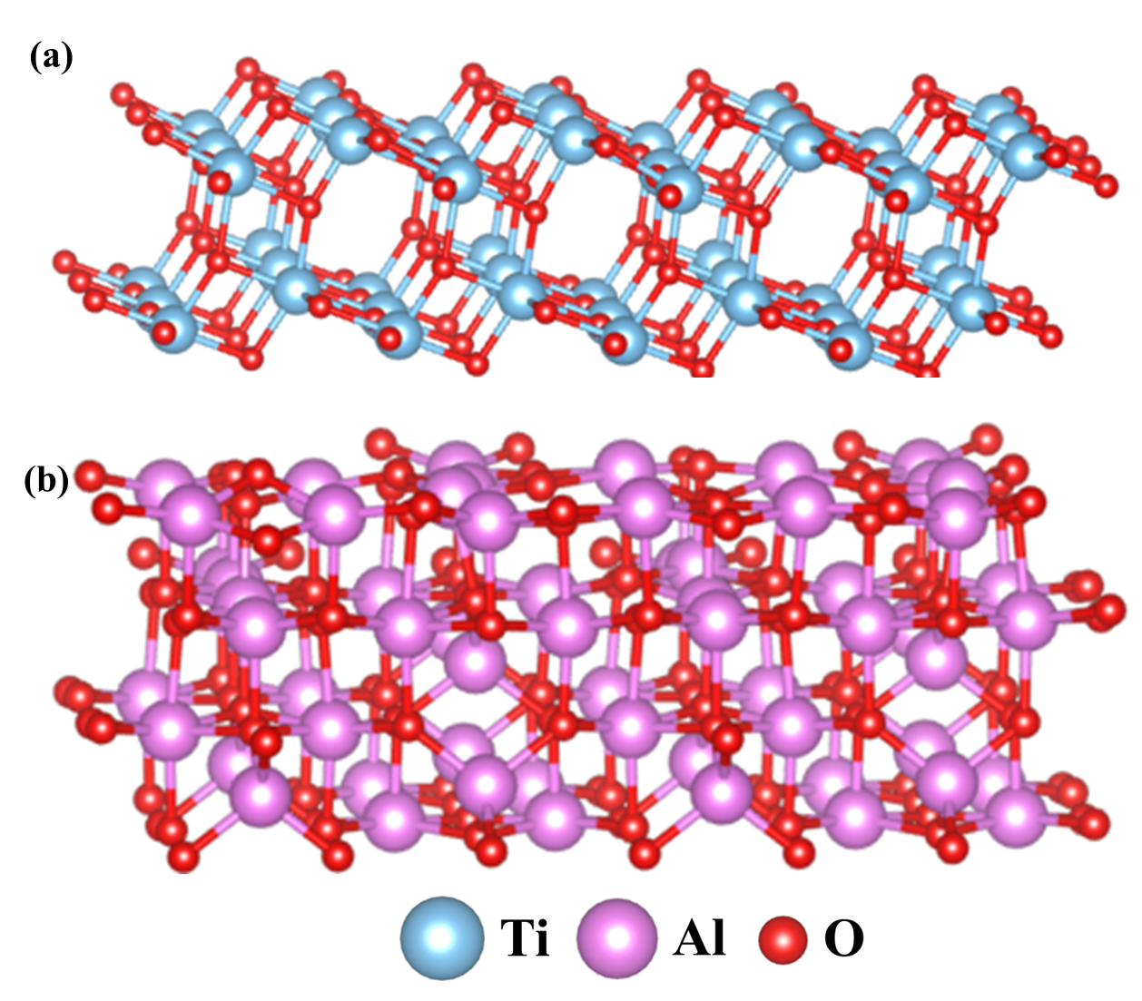
Figure S1. Optimized periodic models: (a) TiO₂ (001) surface and (b) dehydrated Al₂O₃ (100) surface.

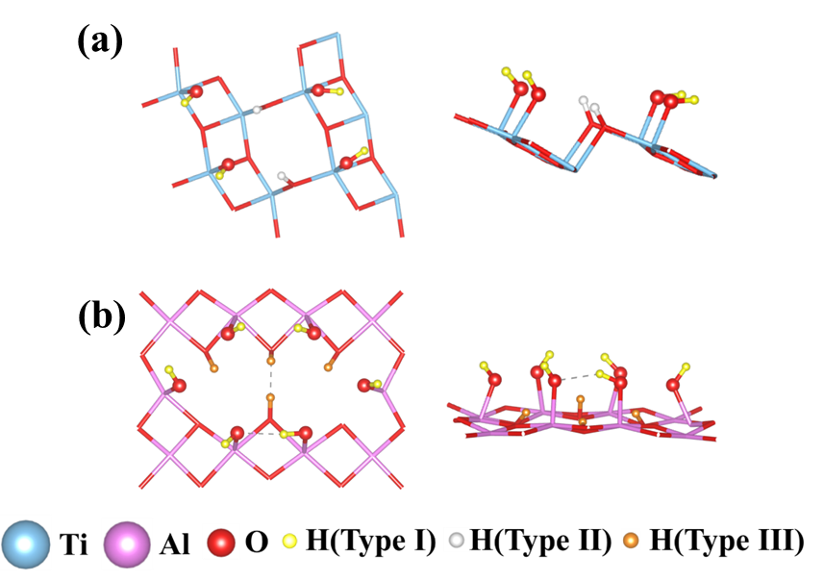
Figure S2. Model structures of (a) hydroxylation TiO₂ (101) slab and (b) hydroxylation Al₂O₃ (100) slab.

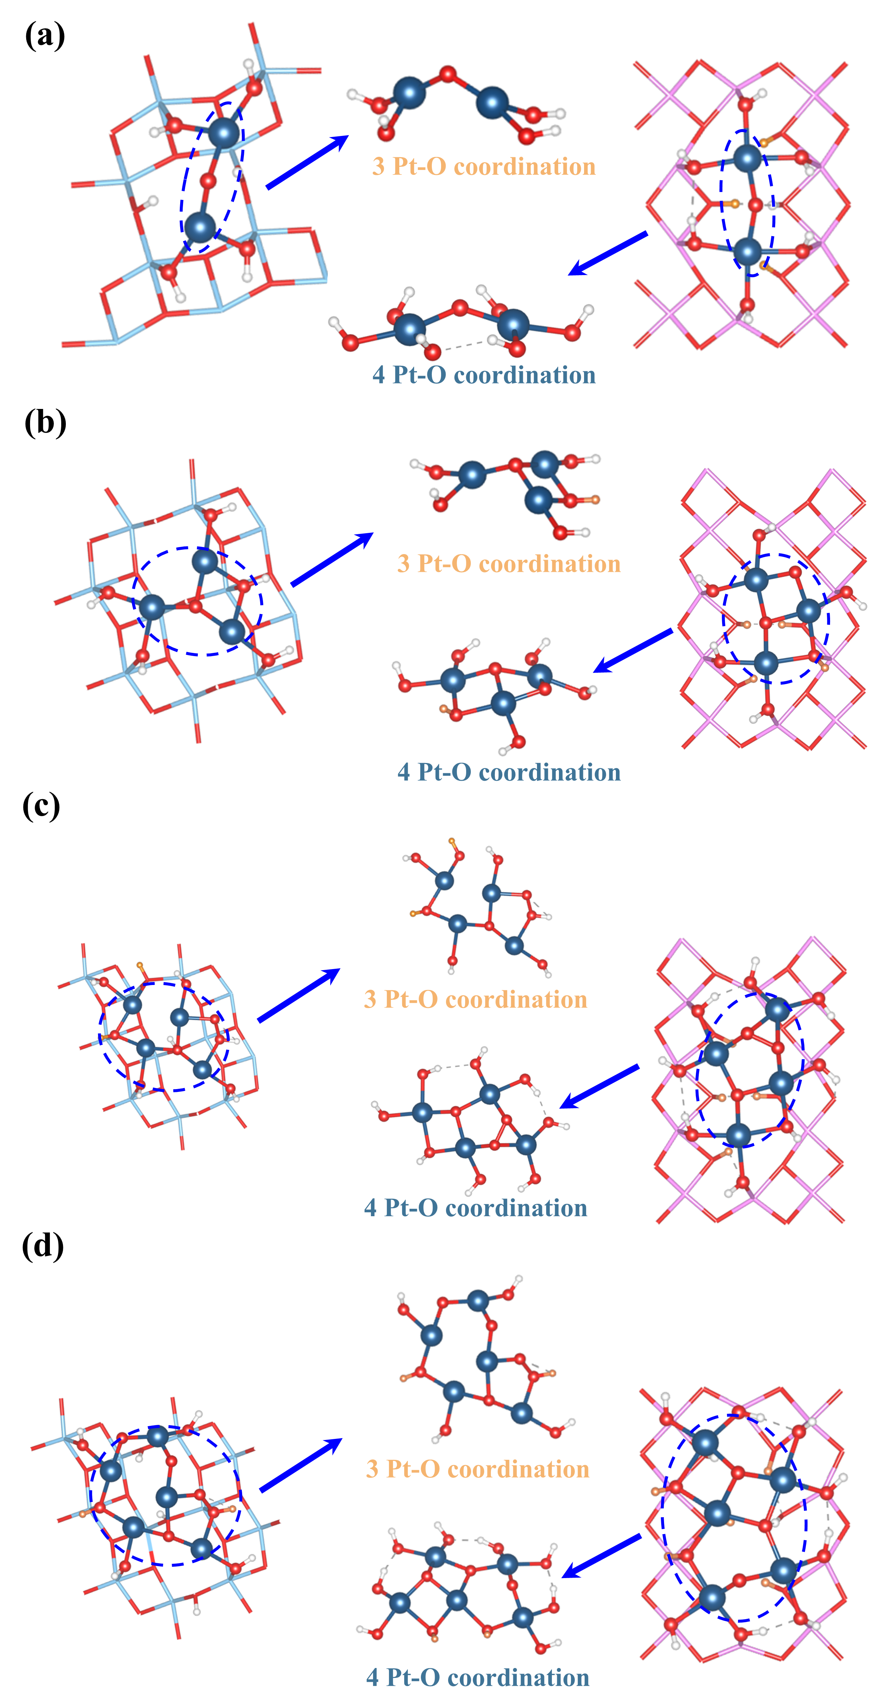
Figure S3. The optimized structures of adsorption of Pt species on hydroxylation TiO₂ (101) and hydroxylation Al₂O₃ (100) slabs: (a) Pt single atoms, (b) Pt₃ ACs, (c) Pt₄ ACs, (d) Pt₅ ACs.
Figure S4. NH₃ adsorbed energy of the (a) Pt/TiO₂ and (b) Pt/Al₂O₃ slab.

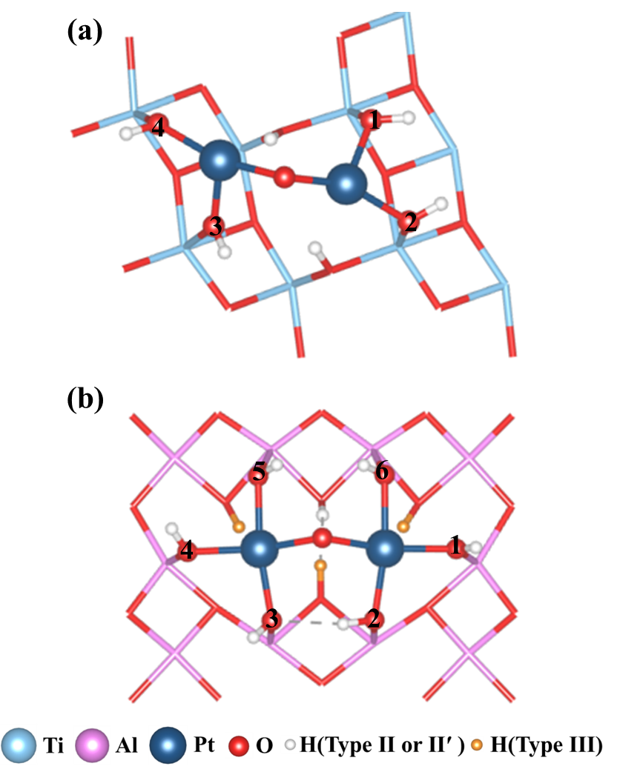
Figure S5. Model structures of (a) Pt/TiO₂ and (b) Pt/Al₂O₃ slabs.

Figure S6. XRD patterns of Pt/TiO₂ and Pt/Al₂O₃ catalysts.

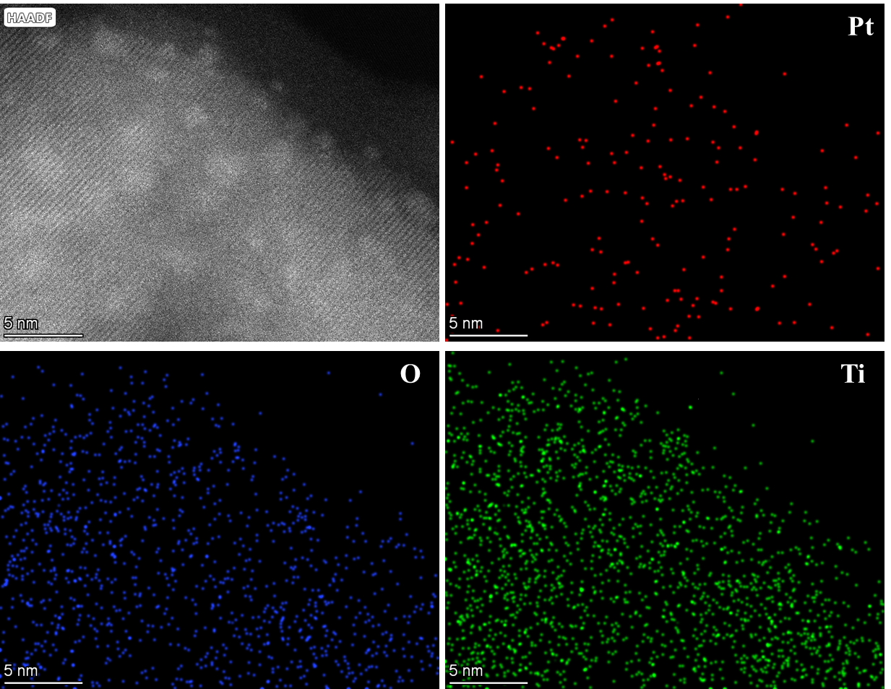
Figure S7. STEM-EDS elemental mapping of Pt/TiO₂.

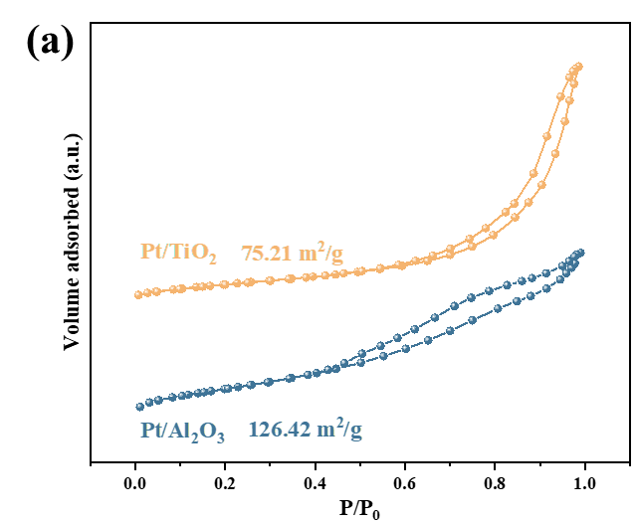
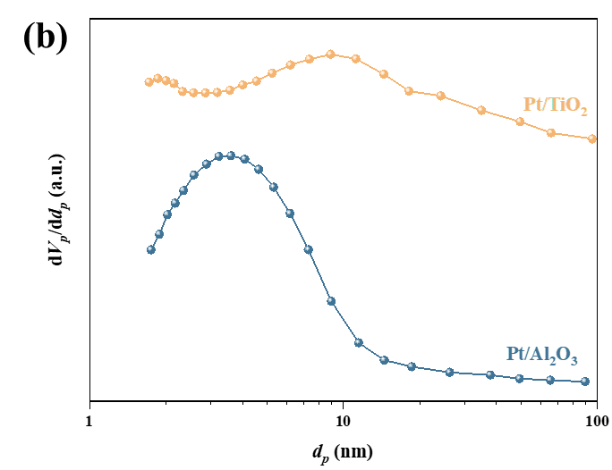
Figure S8. (a) Nitrogen adsorption-desorption isotherms and (b) pore distributions of Pt/TiO₂ and Pt/Al₂O₃ catalysts.

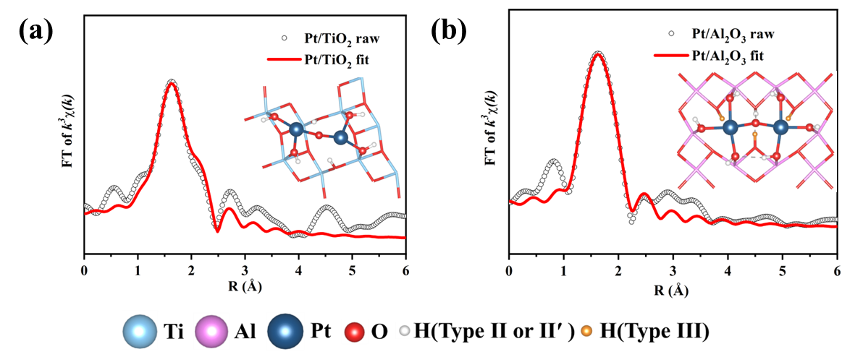
Figure S9. EXAFS curves between the experimental and fit results of (a) Pt/TiO₂ and (b) Pt/Al₂O₃.

Figure S10. Normalized ²⁷Al MAS NMR spectra of Al₂O₃ and 1 wt% Pt/Al₂O₃.

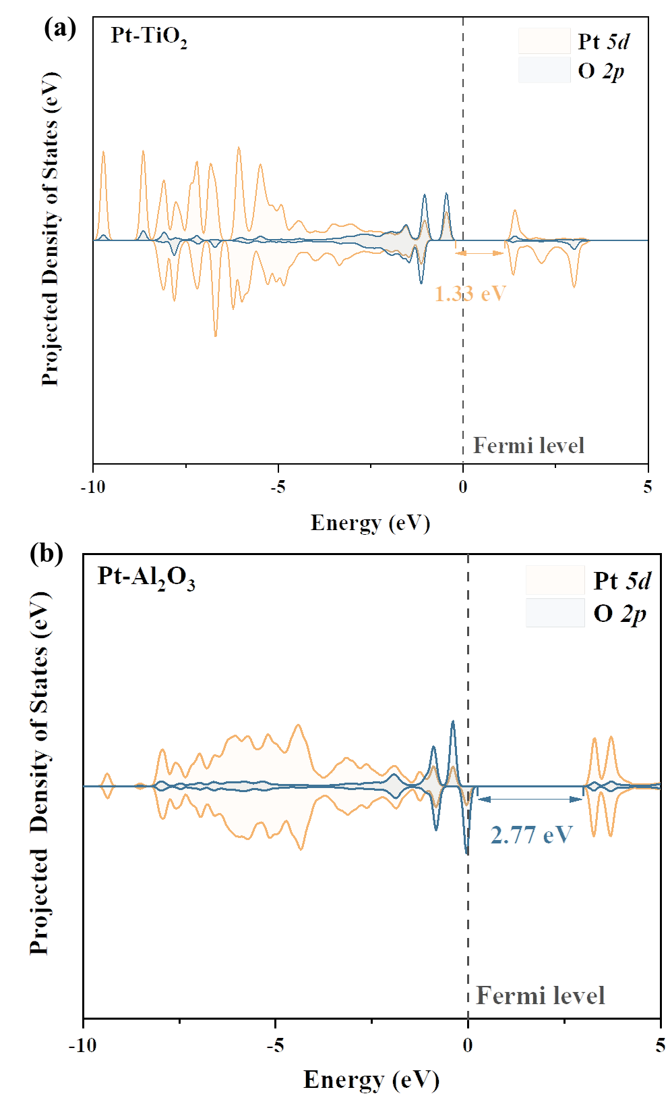
Figure S11. Projected density of states (PDOS) of the (a) Pt/TiO₂ and (b) Pt/Al₂O₃ slab.

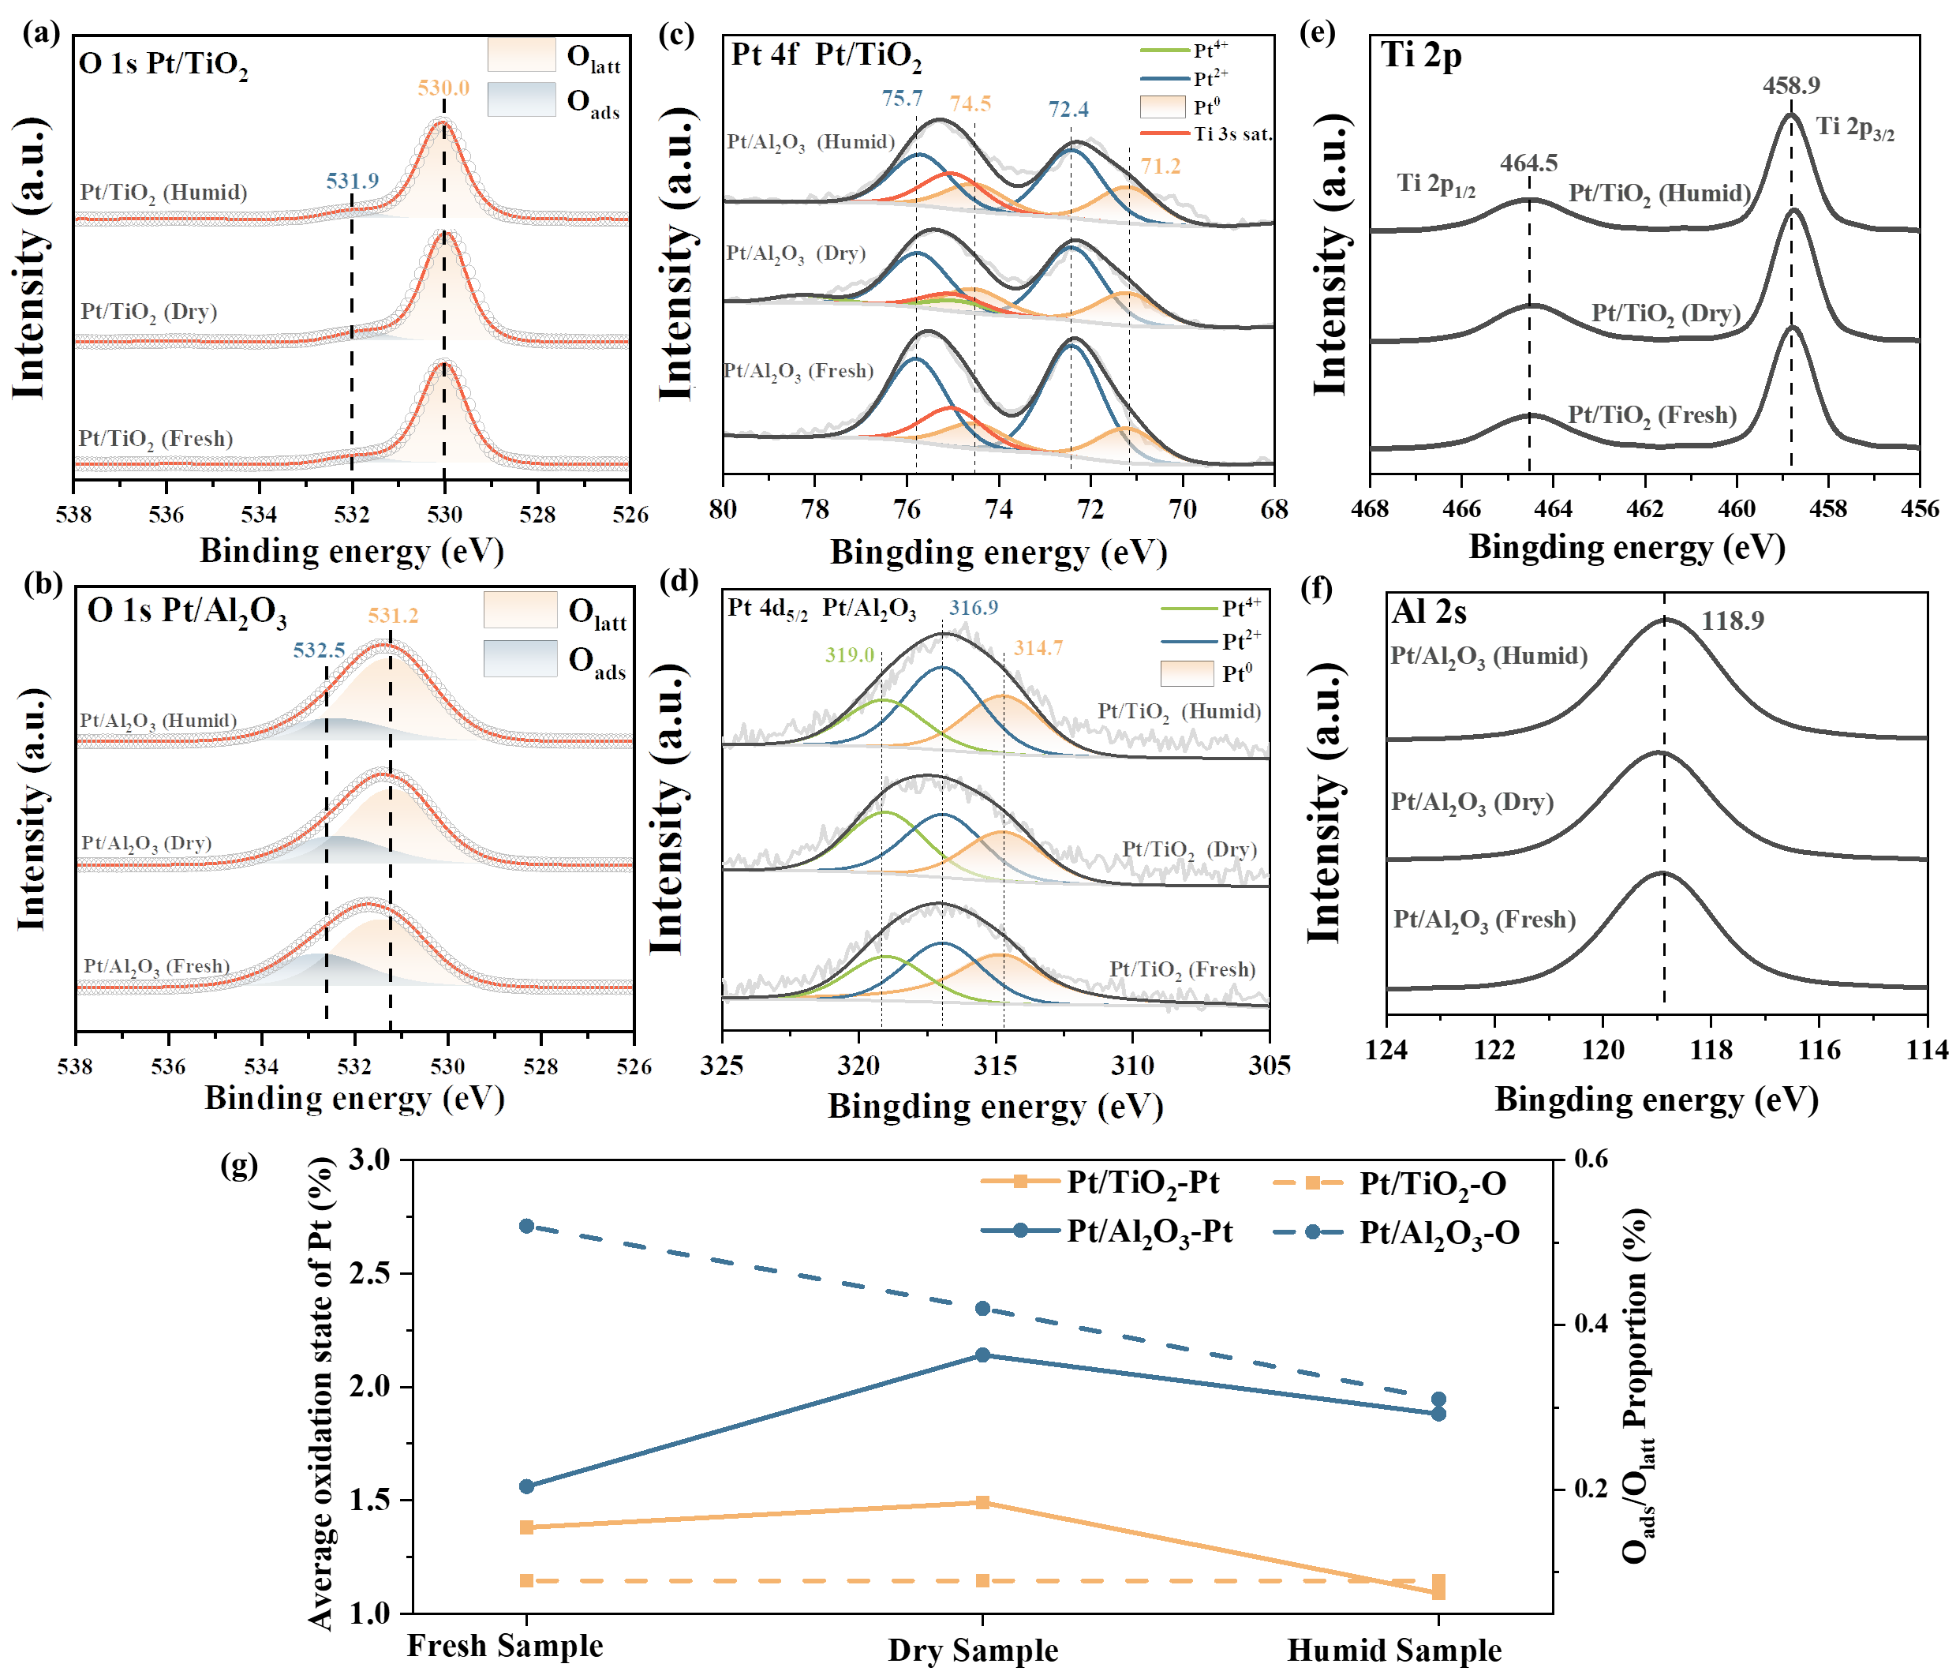
Figure S12. XPS spectra and results of Pt/TiO₂ and Pt/Al₂O₃.

Figure S13. H₂-TPR of Pt/TiO₂ and Pt/Al₂O₃.

Figure S14. EPR of Pt/TiO₂ and Pt/Al₂O₃.
.

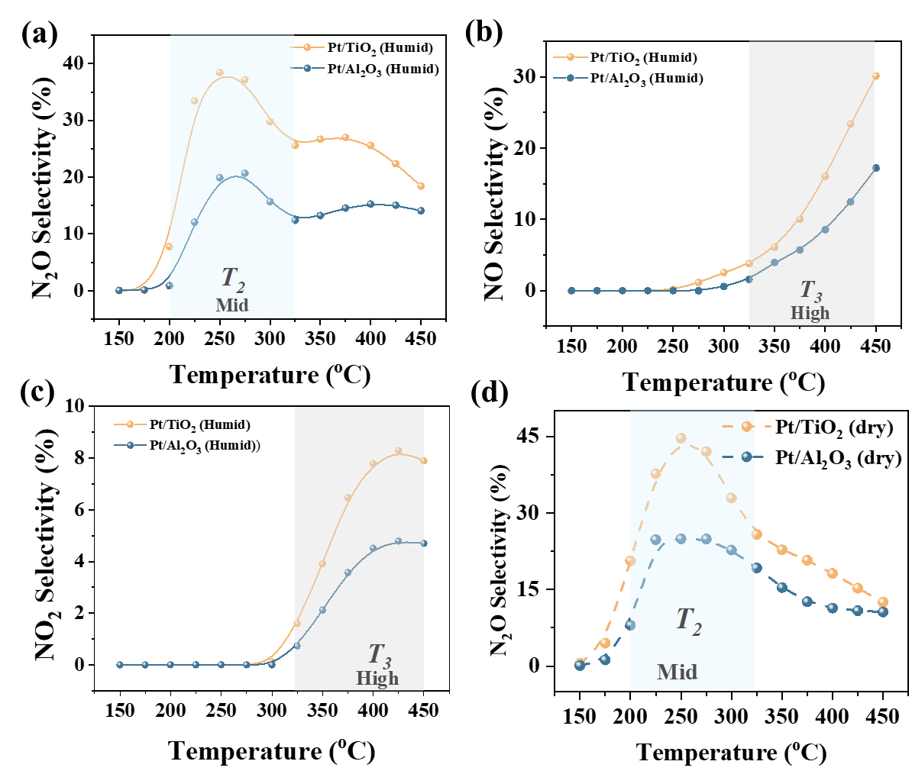
Figure S15. NH₃ oxidation performance of the Pt/TiO₂ and Pt/Al₂O₃ catalysts with moisture: (a) N₂O selectivity, (b) NO selectivity, and (c) NO₂ selectivity, and (d) N₂O selectivity without moisture. Reaction conditions: O₂ = 2 %, NH₃ = 500 ppm, H₂O = 4 % (if used), N₂ as the balance gas, GHSV = 60,000 mL·g⁻¹·h⁻¹.

Figure S16. Catalytic performance of Pt/TiO₂ and Pt/Al₂O₃ catalysts in the purification of NH₃: TOF of NH₃ oxidation. Reaction conditions: O₂ =2 %, NH₃ = 500 ppm, N₂ as the balance gas, GHSV = 60,000 mL g⁻¹ h⁻¹.

Py-IR is performed to further investigate the influence of support modification on the superficial acidic sites in Figure 4b. On Pt/TiO₂, the peaks around 1540 and 1640 cm⁻¹ are attributed to the adsorbed pyridine on the Brønsted acid sites, whereas 1444 and 1605 cm⁻¹ are assigned to the Lewis acid sites, as well as the bands at 1490 and 1575 cm⁻¹ stands for both acid sites.^{3, 4} On Pt/Al₂O₃, the peaks around 1541 and 1577 cm⁻¹ are attributed to the adsorbed pyridine on the Brønsted acid sites, whereas 1446, 1594 and 1614 cm⁻¹ are assigned to the Lewis acid sites, as well as the bands at 1492 cm⁻¹ stands for both acid sites.⁵
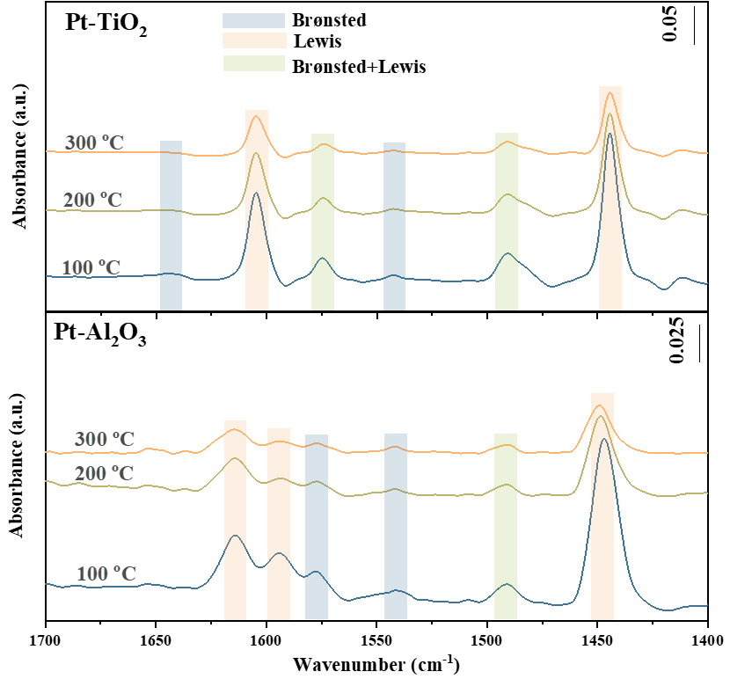
Figure S17. Py-IR of Pt/TiO₂ and Pt/Al₂O₃.
.

Figure S18. In situ DRIFTS of NH₃ adsorption at 50 °C on Pt/TiO₂ and Pt/Al₂O₃.

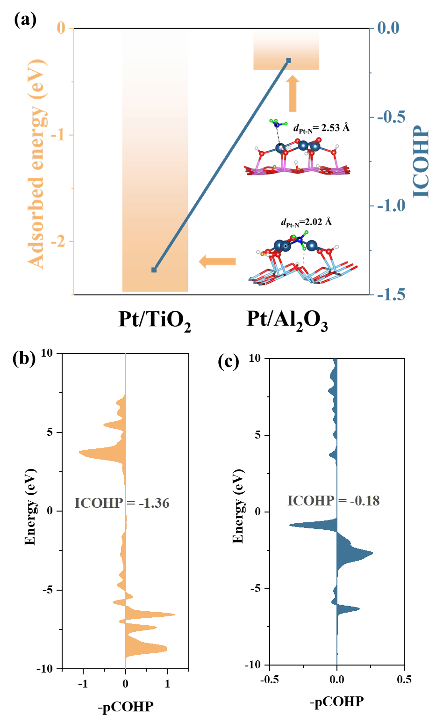
Figure S19. (a) adsorbed energy of NH₃ and ICOHP on Pt₃O₅ ACs/TiO₂ (101) and Pt₃O₈ ACs/Al₂O₃ (100) slabs, Crystal orbital Hamilton population (COHP) on (b) Pt/TiO₂ and (c) Pt/Al₂O₃ slab.

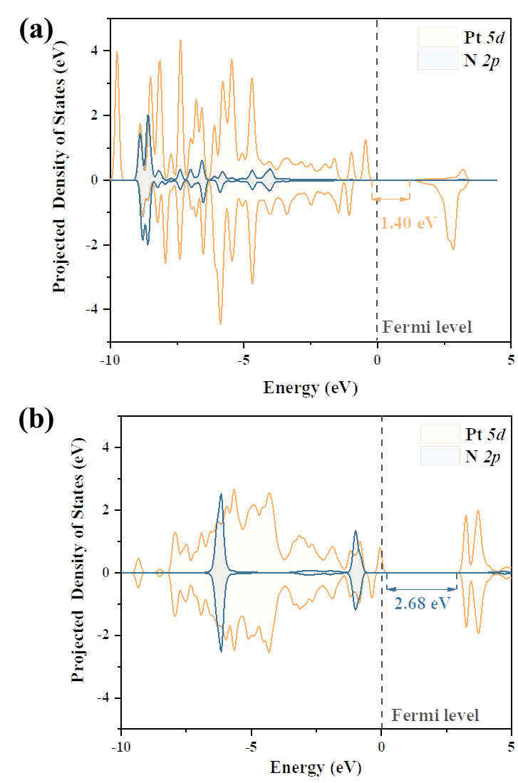
Figure S20. Projected density of states (PDOS) of NH₃ gas molecules on (a) Pt/TiO₂ and (b) Pt/Al₂O₃ slab.

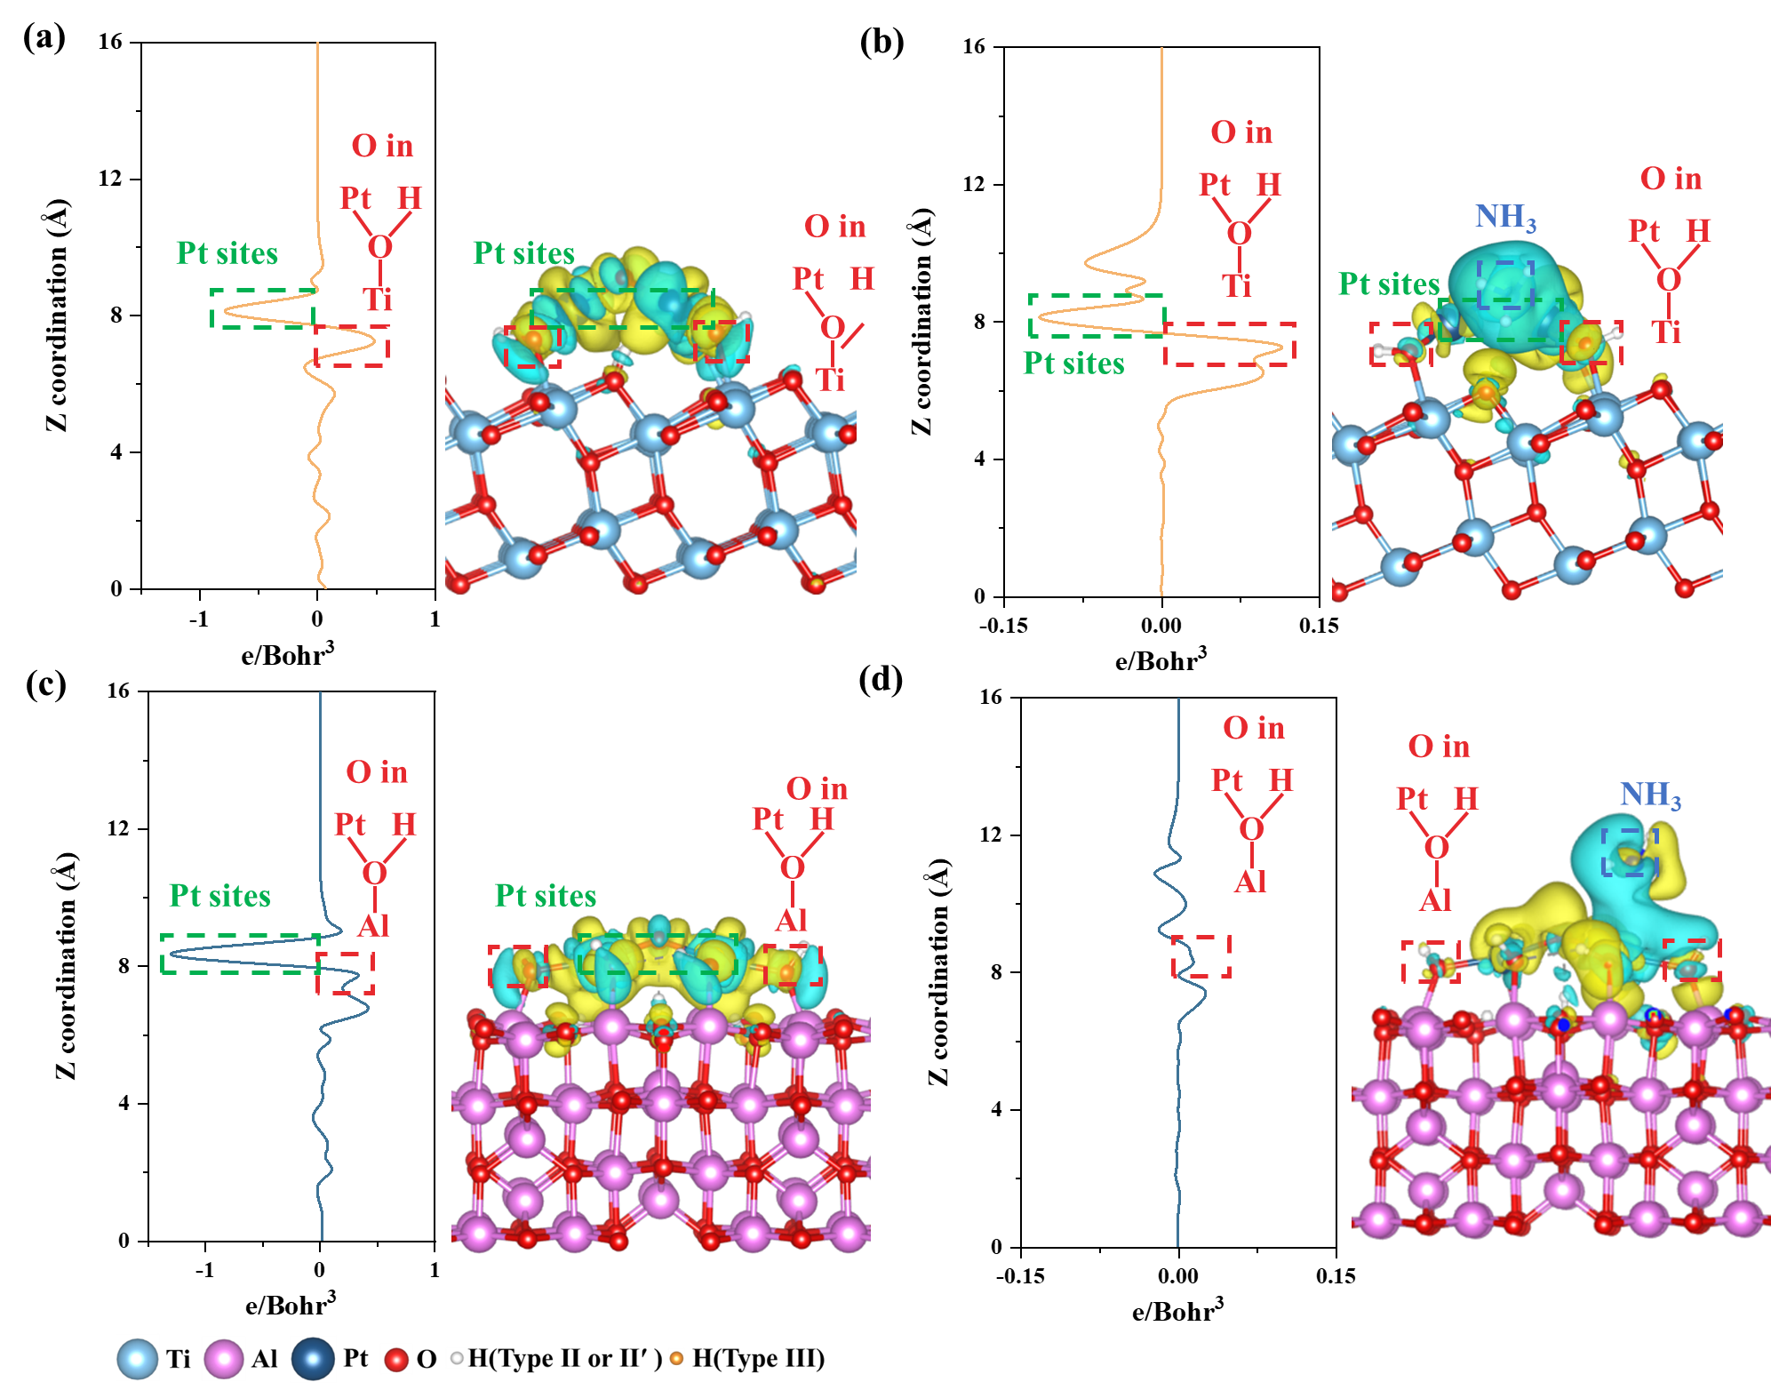

Figure S21. Charge density difference and the corresponding planar-average charge density analyses of Pt ACs loading and NH₃ adsorption on (a-b) Pt/TiO₂ slab and (c-d) Pt/Al₂O₃ slab.

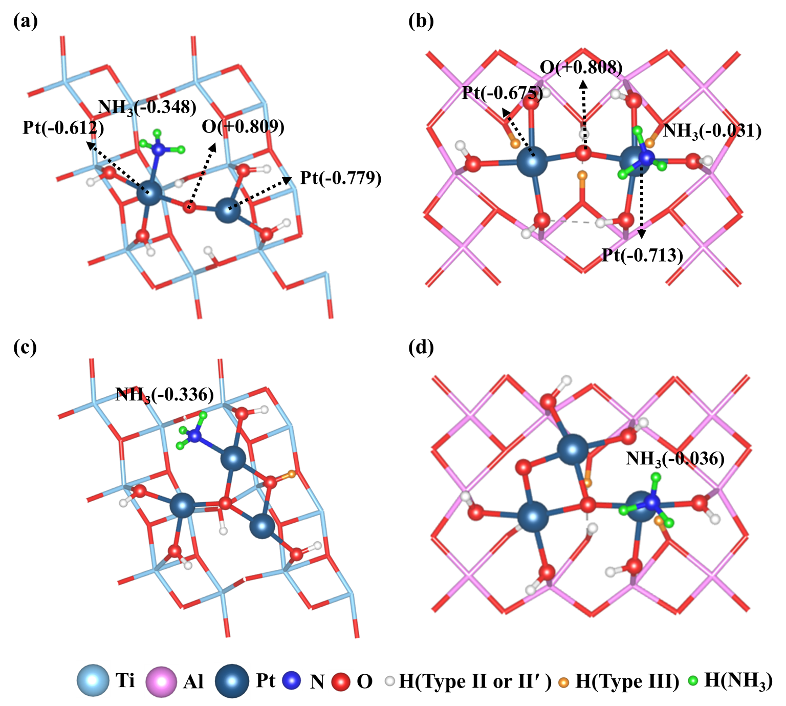
Figure S22. Bader charge of (a) single-atom Pt/TiO₂, (b) single-atom Pt/Al₂O₃, (c) Pt₃ ACs/TiO₂, (d) Pt₃ ACs/Al₂O₃ slab.

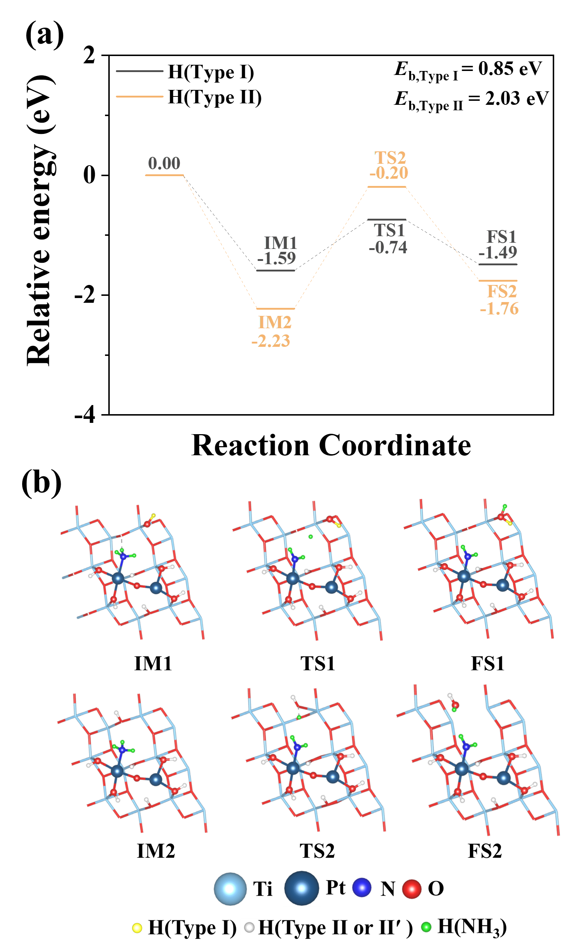
Figure S23. NH₃ dehydrogenation via hydrogen spillover on Pt/TiO₂ (101) slabs.

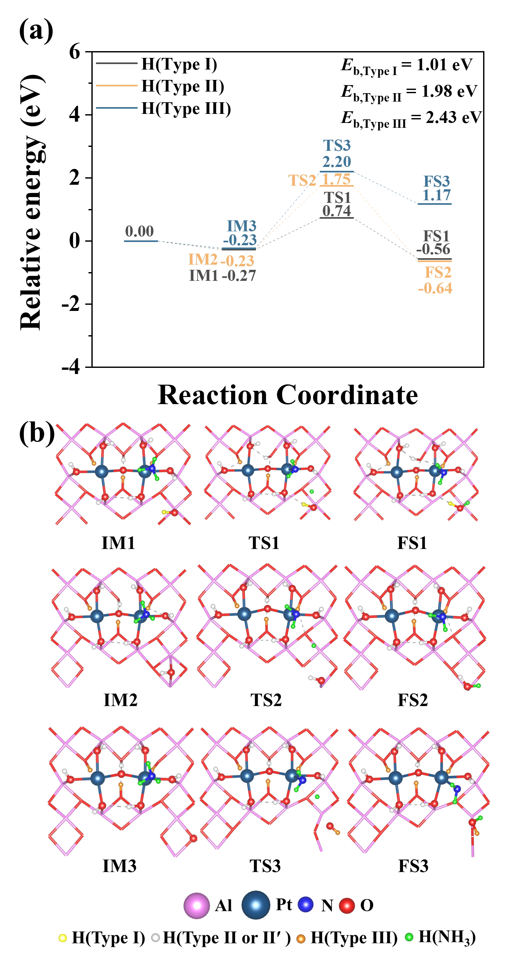
Figure S24. NH₃ dehydrogenation via hydrogen spillover on Pt/Al₂O₃ (100) slabs.

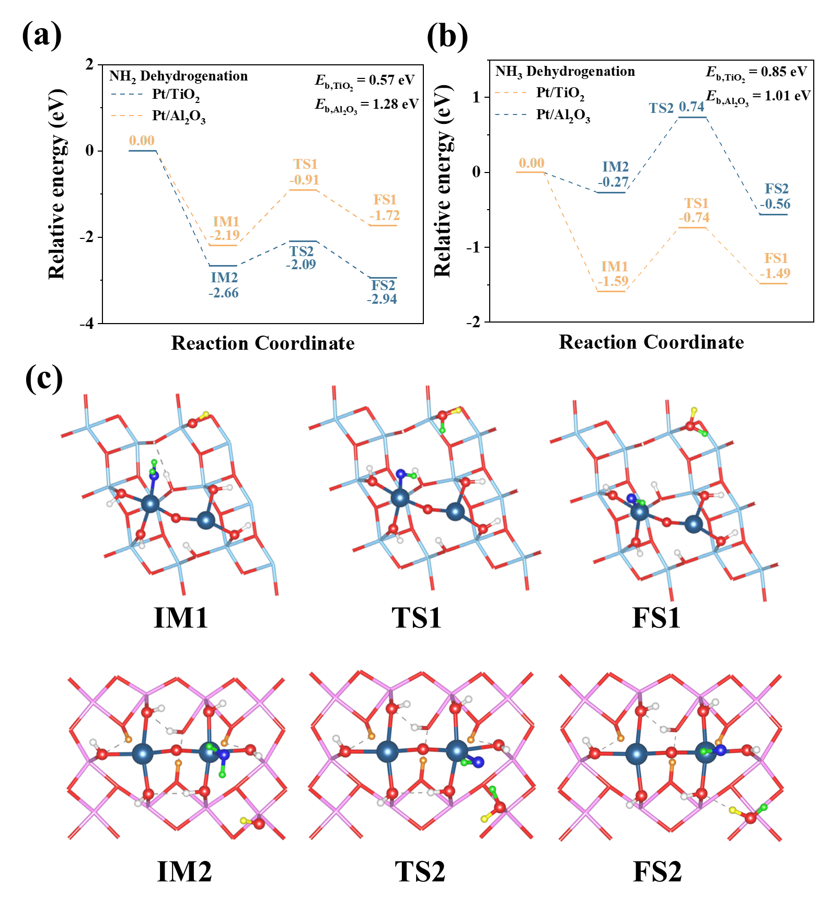
Figure S25. (a) NH₃ and (b) NH₂ dehydrogenation via hydrogen spillover on single-atom Pt/TiO₂ (101) and single-atom Pt/Al₂O₃ (100) slabs, (c) the optimized structures of intermediates, transition states, and final states of NH species formation on single-atom Pt/TiO₂ and single-atom Pt/Al₂O₃ slab.

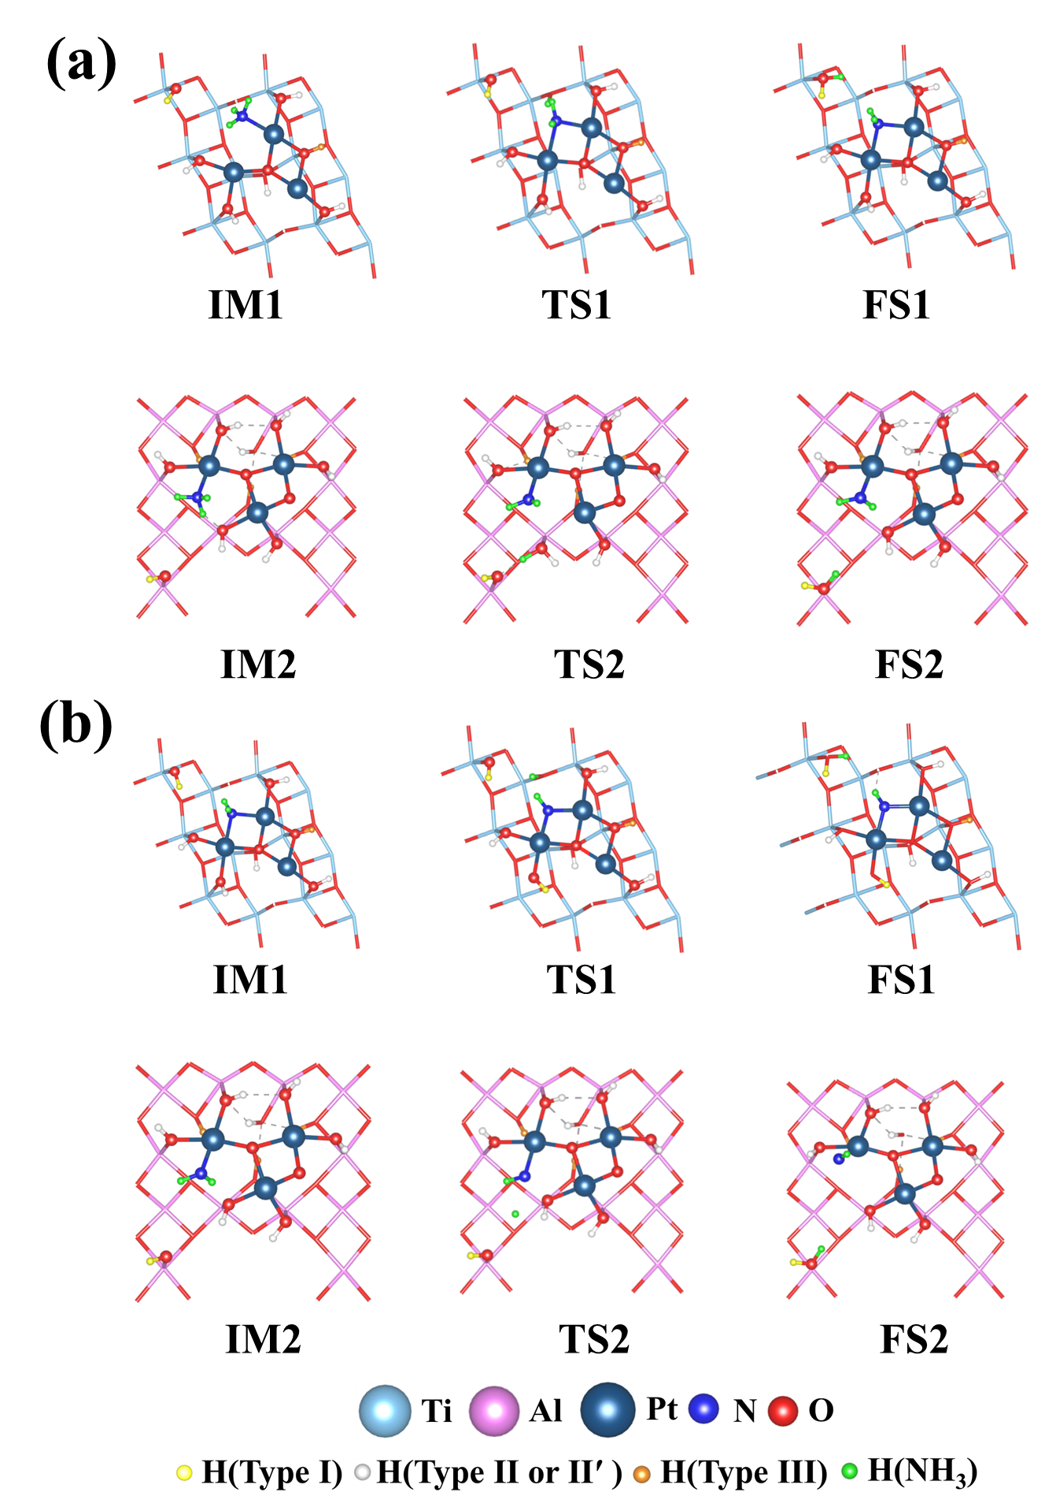
Figure S26. The optimized structures of intermediates, transition states, and final states of NH₂ and NH species formation on Pt ACs/TiO₂ and Pt ACs/Al₂O₃ slab.
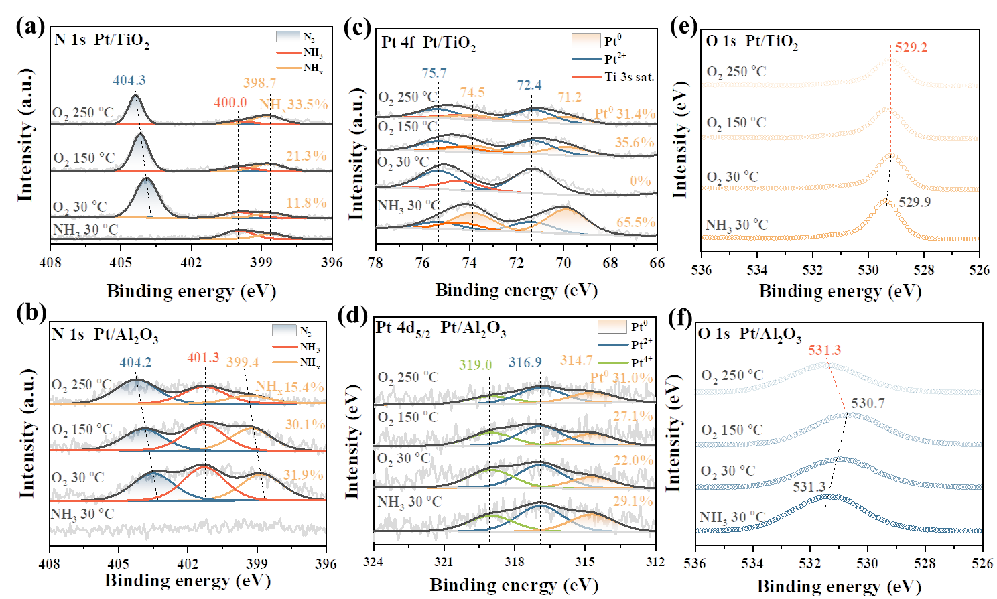
Figure S27. In-situ NAP-XPS of N 1s on the (a) Pt/TiO₂ and (b) Pt/Al₂O₃, Pt 4f on the (c) Pt/TiO₂ and Pt 4d (d) Pt/Al₂O₃, O 1s on the (e) Pt/TiO₂ and (f) Pt/Al₂O₃, is pretreated with 500 ppm NH₃ at 30 °C, exposed to 1 mbar of O₂ at 30 °C, at 150 °C, at 250 °C.

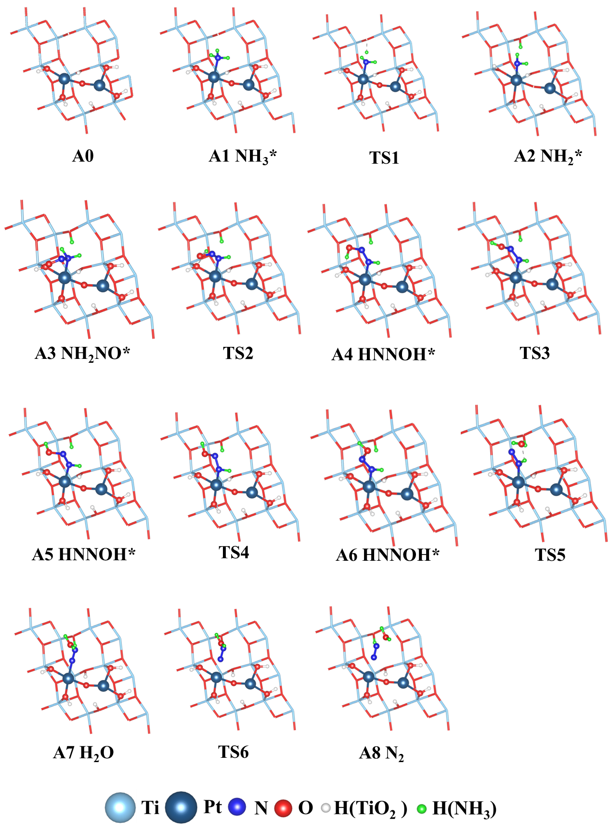
Figure S28. The optimized structures of intermediates, transition states, and final states of N₂ formation on Pt/TiO₂ slab.

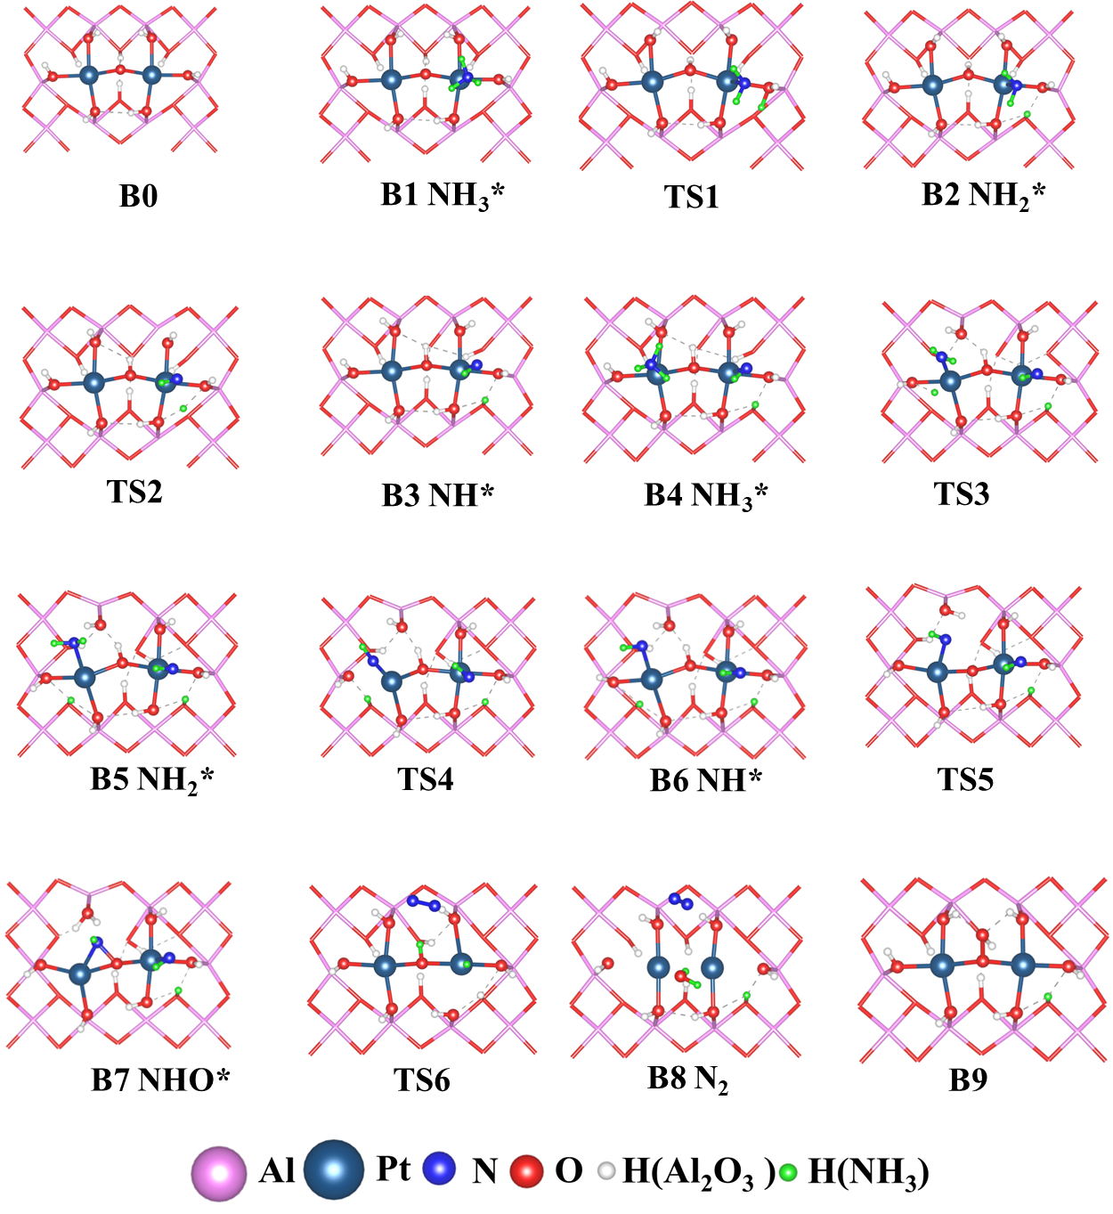
Figure S29. The optimized structures of intermediates, transition states, and final states of N₂ formation on Pt/Al₂O₃ slab.

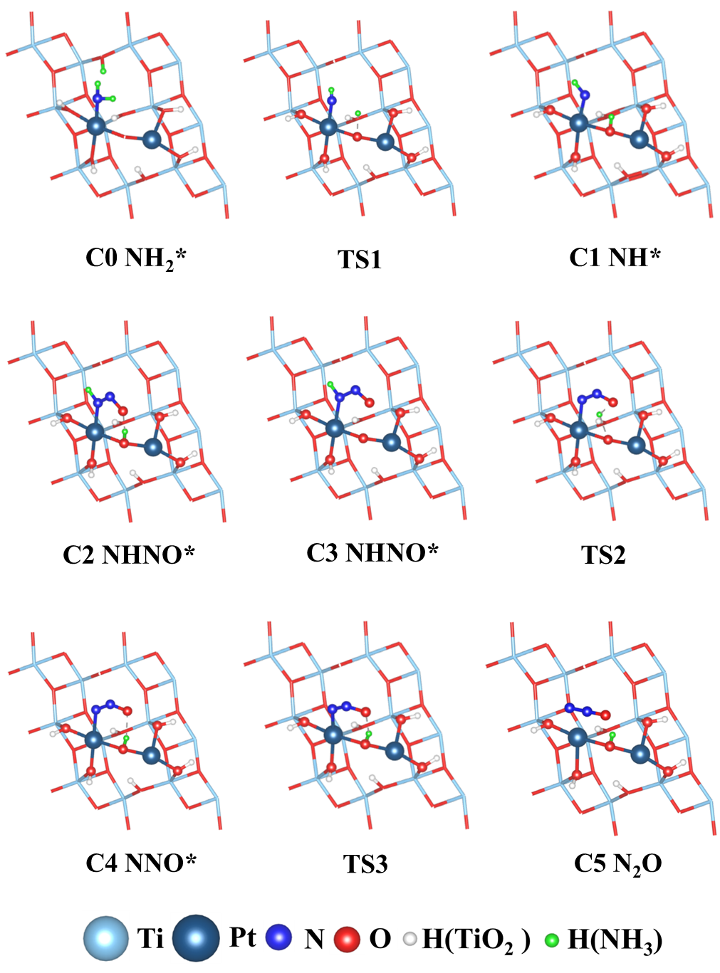
Figure S30. The optimized structures of intermediates, transition states, and final states of N₂O formation on Pt/TiO₂ slab.

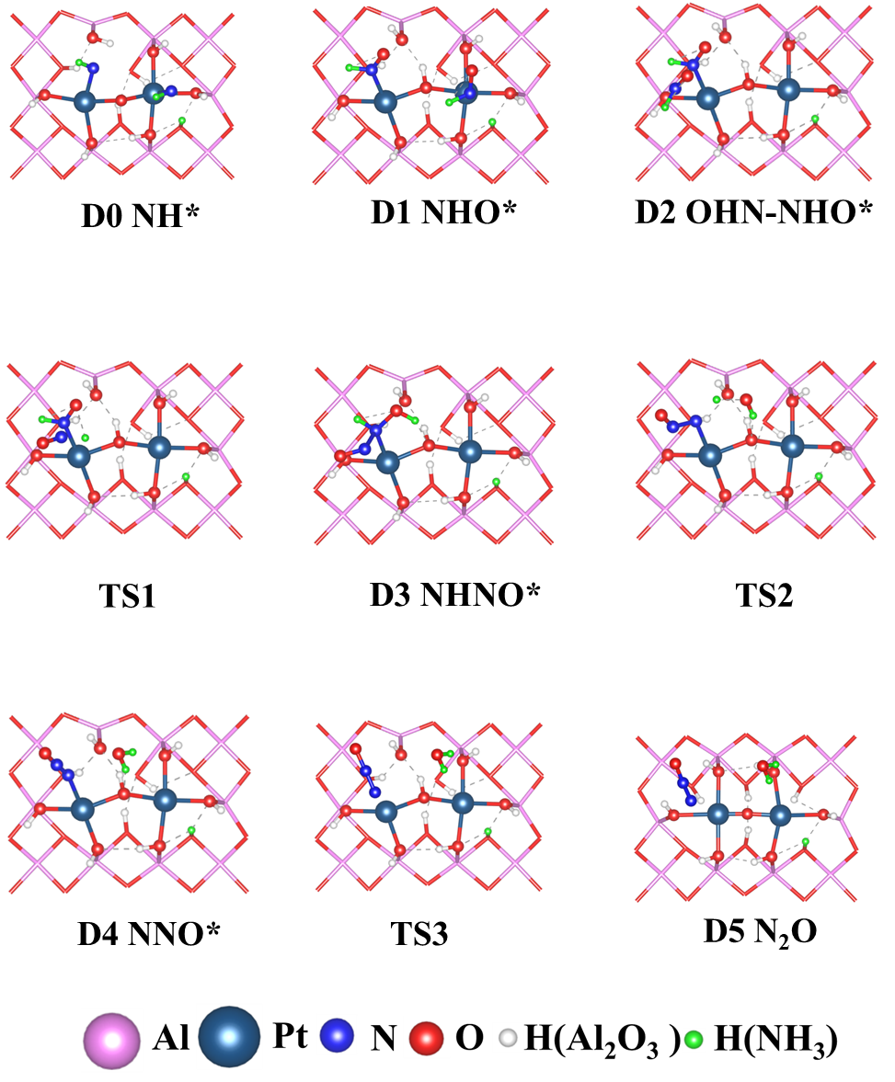
Figure S31. The optimized structures of intermediates, transition states, and final states of N₂O formation on Pt/Al₂O₃ slab.

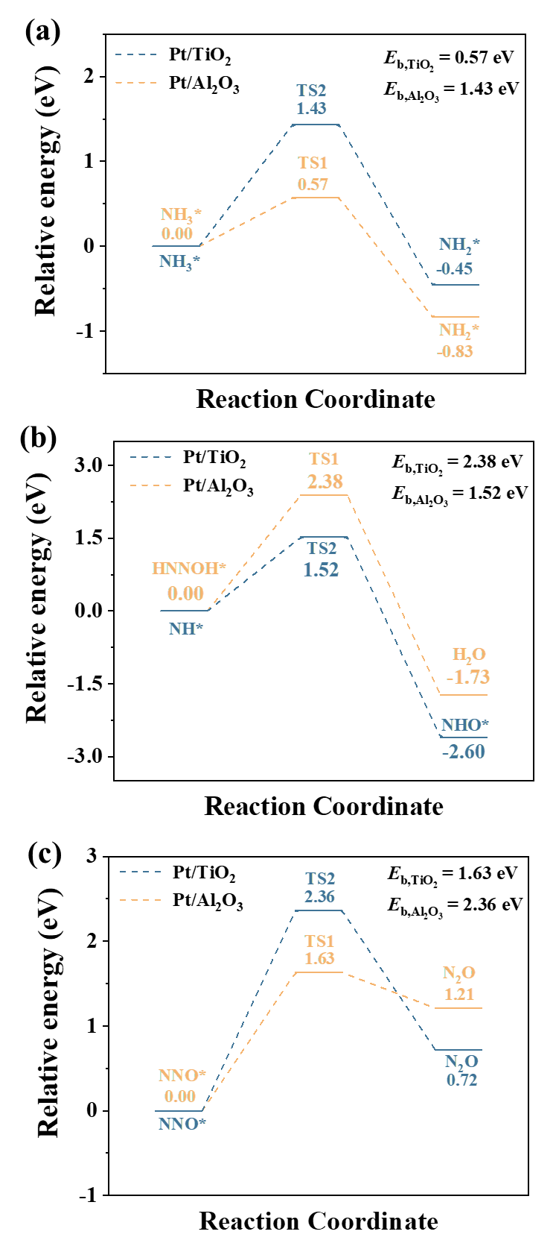
Figure S32. NH₃ oxidation mechanisms to (a) NH₃ dehydrogenation, formation of (b)H₂O and NHO*, (c) N₂O on the Pt₃O₅/TiO₂ (101) and Pt₃O₈/Al₂O₃ (100) slabs.

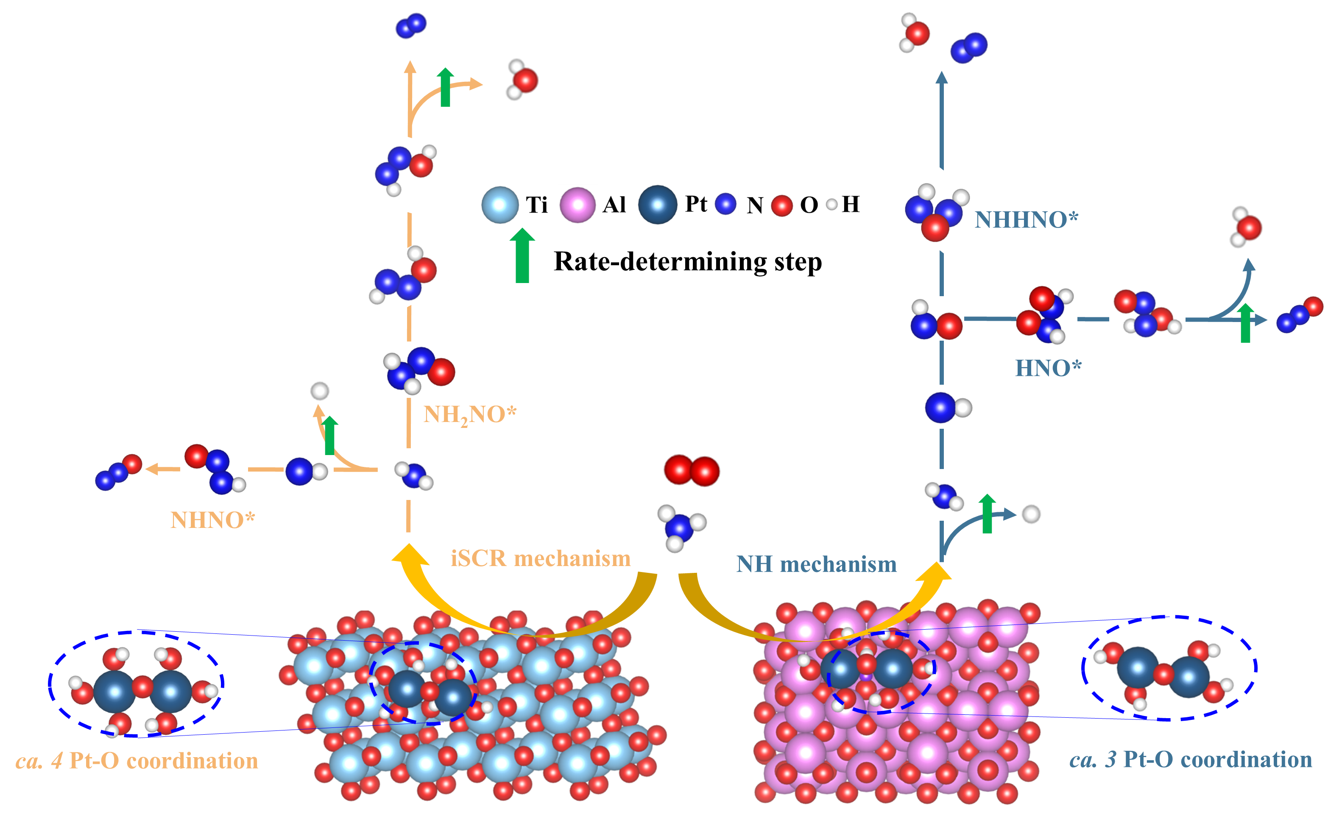
Figure S33. Plausible oxidation mechanism of the single-layer Pt ACs catalyst under the NH₃ oxidation.

Table S1 EXAFS fitting parameters at the Pt L-edge various samples (S₀²=0.92)
samples | path | C. N.^{[a]} | R (Å) ^{[b]} | σ² (× 10⁻³ Å²) ^{[c]} | ΔE (eV) ^{[d]} | R factor^{[e]}
Pt/TiO₂ | Pt-O | 3.6 | 2.03±0.02 | 9.6±3.5 | 5.9±2.8 | 0.02
Pt/TiO₂ | Pt-Ti | 0.6 | 2.65±0.03 | 4.8±1.1 | 5.9±2.8 | 0.02
Pt/Al₂O₃ | Pt-O | 4.1 | 2.00±0.02 | 4.1±2.2 | 4.1±4.2 | 0.02
Pt/Al₂O₃ | Pt-Cl | 0.5 | 2.30±0.03 | 9.3±7.5 | 4.1±4.2 | 0.02
ªC. N.: coordination numbers; ^{b}R: bond distance; ^{c}σ²: Debye-Waller factors; ^{d}ΔE₀: the inner potential correction. ^{e}R factor: goodness of fit.

Table S2 Element analyses of fresh and spent catalysts.
Catalysts | (Pt⁴⁺ + Pt²⁺)/  Pt⁰ | AOS(Pt)ª | O_{ads}/O_{latt}
Pt-TiO₂ (Fresh) | 3.97 | 1.38 | 0.09
Pt-TiO₂ (Dry) | 2.58 | 1.49 | 0.09
Pt-TiO₂ (Humid) | 1.88 | 1.09 | 0.09
Pt-Al₂O₃ (Fresh) | 1.29 | 1.56 | 0.52
Pt-Al₂O₃ (Dry) | 2.53 | 2.14 | 0.42
Pt-Al₂O₃ (Humid) | 2.11 | 1.88 | 0.31
- AOS is average oxidation state.

Table S3 Formation energy of oxygen vacancy.
Catalyst | Pt-O-H
Catalyst | 1 | 2 | 3 | 4 | 5 | 6
Pt/TiO₂ | 2.44 | 2.55 | 2.22 | 3.37 | - | -
Pt/Al₂O₃ | 3.51 | 2.62 | 2.76 | 3.52 | 3.51 | 2.71

Table S4 Acidity from NH₃-TPD.
Catalyst | NH₃ consumption (umol/g)
Catalyst | Weak | Strong | Total
Pt/TiO₂ | 55 | 172 | 227
Pt/Al₂O₃ | 112 | 101 | 213

Table S5 Comparison of NH₃-SCO performance of Pt-based catalysts reported by this work and other literature.
Catalyst | Reaction conditions | T₉₀ (°C) | N₂ Sel. (%) ª | TOF (10⁻³·s⁻¹) | Ref.
1 wt%Pt/TiO₂ | 500ppm NH₃, 2%O₂, 4%H₂O, 100 ml·min⁻¹,  60000 ml·g⁻¹·h⁻¹ | 232 | 86 | 1.32 (170 °C) | This work
1 wt%Pt/Al₂O₃ | 500ppm NH₃, 2%O₂, 4%H₂O, 100 ml·min⁻¹,  60000 ml·g⁻¹·h⁻¹ | 255 | 81 | 1.03 (170 °C) | This work
PtCu-Al₂O₃ ST | 600ppm NH₃, 10%O₂, 200 ml·min⁻¹,  120000 ml·g⁻¹·h⁻¹ | 170 | 95 | 1.08 (115 °C) | Ref⁶
2.00 wt%Pt/Al₂O₃ | 600ppm NH₃, 10%O₂, 200 ml·min⁻¹,  120000 ml·g⁻¹·h⁻¹ | 223 | 74 | 0.45 (180 °C) | Ref⁶
1.1 wt%Pt/Nb₂O₅ | 50ppm NH₃, 20%O₂, 100 ml·min⁻¹,  0.15 g, 40000 ml·g⁻¹·h⁻¹ | 250 | 100 | 0.04 (140 °C) | Ref⁷
Pt₇₇Au₂₃/Al₂O₃ | 100ppm NH₃, 10%O₂, 100 ml·min⁻¹,  40000 ml·g⁻¹·h⁻¹ | 145 | 68 | 0.23 (125°C) | Ref⁸
Pt-Fe/ZSM-5 | 500ppm NH₃, 10%O₂, 5%H₂O, 100 ml·min⁻¹,  140000 h⁻¹ | 220 | 63 | 1.16 (175 °C) | Ref⁹
1 wt%Pt/CeZrO₂ | 200ppm NH₃, 8%O₂, 100000 h⁻¹ | 307 | 90 | 0.92 (233°C) | Ref¹⁰
a. The N₂ selectivity at T₉₀.

Table S6 Acidity from Py-IR.
Catalyst | Pyridine consumption (umol/g)
Catalyst | B | L | Total | B/L
Pt/TiO₂-100 | 6.32198 | 68.56571 | 74.88769 | 0.092203
Pt/TiO₂-200 | 5.592520408 | 56.0157398 | 61.6082602 | 0.099838375
Pt/TiO₂-300 | 2.998888 | 25.09995 | 28.09884 | 0.119478
Pt/Al₂O₃-100 | 5.094753 | 50.90485 | 55.9996 | 0.100084
Pt/Al₂O₃-200 | 2.326737 | 22.72538 | 25.05212 | 0.102385
Pt/Al₂O₃-300 | 1.644763 | 13.93823 | 15.58299 | 0.118004

References
1. Chen, J.; Xiong, S.; Liu, H.; Shi, J.; Mi, J.; Liu, H.; Gong, Z.; Oliviero, L.; Maugé, F.; Li, J., Reverse oxygen spillover triggered by CO adsorption on Sn-doped Pt/TiO2 for low-temperature CO oxidation. Nature Communications 2023, 14, (1), 3477.
2. Zhao, Y.; Kumar, P. V.; Tan, X.; Lu, X.; Zhu, X.; Jiang, J.; Pan, J.; Xi, S.; Yang, H. Y.; Ma, Z.; Wan, T.; Chu, D.; Jiang, W.; Smith, S. C.; Amal, R.; Han, Z.; Lu, X., Modulating Pt-O-Pt atomic clusters with isolated cobalt atoms for enhanced hydrogen evolution catalysis. Nature Communications 2022, 13, (1), 2430.
3. Song, Z.; Peng, Y.; Zhao, X.; Liu, H.; Gao, C.; Si, W.; Li, J., Roles of Ru on the V₂O₅-WO₃/TiO₂ Catalyst for the Simultaneous Purification of NO_{x} and Chlorobenzene: A Dechlorination Promoter and a Redox Inductor. ACS Catalysis 2022, 12, (18), 11505-11517.
4. Yuan, X.; Peng, Y.; Zhu, X.; Wang, H.; Song, Z.; Si, W.; Wang, Y.; Li, J., Anti-Poisoning Mechanisms of Sb on Vanadia-Based Catalysts for NOx and Chlorobenzene Multi-Pollutant Control. Environmental Science & Technology 2023, 57, (28), 10211-10220.
5. Oenema, J.; van Alst, R. A.; Meijerink, M. J.; Zečević, J.; de Jong, K. P., The Influence of Residual Chlorine on Pt/Zeolite Y/γ-Al2O3 Composite Catalysts: Acidity and Performance. Applied Catalysis A: General 2020, 605, 117815.
6. Liu, Y.; Liu, Z.; Wang, C.; Xu, J.; Ai, J.; Liu, X.; Zhang, A.; Zhao, Y.; Du, C.; Shan, B., Unraveling the Lattice O Assisted Internal Selective Catalytic Reduction Mechanism on High N2 Selectivity of CuOx/PtCu Catalysts in NH3-SCO. ACS Catalysis 2023, 13, (11), 7178-7188.
7. Lin, M.; An, B.; Takei, T.; Shishido, T.; Ishida, T.; Haruta, M.; Murayama, T., Features of Nb2O5 as a metal oxide support of Pt and Pd catalysts for selective catalytic oxidation of NH3 with high N2 selectivity. Journal of Catalysis 2020, 389, 366-374.
8. Wang, H.; Lin, M.; Murayama, T.; Feng, S.; Haruta, M.; Miura, H.; Shishido, T., Selective catalytic oxidation of ammonia to nitrogen over zeolite-supported Pt-Au catalysts: Effects of alloy formation and acid sites. Journal of Catalysis 2021, 402, 101-113.
9. Wang, F.; Zhu, Y.; Li, Z.; Shan, Y.; Shan, W.; Shi, X.; Yu, Y.; Zhang, C.; Li, K.; Ning, P.; Zhang, Y.; He, H., Promoting effect of acid sites on NH3-SCO activity with water vapor participation for Pt-Fe/ZSM-5 catalyst. Catalysis Today 2021, 376, 311-317.
10. Sun, M.; Liu, J.; Song, C.; Ogata, Y.; Rao, H.; Zhao, X.; Xu, H.; Chen, Y., Different Reaction Mechanisms of Ammonia Oxidation Reaction on Pt/Al2O3 and Pt/CeZrO2 with Various Pt States. ACS Applied Materials & Interfaces 2019, 11, (26), 23102-23111.

