Supplementary Information
Title
Clinical subtyping for patients with acute exacerbations of interstitial lung diseases guided by serum KL-6 measurement

Journal name
Lung

Authors and affiliations

Yoichi Tagami, MD¹ (ORCID: 0000-0002-2134-1192) ytagami8@yokohama-cu.ac.jp

Yu Hara, MD, PhD¹ (ORCID: 0000-0002-2574-2516) yhara723@yokohama-cu.ac.jp

Kota Murohashi, MD¹ murohashi36@hotmail.com

Ryo Nagasawa, MD¹ 0529orange@gmail.com
Yurika Nishikawa, MD¹ e153064c@yokohama-cu.ac.jp
Meiro Tanaka, MD¹ e153052e@yokohama-cu.ac.jp

Ayako Aoki, MD¹ aya.bluetree.29@gmail.com
Katsushi Tanaka, MD¹ katsushi0412@live.jp
Kentaro Nakashima, MD, PhD¹ kentaro0817@gmail.com
Keisuke Watanabe, MD, PhD¹ mmx3680034@yahoo.co.jp

Nobuyuki Horita, MD, PhD¹ horitano@yokohama-cu.ac.jp
Nobuaki Kobayashi, MD, PhD¹ nkobayas@yokohama-cu.ac.jp
Masaki Yamamoto, MD, PhD² masakiy@yokohama-cu.ac.jp
Makoto Kudo, MD, PhD² m_kudo@yokohama-cu.ac.jp
Koji Okudela, MD, PhD³ krascv@yahoo.co.jp
Takeshi Kaneko, MD, PhD¹ takeshi@yokohama-cu.ac.jp

¹ Department of Pulmonology, Yokohama City University Graduate School of Medicine, Yokohama, Japan
² Respiratory Disease Center, Yokohama City University Medical Center, Yokohama, Japan.
³ Department of Pathology, Yokohama City University Graduate School of Medicine, Yokohama, Japan.

Corresponding author full contact details:
Yu Hara (ORCID: 0000-0002-2574-2516),
Department of Pulmonology, Yokohama City University Graduate School of Medicine
4-57 Fukuura, Kanazawa-ku, Yokohama City, Kanagawa 236-0024, Japan
Tel: 045-787-2800, Fax: 045-352-7963
E-mail: yhara723@yokohama-cu.ac.jp

Figure S1. Pathological findings at autopsy of AEs of ILDs (12, 31)
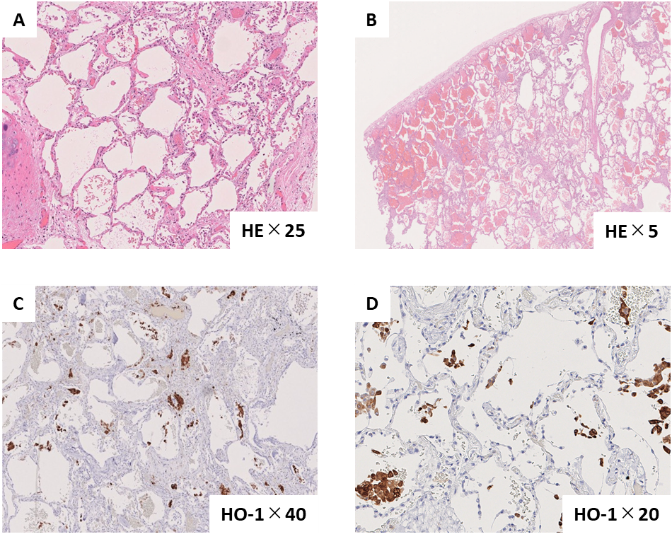 Figure legends
Case 1 is a patient with a high serum KL-6 (A: HE staining, C: Immunohistochemical staining for HO-1 expression). (12)
Case 2 is a patient with a low serum KL-6 (B: HE staining, D: Immunohistochemical staining for HO-1 expression). (31)
(A) In addition to the fibrotic lesions that had passed for a relatively long time, oedematous thickening of the alveolar septum and vitreous membrane formation are observed focally. There is no evidence of granulomas or vasculitis. This is considered consistent with active DAD superimposed on fibrosis.
(B) DAH and relatively mild DAD-like change are superimposed on fibrosis. DAH is the more predominant pattern than DAD. In addition, pulmonary vascular thrombosis is evident. This case is considered to be not typical for AE of ILD.
(C, D) In both cases, high expression of HO-1 is similarly observed mainly in alveolar macrophages, whereas expression of HO-1 in fibrotic lesions is not conspicuous.
Abbreviations: AE, acute exacerbation; DAD, diffuse alveolar damage; DAH, diffuse alveolar haemorrhage; HE, haematoxylin-eosin staining; HO-1, hemeoxygenase-1; KL-6, Krebs von den Lungen; ILD, interstitial lung disease.

