Supplementary file (S2)
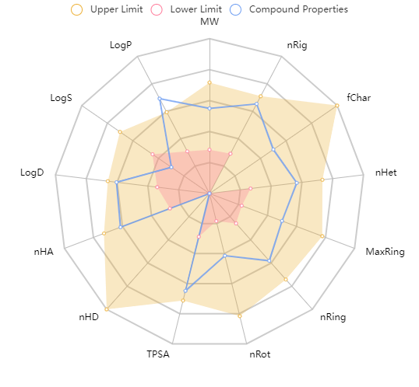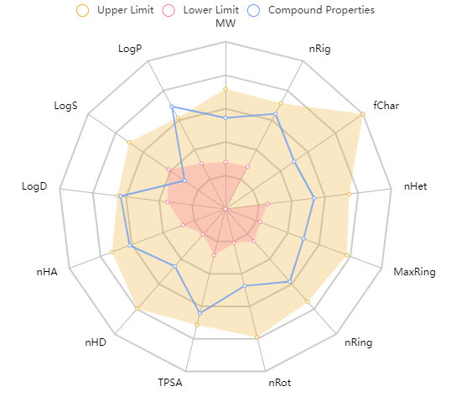
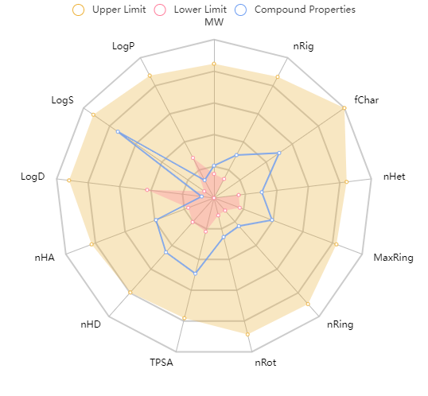
INH
Figure 1: Radar chart for basic physicochemical properties and drug likeness of 6a, 8f and INH.

Table (1): Predicted physicochemical properties and drug-likeness of 6a and 8f, compared to INH:
Physicochemical properties and drug likness
 | M.W (g/mol) | n-rig | f-Char | n-Het | Max ring | n-Ring | n-Rot | TPSA | HD | HA | Log D | Log S | Log p
6a | 407.8 | 26 | 0 | 10 | 9 | 4 | 4 | 118.7 | 0 | 9 | 2.6 | -6.6 | 4.0
8f | 401.4 | 25 | 0 | 9 | 9 | 4 | 5 | 116.810 | 3 | 9 | 2.878 | -5.860 | 3.742
INH | 137.0 | 7 | 0 | 4 | 6 | 1 | 2 | 68.010 | 3 | 4 | -0.395 | -0.495 | -0.813
Table (2): the predicted ADMET properties of compounds 6a and 8f compared to INH
ADMET
 | Absorption  HIA | Distribution  BBB | Metabolism  Cytochrome P450  (CYP2D6 inhibitor) | Toxicity
 |  |  |  | Ames | Rat oral toxicity
8f | +ve | -ve | -ve | -ve | -ve
6a | +ve | -ve | -ve | -ve | -ve
INH | +ve | -ve | -ve | -ve | +ve

