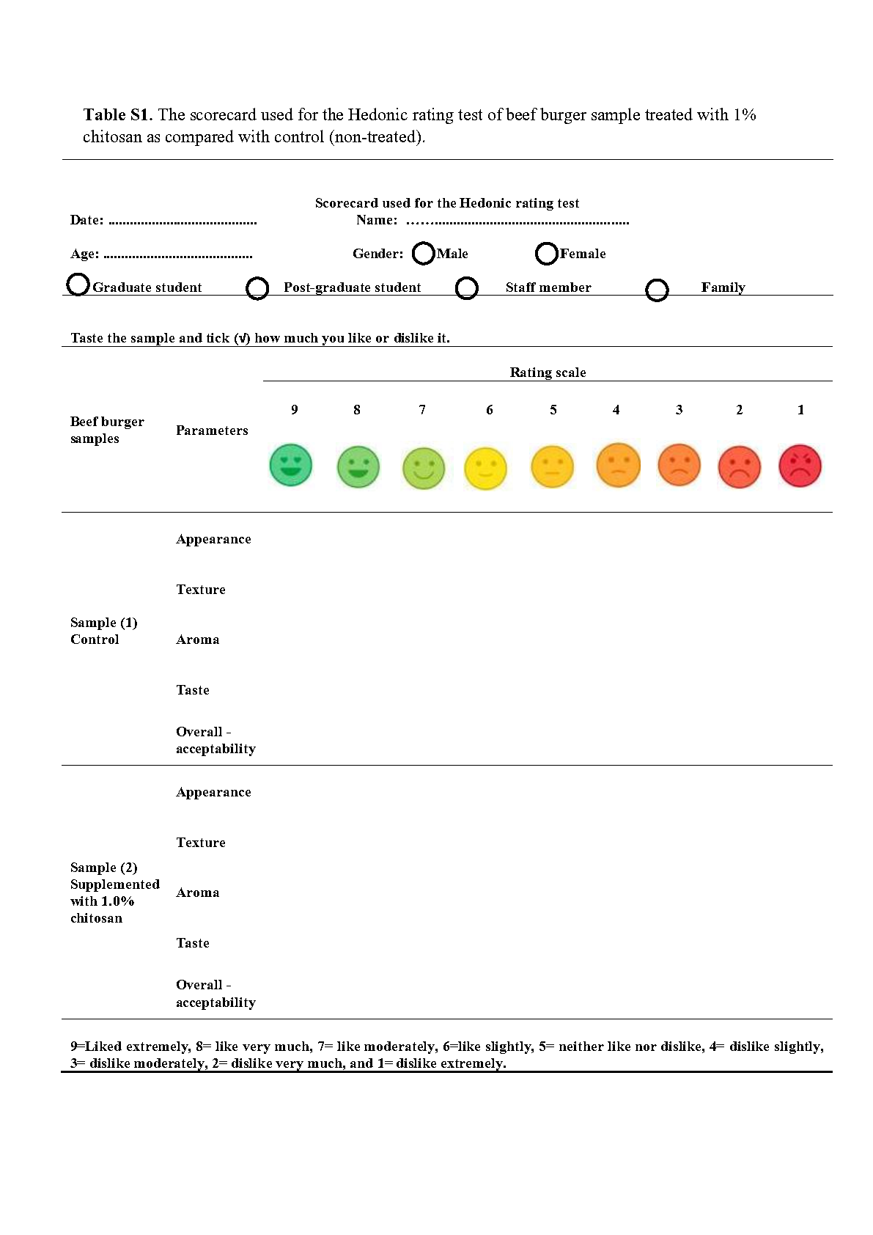
Table S1. The scorecard used for the Hedonic rating test of beef burger sample treated with 1% chitosan as compared with control (non-treated).

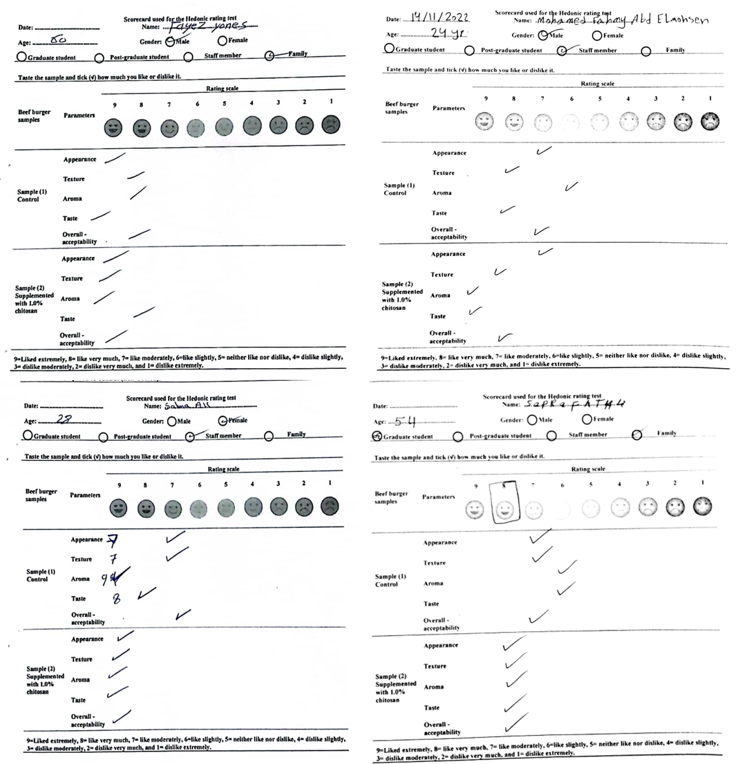
Table S2. Graduate and post-graduate students and staff members from the Faculty of Agriculture at Ain Shams University and families in Egypt conducted sensory parameter evaluation (appearance, texture, aroma, taste, and overall acceptability) of beef burger sample treated with 1% chitosan as compared with control (non-treated) according to Table S1. The scorecard used for the Hedonic rating test of beef burger sample treated with 1% chitosan compared to control (non-treated).

