The acoustic presence and migration timing of subarctic baleen whales in the Bering Strait in relation to environmental factors
Erica D. Escajeda^{a,*}, Kathleen M. Stafford^{b}, Rebecca A. Woodgate^{c}, and Kristin L. Laidre^{d}
ª School of Aquatic and Fishery Sciences, University of Washington, Seattle, Washington, USA; email: ericaescajeda@gmail.com
^{b} Marine Mammal Institute, Oregon State University, Newport, Oregon, USA; email: kate.stafford@oregonstate.edu
^{c} Applied Physics Laboratory, University of Washington, Seattle, Washington, USA; email: woodgate@uw.edu
^{d} Applied Physics Laboratory, University of Washington, Seattle, Washington, USA; email: klaidre@uw.edu

* Contact information for corresponding author: ericaescajeda@gmail.com ORCID: 0000-0003-4194-8992

Supplementary Tables and Figures
Table S1. Results of the Pearson correlation tests between seasonal means for near-bottom temperature and salinities (‘SBE Temp’ and ‘SBE Salt’), sea-surface temperatures (SST), water speeds, and wind speeds. The pink shading denotes correlations with an absolute value > 0.7 and p < 0.05.

Table S2. Results of the linear regression for the departure dates (y) for each species vs. seasonal means of environmental variables (x). Only the variables with a significant, linear relationship to the departure dates (p < 0.05) are listed below, including seasonal means for sea-surface temperatures (SST, °C), near bottom temperatures (measured with SBE-16 instrument, °C), and mid-column water speeds (measured by ADCP instrument, cm s⁻¹). Seasons were defined as follows: winter = 21 Dec‒20 Mar, spring = 21 Mar‒20 Jun, summer = 21 Jun‒20 Sep, and fall = 21 Sep‒20 Dec. Winter here indicates the previous winter to the arrival of the whales to the Bering Strait.
Fin Whales
Variable (x) | R² | p | Equation
Bottom Temp Winter | 0.69 | 0.006 | y = 70.9x + 435.1
Bottom Temp Spring | 0.63 | 0.01 | y = 17.4x + 332.7
Bottom Temp Summer | 0.73 | 0.003 | y = 8.6x + 293.2
Bottom Temp Fall | 0.69 | 0.005 | y = 8.6x + 301.6
SST Winter | 0.58 | 0.02 | y = 45.7x + 389.8
SST Spring | 0.59 | 0.02 | y = 16.9x + 318.6
SST Fall | 0.54 | 0.02 | y = 9.8x + 297.9
Water Speed Winter | 0.69 | 0.006 | y = 1.3x + 272.3
Humpback Whales
Variable (x) | R² | p | Equation
Bottom Temp Winter | 0.78 | 0.002 | y = 61x + 413.1
Bottom Temp Spring | 0.61 | 0.01 | y = 13.8x + 323.7
Bottom Temp Summer | 0.53 | 0.03 | y = 5.8x + 295.1
Bottom Temp Fall | 0.61 | 0.01 | y = 6.6x + 299.4
SST Winter | 0.83 | 0.001 | y = 44.1x + 381.8
SST Spring | 0.73 | 0.003 | y = 15.2x + 312.9
SST Summer | 0.52 | 0.03 | y = 7.2x + 270.7
SST Fall | 0.66 | 0.008 | y = 8.7x + 294.4

Table S3. Best models for each species according to Akaike information criterion with a correction for small sample sizes (AICc) along with their R² values (Cox-Snell). Other models that had ΔAICc < 10 are also listed. Note that the two models for gray whale had the same AICc score and R² value, thus we chose the model with fewer variables. The smoothing terms are specified next to the variable names: cs = cubic spline, pb = penalized b-spline smoothers. DOY = day of the year; SBE Temp = daily mean near-bottom temperatures; SBE Salt = daily mean near-bottom salinities; Water Speed = daily mean water speeds; Wind Speed = daily mean wind speeds; SST Grad = SST gradient (represents presence of a thermal front); SST Grad Lagged = SST Gradient lagged by one month.
AICc | Fin Whale Models | ΔAICc | R²
3320 | pb(DOY) + cs(SBE Temp) + cs(SST) + cs(Water Speed) + cs(SSTGrad) + cs(SST Grad Lagged) | 0 | 0.51
3324 | pb(DOY) + cs(SBE Temp) + cs(SST) + cs(Water Speed) + cs(Wind Speed) + cs(SST Grad) + cs(SST Grad Lagged) | 4 | 0.51
3329 | pb(DOY) + cs(SBE Temp) + cs(SST) + cs(Water Speed) + cs(SST Grad) | 9 | 0.5
AICc | Humpback Whale Models | ΔAICc | R²
4454 | pb(DOY) + cs(SBE Temp) + cs(SBE Salt) +cs(SST) + cs(Water Speed) + cs(Wind Speed) + cs(SST Grad) + cs(SST Grad Lagged) | 0 | 0.6
4455 | pb(DOY) + cs(SBE Temp) +cs(SST) + cs(Water Speed) + cs(Wind Speed) + cs(SST Grad) + cs(SST Grad Lagged) | 1 | 0.59
4460 | pb(DOY) + cs(SBE Temp) +cs(SST) + cs(Water Speed) + cs(Wind Speed) + cs(SST Grad Lagged) | 6 | 0.59
4462 | pb(DOY) + cs(SBE Temp) + cs(SBE Salt) +cs(SST) + cs(Water Speed) + cs(Wind Speed) + cs(SST Grad Lagged) | 8 | 0.59
AICc | Gray Whale Models | ΔAICc | R²
3087 | pb(DOY) + cs(SBE Temp) + cs(SBE Salt) + cs(SST) + cs(Water Speed) + cs(Wind Speed) + cs(SST Grad Lagged) | 0 | 0.45
3087 | pb(DOY) + cs(SBE Temp) + cs(SBE Salt) + cs(SST) + cs(Water Speed) + cs(Wind Speed) + cs(SST Grad) + cs(SST Grad Lagged) | 0 | 0.45

Fig. S1. Vector plots of daily mean water speed (cm s⁻¹) measured at 30-m depth at the A3 mooring site.
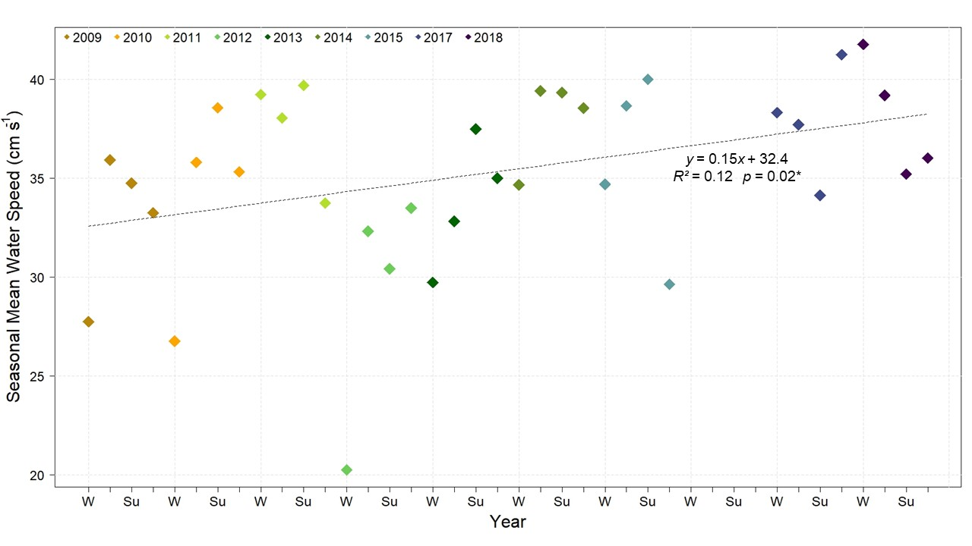Fig. S2. Seasonal means for water speed (cm s⁻¹) measured at 30-m depth at the A3 mooring site. Note that 2016 was omitted since we do not have acoustic data for that year. The seasons were defined as follows: Winter (‘W’) = 21 Dec‒20 Mar; Spring = 21 Mar‒20 Jun; Summer (‘Su’) = 21 Jun‒20 Sep; Fall = 21 Sep‒20 Dec. Water speeds throughout the seasons were highly variable with standard deviations ranging from 13 cm s⁻¹ to 27 cm s⁻¹. A linear regression of the seasonal means with year shows a significant increasing trend over the study period (p = 0.02).

Fig. S3. Vector plots of daily mean wind speed (cm s⁻¹) at the A3 mooring site. The gray dashed lines at ± 10 m s⁻¹ indicate strong wind speeds.
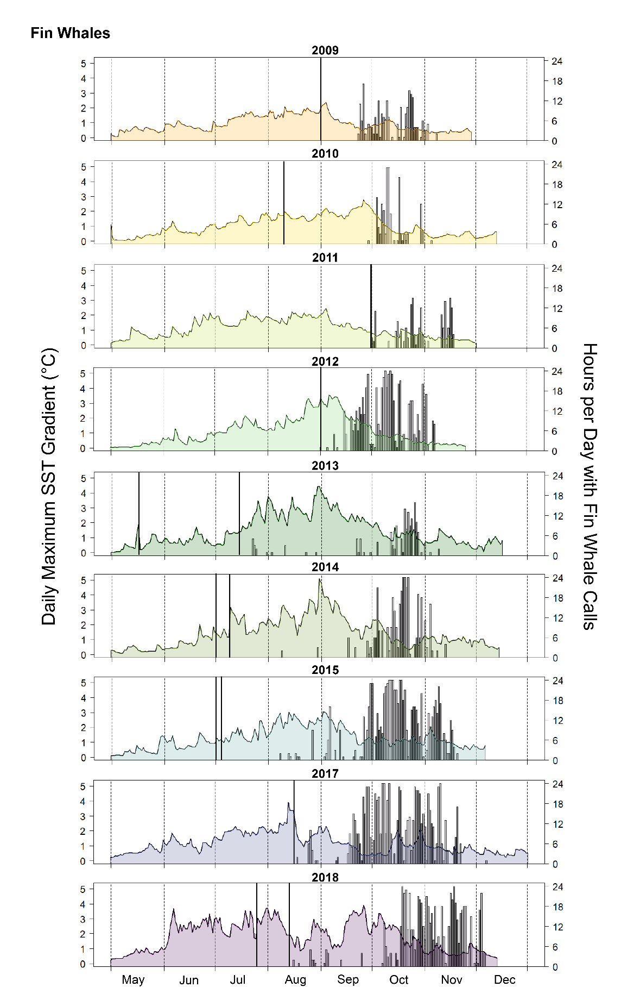
Fig. S4. Plots of the daily maximum sea-surface temperature (SST) gradient (°C) within a 30-km radius of the A3 mooring site for the open-water season of each year (1 May through freeze-up; see Table 2). The SST gradient is a proxy for the presence of a thermal front—the higher the gradient, the stronger the front. Each plot is overlaid with a bar plot of the hours per day with fin whale calls with bold lines indicating the start and end of the recording period.
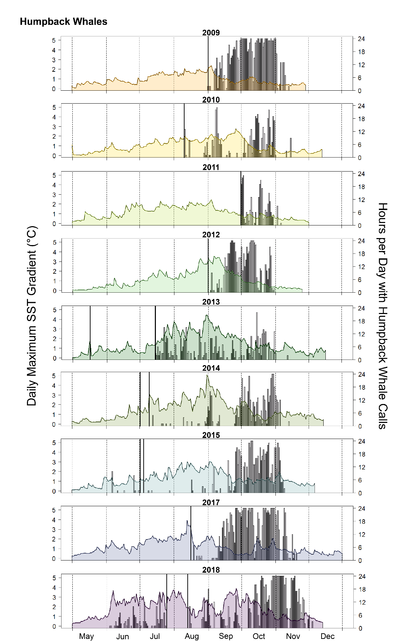
Fig. S5. Plots of the daily maximum sea-surface temperature (SST) gradient (°C) within a 30-km radius of the A3 mooring site for the open-water season of each year (1 May through freeze-up; see Table 2). The SST gradient is a proxy for the presence of a thermal front—the higher the gradient, the stronger the front. Each plot is overlaid with a bar plot of the hours per day with humpback whale calls with bold lines indicating the start and end of the recording period.
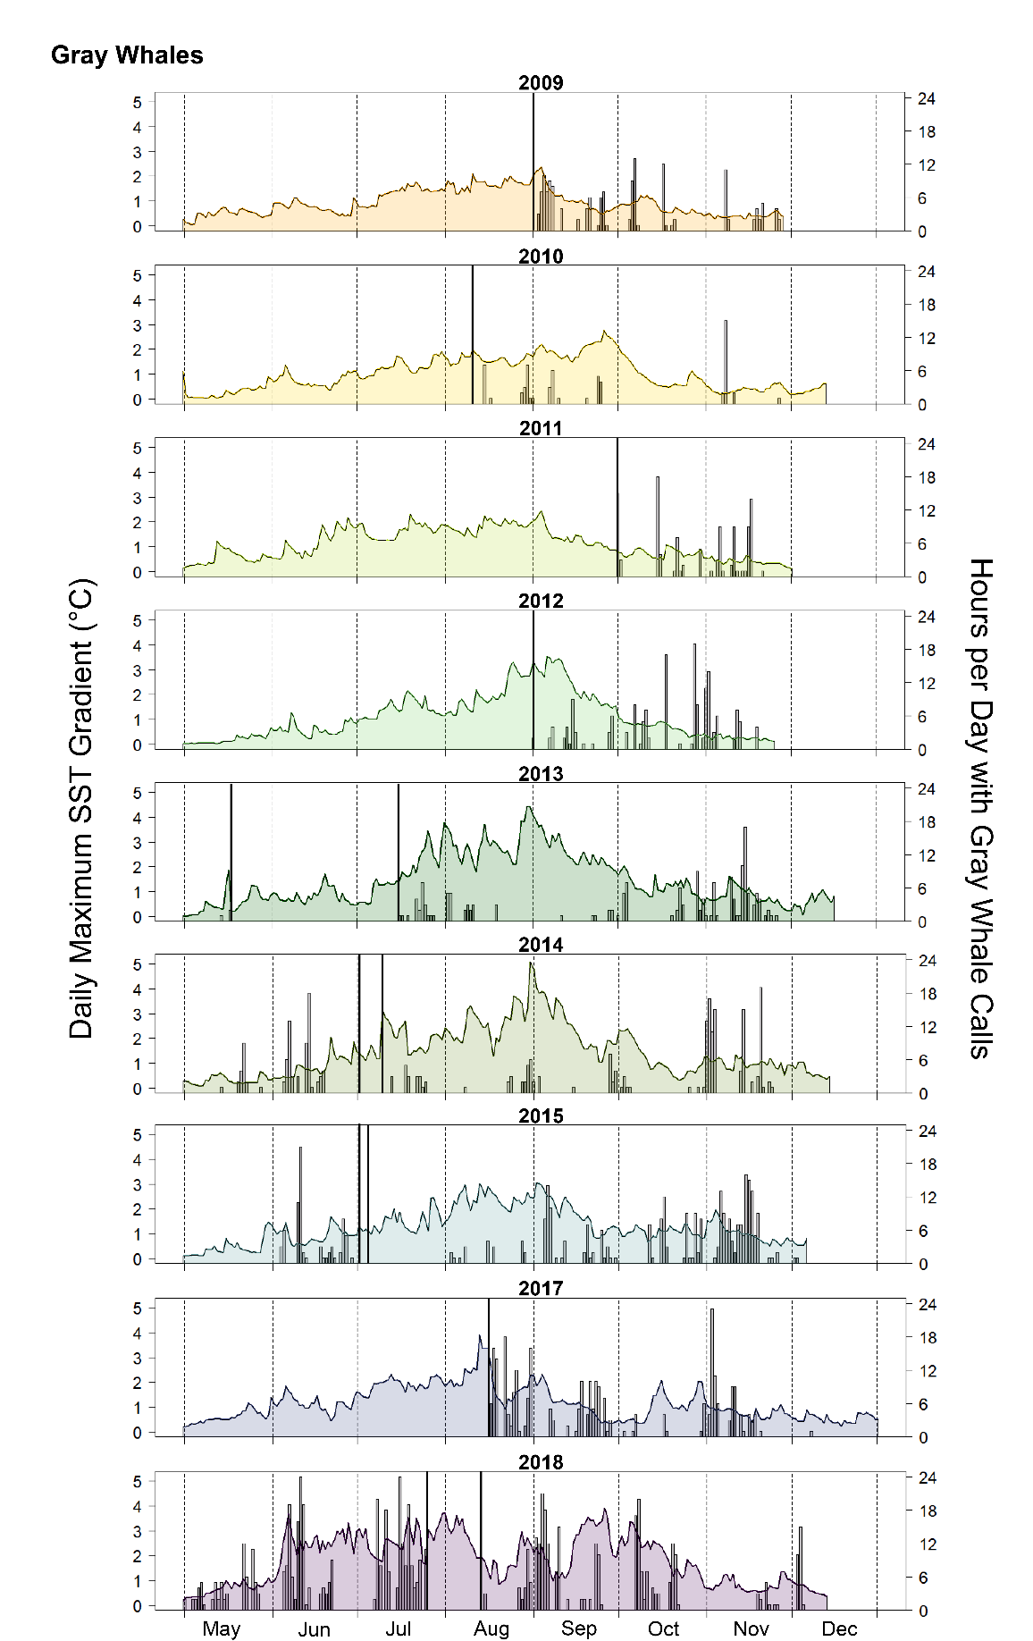
Fig. S6. Plots of the daily maximum sea-surface temperature (SST) gradient (°C) within a 30-km radius of the A3 mooring site for the open-water season of each year (1 May through freeze-up; see Table 2). The SST gradient is a proxy for the presence of a thermal front—the higher the gradient, the stronger the front. Each plot is overlaid with a bar plot of the hours per day with gray whale calls with bold lines indicating the start and end of the recording period.
Fig. S7. Proportion of recordings with gray whale calls by month. Only the years with both spring and fall recordings are shown. In some years, particularly 2013 and 2014, a peak in gray whale calls is evident in the spring and fall, possibly reflecting the spring and fall migration of gray whales into and from the study region.

