Supplementary figure 1. UBA1 dynamics in this study. Fish plots of somatic variants detected in HN patients with UBA1 and other concurrent variants. PV, pathogenic and likely pathogenic variants; VUS, variants of uncertain significance; Y-axis represents normalized VAF (%) and X-axis is the time in months.
Supplementary figure 2. Sigmoidal clone growth models of TET2 and DNMT3A variants in CCUS and MDS patients with wild-type UBA1. (a-b) The optimized sigmoidal growth curves of TET2 (a) and DNMT3A (b) variants with the narrowest 95% CI width. (c-d) The modeling process of TET2 (c) and DNMT3A (d) variant growth involved scanning through α values ranging from 0.02 to 0.25 with a step size of 0.01. The optimal α values were determined based on achieving the smallest widths of the 95% CI.

Supplementary Figures
Supplementary Figure 1.

Supplementary Figure 2.

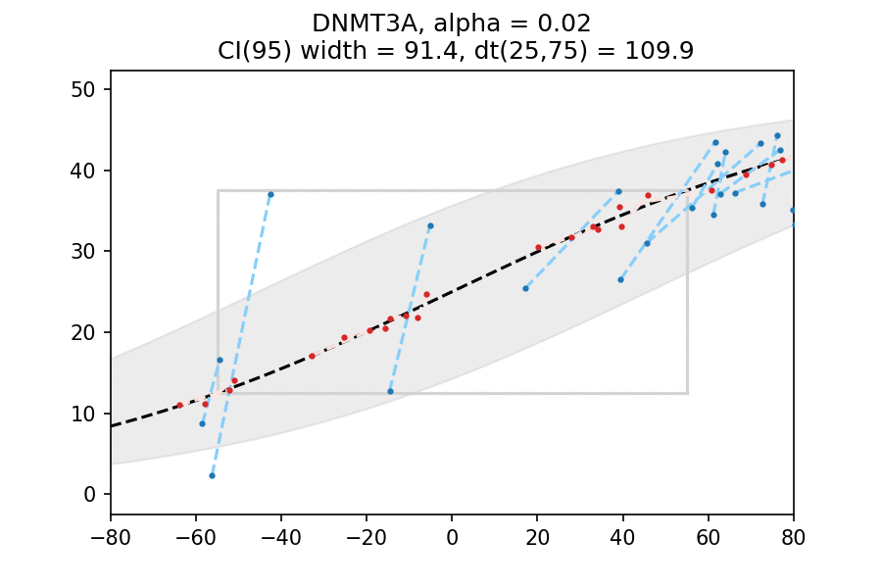
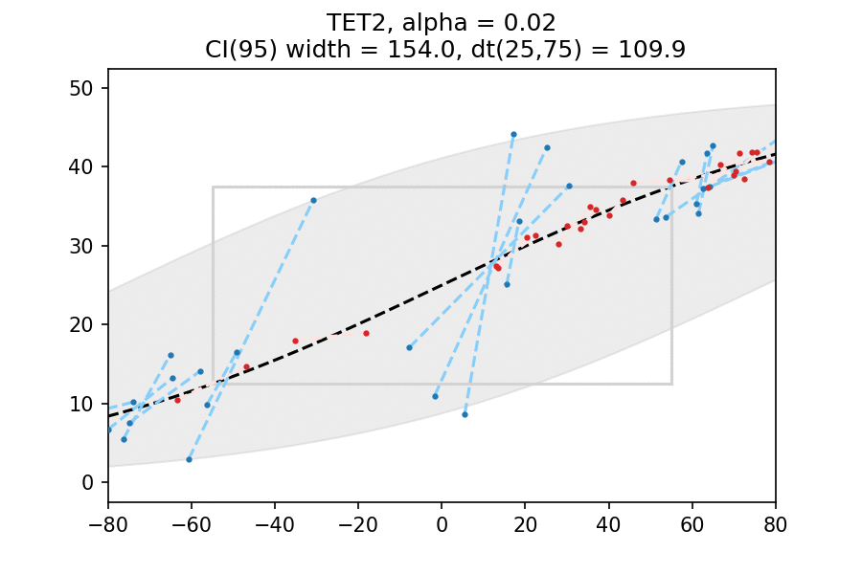

Supplementary Tables
Supplementary Table 1. Genes tested by NGS panels at each institution.

Institutions | Gene lists
Geisinger | ABL1, ANKRD26, ASXL1, ATRX, BCOR, BCORL1, BRAF, BRCC3, BTK, CALR, CBL, CBLB, CBLC, CCND2, CDC25C, CDKN2A, CEBPA, CREBBP, CSF1R, CSF3R, CTCF, CUX1, CXCR4, DCK, DDX41, DHX15, DNMT3A, ENTK1, ETV6, EZH2, FBXW7, FLT3, GATA1, GATA2, GNAS, GNB1, HRAS, IDH1, IDH2, IKZF1, JAK2, JAK3, KDM6A, KIT, KMT2A, KRAS, LUC7L2, MAP2K1, MPL, MYC, MYD88, NF1, NOTCH1, NPM1, NRAS, PDGFRA, PHF6, PIGA, PPM1D, PRPF40B, PTEN, PTPN11, RAD21, RBBP6, RHOA, RPS14, RUNX1, SAMD9, SAMD9L, SETBP1, SF1, SF3A1, SF3B1, SH2B3, SLC29A1, SMC1A, SMC3, SRSF2, STAG2, STAT3, STAT5B, TET2, TP53, U2AF1, U2AF2, UBA1, WT1, XPO1, ZRSR2
OHSU | ABL1, AKT1, ANKRD26, ARID1A, ARID1B, ASXL1, ASXL2, ATG2B, ATM, ATRX, BCL2, BCL6, BCOR, BCORL1, BIRC3, BIRC6, BLM, BRAF, BRCA1, BRCA2, BRCC3, BRD4, BTK, CALR, CARD11, CASP10, CBL, CBLB, CBLC, CCND1, CCND3, CCR4, CD27, CD79A, CD79B, CDH11, CDKN2A, CDKN2C, CEBPA, CHD2, CHEK2, CREBBP, CRLF2, CSF1R, CSF3R, CTCF, CTLA4, CUX1, CXCR4, DAXX, DDX41, DDX54, DHX15, DHX29, DIS3, DNAH5, DNAH9, DNAJC21, DNM2, DNMT1, DNMT3A, DOCK8, DTX1, EED, EFTUD1, EGFR, ELANE, EP300, ERBB4, ETNK1, ETV6, EZH2, FAM47A, FAM5C, FAS, FAT1, FAT4, FBXO11, FBXW7, FLT3, FOXO1, FYN, GATA1, GATA2, GATA3, GNA13, GNAS, GNB1, GSKIP, HAX1, HIST1H1E, HNRNPK, HRAS, HVCN1, ID3, IDH1, IDH2, IGLL5, IKZF1, IKZF3, IL7R, IRF4, JAK1, JAK2, JAK3, KDM6A, KIT, KLF2, KLHL6, KMT2A, KMT2C, KMT2D, KRAS, LLGL2, LRRC4, LUC7L2, MAGT1, MAML1, MAP2K1, MECOM, MED12, MEF2B, MGA, MLH1, MPL, MSH2, MSH6, MYC, MYD88, NAF1, NBN, NF1, NFKBIE, NOTCH1, NOTCH2, NPAT, NPM1, NRAS, NT5C2, NXF1, PAX5, PCLO, PDGFRA, PHF6, PIGA, PIK3CD, PIM1, PLCG1, PLCG2, PMS2, POT1, PPM1D, PRDM1, PRKCB, PRPF40B, PRPF8, PRPS1, PSMB5, PTCH1, PTEN, PTPN11, RAD21, RB1, RBBP6, RELN, RHOA, RIT1, RPS15, RTEL1, RUNX1, RYR1, RYR2, SAMD9, SAMD9L, SAMHD1, SBDS, SETBP1, SETD2, SETDB1, SF1, SF3A1, SF3B, SH2B3, SMARCA2, SMARCB1, SMC1A, SMC3, SOCS1, SPEN, SPI1, SRP72, SRSF2, STAG2, STAT3, STAT5B, STXBP2, SUZ12, SYK, SYNE1, TBL1XR1, TCF3, TCF4, TERC, TERT, TET2, TNFAIP3, TNFRSF14, TP53, TRAF3, U2AF1, U2AF2, UBA1, UBR5, USH2A, VAV1, WAS, WHSC1, WT1, XPO1, ZBTB7A, ZRSR2
Mayo Clinic | ANKRD26, ASXL1, BCOR, BCORL1, BRAF, CALR, CBL, CEBPA, CSF3R, DDX41, DNMT3A, ELANE, ETNK1, ETV6, EZH2, FLT3, GATA1, GATA2, IDH1, IDH2, JAK2, KDM6A, KIT, KRAS, MPL, NF1, NPM1, NRAS, PHF6, PPM1D, PTPN11, RAD21, RUNX1, SETBP1, SH2B3, SF3B1, SMC3, SRSF2, STAG2, STAT3, TERT, TET2, TP53, U2AF1, UBA1, WT1, ZRSR2
ARUP | ANKRD26, ASXL1, ASXL2, BCOR, BCORL1, BRAF, CALR, CBL, CBLB, CEBPA, CSF3R, CUX1, DDX41, DNMT1, DNMT3A, ELANE, ETNK1, ETV6, EZH2, FBXW7, FLT3, GATA1, GATA2, GNAS, HNRNPK, IDH1, IDH2, IL7R, JAK1, JAK2, JAK3, KDM6A, KIT, KMT2A, KRAS, LUC7L2, MPL, NOTCH1, NPM1, NRAS, NSD1, PHF6, PIGA, PPM1D, PRPF40B, PRPF8, PTPN11, RAD21, RUNX1, SAMD9, SAMD9L, SETBP1, SF3B1, SH2B3, SMC1A, SMC3, SRSF2, STAG2, STAT3, STAT5B, SUZ12, TET2, TP53, U2AF1, U2AF2, UBA1, WT1, ZRSR2

Supplementary Table 2. Common genes tested by myeloid mutation NGS panels and transcript ID (RefSeq accession number).
Genes | Accession | Genes |  | Accession | Genes | Accession | Genes | Accession | Genes | Accession | Genes | Accession
ANKRD26 | NM_014915.2 |  | CSF3R | NM_156039.3 | GATA1 | NM_002049.3 | KMT2A | NM_001197104 | PTPN11 | NM_002834.3 | STAG2 | NM_001042749.2
ASXL1 | NM_015338.5 |  | CUX1 | NM_181552.2 | GATA2 | NM_001145661.1 | KRAS | NM_004985.4 | RAD21 | NM_006265.2 | STAT3 | NM_139276.2
BCOR | NM_001123385.1 |  | DDX41 | NM_016222.4 | GNAS | NM_000516.1 | LUC7L2 | NM_016019.1 | RUNX1 | NM_001754.4 | TET2 | NM_001127208.2
BCORL1 | NM_021946.4 |  | DNMT3A | NM_175629.2 | IDH1 | NM_005896.3 | MPL | NM_005373.2 | SETBP1 | NM_015559.2 | TP53 | NM_000546.5
BRAF | NM_004333.4 |  | ETNK1 | NM_018638.4 | IDH2 | NM_002168.3 | NF1 | NM_000267.3 | SF3B1 | NM_012433.3 | UBA1 | NM_003334
CALR | NM_004343.3 |  | ETV6 | NM_001987.4 | JAK2 | NM_004972.3 | NOTCH1 | NM_017617.3 | SH2B3 | NM_005475.3 | U2AF1 | NM_006758.2
CBL | NM_005188.3 |  | EZH2 | NM_004456.4 | JAK3 | NM_000215.3 | NPM1 | NM_002520.6 | SMC1A | NM_006306.2 | U2AF2 | NM_007279.2
CBLB | NM_1706624.2 |  | FBXW7 | NM_018315.5 | KDM6A | NM_001291415.1 | NRAS | NM_002524.5 | SMC3 | NM_005445.3 | WT1 | NM_024426.4
CEBPA | NM_004364.4 |  | FLT3 | NM_004119.2 | KIT | NM_000222.2 | PHF6 | NM_001015877.1 | SRSF2 | NM_003016.4 | ZRSR2 | NM_005089.3

