Table 1.
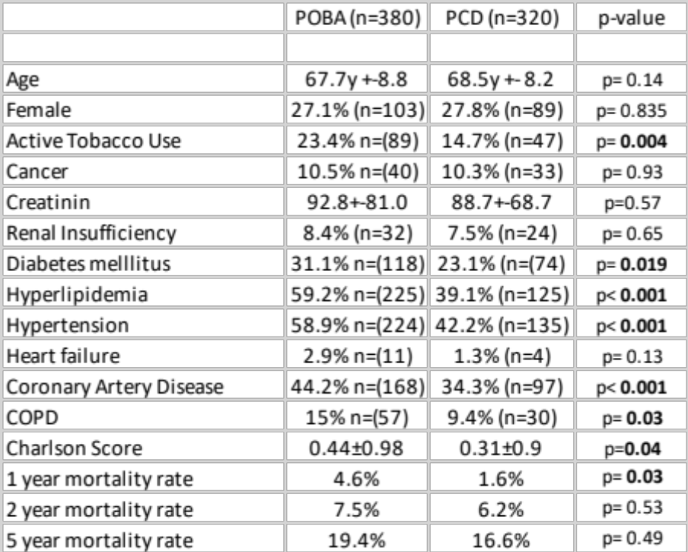
Tab. 1: Comparison of the baseline characteristics of the patients in the PCD and POBA groups and the 1, 2 and 5 years mortality rates.

Table 2.
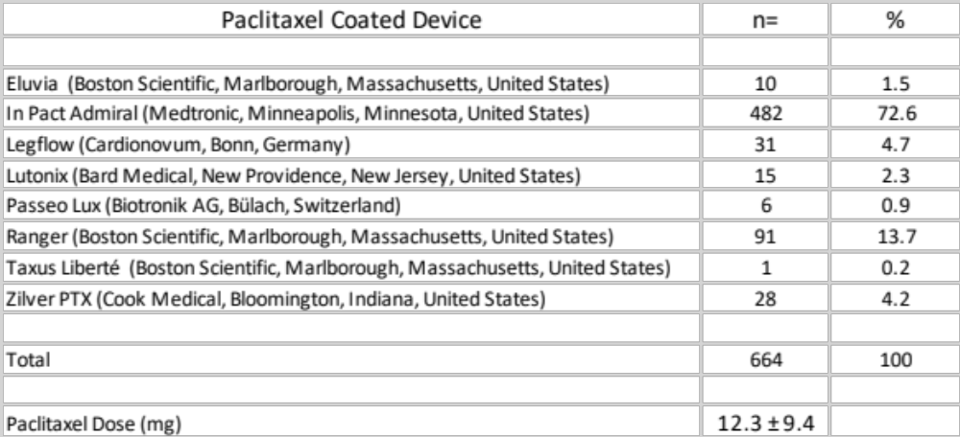
Tab.2: Characteristics of the paclitaxel coated devices used in the PCD group.

Table 3.
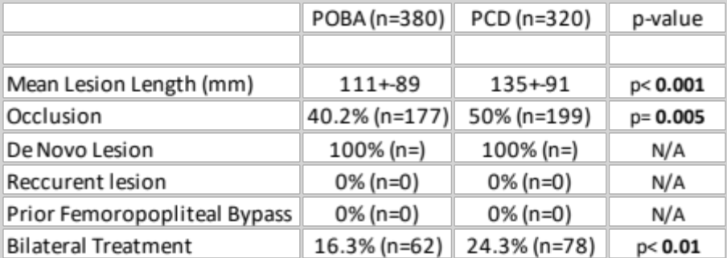
Tab.3: Characteristics of the femoropopliteal lesions in both PCD and POBA groups.

Table 4.
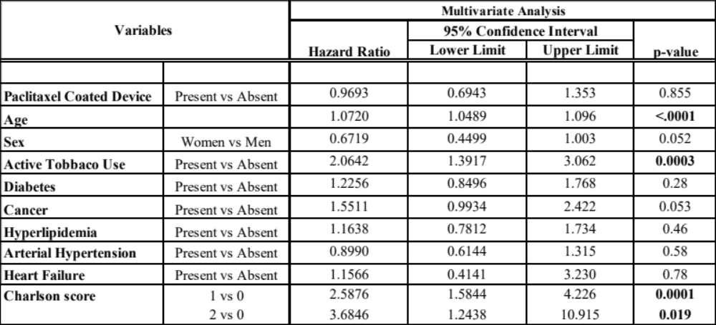Tab.4: Multivariable Cox Regression Analysis for defining the independent factors of all cause death of the entire cohort of patients presenting with claudication and de novo femoropopliteal lesion(s).

