Table 1. Correlations between the MMSE and go/no-go task scores
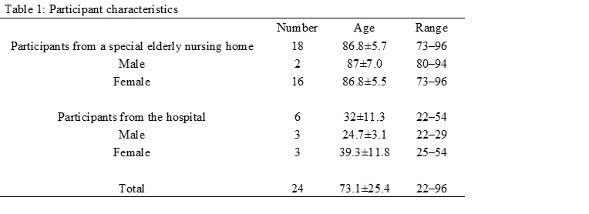

Table 2. Correlations between the MoCA and go/no-go task scores
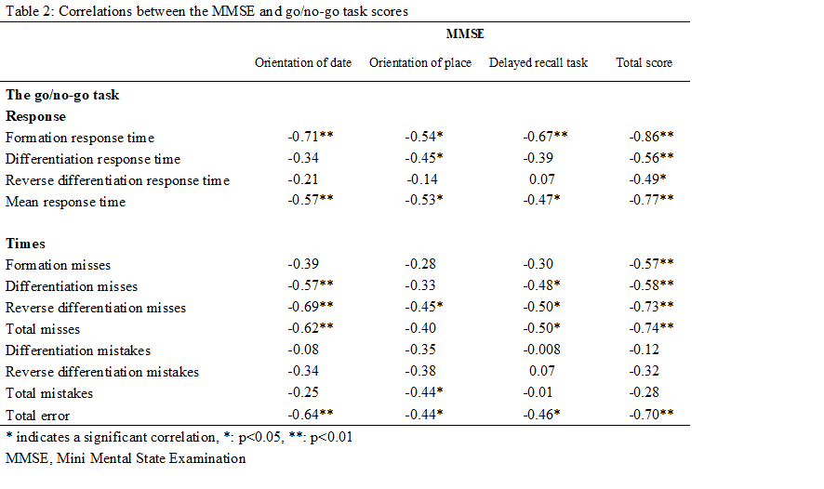

Table 3. Correlations between the total scores of the MoCA and MMSE and that of go/no-go task
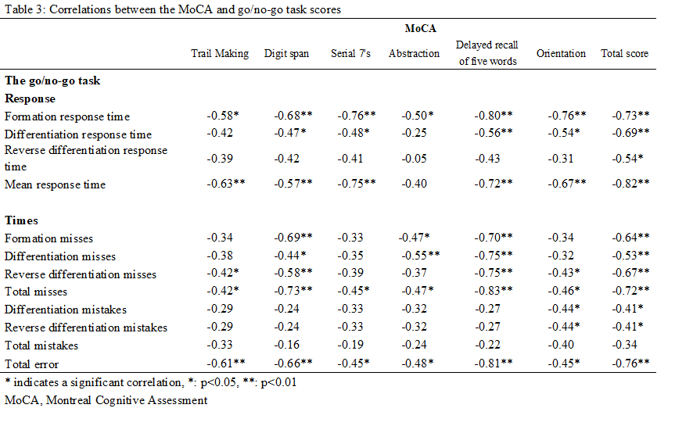

Table 4. Participant characteristics
