Supplementary Material

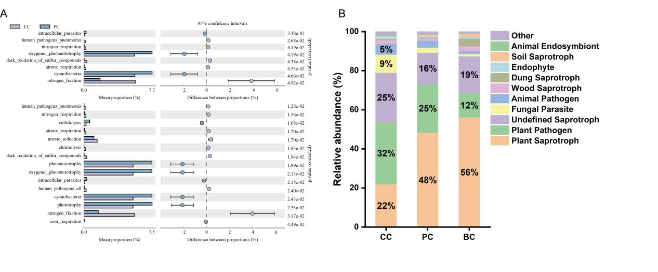
Fig. S1 Functional prediction of rhizosphere soil bacteria and fungi in three treatments

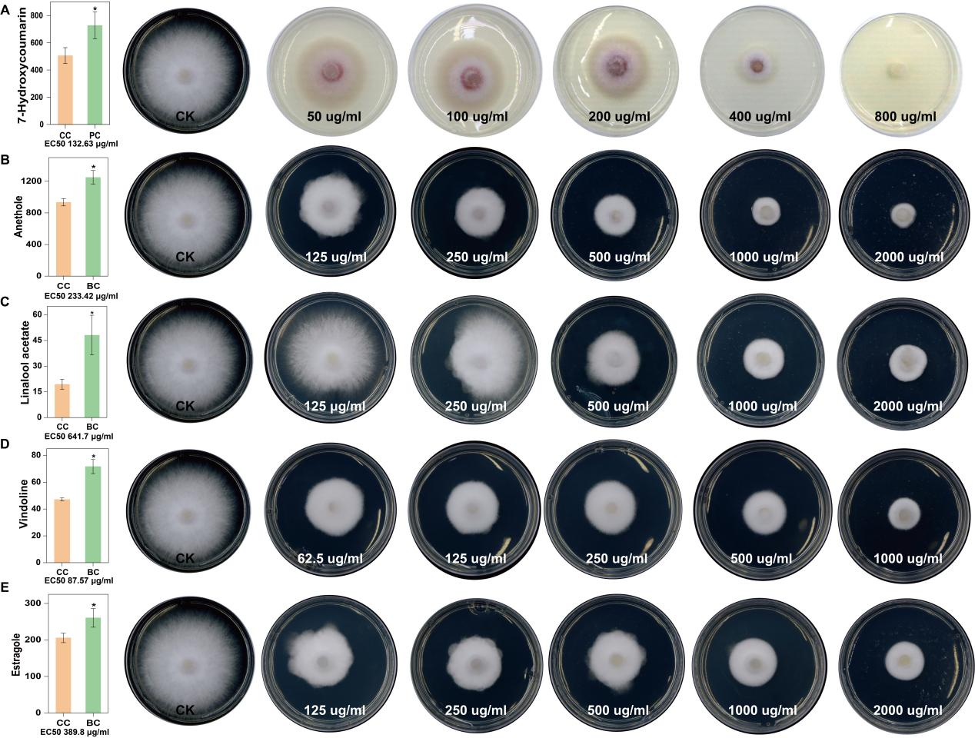
Fig. S2 The relative content of antifungal substances from upregulated metabolites and their EC₅₀ values for Fusarium oxysporum. From top to bottom are 7-hydroxycoumarin (PC), anethole, linalool acetate, vindoline, and estragole (BC), respectively (A-E). The each value (n=3) with * are significantly different (p<0.05).
Method
Verification of antibacterial activity of differential metabolites
The differential metabolites between samples of CC group versus PC group and CC group versus BC group were identified. We screened some substances that may have antibacterial activity from upregulated differential metabolites, including 7-hydroxycoumarin (CC vs PC), anethole, linalool acetate, vindoline, and estragole (CC vs BC). These substances were purchased from Chengdu Biopurify Phytochemicals Ltd.. Strong virulence Fusarium oxysporum f.sp. foetens strain ZJ-3-1 was selected, and was maintained at -80°C in 20% glycerol in the Academic of Pharmacy, Hubei University of Chinese Medicine. Mixed the required concentration of selected substances solution with potato dextrose agar (PDA) medium, and poured them into a 6 cm flat plate. The 5 mm cakes of ZJ-3-1 were placed in the center of PDA medium with different metabolites. Then the PDA plates were put into in a 25 ℃ incubator for culture with 3 replicates per group. On the 3rd day, the colony diameter were measured, mycelial growth inhibition rate and EC₅₀ value were calculated.

