PAGE
Fig.1E
Fig.1F
WB Si Circ4207(SW480) Fig.6C
actin
VEGFA
VEGFR1
VEGFR2
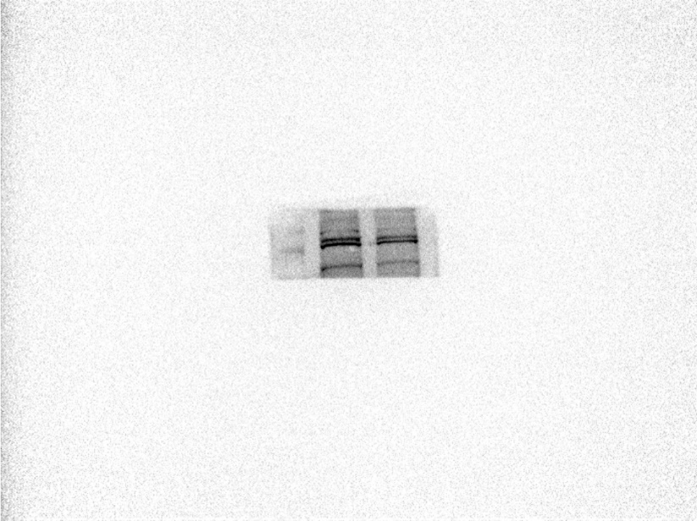
WB-Si Circ4207(Caco2)
Actin
VEGFA
VEGFR1
VEGFR2
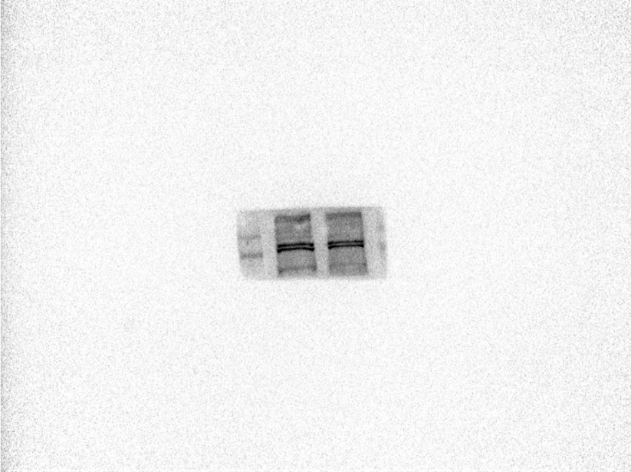

WB miR mimics inhibitor (SW480) Fig.6D
Actin
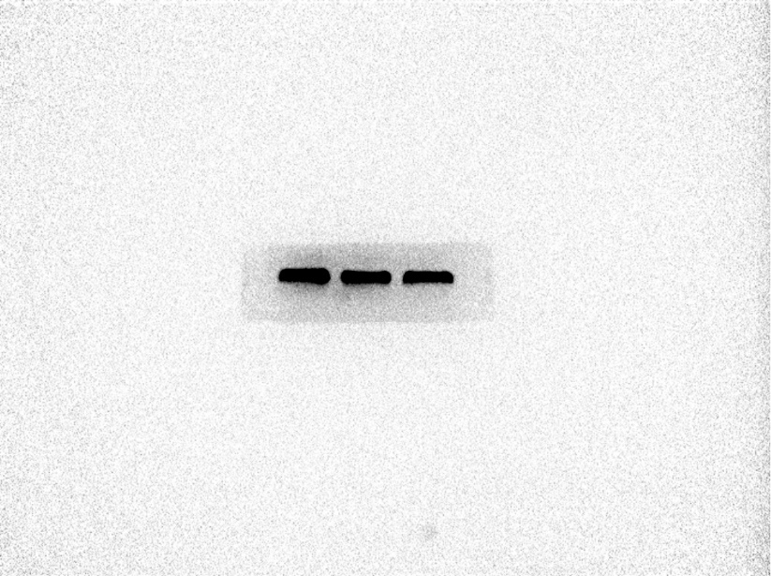
VEGFA
VEGFR1
VEGFR2
WB-miR mimics inhibitor (Caco2)
Actin
VEGFA
VEGFR1
VEGFR2

