Supplementary Materials
Static and Dynamic Connectivity Structure of White-Matter Functional Network across the Adult Lifespan
Zeqiang LinLi^{1,2} Ph.D., Kang Hu³ Ph.D., Qingdong Guo⁴ M.Sc., Shuixia Guo^{2,5} Ph.D.
Author Affiliations:
¹ School of Mathematics and Statistics, Guangdong University of Foreign Studies, Guangzhou 510004, P.R. China
² MOE-LCSM, School of Mathematics and Statistics, Hunan Normal University, Changsha 410006, P. R. China
³ School of Information Engineering, Wuhan Business University, Wuhan 430056, P.R. China
⁴ School of Mathematical Sciences, Xiamen University, Xiamen 361005, P.R. China
⁵ Key Laboratory of Applied Statistics and Data Science, Hunan Normal University, College of Hunan Province, Changsha 410006, P.R. China

Contents
Supporting Information 1
MRI acquisition of SALD 2
Replication Dataset 2
Neuroimaging Data Preprocessing 3
Creation of WM and GM Group-level Masks 4
Identification of Large-scale Brain Functional Network 5
Supplementary Tables 6
Supplementary Figures 12

MRI acquisition of SALD
All of the data were collected at the Southwest University Center for Brain Imaging using a 3.0-T Siemens Trio MRI scanner (Siemens Medical, Erlangen, Germany). Each participant took part in 3D sMRI and rs-fMRI scans. The scan parameters were as follows. A magnetization-prepared rapid gradient echo (MPRAGE) sequence was used to acquire high-resolution T1-weighted anatomical images (repetition time=1,900 ms, echo time=2.52 ms, inversion time=900 ms, flip angle=90 degrees, resolution matrix=256 × 256, slices=176, thickness =1.0 mm, and voxel size =1 × 1 × 1 mm³). During the resting-state MRI scan, the subjects were instructed to lie down, close their eyes, and rest without thinking about any specific thing but to refrain from falling asleep. The 8- min scan of 242 contiguous whole-brain resting-state functional images was obtained using gradient echo echo-planar-imaging (GRE-EPI) sequences with the following parameters: slices =32, repetition time (TR)/echo time (TE)=2000/30 ms, flip angle=90, field of view (FOV) =220 × 220 mm, thickness/ slice gap=3/1 mm, and voxel size=3.4 × 3.4 × 4 mm³.

Replication Dataset
The National Institute of Mental Health (NIMH) Intramural Healthy Volunteer Dataset, a comprehensive dataset encompassing clinical assessments, mood-related psychometrics, cognitive function neuropsychological tests, and structural and functional magnetic resonance imaging (fMRI), was recruited as a replication dataset to validate the results. Participants had the opportunity to participate in optional magnetic resonance imaging (MRI) and magnetoencephalography (MEG) studies. The MRI protocol initially followed the ADNI-3 basic protocol but was subsequently modified to incorporate elements of the ABCD protocol. Detailed information regarding the image acquisition protocol and parameters can be found on the website (https://openneuro.org/datasets/ds004215/).
Utilizing nine white matter functional networks (WM-FNs) and twelve gray matter functional networks (GM-FNs) derived from the main study, network BOLD signals were extracted and used to construct static and dynamic white matter functional network connectivity (WM-FNC) and white matter-gray matter functional network connectivity (WM-GM FNC) analyses.

Neuroimaging Data Preprocessing
All acquired images were subjected to preprocessing using a combination of the SPM12 toolbox (http://www.fil.ion.ucl.ac.uk/spm/software/spm12), DPARSF (version 5.4, http://rfmri.org/DPARSF) toolboxes, and customized scripts inspired by the work of (Peer et al. 2017). As depicted in Figure 1A, the preprocessing steps involved in this study were as follows: (1) Removal of the initial 7 time points to exclude signal fluctuation (resulting in total of 235 time-points for each rs-fMRI scan). (2) Slice timing correction to compensate for temporal differences between slices. (3) Head movement correction using a 24-parameter rigid-body transformation and realignment to the mean functional image, with excessive motion (mean FD>0.2 mm) were excluded from further analysis. (4) Co-registration of the functional images with the corresponding T1-weighted images. (5) Segmentation of the T1-weighted images into GM, WM, and cerebrospinal fluid (CSF) using the DARTEL (Diffeomorphic Anatomical Registration Through Exponentiated Lie Algebra) method. (6) Removal of confounding signals, including the mean CSF signal and the 24 rigid-body motion parameters, note global signal regression was not performed due to its controversial nature. (7) Temporal scrubbing was conducted using motion spikes (FD > 0.5 mm, along with one-forward and two-back neighbors) as separate regressors. (8) Removal of linear trends to correct signal drift caused by other disturbances. (9) Bandpass filtering with a passband of 0.01~0.15 Hz to attenuate non-neuronal contributions. (10) Separate smoothing of the WM and GM images using a 4-mm full-width at half-maximum (FWHM) Gaussian kernel. The smoothing was performed within the WM and GM masks, generated from individual segmented tissue probability maps (TPM) (thresholded at 0.5) specific to each subject. (11) Combination of the smoothed GM and WM images, followed by normalization to Montreal Neurological Institute (MNI) space and resampling to 3 mm³ voxels using the DARTEL algorithm.

Creation of WM and GM Group-level Masks
As presented in Figure 1B, the initial group masks for WM and GM were derived by performing T1 image segmentation on each subject. Specifically, each voxel in the whole brain was categorized into GM, WM, and CSF based on the maximum probability from TPM, resulting in a binary combination mask for each subject. The individual masks were then averaged across all subjects, yielding the initial group-level WM and GM masks. Then, to determine the composition of each voxel as WM or GM, the percentage of subjects classifying them as such was calculated. Inclusion of a voxel in the WM mask required its presence in at least 60% of the subjects, while for the GM mask, a minimum presence of 20% across subjects was needed. Notably, any voxels present in both the WM and GM masks were excluded from the final set of identified GM voxels. Furthermore, the Harvard-Oxford Atlas (Desikan et al. 2006), providing definitions for subcortical structures, was used to accurately categorize deep brain structures. Specifically, we utilized the atlas to identify and label voxels corresponding to the thalamus, caudate nucleus, putamen, globus pallidus, and nucleus accumbens as GM, thereby removing them from the WM mask. Finally, the obtained mask was compared with subjects’ mean functional images, and regions where over 80% of the identified voxels corresponded to functional images were designated as part of the group-level WM or GM masks. Ultimately, the group WM and GM masks consisted of 19018 voxels and 38176 voxels respectively.

Identification of Large-scale Brain Functional Network
As shown in Figure 1C, to mitigate the calculative complexity of clustering, we employed an interchanging grid to subsample the group WM mask. This involved selecting every second voxel along the image rows and columns, with a shift of 1 between slices to minimize the occurrence of missing columns in the data, resulting in a subsampled mask consisting of 4768 voxels. Following this, the correlation pattern between each WM voxel and the subsampled voxel was calculated using the Pearson correlation coefficient for each subject. These correlation values were then averaged across all 440 subjects to obtain the group-level correlation matrix (19018*4768).
K-means clustering (distance metric-correlation, 10 replications) was performed on the above group-level correlation matrix to obtain the WM FNs. We explored the number of clusters ranging from 2 to 22. To identify the optimal number of WM FNs, we employed cross-validation (CV) and the Dice coefficient (Yeo et al. 2011). Specifically, the correlation matrix was randomly divided into four folds, and the eigenvalues of each voxel were equally split into four parts. For each number of clusters, we performed the clustering process separately on each fold and analyzed the similarity between the resulting clusters. To measure the similarity of clustering across different folds, we generated an adjacency matrix for each fold and compared them using the Dice coefficient. The Dice coefficient provides an indication of similarity, with categories including low (0-0.19) to moderate (0.2-0.39), moderate (0.4-0.59), moderate to high (0.6-0.79), or high (0.8-1). In this study, we set a threshold of 0.85 for the Dice coefficient. The average Dice coefficient, calculated by comparing each fold's adjacency matrix with the others, was used to assess the stability of each clustering configuration. Based on the stability analysis, a number of stable clusters were found at 2, 3, 5, 7, and 9 clusters. We selected the most detailed level of clustering, which consisting of 9 WM FNs.

Supplementary Tables

Table S1. WM-FNC pair with significant age effect
 | β_{Age} | T-value | P-value | Q-value
WM1-2 | 0.21 | 4.33 | 1.86E-05 | 1.11E-04
WM1-3 | 0.31 | 6.47 | 2.57E-10 | 4.91E-09
WM1-7 | 0.16 | 3.25 | 1.23E-03 | 4.42E-03
WM2-3 | -0.19 | -3.84 | 1.40E-04 | 6.31E-04
WM2-4 | 0.20 | 4.02 | 6.80E-05 | 3.50E-04
WM2-5 | 0.22 | 4.61 | 5.39E-06 | 3.88E-05
WM2-7 | 0.14 | 2.89 | 4.03E-03 | 1.21E-02
WM2-8 | 0.31 | 6.46 | 2.73E-10 | 4.91E-09
WM3-4 | 0.25 | 5.16 | 3.70E-07 | 3.33E-06
WM3-5 | 0.17 | 3.40 | 7.45E-04 | 2.98E-03
WM3-7 | 0.15 | 3.02 | 2.71E-03 | 8.88E-03
WM3-8 | 0.27 | 5.46 | 7.97E-08 | 9.56E-07
 | β_{Age2} | T-value | P-value | Q-value | Peak Age
WM2-9 | -0.14 | -2.43 | 1.55E-02 | 3.71E-02 | 55.03
WM5-9 | -0.16 | -2.81 | 5.12E-03 | 1.42E-02 | 38.75
WM8-9 | -0.14 | -2.44 | 1.52E-02 | 3.71E-02 | 35.83
Note. The upper half of the table represents the first-order effects, while the lower half represents the second-order effects.

Table S2. Dynamic WM-FNC pair with significant age effect
 | β_{Age} | T-value | P-value | Q-value
WM3-1 | -0.20 | -4.01 | 7.18E-05 | 2.59E-03
WM4-3 | -0.18 | -3.59 | 3.67E-04 | 6.61E-03
WM8-3 | -0.17 | -3.34 | 9.12E-04 | 1.09E-02
 | β_{Age2} | T-value | P-value | Q-value | Peak Age
WM9-5 | 0.18 | 3.02 | 4.51E-02 | 2.43E-02 | 38.57
WM9-8 | -0.16 | -2.76 | 3.08E-01 | 4.33E-02 | 40.80

Table S3. WM-GM FNC pair with significant age effect
 | β_{Age} | T-value | P-value | Q-value
WM1-GM1 | 0.29 | 6.31 | 6.68E-10 | 3.61E-09
WM1-GM3 | 0.26 | 5.35 | 1.42E-07 | 4.51E-07
WM1-GM5 | 0.29 | 6.20 | 1.30E-09 | 6.67E-09
WM1-GM7 | 0.29 | 5.88 | 8.09E-09 | 3.49E-08
WM1-GM8 | 0.11 | 2.19 | 2.94E-02 | 4.40E-02
WM1-GM9 | 0.26 | 5.40 | 1.12E-07 | 3.78E-07
WM1-GM10 | 0.34 | 7.43 | 5.78E-13 | 3.90E-12
WM1-GM11 | 0.23 | 4.65 | 4.48E-06 | 1.24E-05
WM1-GM12 | 0.25 | 5.43 | 9.31E-08 | 3.24E-07
WM2-GM1 | 0.41 | 8.88 | 1.76E-17 | 2.11E-16
WM2-GM3 | 0.35 | 7.52 | 3.21E-13 | 2.48E-12
WM2-GM4 | 0.45 | 10.10 | 1.13E-21 | 6.09E-20
WM2-GM5 | 0.39 | 8.20 | 2.67E-15 | 2.22E-14
WM2-GM7 | 0.40 | 8.69 | 7.30E-17 | 7.89E-16
WM2-GM9 | 0.33 | 6.94 | 1.43E-11 | 9.09E-11
WM2-GM10 | 0.42 | 9.20 | 1.46E-18 | 2.25E-17
WM2-GM11 | 0.28 | 5.87 | 8.43E-09 | 3.50E-08
WM2-GM12 | 0.41 | 9.21 | 1.36E-18 | 2.25E-17
WM3-GM1 | 0.45 | 10.04 | 1.84E-21 | 6.61E-20
WM3-GM2 | 0.15 | 2.99 | 2.92E-03 | 5.34E-03
WM3-GM3 | 0.41 | 8.94 | 1.12E-17 | 1.52E-16
WM3-GM4 | 0.43 | 9.42 | 2.58E-19 | 5.58E-18
WM3-GM6 | 0.22 | 4.39 | 1.40E-05 | 3.68E-05
WM3-GM7 | 0.46 | 10.11 | 9.82E-22 | 6.09E-20
WM3-GM8 | 0.40 | 8.50 | 3.06E-16 | 3.00E-15
WM3-GM9 | 0.32 | 6.85 | 2.50E-11 | 1.50E-10
WM3-GM10 | 0.45 | 9.90 | 5.72E-21 | 1.55E-19
WM3-GM11 | 0.32 | 6.57 | 1.46E-10 | 8.33E-10
WM3-GM12 | 0.38 | 8.29 | 1.42E-15 | 1.28E-14
WM4-GM1 | 0.28 | 6.02 | 3.70E-09 | 1.74E-08
WM4-GM3 | 0.13 | 2.66 | 8.11E-03 | 1.37E-02
WM4-GM5 | 0.23 | 4.76 | 2.61E-06 | 7.42E-06
WM4-GM7 | 0.20 | 4.06 | 5.83E-05 | 1.40E-04
WM4-GM9 | 0.16 | 3.30 | 1.05E-03 | 2.07E-03
WM4-GM10 | 0.17 | 3.39 | 7.55E-04 | 1.54E-03
WM4-GM12 | 0.26 | 5.55 | 4.92E-08 | 1.83E-07
WM5-GM1 | 0.23 | 4.87 | 1.53E-06 | 4.48E-06
WM5-GM3 | 0.28 | 5.84 | 1.04E-08 | 4.17E-08
WM5-GM4 | 0.13 | 2.74 | 6.39E-03 | 1.10E-02
WM5-GM5 | 0.12 | 2.47 | 1.38E-02 | 2.25E-02
WM5-GM7 | 0.21 | 4.37 | 1.52E-05 | 3.92E-05
WM5-GM10 | 0.22 | 4.43 | 1.17E-05 | 3.16E-05
WM5-GM11 | 0.20 | 3.95 | 8.95E-05 | 2.01E-04
WM6-GM1 | 0.27 | 5.60 | 3.88E-08 | 1.50E-07
WM6-GM3 | 0.21 | 4.30 | 2.13E-05 | 5.23E-05
WM6-GM4 | 0.25 | 5.04 | 6.91E-07 | 2.07E-06
WM6-GM5 | 0.25 | 5.18 | 3.42E-07 | 1.05E-06
WM6-GM7 | 0.29 | 5.90 | 7.23E-09 | 3.26E-08
WM6-GM8 | 0.18 | 3.63 | 3.13E-04 | 6.75E-04
WM6-GM9 | 0.17 | 3.41 | 7.19E-04 | 1.49E-03
WM6-GM10 | 0.26 | 5.36 | 1.34E-07 | 4.39E-07
WM6-GM11 | 0.14 | 2.79 | 5.45E-03 | 9.74E-03
WM6-GM12 | 0.21 | 4.34 | 1.77E-05 | 4.44E-05
WM7-GM7 | 0.11 | 2.26 | 2.43E-02 | 3.75E-02
WM7-GM10 | 0.20 | 4.02 | 6.98E-05 | 1.64E-04
WM8-GM1 | 0.26 | 5.51 | 6.12E-08 | 2.20E-07
WM8-GM4 | 0.28 | 6.11 | 2.25E-09 | 1.10E-08
WM8-GM5 | 0.19 | 3.96 | 8.61E-05 | 1.98E-04
WM8-GM6 | -0.12 | -2.45 | 1.48E-02 | 2.38E-02
WM8-GM7 | 0.18 | 3.78 | 1.79E-04 | 3.94E-04
WM8-GM9 | 0.13 | 2.76 | 5.94E-03 | 1.04E-02
WM8-GM10 | 0.17 | 3.45 | 6.05E-04 | 1.28E-03
WM8-GM12 | 0.34 | 7.47 | 4.37E-13 | 3.15E-12
 | β_{Age2} | T-value | P-value | Q-value | Peak Age
WM5-GM6 | -0.19 | -3.21 | 1.44E-03 | 2.78E-03 | 46.47
WM7-GM2 | -0.18 | -3.15 | 1.76E-03 | 3.33E-03 | 31.90
WM7-GM6 | -0.19 | -3.34 | 9.09E-04 | 1.82E-03 | 42.90
WM9-GM1 | -0.14 | -2.38 | 1.78E-02 | 2.79E-02 | 41.85
WM9-GM8 | -0.16 | -2.79 | 5.50E-03 | 9.74E-03 | 37.93
WM9-GM9 | -0.18 | -3.10 | 2.06E-03 | 3.83E-03 | 44.72
WM9-GM10 | -0.14 | -2.50 | 1.28E-02 | 2.12E-02 | 45.20
WM9-GM11 | -0.14 | -2.41 | 1.62E-02 | 2.57E-02 | 41.36
WM9-GM12 | -0.12 | -2.21 | 2.75E-02 | 4.19E-02 | 43.50
Note. The upper half of the table represents the first-order effects, while the lower half represents the second-order effects.

Table S4. Dynamic WM-GM FNC pair with significant age effect
 | β_{Age} | T-value | P-value | Q-value
WM1-GM1 | -0.25 | -5.13 | 4.39E-07 | 4.41E-05
WM1-GM3 | -0.18 | -3.50 | 5.19E-04 | 5.61E-03
WM1-GM4 | -0.15 | -2.98 | 3.07E-03 | 1.95E-02
WM1-GM5 | -0.18 | -3.65 | 2.97E-04 | 4.00E-03
WM1-GM7 | -0.23 | -4.63 | 4.90E-06 | 1.76E-04
WM1-GM10 | -0.22 | -4.46 | 1.03E-05 | 2.79E-04
WM3-GM1 | -0.15 | -3.07 | 2.28E-03 | 1.69E-02
WM3-GM3 | -0.24 | -5.00 | 8.16E-07 | 4.41E-05
WM3-GM4 | -0.16 | -3.18 | 1.59E-03 | 1.32E-02
WM3-GM11 | -0.14 | -2.85 | 4.54E-03 | 2.33E-02
WM4-GM1 | -0.18 | -3.61 | 3.39E-04 | 4.07E-03
WM4-GM5 | -0.14 | -2.69 | 7.42E-03 | 3.08E-02
WM4-GM7 | -0.14 | -2.75 | 6.13E-03 | 2.99E-02
WM5-GM3 | -0.16 | -3.23 | 1.35E-03 | 1.21E-02
WM5-GM10 | -0.15 | -2.93 | 3.62E-03 | 2.06E-02
WM7-GM2 | 0.14 | 2.74 | 6.36E-03 | 2.99E-02
WM8-GM4 | -0.20 | -4.10 | 5.02E-05 | 9.90E-04
WM8-GM5 | -0.15 | -3.04 | 2.50E-03 | 1.69E-02
WM8-GM7 | -0.17 | -3.36 | 8.48E-04 | 8.33E-03
WM8-GM12 | -0.18 | -3.79 | 1.74E-04 | 2.69E-03
 | β_{Age2} | T-value | P-value | Q-value | Peak Age
WM1-GM11 | 0.16 | 2.71 | 6.96E-03 | 3.01E-02 | 40.40
WM2-GM8 | 0.16 | 2.96 | 3.26E-03 | 1.96E-02 | 61.31
WM7-GM6 | 0.24 | 4.07 | 5.50E-05 | 9.90E-04 | 42.79
WM9-GM1 | 0.16 | 2.72 | 2.48E-03 | 3.01E-02 | 42.77
WM9-GM3 | 0.17 | 2.87 | 4.30E-03 | 2.32E-02 | 38.46
WM9-GM4 | -0.18 | -3.04 | 6.78E-03 | 1.69E-02 | 40.59
WM9-GM11 | 0.15 | 2.63 | 8.85E-03 | 3.54E-02 | 37.75
Note. The upper half of the table represents the first-order effects, while the lower half represents the second-order effects.

Table S5 Correlation of state index and age
State Index | r | P_{FDR}
Transition probability of 1-2 | －0.12 | 1.80×10⁻⁰²
Transition probability of 1-3 | 0.13 | 1.01×10⁻⁰²
Transition probability of 2-1 | 0.14 | 8.53×10⁻⁰³
Proportion of State 2 | －0.26 | 1.18×10⁻⁰⁷
Proportion of State 3 | 0.23 | 1.35×10⁻⁰⁶
Dwell time of State 2 | －0.16 | 8.74×10⁻⁰⁴
Dwell time of State 3 | 0.21 | 3.61×10⁻⁰⁵

Supplementary Figures
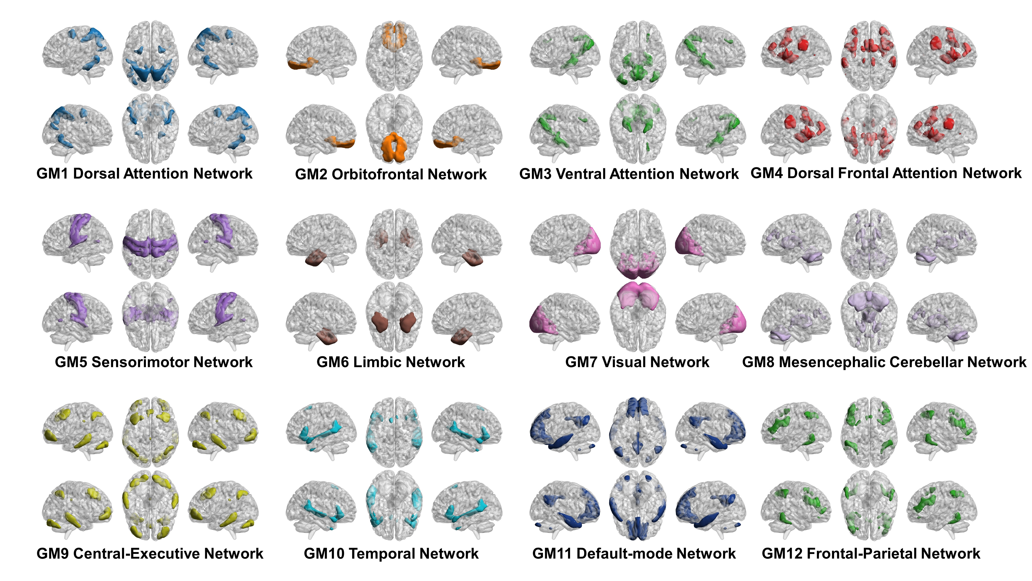

Figure S1. Large-scale brain gray matter functional networks.
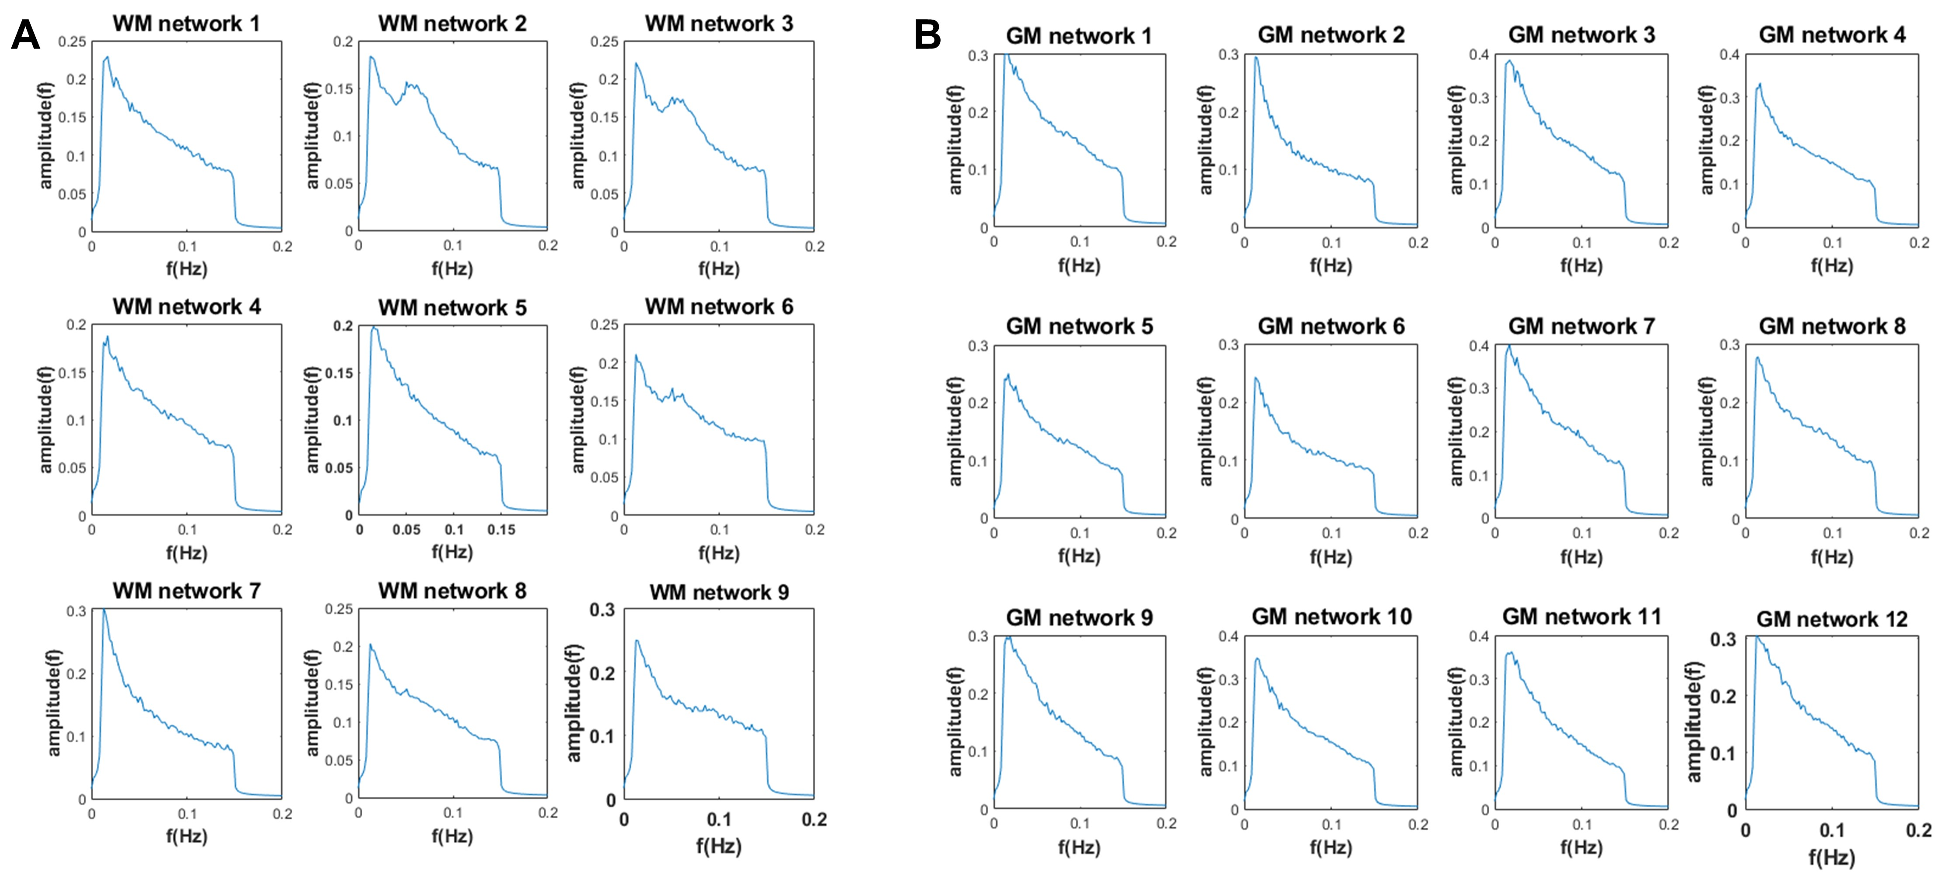

Figure S2. Power frequency graphs for the (A) 9 white-matter functional network and (B) 12 gray-matter functional network.

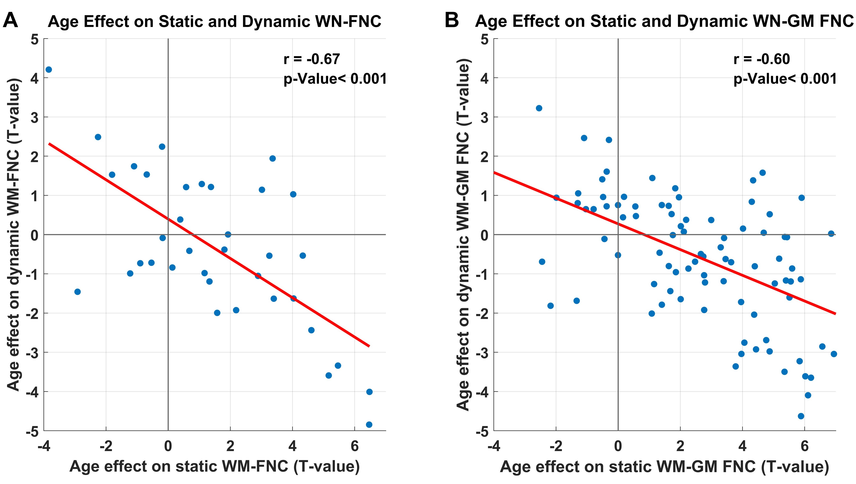

Figure S3. Correlation of age effect (T-value) on static and dynamic FNC in (A) WM-FNC and (B) WM-GM FNC analysis.

Figure S4. The results of the validation analyses of changing in windows length and step.
A. By changing the window length and conducting dynamic functional network connectivity (dFNC) analysis again, the results showed highly consistent effect sizes with the main results, whether it was for WM-dFNC or WM-GM dFNC. Additionally, three brain states that repeatedly appeared were identified, which exhibited similar patterns to the states observed in the main results. B. By changing the step length and conducting dynamic functional network connectivity (dFNC) analysis again, the results showed highly consistent effect sizes with the main results, whether it was for WM-dFNC or WM-GM dFNC. Similarly, three brain states that repeatedly appeared were identified, which exhibited similar patterns to the states observed in the main results.

Figure S5. The results of the validation analyses of changing in number of networks (7WM-FNs, 10GM-FNs).
A. The overall connectivity strength of WM-FNC and WM-GM FNC showed a significant positive correlation with age. B. The t-value distribution plots of static and dynamic WM-FNC and WM-GM FNC analyses were compared with the t-value distribution plots of the main results using kernel density estimation. The p-values were obtained through the Kolmogorov-Smirnov test, with the null hypothesis being that there is no difference between the two distributions. C. Three brain states that repeatedly appeared were identified through cluster analysis, and they exhibited similar patterns to the states observed in the main results.

Figure S6. The results of the validation analyses of replication dataset.
A. The overall connectivity strength of WM-FNC and WM-GM FNC showed a significant positive correlation with age. B. The t-value distribution plots of dynamic WM-FNC and WM-GM FNC analyses were compared with the t-value distribution plots of the main results using kernel density estimation. The p-values were obtained through the Kolmogorov-Smirnov test, with the null hypothesis being that there is no difference between the two distributions. C. Three brain states that repeatedly appeared were identified through cluster analysis, and they exhibited similar patterns to the states observed in the main results.

