An Integrated Multi-omics Mendelian Randomization Identifies Predictive Transcription Gene Signature of Liver Fibrosis

Supplementary Fig.S1 Illustration of the other genes in all the validation cohorts (representative genes shown in Fig.3A)
Supplementary Fig.S2 Network analysis results of key genes and metabolites.

Supplementary Table S1. Demographic and clinical characteristic of patients with NAFLD in two independent validation Cohort.
Supplementary Table S2. Metabolites appearing in at least two different datasets across the five studies
Supplementary Table S3. Data sources for Genes
Supplementary Table S4. Data sources for Metabolites
Supplementary Table S5. Data sources for NASH
Supplementary Table S6. Causal effects of Gene-to-metabolite
Supplementary Table S7. Causal effects of Metabolite-to-NASH

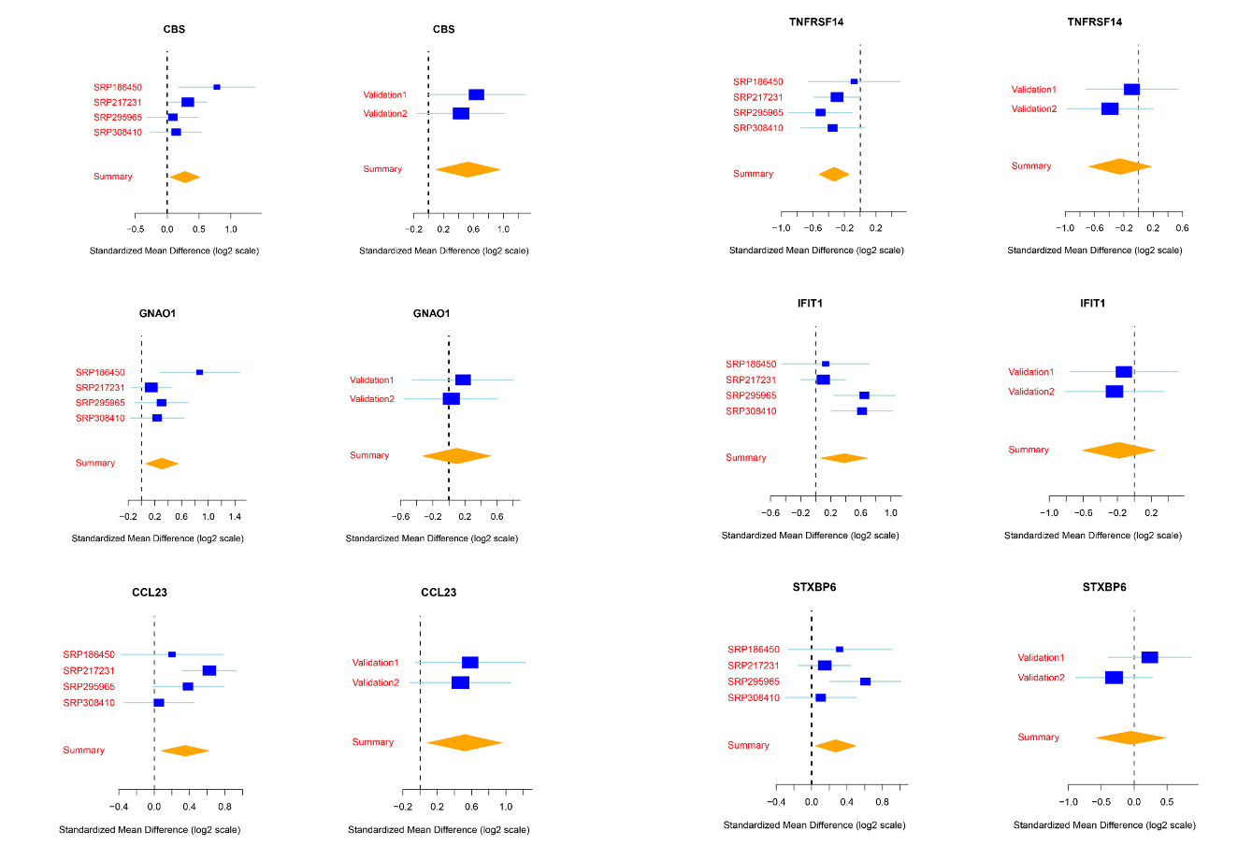

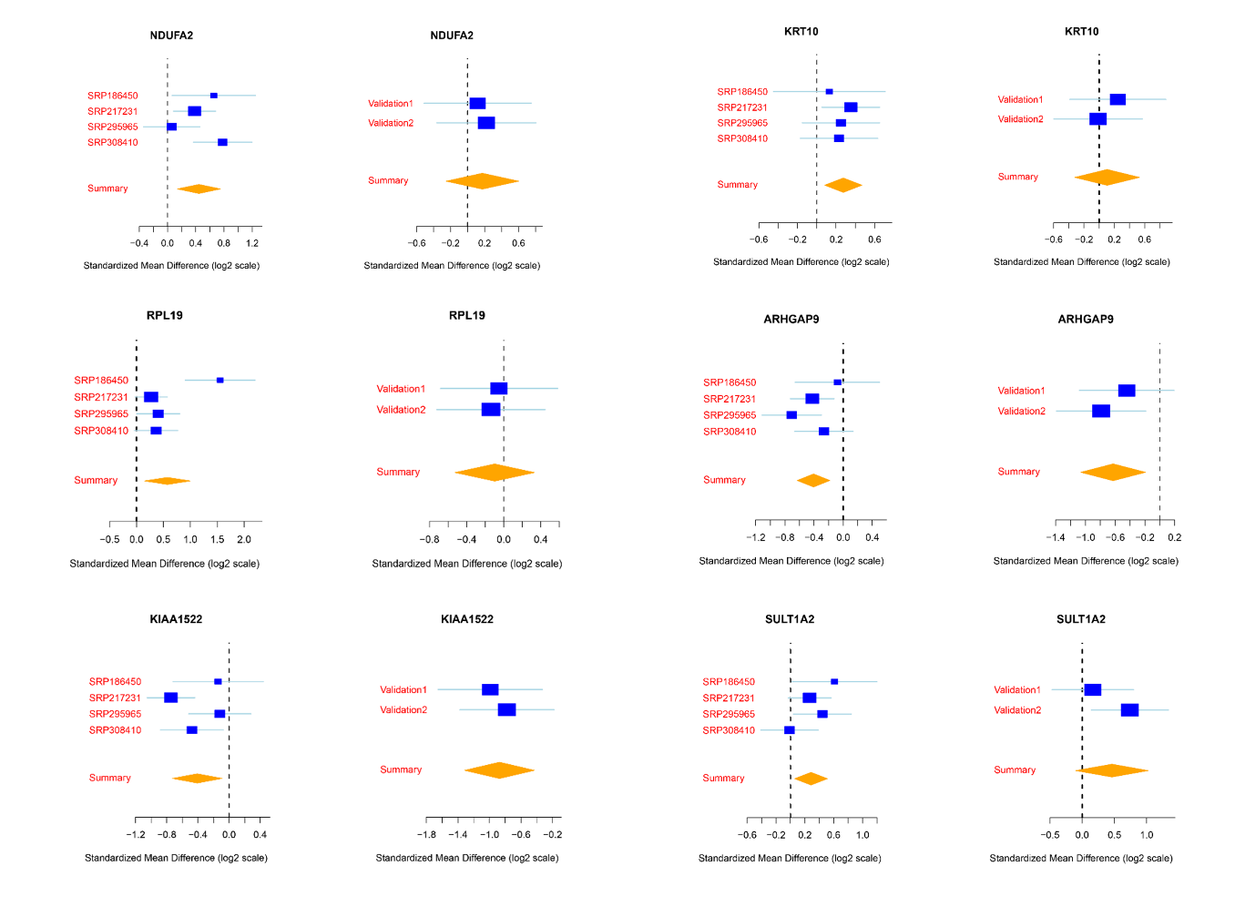
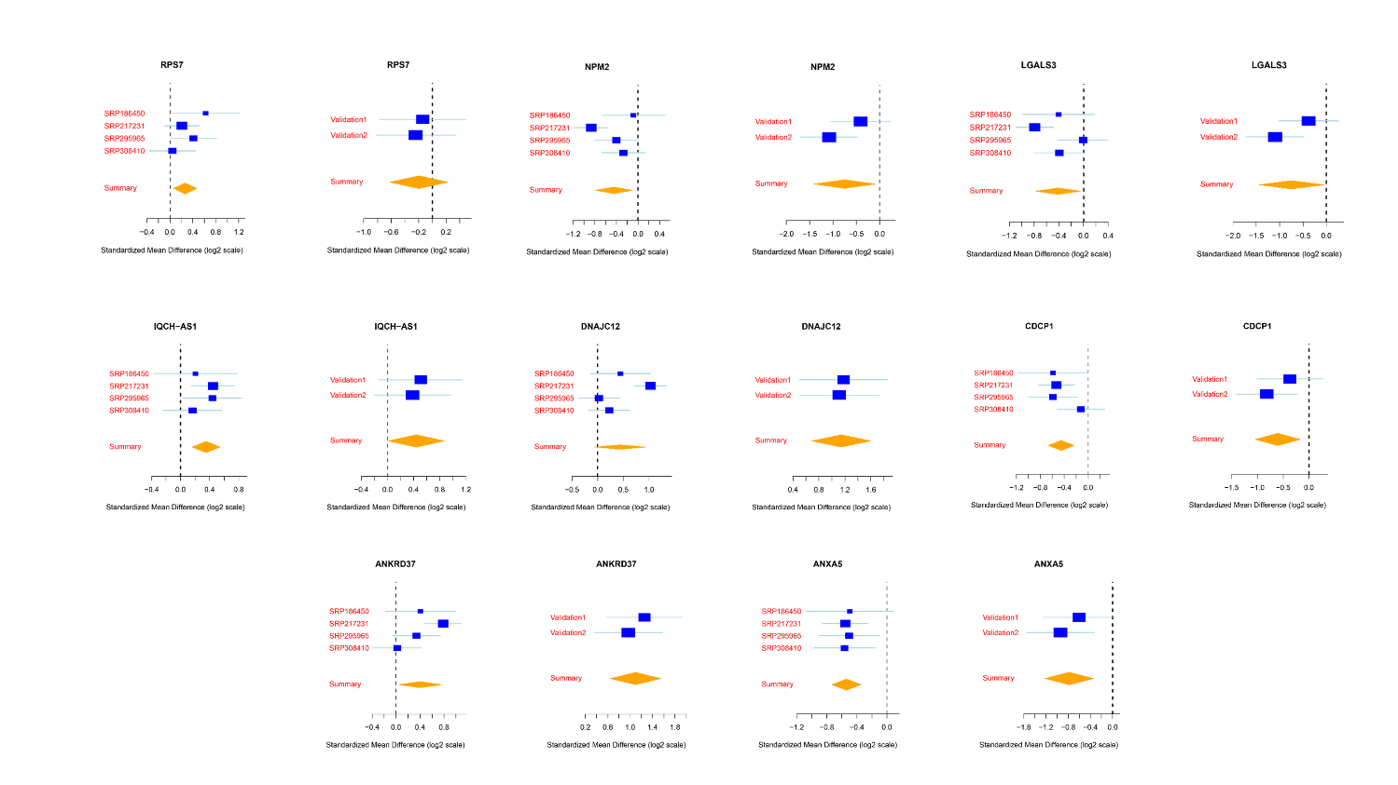
Supplementary Fig.S1 Illustration of the other genes in all the validation cohorts (representative genes shown in Fig.3A)

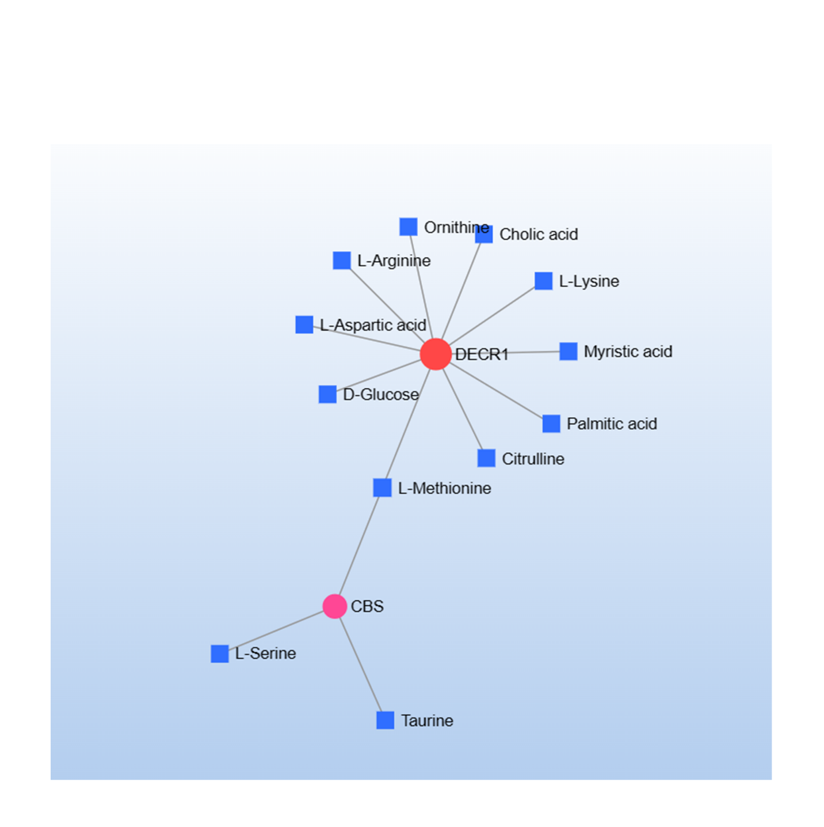
Supplementary Fig.S2 Network analysis results of key genes and metabolites.

Supplementary Table S1. Demographic and clinical characteristic of patients with NAFLD in two independent validation Cohort.

Cohorts Independent validation 1 Independent validation 2

Num of patients | 51 | 62
Age in years, median(IQR) | 57(52.4‐71.2) | 59(53.1‐72.3)
Race | Asian | Asian
N | 51 | 62
Final diagnosis, count (%)
of Fibrosis 38(74.5%) 47(75.8%)

Supplementary Table S2. Metabolites appearing in at least two different datasets across the five studies
 | Meera Shanmuganathan,et al |  | Ainara Cano,et al |  | Guoxiang Xie,et al | Xian et al. |  | Caussy, Ajmera and Puri et al. |  | Caussy et al.
Metabolites
 | P value | Fold-change | P value | Fold-change | Fold-change | P value | Fold-change | P value | Fold-change | P value | Fold-change
Valine | 0.947 | 0.959 | 0.123 | 0.932 | 0.914 | / | / | / | / | 0.87 | 0.016
Glycine | 0.251 | 0.988 | 0.749 | 1.034 | 1.592 | / | / | / | / | / | /
Alanine | 0.028 | 1.232 | 0.524 | 0.995 | 1.334 | / | / | / | / | / | /
Serine | 0 | 0.985 | 0.996 | 1.022 | 1.563 | / | / | 1.17 | 0.002 | / | /
Proline | 0.028 | 1.239 | 0.843 | 0.982 | 0.889 | / | / | / | / | / | /
Threonine | 0.1 | 1.083 | 0.002 | 1.242 | 1.306 | / | / | / | / | / | /
Isoleucine | 0.002 | 1.051 | 0.106 | 0.924 | 0.815 | / | / | / | / | 0.89 | 0.081
Leucine | 0.007 | 1.099 | 0.068 | 0.961 | 1.236 | / | / | / | / | 0.87 | 0.025
Asparagine | 0 | 1.15 | 0.106 | 1.101 | 1.714 | / | / | / | / | / | /
Glutamine | 0.035 | 1.165 | 0.037 | 0.788 | 1.002 | / | / | / | / | / | /
Lysine | 0.024 | 1.151 | 0.826 | 0.985 | 0.863 | / | / | / | / | / | /
Glutamate | 0.84 | 1.215 | 0.766 | 1.064 | 1.306 | / | / | / | / | / | /
Methionine | 0 | 1.332 | 0.002 | 1.207 | 1.879 | / | / | / | / | / | /
Histidine | 0.004 | 1.011 | 0.128 | 1.006 | 1.34 | / | / | / | / | / | /
Phenylalanine | 0.119 | 1.357 | 0.057 | 1.075 | 1.871 | / | / | / | / | 1.04 | 0.3
Arginine | 0.018 | 1.088 | 0.143 | 0.998 | 0.895 | / | / | / | / | / | /
Tyrosine | 0.269 | 1.466 | 0 | 1.203 | 1.135 | / | / | / | / | / | /
Tryptophan | 0.039 | 1.018 | 0.008 | 1.069 | 1.71 | / | / | / | / | / | /
Taurine | 0.002 | 0.944 | 0.001 | 0.87 | 1.409 | / | / | 0.77 | 0.001 | / | /
Aspartic Acid | 0.005 | 1.31 | 0.766 | 1.064 | / | / | / | / | / | / | /
Sarcosine | 0.029 | 1.019 | / | / | 1.213 | / | / | / | / | / | /
Creatinine | 0.041 | 1.065 | / | / | 1.276 | / | / | / | / | 0.87 | 0.03
Ornithine | 0.028 | 1.183 | / | / | 0.951 | / | / | / | / | / | /
Citrulline | 0.047 | 1.069 | / | / | 1.035 | / | / | / | / | / | /
Cystine | / | / | 0.393 | 0.932 | / | / | / | / | / | / | /
Cholic acid | / | / | 0.073 | 0.808 | 2.198 | / | / | / | / | / | /
Deoxycholic acid | / | / | 0.002 | 0.365 | 1.05 | / | / | / | / | / | /
Chenodeoxycholic acid | / | / | 0.055 | 0.735 | 1.439 | / | / | / | / | / | /
Lithocholic acid | / | / | 0.654 | 0.669 | 1.094 | / | / | / | / | / | /
Ursodeoxycholic acid | / | / | 0.006 | 0.479 | 1.086 | / | / | / | / | / | /
Glycochenodeoxycholic acid | / | / | 0 | 1.771 | 5.383 | / | / | / | / | / | /
Glycocholic acid | / | / | 0 | 1.723 | 9.141 | / | / | / | / | / | /
Taurocholic acid | / | / | 0 | 2.897 | 7.278 | / | / | / | / | / | /
Taurodeoxycholic acid | / | / | 0.023 | 1.026 | 9.886 | / | / | / | / | / | /
Taurochenodeoxycholic acid | / | / | 0 | 2.554 | 12.474 | / | / | / | / | / | /
Taurolithocholic acid | / | / | 0.014 | 1.711 | 2.009 | / | / | / | / | / | /
Tauroursodeoxycholic acid | / | / | 0.043 | 1.311 | 3.75 | / | / | / | / | / | /
Glycodeoxycholate | / | / | / | / | 3.908 | / | / | / | / | / | /
Glycoursodeoxycholate | / | / | / | / | 3.334 | / | / | / | / | / | /
12-ketochenodeoxycholate | / | / | / | / | 1.216 | / | / | / | / | / | /
Apocholate | / | / | / | / | 1.114 | / | / | / | / | / | /
Taurocholate | / | / | / | / | 25.41 | / | / | 7.27 | 0.001 | / | /
Glyco-hyocholate | / | / | / | / | 4.819 | / | / | / | / | / | /
Hyocholate | / | / | / | / | 3.206 | / | / | / | / | / | /
7-Ketolithocholate | / | / | / | / | 1.439 | / | / | / | / | / | /
7-Ketodeoxycholate | / | / | / | / | 1.667 | / | / | / | / | / | /
3-Ketocholate | / | / | / | / | 1.091 | / | / | / | / | / | /
23-Nordeoxycholate | / | / | / | / | 1.033 | / | / | / | / | / | /
Glycolithocholate | / | / | / | / | 2.673 | / | / | / | / | / | /
14:00 | / | / | 0 | 1.455 | 0.863 | / | / | / | / | / | /
15:00 | / | / | 0.001 | 1.375 | 0.906 | / | / | / | / | / | /
16:00 | / | / | 0.002 | 1.341 | 0.979 | / | / | / | / | / | /
17:00(Margarate) | / | / | 0.698 | 0.969 | 0.785 | / | / | / | / | / | /
18:00 | / | / | 0.299 | 0.933 | 0.933 | / | / | / | / | / | /
20:00 | / | / | 0.09 | 0.942 | 1.033 | / | / | / | / | / | /
14:1n-5 | / | / | 0 | 1.547 | 0.873 | / | / | / | / | / | /
16:1n-7 | / | / | 0 | 1.566 | 1.306 | / | / | / | / | / | /
18:1n-9 | / | / | 0.001 | 1.353 | 1.054 | / | / | / | / | / | /
20:1n-9 | / | / | 0.498 | 0.433 | 1.117 | / | / | / | / | / | /
24:1n-9 | / | / | 0 | 1.194 | 1.091 | / | / | / | / | / | /
16:2n-4,7 | / | / | 0.001 | 1.306 | 0.705 | / | / | / | / | / | /
18:2n-6 | / | / | 0.017 | 1.127 | 0.883 | / | / | / | / | / | /
18:2n-6 trans | / | / | 0.66 | 0.61 | 0 | / | / | / | / | / | /
18:3n-3(Linolenate) | / | / | 0.001 | 1.623 | 0.826 | / | / | / | / | / | /
18:3n-6 | / | / | 0.002 | 1.67 | 0.594 | / | / | / | / | / | /
20:4n-6(Adrenate) | / | / | 0.348 | 1.001 | 0.813 | / | / | / | / | / | /
20:5n-3 | / | / | 0.296 | 1.405 | 0.982 | / | / | / | / | / | /
22:4n-6 | / | / | 0.005 | 1.164 | 0.942 | / | / | / | / | / | /
22:5n-3 | / | / | 0.028 | 1.198 | 0.895 | / | / | / | / | / | /
22:5n-6 | / | / | 0 | 1.173 | 0.893 | / | / | / | / | / | /
22:6n-3 | / | / | 0.111 | 1.07 | 0.977 | / | / | / | / | / | /
Glycocholate | / | / | / | / | 9.141 | / | / | / | / | / | /
lactate | 1.168 | 0.009 | / | / | / | / | / | / | / | 1.1 | 0.066
urate | 1.016 | 0.003 | / | / | / | / | / | / | / | 0.86 | 0.017
3-methyl-2-oxovalerate | 1.136 | 0.000 | / | / | / | / | / | / | / | 0.93 | 0.174
gamma-glutamylleucine | / | / | / | / | / | / | / | / | / | 0.81 | 0.002
glucose | 1.767 | 0.738 | / | / | / | / | / | / | / | / | /
3-(4-hydroxyphenyl)lactate | / | / | / | / | / | / | / | / | / | 1.26 | 0.037

Supplementary Table S3. Data sources for Genes
Association ID | Reported Trait | Sample size & Race | Database
ENSG00000108298 | RPL19 | 6421 European | IEU openGWAS project
ENSG00000259673 | IQCH-AS1 | 5502 European | IEU openGWAS project
ENSG00000186395 | KRT10 | 14263 European | IEU openGWAS project
ENSG00000131495 | NDUFA2 | 21335 European | IEU openGWAS project
ENSG00000160200 | CBS | 31684 European | IEU openGWAS project
ENSG00000185745 | IFIT1 | 31684 European | IEU openGWAS project
ENSG00000168952 | STXBP6 | 29726 European | IEU openGWAS project
ENSG00000197165 | SULT1A2 | 14263 European | IEU openGWAS project
ENSG00000186352 | ANKRD37 | 31684 European | IEU openGWAS project
ENSG00000087258 | GNAO1 | 31684 European | IEU openGWAS project
ENSG00000171863 | RPS7 | 22879 European | IEU openGWAS project
ENSG00000170421 | KRT8 | 22336 European | IEU openGWAS project
ENSG00000127564 | PKMYT1 | 31470 European | IEU openGWAS project
ENSG00000123329 | ARHGAP9 | 31684 European | IEU openGWAS project
ENSG00000164111 | ANXA5 | 31684 European | IEU openGWAS project
ENSG00000104325 | DECR1 | 14263 European | IEU openGWAS project
ENSG00000157873 | TNFRSF14 | 26609 European | IEU openGWAS project
ENSG00000214293 | RSBN1L‐AS1 | 5502 European | IEU openGWAS project
ENSG00000163814 | CDCP1 | 31684 European | IEU openGWAS project
ENSG00000162522 | KIAA1522 | 31684 European | IEU openGWAS project
ENSG00000266173 | STRADA | 26395 European | IEU openGWAS project
ENSG00000131981 | LGALS3 | 31470 European | IEU openGWAS project
ENSG00000116874 | WARS2 | 31470 European | IEU openGWAS project
ENSG00000158806 | NPM2 | 14263 European | IEU openGWAS project

Supplementary Table S4. Data sources for Metabolites
Association ID | Reported Trait | Sample size & Race | Database
GCST90200442 | Valine | 8299 European | GWAS catalog
GCST90200707 | Glycine | 8299 European | GWAS catalog
GCST90200431 | Alanine | 8299 European | GWAS catalog
GCST90200415 | Serine | 8299 European | GWAS catalog
GCST90010737 | Proline | 8299 European | GWAS catalog
GCST90200432 | Threonine | 8299 European | GWAS catalog
GCST90200399 | Isoleucine | 8299 European | GWAS catalog
GCST90200389 | Leucine | 8299 European | GWAS catalog
GCST90010724 | Asparagine | 8299 European | GWAS catalog
GCST90200419 | Glutamine | 8299 European | GWAS catalog
GCST90200402 | Lysine | 8299 European | GWAS catalog
GCST90200412 | Glutamate | 8299 European | GWAS catalog
GCST90200391 | Methionine | 8299 European | GWAS catalog
GCST90200377 | Histidine | 8299 European | GWAS catalog
GCST90200396 | Phenylalanine | 8299 European | GWAS catalog
GCST90200372 | Arginine | 8299 European | GWAS catalog
GCST90200427 | Tyrosine | 8299 European | GWAS catalog
GCST90200441 | Tryptophan | 8299 European | GWAS catalog
GCST90200420 | Taurine | 8299 European | GWAS catalog
GCST90200370 | Aspartic Acid | 8299 European | GWAS catalog
GCST90200291 | Sarcosine | 8299 European | GWAS catalog
GCST90200366 | Creatinine | 8299 European | GWAS catalog
GCST90200404 | Ornithine | 8299 European | GWAS catalog
GCST90200403 | Citrulline | 8299 European | GWAS catalog
GCST90200382 | Cystine | 8299 European | GWAS catalog
GCST90200219 | Cholic acid | 8299 European | GWAS catalog
GCST90176041 | Deoxycholic acid | 8299 European | GWAS catalog
GCST90264913 | Chenodeoxycholic acid | 8299 European | GWAS catalog
GCST90200297 | Ursodeoxycholic acid | 8299 European | GWAS catalog
GCST90200342 | Glycochenodeoxycholic acid | 8299 European | GWAS catalog
GCST90200387 | Glycocholic acid | 8299 European | GWAS catalog
GCST90200333 | Taurocholic acid | 8299 European | GWAS catalog
GCST90200334 | Taurodeoxycholic acid | 8299 European | GWAS catalog
GCST90200337 | Taurochenodeoxycholic acid | 8299 European | GWAS catalog
GCST90199809 | Taurolithocholic acid | 8299 European | GWAS catalog
GCST90199643 | Glycodeoxycholate | 8299 European | GWAS catalog
GCST90199898 | Glycoursodeoxycholate | 8299 European | GWAS catalog
GCST90200333 | Taurocholate | 8299 European | GWAS catalog
GCST90199935 | Glyco-hyocholate | 8299 European | GWAS catalog
GCST90199734 | Hyocholate | 8299 European | GWAS catalog
GCST90264734 | 7-Ketodeoxycholate | 8299 European | GWAS catalog
GCST90199689 | Glycolithocholate | 8299 European | GWAS catalog
GCST90200326 | gamma-glutamylleucine | 8299 European | GWAS catalog
GCST90199631 | 3-Methyl-2-Oxovalerate | 8299 European | GWAS catalog
GCST90200307 | Urate | 8299 European | GWAS catalog
GCST90200457 | Pentadecanoic | 8299 European | GWAS catalog
GCST90176103 | Palmitic acid | 8299 European | GWAS catalog
GCST90200459 | Margaric acid | 8299 European | GWAS catalog
GCST90176104 | Stearic acid | 8299 European | GWAS catalog
GCST90199715 | Myristoleic acid | 8299 European | GWAS catalog
GCST90200042 | Linoleic acid | 8299 European | GWAS catalog
GCST90199748 | alpha-Linolenic acid | 8299 European | GWAS catalog
GCST90199748 | gamma-Linolenic acid | 8299 European | GWAS catalog
GCST90200358 | Arachidonic acid | 8299 European | GWAS catalog
GCST90200349 | EPA | 8299 European | GWAS catalog
GCST90199709 | Adrenic Acid | 8299 European | GWAS catalog
GCST90199713 | Docosapentaenoic acid | 8299 European | GWAS catalog
GCST90199651 | Docosahexaenoic acid | 8299 European | GWAS catalog

Supplementary Table S5. Data sources for NASH
Association ID | Reported Trait | Sample size & Race | Database
K74 | Diagnoses - main ICD10: K74 Fibrosis and cirrhosis of liver_both_sexes | 3108 European | UKBiobank Neale lab
K74 | Diagnoses - main ICD10: K74 Fibrosis and cirrhosis of liver_female | 3108 European | UKBiobank Neale lab
K74 | Diagnoses - main ICD10: K74 Fibrosis and cirrhosis of liver_male | 3108 European | UKBiobank Neale lab
FIBROLIV | Fibrosis of liver | 373453 European | Finngen
NASH | Nonalcoholic steatohepatitis | 377277 European | Finngen
K11_FIBROCHIRLIV | Fibrosis and cirrhosis of liver | 368291 European | Finngen

Supplementary Table S6. Causal effects of Gene-to-metabolite
Exposure | Outcome | Method | nSNP |  | Beta | SE | P | Het | Ple
STRADA | 3-methyl-2-oxovalerate | Weighted median | 6 | -0.08 |  | 0.038 | 0.036 | 0.670 | 0.490
STRADA | 3-methyl-2-oxovalerate | IVW | 6 | -0.10 |  | 0.036 | 0.009 | 0.670 | 0.490
GNAO1 | Docosahexaenoate DHA | Weighted median | 14 | 0.14 |  | 0.057 | 0.016 | 0.071 | 0.832
GNAO1 | Docosahexaenoate DHA | IVW | 14 | 0.11 |  | 0.045 | 0.013 | 0.071 | 0.832
GNAO1 | Docosahexaenoate DHA | Weighted mode | 14 | 0.23 |  | 0.101 | 0.044 | 0.071 | 0.832
ANXA5 | Glycolithocholate | MR Egger | 10 | -0.19 |  | 0.070 | 0.028 | 0.418 | 0.074
ANXA5 | Glycolithocholate | Weighted median | 10 | -0.10 |  | 0.049 | 0.043 | 0.418 | 0.074
GNAO1 | Glycolithocholate | IVW | 14 | -0.08 |  | 0.040 | 0.043 | 0.631 | 0.526
TNFRSF14 | Glycolithocholate | Weighted median | 4 | -0.15 |  | 0.063 | 0.019 | 0.143 | 0.806
TNFRSF14 | Glycolithocholate | IVW | 4 | -0.18 |  | 0.079 | 0.023 | 0.143 | 0.806
PKMYT1 | Glycolithocholate | IVW | 16 | -0.08 |  | 0.033 | 0.011 | 0.381 | 0.050
GNAO1 | Adrenate (22:4n6) | Weighted median | 14 | 0.10 |  | 0.050 | 0.044 | 0.311 | 0.368
GNAO1 | Adrenate (22:4n6) | IVW | 14 | 0.10 |  | 0.039 | 0.009 | 0.311 | 0.368
GNAO1 | Docosapentaenoate n3 DPA | Weighted median | 14 | 0.12 |  | 0.052 | 0.027 | 0.032 | 0.224
GNAO1 | Docosapentaenoate n3 DPA | IVW | 14 | 0.11 |  | 0.048 | 0.020 | 0.032 | 0.224
GNAO1 | Myristoleate (14:1n5) | Weighted median | 14 | 0.13 |  | 0.048 | 0.007 | 0.153 | 0.904
GNAO1 | Myristoleate (14:1n5) | IVW | 14 | 0.11 |  | 0.040 | 0.006 | 0.153 | 0.904
KRT10 | Myristoleate (14:1n5) | Weighted median | 24 | 0.06 |  | 0.025 | 0.012 | 0.071 | 0.423
KRT10 | Myristoleate (14:1n5) | Weighted mode | 24 | 0.05 |  | 0.022 | 0.027 | 0.071 | 0.423
GNAO1 | Linolenate | Weighted median | 14 | 0.12 |  | 0.050 | 0.013 | 0.357 | 0.948
GNAO1 | Linolenate | IVW | 14 | 0.09 |  | 0.037 | 0.017 | 0.357 | 0.948
GNAO1 | Linolenate | Simple mode | 14 | 0.18 |  | 0.077 | 0.039 | 0.357 | 0.948
KRT10 | Linolenate | IVW | 24 | 0.04 |  | 0.021 | 0.041 | 0.317 | 0.821
KRT10 | Linolenate | Weighted mode | 24 | 0.05 |  | 0.025 | 0.042 | 0.317 | 0.821
PKMYT1 | Taurolithocholate 3-sulfate | MR Egger | 16 | -0.15 |  | 0.061 | 0.025 | 0.602 | 0.125
PKMYT1 | Taurolithocholate 3-sulfate | IVW | 16 | -0.07 |  | 0.030 | 0.026 | 0.602 | 0.125
ANXA5 | Glycoursodeoxycholate | Weighted median | 10 | -0.10 |  | 0.046 | 0.038 | 0.609 | 0.252
ANXA5 | Glycoursodeoxycholate | IVW | 10 | -0.11 |  | 0.041 | 0.005 | 0.609 | 0.252
CBS | Glycoursodeoxycholate | IVW | 4 | 0.13 |  | 0.063 | 0.035 | 0.481 | 0.276
TNFRSF14 | Glycohyocholate | IVW | 4 | 0.12 |  | 0.058 | 0.036 | 0.499 | 0.734
GNAO1 | Oleate/vaccenate (18:1) | Weighted median | 14 | 0.17 |  | 0.052 | 0.001 | 0.116 | 0.699
GNAO1 | Oleate/vaccenate (18:1) | IVW | 14 | 0.12 |  | 0.044 | 0.008 | 0.116 | 0.699
CBS | Cholic acid glucuronide | Weighted median | 4 | 0.22 |  | 0.095 | 0.023 | 0.317 | 0.378
ARHGAP9 | Cholic acid glucuronide | Weighted median | 5 | -0.15 |  | 0.071 | 0.031 | 0.597 | 0.544
ARHGAP9 | Cholic acid glucuronide | IVW | 5 | -0.16 |  | 0.067 | 0.020 | 0.597 | 0.544
STRADA | Sarcosine | Simple mode | 6 | 0.28 |  | 0.103 | 0.040 | 0.051 | 0.142
CBS | Ursodeoxycholate | Weighted median | 4 | 0.18 |  | 0.076 | 0.018 | 0.775 | 0.545
CBS | Ursodeoxycholate | IVW | 4 | 0.20 |  | 0.074 | 0.007 | 0.775 | 0.545
PKMYT1 | Ursodeoxycholate | Weighted median | 16 | 0.12 |  | 0.043 | 0.005 | 0.572 | 0.561
PKMYT1 | Ursodeoxycholate | IVW | 16 | 0.08 |  | 0.034 | 0.026 | 0.572 | 0.561
PKMYT1 | Ursodeoxycholate | Weighted mode | 16 | 0.10 |  | 0.039 | 0.019 | 0.572 | 0.561
IFIT1 | Gamma-glutamylleucine | MR Egger | 31 | -0.07 |  | 0.024 | 0.006 | 0.700 | 0.166
IFIT1 | Gamma-glutamylleucine | IVW | 31 | -0.05 |  | 0.018 | 0.007 | 0.700 | 0.166
IFIT1 | Gamma-glutamylleucine | Weighted mode | 31 | -0.06 |  | 0.028 | 0.043 | 0.700 | 0.166
GNAO1 | Gamma-glutamylleucine | IVW | 14 | -0.10 |  | 0.037 | 0.008 | 0.743 | 0.908
PKMYT1 | Gamma-glutamylleucine | IVW | 16 | 0.07 |  | 0.029 | 0.014 | 0.975 | 0.447
IFIT1 | Glycochenodeoxycholate | Simple mode | 31 | -0.09 |  | 0.043 | 0.050 | 0.780 | 0.293
ANXA5 | Glycochenodeoxycholate | IVW | 10 | -0.09 |  | 0.041 | 0.037 | 0.824 | 0.926
GNAO1 | Eicosapentaenoate | Weighted median | 14 | 0.14 |  | 0.052 | 0.009 | 0.070 | 0.390
GNAO1 | Eicosapentaenoate | IVW | 14 | 0.10 |  | 0.045 | 0.023 | 0.070 | 0.390
GNAO1 | Eicosapentaenoate | Weighted mode | 14 | 0.15 |  | 0.064 | 0.040 | 0.070 | 0.390
GNAO1 | Arachidonate (20:4n6) | Weighted median | 14 | 0.12 |  | 0.052 | 0.025 | 0.171 | 0.329
GNAO1 | Arachidonate (20:4n6) | IVW | 14 | 0.10 |  | 0.042 | 0.020 | 0.171 | 0.329
STRADA | Creatinine | IVW | 6 | 0.06 |  | 0.032 | 0.049 | 0.672 | 0.538
KIAA1522 | Creatinine | Weighted mode | 24 | -0.05 |  | 0.022 | 0.048 | 0.274 | 0.560
PKMYT1 | Aspartate | MR Egger | 16 | 0.15 |  | 0.059 | 0.023 | 0.854 | 0.143
PKMYT1 | Aspartate | Weighted median | 16 | 0.09 |  | 0.035 | 0.010 | 0.854 | 0.143
PKMYT1 | Aspartate | IVW | 16 | 0.07 |  | 0.028 | 0.015 | 0.854 | 0.143
PKMYT1 | Aspartate | Weighted mode | 16 | 0.09 |  | 0.037 | 0.034 | 0.854 | 0.143
WARS2 | Arginine | MR Egger | 15 | -0.15 |  | 0.058 | 0.024 | 0.017 | 0.002
KIAA1522 | Arginine | IVW | 24 | -0.04 |  | 0.020 | 0.044 | 0.472 | 0.651
KIAA1522 | Histidine | MR Egger | 24 | -0.11 |  | 0.045 | 0.021 | 0.089 | 0.037
WARS2 | Cystine | Weighted median | 15 | -0.08 |  | 0.038 | 0.043 | 0.737 | 0.667
WARS2 | Cystine | IVW | 15 | -0.08 |  | 0.035 | 0.021 | 0.737 | 0.667
KIAA1522 | Cystine | Weighted median | 24 | -0.07 |  | 0.030 | 0.016 | 0.457 | 0.916
KIAA1522 | Cystine | IVW | 24 | -0.04 |  | 0.020 | 0.038 | 0.457 | 0.916
KIAA1522 | Cystine | Weighted mode | 24 | -0.07 |  | 0.033 | 0.036 | 0.457 | 0.916
PKMYT1 | Cystine | Weighted median | 16 | 0.08 |  | 0.036 | 0.022 | 0.590 | 0.808
PKMYT1 | Cystine | IVW | 16 | 0.09 |  | 0.029 | 0.004 | 0.590 | 0.808
NDUFA2 | Glycocholate | IVW | 4 | 0.11 |  | 0.049 | 0.028 | 0.524 | 0.350
GNAO1 | Leucine | Weighted median | 14 | -0.12 |  | 0.049 | 0.013 | 0.726 | 0.961
GNAO1 | Leucine | IVW | 14 | -0.08 |  | 0.036 | 0.024 | 0.726 | 0.961
GNAO1 | Leucine | Weighted mode | 14 | -0.14 |  | 0.058 | 0.035 | 0.726 | 0.961
CBS | Leucine | Weighted median | 4 | -0.15 |  | 0.064 | 0.016 | 0.551 | 0.718
CBS | Leucine | IVW | 4 | -0.15 |  | 0.061 | 0.015 | 0.551 | 0.718
STRADA | Leucine | IVW | 6 | -0.08 |  | 0.039 | 0.045 | 0.342 | 0.120
PKMYT1 | Leucine | IVW | 16 | 0.06 |  | 0.029 | 0.027 | 0.979 | 0.299
PKMYT1 | Methionine | MR Egger | 16 | 0.16 |  | 0.060 | 0.019 | 0.533 | 0.037
RPL19 | Phenylalanine | Simple mode | 8 | -0.28 |  | 0.112 | 0.042 | 0.203 | 0.575
GNAO1 | Isoleucine | IVW | 14 | -0.10 |  | 0.036 | 0.005 | 0.502 | 0.620
PKMYT1 | Isoleucine | IVW | 16 | 0.06 |  | 0.029 | 0.041 | 0.877 | 0.278
RPL19 | Citrulline | Simple mode | 8 | -0.21 |  | 0.079 | 0.032 | 0.758 | 0.523
STRADA | Citrulline | Weighted median | 6 | 0.09 |  | 0.041 | 0.030 | 0.487 | 0.565
STRADA | Citrulline | IVW | 6 | 0.10 |  | 0.038 | 0.006 | 0.487 | 0.565
STRADA | Citrulline | Weighted mode | 6 | 0.10 |  | 0.040 | 0.048 | 0.487 | 0.565
STRADA | Glutamate | IVW | 6 | -0.08 |  | 0.035 | 0.032 | 0.633 | 0.403
GNAO1 | Serine | Weighted median | 14 | 0.14 |  | 0.051 | 0.007 | 0.005 | 0.215
WARS2 | Glutamine | MR Egger | 15 | -0.19 |  | 0.084 | 0.043 | 0.000 | 0.005
PKMYT1 | Glutamine | IVW | 16 | -0.07 |  | 0.030 | 0.013 | 0.532 | 0.399
RPL19 | Tyrosine | IVW | 8 | -0.07 |  | 0.034 | 0.045 | 0.298 | 0.314
IFIT1 | Alanine | Simple mode | 31 | 0.16 |  | 0.046 | 0.002 | 0.135 | 0.212
GNAO1 | Tryptophan | IVW | 14 | -0.08 |  | 0.036 | 0.030 | 0.969 | 0.598
KIAA1522 | Tryptophan | MR Egger | 24 | -0.09 |  | 0.041 | 0.046 | 0.444 | 0.080
KIAA1522 | Tryptophan | Simple mode | 24 | -0.11 |  | 0.050 | 0.047 | 0.444 | 0.080
GNAO1 | Valine | IVW | 14 | -0.08 |  | 0.036 | 0.030 | 0.599 | 0.889
GNAO1 | Pentadecanoate (15:0) | Weighted median | 14 | 0.15 |  | 0.054 | 0.007 | 0.002 | 0.868
GNAO1 | Pentadecanoate (15:0) | IVW | 14 | 0.11 |  | 0.056 | 0.041 | 0.002 | 0.868
CBS | Pentadecanoate (15:0) | IVW | 4 | 0.13 |  | 0.061 | 0.029 | 0.794 | 0.684
KRT10 | Pentadecanoate (15:0) | Weighted median | 24 | 0.05 |  | 0.026 | 0.042 | 0.095 | 0.418
CBS | Margarate (17:0) | IVW | 4 | 0.13 |  | 0.062 | 0.035 | 0.798 | 0.643
NDUFA2 | Glycine | Weighted median | 4 | -0.10 |  | 0.050 | 0.038 | 0.562 | 0.466
NDUFA2 | Glycine | IVW | 4 | -0.10 |  | 0.047 | 0.030 | 0.562 | 0.466
Note: nSNP, number of SNPs fit MR’s three hypotheses; Het, Heterogeneity test P value; Ple, Horizontal Pleiotropy test P value

Supplementary Table S7. Causal effects of Metabolite-to-NASH
Exposure | Outcome | Method | nSNP | Beta | SE | P | Het | Ple
Glycocholate | Fibrosis of liver | MR Egger | 35 | -1.20 | 0.509 | 0.025 | 0.570 | 0.044
Taurodeoxycholate | Fibrosis of liver | Simple mode | 20 | 2.22 | 1.038 | 0.046 | 0.183 | 0.621
Leucine | Fibrosis of liver | IVW | 15 | -1.13 | 0.528 | 0.032 | 0.936 | 0.179
Methionine | Fibrosis of liver | MR Egger | 17 | -2.98 | 0.987 | 0.009 | 0.138 | 0.019
Glutamine | Fibrosis of liver | Weighted mode | 27 | -1.04 | 0.490 | 0.044 | 0.067 | 0.231
Alanine | Fibrosis and cirrhosis of liver | MR Egger | 21 | 0.48 | 0.204 | 0.028 | 0.549 | 0.029
Threonine | Fibrosis and cirrhosis of liver | IVW | 27 | -0.19 | 0.093 | 0.046 | 0.107 | 0.980
Adrenate (22:4n6) | Fibrosis and cirrhosis of liver | IVW | 21 | -0.08 | 0.038 | 0.042 | 0.522 | 0.983
Taurolithocholate 3-sulfate | Fibrosis and cirrhosis of liver | MR Egger | 21 | -0.51 | 0.184 | 0.012 | 0.732 | 0.057
Taurolithocholate 3-sulfate | Fibrosis and cirrhosis of liver | IVW | 21 | -0.19 | 0.091 | 0.040 | 0.732 | 0.057
Glycocholate | Nonalcoholic fatty liver disease | IVW | 35 | 0.17 | 0.063 | 0.006 | 0.732 | 0.963
Phenylalanine | Nonalcoholic fatty liver disease | Weighted median | 18 | 0.28 | 0.127 | 0.028 | 0.434 | 0.361
Phenylalanine | Nonalcoholic fatty liver disease | IVW | 18 | 0.21 | 0.087 | 0.016 | 0.434 | 0.361
Histidine | Nonalcoholic fatty liver disease | Weighted median | 19 | -0.26 | 0.106 | 0.015 | 0.030 | 0.887
Histidine | Nonalcoholic fatty liver disease | IVW | 19 | -0.23 | 0.083 | 0.005 | 0.030 | 0.887
Histidine | Nonalcoholic fatty liver disease | Weighted mode | 19 | -0.21 | 0.102 | 0.049 | 0.030 | 0.887
Taurochenodeoxycholate | Nonalcoholic fatty liver disease | IVW | 19 | 0.24 | 0.102 | 0.019 | 0.208 | 0.950
Glycine | Nonalcoholic steatohepatitis | MR Egger | 22 | 0.54 | 0.250 | 0.045 | 0.472 | 0.138
Threonine | Nonalcoholic steatohepatitis | Weighted median | 27 | -0.84 | 0.390 | 0.030 | 0.851 | 0.500
Threonine | Nonalcoholic steatohepatitis | IVW | 27 | -0.75 | 0.272 | 0.005 | 0.851 | 0.500
Isoleucine | Nonalcoholic steatohepatitis | Weighted median | 16 | 0.55 | 0.255 | 0.031 | 0.146 | 0.568
Isoleucine | Nonalcoholic steatohepatitis | IVW | 16 | 0.56 | 0.227 | 0.013 | 0.146 | 0.568
Isoleucine | Nonalcoholic steatohepatitis | Weighted mode | 16 | 0.54 | 0.250 | 0.048 | 0.146 | 0.568
Taurochenodeoxycholate | Nonalcoholic steatohepatitis | MR Egger | 19 | -1.92 | 0.861 | 0.039 | 0.660 | 0.031
Linolenate | Nonalcoholic steatohepatitis | Weighted median | 21 | 1.21 | 0.572 | 0.034 | 0.102 | 0.332
Tryptophan | Liver fat | IVW | 22 | -0.08 | 0.023 | 0.000 | 0.688 | 0.538
Arginine | Liver fat | MR Egger | 20 | -0.15 | 0.061 | 0.029 | 0.233 | 0.107
Arginine | Liver fat | IVW | 20 | -0.05 | 0.024 | 0.041 | 0.233 | 0.107
Taurochenodeoxycholate | Liver fat | MR Egger | 17 | -0.14 | 0.065 | 0.046 | 0.434 | 0.093
Glutamate | Liver fat | IVW | 17 | 0.08 | 0.036 | 0.034 | 0.032 | 0.305
Hyocholate | Nonalcoholic fatty liver disease | IVW | 10 | 0.13 | 0.058 | 0.021 | 0.820 | 0.965
Ursodeoxycholate | Nonalcoholic fatty liver disease | IVW | 15 | -0.14 | 0.064 | 0.030 | 0.052 | 0.888
Threonine | Nonalcoholic fatty liver disease | IVW | 23 | -0.13 | 0.055 | 0.021 | 0.029 | 0.979
Glutamine | Nonalcoholic fatty liver disease | Weighted median | 21 | -0.13 | 0.063 | 0.040 | 0.034 | 0.625
Glutamine | Nonalcoholic fatty liver disease | IVW | 21 | -0.14 | 0.053 | 0.010 | 0.034 | 0.625
Glutamine | Nonalcoholic fatty liver disease | Weighted mode | 21 | -0.18 | 0.071 | 0.023 | 0.034 | 0.625
Citrulline | Nonalcoholic fatty liver disease | IVW | 20 | 0.10 | 0.049 | 0.033 | 0.551 | 0.911
Margarate (17:0) | Diagnoses - main ICD10: K74 Fibrosis and cirrhosis of liver_both_sexes | IVW | 20 | 0.00 | 0.000 | 0.027 | 0.722 | 0.105
Threonine | Diagnoses - main ICD10: K74 Fibrosis and cirrhosis of liver_both_sexes | MR Egger | 28 | 0.00 | 0.000 | 0.036 | 0.768 | 0.017
Serine | Diagnoses - main ICD10: K74 Fibrosis and cirrhosis of liver_female | MR Egger | 39 | 0.00 | 0.000 | 0.041 | 0.995 | 0.171
Serine | Diagnoses - main ICD10: K74 Fibrosis and cirrhosis of liver_female | IVW | 39 | 0.00 | 0.000 | 0.048 | 0.995 | 0.171
Margarate (17:0) | Diagnoses - main ICD10: K74 Fibrosis and cirrhosis of liver_female | IVW | 20 | 0.00 | 0.000 | 0.041 | 0.316 | 0.189
Histidine | Diagnoses - main ICD10: K74 Fibrosis and cirrhosis of liver_female | Weighted median | 18 | 0.00 | 0.000 | 0.032 | 0.247 | 0.292
Sarcosine | Diagnoses - main ICD10: K74 Fibrosis and cirrhosis of liver_female | Weighted median | 17 | 0.00 | 0.000 | 0.046 | 0.287 | 0.239
Hyocholate | Diagnoses - main ICD10: K74 Fibrosis and cirrhosis of liver_female | Weighted median | 15 | 0.00 | 0.000 | 0.047 | 0.275 | 0.814
Creatinine | Diagnoses - main ICD10: K74 Fibrosis and cirrhosis of liver_female | MR Egger | 24 | 0.00 | 0.001 | 0.032 | 0.440 | 0.018
Threonine | Diagnoses - main ICD10: K74 Fibrosis and cirrhosis of liver_male | MR Egger | 28 | 0.00 | 0.001 | 0.038 | 0.609 | 0.012
Valine | Diagnoses - main ICD10: K74 Fibrosis and cirrhosis of liver_male | Weighted median | 18 | 0.00 | 0.000 | 0.038 | 0.304 | 0.929
Taurocholic acid | Diagnoses - main ICD10: K74 Fibrosis and cirrhosis of liver_male | Weighted median | 22 | 0.00 | 0.000 | 0.038 | 0.261 | 0.873
Arachidonate (20:4n6) | Nonalcoholic fatty liver disease_both_sexes | MR Egger | 29 | 0.00 | 0.000 | 0.034 | 0.192 | 0.176
Arachidonate (20:4n6) | Nonalcoholic fatty liver disease_both_sexes | Weighted median | 29 | 0.00 | 0.000 | 0.008 | 0.192 | 0.176
Arachidonate (20:4n6) | Nonalcoholic fatty liver disease_both_sexes | Weighted mode | 29 | 0.00 | 0.000 | 0.012 | 0.192 | 0.176
Glycocholate | Nonalcoholic fatty liver disease_both_sexes | MR Egger | 34 | 0.00 | 0.000 | 0.034 | 0.799 | 0.131
Hyocholate | Nonalcoholic fatty liver disease_both_sexes | Weighted median | 15 | 0.00 | 0.000 | 0.045 | 0.450 | 0.685
Hyocholate | Nonalcoholic fatty liver disease_both_sexes | IVW | 15 | 0.00 | 0.000 | 0.041 | 0.450 | 0.685
Glutamine | Nonalcoholic fatty liver disease_both_sexes | Weighted mode | 27 | 0.00 | 0.000 | 0.037 | 0.059 | 0.231
Glycochenodeoxycholate | Nonalcoholic fatty liver disease_both_sexes | MR Egger | 35 | 0.00 | 0.000 | 0.047 | 0.696 | 0.039
Pentadecanoate (15:0) | Nonalcoholic fatty liver disease_female | IVW | 17 | 0.00 | 0.000 | 0.050 | 0.909 | 0.877
Arachidonate (20:4n6) | Nonalcoholic fatty liver disease_male | Weighted median | 29 | 0.00 | 0.000 | 0.005 | 0.387 | 0.511
Arachidonate (20:4n6) | Nonalcoholic fatty liver disease_male | IVW | 29 | 0.00 | 0.000 | 0.023 | 0.387 | 0.511
Arachidonate (20:4n6) | Nonalcoholic fatty liver disease_male | Weighted mode | 29 | 0.00 | 0.000 | 0.010 | 0.387 | 0.511
Serine | Nonalcoholic fatty liver disease_male | MR Egger | 39 | 0.00 | 0.000 | 0.020 | 0.179 | 0.108
Serine | Nonalcoholic fatty liver disease_male | Weighted median | 39 | 0.00 | 0.000 | 0.031 | 0.179 | 0.108
Serine | Nonalcoholic fatty liver disease_male | IVW | 39 | 0.00 | 0.000 | 0.034 | 0.179 | 0.108
Glycocholate | Nonalcoholic fatty liver disease_male | MR Egger | 34 | 0.00 | 0.001 | 0.010 | 0.779 | 0.088
Glycocholate | Nonalcoholic fatty liver disease_male | IVW | 34 | 0.00 | 0.000 | 0.007 | 0.779 | 0.088
Glutamine | Nonalcoholic fatty liver disease_male | Weighted median | 27 | 0.00 | 0.000 | 0.006 | 0.200 | 0.238
Glutamine | Nonalcoholic fatty liver disease_male | Weighted mode | 27 | 0.00 | 0.000 | 0.009 | 0.200 | 0.238
Glycochenodeoxycholate | Nonalcoholic fatty liver disease_male | MR Egger | 35 | 0.00 | 0.001 | 0.007 | 0.199 | 0.003
Note: nSNP, number of SNPs fit MR’s three hypotheses; Het, Heterogeneity test P value; Ple, Horizontal Pleiotropy test P value

