Supplementary Figures

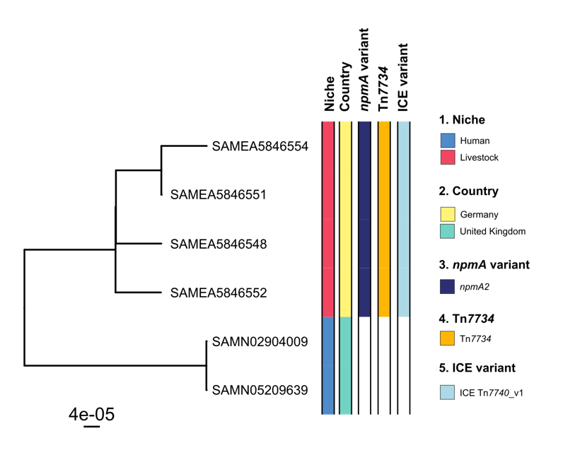

Supplementary Figure 1. Phylogenetic analysis of C. difficile ST36. Maximum likelihood phylogeny based on non-recombinant core SNPs for 6 ST36 C. difficile isolates (4 npmA-carrying isolates and 2 contextual genomes), sharing 2,096 core-genome alleles. The tree was midpoint rooted. Metadata columns show the niche, country, npmA gene variant, the presence of Tn7734 composite transposon and the ICE Tn7740 variant.

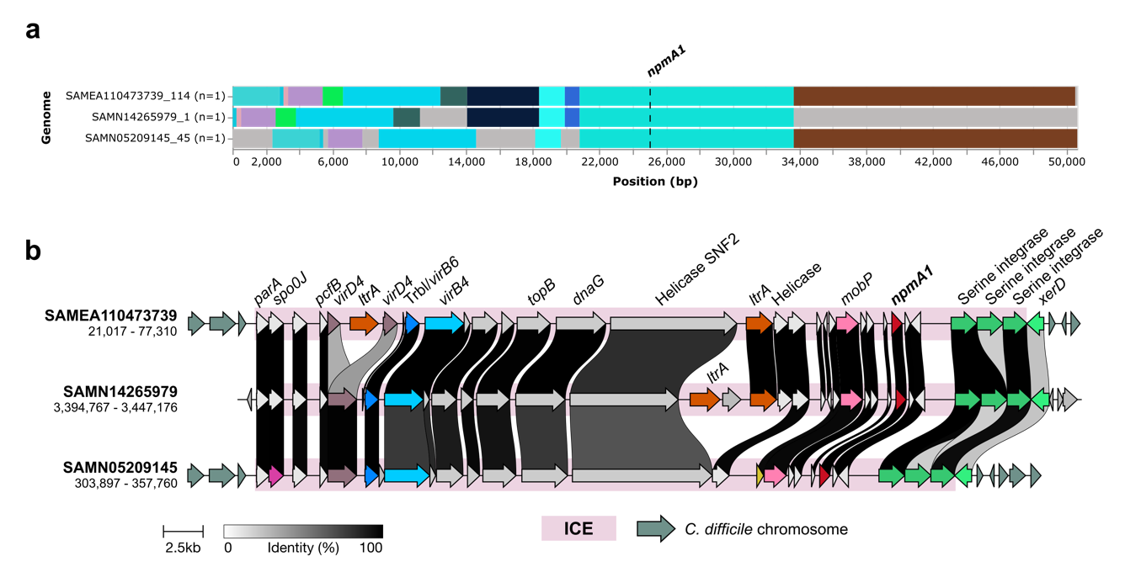

Supplementary Figure 2. Genomic characterization of MGEs in npmA1-carrying C. difficile isolates. a Genetic context using a 25 kb upstream and downstream window to npmA1. Blocks of the same colour indicate homology and the grey block represent areas of non-homology within the dataset. b Genetic structure and comparison of the putative ICE carrying npmA1.

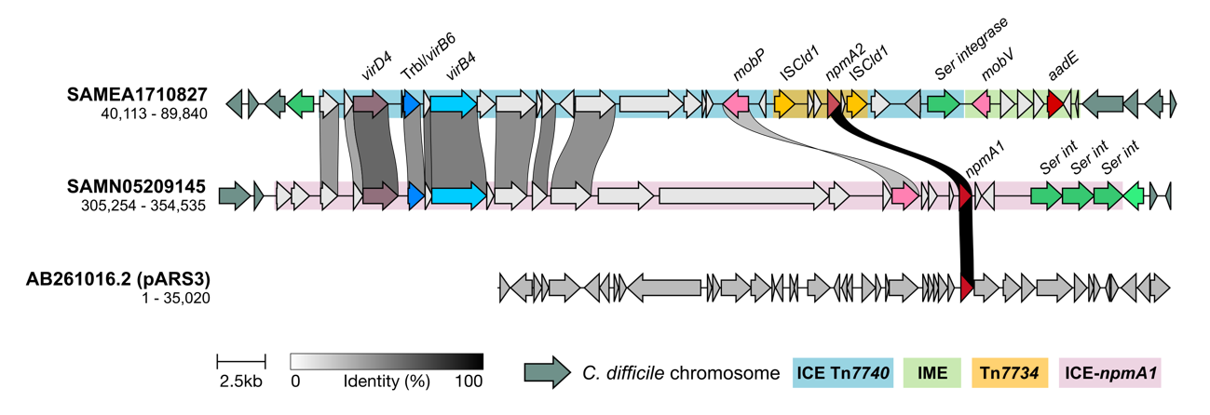

Supplementary Figure 3. Comparison of the genetic environment of ICE Tn7740 carrying npmA2 (SAME1710827), putative ICE carrying npmA1 (SAMN05209145) and the E. coli pARS3 plasmid (AB261016.2).

Supplementary Tables

Supplementary Table 1. MICs for the two npmA2-carrying E. faecium isolates. E. faecium ATCC 19434 was used as a quality control.

 | MIC (mg/liter)ª
Isolate | AMK | APR | GEN | KAN | NEO
SAMEA4885232 (strain E7474) | ≥1,024 | ≥1,024 | ≥1,024 | ≥1,024 | ≥1,024
SAMEA4885233 (strain E7475) | ≥1,024 | ≥1,024 | ≥1,024 | ≥1,024 | ≥1,024
E. faecium ATCC 19434 | 8 | 8 | 2 | 16 | 8

ªAMK, amikacin; APR, apramycin; GEN, gentamicin; KAN, kanamycin; NEO, Neomycin

Supplementary Table 2. Predicted antibiotic susceptibility phenotype based on the detection of AMR genotypes of SAMEA4885232 and SAMEA4885233.

 | Isolate
ª | SAMEA4885232 | SAMEA4885233
AMP | Resistance | Resistance
TEC | Resistance | Resistance
VAN | Resistance | Resistance
DAP | Susceptible | Susceptible
FQ | Susceptible | Susceptible
HL-GEN | Resistance | Resistance
HL-KAN | Resistance | Resistance
HL-STR | Resistance | Resistance
TGC | Susceptible | Susceptible
CLI | Resistance | Resistance
ERY | Resistance | Resistance
LZD | Susceptible | Susceptible
QD | Susceptible | Susceptible
Str A | Susceptible | Susceptible
Str B | Resistance | Resistance
TET | Resistance | Resistance

ªAMP, Ampicillin; TEC, Teicoplanin; VAN, Vancomycin; DAP, Daptomycin; FQ, Fluoroquinolones; HL-GEN, High-level Gentamicin; HL-KAN, High-level Kanamycin; HL-STR, High-level Streptomycin; TGC, Tigecycline; CLI, Clindamycin; ERY, Erythromycin; LZD, Linezolid; QD, Quinupristin-Dalfopristin; Str A, Streptogramin A; Str B, Streptogramin B; TET, Tetracycline.

Supplementary Table 3. AMR genetic determinants detected for SAMEA4885232 and SAMEA4885233.

 | Isolate
ª | SAMEA4885232 | SAMEA4885233
AMP | pbp5_E629V;pbp5_M485A | pbp5_M485A;pbp5_E629V
TEC | ﻿vanA-operon-v3;﻿vanA-operon;﻿vanA-operon-v2;﻿vanA-operon-v5;﻿vanA-operon-v4 | ﻿vanA-operon-v4;﻿vanA-operon;﻿vanA-operon-v5;﻿vanA-operon-v2;﻿vanA-operon-v3
VAN | ﻿vanA-operon-v3;﻿vanA-operon;﻿vanA-operon-v2;﻿vanA-operon-v5;﻿vanA-operon-v4 | ﻿vanA-operon-v4;﻿vanA-operon;﻿vanA-operon-v5;﻿vanA-operon-v2;﻿vanA-operon-v3
DAP | not_found | not_found
FQ | not_found | not_found
HL-GEN | AAC(6')-Ie-APH(2'')-Ia | AAC(6')-Ie-APH(2'')-Ia
HL-KAN | APH(3')-IIIa;AAC(6')-Ie-APH(2'')-Ia | APH(3')-IIIa;AAC(6')-Ie-APH(2'')-Ia
HL-STR | aad(6);ANT(6)-Ia-pAML0157;ANT(6)-Ia | aad(6);ANT(6)-Ia-pAML0157;ANT(6)-Ia
TGC | not_found | not_found
CLI | ermB-E7067;ermA | ermB-E7067;ermA
ERY | ermB-E7067;ermA | ermB-E7067;ermA
LZD | not_found | not_found
QD | not_found | not_found
Str A | not_found | not_found
Str B | ermB-E7067 | ermB-E7067
TET | tetM;tetL | tetM;tetL

ªAMP, Ampicillin; TEC, Teicoplanin; VAN, Vancomycin; DAP, Daptomycin; FQ, Fluoroquinolones; HL-GEN, High-level Gentamicin; HL-KAN, High-level Kanamycin; HL-STR, High-level Streptomycin; TGC, Tigecycline; CLI, Clindamycin; ERY, Erythromycin; LZD, Linezolid; QD, Quinupristin-Dalfopristin; Str A, Streptogramin A; Str B, Streptogramin B; TET, Tetracycline.

Supplementary Table 4. Distribution of MGEs (ISCld1 and ICE Tn7740) in the study dataset. The table illustrates the presence (Yes) or absence (No) of ISCld1 and the ICE Tn7740 across C. difficile and Lachnospiraceae family genomes. Data are presented with specifics on identity and coverage percentages using as a reference ISCldi1 (WP_330681815.1) and ICE Tn7740 (present in SAMN32115919).

BioSample ID | ISCld1 | ICE Tn7740 | Identity (%) | Coverage (%) | Organism
SAMEA5086679 | yes | no | 100 | 100 | C. difficile ST11
SAMEA5086680 | yes | no | 100 | 100 | C. difficile ST11
SAMEA5086681 | yes | no | 100 | 100 | C. difficile ST11
SAMEA5086682 | yes | no | 100 | 100 | C. difficile ST11
SAMEA5086719 | yes | no | 100 | 100 | C. difficile ST11
SAMEA5086720 | yes | no | 100 | 100 | C. difficile ST11
SAMN05209291 | yes | no | 100 | 100 | C. difficile ST11
SAMN05209536 | yes | no | 100 | 100 | C. difficile ST11
CLO_FA6664AA_AS | yes | yes | 100 / 99.99 | 100 / 99.0 | C. difficile ST11
CLO_GA0362AA_AS | yes | yes | 100 / 99.99 | 100 / 99.0 | C. difficile ST11
SAMEA104432227 | yes | yes | 100 / 97.45 | 100 / 99.0 | C. difficile ST11
SAMEA1710388 | yes | yes | 100 / 99.85 | 100 / 99.0 | C. difficile ST11
SAMN09233798 | yes | yes | 100 / 100 | 100 / 99.0 | C. difficile ST11
SAMN09406529 | yes | yes | 100 / 99.85 | 100 / 99.0 | C. difficile ST11
SAMN13621923 | yes | yes | 100 / 100 | 100 / 99.0 | C. difficile ST11
SAMN14074617 | yes | yes | 100 / 97.45 | 100 / 99.0 | C. difficile ST11
CLO_EA5945AA_AS | no | yes | 99.10 | 97.0 | C. difficile ST5
SAMEA110473598 | no | yes | 99.94 | 95.0 | C. difficile ST14
SAMEA1487063 | no | yes | 99.14 | 95.0 | C. difficile ST2
SAMEA1571278 | no | yes | 99.95 | 95.0 | C. difficile ST6
SAMEA1904960 | no | yes | 99.91 | 95.0 | C. difficile ST5
SAMEA1905104 | no | yes | 99.10 | 97.0 | C. difficile ST5
SAMEA1905109 | no | yes | 99.56 | 95.0 | C. difficile ST5
SAMEA2057041 | no | yes | 99.90 | 95.0 | C. difficile ST37
SAMEA2070757 | no | yes | 99.95 | 95.0 | C. difficile ST6
SAMEA2187373 | no | yes | 99.94 | 95.0 | C. difficile ST8
SAMEA3906568 | no | yes | 99.90 | 95.0 | C. difficile ST37
SAMEA5086625 | no | yes | 99.88 | 100 | C. difficile ST11
SAMN05207948 | no | yes | 99.96 | 95.0 | C. difficile ST2
SAMN05207974 | no | yes | 99.39 | 95.0 | C. difficile ST39
SAMN07633037 | no | yes | 99.78 | 95.0 | C. difficile ST10
SAMN11897812 | no | yes | 99.95 | 95.0 | C. difficile ST42
SAMN12606955 | no | yes | 99.11 | 97.0 | C. difficile ST67
SAMN13541337 | no | yes | 99.11 | 97.0 | C. difficile ST67
SAMN13639177 | no | yes | 99.93 | 95.0 | C. difficile ST109
SAMN16340105 | no | yes | 99.10 | 97.0 | C. difficile ST1
SAMN16556780 | no | yes | 99.94 | 95.0 | C. difficile ST42
SAMN20109946 | no | yes | 99.92 | 94.0 | C. difficile ST54
SAMN20110563 | no | yes | 99.95 | 97.0 | C. difficile ST41
SAMN24152405 | no | yes | 98.37 | 97.00 | C. difficile ST67
SAMN32115902 | no | yes | 99.95 | 95.0 | C. difficile ST42
SAMEA3725555 | no | yes | 99.64 | 98.0 | Acetatifactor muris
SAMEA44049418 | no | yes | 99.94 | 100 | Lachnospiraceae bacterium
SAMN00013314 | no | yes | 99.94 | 95.0 | Lachnospiraceae bacterium
SAMN01730992 | no | yes | 99.53 | 94.0 | Lachnospiraceae bacterium
SAMN07340702 | no | yes | 99.96 | 93.0 | Enterocloster bolteae

Supplementary Table 5. Distribution of ISCld1 and the ICE Tn7740 across 147,851 high-quality metagenomic assembled genomes from the human gut microbiome. Data are presented with specifics on identity and coverage percentages using as a reference ISCldi1 (WP_330681815.1) and ICE Tn7740 (present in SAMN32115919).

Genome ID | ISCld1 | ICE Tn7740 | Identity (%) | Coverage (%) | Organism
GENOME218953 | yes | no | 100 | 100 | Roseburia hominis
GENOME000014 | no | yes | 99.8 | 90.89 | Eisenbergiella massiliensis
GENOME000081 | no | yes | 99.8 | 90.89 | Eisenbergiella massiliensis
GENOME000443 | no | yes | 99.8 | 91.27 | Sellimonas intestinalis
GENOME000604 | no | yes | 99.24 | 99.99 | Lachnospiraceae bacteria
GENOME000767 | no | yes | 99.31 | 100 | Sellimonas intestinalis
GENOME075558 | no | yes | 98.84 | 100 | Clostridium spp
GENOME095966 | no | yes | 99.81 | 100 | Clostridium M bolteae
GENOME095986 | no | yes | 99.81 | 100 | Clostridium M sp000155435
GENOME096491 | no | yes | 99.81 | 100 | Dorea sp001185345
GENOME103760 | no | yes | 99.81 | 100 | Dorea sp001185345
GENOME103870 | no | yes | 99.81 | 100 | Clostridium M sp000155435
GENOME107402 | no | yes | 99.8 | 90.67 | Ruminococcus sp003526955
GENOME140254 | no | yes | 99.22 | 99.99 | CAG-45 sp900066395
GENOME140258 | no | yes | 99.21 | 100 | CAG-45 sp900066395
GENOME143523 | no | yes | 99.81 | 99.87 | Ruminococcus E bromii B
GENOME239714 | no | yes | 99.66 | 99.99 | Clostridium M sp000155435

