Supplementary material 2

Table 3 Threshold analysis between age and periodontitis.
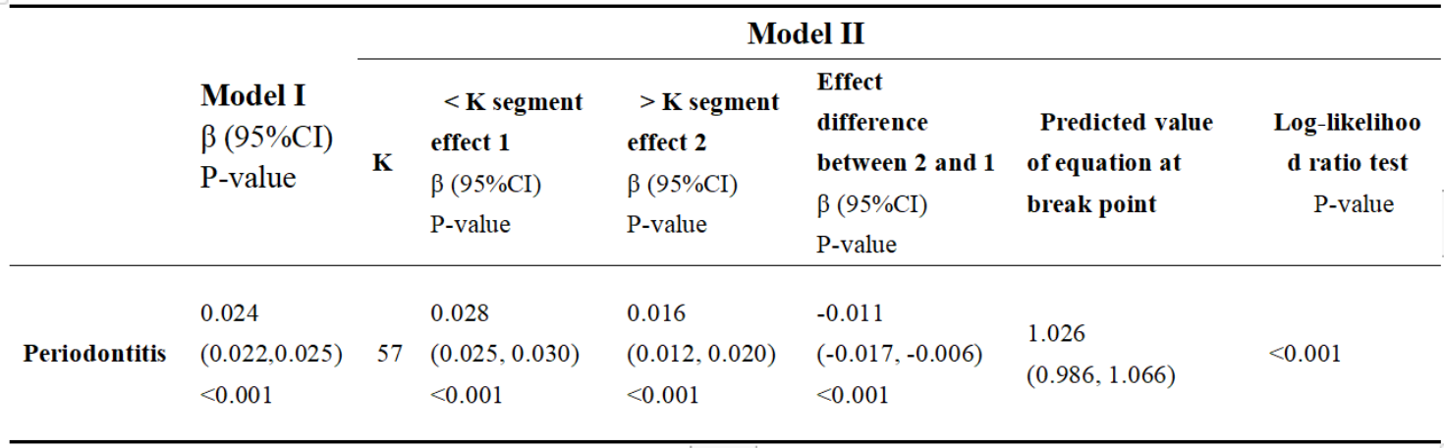
Model I, linear model; Model II, segmented model; K, Break point; CI, confidence intervals.

