Supplementary material 1

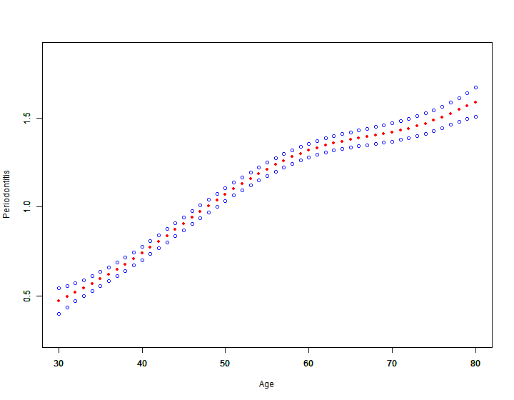
The model is weighted and adjusted for gender, race, education, marriage, drinking, hypertension, body mass index, family PIR, smoking and diabetes. The red line is a fit line, and the blue line on both sides is a 95% confidence interval.
Figure 3 Curve fitting graph of age and periodontitis.

