- Extended data sheet

Fossil record misconstrued: Sponge-like microfabrics may reflect incipient carbonate metamorphism
Fritz Neuweiler, Mathias Mueller, Benjamin F. Walter, Ed Landing, Aratz Beranoaguirre, Consuelo Sendino, Lisa Amati & Stephen Kershaw

Results (micro-XRF)
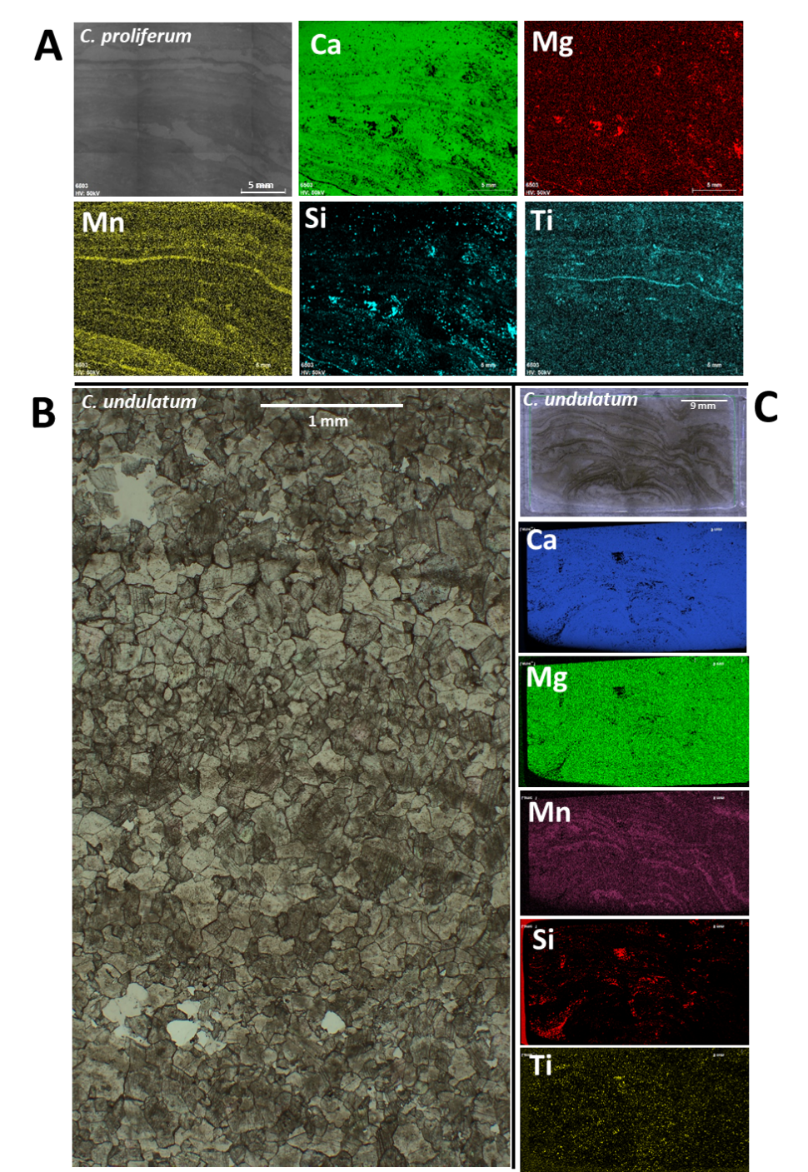
Figure 1 – (A) Micro-XRF of weakly dolomitized (essentially microdolomitic) C. proliferum, sample NYSM 6503.1. (B) Thin-section micrograph of pervasively dolomitized C. undulatum. Zoned dolomite grades into warped to saddle dolomite (more translucent), sample NYSM 6517.1. (C) Micro-XRF of C. undulatum, sample NYSM 6517.2.
Results (fluid inclusions and crystallographic orientation)

The sample NYSM 6508.2 was petrographically studied for its fluid inclusion inventory. Fluid inclusions are rare and tiny (<5µm) and only 6 isolated inclusions were measurable in dolomite, whereas fluid inclusions in the calcite veinlets are abundant (data of 17 FI are studied) and of primary nature. All fluid inclusions show a thermodynamic behavior of the NaCl-H₂O system with T_{ice} for calcite hosted FI between -07 and -4°C which correspond to a salinity of 1.1 to 6.5 wt.% NaCl_{eq}. Dolomite hosted FI contain T_{ice} values between -4.8 to -6.2°C (7.6-9.8wt.% NaCl_{eq}) and, therefore, show a slightly higher salinity. Homogenization temperatures in dolomite were recorded between 119-141°C whereas T_{h} in calcite scatter between 138 and 155°C. Based on the burial history of formation pressure correction of 100-200 bar was applied for the dolomite hosted fluid inclusions whereas 300 to 400 bar was used for vein calcite hosted FI.
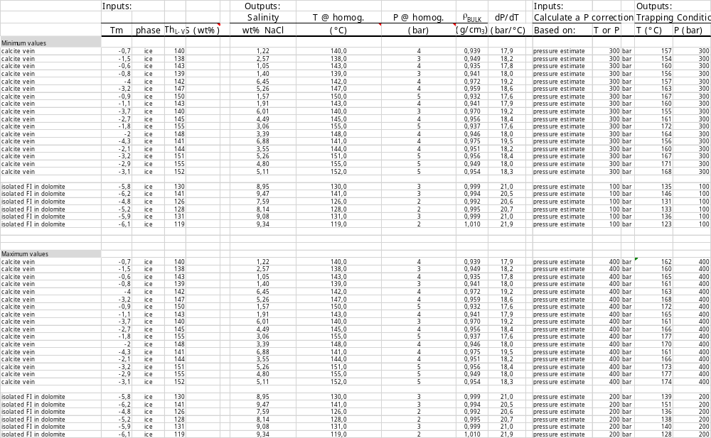
Table 1 – Original data sheet, fluid inventory of sample NYSM 6508.2

Results (electron backscatter diffraction, EBSD, sample NYSM 6508.1)

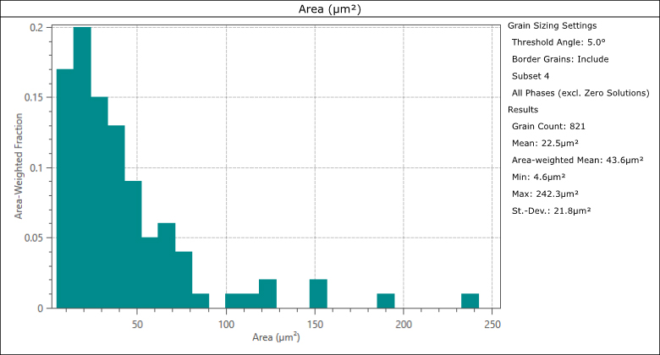
Figure 2 – EBSD analysis statistics of microcrystalline grain surface area versus area-weighted fraction in the analyzed map domain.

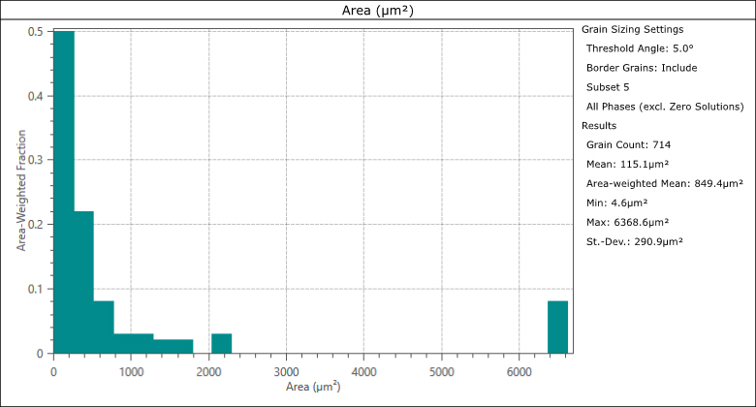
Figure 3 – EBSD analysis statistics of recrystallized granoblastic calcite surface area versus area-weighted fraction in the analyzed map domain.
U-Pb dating (1) - LA-ICP-MS U-Th-Pb data report
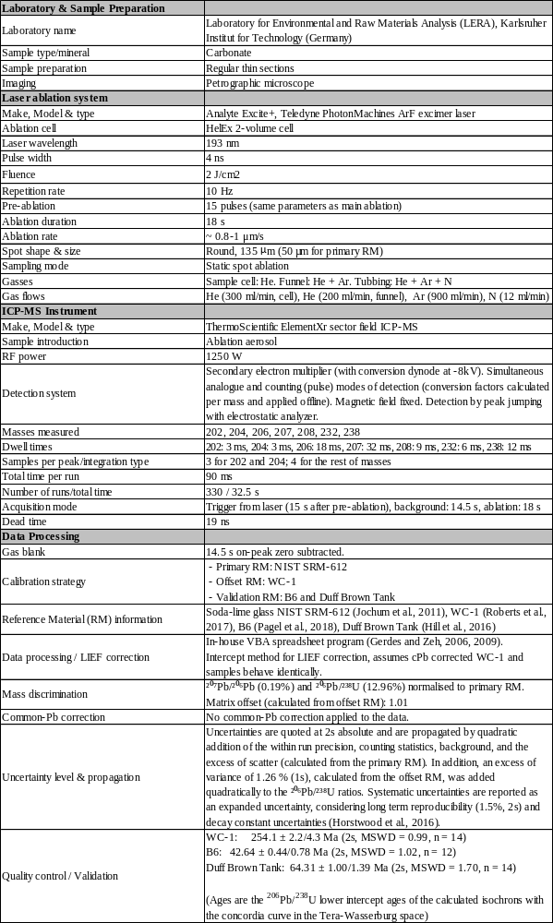

U-Pb dating (2) - LA-ICP-MS U-Th-Pb original data sheet
grain | name / | ²⁰⁷Pbª | U^{b} | Pb^{b} | Th^{b} | ²³⁸U^{c} | ±2s | ²⁰⁷Pb^{c} | ±2s
grain | sample | (cps) | (µg/g) | (µg/g) | U | ²⁰⁶Pb | (%) | ²⁰⁶Pb | (%)
U047 | NYSM-6517-2 | 8945 | 0 | 0 | 0,7 | 7 | 3 | 0 | 3
U048 | pervasive dolomite | 27878 | 0 | 0 | 0,7 | 4 | 4 | 1 | 2
U049 |  | 72428 | 0 | 0 | 0,6 | 3 | 10 | 1 | 2
U050 |  | 53257 | 0 | 0 | 0,6 | 3 | 11 | 1 | 2
U051 |  | 218720 | 0 | 1 | 0,6 | 1 | 11 | 1 | 1
U052 |  | 475623 | 0 | 3 | 0,5 | 0 | 6 | 1 | 1
U053 |  | 24256 | 0 | 0 | 0,7 | 4 | 5 | 1 | 2
U054 |  | 4175 | 0 | 0 | 0,8 | 8 | 5 | 0 | 4
U055 |  | 66028 | 0 | 0 | 0,9 | 2 | 5 | 1 | 1
U056 |  | 16029 | 0 | 0 | 0,6 | 5 | 5 | 1 | 2
U057 |  | 42881 | 0 | 0 | 0,5 | 3 | 4 | 1 | 2
U058 |  | 100586 | 0 | 1 | 0,7 | 2 | 9 | 1 | 2
U059 |  | 4378 | 0 | 0 | 0,6 | 6 | 5 | 1 | 4
U060 |  | 40281 | 0 | 0 | 0,8 | 2 | 8 | 1 | 2
U061 |  | 2652663 | 5 | 16 | 0,1 | 1 | 8 | 1 | 2
U062 |  | 221726 | 0 | 1 | 0,9 | 0 | 10 | 1 | 2
U063 |  | 13787 | 0 | 0 | 0,7 | 6 | 4 | 0 | 3
U064 |  | 251705 | 0 | 2 | 0,7 | 0 | 6 | 1 | 1
U065 |  | 178135 | 0 | 1 | 0,7 | 1 | 13 | 1 | 2
U066 |  | 7814 | 0 | 0 | 1,1 | 6 | 5 | 0 | 3
U067 |  | 31276 | 0 | 0 | 0,6 | 2 | 6 | 1 | 2
U068 |  | 10691 | 0 | 0 | 0,5 | 6 | 6 | 0 | 4
U069 |  | 101225 | 0 | 1 | 0,6 | 1 | 5 | 1 | 1
U070 |  | 9437 | 0 | 0 | 0,9 | 5 | 8 | 1 | 3
U079 |  | 1034352 | 0 | 6 | 0,9 | 0 | 7 | 1 | 1
U080 |  | 8002 | 0 | 0 | 0,8 | 6 | 5 | 0 | 3
U081 |  | 8304 | 0 | 0 | 0,6 | 5 | 4 | 1 | 3
U082 |  | 9279 | 0 | 0 | 0,6 | 7 | 4 | 0 | 3
U083 |  | 20265 | 0 | 0 | 0,8 | 4 | 9 | 1 | 3
U084 |  | 40459 | 0 | 0 | 0,8 | 2 | 9 | 1 | 2
U085 |  | 19674 | 0 | 0 | 1,1 | 4 | 4 | 1 | 2
U086 |  | 18930 | 0 | 0 | 0,9 | 3 | 5 | 1 | 2
U087 |  | 93032 | 0 | 1 | 0,6 | 1 | 8 | 1 | 1
U088 |  | 25625 | 0 | 0 | 0,9 | 3 | 6 | 1 | 2
U089 |  | 67512 | 0 | 0 | 1,0 | 1 | 10 | 1 | 2
U090 |  | 16464 | 0 | 0 | 0,8 | 4 | 7 | 1 | 3
U091 |  | 8471 | 0 | 0 | 1,0 | 5 | 5 | 1 | 3
U092 |  | 54906 | 0 | 0 | 0,7 | 2 | 8 | 1 | 2
U093 |  | 322699 | 0 | 2 | 0,6 | 1 | 11 | 1 | 1
U094 |  | 37791 | 0 | 0 | 0,6 | 4 | 4 | 1 | 2
U095 |  | 60251 | 0 | 0 | 0,6 | 3 | 8 | 1 | 2
U096 |  | 21155 | 0 | 0 | 0,6 | 4 | 4 | 1 | 2
U097 | NYSM 6508.2 spongy microfabric; spar domain | 13083 | 0 | 0 | 0,1 | 7 | 3 | 1 | 2
U098 | NYSM 6508.2 spongy microfabric; spar domain | 12318 | 0 | 0 | 0,1 | 9 | 4 | 1 | 2
U099 |  | 23420 | 0 | 0 | 0,1 | 6 | 5 | 1 | 3
U100 |  | 53344 | 0 | 0 | 0,1 | 3 | 5 | 1 | 3
U101 |  | 331262 | 0 | 2 | 0,2 | 1 | 6 | 1 | 2
U102 |  | 8994 | 0 | 0 | 0,2 | 9 | 3 | 0 | 3
U103 |  | 24073 | 0 | 0 | 0,3 | 7 | 5 | 1 | 2
U104 |  | 331031 | 0 | 2 | 0,3 | 1 | 9 | 1 | 1
U105 |  | 17233 | 1 | 0 | 0,2 | 13 | 4 | 0 | 3
U105i |  | 191905 | 1 | 1 | 0,1 | 3 | 5 | 1 | 1
U107 |  | 296052 | 0 | 2 | 0,2 | 1 | 4 | 1 | 1
U108 |  | 18694 | 0 | 0 | 0,3 | 7 | 3 | 1 | 3
U120 |  | 171636 | 0 | 1 | 0,2 | 1 | 7 | 1 | 1
U121 |  | 21309 | 1 | 0 | 0,2 | 10 | 4 | 1 | 2
U122 |  | 43009 | 0 | 0 | 0,2 | 5 | 7 | 1 | 3
U123 |  | 16085 | 0 | 0 | 0,2 | 9 | 3 | 0 | 3
U124 |  | 15804 | 0 | 0 | 0,3 | 9 | 3 | 0 | 2
U125 |  | 167973 | 1 | 1 | 0,2 | 2 | 4 | 1 | 2
U126 |  | 25064 | 0 | 0 | 0,3 | 8 | 4 | 1 | 2
U127 |  | 49383 | 0 | 0 | 1,7 | 4 | 13 | 1 | 3
U128 |  | 25447 | 0 | 0 | 0,8 | 7 | 5 | 1 | 2
U129 |  | 43031 | 0 | 0 | 0,3 | 4 | 4 | 1 | 2
U130 |  | 187262 | 0 | 1 | 0,1 | 1 | 15 | 1 | 2
U131 |  | 54539 | 0 | 0 | 0,2 | 4 | 6 | 1 | 2
U132 |  | 30253 | 0 | 0 | 0,1 | 6 | 4 | 1 | 2
U133 |  | 30577 | 0 | 0 | 0,1 | 3 | 6 | 1 | 2
U134 |  | 29418 | 0 | 0 | 0,2 | 5 | 4 | 1 | 2
U135 |  | 24114 | 1 | 0 | 0,2 | 9 | 3 | 0 | 2
U148 |  | 25055 | 1 | 0 | 0,2 | 9 | 4 | 0 | 2
U150 |  | 28436 | 1 | 0 | 0,2 | 8 | 4 | 1 | 2
U168 |  | 1998193 | 1 | 11 | 0,4 | 0 | 5 | 1 | 1
U171 |  | 54794 | 1 | 0 | 0,3 | 6 | 3 | 1 | 2
U172 |  | 39695 | 1 | 0 | 0,3 | 8 | 3 | 0 | 1
U136 | NYSM 6508.2 spongy microfabric; microcrystalline domain | 183202 | 1 | 1 | 0,2 | 2 | 4 | 1 | 2
U136i | NYSM 6508.2 spongy microfabric; microcrystalline domain | 45105 | 1 | 0 | 0,2 | 6 | 4 | 1 | 2
U137 |  | 37294 | 1 | 0 | 0,2 | 7 | 3 | 1 | 2
U138 |  | 98122 | 1 | 1 | 0,2 | 3 | 6 | 1 | 2
U139 |  | 38011 | 1 | 0 | 0,2 | 6 | 4 | 1 | 2
U140 |  | 91215 | 1 | 1 | 0,2 | 3 | 4 | 1 | 1
U141 |  | 26767 | 1 | 0 | 0,2 | 8 | 3 | 0 | 2
U142 |  | 45704 | 1 | 0 | 0,3 | 6 | 5 | 1 | 2
U143 |  | 26486 | 1 | 0 | 0,5 | 8 | 4 | 0 | 2
U144 |  | 137534 | 1 | 1 | 1,3 | 3 | 5 | 1 | 2
U145 |  | 95697 | 1 | 1 | 4,9 | 3 | 5 | 1 | 2
U146 |  | 72581 | 1 | 0 | 0,3 | 3 | 9 | 1 | 2
U147 |  | 25983 | 1 | 0 | 0,5 | 8 | 3 | 0 | 2
U149 |  | 68670 | 1 | 0 | 0,2 | 4 | 9 | 1 | 3
U159 |  | 74174 | 1 | 0 | 0,3 | 4 | 5 | 1 | 2
U160 |  | 82556 | 0 | 0 | 0,3 | 3 | 8 | 1 | 2
U161 |  | 259692 | 1 | 2 | 0,3 | 1 | 6 | 1 | 1
U162 |  | 62283 | 1 | 0 | 0,4 | 5 | 3 | 0 | 2
U163 |  | 282977 | 1 | 2 | 0,3 | 1 | 8 | 1 | 1
U163i |  | 36744 | 1 | 0 | 0,3 | 7 | 6 | 1 | 4
U164 |  | 126099 | 1 | 1 | 0,3 | 3 | 4 | 1 | 2
U165 |  | 28992 | 1 | 0 | 0,3 | 9 | 4 | 0 | 3
U166 |  | 57928 | 1 | 0 | 0,3 | 4 | 4 | 1 | 3
U166i |  | 30232 | 1 | 0 | 0,3 | 7 | 4 | 0 | 2
U167 |  | 22527 | 1 | 0 | 0,3 | 9 | 3 | 0 | 2
U169 |  | 34227 | 1 | 0 | 0,4 | 7 | 5 | 1 | 3
U169i |  | 30609 | 1 | 0 | 0,3 | 8 | 4 | 0 | 3
U170 |  | 53886 | 1 | 0 | 0,3 | 6 | 4 | 1 | 2
U106 |  | 131337 | 0 | 1 | 0,2 | 2 | 9 | 1 | 2
U109 |  | 451392 | 0 | 2 | 0,3 | 1 | 15 | 1 | 2
U110 |  | 27742 | 0 | 0 | 0,3 | 5 | 3 | 1 | 2
U119 |  | 19368 | 1 | 0 | 0,3 | 9 | 3 | 0 | 3
U173 | NYSM 6508.2  vein calcite | 29970 | 0 | 0 | 0,1 | 3 | 7 | 1 | 2
U174 | NYSM 6508.2  vein calcite | 4642 | 0 | 0 | 0,0 | 10 | 3 | 0 | 4
U175 |  | 32926 | 0 | 0 | 0,2 | 4 | 4 | 1 | 2
U176 |  | 89672 | 0 | 1 | 0,3 | 1 | 6 | 1 | 2
U177 |  | 2914 | 0 | 0 | 0,2 | 12 | 4 | 0 | 8
U178 |  | 16320 | 0 | 0 | 0,1 | 6 | 3 | 1 | 2
U179 |  | 3761 | 0 | 0 | 0,3 | 11 | 3 | 0 | 4
U180 |  | 12881 | 0 | 0 | 0,0 | 5 | 4 | 1 | 2
U181 |  | 776505 | 0 | 4 | 0,2 | 0 | 8 | 1 | 1
U182 |  | 111309 | 0 | 1 | 0,0 | 0 | 5 | 1 | 1
U183 |  | 44792 | 0 | 0 | 0,1 | 2 | 4 | 1 | 2
U184 |  | 1643 | 0 | 0 | 0,2 | 13 | 4 | 0 | 6
U185 |  | 72517 | 0 | 0 | 0,1 | 2 | 9 | 1 | 2
U186 |  | 48221 | 0 | 0 | 0,0 | 4 | 11 | 1 | 4
U187 |  | 159297 | 0 | 1 | 0,1 | 1 | 7 | 1 | 1
U188 |  | 134539 | 0 | 1 | 0,2 | 1 | 6 | 1 | 1
U189 |  | 152490 | 0 | 1 | 0,1 | 0 | 4 | 1 | 1
U190 |  | 361574 | 0 | 2 | 0,1 | 0 | 8 | 1 | 1
U191 |  | 22117 | 0 | 0 | 0,1 | 4 | 7 | 1 | 2
U192 |  | 44559 | 0 | 0 | 0,2 | 4 | 10 | 1 | 3
U193 |  | 20941 | 0 | 0 | 0,1 | 4 | 3 | 1 | 2
U194 |  | 64600 | 0 | 0 | 0,1 | 2 | 8 | 1 | 2
U195 |  | 1912 | 0 | 0 | 0,1 | 13 | 4 | 0 | 7
U196 |  | 15439 | 0 | 0 | 0,4 | 5 | 3 | 1 | 2
U197 |  | 142107 | 0 | 1 | 0,3 | 1 | 8 | 1 | 1
U198 |  | 14561 | 0 | 0 | 0,3 | 3 | 3 | 1 | 2
U199 |  | 78616 | 0 | 0 | 0,3 | 0 | 4 | 1 | 1
U200 |  | 626 | 0 | 0 | 0,6 | 8 | 6 | 0 | 9
U209 | NYSM 6508.2 zoned dolomite | 14942 | 1 | 1 | 0,1 | 5 | 4 | 1 | 2
U210 | NYSM 6508.2 zoned dolomite | 48653 | 1 | 1 | 0,1 | 3 | 9 | 1 | 3
U211 |  | 98945 | 1 | 1 | 0,1 | 2 | 8 | 1 | 1
U212 |  | 43832 | 1 | 1 | 0,1 | 3 | 6 | 1 | 2
U213 |  | 102699 | 1 | 1 | 0,1 | 2 | 9 | 1 | 2
U214 |  | 6686 | 1 | 0 | 0,1 | 8 | 6 | 0 | 8
U215 |  | 16206 | 1 | 0 | 0,1 | 6 | 5 | 0 | 4
U216 |  | 95924 | 1 | 1 | 0,1 | 2 | 6 | 1 | 1
U217 |  | 36113 | 1 | 0 | 0,2 | 4 | 10 | 1 | 5
U218 |  | 418800 | 1 | 1 | 0,2 | 5 | 9 | 1 | 4
U219 |  | 16408 | 1 | 0 | 0,1 | 4 | 4 | 1 | 5
U219i |  | 99630 | 1 | 1 | 0,1 | 2 | 12 | 1 | 2
U220 |  | 26923 | 0 | 0 | 0,2 | 2 | 7 | 1 | 2
U221 |  | 75766 | 0 | 1 | 0,2 | 1 | 7 | 1 | 1
U222 |  | 19825 | 1 | 0 | 0,2 | 4 | 9 | 1 | 3
U223 |  | 37659 | 1 | 1 | 0,1 | 3 | 6 | 1 | 2
U224 |  | 121719 | 1 | 2 | 0,1 | 1 | 7 | 1 | 2
U225 |  | 31405 | 1 | 0 | 0,1 | 4 | 5 | 1 | 2
U226 |  | 37657 | 0 | 1 | 0,2 | 3 | 7 | 1 | 2
U227 |  | 61766 | 0 | 1 | 0,1 | 2 | 10 | 1 | 2
U228 |  | 28483 | 1 | 0 | 0,1 | 4 | 3 | 1 | 2
U229 |  | 80910 | 0 | 1 | 0,2 | 1 | 5 | 1 | 2
U230 |  | 36790 | 0 | 1 | 0,2 | 3 | 8 | 1 | 2
U231 |  | 52968 | 1 | 1 | 0,1 | 2 | 9 | 1 | 2
U232 |  | 22453 | 0 | 0 | 0,1 | 4 | 8 | 1 | 3
U233 |  | 45656 | 1 | 1 | 0,1 | 2 | 3 | 1 | 1
U234 |  | 59164 | 1 | 1 | 0,2 | 2 | 7 | 1 | 2
U235 |  | 46164 | 1 | 1 | 0,1 | 3 | 7 | 1 | 2
U236 |  | 118365 | 1 | 2 | 0,2 | 2 | 8 | 1 | 1
U237 |  | 139203 | 1 | 2 | 0,2 | 1 | 4 | 1 | 1
U238 |  | 50576 | 1 | 1 | 0,2 | 4 | 5 | 1 | 2
RM₀ (n=14) ^{d} |  | 552425 | 37 | 38 | 1,0 | 3 | 1 | 1 | 1
RM₁ (n=14) ^{d} |  | 7191 | 2 | 0 | 0,0 | 22 | 55 | 0 | 239
RM₂ (n=12) ^{d} |  | 1555 | 3 | 0 | 0,0 | 139 | 18 | 0 | 122
RM₃ (n=14) ^{d} |  | 40162 | 9 | 0 | 0,0 | 57 | 45 | 0 | 50
ª Within run background-corrected mean ²⁰⁷Pb signal in cps (counts per second).
^{b} U and Pb concentrations and Th/U ratio were calculated relative to the primary reference material.
^{c} Corrected for background, within-run Pb/U fractionation (in case of ²⁰⁶Pb/²³⁸U) and subsequently normalised to the primary reference material (ID-TIMS value/measured value).
^{d} RM₁: Reference material 1.
Accuracy and reproducibilty was checked by repeated analyses of secondary reference materials; data given as mean with 2 standard deviation uncertainties.

RM₀
A001 | NIST612 - 1 | 549178 | 38 | 38 | 1,0 | 3 | 0 | 1 | 1
A002 | NIST612 - 2 | 543366 | 37 | 38 | 1,0 | 3 | 1 | 1 | 1
A031 | NIST612 - 3 | 560686 | 38 | 38 | 1,0 | 3 | 1 | 1 | 1
A032 | NIST612 - 4 | 548722 | 37 | 38 | 1,0 | 3 | 1 | 1 | 1
A071 | NIST612 - 5 | 564435 | 38 | 38 | 1,0 | 4 | 1 | 1 | 1
A072 | NIST612 - 6 | 558028 | 37 | 38 | 1,0 | 4 | 1 | 1 | 1
A111 | NIST612 - 7 | 551402 | 37 | 38 | 1,0 | 3 | 1 | 1 | 1
A112 | NIST612 - 8 | 553096 | 37 | 38 | 1,0 | 3 | 1 | 1 | 1
A151 | NIST612 - 9 | 554063 | 37 | 38 | 1,0 | 3 | 1 | 1 | 1
A152 | NIST612 - 10 | 550006 | 37 | 38 | 1,0 | 3 | 1 | 1 | 1
A201 | NIST612 - 11 | 553002 | 37 | 38 | 1,0 | 3 | 1 | 1 | 1
A202 | NIST612 - 12 | 551646 | 38 | 38 | 1,0 | 3 | 1 | 1 | 1
A251 | NIST612 - 13 | 549708 | 38 | 38 | 1,0 | 3 | 1 | 1 | 1
A252 | NIST612 - 14 | 546612 | 37 | 38 | 1,0 | 3 | 1 | 1 | 1
 |  | 552425 | 37 | 38 | 1,0 | 3 | 1 | 1 | 1
RM₀
B003 | WC1 - 1 | 7579 | 3 | 0 | 0,0 | 24 | 3 | 0 | 2
B004 | WC1 - 2 | 7275 | 2 | 0 | 0,0 | 23 | 3 | 0 | 2
B033 | WC1 - 3 | 7734 | 2 | 0 | 0,0 | 23 | 3 | 0 | 2
B034 | WC1 - 4 | 7409 | 2 | 0 | 0,0 | 22 | 3 | 0 | 2
B073 | WC1 - 5 | 6993 | 2 | 0 | 0,0 | 22 | 3 | 0 | 3
B074 | WC1 - 6 | 8173 | 3 | 0 | 0,0 | 23 | 3 | 0 | 2
B113 | WC1 - 7 | 7935 | 3 | 0 | 0,0 | 24 | 3 | 0 | 2
B114 | WC1 - 8 | 8584 | 3 | 0 | 0,0 | 24 | 3 | 0 | 2
B153 | WC1 - 9 | 8305 | 3 | 0 | 0,0 | 23 | 3 | 0 | 2
B154 | WC1 - 10 | 9058 | 3 | 0 | 0,0 | 23 | 3 | 0 | 2
B203 | WC1 - 11 | 7974 | 3 | 0 | 0,0 | 23 | 3 | 0 | 2
B204 | WC1 - 12 | 7584 | 2 | 0 | 0,0 | 23 | 3 | 0 | 2
B253 | WC1 - 13 | 5722 | 2 | 0 | 0,0 | 22 | 3 | 0 | 2
B254 | WC1 - 14 | 7544 | 2 | 0 | 0,0 | 23 | 3 | 0 | 3
Anchor |  | 0 | 0 | 0 | 0,0 | 0 | 0 | 1 | 5
 |  | 7191 | 2 | 0 | 0,0 | 22 | 55 | 0 | 239
RM₀
C005 | B6 - 1 | 1116 | 4 | 0 | 0,0 | 147 | 3 | 0 | 5
C006 | B6 - 2 | 158 | 0 | 2 | 0,0 | 44 | 12 | 0 | 23
C035 | B6 - 3 | 787 | 3 | 0 | 0,0 | 148 | 3 | 0 | 6
C036 | B6 - 4 | 2624 | 5 | 0 | 0,0 | 139 | 3 | 0 | 6
C075 | B6 - 5 | 647 | 2 | 0 | 0,0 | 149 | 3 | 0 | 7
C076 | B6 - 6 | 412 | 1 | 0 | 0,0 | 145 | 4 | 0 | 11
C115 | B6 - 7 | 1010 | 2 | 0 | 0,0 | 137 | 3 | 0 | 8
C116 | B6 - 8 | 352 | 1 | 0 | 0,0 | 148 | 4 | 0 | 9
C155 | B6 - 9 | 2209 | 2 | 0 | 0,0 | 125 | 4 | 0 | 6
C156 | B6 - 10 | 4410 | 2 | 0 | 0,0 | 108 | 3 | 0 | 3
C205 | B6 - 11 | 824 | 1 | 0 | 0,0 | 136 | 4 | 0 | 7
C206 | B6 - 12 | 581 | 1 | 0 | 0,0 | 137 | 4 | 0 | 7
C255 | B6 - 13 | 3690 | 13 | 0 | 0,0 | 150 | 3 | 0 | 3
C256 | B6 - 14 | 367 | 0 | 0 | 0,0 | 131 | 8 | 0 | 13
Anchor |  | 0 | 0 | 0 | 0,0 | 0 | 2 | 1 | 4
 |  | 1555 | 3 | 0 | 0,0 | 139 | 18 | 0 | 122
RM₀
D007 | Duff - 1 | 28206 | 9 | 0 | 0,0 | 64 | 3 | 0 | 2
D008 | Duff - 2 | 122994 | 7 | 1 | 0,0 | 25 | 3 | 1 | 1
D037 | Duff - 3 | 28677 | 7 | 0 | 0,0 | 59 | 3 | 0 | 2
D038 | Duff - 4 | 29491 | 9 | 0 | 0,0 | 62 | 3 | 0 | 1
D077 | Duff - 5 | 30943 | 9 | 0 | 0,0 | 62 | 3 | 0 | 1
D078 | Duff - 6 | 41436 | 9 | 0 | 0,0 | 52 | 3 | 0 | 2
D117 | Duff - 7 | 67033 | 8 | 0 | 0,0 | 38 | 4 | 0 | 2
D118 | Duff - 8 | 42592 | 7 | 0 | 0,0 | 46 | 3 | 0 | 2
D157 | Duff - 9 | 28659 | 11 | 0 | 0,0 | 69 | 3 | 0 | 1
D158 | Duff - 10 | 34774 | 8 | 0 | 0,0 | 57 | 3 | 0 | 2
D207 | Duff - 11 | 29070 | 10 | 0 | 0,0 | 65 | 3 | 0 | 1
D208 | Duff - 12 | 28370 | 11 | 0 | 0,0 | 67 | 3 | 0 | 2
D257 | Duff - 13 | 22791 | 10 | 0 | 0,0 | 72 | 3 | 0 | 2
D258 | Duff - 14 | 27235 | 7 | 0 | 0,0 | 59 | 3 | 0 | 1
Anchor |  | 0 | 0 | 0 | 0,0 | 0 | 3 | 1 | 4
 |  | 40162 | 9 | 0 | 0,0 | 57 | 45 | 0 | 50

