Supplementary Files

Radiopaque thermosensitive Pickering emulsion vascular embolist for permanent arterial embolization
Ling Li^{1, 6#}, Ning Chen^{3#}, Guotao Cheng^{2#}, Anna Liu³, Ling Zhang¹, Jun Xing¹, Yanyan Cao^{4*}, Houqiang Yu⁵*
¹ School of Biomedical Engineering and Imaging, Xianning Medical College, Hubei University of Science and Technolog, Xianning 437100, PR China
² Department of Radiology, Xianning Central Hospital, The First Affiliated Hospital of Hubei University of Science and Technology, Xianning, P.R. China
³ School of Pharmacy, Xianning Medical College, Hubei University of Science and Technology, Xianning 437100, PR China
⁴ Department of Radiology, Union Hospital, Tongji Medical College, Huazhong University of Science and Technology, Hubei Province Key Laboratory of Molecular Imaging, Wuhan 430022, China.
⁵ Department of mathematics and statistics, Hubei University of Science and Technology, Xianning 437100, PR China
⁶ Key Laboratory of Optoelectronic Information and Intelligent Control, Hubei University of Science and Technology, Xianning, 437100, China
# These authors contributed equally to this work.
* Corresponding Authors. E-mail addresses: Yanyan Cao (yany1992@163.com), Houqiang Yu (yuhouqiang@hbust.edu.cn)

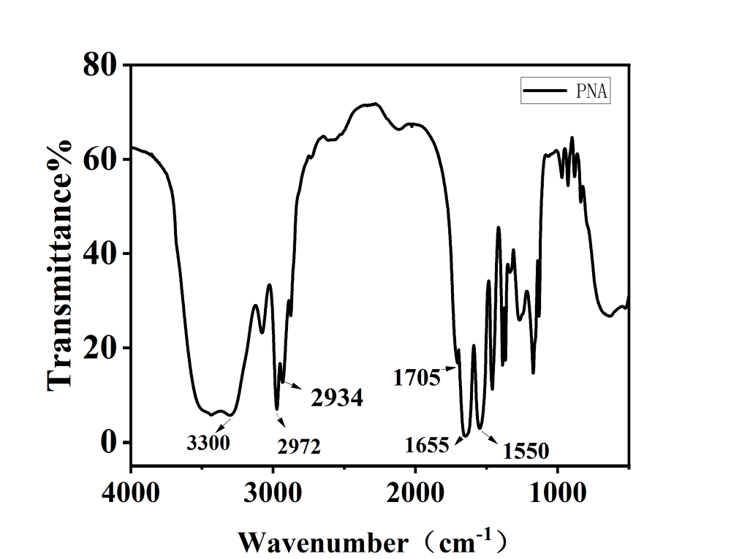
Fig S1. Infrared spectrum of PNA nanogel

Fig S2. Phase transition diagrams of four different concentrations of PNA at different temperatures

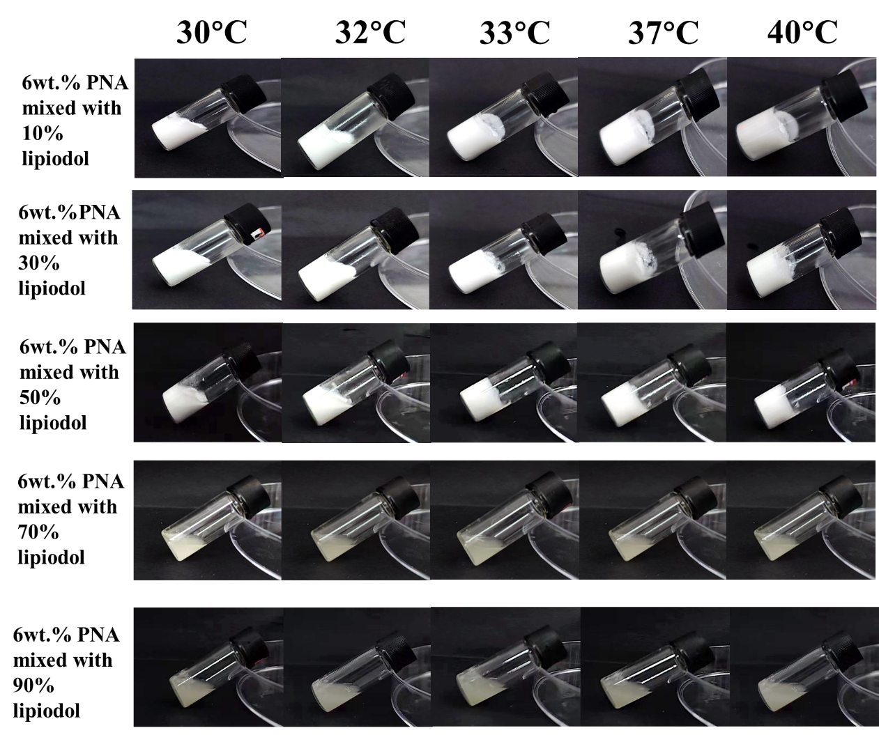
Fig S3. 6wt.%PNA was mixed with different contents of lipiodol

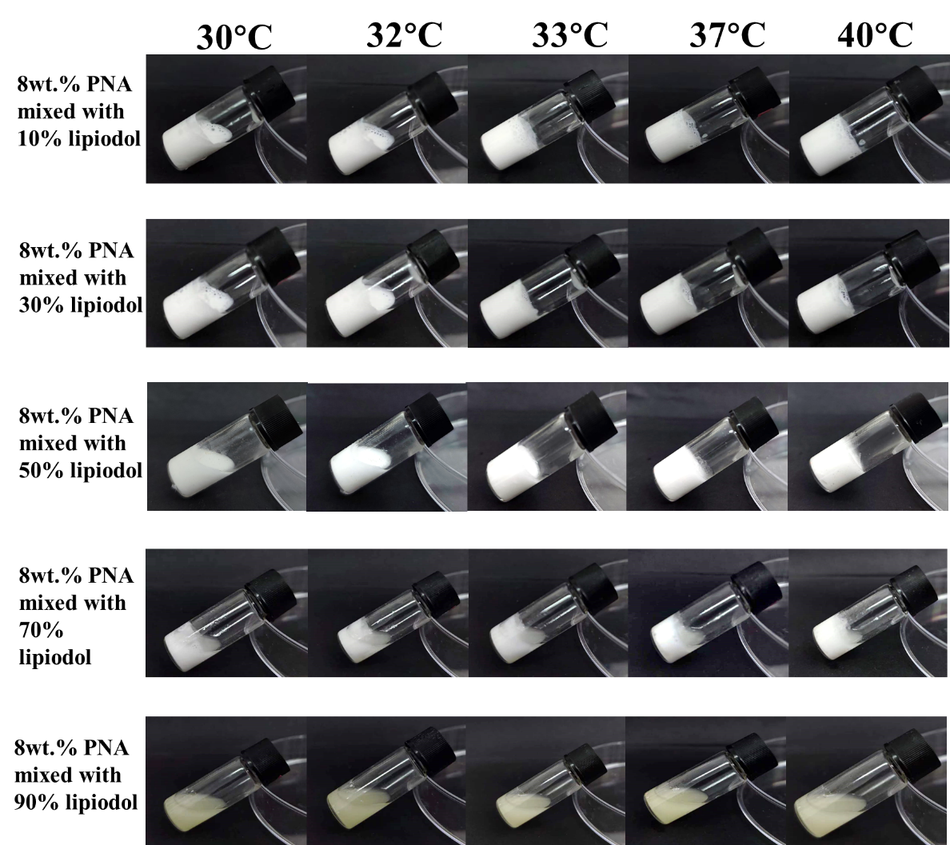
Fig S4. 8wt.%PNA was mixed with different contents of lipiodol

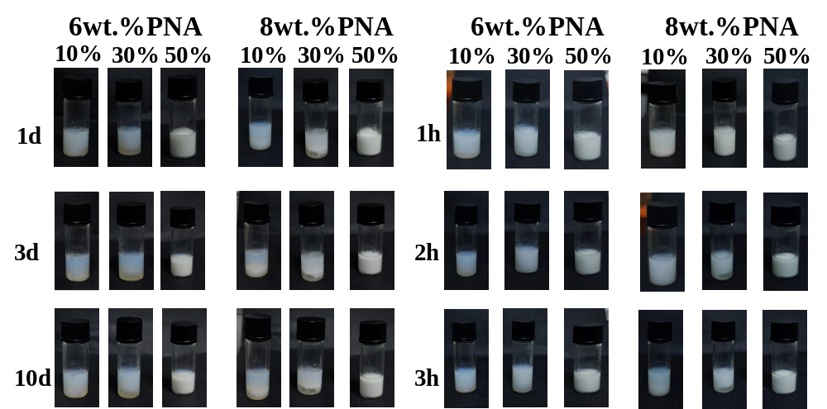
Fig S5. Comparison of in vitro stability of 6wt.%PNA and 8wt.%PNA mixed with different contents of lipiodol

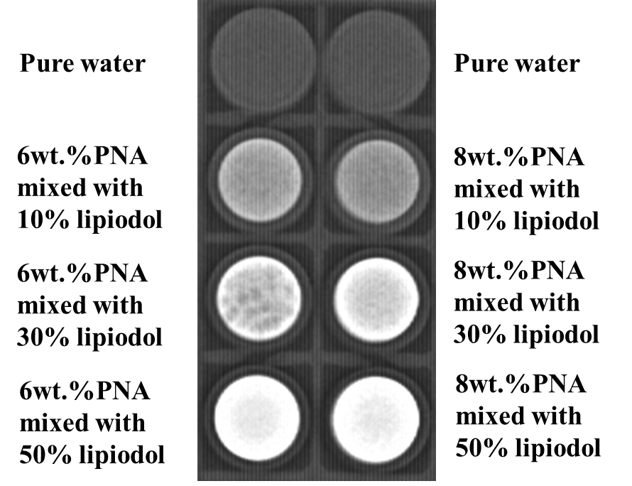
Fig S6. Comparison of X-ray development of 6wt.%PNA and 8wt.%PNA mixed with different contents of lipiodol

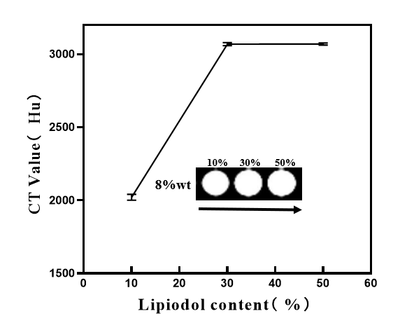
Fig S7. Contrast of 8wt.%PNA mixed with different contents of lipiodol under CT

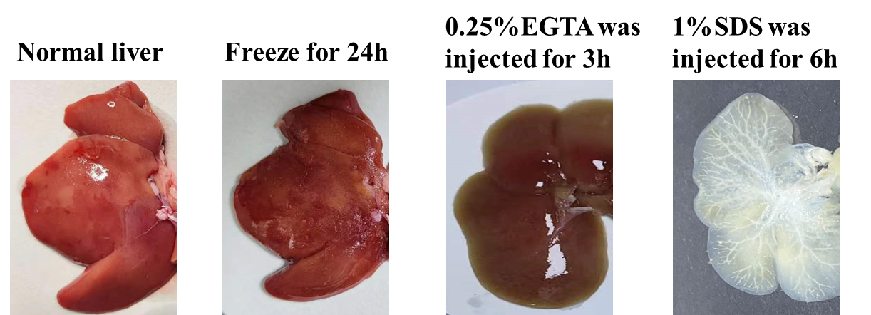
Fig S8. Representative images of rat livers during decellularization process

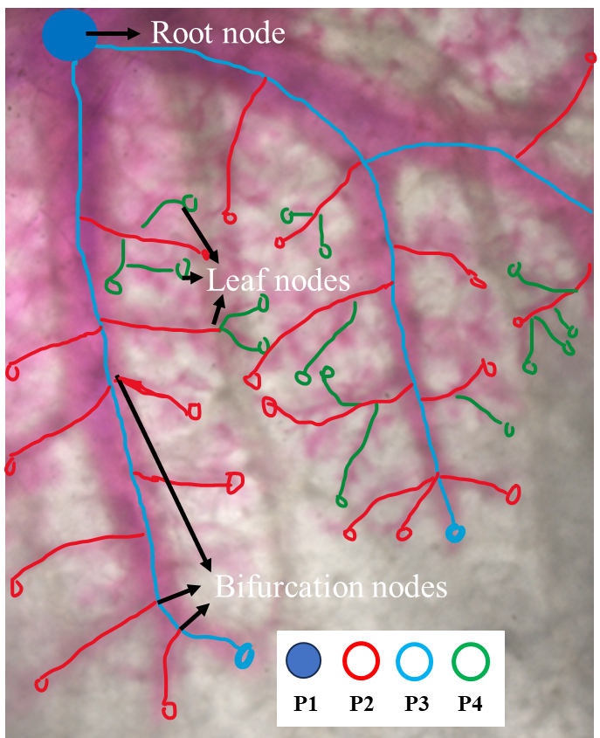
Fig S9. Skeletal diagram of TLGE through decellularized liver vascular structures. The vessel skeleton is defined as 4 elements: root node, bifurcation nodes and leaf nodes. The vessel branches are divided into 3 levels with a custom-designed rule, which is marked in different colors.

Table S1. TLGE emulsion mixing method
Lipiodol | PNA
Lipiodol | 6wt.%PNA |  | 8wt.%PNA
0.1ml Lipiodol（10%） | 0.9ml |  | 0.9ml
0.3ml Lipiodol（30%） | 0.7ml |  | 0.7ml
0.5ml Lipiodol（50%） | 0.5ml |  | 0.5ml
0.7ml Lipiodol（70%） | 0.3ml |  | 0.3ml
0.9ml Lipiodol（90%） | 0.1ml |  | 0.1ml

