Supplemental Information
Chemical looping synthesis of amines from N₂ via iron nitride as a mediator
Haoyue Li,^{ab} Tie Wang,^{ab} Shifu Wang,^{d} Xuning Li,^{d} Yanqiang Huang,^{d} Ning Yan*^{abc}
* Corresponding author
a Joint School of National University of Singapore and Tianjin University, International Campus of Tianjin University, Binhai New City, Fuzhou 350207, China
b Department of Chemical and Biomolecular Engineering, National University of Singapore, Singapore 117585, Singapore
c Centre for Hydrogen Innovations, National University of Singapore, Singapore 117585, Singapore
d State Key Laboratory of Catalysis, Dalian Institute of Chemical Physics, Chinese Academy of Sciences, Dalian 116023, China

Table of contents
Figure S1. SEM images of (a) fresh Fe_{x}N and (f) 32 h spent Fe_{x}N. EDS color mapping images of (b-e) fresh Fe_{x}N and (g-j) 32 h spent Fe_{x}N. 4
Figure S2. TEM images and EDS color mapping images of (a-f) fresh Fe_{x}N and (g-k) 32 h spent Fe_{x}N. 5
Figure S3. XPS survey spectra of fresh Fe_{2.5}N, 2 h spent Fe_{2.5}N, and 32 h spent Fe_{2.5}N. 6
Figure S4. XPS high-resolution spectra of the (a) Fe 2p and (b) O 1s regions of the fresh Fe_{2.5}N, 2 h spent Fe_{2.5}N, and 32 h spent Fe_{2.5}N. 7
Figure S5. Ar-TPD-MS spectra of fresh Fe_{2.5}N, pure Ar gas was used for Ar-TPD. The outlet gas was connected to the MS for the real-time observation. N₂ MS signal: m/z=14. 8
Figure S6. Conversion of isopropanol and the yields of main products using Fe_{2.5}N at 250 ℃ and 10 bar total pressure with 30 mL/min Ar and 30 mL/min H₂ flow. IPO bubbling chamber temperature is 25 ℃ (equivalent flow rate: 1.438*10⁻⁵ mol/min). 9
Figure S7. Accumulated chemicals amount and conversion of N in Fe_{2.5}N at different temperatures with 5 bar H₂ partial pressure. 10
Figure S8. Conversion of isopropanol or acetone to isopropylamine at different temperatures. Accumulated chemicals amount represents the obtained chemicals amount within the first 300 min. Conversion of N in Fe_{2.5}N = $\text{(nNfresh-nNspent)/nNfresh}$. Total flow rate is 60 mL/min, and the total pressure is 10 bar. IPO bubbling chamber temperature is 25 ℃ (equivalent flow rate: 1.438*10⁻⁵ mol/min). 11
Figure S9. DRIFTS spectra of adsorbed NH₃ at various temperatures over fresh Fe_{2.5}N. Ammonia was injected at 50 ℃, and spectrums were collected under Ar purging flow when increasing temperature to 200 ℃. 12
Figure S10. DRIFTS spectra of isopropanol, isopropylamine and acetone adsorption on fully spent Fe_{2.5}N at Ar atmosphere at 25 ℃. 13
Figure S11. SEM image and EDX mapping images (a-c), TEM image and EDX mapping images (d-f) of N₂-nitridated Fe_{x}N. 14
Table S1. Summary of some existing amination reaction systems. 15
Table S2. C, N, O, and Fe element content of fresh Fe_{x}N, spent Fe_{x}N, N₂-nitridated Fe_{x}N, spent N₂-nitridated Fe_{x}N obtained by TEM-EDS mapping and SEM-EDS mapping. 16
Table S3. BET surface area of iron nitrides. 17
Table S4. Fe 2p, N 1s, and O 1s binding energies (eV) and relative peak area obtained by XPS of fresh Fe_{2.5}N, 2 h spent Fe_{2.5}N, and 32 h spent Fe_{2.5}N. 18
Table S5. C, H, N element content obtained by elemental analysis of different particles. The reaction was conducted at 250 ℃. 19
Table S6. Values of the Mössbauer hyperfine parameters, derived from the least-square fitting of the Mössbauer spectra of the fresh Fe_{2.5}N and spent Fe_{2.5}N of 2 h, 5 h, and 32 h. 20
Table S7. IR band assignments for isopropanol absorbed over Fe_{2.5}N. 21
Table S8. N content of N₂-nitridated Fe_{x}N and spent N₂-nitridated Fe_{x}N determined by acid treatment. 22
REFERENCES 23

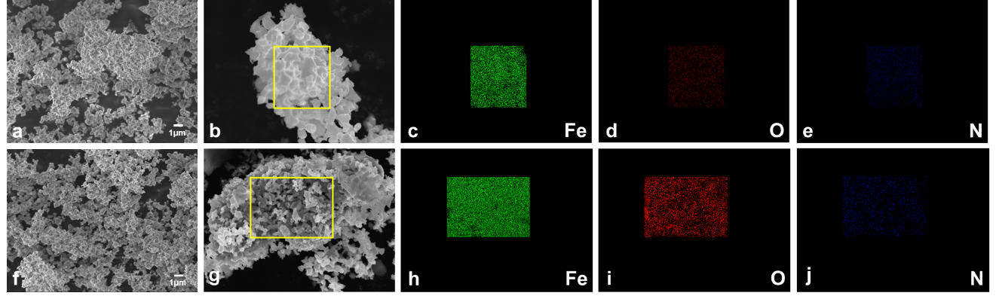

Figure S1. SEM images of (a) fresh Fe_{x}N and (f) 32 h spent Fe_{x}N. EDS color mapping images of (b-e) fresh Fe_{x}N and (g-j) 32 h spent Fe_{x}N.

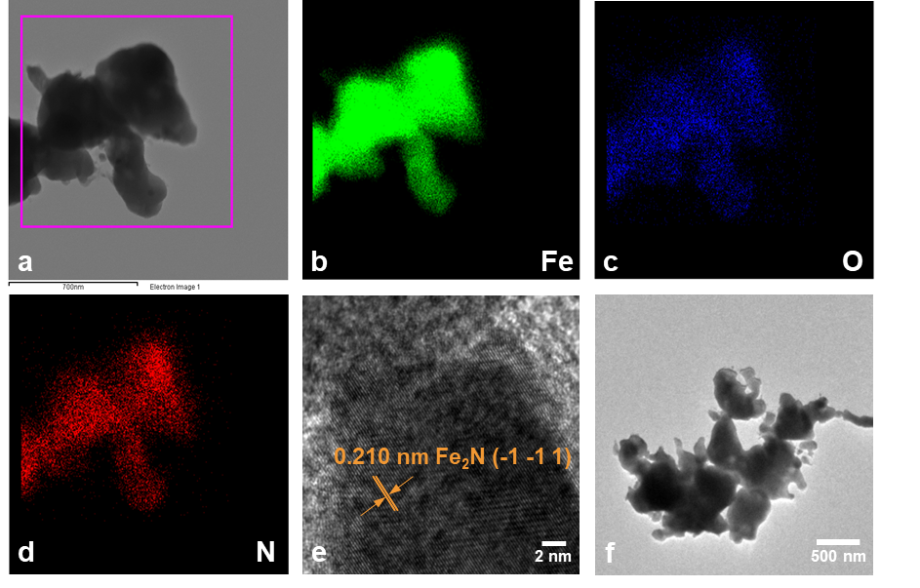
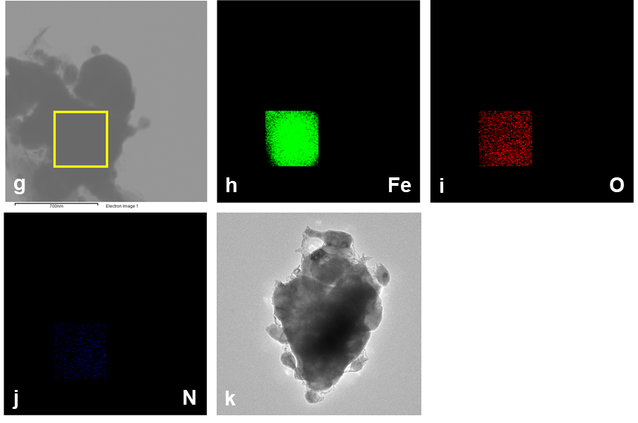

Figure S2. TEM images and EDS color mapping images of (a-f) fresh Fe_{x}N and (g-k) 32 h spent Fe_{x}N.

Figure S3. XPS survey spectra of fresh Fe_{2.5}N, 2 h spent Fe_{2.5}N, and 32 h spent Fe_{2.5}N.

Figure S4. XPS high-resolution spectra of the (a) Fe 2p and (b) O 1s regions of the fresh Fe_{2.5}N, 2 h spent Fe_{2.5}N, and 32 h spent Fe_{2.5}N.

Figure S5. Ar-TPD-MS spectra of fresh Fe_{2.5}N, pure Ar gas was used for Ar-TPD. The outlet gas was connected to the MS for the real-time observation. N₂ MS signal: m/z=14.

Figure S6. Conversion of isopropanol and the yields of main products using Fe_{2.5}N at 250 ℃ and 10 bar total pressure with 30 mL/min Ar and 30 mL/min H₂ flow. IPO bubbling chamber temperature is 25 ℃ (equivalent flow rate: 1.438*10⁻⁵ mol/min).

Figure S7. Accumulated chemicals amount and conversion of N in Fe_{2.5}N at different temperatures with 5 bar H₂ partial pressure.

Figure S8. Conversion of isopropanol or acetone to isopropylamine at different temperatures. Accumulated chemicals amount represents the obtained chemicals amount within the first 300 min. Conversion of N in Fe_{2.5}N = $\text{(}{\text{n}}_{{\text{N}}_{\text{fresh}}}\text{-}{\text{n}}_{{\text{N}}_{\text{spent}}}\text{)/}{\text{n}}_{{\text{N}}_{\text{fresh}}}$. Total flow rate is 60 mL/min, and the total pressure is 10 bar. IPO bubbling chamber temperature is 25 ℃ (equivalent flow rate: 1.438*10⁻⁵ mol/min).

Figure S9. DRIFTS spectra of adsorbed NH₃ at various temperatures over fresh Fe_{2.5}N. Ammonia was injected at 50 ℃, and spectrums were collected under Ar purging flow when increasing temperature to 200 ℃.

Figure S10. DRIFTS spectra of isopropanol, isopropylamine and acetone adsorption on fully spent Fe_{2.5}N at Ar atmosphere at 25 ℃.

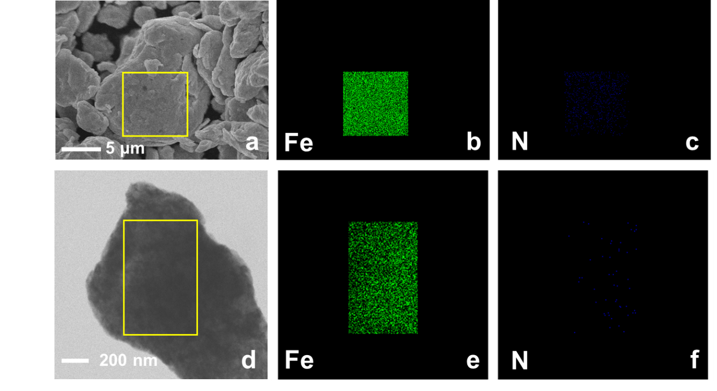

Figure S11. SEM image and EDX mapping images (a-c), TEM image and EDX mapping images (d-f) of N₂-nitridated Fe_{x}N.

Table S1. Summary of some existing amination reaction systems.
Ref | Catalyst | Reaction | T (℃) | Yield (%) | NH₃ : substrate | N utilization efficiency (%)
1 | Ru/ZrO₂ | Glycolaldehyde to ethanolamine | 85 | 94 | 14.7 | 6.4
2 | Ru/Nb₂O₅ | Furfural to furfurylamine | 90 | 99 | 16 | 6.2
3 | Ru/CNT | Lactic acid to alanine | 220 | 62 | 73.5 | 0.8
4 | Ru/C | Isomannide to monoamine or diamine | 170 | 45 | 11.8 | 3.8
5 | Ru NPs | 1-Octanol to 1-Octylamine | 180 | 80 | 17 | 4.7
6 | Ru₁Ni₇/MgO | Lactic acid to alanine | 220 | 6.2 | 26.5 | 0.2
7 | Pt/graphite | Butyraldehyde to butylamine | 50 | 83 | 16.5 | 5.0
8 | Pt/ZrO₂ | Trilaurin to dodecylamine | 220 | 59 | 150 | 0.4
9 | Rh/α- Al₂O₃ | Butyraldehyde to butylamine | 80 | 66.2 | 11.3 | 5.9
10 | Rh/Al₂O₃ | Furfural to furfurylamine | 80 | 91.5 | 33.3 | 2.7
11 | Pd/C | Dodecanol to dodecylamine | 200 | 96.5 | 64.6 | 1.5
12 | Au/TiO₂ + Cu/SiO₂ | Benzyl alcohol to benzylamine | 225 | 95 | 40 | 2.4
13 | Ag-Co/Al₂O₃ | 1-Octanol to 1-Octylamine | 200 | 78 | 21 | 3.7
14 | Co-DABCO-TPA@C | Acetophenone to phenethylamine | 120 | 87 | 121.1 | 0.7
15 | Ni/Al₂O₃ | Furfural to furfurylamine | 100 | 92 | 21 | 4.3
16 | Ni@C/Al₂O₃ | 5-Hydroxymethylfurfural to 5-Hydroxymethylfurfurylamine | 30 | 96 | 14 | 6.9

Table S2. C, N, O, and Fe element content of fresh Fe_{x}N, spent Fe_{x}N, N₂-nitridated Fe_{x}N, spent N₂-nitridated Fe_{x}N obtained by TEM-EDS mapping and SEM-EDS mapping.
 | Particles | C (wt.%) | N (wt.%) | O (wt.%) | Fe (wt.%)
TEM-mapping | Fresh Fe_{x}N | 2.99 | 5.94 | 1.19 | 89.88
TEM-mapping | 32 h Spent Fe_{x}N | 5.98 | -0.23 | 1.72 | 92.53
TEM-mapping | N₂-nitridated Fe_{x}N | 7.30 | 0.11 | 2.02 | 90.58
TEM-mapping | Spent N₂-nitridated Fe_{x}N | 5.36 | -0.31 | 0.96 | 93.99
SEM-mapping | Fresh Fe_{x}N | 23.44 | 8.21 | 4.34 | 64.01
SEM-mapping | 32 h Spent Fe_{x}N | 7.31 | 0.09 | 3.72 | 88.89
SEM-mapping | N₂-nitridated Fe_{x}N | 4.43 | 0.53 | 1.76 | 93.27
SEM-mapping | Spent N₂-nitridated Fe_{x}N | 5.57 | -0.12 | 1.33 | 93.22

Table S3. BET surface area of iron nitrides.
Catalyst | BET specific surface area (m² g⁻¹)
Fresh Fe_{x}N | 14
32 h Spent Fe_{x}N | 12
5 h Spent Fe_{x}N | 11

Table S4. Fe 2p, N 1s, and O 1s binding energies (eV) and relative peak area obtained by XPS of fresh Fe_{2.5}N, 2 h spent Fe_{2.5}N, and 32 h spent Fe_{2.5}N.
 | Fe |  |  | N |  |  | O
Particles | B.E. (eV) | State | Rel. area (%) | B.E. (eV) | State | Rel. area (%) | B.E. (eV) | State | Rel. area (%)
Fresh Fe_{2.5}N | 706.8, 719.8 | Fe_{x}N/Fe⁰ | 12.5, 7.5 | 396.7 | Fe-N | 35.6 | 529.7 | Fe-O | 20.7
Fresh Fe_{2.5}N | 709.0, 711.3, 723.0, 728.2 | Fe-O/Fe-O-N | 30.5, 13.8, 17.7, 6.9 | 397.6 | Fe-O-N | 27.6 | 530.7 | Fe-O-N | 10.2
Fresh Fe_{2.5}N | 716.3, 734.2 | Fe sat. | 3.8, 7.5 | 399.1 | NH_{3 ad} | 36.9 | 532.2 | H₂O _{ad} | 69.1
2 h Spent Fe_{2.5}N | 707.1, 720.0 | Fe_{x}N/Fe⁰ | 5.2, 7.0 | 396.7 | Fe-N | 55.8 | 529.8 | Fe-O | 36.2
2 h Spent Fe_{2.5}N | 710.7, 714.1, 724.2, 727.1 | Fe-O/Fe-O-N | 39.2, 10.2, 17.7, 9.7 | 397.8 | Fe-O-N | 23.5 | 531.2 | Fe-O-N | 41.7
2 h Spent Fe_{2.5}N | 717.8, 733.2 | Fe sat. | 3.6, 7.4 | 399.1 | NH_{3 ad} | 20.77 | 532.4 | H₂O _{ad} | 22.1
32 h Spent Fe_{2.5}N | 706.3, 720.4 | Fe_{x}N/Fe⁰ | 4.0, 4.6 | --- | --- | --- | 529.6 | Fe-O | 41.4
32 h Spent Fe_{2.5}N | 710.4, 714.8, 723.6, 726.4 | Fe-O/Fe-O-N | 49.0, 6.7, 17.2, 7.9 | --- | --- | --- | 531.0 | Fe-O-N | 39.1
32 h Spent Fe_{2.5}N | 718.5, 732.8 | Fe sat. | 4.9, 5.8 | --- | --- | --- | 532.4 | H₂O _{ad} | 19.5

Table S5. C, H, N element content obtained by elemental analysis of different particles. The reaction was conducted at 250 ℃.
Particles | Reaction time (hrs.) | P_{H2} (bar) | N (wt.%) | H (wt.%) | C (wt.%)
Fresh Fe_{2.5}N | --- | --- | 9.07 | 0.00 | 0.36
Spent Fe_{2.5}N | 2 | 5 | 1.57 | 0.00 | 0.55
Spent Fe_{2.5}N | 5 | 5 | 0.24 | 0.00 | 0.32
Spent Fe_{2.5}N | 32 | 5 | 0.09 | 0.09 | 0.39
Spent Fe_{2.5}N | 5 | 3 | 0.25 | 0.00 | 0.33
Spent Fe_{2.5}N | 5 | 1 | 0.31 | 0.00 | 0.37
N₂-nitridated Fe_{x}N | --- | --- | 0.10 | 0.00 | 0.00
Spent N₂-nitridated Fe_{x}N | 6 | 10 | 0.00 | 0.00 | 0.00

Table S6. Values of the Mössbauer hyperfine parameters, derived from the least-square fitting of the Mössbauer spectra of the fresh Fe_{2.5}N and spent Fe_{2.5}N of 2 h, 5 h, and 32 h.
sample | δª (mm/s) | Δ^{b} (mm/s) | H^{c} (T) | Line width | Area^{d} (%) | Assignment^{e}
Fresh Fe_{2.5}N | 0.24 | 0.13 | 20.78 | 0.78 | 26.11 | γ-Fe₄N
Fresh Fe_{2.5}N | 0.40 | 0.27 | -- | 0.62 | 73.89 | ε-Fe_{2.1}N
2 h Spent Fe_{2.5}N | 0.024 | -- | 32.95 | 0.30 | 100 | α-Fe
5 h Spent Fe_{2.5}N | 0.0018 | -- | 33.01 | 0.30 | 100 | α-Fe
32 h Spent Fe_{2.5}N | 0.0028 | -- | 33.03 | 0.33 | 100 | α-Fe
ªδ is the isomer shift.
^{b}Δ is the quadrupole splitting.
^{c}H is the hyperfine magnetic field.
^{d}Area is the relative spectral area of individual spectral components identified during fitting.
^{e}The spectra were recorded at 298 K.

Table S7. IR band assignments for isopropanol absorbed over Fe_{2.5}N.
Wavenumber (cm⁻¹) | Assignment | Ref
3656 | O-H stretching | 17
3566, 3553, 3545, 3528, 3524 | Fe-NH_{x} stretching | 18
2655 | N-H stretching | 19
1738 | C=O stretching | ^{20,21}
1651, 1642 | C=N stretching | ^{22,23}
1246 | C-N stretching | ^{23,24}
1625, 1593, 1579~1508, 966, 931 | N-H bending | ^{22,23,25}

Table S8. N content of N₂-nitridated Fe_{x}N and spent N₂-nitridated Fe_{x}N determined by acid treatment.
Sample | Sample amount (g) | NH₄⁺ conc. in diluted H₂SO₄ (mg/L) ^{[a]} | N amount (μmol) in 0.5 g sample
N₂-nitridated Fe_{x}N | 0.50 | 2.46 | 143.58
Spent N₂-nitridated Fe_{x}N | 0.50 | n.d. | n.d.
^{[a]} H₂SO₄ adsorption solution was 10 times diluted for IC test, and the volume is 10.5 mL.

REFERENCES
1. Liang, G. et al. Production of primary amines by reductive amination of biomass-derived aldehydes/ketones. Angew. Chem. Int. Ed. 56, 3050-3054 (2017).
2. Komanoya, T., Kinemura, T., Kita, Y., Kamata, K. & Hara, M. Electronic effect of Ruthenium nanoparticles on efficient reductive amination of carbonyl compounds. J. Am. Chem. Soc. 139, 11493-11499 (2017).
3. Deng, W. et al. Catalytic amino acid production from biomass-derived intermediates. Proc. Natl. Acad. Sci. 115, 5093-5098 (2018).
4. Niemeier, J., Engel, R. V. & Rose, M. Is water a suitable solvent for the catalytic amination of alcohols? Green Chem. 19, 2839-2845 (2017).
5. Liang, G., Zhou, Y., Zhao, J., Khodakov, A. Y. & Ordomsky, V. V. Structure-sensitive and insensitive reactions in alcohol amination over nonsupported Ru nanoparticles. ACS Catal. 8, 11226-11234 (2018).
6. Wang, Y. et al. Catalytic production of alanine from waste glycerol. Angew. Chem. Int. Ed. 59, 2289-2293 (2020).
7. Bódis, J., Lefferts, L., Müller, T. E., Pestman, R. & Lercher, J. A. Activity and selectivity control in reductive amination of butyraldehyde over noble metal catalysts. Catal. Lett. 104, 23-28 (2005).
8. Jamil, M. A. R. et al. Selective transformations of triglycerides into fatty amines, amides, and nitriles by using heterogeneous catalysis. ChemSusChem 12, 3115-3125 (2019).
9. Luo, D. et al. Intrinsic mechanism of active metal dependent primary amine selectivity in the reductive amination of carbonyl compounds. J. Catal. 395, 293-301 (2021).
10. Chatterjee, M., Ishizaka, T. & Kawanami, H. Reductive amination of furfural to furfurylamine using aqueous ammonia solution and molecular hydrogen: an environmentally friendly approach. Green Chem. 18, 487-496 (2016).
11. Ruiz, D. et al. Direct amination of dodecanol with NH₃ over heterogeneous catalysts. Catalyst screening and kinetic modelling. Chem. Eng. J. 307, 739-749 (2017).
12. Li, M., Pischetola, C., Cárdenas-Lizana, F. & Keane, M. A. Production of benzylamine by tandem dehydrogenation/amination/reduction over Cu and Au catalysts. Appl. Catal., A 590, (2020).
13. Ibáñez, J., Kusema, B. T., Paul, S. & Pera-Titus, M. Ru and Ag promoted Co/Al₂O₃ catalysts for the gas-phase amination of aliphatic alcohols with ammonia. Catal. Sci. Technol. 8, 5858-5874 (2018).
14. Jagadeesh, R. V. et al. MOF-derived cobalt nanoparticles catalyze a general synthesis of amines. Science 358, 326-332 (2017).
15. Dong, C. et al. Facile and efficient synthesis of primary amines via reductive amination over a Ni/Al₂O₃ Catalyst. ACS Sustainable Chem. Eng. 9, 7318-7327 (2021).
16. Hu, Q. et al. Ambient-temperature reductive amination of 5-Hydroxymethylfurfural over Al₂O₃-supported carbon-doped Nickel catalyst. ChemSusChem 15, e202200192 (2022).
17. Xu, W., Raftery, D. & Francisco, J. S. Effect of irradiation sources and oxygen concentration on the photocatalytic oxidation of 2-propanol and acetone studied by in situ FTIR. J. Phys. Chem. B 107, 4537-4544 (2003).
18. Zhao, B. et al. Unveiling the activity origin of iron nitride as catalytic material for efficient hydrogenation of CO₂ to C₂₊ hydrocarbons. Angew Chem Int Ed Engl 60, 4496-4500 (2021).
19. Brzezinski, B. & Zundel, G. An intramolecular charge relay system via easily polarizable hydrogen bonds in the N-(4-methyl-2-pyridyl)amide of 6-methylpicolinic acid N-oxide. J.Phys.Chem. 83, 1787-1789 (1979).
20. Araña, J. et al. FTIR study of photocatalytic degradation of 2-propanol in gas phase with different TiO₂ catalysts. Appl. Catal. B. 89, 204-213 (2009).
21. Gu, Q. et al. Photocatalytic reforming of C3-polyols for H₂ production: Part II. FTIR study on the adsorption and photocatalytic reforming reaction of 2-propanol on Pt/TiO₂. Appl. Catal. B. 106, 689-696 (2011).
22. Sotowa, K.-I., Amamoto, T., Sobana, A., Kusakabe, K. & Imato, T. Effect of treatment temperature on the amination of chlorinated diamond. Diam. Relat. Mater. 13, 145-150 (2004).
23. Maiyalagan, T. & Viswanathan, B. Template synthesis and characterization of well-aligned nitrogen containing carbon nanotubes. Mater. Chem. Phys. 93, 291-295 (2005).
24. Wilfong, W. C., Srikanth, C. S. & Chuang, S. S. In situ ATR and DRIFTS studies of the nature of adsorbed CO₂ on tetraethylenepentamine films. ACS Appl. Mater. Interfaces 6, 13617-13626 (2014).
25. Yang, X. et al. DRIFTS Study of Ammonia Activation over CaO and Sulfated CaO for NO Reduction by NH₃. Environ. Sci. Technol. 45, 1147-1151 (2011).

