Supplementary Information
Supplementary Figures and Figure Legends
Supplementary Figure 1
Supplementary Figure 1. The body weights and blood profiles of the mice before and 3 months after FMT. (a-f) The body weights and blood profiles of the groups classified through the Rotarod records were shown. (a) The average values of body weight in each group are shown. Blood glucose (b), total glycerol (TG) (c), total cholesterol (TCHO) (d), HDL-cholesterol (HDL-CHO) (e) and LDL-cholesterol (LDL-CHO) (f) are shown. (g-l) The body weights and blood profiles of the groups classified through the Wire suspension records were shown. (g) The average values of body weight in each group are shown. Blood glucose (h), total glycerol (TG) (i), total cholesterol (TCHO) (j), HDL-cholesterol (HDL-CHO) (k) and LDL-cholesterol (LDL-CHO) (l) are shown. The values are represented as mean ± S.E.M. 0m, before FMT; 3m, 3 months after FMT; Rota, mouse groups classified based on the Rotarod records; Wire, mouse groups classified based on the Wire suspension records; SMS, mouse group with stronger muscle strength after FMT; MMS, mouse group with unchanged in muscle strength after FMT; WMS, mouse group with weakened muscle strength after FMT. *p < 0.05; **p < 0.01; ***p < 0.001.

Supplementary Figure 2
Supplementary Figure 2. Additional analysis of the fecal gut microbiome before and after FMT in the Rotarod experimental group. (a) Comparisons of α-diversity indices of the fecal gut microbiome, measured using ACE richness, Evenness, Inverse Simpson, and Shannon methods are shown in box plots. (b-d) Comparisons of phylogenetic compositions of the fecal gut microbiome before and 3 months after FMT at various taxonomic levels (class (b), order (c), and family (d)). (e-g) Nonmetric multidimensional scaling (NMDS) plot (e) showing the difference in fecal gut microbiome before and 3 months after FMT. Redundancy analysis (RDA) plot (f) showing the difference in fecal gut microbiome before and 3 months after FMT. Detrended correspondence analysis (DCA) plot (g) showing the difference in fecal gut microbiome before and 3 months after FMT. Rota, mouse groups classified based on the Rotarod records; 0m, before FMT; 3m, 3 months after FMT; Feces, fecal gut microbiome.

Supplementary Figure 3
Supplementary Figure 3. Additional analysis of the fecal gut microbiome before and after FMT in the Wire suspension experimental group. (a) Comparisons of α-diversity indices of the fecal gut microbiome, measured using ACE richness, Evenness, Inverse Simpson, and Shannon methods are shown in box plots. (b-d) Comparisons of phylogenetic compositions of the fecal gut microbiome before and 3 months after FMT at various taxonomic levels (class (b), order (c), and family (d)). (e-g) Nonmetric multidimensional scaling (NMDS) plot (e) showing the difference in fecal gut microbiome before and 3 months after FMT. Redundancy analysis (RDA) plot (f) showing the difference in fecal gut microbiome before and 3 months after FMT. Detrended correspondence analysis (DCA) plot (g) showing the difference in fecal gut microbiome before and 3 months after FMT. Wire, mouse groups classified based on the Wire suspension records; 0m, before FMT; 3m, 3 months after FMT; Feces, fecal gut microbiome.

Supplementary Figure 4
Supplementary Figure 4. The color legend of maximum-likelihood phylogenetic tree. The color legend explains the circular rings representing the phylum taxonomy and inner layer representing the family taxonomy of maximum-likelihood phylogenetic tree comprising taxa of the fecal gut microbiome (Figure 2, Supplementary Figure 5 and Supplementary Figure 8) and GI gut microbiome (Figure 4 and Figure 5) before and 3 months after FMT.

Supplementary Figure 5
Supplementary Figure 5. Additional analysis of the fecal gut microbiome before and after FMT in individual groups classified through the Rotarod records. (a) Comparisons of α-diversity indices of the fecal gut microbiome, measured using ACE richness, Evenness, Inverse Simpson, and Shannon methods are shown in box plots. (b) Comparisons of phylogenetic compositions of the fecal gut microbiome after FMT at various taxonomic levels (class (left), order (middle), and family (right)) in each group. (c) Maximum-likelihood phylogenetic tree comprising taxa of the fecal gut microbiome in each group before FMT (left) and 3 month after FMT (right) in each group (SMS (upper), MMS (middle), and WMS (lower)). (d) Color-coded network graphs of the fecal gut microbiome in each group before FMT (left) and 3 month after FMT (right) in each group (SMS (upper), MMS (middle), and WMS (lower)). Rota, mouse groups classified based on the Rotarod records; 0m, before FMT; 3m, 3 months after FMT; Feces, fecal gut microbiome; SMS, mouse group with stronger muscle strength after FMT; MMS, mouse group with unchanged in muscle strength after FMT; WMS, mouse group with weakened muscle strength after FMT.

Supplementary Figure 6
Supplementary Figure 6. The beta (β)-diversity plots of the fecal gut microbiome 3 months before and 3months after FMT in individual groups classified through the Rotarod records. (a) Nonmetric multidimensional scaling (NMDS) plot showing the difference in fecal gut microbiome of each group before FMT (upper) and 3 months after FMT (lower). (b) Redundancy analysis (RDA) plot showing the difference in fecal gut microbiome of each group before FMT (upper) and 3 months after FMT (lower). (c) Detrended correspondence analysis (DCA) plot showing the difference in fecal gut microbiome of each group before FMT (upper) and 3 months after FMT (lower). Rota, mouse groups classified based on the Rotarod records; 0m, before FMT; 3m, 3 months after FMT; Feces, fecal gut microbiome; SMS, mouse group with stronger muscle strength after FMT; MMS, mouse group with unchanged in muscle strength after FMT; WMS, mouse group with weakened muscle strength after FMT.

Supplementary Figure 7
Supplementary Figure 7. Heatmap of the microbial composition of the fecal gut microbiome 3 months before and 3 months after FMT in individual groups classified through the Rotarod records. Heatmap of the microbial composition in fecal gut microbiome of each group before FMT (a-e, left) and 3 months after FMT (a-e, right) based on Bray-Curtis distance matrix calculated at the phylum level (a), class level (b), order level (c), family level (d), and genus level (e). Rota, mouse groups classified based on the Rotarod records; 0m, before FMT; 3m, 3 months after FMT; Feces, fecal gut microbiome; SMS, mouse group with stronger muscle strength after FMT; MMS, mouse group with unchanged in muscle strength after FMT; WMS, mouse group with weakened muscle strength after FMT.

Supplementary Figure 8
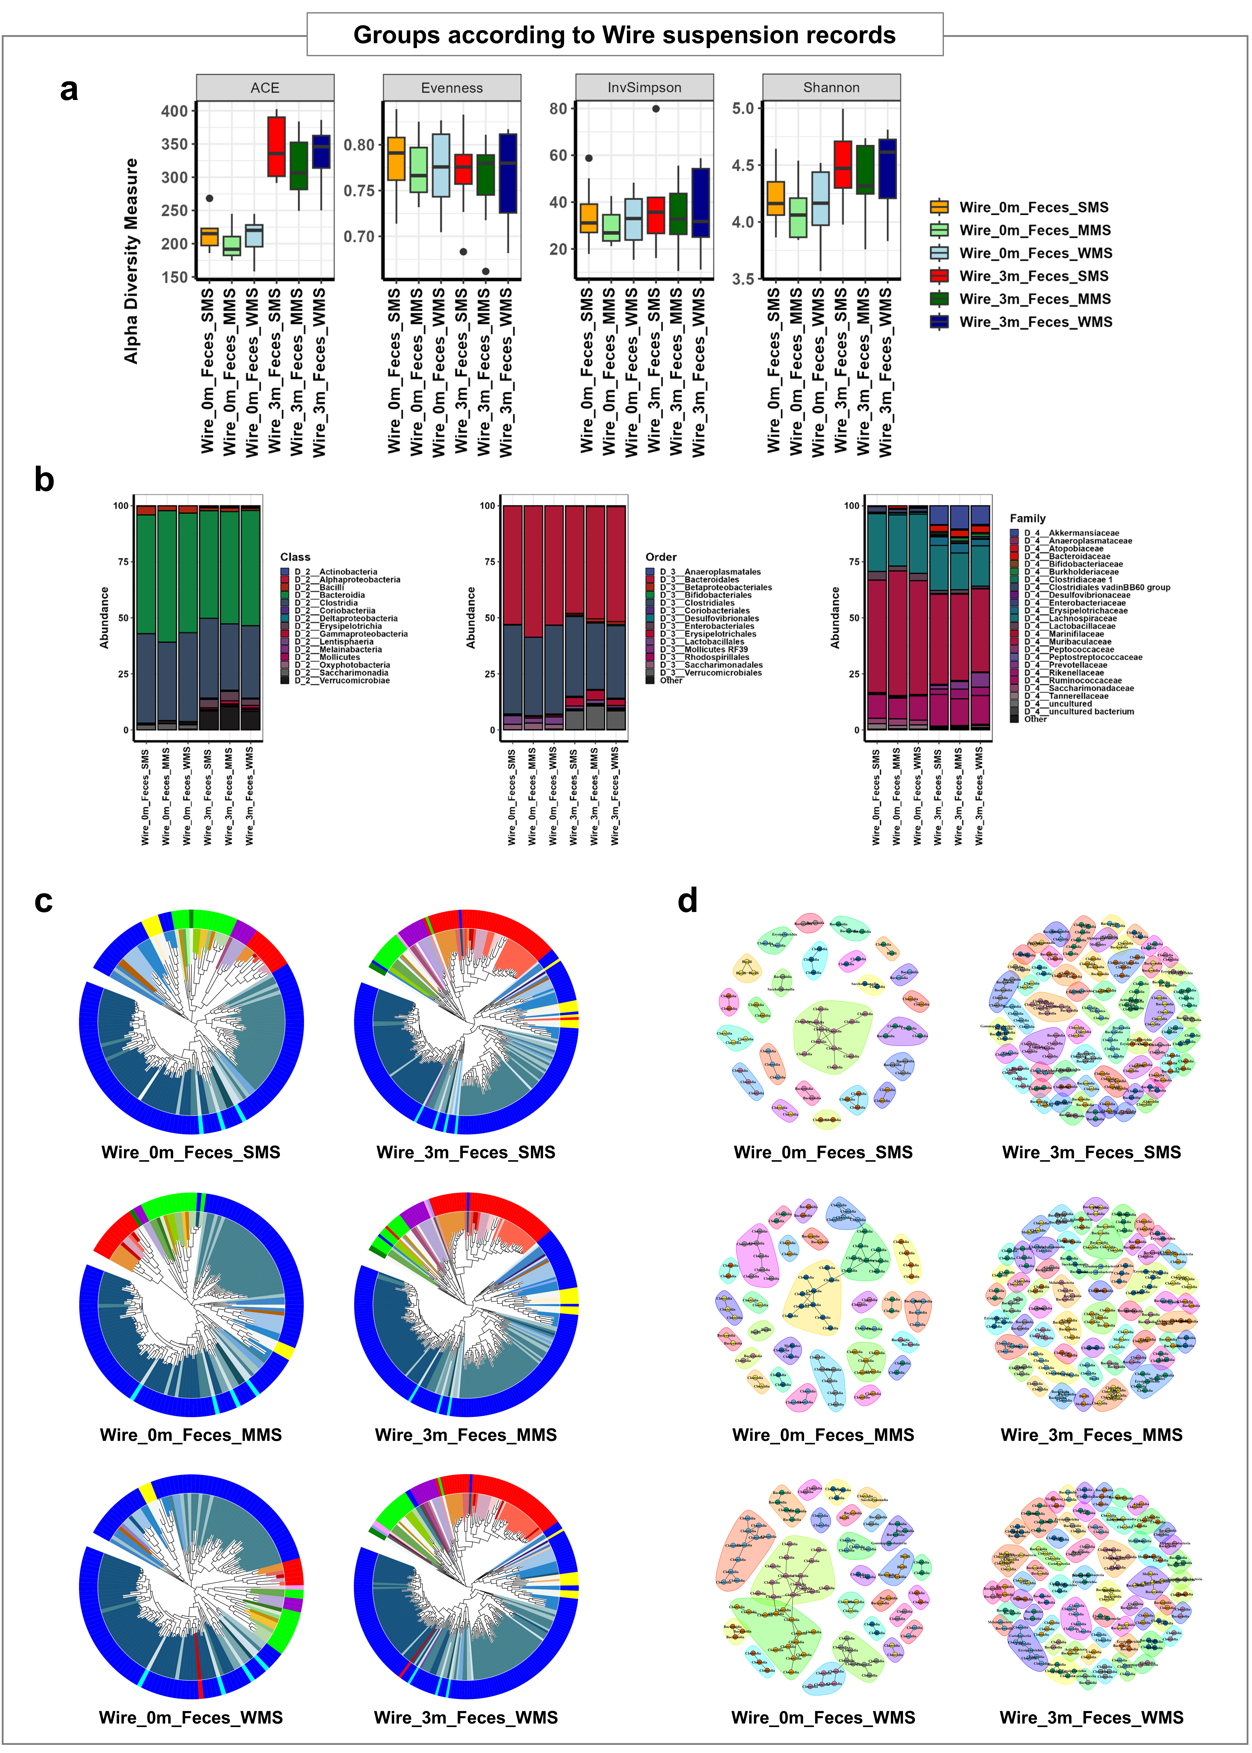
Supplementary Figure 8. Additional analysis of the fecal gut microbiome before and after FMT in individual groups classified through the Wire suspension records. (a) Comparisons of α-diversity indices of the fecal gut microbiome, measured using ACE richness, Evenness, Inverse Simpson, and Shannon methods are shown in box plots. (b) Comparisons of phylogenetic compositions of the fecal gut microbiome after FMT at various taxonomic levels (class (left), order (middle), and family (right)) in each group. (c) Maximum-likelihood phylogenetic tree comprising taxa of the fecal gut microbiome in each group before FMT (left) and 3 month after FMT (right) in each group (SMS (upper), MMS (middle), and WMS (lower)). (d) Color-coded network graphs of the fecal gut microbiome in each group before FMT (left) and 3 month after FMT (right) in each group (SMS (upper), MMS (middle), and WMS (lower)). Wire, mouse groups classified based on the Wire suspension records; 0m, before FMT; 3m, 3 months after FMT; Feces, fecal gut microbiome; SMS, mouse group with stronger muscle strength after FMT; MMS, mouse group with unchanged in muscle strength after FMT; WMS, mouse group with weakened muscle strength after FMT.

Supplementary Figure 9
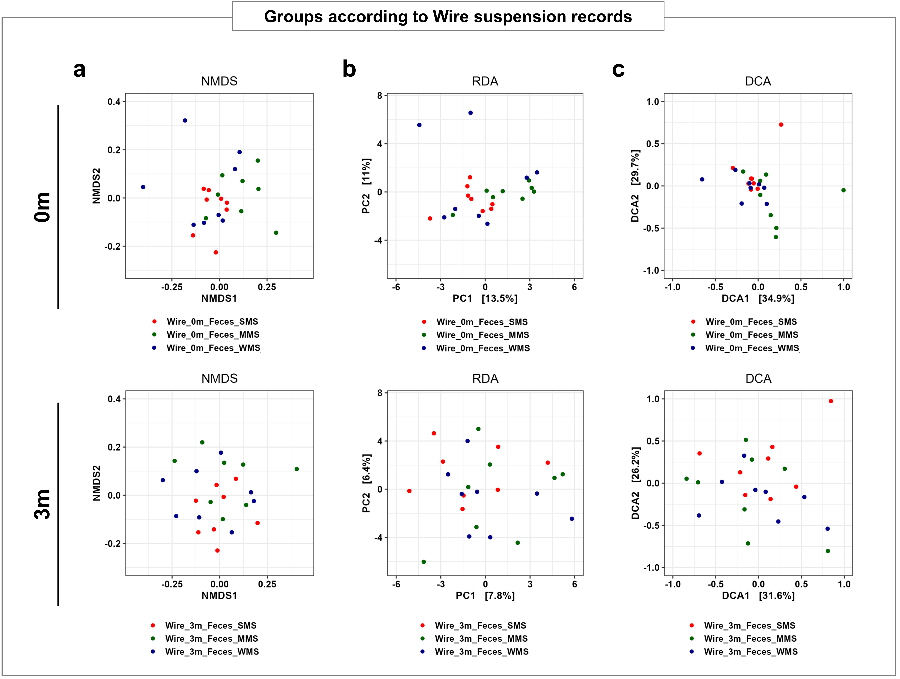
Supplementary Figure 9. The β -diversity plots of the fecal gut microbiome 3 months before and 3 months after FMT in individual groups classified through the Wire suspension records. (a) Nonmetric multidimensional scaling (NMDS) plot showing the difference in fecal gut microbiome of each group before FMT (upper) and 3 months after FMT (lower). (b) Redundancy analysis (RDA) plot showing the difference in fecal gut microbiome of each group before FMT (upper) and 3 months after FMT (lower). (c) Detrended correspondence analysis (DCA) plot showing the difference in fecal gut microbiome of each group before FMT (upper) and 3 months after FMT (lower). Wire, mouse groups classified based on the Wire suspension records; 0m, before FMT; 3m, 3 months after FMT; Feces, fecal gut microbiome; SMS, mouse group with stronger muscle strength after FMT; MMS, mouse group with unchanged in muscle strength after FMT; WMS, mouse group with weakened muscle strength after FMT.

Supplementary Figure 10
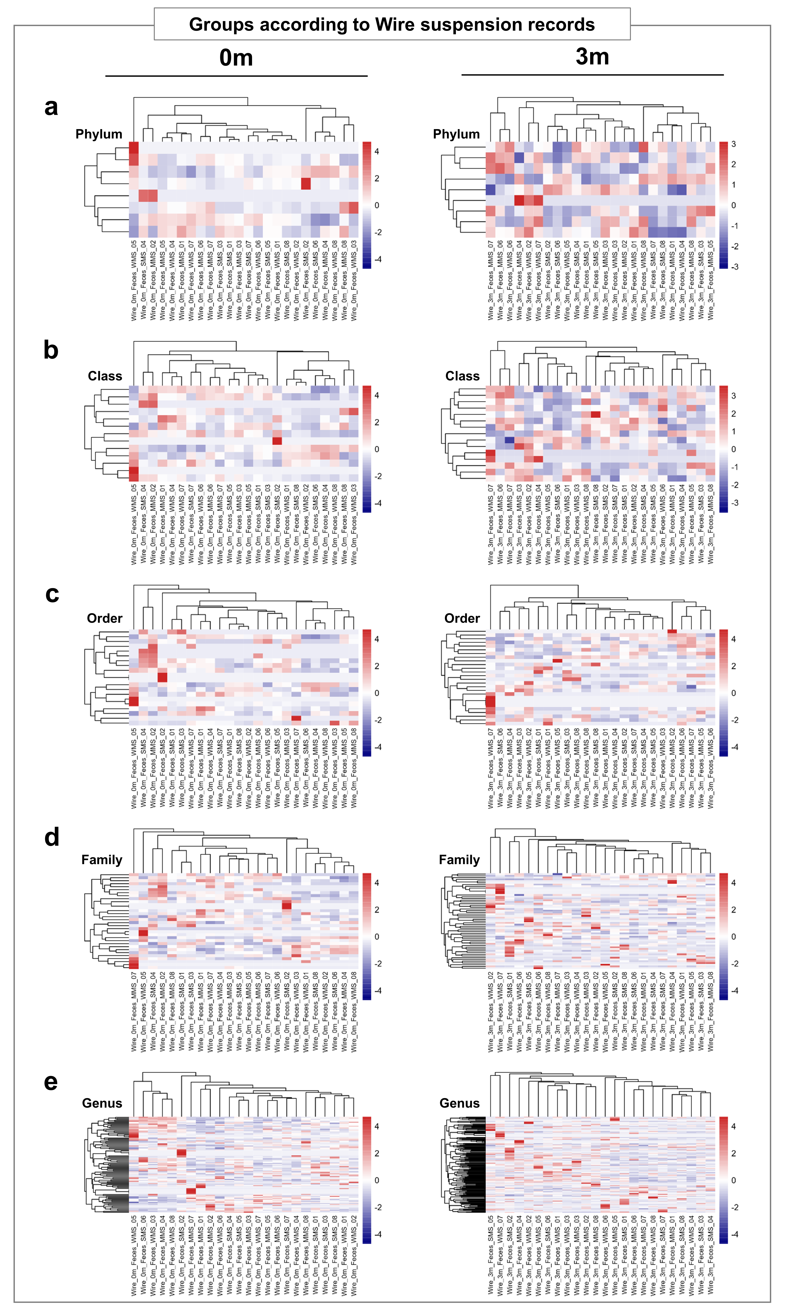
Supplementary Figure 10. Heatmap of the microbial composition of the fecal gut microbiome 3 months before and 3months after FMT in individual groups classified through the Wire suspension records. Heatmap of the microbial composition in fecal gut microbiome of each group before FMT (a-e, left) and 3 months after FMT (a-e, right) based on Bray-Curtis distance matrix calculated at the phylum level (a), class level (b), order level (c), family level (d), and genus level (e). Wire, mouse groups classified based on the Wire suspension records; 0m, before FMT; 3m, 3 months after FMT; Feces, fecal gut microbiome; SMS, mouse group with stronger muscle strength after FMT; MMS, mouse group with unchanged in muscle strength after FMT; WMS, mouse group with weakened muscle strength after FMT.

Supplementary Figure 11
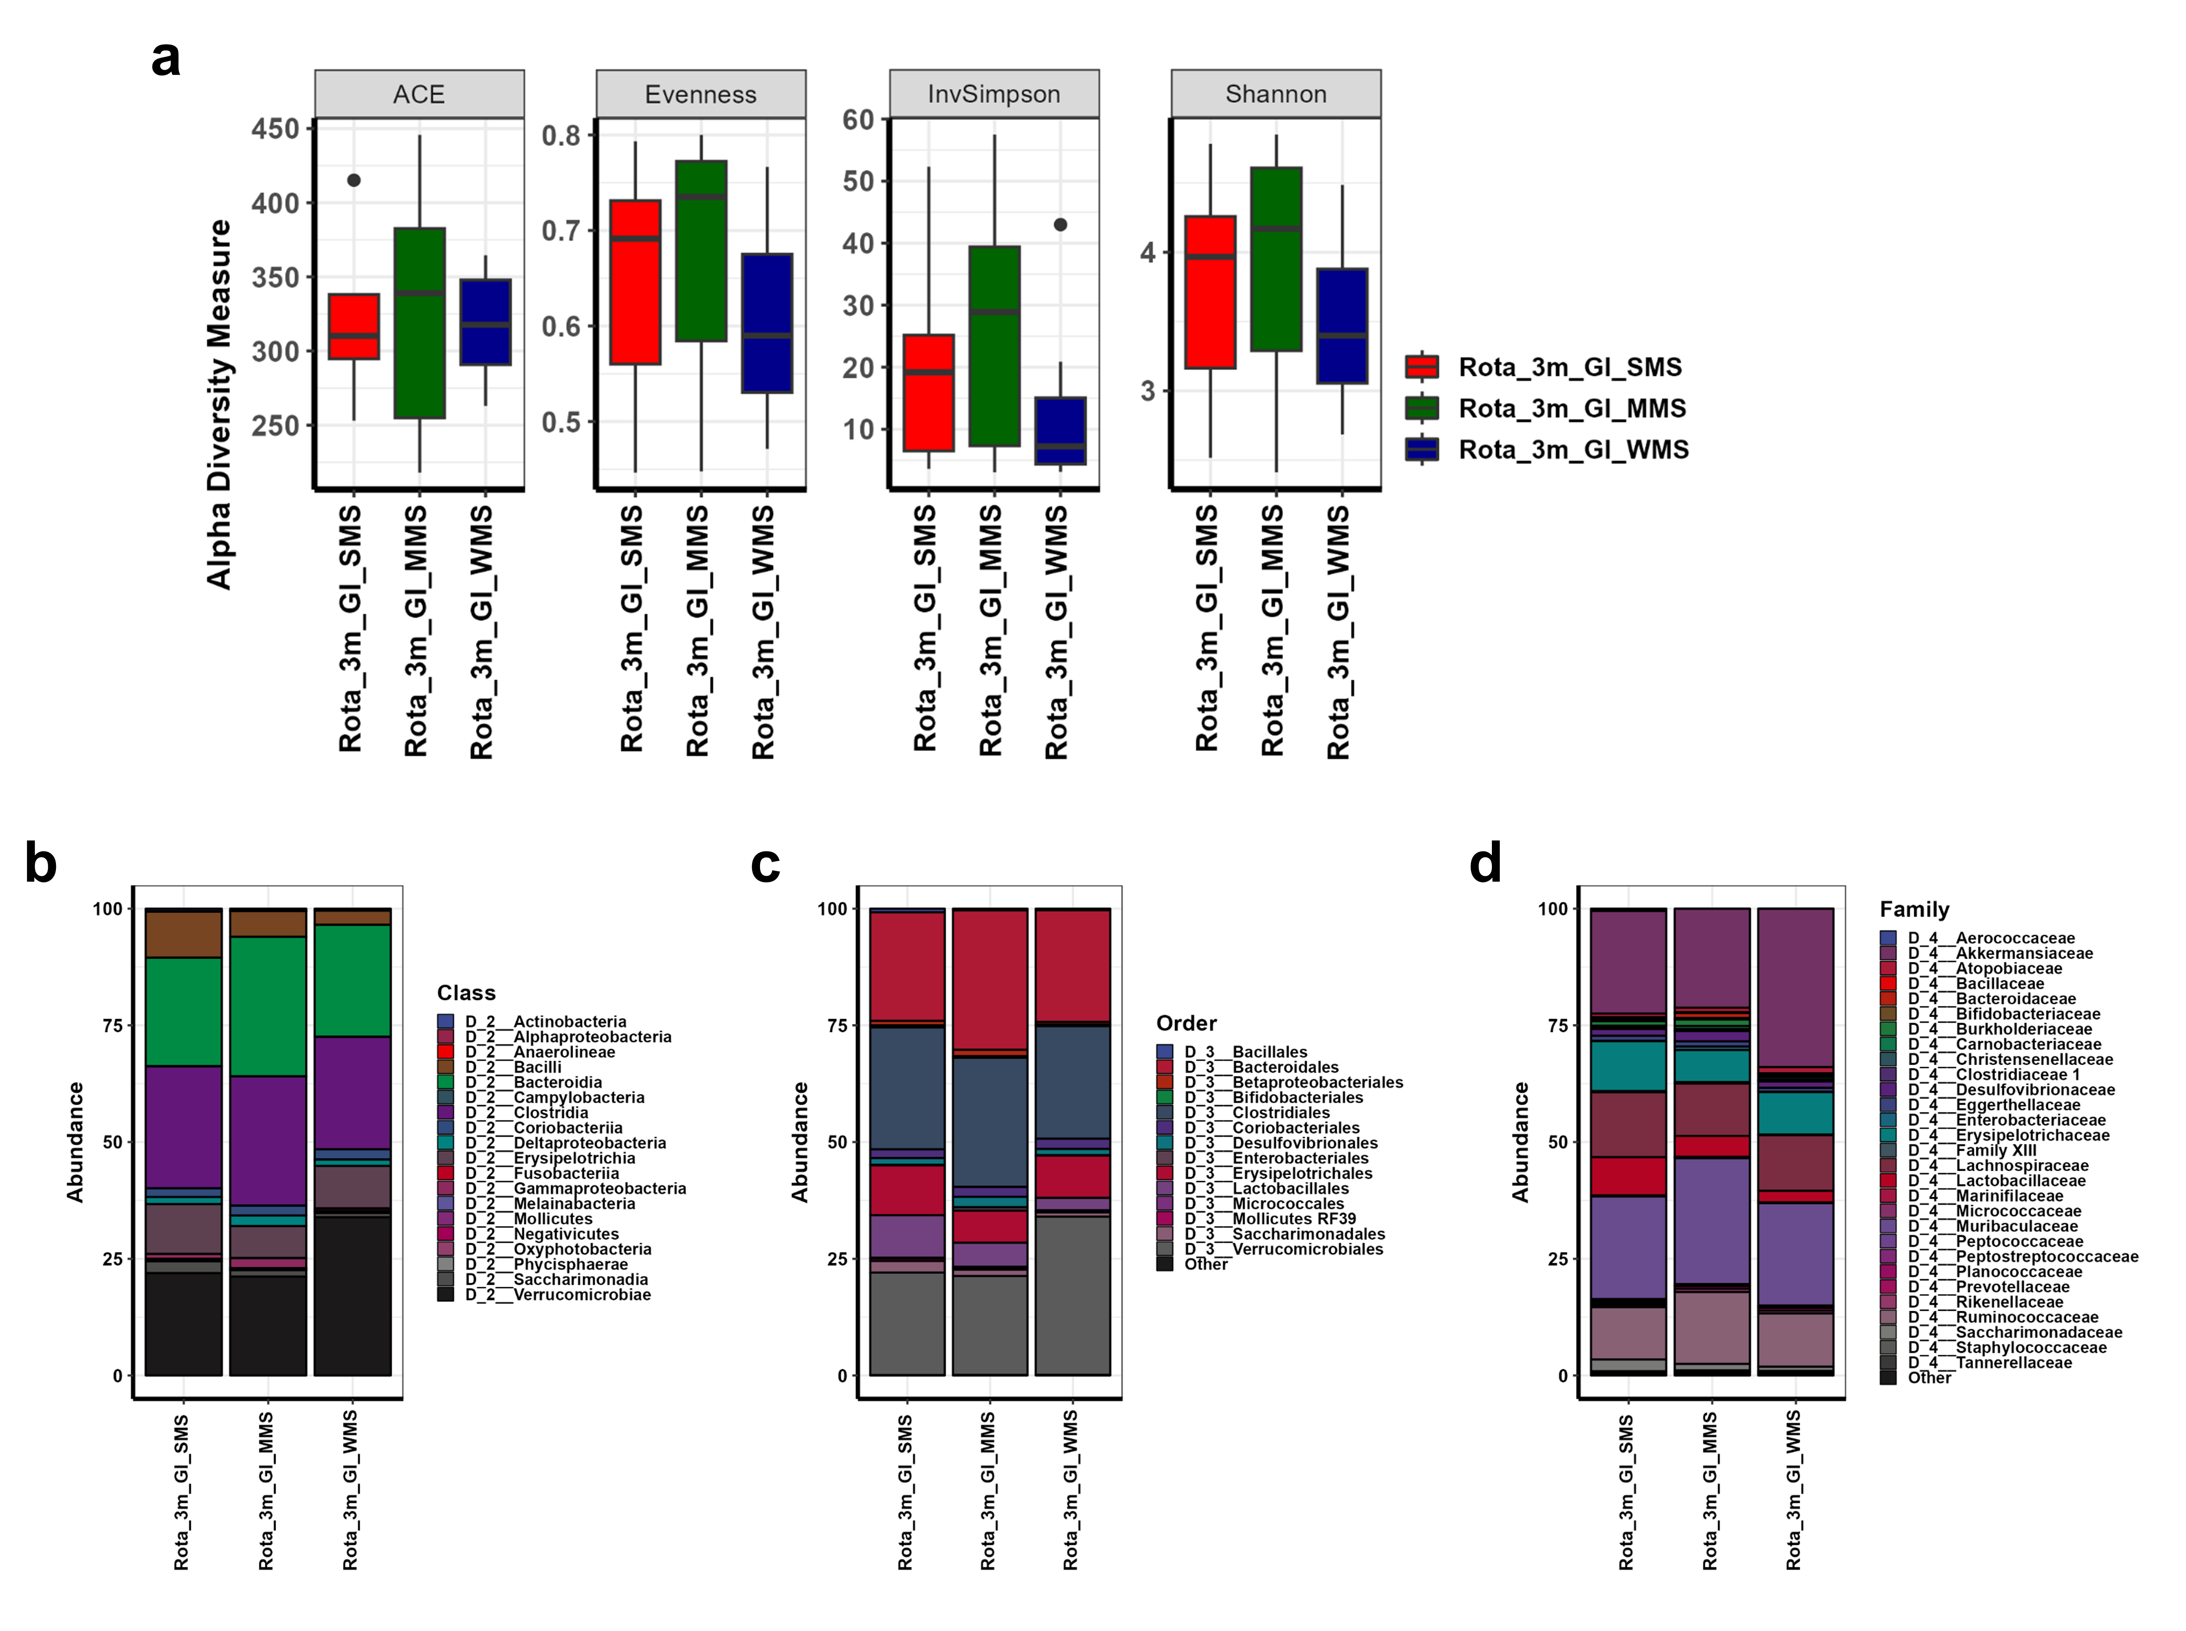
Supplementary Figure 11. The alpha (α)-diversity and phylogenic composition of the GI gut microbiome 3 months after FMT in individual groups classified through the Rotarod records. (a) Comparisons of α-diversity indices of the GI gut microbiome, measured using ACE richness, Evenness, Inverse Simpson, and Shannon methods, 3 months after FMT are shown in box plots. (b-d) Comparisons of phylogenetic compositions of the GI gut microbiome after FMT at various taxonomic levels (class (b), order (c), and family (d)) in each group. Rota, mouse groups classified based on the Rotarod records; 3m, 3 months after FMT; GI, gastrointestinal gut microbiome; SMS, mouse group with stronger muscle strength after FMT; MMS, mouse group with unchanged in muscle strength after FMT; WMS, mouse group with weakened muscle strength after FMT.
Supplementary Figure 12
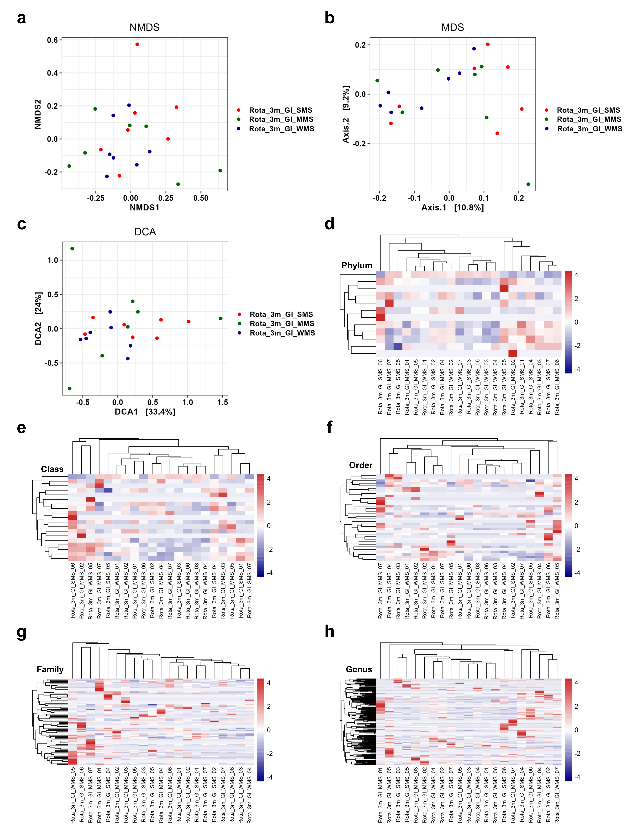
Supplementary Figure 12. The β-diversity plots of the GI gut microbiome 3 months after FMT in individual groups classified through the Rotarod records. (a-c) NMDS plot (a), MDS plot (b), DCA plot (c) showing the difference in GI gut microbiome of each group 3 months after FMT. (d-h) Heatmap of the microbial composition in GI gut microbiome of each group 3 months after FMT based on Bray-Curtis distance matrix calculated at the phylum level (d), the class level (e), the order level (f), the family level (g), and the genus level (h). Rota, mouse groups classified based on the Rotarod records; 3m, 3 months after FMT; GI, gastrointestinal gut microbiome; SMS, mouse group with stronger muscle strength after FMT; MMS, mouse group with unchanged in muscle strength after FMT; WMS, mouse group with weakened muscle strength after FMT.

Supplementary Figure 13
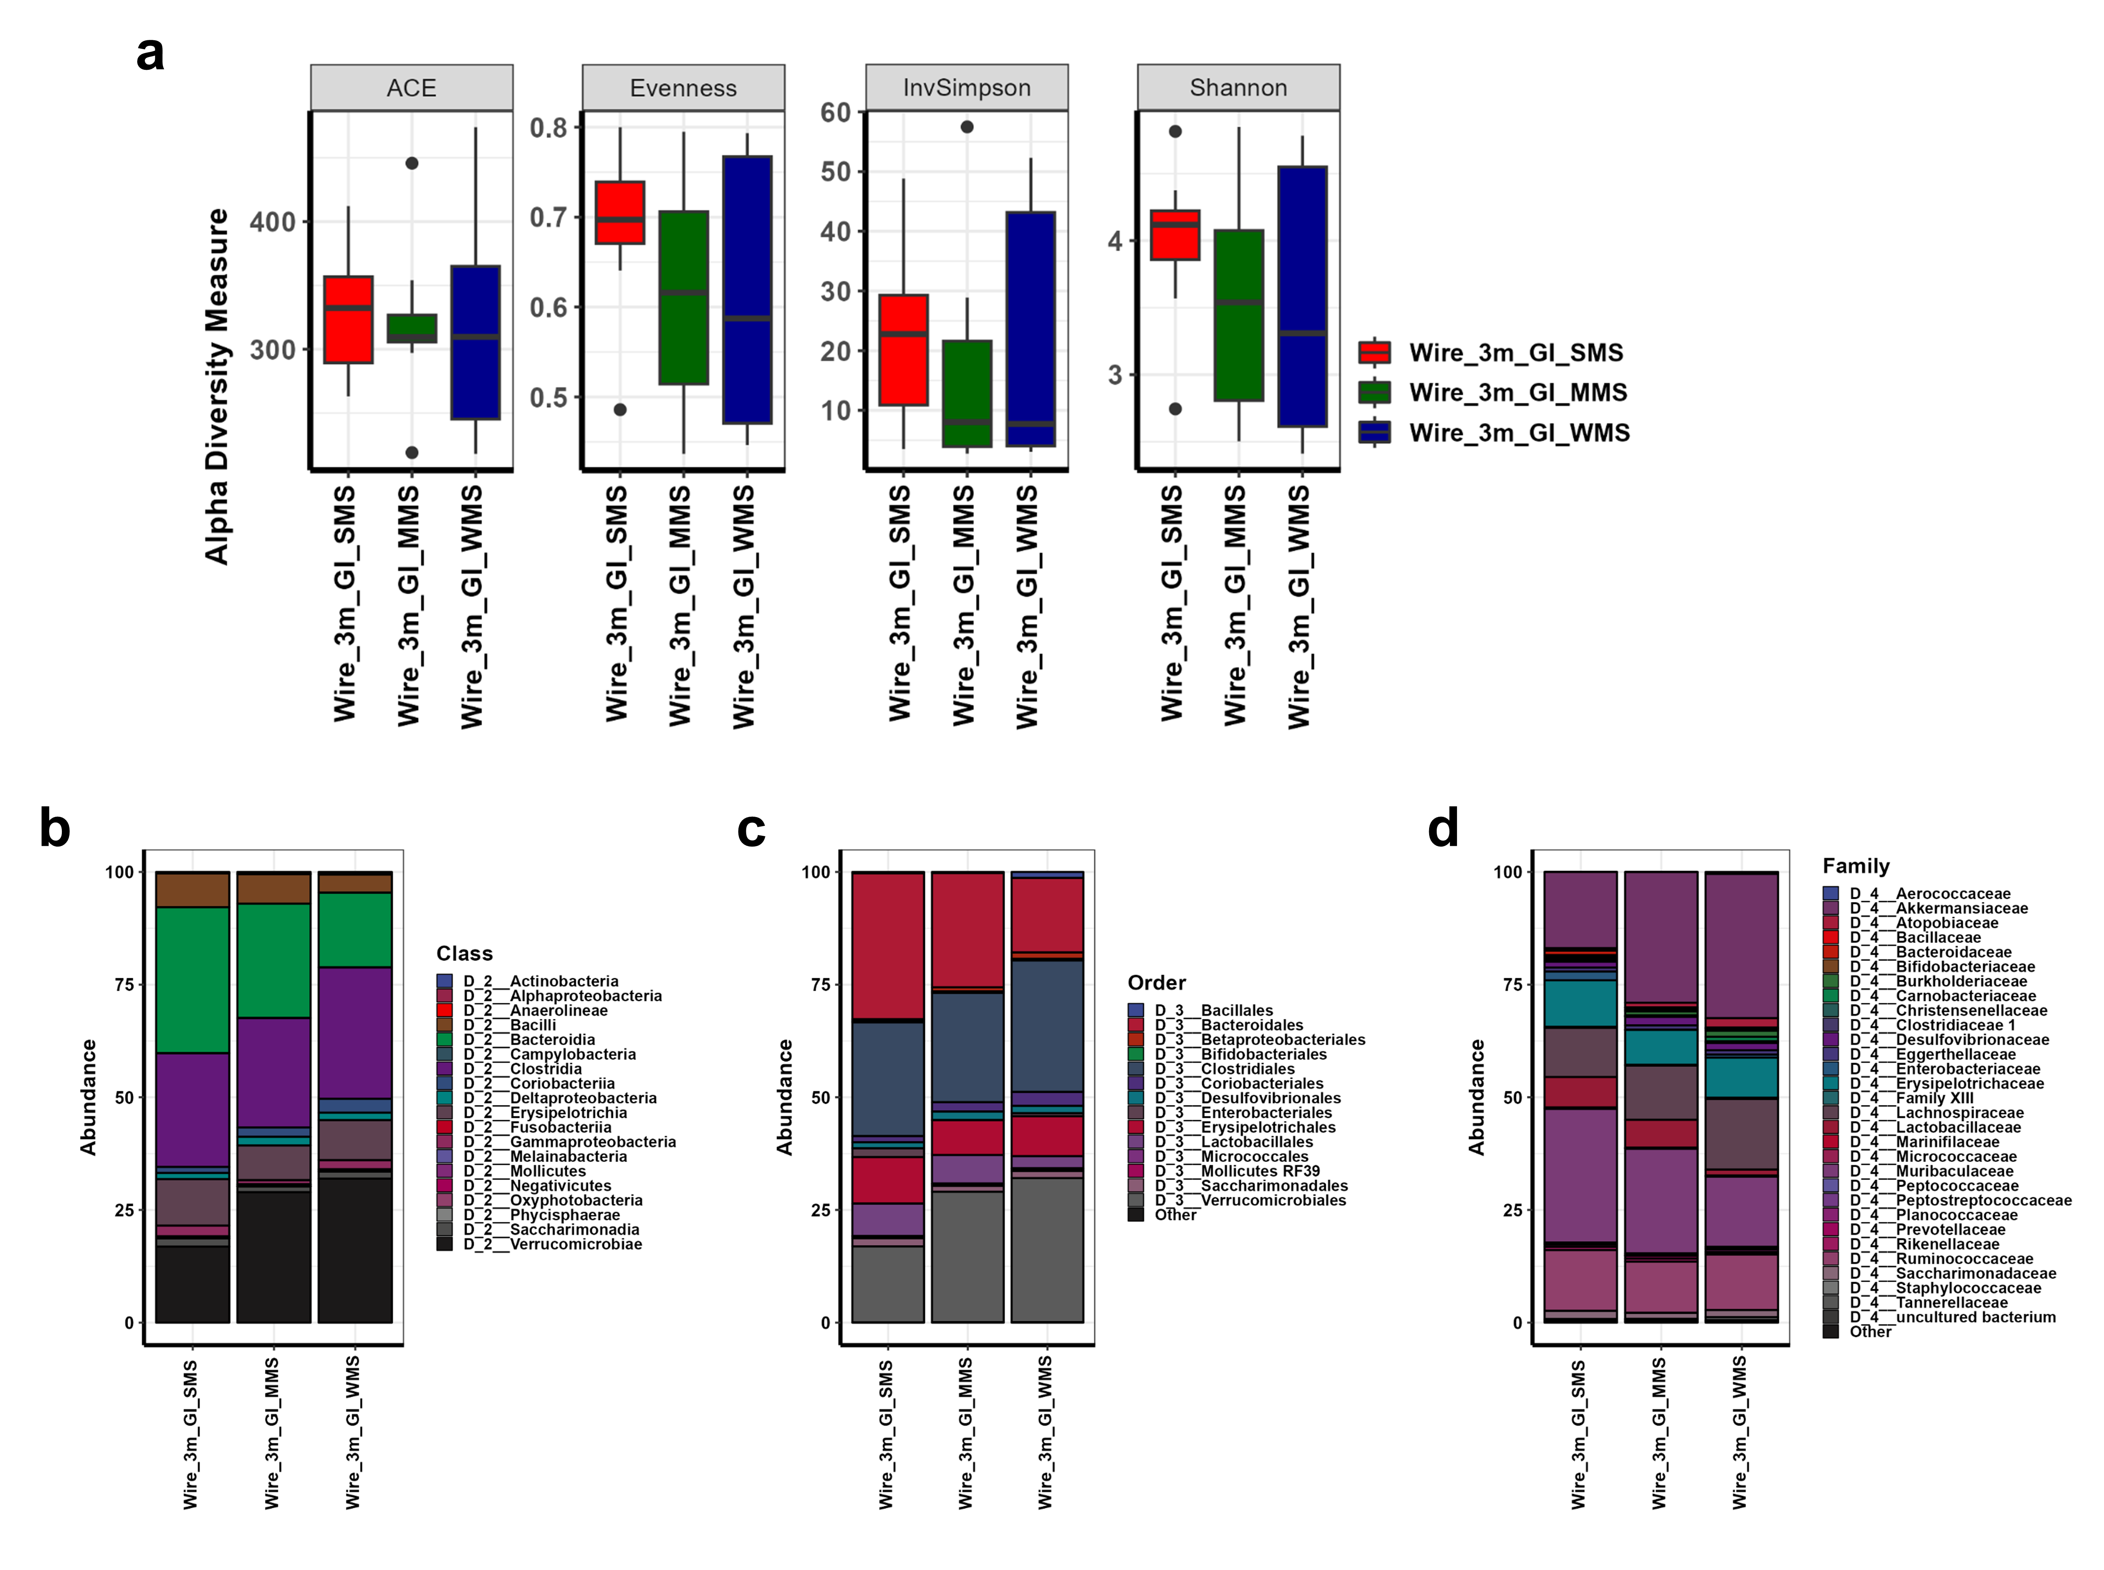
Supplementary Figure 13. The α-diversity and phylogenic composition of the GI gut microbiome 3 months after FMT in individual groups classified through the Wire suspension records. (a) Comparisons of α-diversity indices of the GI gut microbiome, measured using ACE richness, Evenness, Inverse Simpson, and Shannon methods, 3 months after FMT are shown in box plots. (b-d) Comparisons of phylogenetic compositions of the GI gut microbiome after FMT at various taxonomic levels (class (b), order (c), and family (d)) in each group. Wire, mouse groups classified based on the Wire suspension records; 3m, 3 months after FMT; GI, gastrointestinal gut microbiome; SMS, mouse group with stronger muscle strength after FMT; MMS, mouse group with unchanged in muscle strength after FMT; WMS, mouse group with weakened muscle strength after FMT.
Supplementary Figure 14
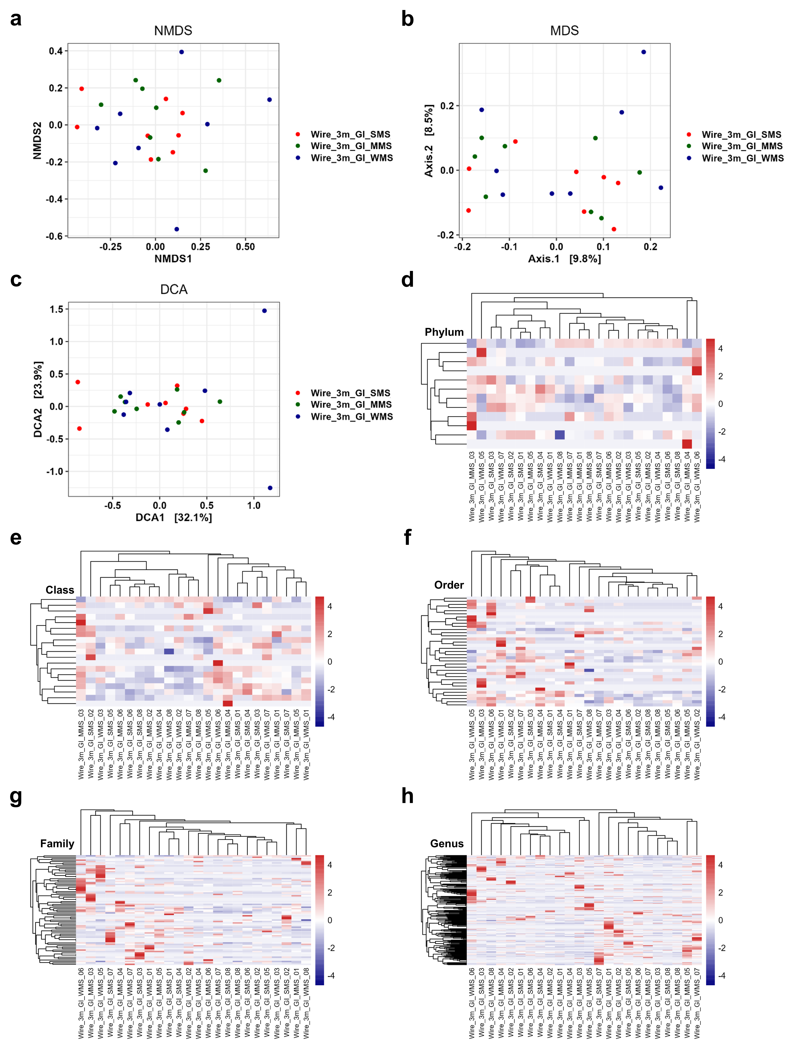
Supplementary Figure 14. The β-diversity plots of the GI gut microbiome 3 months after FMT in individual groups classified through the Wire suspension records. (a-c) NMDS plot (a), MDS plot (b), DCA plot (c) showing the difference in GI gut microbiome of each group 3 months after FMT. (d-h) Heatmap of the microbial composition in GI gut microbiome of each group 3 months after FMT based on Bray-Curtis distance matrix calculated at the phylum level (d), the class level (e), the order level (f), the family level (g), and the genus level (h). Wire, mouse groups classified based on the Wire suspension records; 3m, 3 months after FMT; GI, gastrointestinal gut microbiome; SMS, mouse group with stronger muscle strength after FMT; MMS, mouse group with unchanged in muscle strength after FMT; WMS, mouse group with weakened muscle strength after FMT.

Supplementary Figure 15
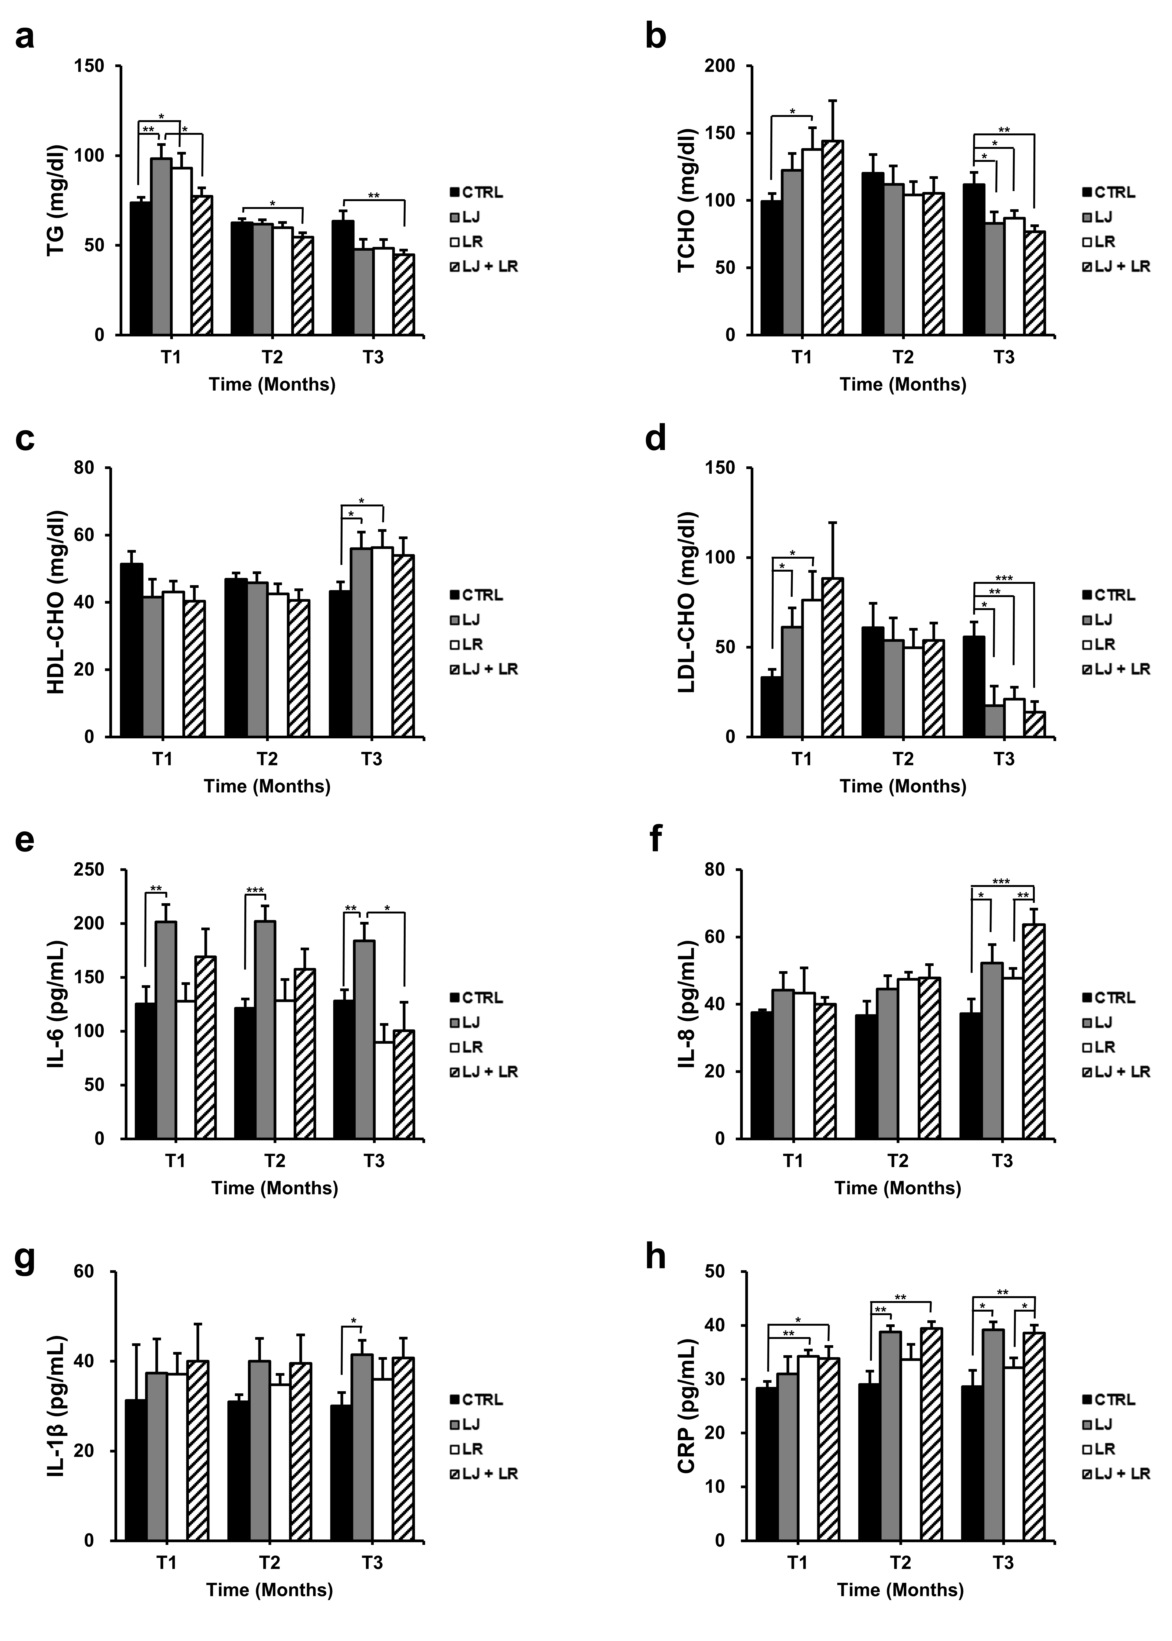
Supplementary Figure 15. The effect of L. johnsonii and L. reuteri on the blood profiles and immune system of wild-type mice. The effect of L. johnsonii and L. reuteri on blood profile. (a-d) The average values of blood profiles in each group. Total glycerol (TG) (a), total cholesterol (TCHO) (b), HDL-cholesterol (HDL-CHO) (c) and LDL-cholesterol (LDL-CHO) (d) in each group are shown. (e-h) Effect of L. johnsonii and L. reuteri on the IL-6 (e), IL-8 (f), IL-1β (g), and C-reactive protein (CRP) (h) expression in the serum confirmed by ELISA. The values are represented as mean ± S.E.M. CTRL, mouse group with administration of PBS; LJ, mouse group with administration of L. johnsonii; LR, mouse group with administration of L. reuteri; LJ+LR, mouse group with administration of L. johnsonii and L. reuteri. The values are represented as mean ± S.E.M. *p < 0.05; **p < 0.01; ***p < 0.001.

Table S1. The valid reads of the 16S rRNA amplicon sequence. The number of valid reads of the 16s rRNA amplicon sequence after filtering sequencing errors in each group are shown in the table. All values are mean ± S.E.M.
Group | Rota_0m_Feces | Rota_3m_Feces | Rota_3m_GI | Rota_0m_Feces_SMS | Rota_0m_Feces_MMS | Rota_0m_Feces_WMS | Rota_3m_Feces_SMS | Rota_3m_Feces_MMS | Rota_3m_Feces_WMS | Rota_3m_GI_SMS | Rota_3m_GI_MMS | Rota_3m_GI_WMS
Total reads | 43220  ± 1186 | 37172  ± 1078 | 53665  ± 1529 | 40990  ± 1520 | 44047  ± 2728 | 44624  ± 1742 | 37241  ± 2715 | 39097  ± 1218 | 35179  ± 1219 | 55193  ± 3619 | 53158  ± 1072 | 52642  ± 2919

Group | Wire_0m_Feces | Wire_3m_Feces | Wire_3m_GI | Wire_0m_Feces_SMS | Wire_0m_Feces_MMS | Wire_0m_Feces_WMS | Wire_3m_Feces_SMS | Wire_3m_Feces_MMS | Wire_3m_Feces_WMS | Wire_3m_GI_SMS | Wire_3m_GI_MMS | Wire_3m_GI_WMS
Total reads | 42859  ± 1300 | 37621  ± 1031 | 54237  ± 1518 | 42078  ± 1683 | 39463  ± 1849 | 47035  ± 2487 | 38806  ± 1844 | 36479  ± 2374 | 37578  ± 1027 | 51307  ± 1801 | 54674  ± 2726 | 56730  ± 3146

Table S2. The α-diversity indices for each group. Comparisons of α-diversity indices of the fecal gut microbiome and GI gut microbiome before and 3 months after FMT in each group measured using observed, ACE, Shannon, Simpson, Inverse Simpson, and Fisher are shown in the table. All values are mean ± S.E.M.
Group | Observed | ACE | Shannon | Simpson | InvSimpson | Fisher
Rota_0m_Feces | 207 ± 6 | 207.036 ± 6.172 | 4.099 ± 0.066 | 0.964 ± 0.003 | 30.963 ± 2.545 | 28.241 ± 0.954
Rota_3m_Feces | 322 ± 10 | 323.239 ± 10.12 | 4.402 ± 0.071 | 0.962 ± 0.005 | 34.362 ± 3.613 | 48.623 ± 1.658
Rota_3m_GI | 321 ± 13 | 321.158 ± 13.055 | 3.703 ± 0.176 | 0.873 ± 0.024 | 19.693 ± 3.902 | 45.61 ± 2.202
Rota_0m_Feces_SMS | 201 ± 7 | 201.131 ± 6.756 | 4.096 ± 0.081 | 0.964 ± 0.003 | 29.723 ± 3.278 | 27.527 ± 1.077
Rota_0m_Feces_MMS | 219 ± 13 | 219.765 ± 12.803 | 4.157 ± 0.127 | 0.964 ± 0.005 | 32.467 ± 5.495 | 30.116 ± 1.915
Rota_0m_Feces_WMS | 200 ± 11 | 200.211 ± 11.437 | 4.044 ± 0.14 | 0.962 ± 0.006 | 30.699 ± 4.816 | 27.08 ± 1.837
Rota_3m_Feces_SMS | 321 ± 24 | 322.638 ± 24.005 | 4.356 ± 0.142 | 0.96 ± 0.01 | 31.635 ± 4.973 | 48.364 ± 3.743
Rota_3m_Feces_MMS | 329 ± 16 | 329.744 ± 16.066 | 4.353 ± 0.145 | 0.956 ± 0.01 | 31.786 ± 8.564 | 49.412 ± 2.798
Rota_3m_Feces_WMS | 317 ± 13 | 317.335 ± 13.297 | 4.497 ± 0.082 | 0.972 ± 0.004 | 39.664 ± 5.046 | 48.093 ± 2.34
Rota_3m_GI_SMS | 320 ± 19 | 320.571 ± 19.506 | 3.73 ± 0.324 | 0.888 ± 0.04 | 19.778 ± 6.495 | 45.37 ± 3.414
Rota_3m_GI_MMS | 325 ± 33 | 325.389 ± 33.398 | 3.889 ± 0.359 | 0.891 ± 0.047 | 26.126 ± 8.135 | 46.501 ± 5.563
Rota_3m_GI_WMS | 317 ± 14 | 317.514 ± 14.256 | 3.491 ± 0.254 | 0.841 ± 0.043 | 13.175 ± 5.468 | 44.96 ± 2.38

Group | Observed | ACE | Shannon | Simpson | InvSimpson | Fisher
Wire_0m_Feces | 208 ± 5 | 208.272 ± 5.352 | 4.149 ± 0.057 | 0.965 ± 0.002 | 32.316 ± 2.259 | 28.46 ± 0.793
Wire_3m_Feces | 330 ± 10 | 330.808 ± 9.75 | 4.429 ± 0.07 | 0.963 ± 0.005 | 35.61 ± 3.492 | 49.876 ± 1.621
Wire_3m_GI | 324 ± 14 | 324.013 ± 14.142 | 3.684 ± 0.171 | 0.869 ± 0.024 | 19.777 ± 3.65 | 46.02 ± 2.345
Wire_0m_Feces_SMS | 214 ± 9 | 215.025 ± 9.188 | 4.217 ± 0.093 | 0.967 ± 0.004 | 34.591 ± 4.778 | 29.56 ± 1.379
Wire_0m_Feces_MMS | 199 ± 8 | 198.898 ± 8.425 | 4.087 ± 0.087 | 0.964 ± 0.003 | 29.661 ± 2.974 | 27.331 ± 1.244
Wire_0m_Feces_WMS | 211 ± 10 | 210.893 ± 10.341 | 4.143 ± 0.119 | 0.965 ± 0.005 | 32.695 ± 4.105 | 28.49 ± 1.549
Wire_3m_Feces_SMS | 342 ± 16 | 343.594 ± 16.402 | 4.48 ± 0.117 | 0.968 ± 0.005 | 37.741 ± 6.879 | 51.802 ± 2.685
Wire_3m_Feces_MMS | 313 ± 19 | 313.711 ± 18.468 | 4.363 ± 0.117 | 0.96 ± 0.009 | 33.026 ± 5.325 | 47.176 ± 3.077
Wire_3m_Feces_WMS | 334 ± 16 | 335.119 ± 16.1 | 4.443 ± 0.139 | 0.962 ± 0.009 | 36.063 ± 6.55 | 50.649 ± 2.753
Wire_3m_GI_SMS | 333 ± 20 | 333.114 ± 19.575 | 3.984 ± 0.216 | 0.918 ± 0.031 | 22.199 ± 5.1 | 47.835 ± 3.294
Wire_3m_GI_MMS | 320 ± 22 | 320.142 ± 22.379 | 3.541 ± 0.298 | 0.841 ± 0.047 | 16.469 ± 6.686 | 45.303 ± 3.809
Wire_3m_GI_WMS | 319 ± 33 | 318.782 ± 32.701 | 3.526 ± 0.365 | 0.849 ± 0.044 | 20.664 ± 7.621 | 44.923 ± 5.303

Table S3. Co-occurrence network indices. Comparisons of co-occurrence network indices of the fecal gut microbiome and GI gut microbiome before and 3 months after FMT in each group are shown in the table. Node, node numbers; Edge, edge number; Modularity, modularity number.
Network indexes indices | Rota_0m_Feces | Rota_3m_Feces | Rota_0m_Feces_SMS | Rota_0m_Feces_MMS | Rota_0m_Feces_WMS | Rota_3m_Feces_SMS | Rota_3m_Feces_MMS | Rota_3m_Feces_WMS | Rota_3m_GI_SMS | Rota_3m_GI_MMS | Rota_3m_GI_WMS
Node | 68 | 149 | 110 | 106 | 110 | 165 | 188 | 160 | 160 | 147 | 159
Edge | 54 | 95 | 102 | 138 | 118 | 151 | 169 | 154 | 166 | 167 | 156
Network Density | 0.024 | 0.009 | 0.017 | 0.025 | 0.020 | 0.011 | 0.010 | 0.012 | 0.013 | 0.016 | 0.012
Assortativity | -0.023 | -0.008 | -0.013 | -0.015 | -0.014 | -0.009 | -0.008 | -0.009 | -0.009 | -0.010 | -0.010
Module | 24 | 65 | 30 | 27 | 28 | 53 | 60 | 46 | 44 | 39 | 45
Modularity (lc) | 0.826 | 0.978 | 0.903 | 0.800 | 0.852 | 0.932 | 0.954 | 0.931 | 0.919 | 0.912 | 0.930

Network indexes indices | Wire_0m_Feces | Wire_3m_Feces | Wire_0m_Feces_SMS | Wire_0m_Feces_MMS | Wire_0m_Feces_WMS | Wire_3m_Feces_SMS | Wire_3m_Feces_MMS | Wire_3m_Feces_WMS | Wire_3m_GI_SMS | Wire_3m_GI_MMS | Wire_3m_GI_WMS
Node | 68 | 149 | 69 | 92 | 108 | 180 | 168 | 175 | 174 | 160 | 164
Edge | 51 | 93 | 55 | 79 | 111 | 146 | 137 | 145 | 150 | 134 | 157
Network Density | 0.022 | 0.008 | 0.023 | 0.019 | 0.019 | 0.009 | 0.010 | 0.010 | 0.010 | 0.011 | 0.012
Assortativity | -0.021 | -0.008 | -0.022 | -0.015 | -0.013 | -0.008 | -0.008 | -0.008 | -0.008 | -0.008 | -0.009
Module | 26 | 66 | 24 | 28 | 26 | 61 | 57 | 60 | 57 | 52 | 51
Modularity (lc) | 0.872 | 0.979 | 0.869 | 0.896 | 0.857 | 0.964 | 0.965 | 0.966 | 0.945 | 0.952 | 0.928

Table S4. Comparison of taxonomy abundance at the phylum level in mouse groups classified based on the Rotarod records. The percentage abundance of the fecal gut microbiome and GI gut microbiome before and 3 months after FMT in each group at the phylum level are shown in the table.
Phylum | Rota_0m_Feces | Rota_3m_Feces | Rota_3m_GI | Rota_0m_Feces_SMS | Rota_0m_Feces_MMS | Rota_0m_Feces_WMS | Rota_3m_Feces_SMS | Rota_3m_Feces_MMS | Rota_3m_Feces_WMS | Rota_3m_GI_SMS | Rota_3m_GI_MMS | Rota_3m_GI_WMS
Verrucomicrobia | 0.147 | 9.029 | 25.684 | 0 | 0.442 | 0 | 7.221 | 13.833 | 6.031 | 21.942 | 21.194 | 33.918
Bacteroidetes | 57.120 | 50.352 | 25.718 | 58.434 | 50.874 | 62.053 | 52.640 | 44.480 | 53.937 | 23.276 | 29.888 | 23.989
Firmicutes | 39.869 | 36.649 | 41.030 | 38.199 | 45.477 | 35.930 | 35.574 | 38.509 | 35.864 | 46.730 | 40.092 | 36.268
Patescibacteria | 2.267 | 0.335 | 1.607 | 2.868 | 2.447 | 1.485 | 0.595 | 0.204 | 0.206 | 2.504 | 1.401 | 0.916
Actinobacteria | 0.123 | 0.904 | 2.505 | 0.064 | 0.231 | 0.076 | 1.234 | 0.502 | 0.976 | 2.404 | 2.566 | 2.545
Proteobacteria | 0.410 | 2.063 | 2.987 | 0.378 | 0.482 | 0.371 | 2.008 | 1.796 | 2.384 | 2.563 | 4.431 | 1.968
Tenericutes | 0.062 | 0.559 | 0.449 | 0.057 | 0.047 | 0.083 | 0.645 | 0.582 | 0.450 | 0.562 | 0.410 | 0.376
Cyanobacteria | 0.001 | 0.107 | 0.014 | 0.002 | 0 | 0.002 | 0.081 | 0.091 | 0.149 | 0.018 | 0.008 | 0.015
Epsilonbacteraeota | 0 | 0 | 0.005 | 0 | 0 | 0 | 0 | 0 | 0 | 0.001 | 0.009 | 0.004
Lentisphaerae | 0 | 0.002 | 0 | 0 | 0 | 0 | 0.001 | 0.003 | 0.003 | 0 | 0 | 0
Chloroflexi | 0 | 0 | 0.001 | 0 | 0 | 0 | 0 | 0 | 0 | 0 | 0.002 | 0
Fusobacteria | 0 | 0 | 0.000 | 0 | 0 | 0 | 0 | 0 | 0 | 0 | 0 | 0.001
Planctomycetes | 0 | 0 | 0.000 | 0 | 0 | 0 | 0 | 0 | 0 | 0.000 | 0 | 0

Table S5. Comparison of taxonomy abundance at the class level in mouse groups classified based on the Rotarod records. The percentage abundance of the fecal gut microbiome and GI gut microbiome before and 3 months after FMT in each group at the class level are shown in the table.
Class | Rota_0m_Feces | Rota_3m_Feces | Rota_3m_GI | Rota_0m_Feces_SMS | Rota_0m_Feces_MMS | Rota_0m_Feces_WMS | Rota_3m_Feces_SMS | Rota_3m_Feces_MMS | Rota_3m_Feces_WMS | Rota_3m_GI_SMS | Rota_3m_GI_MMS | Rota_3m_GI_WMS
Verrucomicrobiae | 0.147 | 9.029 | 25.685 | 0 | 0.442 | 0 | 7.221 | 13.833 | 6.031 | 21.942 | 21.194 | 33.918
Bacteroidia | 57.120 | 50.352 | 25.718 | 58.434 | 50.874 | 62.053 | 52.640 | 44.480 | 53.937 | 23.277 | 29.888 | 23.989
Erysipelotrichia | 0.756 | 3.910 | 8.900 | 0.789 | 1.164 | 0.316 | 4.617 | 2.948 | 4.163 | 10.700 | 6.894 | 9.105
Bacilli | 3.520 | 1.305 | 6.145 | 3.171 | 4.305 | 3.084 | 1.442 | 0.947 | 1.527 | 9.882 | 5.506 | 3.046
Clostridia | 35.592 | 31.434 | 25.984 | 34.238 | 40.008 | 32.531 | 29.515 | 34.613 | 30.174 | 26.146 | 27.690 | 24.117
Saccharimonadia | 2.267 | 0.335 | 1.607 | 2.868 | 2.447 | 1.485 | 0.595 | 0.204 | 0.206 | 2.504 | 1.401 | 0.916
Actinobacteria | 0.050 | 0.681 | 0.453 | 0 | 0.143 | 0.006 | 0.997 | 0.367 | 0.678 | 0.546 | 0.453 | 0.360
Coriobacteriia | 0.074 | 0.223 | 2.052 | 0.064 | 0.088 | 0.070 | 0.237 | 0.134 | 0.298 | 1.858 | 2.112 | 2.186
Deltaproteobacteria | 0.201 | 0.278 | 1.697 | 0.169 | 0.247 | 0.187 | 0.255 | 0.294 | 0.286 | 1.492 | 2.231 | 1.367
Mollicutes | 0.062 | 0.559 | 0.449 | 0.057 | 0.047 | 0.083 | 0.645 | 0.582 | 0.450 | 0.562 | 0.410 | 0.376
Gammaproteobacteria | 0.159 | 1.265 | 1.238 | 0.146 | 0.205 | 0.125 | 1.328 | 0.998 | 1.470 | 1.012 | 2.136 | 0.566
Alphaproteobacteria | 0.050 | 0.519 | 0.053 | 0.063 | 0.030 | 0.059 | 0.425 | 0.504 | 0.628 | 0.059 | 0.063 | 0.036
Melainabacteria | 0 | 0.105 | 0.012 | 0 | 0 | 0 | 0.078 | 0.087 | 0.149 | 0.016 | 0.005 | 0.015
Oxyphotobacteria | 0.001 | 0.002 | 0.002 | 0.002 | 0 | 0.002 | 0.003 | 0.004 | 0 | 0.001 | 0.004 | 0
Campylobacteria | 0 | 0 | 0.005 | 0 | 0 | 0 | 0 | 0 | 0 | 0.001 | 0.009 | 0.004
Lentisphaeria | 0 | 0.002 | 0 | 0 | 0 | 0 | 0.001 | 0.003 | 0.003 | 0 | 0 | 0
Anaerolineae | 0 | 0 | 0.001 | 0 | 0 | 0 | 0 | 0 | 0 | 0 | 0.002 | 0
Negativicutes | 0 | 0 | 0.001 | 0 | 0 | 0 | 0 | 0 | 0 | 0.001 | 0.002 | 0
Fusobacteriia | 0 | 0 | 0.000 | 0 | 0 | 0 | 0 | 0 | 0 | 0 | 0 | 0.001
Phycisphaerae | 0 | 0 | 0.000 | 0 | 0 | 0 | 0 | 0 | 0 | 0.000 | 0 | 0

Table S6. Comparison of taxonomy abundance at the order level in mouse groups classified based on the Rotarod records. The percentage abundance of the fecal gut microbiome and GI gut microbiome before and 3 months after FMT in each group at the order level are shown in the table. The order less than 0.5% of percentage abundance in all groups are included as 'Other'.
Order | Rota_0m_Feces | Rota_3m_Feces | Rota_3m_GI | Rota_0m_Feces_SMS | Rota_0m_Feces_MMS | Rota_0m_Feces_WMS | Rota_3m_Feces_SMS | Rota_3m_Feces_MMS | Rota_3m_Feces_WMS | Rota_3m_GI_SMS | Rota_3m_GI_MMS | Rota_3m_GI_WMS
Verrucomicrobiales | 0.147 | 9.027 | 25.685 | 0 | 0.442 | 0 | 7.218 | 13.833 | 6.031 | 21.942 | 21.194 | 33.918
Bacteroidales | 57.118 | 50.290 | 25.690 | 58.434 | 50.874 | 62.046 | 52.578 | 44.407 | 53.884 | 23.270 | 29.871 | 23.928
Erysipelotrichales | 0.756 | 3.910 | 8.900 | 0.789 | 1.164 | 0.316 | 4.617 | 2.948 | 4.163 | 10.700 | 6.894 | 9.105
Lactobacillales | 3.520 | 1.303 | 5.662 | 3.171 | 4.305 | 3.083 | 1.441 | 0.947 | 1.521 | 9.114 | 5.156 | 2.716
Clostridiales | 35.593 | 31.434 | 25.984 | 34.238 | 40.008 | 32.531 | 29.515 | 34.613 | 30.174 | 26.146 | 27.690 | 24.117
Saccharimonadales | 2.267 | 0.335 | 1.607 | 2.868 | 2.447 | 1.485 | 0.595 | 0.204 | 0.206 | 2.504 | 1.401 | 0.916
Bifidobacteriales | 0.050 | 0.680 | 0.354 | 0 | 0.143 | 0.006 | 0.994 | 0.367 | 0.678 | 0.413 | 0.291 | 0.357
Coriobacteriales | 0.074 | 0.223 | 2.052 | 0.064 | 0.088 | 0.070 | 0.237 | 0.134 | 0.298 | 1.858 | 2.112 | 2.186
Desulfovibrionales | 0.200 | 0.278 | 1.696 | 0.164 | 0.247 | 0.187 | 0.255 | 0.294 | 0.286 | 1.492 | 2.230 | 1.367
Anaeroplasmatales | 0.001 | 0.276 | 0.002 | 0 | 0.003 | 0 | 0.390 | 0.258 | 0.180 | 0.001 | 0.006 | 0.000
Betaproteobacteriales | 0.011 | 1.260 | 0.974 | 0.007 | 0 | 0.027 | 1.322 | 0.998 | 1.462 | 0.964 | 1.405 | 0.553
Mollicutes RF39 | 0.061 | 0.271 | 0.441 | 0.057 | 0.044 | 0.083 | 0.225 | 0.317 | 0.270 | 0.560 | 0.402 | 0.363
Rhodospirillales | 0 | 0.509 | 0.034 | 0 | 0 | 0 | 0.412 | 0.496 | 0.620 | 0.035 | 0.041 | 0.026
Enterobacteriales | 0.078 | 0.005 | 0.259 | 0.044 | 0.166 | 0.026 | 0.007 | 0 | 0.008 | 0.042 | 0.725 | 0.010
Bacillales | 0 | 0.002 | 0.483 | 0 | 0 | 0 | 0.001 | 0 | 0.006 | 0.768 | 0.351 | 0.331
Micrococcales | 0 | 0.001 | 0.097 | 0 | 0 | 0 | 0.002 | 0 | 0 | 0.130 | 0.160 | 0.002
Other < 0.5% | 0.125 | 0.196 | 0.080 | 0.164 | 0.069 | 0.140 | 0.192 | 0.181 | 0.213 | 0.060 | 0.072 | 0.108

Table S7. Comparison of taxonomy abundance at the family level in mouse groups classified based on the Rotarod records. The percentage abundance of the fecal gut microbiome and GI gut microbiome before and 3 months after FMT in each group at the family level are shown in the table. The family less than 0.5% of percentage abundance in all groups are included as 'Other'.
Family | Rota_0m_Feces | Rota_3m_Feces | Rota_3m_GI | Rota_0m_Feces_SMS | Rota_0m_Feces_MMS | Rota_0m_Feces_WMS | Rota_3m_Feces_SMS | Rota_3m_Feces_MMS | Rota_3m_Feces_WMS | Rota_3m_GI_SMS | Rota_3m_GI_MMS | Rota_3m_GI_WMS
Akkermansiaceae | 0.147 | 9.032 | 25.724 | 0 | 0.442 | 0 | 7.218 | 13.843 | 6.033 | 22.000 | 21.219 | 33.952
Muribaculaceae | 54.524 | 39.224 | 23.656 | 57.004 | 48.600 | 57.969 | 41.859 | 33.576 | 42.236 | 22.005 | 26.974 | 21.989
Erysipelotrichaceae | 0.757 | 3.912 | 8.928 | 0.789 | 1.165 | 0.316 | 4.619 | 2.950 | 4.166 | 10.735 | 6.908 | 9.140
Lactobacillaceae | 3.501 | 1.297 | 5.055 | 3.155 | 4.278 | 3.069 | 1.431 | 0.941 | 1.519 | 8.189 | 4.490 | 2.485
Lachnospiraceae | 23.271 | 17.195 | 12.352 | 22.704 | 25.937 | 21.171 | 15.076 | 19.897 | 16.613 | 13.934 | 11.227 | 11.895
Ruminococcaceae | 9.707 | 12.848 | 12.690 | 8.881 | 11.346 | 8.894 | 12.952 | 13.330 | 12.261 | 11.212 | 15.431 | 11.427
Saccharimonadaceae | 2.267 | 0.335 | 1.612 | 2.869 | 2.448 | 1.485 | 0.595 | 0.205 | 0.206 | 2.513 | 1.404 | 0.919
Tannerellaceae | 1.749 | 0.737 | 0.283 | 1.197 | 1.846 | 2.205 | 0.586 | 0.679 | 0.945 | 0.108 | 0.462 | 0.279
Bacteroidaceae | 0.411 | 2.925 | 0.610 | 0 | 0 | 1.232 | 2.941 | 3.081 | 2.754 | 0.359 | 1.101 | 0.368
Clostridiales vadinBB60 group | 1.638 | 0.717 | 0.045 | 1.933 | 1.607 | 1.373 | 0.742 | 0.689 | 0.720 | 0.060 | 0.035 | 0.040
Rikenellaceae | 0.414 | 3.410 | 0.573 | 0.248 | 0.439 | 0.554 | 3.599 | 3.667 | 2.965 | 0.449 | 0.658 | 0.613
Prevotellaceae | 0.032 | 3.722 | 0.519 | 0 | 0 | 0.095 | 3.364 | 3.226 | 4.576 | 0.367 | 0.593 | 0.596
Bifidobacteriaceae | 0.050 | 0.680 | 0.355 | 0 | 0.143 | 0.006 | 0.994 | 0.368 | 0.679 | 0.414 | 0.292 | 0.359
Atopobiaceae | 0 | 0.157 | 1.031 | 0 | 0 | 0 | 0.175 | 0.065 | 0.230 | 0.779 | 0.986 | 1.329
Desulfovibrionaceae | 0.200 | 0.279 | 1.701 | 0.164 | 0.247 | 0.187 | 0.255 | 0.294 | 0.287 | 1.498 | 2.234 | 1.371
Peptococcaceae | 0.163 | 0.360 | 0.238 | 0.173 | 0.161 | 0.154 | 0.395 | 0.481 | 0.205 | 0.243 | 0.316 | 0.154
Clostridiaceae 1 | 0.397 | 0.137 | 0.104 | 0.182 | 0.534 | 0.474 | 0.173 | 0.064 | 0.175 | 0.081 | 0.096 | 0.134
Anaeroplasmataceae | 0.001 | 0.276 | 0.002 | 0 | 0.003 | 0 | 0.390 | 0.258 | 0.180 | 0.001 | 0.006 | 0.000
Peptostreptococcaceae | 0.229 | 0.023 | 0.216 | 0.173 | 0.232 | 0.281 | 0.010 | 0.005 | 0.055 | 0.352 | 0.035 | 0.261
Family XIII | 0.184 | 0.095 | 0.216 | 0.190 | 0.180 | 0.182 | 0.101 | 0.101 | 0.082 | 0.220 | 0.277 | 0.152
Burkholderiaceae | 0.011 | 1.261 | 0.976 | 0.007 | 0 | 0.027 | 1.322 | 0.999 | 1.463 | 0.967 | 1.406 | 0.554
Carnobacteriaceae | 0 | 0.000 | 0.448 | 0 | 0 | 0 | 0.001 | 0 | 0 | 0.459 | 0.669 | 0.217
Marinifilaceae | 0 | 0.291 | 0.100 | 0 | 0 | 0 | 0.243 | 0.188 | 0.442 | 0.062 | 0.123 | 0.115
Eggerthellaceae | 0.074 | 0.061 | 1.004 | 0.064 | 0.088 | 0.070 | 0.057 | 0.066 | 0.061 | 1.070 | 1.096 | 0.845
uncultured bacterium | 0.045 | 0.171 | 0.177 | 0.037 | 0.027 | 0.072 | 0.160 | 0.208 | 0.145 | 0.192 | 0.194 | 0.146
uncultured | 0 | 0.510 | 0.034 | 0 | 0 | 0 | 0.412 | 0.497 | 0.620 | 0.036 | 0.042 | 0.026
Enterobacteriaceae | 0.078 | 0.005 | 0.259 | 0.044 | 0.166 | 0.026 | 0.007 | 0 | 0.008 | 0.042 | 0.726 | 0.010
Christensenellaceae | 0.009 | 0.059 | 0.174 | 0.009 | 0.014 | 0.004 | 0.058 | 0.050 | 0.068 | 0.127 | 0.307 | 0.088
Staphylococcaceae | 0 | 0 | 0.278 | 0 | 0 | 0 | 0 | 0 | 0 | 0.386 | 0.158 | 0.291
Aerococcaceae | 0 | 0 | 0.165 | 0 | 0 | 0 | 0 | 0 | 0 | 0.480 | 0 | 0.014
Micrococcaceae | 0 | 0 | 0.097 | 0 | 0 | 0 | 0 | 0 | 0 | 0.130 | 0.159 | 0.002
Planococcaceae | 0 | 0 | 0.132 | 0 | 0 | 0 | 0 | 0 | 0 | 0.295 | 0.062 | 0.038
Bacillaceae | 0 | 0.000 | 0.073 | 0 | 0 | 0 | 0.001 | 0 | 0 | 0.086 | 0.131 | 0.001
Other < 0.5% | 0.143 | 0.281 | 0.175 | 0.180 | 0.098 | 0.153 | 0.264 | 0.272 | 0.306 | 0.150 | 0.183 | 0.191

Table S8. Comparison of taxonomy abundance at the genus level in mouse groups classified based on the Rotarod records. The percentage abundance of the fecal gut microbiome and GI gut microbiome before and 3 months after FMT in each group at the genus level are shown in the table. The genus less than 0.5% of percentage abundance in all groups are included as 'Other'.
Genus | Rota_0m_Feces | Rota_3m_Feces | Rota_3m_GI | Rota_0m_Feces_SMS | Rota_0m_Feces_MMS | Rota_0m_Feces_WMS | Rota_3m_Feces_SMS | Rota_3m_Feces_MMS | Rota_3m_Feces_WMS | Rota_3m_GI_SMS | Rota_3m_GI_MMS | Rota_3m_GI_WMS
Akkermansia | 0.189 | 10.121 | 27.038 | 0 | 0.567 | 0 | 7.793 | 15.658 | 6.912 | 22.959 | 22.324 | 35.830
Ambiguous_taxa | 3.942 | 10.460 | 6.039 | 3.147 | 3.918 | 4.762 | 14.012 | 7.860 | 9.509 | 7.566 | 5.482 | 5.069
uncultured organism | 18.303 | 1.240 | 0.245 | 20.139 | 15.258 | 19.514 | 1.058 | 0.700 | 1.962 | 0.098 | 0.307 | 0.329
uncultured bacterium | 28.039 | 15.335 | 10.318 | 30.462 | 25.021 | 28.634 | 15.712 | 12.802 | 17.491 | 8.847 | 12.730 | 9.376
Turicibacter | 0.594 | 1.396 | 3.858 | 0.449 | 0.997 | 0.334 | 1.740 | 0.881 | 1.565 | 7.112 | 2.602 | 1.859
uncultured Bacteroidales bacterium | 1.723 | 7.617 | 4.816 | 1.677 | 1.566 | 1.925 | 7.295 | 7.511 | 8.045 | 3.375 | 6.292 | 4.780
Lactobacillus | 4.581 | 1.475 | 5.400 | 4.289 | 5.384 | 4.071 | 1.617 | 1.078 | 1.731 | 8.705 | 4.871 | 2.625
Lachnospiraceae NK4A136 group | 7.845 | 11.723 | 7.640 | 7.046 | 9.194 | 7.296 | 9.787 | 13.033 | 12.348 | 8.274 | 6.560 | 8.084
[Eubacterium] coprostanoligenes group | 0.041 | 0.913 | 2.697 | 0.027 | 0.076 | 0.021 | 0.660 | 0.971 | 1.107 | 1.367 | 2.641 | 4.083
Candidatus Saccharimonas | 2.978 | 0.379 | 1.717 | 3.877 | 3.108 | 1.948 | 0.677 | 0.230 | 0.230 | 2.687 | 1.497 | 0.968
Parabacteroides | 2.272 | 0.849 | 0.312 | 1.597 | 2.330 | 2.891 | 0.691 | 0.772 | 1.083 | 0.119 | 0.524 | 0.292
Ruminococcaceae UCG-014 | 2.169 | 7.037 | 5.072 | 1.823 | 1.456 | 3.227 | 8.174 | 6.532 | 6.405 | 5.511 | 6.389 | 3.316
Ruminiclostridium | 3.115 | 0.536 | 0.178 | 3.039 | 3.702 | 2.604 | 0.575 | 0.528 | 0.505 | 0.089 | 0.300 | 0.145
Alloprevotella | 0.022 | 0.908 | 0.273 | 0 | 0 | 0.067 | 0.557 | 0.908 | 1.260 | 0.094 | 0.320 | 0.404
Bacteroides | 0.530 | 3.313 | 0.676 | 0 | 0 | 1.589 | 3.290 | 3.511 | 3.138 | 0.388 | 1.248 | 0.391
uncultured bacterium | 0.933 | 0.482 | 0.038 | 1.081 | 0.820 | 0.897 | 0.465 | 0.455 | 0.527 | 0.054 | 0.024 | 0.037
Alistipes | 0.430 | 2.745 | 0.498 | 0.330 | 0.557 | 0.402 | 2.187 | 3.929 | 2.120 | 0.436 | 0.590 | 0.470
Faecalibaculum | 0.307 | 0.513 | 0.789 | 0.599 | 0.320 | 0.002 | 0.476 | 0.224 | 0.839 | 0.780 | 0.535 | 1.053
Prevotellaceae UCG-001 | 0.018 | 1.716 | 0.035 | 0 | 0 | 0.055 | 2.353 | 1.337 | 1.459 | 0.007 | 0.062 | 0.035
Muribaculum | 0.015 | 1.106 | 0.291 | 0 | 0.034 | 0.011 | 1.115 | 1.131 | 1.072 | 0.250 | 0.217 | 0.406
Bifidobacterium | 0.063 | 0.770 | 0.381 | 0 | 0.180 | 0.008 | 1.106 | 0.417 | 0.786 | 0.446 | 0.317 | 0.380
Intestinimonas | 1.758 | 0.139 | 0.226 | 1.552 | 2.549 | 1.171 | 0.133 | 0.176 | 0.106 | 0.178 | 0.361 | 0.138
Coriobacteriaceae UCG-002 | 0 | 0.178 | 1.091 | 0 | 0 | 0 | 0.201 | 0.075 | 0.258 | 0.835 | 1.042 | 1.397
Dubosiella | 0 | 2.217 | 3.288 | 0 | 0 | 0 | 2.744 | 1.867 | 2.039 | 2.434 | 2.360 | 5.071
Desulfovibrio | 0.260 | 0.052 | 1.369 | 0.218 | 0.318 | 0.244 | 0.065 | 0.069 | 0.022 | 1.097 | 1.981 | 1.028
uncultured | 6.128 | 1.281 | 0.724 | 5.317 | 7.304 | 5.763 | 1.328 | 1.689 | 0.826 | 0.637 | 1.106 | 0.430
[Eubacterium] ventriosum group | 0.203 | 0.021 | 0.011 | 0.084 | 0.358 | 0.168 | 0.002 | 0.060 | 0 | 0.018 | 0.016 | 0
Oscillibacter | 0.951 | 0.465 | 0.173 | 1.051 | 1.071 | 0.730 | 0.455 | 0.513 | 0.427 | 0.071 | 0.290 | 0.156
Prevotellaceae NK3B31 group | 0 | 1.230 | 0.058 | 0 | 0 | 0 | 0.582 | 1.022 | 2.087 | 0.037 | 0.062 | 0.074
[Eubacterium] ruminantium group | 0 | 0.208 | 1.263 | 0 | 0 | 0 | 0.123 | 0.261 | 0.240 | 2.241 | 0.886 | 0.664
uncultured | 0.510 | 1.010 | 0.830 | 0.375 | 0.665 | 0.491 | 0.948 | 0.901 | 1.182 | 0.717 | 0.931 | 0.842
Ambiguous_taxa | 0.958 | 0.172 | 0.005 | 1.335 | 0.886 | 0.652 | 0.204 | 0.175 | 0.137 | 0.005 | 0.007 | 0.002
[Eubacterium] fissicatena group | 0 | 0.041 | 0.197 | 0 | 0 | 0 | 0.030 | 0.085 | 0.008 | 0.131 | 0.373 | 0.088
Blautia | 0.363 | 0.296 | 0.350 | 0.339 | 0.439 | 0.313 | 0.270 | 0.180 | 0.438 | 0.289 | 0.055 | 0.705
Ruminiclostridium 9 | 1.371 | 1.204 | 0.714 | 1.672 | 1.306 | 1.135 | 1.059 | 1.499 | 1.054 | 0.629 | 0.953 | 0.560
Rikenellaceae RC9 gut group | 0.107 | 1.030 | 0.067 | 0 | 0 | 0.320 | 1.747 | 0.251 | 1.093 | 0.012 | 0.145 | 0.042
uncultured | 0 | 0.195 | 0.355 | 0 | 0 | 0 | 0.198 | 0.232 | 0.156 | 0.398 | 0.383 | 0.282
[Eubacterium] xylanophilum group | 0.446 | 0.296 | 0.278 | 0.464 | 0.433 | 0.440 | 0.179 | 0.345 | 0.362 | 0.301 | 0.272 | 0.262
Lachnospiraceae UCG-001 | 0.864 | 0.184 | 0.001 | 0.842 | 0.716 | 1.035 | 0.110 | 0.240 | 0.201 | 0 | 0.002 | 0.001
uncultured | 0.195 | 0.404 | 0.252 | 0.220 | 0.184 | 0.181 | 0.437 | 0.546 | 0.228 | 0.258 | 0.342 | 0.155
uncultured Clostridia bacterium | 0.181 | 0.016 | 0 | 0.150 | 0.195 | 0.198 | 0.019 | 0.016 | 0.012 | 0 | 0 | 0
Marvinbryantia | 0.493 | 0.082 | 0.074 | 0.457 | 0.438 | 0.585 | 0.038 | 0.049 | 0.159 | 0.085 | 0.073 | 0.063
Allobaculum | 0 | 0.023 | 0.619 | 0 | 0 | 0 | 0 | 0.068 | 0 | 0.375 | 0.369 | 1.113
Parasutterella | 0.009 | 1.424 | 0.449 | 0 | 0 | 0.028 | 1.481 | 1.153 | 1.638 | 0.584 | 0.180 | 0.583
Ruminococcaceae UCG-009 | 0.291 | 0.183 | 0.044 | 0.295 | 0.347 | 0.232 | 0.131 | 0.244 | 0.174 | 0.045 | 0.059 | 0.029
Ruminococcus 1 | 0.079 | 1.280 | 0.256 | 0.011 | 0.225 | 0 | 0.993 | 1.702 | 1.146 | 0.361 | 0.186 | 0.223
Prevotellaceae Ga6A1 group | 0 | 0.106 | 0.186 | 0 | 0 | 0 | 0.307 | 0.011 | 0 | 0.248 | 0.198 | 0.113
Clostridium sensu stricto 1 | 0.474 | 0.114 | 0.056 | 0.244 | 0.665 | 0.511 | 0.145 | 0.022 | 0.175 | 0.051 | 0.041 | 0.075
Roseburia | 0.697 | 0.301 | 0.122 | 0.574 | 0.892 | 0.625 | 0.388 | 0.212 | 0.305 | 0.184 | 0.095 | 0.088
Lachnoclostridium | 0.597 | 0.224 | 0.132 | 0.685 | 0.597 | 0.509 | 0.148 | 0.371 | 0.155 | 0.121 | 0.161 | 0.115
Candidatus Arthromitus | 0.040 | 0.046 | 0.057 | 0.003 | 0 | 0.118 | 0.055 | 0.051 | 0.031 | 0.037 | 0.066 | 0.067
GCA-900066575 | 0.574 | 0.137 | 0.119 | 0.844 | 0.469 | 0.408 | 0.108 | 0.193 | 0.110 | 0.097 | 0.164 | 0.095
Ileibacterium | 0 | 0.126 | 0.630 | 0 | 0 | 0 | 0.097 | 0.202 | 0.079 | 0.214 | 1.290 | 0.387
A2 | 0.548 | 0.043 | 0.039 | 0.458 | 0.665 | 0.521 | 0.019 | 0.086 | 0.025 | 0.029 | 0.022 | 0.066
Anaeroplasma | 0.001 | 0.314 | 0.002 | 0 | 0.004 | 0 | 0.440 | 0.298 | 0.204 | 0.001 | 0.006 | 0.000
Lachnospira | 0.320 | 0.005 | 0.001 | 0.278 | 0.450 | 0.231 | 0.007 | 0 | 0.007 | 0.001 | 0 | 0.001
Romboutsia | 0.300 | 0.028 | 0.229 | 0.236 | 0.293 | 0.371 | 0.011 | 0.006 | 0.066 | 0.374 | 0.038 | 0.275
Ruminococcaceae NK4A214 group | 0.131 | 0.065 | 0.115 | 0.145 | 0.098 | 0.152 | 0.054 | 0.070 | 0.070 | 0.084 | 0.177 | 0.083
Paenalcaligenes | 0 | 0 | 0.574 | 0 | 0 | 0 | 0 | 0 | 0 | 0.461 | 1.260 | 0
Anaerostipes | 0 | 0.250 | 0.024 | 0 | 0 | 0 | 0.360 | 0.343 | 0.047 | 0.007 | 0.056 | 0.009
Anaerotruncus | 0.188 | 0.035 | 0.043 | 0.116 | 0.314 | 0.134 | 0.025 | 0.064 | 0.016 | 0.056 | 0.036 | 0.036
Atopostipes | 0 | 0.000 | 0.461 | 0 | 0 | 0 | 0.001 | 0 | 0 | 0.470 | 0.683 | 0.230
Fournierella | 0 | 0.030 | 0.152 | 0 | 0 | 0 | 0.052 | 0.038 | 0 | 0.138 | 0.282 | 0.036
Tyzzerella 3 | 0.229 | 0.021 | 0.002 | 0.249 | 0.218 | 0.220 | 0.022 | 0.011 | 0.030 | 0.004 | 0.002 | 0
Lachnospiraceae UCG-006 | 0.062 | 0.096 | 0.168 | 0.054 | 0.059 | 0.074 | 0.055 | 0.135 | 0.099 | 0.079 | 0.279 | 0.147
Odoribacter | 0 | 0.212 | 0.092 | 0 | 0 | 0 | 0.200 | 0.116 | 0.322 | 0.062 | 0.105 | 0.110
Erysipelatoclostridium | 0.006 | 0.069 | 0.107 | 0 | 0.017 | 0 | 0.073 | 0.087 | 0.047 | 0.190 | 0.093 | 0.038
Enterorhabdus | 0.096 | 0.034 | 0.839 | 0.085 | 0.110 | 0.093 | 0.033 | 0.042 | 0.026 | 0.938 | 1.023 | 0.557
Ruminiclostridium 5 | 0.531 | 0.148 | 0.589 | 0.259 | 1.008 | 0.326 | 0.135 | 0.203 | 0.105 | 0.459 | 0.897 | 0.411
uncultured bacterium | 0.059 | 0.195 | 0.192 | 0.050 | 0.034 | 0.093 | 0.184 | 0.236 | 0.166 | 0.209 | 0.211 | 0.154
Acetatifactor | 0.146 | 0.085 | 0.010 | 0.183 | 0.156 | 0.097 | 0.042 | 0.124 | 0.090 | 0.007 | 0.009 | 0.014
Ruminiclostridium 6 | 0.365 | 0.285 | 0.293 | 0.317 | 0.463 | 0.316 | 0.101 | 0.279 | 0.475 | 0.175 | 0.282 | 0.422
Bilophila | 0 | 0.070 | 0.120 | 0 | 0 | 0 | 0.025 | 0.033 | 0.152 | 0.136 | 0.090 | 0.133
Azospirillum sp. 47_25 | 0 | 0.229 | 0.008 | 0 | 0 | 0 | 0.262 | 0.174 | 0.253 | 0.006 | 0.015 | 0.002
Ruminococcaceae UCG-013 | 0.082 | 0.054 | 0.662 | 0.123 | 0.063 | 0.061 | 0.051 | 0.093 | 0.016 | 0.854 | 0.874 | 0.258
Escherichia-Shigella | 0.087 | 0.006 | 0.258 | 0.037 | 0.209 | 0.016 | 0.008 | 0 | 0.010 | 0.045 | 0.719 | 0.010
Ruminococcaceae UCG-010 | 0.044 | 0.260 | 0.223 | 0.046 | 0.043 | 0.044 | 0.294 | 0.169 | 0.316 | 0.143 | 0.218 | 0.308
Christensenellaceae R-7 group | 0 | 0.042 | 0.122 | 0 | 0 | 0 | 0.040 | 0.030 | 0.056 | 0.111 | 0.187 | 0.069
Prevotellaceae UCG-003 | 0 | 0.267 | 0 | 0 | 0 | 0 | 0 | 0.282 | 0.519 | 0 | 0 | 0
Butyricimonas | 0 | 0.121 | 0.018 | 0 | 0 | 0 | 0.086 | 0.096 | 0.180 | 0.006 | 0.035 | 0.012
Staphylococcus | 0 | 0 | 0.259 | 0 | 0 | 0 | 0 | 0 | 0 | 0.365 | 0.124 | 0.287
uncultured | 0.052 | 0.072 | 0.240 | 0.009 | 0.098 | 0.050 | 0.051 | 0.049 | 0.115 | 0.407 | 0.178 | 0.136
uncultured rumen bacterium | 0 | 0.116 | 0.014 | 0 | 0 | 0 | 0.089 | 0.113 | 0.147 | 0.021 | 0.015 | 0.006
Rikenella | 0 | 0.063 | 0.057 | 0 | 0 | 0 | 0.110 | 0.001 | 0.078 | 0.038 | 0 | 0.134
uncultured bacterium | 0 | 0.118 | 0.012 | 0 | 0 | 0 | 0.098 | 0.146 | 0.109 | 0.003 | 0.017 | 0.018
Lachnospiraceae NK4B4 group | 0.062 | 0 | 0.020 | 0 | 0.088 | 0.098 | 0 | 0 | 0 | 0.056 | 0.003 | 0
Aerococcus | 0 | 0 | 0.186 | 0 | 0 | 0 | 0 | 0 | 0 | 0.542 | 0 | 0.015
Enteractinococcus | 0 | 0 | 0.090 | 0 | 0 | 0 | 0 | 0 | 0 | 0.115 | 0.156 | 0
uncultured Barnesiella sp. | 0 | 0.049 | 0.023 | 0 | 0 | 0 | 0 | 0.139 | 0.006 | 0 | 0.020 | 0.049
Sporosarcina | 0 | 0 | 0.138 | 0 | 0 | 0 | 0 | 0 | 0 | 0.310 | 0.064 | 0.041
Adlercreutzia | 0 | 0.002 | 0.083 | 0 | 0 | 0 | 0 | 0.002 | 0.004 | 0.053 | 0.043 | 0.153
Pseudogracilibacillus | 0 | 0.000 | 0.057 | 0 | 0 | 0 | 0.001 | 0 | 0 | 0.068 | 0.103 | 0
Other < 0.5% | 1.032 | 1.298 | 1.174 | 1.041 | 1.066 | 0.989 | 1.008 | 1.584 | 1.303 | 1.122 | 1.396 | 1.002

Table S9. Comparison of taxonomy abundance at the species level in mouse groups classified based on the Rotarod records. The percentage abundance of the fecal gut microbiome and GI gut microbiome before and 3 months after FMT in each group at the species level are shown in the table. The species less than 0.5% of percentage abundance in all groups are included as 'Other'.
Species | Rota_0m_Feces | Rota_3m_Feces | Rota_3m_GI | Rota_0m_Feces_SMS | Rota_0m_Feces_MMS | Rota_0m_Feces_WMS | Rota_3m_Feces_SMS | Rota_3m_Feces_MMS | Rota_3m_Feces_WMS | Rota_3m_GI_SMS | Rota_3m_GI_MMS | Rota_3m_GI_WMS
uncultured bacterium | 0.258 | 12.270 | 29.023 | 0 | 0.774 | 0 | 9.464 | 19.221 | 8.125 | 21.925 | 25.488 | 39.655
Ambiguous_taxa | 4.769 | 12.581 | 7.575 | 3.619 | 4.975 | 5.713 | 17.087 | 9.430 | 11.226 | 9.894 | 6.967 | 5.863
uncultured organism | 21.585 | 1.517 | 0.285 | 23.233 | 18.100 | 23.423 | 1.364 | 0.842 | 2.346 | 0.129 | 0.364 | 0.362
uncultured bacterium | 33.205 | 18.535 | 12.734 | 34.982 | 30.041 | 34.592 | 19.164 | 15.499 | 20.943 | 11.348 | 15.835 | 11.020
Turicibacter sp. LA61 | 0.673 | 1.675 | 5.016 | 0.502 | 1.120 | 0.395 | 2.128 | 1.060 | 1.839 | 9.562 | 3.180 | 2.306
uncultured Bacteroidales bacterium | 2.071 | 9.227 | 5.874 | 1.945 | 1.920 | 2.349 | 8.955 | 9.057 | 9.668 | 4.274 | 7.802 | 5.546
Trichinella pseudospiralis | 0 | 2.272 | 1.759 | 0 | 0 | 0 | 2.632 | 2.023 | 2.160 | 2.286 | 1.530 | 1.461
Lachnospiraceae bacterium 10-1 | 0 | 1.740 | 3.091 | 0 | 0 | 0 | 1.686 | 1.320 | 2.214 | 4.210 | 1.103 | 3.961
uncultured bacterium | 3.493 | 0.455 | 2.297 | 4.461 | 3.662 | 2.354 | 0.825 | 0.267 | 0.272 | 3.896 | 1.815 | 1.181
uncultured Parabacteroides sp. | 2.587 | 0.029 | 0.006 | 1.853 | 2.624 | 3.285 | 0.017 | 0.009 | 0.062 | 0.007 | 0.001 | 0.011
Lactobacillus murinus | 2.513 | 0.352 | 0.831 | 2.532 | 2.764 | 2.243 | 0.219 | 0.168 | 0.671 | 1.798 | 0.464 | 0.230
uncultured rumen bacterium | 0.005 | 1.837 | 1.307 | 0 | 0.016 | 0 | 2.242 | 2.047 | 1.224 | 1.148 | 2.263 | 0.510
uncultured bacterium | 3.778 | 0.634 | 0.203 | 3.540 | 4.544 | 3.249 | 0.689 | 0.614 | 0.599 | 0.086 | 0.360 | 0.163
gut metagenome | 0.030 | 1.107 | 0.328 | 0 | 0 | 0.090 | 0.664 | 1.035 | 1.623 | 0.122 | 0.413 | 0.447
uncultured bacterium | 1.115 | 0.579 | 0.058 | 1.263 | 0.995 | 1.085 | 0.560 | 0.546 | 0.629 | 0.100 | 0.029 | 0.044
uncultured bacterium | 0.038 | 2.574 | 0.482 | 0 | 0.110 | 0.004 | 2.405 | 3.436 | 1.882 | 0.546 | 0.467 | 0.434
uncultured bacterium | 4.064 | 5.254 | 1.739 | 3.965 | 4.811 | 3.414 | 3.846 | 6.271 | 5.647 | 1.995 | 1.554 | 1.668
uncultured bacterium | 0.369 | 0.617 | 0.994 | 0.690 | 0.415 | 0.002 | 0.583 | 0.275 | 0.992 | 1.008 | 0.659 | 1.316
uncultured bacterium | 0.020 | 1.342 | 0.344 | 0 | 0.044 | 0.015 | 1.376 | 1.371 | 1.279 | 0.301 | 0.277 | 0.453
uncultured bacterium | 2.105 | 0.063 | 0.075 | 1.773 | 3.130 | 1.411 | 0.043 | 0.089 | 0.058 | 0.034 | 0.152 | 0.039
uncultured bacterium | 0 | 1.974 | 3.490 | 0 | 0 | 0 | 1.495 | 2.091 | 2.335 | 2.615 | 2.345 | 5.510
uncultured bacterium | 0.315 | 0.045 | 1.726 | 0.253 | 0.393 | 0.299 | 0.084 | 0.042 | 0.010 | 1.433 | 2.463 | 1.283
Clostridiales bacterium CIEAF 020 | 0 | 0.983 | 1.636 | 0 | 0 | 0 | 0.475 | 0.956 | 1.518 | 1.221 | 2.480 | 1.208
Bacteroides caecimuris | 0 | 0.737 | 0.034 | 0 | 0 | 0 | 0.836 | 0.038 | 1.337 | 0.023 | 0.013 | 0.067
Bacteroides acidifaciens | 0 | 0.179 | 0.035 | 0 | 0 | 0 | 0.310 | 0.181 | 0.046 | 0.063 | 0.036 | 0.007
uncultured bacterium | 0.606 | 0.333 | 0.123 | 0.683 | 0.681 | 0.454 | 0.356 | 0.281 | 0.361 | 0.046 | 0.217 | 0.104
uncultured bacterium | 0 | 1.505 | 0.073 | 0 | 0 | 0 | 0.695 | 1.225 | 2.596 | 0.047 | 0.081 | 0.093
uncultured bacterium | 2.986 | 1.012 | 0.747 | 2.443 | 3.684 | 2.830 | 0.785 | 1.488 | 0.763 | 0.710 | 1.140 | 0.390
uncultured bacterium | 0 | 0.248 | 1.465 | 0 | 0 | 0 | 0.150 | 0.316 | 0.278 | 2.616 | 1.062 | 0.715
Clostridium sp. Culture-1 | 0.213 | 0.931 | 0.795 | 0.143 | 0.294 | 0.201 | 0.923 | 0.751 | 1.118 | 0.678 | 0.935 | 0.773
Ambiguous_taxa | 1.152 | 0.204 | 0.006 | 1.562 | 1.101 | 0.794 | 0.245 | 0.206 | 0.162 | 0.007 | 0.009 | 0.002
unidentified | 0.436 | 0.237 | 0.001 | 0.237 | 0.604 | 0.467 | 0.183 | 0.252 | 0.276 | 0 | 0 | 0.002
uncultured Bacteroidales bacterium | 0.154 | 0.576 | 0.203 | 0 | 0.213 | 0.250 | 0.467 | 0.351 | 0.909 | 0.068 | 0.249 | 0.292
uncultured bacterium | 0 | 0.051 | 0.227 | 0 | 0 | 0 | 0.038 | 0.105 | 0.009 | 0.145 | 0.440 | 0.097
Ambiguous_taxa | 0.143 | 1.242 | 0.084 | 0 | 0 | 0.428 | 2.134 | 0.300 | 1.293 | 0.015 | 0.192 | 0.047
Ambiguous_taxa | 0 | 0.233 | 0.466 | 0 | 0 | 0 | 0.236 | 0.276 | 0.186 | 0.584 | 0.482 | 0.332
uncultured bacterium | 0.534 | 0.356 | 0.349 | 0.535 | 0.527 | 0.541 | 0.215 | 0.420 | 0.434 | 0.385 | 0.332 | 0.330
uncultured bacterium | 1.038 | 0.186 | 0.001 | 0.974 | 0.862 | 1.278 | 0.100 | 0.244 | 0.213 | 0 | 0.003 | 0.002
uncultured organism | 0 | 0.311 | 0.126 | 0 | 0 | 0 | 0.370 | 0.464 | 0.101 | 0.126 | 0.219 | 0.033
unidentified | 0.363 | 0.142 | 0.053 | 0.356 | 0.440 | 0.292 | 0.117 | 0.195 | 0.112 | 0.031 | 0.083 | 0.046
Parabacteroides distasonis | 0 | 0.274 | 0.065 | 0 | 0 | 0 | 0.165 | 0.427 | 0.230 | 0.049 | 0.131 | 0.015
Lachnospiraceae bacterium COE1 | 0.248 | 0.319 | 0.101 | 0.308 | 0.128 | 0.308 | 0.215 | 0.538 | 0.205 | 0.022 | 0.110 | 0.170
uncultured Clostridia bacterium | 0.216 | 0.019 | 0 | 0.175 | 0.235 | 0.237 | 0.023 | 0.020 | 0.015 | 0 | 0 | 0
uncultured bacterium | 0.506 | 0.066 | 0.001 | 0.464 | 0.445 | 0.608 | 0.020 | 0.028 | 0.151 | 0.003 | 0 | 0
Bacteroides dorei | 0 | 0.185 | 0.041 | 0 | 0 | 0 | 0.216 | 0.061 | 0.278 | 0.022 | 0.098 | 0.004
uncultured Clostridiales bacterium | 0.519 | 0.527 | 0.383 | 0.612 | 0.534 | 0.410 | 0.650 | 0.772 | 0.159 | 0.622 | 0.376 | 0.150
uncultured Allobaculum sp. | 0 | 0.027 | 0.719 | 0 | 0 | 0 | 0 | 0.082 | 0 | 0.467 | 0.471 | 1.217
uncultured bacterium | 0.012 | 0.312 | 0.202 | 0 | 0 | 0.037 | 0.543 | 0.105 | 0.288 | 0.094 | 0.120 | 0.391
Ambiguous_taxa | 0.348 | 0.213 | 0.030 | 0.341 | 0.423 | 0.281 | 0.153 | 0.290 | 0.198 | 0.048 | 0.028 | 0.015
Firmicutes bacterium M10-2 | 0 | 0.616 | 0.591 | 0 | 0 | 0 | 1.764 | 0.082 | 0.002 | 0.461 | 0.489 | 0.823
Ambiguous_taxa | 0 | 0.121 | 0.224 | 0 | 0 | 0 | 0.361 | 0.001 | 0 | 0.306 | 0.239 | 0.127
uncultured bacterium | 0.705 | 1.096 | 0.311 | 0.915 | 0.615 | 0.585 | 0.891 | 1.497 | 0.899 | 0.355 | 0.327 | 0.251
uncultured bacterium | 0.249 | 1.422 | 1.479 | 0.374 | 0.198 | 0.175 | 1.701 | 1.005 | 1.559 | 1.323 | 1.668 | 1.446
uncultured bacterium | 0.556 | 0.142 | 0.073 | 0.281 | 0.784 | 0.603 | 0.173 | 0.027 | 0.225 | 0.070 | 0.051 | 0.099
uncultured bacterium | 0.533 | 0.095 | 0.031 | 0.379 | 0.822 | 0.398 | 0.127 | 0.060 | 0.098 | 0.028 | 0.011 | 0.055
uncultured bacterium | 0.331 | 0.201 | 0.119 | 0.383 | 0.303 | 0.307 | 0.103 | 0.395 | 0.104 | 0.055 | 0.183 | 0.119
uncultured bacterium | 0.366 | 0.121 | 0.116 | 0.441 | 0.341 | 0.317 | 0.083 | 0.181 | 0.099 | 0.099 | 0.151 | 0.099
Lactobacillus reuteri | 0.261 | 0.120 | 0.379 | 0.279 | 0.301 | 0.202 | 0.160 | 0.090 | 0.112 | 0.611 | 0.295 | 0.232
Ambiguous_taxa | 0 | 0.152 | 0.820 | 0 | 0 | 0 | 0.114 | 0.251 | 0.091 | 0.276 | 1.727 | 0.456
Lachnospiraceae bacterium A2 | 0.417 | 0.007 | 0 | 0.366 | 0.520 | 0.365 | 0 | 0.022 | 0 | 0 | 0 | 0
Ambiguous_taxa | 0.313 | 0.062 | 0.109 | 0.157 | 0.533 | 0.249 | 0.078 | 0.059 | 0.047 | 0.054 | 0.250 | 0.022
uncultured bacterium | 0.002 | 0.380 | 0.003 | 0 | 0.005 | 0 | 0.525 | 0.364 | 0.250 | 0.001 | 0.007 | 0.001
uncultured bacterium | 0 | 0.247 | 0.016 | 0 | 0 | 0 | 0.064 | 0.677 | 0.001 | 0 | 0.040 | 0.007
uncultured bacterium | 0.158 | 0.078 | 0.108 | 0.167 | 0.117 | 0.190 | 0.066 | 0.084 | 0.084 | 0.103 | 0.121 | 0.098
Burkholderiales bacterium YL45 | 0 | 0.771 | 0.194 | 0 | 0 | 0 | 0.869 | 0.725 | 0.721 | 0.389 | 0.039 | 0.154
uncultured organism | 0.162 | 0 | 0 | 0 | 0.463 | 0.023 | 0 | 0 | 0 | 0 | 0 | 0
mouse gut metagenome | 0.296 | 0.002 | 0 | 0.288 | 0.225 | 0.376 | 0 | 0 | 0.005 | 0 | 0 | 0
Ambiguous_taxa | 0 | 0 | 0.678 | 0 | 0 | 0 | 0 | 0 | 0 | 0.645 | 1.388 | 0
Ambiguous_taxa | 0 | 0.238 | 0.028 | 0 | 0 | 0 | 0.349 | 0.328 | 0.038 | 0.007 | 0.071 | 0.004
uncultured bacterium | 0.235 | 0.043 | 0.052 | 0.135 | 0.406 | 0.163 | 0.031 | 0.078 | 0.019 | 0.067 | 0.046 | 0.042
unidentified | 0.239 | 0.049 | 0.007 | 0.195 | 0.291 | 0.231 | 0.037 | 0.052 | 0.059 | 0 | 0.013 | 0.008
Bacteroides thetaiotaomicron | 0 | 0.091 | 0.002 | 0 | 0 | 0 | 0.098 | 0.144 | 0.030 | 0.003 | 0.004 | 0
uncultured bacterium | 0 | 0.000 | 0.287 | 0 | 0 | 0 | 0.001 | 0 | 0 | 0.414 | 0.224 | 0.222
uncultured bacterium | 0.069 | 0.114 | 0.202 | 0.059 | 0.066 | 0.081 | 0.067 | 0.156 | 0.119 | 0.099 | 0.341 | 0.167
Ambiguous_taxa | 0 | 0.230 | 0.076 | 0 | 0 | 0 | 0.195 | 0.127 | 0.368 | 0.074 | 0.084 | 0.072
Clostridium sp. Culture-27 | 0.154 | 0.020 | 0.012 | 0.084 | 0.224 | 0.153 | 0.027 | 0.011 | 0.021 | 0.004 | 0.030 | 0.003
uncultured bacterium | 0.014 | 0.015 | 0.766 | 0.015 | 0.016 | 0.009 | 0.011 | 0.020 | 0.014 | 1.104 | 0.828 | 0.367
uncultured bacterium | 0.071 | 0.234 | 0.241 | 0.056 | 0.040 | 0.116 | 0.231 | 0.272 | 0.199 | 0.275 | 0.264 | 0.184
Ambiguous_taxa | 0.176 | 0.001 | 0 | 0.214 | 0.194 | 0.120 | 0 | 0.002 | 0 | 0 | 0 | 0
uncultured bacterium | 0 | 0.269 | 0.338 | 0 | 0 | 0 | 0.077 | 0.270 | 0.461 | 0.203 | 0.335 | 0.477
Dubosiella newyorkensis | 0 | 0.086 | 0.147 | 0 | 0 | 0 | 0.083 | 0.100 | 0.075 | 0.030 | 0.021 | 0.389
uncultured bacterium | 0 | 0.084 | 0.152 | 0 | 0 | 0 | 0.029 | 0.040 | 0.181 | 0.168 | 0.110 | 0.177
Azospirillum sp. 47_25 | 0 | 0.285 | 0.010 | 0 | 0 | 0 | 0.335 | 0.212 | 0.307 | 0.009 | 0.019 | 0.003
uncultured bacterium | 0.019 | 0.184 | 0.109 | 0 | 0.057 | 0 | 0.066 | 0.229 | 0.258 | 0.022 | 0.084 | 0.220
uncultured organism | 0 | 0.009 | 0.639 | 0 | 0 | 0 | 0 | 0.028 | 0 | 1.211 | 0.642 | 0.064
gut metagenome | 0 | 0.226 | 0.020 | 0 | 0 | 0 | 0.044 | 0.269 | 0.365 | 0.006 | 0.035 | 0.019
uncultured bacterium | 0 | 0.067 | 0.141 | 0 | 0 | 0 | 0.048 | 0.096 | 0.058 | 0.102 | 0.216 | 0.103
uncultured Ruminococcaceae bacterium | 0.102 | 0.039 | 0.010 | 0 | 0.307 | 0 | 0.069 | 0.022 | 0.026 | 0.010 | 0.005 | 0.015
uncultured bacterium | 0.255 | 0.042 | 0.049 | 0.168 | 0.323 | 0.273 | 0.023 | 0.082 | 0.021 | 0.028 | 0.027 | 0.091
uncultured bacterium | 0 | 0.340 | 0 | 0 | 0 | 0 | 0 | 0.344 | 0.675 | 0 | 0 | 0
uncultured bacterium | 0 | 0.110 | 0.038 | 0 | 0 | 0 | 0.057 | 0.255 | 0.018 | 0.074 | 0.025 | 0.015
unidentified rumen bacterium JW32 | 0 | 0.030 | 0.166 | 0 | 0 | 0 | 0.041 | 0.019 | 0.031 | 0.458 | 0.040 | 0
uncultured bacterium | 0.065 | 0.089 | 0.307 | 0.010 | 0.127 | 0.059 | 0.063 | 0.060 | 0.143 | 0.519 | 0.231 | 0.171
Bacteroides massiliensis B84634 | 0 | 0.431 | 0.156 | 0 | 0 | 0 | 0.181 | 0.835 | 0.278 | 0.048 | 0.411 | 0.007
uncultured rumen bacterium | 0 | 0.140 | 0.019 | 0 | 0 | 0 | 0.106 | 0.136 | 0.177 | 0.032 | 0.018 | 0.007
Lactobacillus gasseri | 0 | 0.036 | 0.186 | 0 | 0 | 0 | 0 | 0.005 | 0.101 | 0 | 0.008 | 0.549
Ambiguous_taxa | 0 | 0.077 | 0.071 | 0 | 0 | 0 | 0.142 | 0 | 0.091 | 0.054 | 0 | 0.160
uncultured bacterium | 0 | 0.007 | 0.069 | 0 | 0 | 0 | 0.004 | 0.016 | 0 | 0.037 | 0.167 | 0.001
uncultured bacterium | 0 | 0.141 | 0.015 | 0 | 0 | 0 | 0.116 | 0.176 | 0.129 | 0.003 | 0.021 | 0.020
uncultured bacterium | 0.078 | 0 | 0.024 | 0 | 0.118 | 0.117 | 0 | 0 | 0 | 0.070 | 0.003 | 0
Ambiguous_taxa | 0.098 | 0.026 | 0.251 | 0.083 | 0.118 | 0.093 | 0.029 | 0.032 | 0.018 | 0.148 | 0.365 | 0.239
uncultured rumen bacterium | 0 | 0.005 | 0.060 | 0 | 0 | 0 | 0.010 | 0.006 | 0 | 0.040 | 0.010 | 0.130
Ambiguous_taxa | 0 | 0.006 | 0.047 | 0 | 0 | 0 | 0.018 | 0 | 0 | 0.004 | 0.118 | 0.021
Ambiguous_taxa | 0 | 0.097 | 0.044 | 0 | 0 | 0 | 0.012 | 0.190 | 0.088 | 0.026 | 0.052 | 0.053
uncultured Acetivibrio sp. | 0 | 0.028 | 0.094 | 0 | 0 | 0 | 0.021 | 0 | 0.064 | 0.209 | 0.059 | 0.014
uncultured bacterium | 0 | 0 | 0.104 | 0 | 0 | 0 | 0 | 0 | 0 | 0.138 | 0.174 | 0
uncultured Barnesiella sp. | 0 | 0.060 | 0.027 | 0 | 0 | 0 | 0 | 0.172 | 0.008 | 0 | 0.026 | 0.054
Ambiguous_taxa | 0 | 0 | 0.206 | 0 | 0 | 0 | 0 | 0 | 0 | 0.122 | 0.477 | 0.020
uncultured bacterium | 0 | 0.002 | 0.111 | 0 | 0 | 0 | 0 | 0.002 | 0.004 | 0.069 | 0.053 | 0.211
uncultured bacterium | 0.080 | 0.009 | 0.026 | 0.068 | 0.143 | 0.030 | 0 | 0.008 | 0.017 | 0.013 | 0.046 | 0.021
uncultured Clostridiales bacterium | 0 | 0.065 | 0 | 0 | 0 | 0 | 0.170 | 0 | 0.024 | 0 | 0 | 0
Clostridium sp. Clone-44 | 0.035 | 0 | 0 | 0 | 0.098 | 0.006 | 0 | 0 | 0 | 0 | 0 | 0
Pseudogracilibacillus auburnensis | 0 | 0.000 | 0.048 | 0 | 0 | 0 | 0.001 | 0 | 0 | 0.040 | 0.105 | 0
uncultured bacterium | 0 | 0 | 0.048 | 0 | 0 | 0 | 0 | 0 | 0 | 0.123 | 0.014 | 0.007
Staphylococcus sciuri | 0 | 0 | 0.035 | 0 | 0 | 0 | 0 | 0 | 0 | 0.106 | 0 | 0
uncultured bacterium | 0 | 0.039 | 0 | 0 | 0 | 0 | 0 | 0.036 | 0.080 | 0 | 0 | 0
Ambiguous_taxa | 0 | 0.039 | 0 | 0 | 0 | 0 | 0 | 0.108 | 0.009 | 0 | 0 | 0
Other < 0.5% | 1.496 | 2.176 | 2.106 | 1.436 | 1.637 | 1.416 | 1.984 | 2.454 | 2.089 | 2.245 | 2.355 | 1.719

Table S10. Comparison of taxonomy abundance at the phylum level in mouse groups classified based on the Wire suspension records. The percentage abundance of the fecal gut microbiome and GI gut microbiome before and 3 months after FMT in each group at the phylum level are shown in the table.
Phylum | Wire_0m_Feces | Wire_3m_Feces | Wire_3m_GI | Wire_0m_Feces_SMS | Wire_0m_Feces_MMS | Wire_0m_Feces_WMS | Wire_3m_Feces_SMS | Wire_3m_Feces_MMS | Wire_3m_Feces_WMS | Wire_3m_GI_SMS | Wire_3m_GI_MMS | Wire_3m_GI_WMS
Verrucomicrobia | 0.129 | 9.060 | 25.930 | 0 | 0 | 0.387 | 8.463 | 10.368 | 8.348 | 16.884 | 28.954 | 31.952
Bacteroidetes | 54.994 | 49.785 | 24.789 | 53.026 | 58.645 | 53.312 | 47.909 | 50.059 | 51.388 | 32.404 | 25.391 | 16.572
Firmicutes | 41.866 | 37.415 | 41.226 | 44.074 | 37.880 | 43.644 | 40.619 | 35.485 | 36.142 | 43.045 | 38.563 | 42.071
Patescibacteria | 2.430 | 0.399 | 1.562 | 2.359 | 2.916 | 2.014 | 0.200 | 0.421 | 0.574 | 1.799 | 1.300 | 1.587
Actinobacteria | 0.107 | 0.780 | 2.573 | 0.188 | 0.046 | 0.088 | 0.842 | 0.652 | 0.845 | 1.644 | 2.479 | 3.595
Proteobacteria | 0.386 | 1.835 | 3.458 | 0.330 | 0.389 | 0.440 | 1.461 | 2.188 | 1.855 | 3.752 | 2.881 | 3.741
Tenericutes | 0.086 | 0.610 | 0.445 | 0.022 | 0.122 | 0.115 | 0.428 | 0.635 | 0.767 | 0.466 | 0.402 | 0.466
Cyanobacteria | 0.001 | 0.116 | 0.012 | 0.001 | 0.001 | 0 | 0.078 | 0.191 | 0.078 | 0.005 | 0.027 | 0.003
Epsilonbacteraeota | 0 | 0 | 0.004 | 0 | 0 | 0 | 0 | 0 | 0 | 0 | 0 | 0.012
Lentisphaerae | 0 | 0.001 | 0 | 0 | 0 | 0 | 0 | 0.001 | 0.002 | 0 | 0 | 0
Chloroflexi | 0 | 0 | 0.001 | 0 | 0 | 0 | 0 | 0 | 0 | 0 | 0.002 | 0
Fusobacteria | 0 | 0 | 0.000 | 0 | 0 | 0 | 0 | 0 | 0 | 0 | 0 | 0.001
Planctomycetes | 0 | 0 | 0.000 | 0 | 0 | 0 | 0 | 0 | 0 | 0 | 0.000 | 0

Table S11. Comparison of taxonomy abundance at the class level in mouse groups classified based on the Wire suspension records. The percentage abundance of the fecal gut microbiome and GI gut microbiome before and 3 months after FMT in each group at the class level are shown in the table.
Class | Wire_0m_Feces | Wire_3m_Feces | Wire_3m_GI | Wire_0m_Feces_SMS | Wire_0m_Feces_MMS | Wire_0m_Feces_WMS | Wire_3m_Feces_SMS | Wire_3m_Feces_MMS | Wire_3m_Feces_WMS | Wire_3m_GI_SMS | Wire_3m_GI_MMS | Wire_3m_GI_WMS
Verrucomicrobiae | 0.129 | 9.060 | 25.930 | 0 | 0 | 0.387 | 8.463 | 10.368 | 8.348 | 16.884 | 28.955 | 31.952
Bacteroidia | 54.994 | 49.785 | 24.789 | 53.026 | 58.645 | 53.312 | 47.909 | 50.059 | 51.388 | 32.404 | 25.391 | 16.572
Erysipelotrichia | 0.665 | 3.645 | 8.972 | 0.452 | 0.794 | 0.750 | 3.795 | 4.274 | 2.866 | 10.319 | 7.729 | 8.867
Bacilli | 3.125 | 1.289 | 6.018 | 3.916 | 2.179 | 3.280 | 1.305 | 1.588 | 0.974 | 7.479 | 6.550 | 4.025
Clostridia | 38.076 | 32.481 | 26.236 | 39.706 | 34.907 | 39.614 | 35.519 | 29.623 | 32.301 | 25.245 | 24.283 | 29.179
Saccharimonadia | 2.430 | 0.399 | 1.562 | 2.359 | 2.916 | 2.014 | 0.200 | 0.421 | 0.574 | 1.799 | 1.300 | 1.587
Actinobacteria | 0.042 | 0.579 | 0.405 | 0.125 | 0 | 0 | 0.571 | 0.491 | 0.676 | 0.287 | 0.416 | 0.510
Coriobacteriia | 0.065 | 0.200 | 2.168 | 0.063 | 0.046 | 0.088 | 0.271 | 0.161 | 0.169 | 1.357 | 2.063 | 3.085
Deltaproteobacteria | 0.192 | 0.275 | 1.622 | 0.187 | 0.176 | 0.212 | 0.304 | 0.264 | 0.258 | 1.334 | 1.902 | 1.630
Mollicutes | 0.086 | 0.610 | 0.445 | 0.022 | 0.122 | 0.115 | 0.428 | 0.635 | 0.767 | 0.466 | 0.402 | 0.466
Gammaproteobacteria | 0.145 | 1.112 | 1.788 | 0.094 | 0.146 | 0.194 | 0.773 | 1.393 | 1.170 | 2.381 | 0.920 | 2.064
Alphaproteobacteria | 0.050 | 0.447 | 0.048 | 0.049 | 0.067 | 0.034 | 0.384 | 0.531 | 0.427 | 0.037 | 0.059 | 0.047
Melainabacteria | 0 | 0.113 | 0.010 | 0 | 0 | 0 | 0.077 | 0.189 | 0.074 | 0.004 | 0.023 | 0.003
Oxyphotobacteria | 0.001 | 0.003 | 0.002 | 0.001 | 0.001 | 0 | 0.001 | 0.002 | 0.004 | 0.001 | 0.003 | 0
Campylobacteria | 0 | 0 | 0.004 | 0 | 0 | 0 | 0 | 0 | 0 | 0 | 0 | 0.012
Lentisphaeria | 0 | 0.001 | 0 | 0 | 0 | 0 | 0 | 0.001 | 0.002 | 0 | 0 | 0
Anaerolineae | 0 | 0 | 0.001 | 0 | 0 | 0 | 0 | 0 | 0 | 0 | 0.002 | 0
Negativicutes | 0 | 0 | 0.001 | 0 | 0 | 0 | 0 | 0 | 0 | 0.002 | 0.001 | 0.001
Fusobacteriia | 0 | 0 | 0.000 | 0 | 0 | 0 | 0 | 0 | 0 | 0 | 0 | 0.001
Phycisphaerae | 0 | 0 | 0.000 | 0 | 0 | 0 | 0 | 0 | 0 | 0 | 0.000 | 0

Table S12. Comparison of taxonomy abundance at the order level in mouse groups classified based on the Wire suspension records. The percentage abundance of the fecal gut microbiome and GI gut microbiome before and 3 months after FMT in each group at the order level are shown in the table. The order less than 0.5% of percentage abundance in all groups are included as 'Other'.
Order | Wire_0m_Feces | Wire_3m_Feces | Wire_3m_GI | Wire_0m_Feces_SMS | Wire_0m_Feces_MMS | Wire_0m_Feces_WMS | Wire_3m_Feces_SMS | Wire_3m_Feces_MMS | Wire_3m_Feces_WMS | Wire_3m_GI_SMS | Wire_3m_GI_MMS | Wire_3m_GI_WMS
Verrucomicrobiales | 0.129 | 9.059 | 25.930 | 0 | 0 | 0.387 | 8.463 | 10.368 | 8.345 | 16.884 | 28.955 | 31.952
Bacteroidales | 54.994 | 49.716 | 24.777 | 53.026 | 58.645 | 53.312 | 47.858 | 50.008 | 51.283 | 32.401 | 25.380 | 16.550
Erysipelotrichales | 0.665 | 3.645 | 8.972 | 0.452 | 0.794 | 0.750 | 3.795 | 4.274 | 2.866 | 10.319 | 7.729 | 8.867
Lactobacillales | 3.125 | 1.287 | 5.402 | 3.915 | 2.179 | 3.280 | 1.305 | 1.582 | 0.974 | 7.199 | 6.308 | 2.698
Clostridiales | 38.076 | 32.481 | 26.236 | 39.707 | 34.907 | 39.614 | 35.519 | 29.623 | 32.301 | 25.245 | 24.283 | 29.179
Saccharimonadales | 2.430 | 0.399 | 1.562 | 2.359 | 2.916 | 2.014 | 0.200 | 0.421 | 0.574 | 1.799 | 1.300 | 1.587
Bifidobacteriales | 0.042 | 0.579 | 0.316 | 0.125 | 0 | 0 | 0.571 | 0.491 | 0.673 | 0.270 | 0.306 | 0.373
Coriobacteriales | 0.065 | 0.200 | 2.168 | 0.063 | 0.046 | 0.088 | 0.271 | 0.161 | 0.169 | 1.357 | 2.063 | 3.085
Desulfovibrionales | 0.189 | 0.275 | 1.622 | 0.180 | 0.176 | 0.212 | 0.304 | 0.264 | 0.258 | 1.333 | 1.902 | 1.630
Anaeroplasmatales | 0.001 | 0.326 | 0.002 | 0.003 | 0 | 0 | 0.158 | 0.388 | 0.432 | 0 | 0.005 | 0.001
Betaproteobacteriales | 0.009 | 1.108 | 0.905 | 0.004 | 0.022 | 0 | 0.773 | 1.391 | 1.162 | 0.422 | 0.895 | 1.397
Enterobacteriales | 0.074 | 0.004 | 0.878 | 0.021 | 0.039 | 0.161 | 0 | 0.002 | 0.008 | 1.958 | 0.023 | 0.653
Mollicutes RF39 | 0.086 | 0.266 | 0.438 | 0.019 | 0.122 | 0.115 | 0.227 | 0.247 | 0.324 | 0.463 | 0.396 | 0.456
Rhodospirillales | 0 | 0.438 | 0.031 | 0 | 0 | 0 | 0.376 | 0.523 | 0.414 | 0.031 | 0.036 | 0.026
Bacillales | 0 | 0.002 | 0.616 | 0 | 0 | 0 | 0 | 0.006 | 0 | 0.280 | 0.242 | 1.327
Micrococcales | 0 | 0.001 | 0.086 | 0 | 0 | 0 | 0 | 0 | 0.002 | 0.016 | 0.110 | 0.133
Other < 0.5% | 0.115 | 0.215 | 0.059 | 0.126 | 0.153 | 0.067 | 0.180 | 0.252 | 0.213 | 0.023 | 0.066 | 0.087

Table S13. Comparison of taxonomy abundance at the family level in mouse groups classified based on the Wire suspension records. The percentage abundance of the fecal gut microbiome and GI gut microbiome before and 3 months after FMT in each group at the family level are shown in the table. The family less than 0.5% of percentage abundance in all groups are included as 'Other'.
Family | Wire_0m_Feces | Wire_3m_Feces | Wire_3m_GI | Wire_0m_Feces_SMS | Wire_0m_Feces_MMS | Wire_0m_Feces_WMS | Wire_3m_Feces_SMS | Wire_3m_Feces_MMS | Wire_3m_Feces_WMS | Wire_3m_GI_SMS | Wire_3m_GI_MMS | Wire_3m_GI_WMS
Akkermansiaceae | 0.129 | 9.064 | 25.967 | 0 | 0 | 0.387 | 8.468 | 10.378 | 8.347 | 16.904 | 28.998 | 32.000
Muribaculaceae | 52.118 | 38.562 | 22.826 | 50.100 | 55.532 | 50.722 | 40.173 | 38.523 | 36.991 | 29.683 | 23.204 | 15.591
Erysipelotrichaceae | 0.666 | 3.647 | 8.996 | 0.452 | 0.795 | 0.750 | 3.796 | 4.278 | 2.867 | 10.342 | 7.745 | 8.901
Lactobacillaceae | 3.105 | 1.282 | 4.740 | 3.895 | 2.161 | 3.260 | 1.304 | 1.572 | 0.970 | 6.766 | 6.160 | 1.293
Lachnospiraceae | 24.998 | 18.164 | 12.881 | 25.731 | 22.841 | 26.424 | 20.094 | 16.388 | 18.011 | 10.892 | 12.056 | 15.696
Ruminococcaceae | 10.258 | 12.945 | 12.401 | 10.594 | 9.345 | 10.836 | 14.073 | 11.928 | 12.835 | 13.518 | 11.375 | 12.311
Saccharimonadaceae | 2.430 | 0.399 | 1.566 | 2.359 | 2.917 | 2.015 | 0.200 | 0.422 | 0.575 | 1.805 | 1.303 | 1.591
Tannerellaceae | 1.952 | 0.612 | 0.238 | 2.450 | 1.516 | 1.890 | 0.514 | 0.419 | 0.904 | 0.275 | 0.322 | 0.117
Prevotellaceae | 0.028 | 3.862 | 0.475 | 0 | 0.083 | 0 | 1.704 | 3.457 | 6.426 | 0.515 | 0.595 | 0.317
Clostridiales vadinBB60 group | 1.811 | 0.728 | 0.038 | 2.511 | 1.494 | 1.427 | 0.635 | 0.758 | 0.791 | 0.022 | 0.019 | 0.072
Rikenellaceae | 0.415 | 3.464 | 0.563 | 0.486 | 0.450 | 0.310 | 2.408 | 4.295 | 3.689 | 0.701 | 0.703 | 0.285
Bacteroidaceae | 0.495 | 2.911 | 0.554 | 0 | 1.078 | 0.406 | 2.719 | 2.962 | 3.053 | 1.013 | 0.472 | 0.178
Bifidobacteriaceae | 0.042 | 0.579 | 0.317 | 0.125 | 0 | 0 | 0.572 | 0.491 | 0.674 | 0.271 | 0.307 | 0.375
Atopobiaceae | 0 | 0.131 | 1.212 | 0 | 0 | 0 | 0.198 | 0.085 | 0.110 | 0.482 | 1.068 | 2.086
Desulfovibrionaceae | 0.189 | 0.275 | 1.626 | 0.180 | 0.176 | 0.212 | 0.304 | 0.264 | 0.258 | 1.335 | 1.905 | 1.636
Peptococcaceae | 0.183 | 0.355 | 0.250 | 0.190 | 0.165 | 0.193 | 0.335 | 0.392 | 0.339 | 0.159 | 0.258 | 0.333
Clostridiaceae 1 | 0.386 | 0.121 | 0.112 | 0.270 | 0.491 | 0.398 | 0.136 | 0.075 | 0.152 | 0.123 | 0.083 | 0.129
Anaeroplasmataceae | 0.001 | 0.326 | 0.002 | 0.003 | 0 | 0 | 0.158 | 0.388 | 0.432 | 0 | 0.005 | 0.001
Peptostreptococcaceae | 0.261 | 0.024 | 0.203 | 0.244 | 0.362 | 0.177 | 0.015 | 0.004 | 0.052 | 0.140 | 0.252 | 0.218
Family XIII | 0.176 | 0.093 | 0.214 | 0.161 | 0.209 | 0.158 | 0.156 | 0.064 | 0.059 | 0.216 | 0.165 | 0.259
Burkholderiaceae | 0.009 | 1.109 | 0.906 | 0.004 | 0.022 | 0 | 0.773 | 1.392 | 1.163 | 0.423 | 0.897 | 1.399
Carnobacteriaceae | 0 | 0.000 | 0.507 | 0 | 0 | 0 | 0 | 0 | 0.001 | 0.430 | 0.132 | 0.959
Marinifilaceae | 0 | 0.326 | 0.164 | 0 | 0 | 0 | 0.348 | 0.386 | 0.245 | 0.264 | 0.121 | 0.108
Eggerthellaceae | 0.065 | 0.065 | 0.942 | 0.063 | 0.046 | 0.088 | 0.063 | 0.074 | 0.058 | 0.863 | 0.976 | 0.987
Enterobacteriaceae | 0.074 | 0.004 | 0.880 | 0.021 | 0.040 | 0.161 | 0 | 0.002 | 0.008 | 1.961 | 0.023 | 0.655
uncultured bacterium | 0.066 | 0.158 | 0.195 | 0.008 | 0.102 | 0.090 | 0.150 | 0.124 | 0.200 | 0.245 | 0.196 | 0.143
uncultured | 0 | 0.438 | 0.031 | 0 | 0 | 0 | 0.376 | 0.523 | 0.415 | 0.031 | 0.036 | 0.026
Christensenellaceae | 0.008 | 0.053 | 0.182 | 0.009 | 0.006 | 0.009 | 0.057 | 0.029 | 0.072 | 0.205 | 0.111 | 0.229
Staphylococcaceae | 0 | 0 | 0.304 | 0 | 0 | 0 | 0 | 0 | 0 | 0.119 | 0.142 | 0.650
Aerococcaceae | 0 | 0 | 0.158 | 0 | 0 | 0 | 0 | 0 | 0 | 0.012 | 0.021 | 0.439
Micrococcaceae | 0 | 0 | 0.086 | 0 | 0 | 0 | 0 | 0 | 0 | 0.015 | 0.110 | 0.133
Planococcaceae | 0 | 0 | 0.244 | 0 | 0 | 0 | 0 | 0 | 0 | 0.130 | 0.048 | 0.556
Bacillaceae | 0 | 0.000 | 0.069 | 0 | 0 | 0 | 0 | 0.001 | 0 | 0.031 | 0.050 | 0.125
Other < 0.5% | 0.134 | 0.300 | 0.150 | 0.146 | 0.169 | 0.088 | 0.271 | 0.325 | 0.304 | 0.109 | 0.142 | 0.199

Table S14. Comparison of taxonomy abundance at the genus level in mouse groups classified based on the Wire suspension records. The percentage abundance of the fecal gut microbiome and GI gut microbiome before and 3 months after FMT in each group at the genus level are shown in the table. The genus less than 0.5% of percentage abundance in all groups are included as 'Other'.
Genus | Wire_0m_Feces | Wire_3m_Feces | Wire_3m_GI | Wire_0m_Feces_SMS | Wire_0m_Feces_MMS | Wire_0m_Feces_WMS | Wire_3m_Feces_SMS | Wire_3m_Feces_MMS | Wire_3m_Feces_WMS | Wire_3m_GI_SMS | Wire_3m_GI_MMS | Wire_3m_GI_WMS
Akkermansia | 0.166 | 10.148 | 27.342 | 0 | 0 | 0.497 | 9.666 | 11.459 | 9.321 | 18.241 | 30.709 | 33.076
Ambiguous_taxa | 3.641 | 10.298 | 5.861 | 2.530 | 3.158 | 5.235 | 10.565 | 9.752 | 10.576 | 7.555 | 6.058 | 3.969
uncultured organism | 17.444 | 1.211 | 0.232 | 17.107 | 18.941 | 16.282 | 1.802 | 1.476 | 0.356 | 0.277 | 0.273 | 0.146
uncultured bacterium | 27.114 | 14.833 | 9.992 | 26.531 | 29.542 | 25.271 | 13.829 | 17.210 | 13.460 | 13.772 | 9.425 | 6.779
Turicibacter | 0.521 | 1.556 | 3.812 | 0.239 | 0.937 | 0.388 | 1.725 | 1.652 | 1.292 | 5.596 | 3.975 | 1.865
uncultured Bacteroidales bacterium | 1.696 | 7.745 | 4.476 | 1.701 | 2.068 | 1.319 | 8.858 | 6.467 | 7.909 | 5.617 | 4.815 | 2.997
Lactobacillus | 4.042 | 1.465 | 5.085 | 4.942 | 2.916 | 4.268 | 1.536 | 1.750 | 1.108 | 7.299 | 6.601 | 1.355
Lachnospiraceae NK4A136 group | 8.587 | 11.988 | 8.181 | 8.073 | 7.777 | 9.911 | 12.705 | 11.217 | 12.041 | 6.996 | 7.350 | 10.196
[Eubacterium] coprostanoligenes group | 0.038 | 0.902 | 2.767 | 0.056 | 0.014 | 0.042 | 0.632 | 1.058 | 1.016 | 3.084 | 2.060 | 3.156
Candidatus Saccharimonas | 3.191 | 0.453 | 1.679 | 3.015 | 3.910 | 2.648 | 0.234 | 0.469 | 0.657 | 1.935 | 1.401 | 1.700
Parabacteroides | 2.518 | 0.709 | 0.263 | 3.133 | 2.011 | 2.410 | 0.606 | 0.464 | 1.058 | 0.315 | 0.346 | 0.128
Ruminococcaceae UCG-014 | 1.965 | 6.736 | 4.791 | 2.295 | 2.636 | 0.964 | 8.119 | 5.547 | 6.542 | 6.095 | 4.314 | 3.964
Ruminiclostridium | 3.531 | 0.631 | 0.159 | 3.674 | 2.930 | 3.989 | 0.528 | 0.496 | 0.868 | 0.188 | 0.196 | 0.095
Alloprevotella | 0.020 | 1.349 | 0.275 | 0 | 0.059 | 0 | 0.208 | 0.489 | 3.350 | 0.104 | 0.539 | 0.181
uncultured bacterium | 1.037 | 0.473 | 0.030 | 1.331 | 0.953 | 0.828 | 0.437 | 0.476 | 0.508 | 0.012 | 0.012 | 0.066
Alistipes | 0.444 | 3.054 | 0.499 | 0.621 | 0.311 | 0.399 | 2.610 | 3.311 | 3.242 | 0.675 | 0.525 | 0.298
Bacteroides | 0.623 | 3.313 | 0.615 | 0 | 1.391 | 0.477 | 3.146 | 3.289 | 3.504 | 1.139 | 0.513 | 0.192
Faecalibaculum | 0.268 | 0.450 | 0.671 | 0.268 | 0.002 | 0.535 | 0.372 | 0.553 | 0.426 | 0.753 | 0.492 | 0.767
Prevotellaceae UCG-001 | 0.016 | 1.683 | 0.039 | 0 | 0.048 | 0 | 1.669 | 1.602 | 1.780 | 0.050 | 0.025 | 0.041
Muribaculum | 0.013 | 1.134 | 0.275 | 0.030 | 0.010 | 0 | 1.345 | 1.115 | 0.942 | 0.168 | 0.463 | 0.192
Bifidobacterium | 0.052 | 0.659 | 0.341 | 0.157 | 0 | 0 | 0.673 | 0.544 | 0.761 | 0.294 | 0.332 | 0.399
Intestinimonas | 1.865 | 0.166 | 0.231 | 1.574 | 1.602 | 2.418 | 0.098 | 0.211 | 0.188 | 0.367 | 0.239 | 0.087
Coriobacteriaceae UCG-002 | 0 | 0.149 | 1.289 | 0 | 0 | 0 | 0.225 | 0.095 | 0.127 | 0.525 | 1.131 | 2.211
Desulfovibrio | 0.245 | 0.048 | 1.101 | 0.230 | 0.235 | 0.270 | 0.093 | 0.002 | 0.048 | 0.733 | 1.506 | 1.064
uncultured | 6.575 | 1.464 | 0.785 | 7.686 | 5.114 | 6.923 | 1.991 | 1.136 | 1.266 | 1.136 | 0.671 | 0.549
[Eubacterium] ventriosum group | 0.138 | 0.018 | 0.010 | 0.006 | 0.409 | 0 | 0.001 | 0.053 | 0 | 0.012 | 0 | 0.018
Oscillibacter | 1.043 | 0.523 | 0.194 | 0.944 | 0.908 | 1.277 | 0.448 | 0.480 | 0.642 | 0.131 | 0.235 | 0.215
Dubosiella | 0 | 1.894 | 4.049 | 0 | 0 | 0 | 2.126 | 2.262 | 1.293 | 4.029 | 2.352 | 5.765
Prevotellaceae NK3B31 group | 0 | 1.050 | 0.062 | 0 | 0 | 0 | 0.052 | 1.461 | 1.635 | 0.011 | 0.061 | 0.114
[Eubacterium] ruminantium group | 0 | 0.171 | 1.192 | 0 | 0 | 0 | 0.286 | 0.161 | 0.066 | 0.527 | 1.349 | 1.700
uncultured | 0.560 | 1.066 | 0.706 | 0.630 | 0.418 | 0.630 | 1.156 | 0.925 | 1.119 | 0.614 | 0.919 | 0.585
Ambiguous_taxa | 0.975 | 0.176 | 0.005 | 1.483 | 0.698 | 0.744 | 0.140 | 0.146 | 0.243 | 0.007 | 0.005 | 0.004
[Eubacterium] fissicatena group | 0 | 0.041 | 0.185 | 0 | 0 | 0 | 0.050 | 0.022 | 0.050 | 0.074 | 0.051 | 0.430
Blautia | 0.403 | 0.376 | 0.396 | 0.293 | 0.312 | 0.604 | 0.609 | 0.087 | 0.432 | 0.127 | 0.516 | 0.546
Ruminiclostridium 9 | 1.462 | 1.250 | 0.807 | 1.567 | 1.340 | 1.478 | 1.485 | 1.102 | 1.162 | 0.607 | 0.847 | 0.966
Rikenellaceae RC9 gut group | 0.093 | 0.807 | 0.059 | 0 | 0.280 | 0 | 0.069 | 1.418 | 0.934 | 0.003 | 0.165 | 0.011
uncultured | 0 | 0.171 | 0.519 | 0 | 0 | 0 | 0.155 | 0.231 | 0.128 | 0.572 | 0.423 | 0.563
[Eubacterium] xylanophilum group | 0.461 | 0.326 | 0.285 | 0.438 | 0.501 | 0.444 | 0.355 | 0.275 | 0.348 | 0.262 | 0.192 | 0.401
Lachnospiraceae UCG-001 | 0.957 | 0.205 | 0.005 | 1.225 | 0.776 | 0.871 | 0.202 | 0.198 | 0.216 | 0.004 | 0.002 | 0.010
uncultured | 0.220 | 0.397 | 0.266 | 0.223 | 0.211 | 0.227 | 0.389 | 0.432 | 0.370 | 0.173 | 0.270 | 0.356
uncultured Clostridia bacterium | 0.241 | 0.020 | 0 | 0.360 | 0.221 | 0.143 | 0.015 | 0.029 | 0.016 | 0 | 0 | 0
Marvinbryantia | 0.486 | 0.073 | 0.077 | 0.558 | 0.538 | 0.362 | 0.050 | 0.133 | 0.037 | 0.108 | 0.083 | 0.038
Allobaculum | 0 | 0.020 | 0.223 | 0 | 0 | 0 | 0 | 0.059936 | 0 | 0.124 | 0.218 | 0.327
Parasutterella | 0.008 | 1.258 | 0.447 | 0 | 0.025 | 0 | 0.899 | 1.538 | 1.337 | 0.435 | 0.557 | 0.348
Ruminococcaceae UCG-009 | 0.301 | 0.184 | 0.049 | 0.345 | 0.295 | 0.263 | 0.193 | 0.167 | 0.193 | 0.040 | 0.035 | 0.073
Ruminococcus 1 | 0.069 | 1.267 | 0.289 | 0 | 0.173 | 0.033 | 1.347 | 1.438 | 1.016 | 0.331 | 0.239 | 0.299
Prevotellaceae Ga6A1 group | 0 | 0.093 | 0.130 | 0 | 0 | 0 | 0.002 | 0 | 0.276 | 0.382 | 0.009 | 0
Clostridium sensu stricto 1 | 0.452 | 0.098 | 0.058 | 0.335 | 0.534 | 0.487 | 0.125 | 0.044 | 0.125 | 0.066 | 0.041 | 0.068
Roseburia | 0.727 | 0.337 | 0.137 | 0.701 | 0.515 | 0.964 | 0.423 | 0.319 | 0.269 | 0.236 | 0.076 | 0.100
Lachnoclostridium | 0.641 | 0.232 | 0.132 | 0.665 | 0.573 | 0.686 | 0.266 | 0.123 | 0.306 | 0.105 | 0.146 | 0.147
Candidatus Arthromitus | 0.035 | 0.043 | 0.063 | 0.008 | 0.096 | 0.002 | 0.037 | 0.040 | 0.051 | 0.072 | 0.049 | 0.069
GCA-900066575 | 0.718 | 0.146 | 0.135 | 0.864 | 0.534 | 0.756 | 0.149 | 0.096 | 0.193 | 0.115 | 0.121 | 0.171
Ileibacterium | 0 | 0.089 | 0.490 | 0 | 0 | 0 | 0.039 | 0.110 | 0.118 | 0.313 | 1.021 | 0.136
A2 | 0.542 | 0.090 | 0.062 | 0.490 | 0.494 | 0.641 | 0.068 | 0.033 | 0.171 | 0.022 | 0.016 | 0.146
Anaeroplasma | 0.001 | 0.372 | 0.002 | 0.003 | 0 | 0 | 0.189 | 0.430 | 0.497 | 0 | 0.006 | 0.001
Lachnospira | 0.300 | 0.005 | 0.001 | 0.289 | 0.273 | 0.338 | 0.006 | 0.004 | 0.003 | 0.003 | 0 | 0.001
Romboutsia | 0.346 | 0.029 | 0.217 | 0.311 | 0.498 | 0.230 | 0.019 | 0.005 | 0.062 | 0.153 | 0.268 | 0.229
Ruminococcaceae NK4A214 group | 0.129 | 0.064 | 0.111 | 0.104 | 0.177 | 0.104 | 0.064 | 0.047 | 0.082 | 0.075 | 0.058 | 0.200
Paenalcaligenes | 0 | 0 | 0.502 | 0 | 0 | 0 | 0 | 0 | 0 | 0.015 | 0.403 | 1.088
Anaerostipes | 0 | 0.356 | 0.019 | 0 | 0 | 0 | 0.566 | 0.262 | 0.240 | 0.036 | 0.016 | 0.006
uncultured | 0.047 | 0.074 | 0.273 | 0.027 | 0.045 | 0.068 | 0.053 | 0.076 | 0.094 | 0.314 | 0.224 | 0.282
Anaerotruncus | 0.191 | 0.045 | 0.049 | 0.130 | 0.150 | 0.292 | 0.051 | 0.027 | 0.057 | 0.034 | 0.047 | 0.067
Atopostipes | 0 | 0.000 | 0.514 | 0 | 0 | 0 | 0 | 0 | 0.001 | 0.420 | 0.139 | 0.984
Fournierella | 0 | 0.033 | 0.138 | 0 | 0 | 0 | 0.052 | 0.013 | 0.033 | 0.048 | 0.132 | 0.234
Tyzzerella 3 | 0.239 | 0.019 | 0.002 | 0.308 | 0.237 | 0.171 | 0.029 | 0.016 | 0.014 | 0 | 0.004 | 0.001
Lachnospiraceae UCG-006 | 0.065 | 0.101 | 0.147 | 0.072 | 0.047 | 0.075 | 0.148 | 0.072 | 0.085 | 0.248 | 0.083 | 0.109
Odoribacter | 0 | 0.269 | 0.166 | 0 | 0 | 0 | 0.288 | 0.343 | 0.175 | 0.264 | 0.128 | 0.105
Erysipelatoclostridium | 0.005 | 0.063 | 0.123 | 0.015 | 0 | 0 | 0.102 | 0.039 | 0.047 | 0.073 | 0.040 | 0.256
Enterorhabdus | 0.084 | 0.036 | 0.799 | 0.080 | 0.060 | 0.113 | 0.041 | 0.029 | 0.037 | 0.819 | 0.852 | 0.727
Ruminiclostridium 5 | 0.519 | 0.176 | 0.539 | 0.553 | 0.260 | 0.745 | 0.190 | 0.171 | 0.168 | 0.469 | 0.731 | 0.418
Klebsiella | 0 | 0 | 0.467 | 0 | 0 | 0 | 0 | 0 | 0 | 1.400 | 0 | 0
uncultured bacterium | 0.089 | 0.180 | 0.213 | 0.009 | 0.138 | 0.121 | 0.176 | 0.139 | 0.227 | 0.271 | 0.211 | 0.156
Acetatifactor | 0.167 | 0.102 | 0.021 | 0.223 | 0.108 | 0.168 | 0.153 | 0.071 | 0.083 | 0.043 | 0.003 | 0.018
Ruminiclostridium 6 | 0.390 | 0.341 | 0.222 | 0.313 | 0.382 | 0.475 | 0.411 | 0.246 | 0.367 | 0.337 | 0.233 | 0.097
Bilophila | 0 | 0.096 | 0.154 | 0 | 0 | 0 | 0.110 | 0.060 | 0.119 | 0.192 | 0.119 | 0.152
Azospirillum sp. 47_25 | 0 | 0.216 | 0.008 | 0 | 0 | 0 | 0.213 | 0.225 | 0.209 | 0.009 | 0.014 | 0.001
Ruminococcaceae UCG-013 | 0.066 | 0.051 | 0.674 | 0.040 | 0.096 | 0.061 | 0.055 | 0.049 | 0.048 | 0.462 | 0.465 | 1.094
Escherichia-Shigella | 0.080 | 0.002 | 0.228 | 0.011 | 0.032 | 0.196 | 0 | 0.002 | 0.005 | 0.014 | 0.024 | 0.647
Ruminococcaceae UCG-010 | 0.047 | 0.259 | 0.216 | 0.080 | 0.027 | 0.033 | 0.234 | 0.331 | 0.213 | 0.192 | 0.180 | 0.277
Christensenellaceae R-7 group | 0 | 0.036 | 0.133 | 0 | 0 | 0 | 0.028 | 0.006 | 0.073 | 0.085 | 0.102 | 0.214
Prevotellaceae UCG-003 | 0 | 0.220 | 0.000 | 0 | 0 | 0 | 0.011 | 0.247 | 0.402 | 0 | 0 | 0.001
Butyricimonas | 0 | 0.113 | 0.014 | 0 | 0 | 0 | 0.137 | 0.087 | 0.114 | 0.027 | 0.003 | 0.012
Staphylococcus | 0 | 0 | 0.292 | 0 | 0 | 0 | 0 | 0 | 0 | 0.111 | 0.092 | 0.673
Rikenella | 0 | 0.078 | 0.055 | 0 | 0 | 0 | 0.193 | 0.041 | 0 | 0.096 | 0.067 | 0
uncultured bacterium | 0 | 0.096 | 0.010 | 0 | 0 | 0 | 0.131 | 0.144 | 0.011 | 0.011 | 0.018 | 0.002
Lachnospiraceae NK4B4 group | 0.057 | 0 | 0.019 | 0.010 | 0.008 | 0.153 | 0 | 0 | 0 | 0.006 | 0 | 0.052
Aerococcus | 0 | 0 | 0.177 | 0 | 0 | 0 | 0 | 0 | 0 | 0.013 | 0.022 | 0.496
Enteractinococcus | 0 | 0 | 0.079 | 0 | 0 | 0 | 0 | 0 | 0 | 0.012 | 0.100 | 0.125
uncultured Barnesiella sp. | 0 | 0.042 | 0.019 | 0 | 0 | 0 | 0.006 | 0.122 | 0 | 0.041 | 0.017 | 0
Adlercreutzia | 0 | 0.002 | 0.070 | 0 | 0 | 0 | 0 | 0.005 | 0 | 0.028 | 0.049 | 0.134
Sporosarcina | 0 | 0 | 0.264 | 0 | 0 | 0 | 0 | 0 | 0 | 0.146 | 0.051 | 0.595
Pseudogracilibacillus | 0 | 0.000 | 0.051 | 0 | 0 | 0 | 0 | 0.001 | 0 | 0.018 | 0.044 | 0.091
Other < 0.5% | 1.036 | 1.482 | 1.182 | 1.091 | 1.049 | 0.966 | 1.536 | 1.469 | 1.440 | 1.083 | 1.081 | 1.381

Table S15. Comparison of taxonomy abundance at the species level in mouse groups classified based on the Wire suspension records. The percentage abundance of the fecal gut microbiome and GI gut microbiome before and 3 months after FMT in each group at the species level are shown in the table. The species less than 0.5% of percentage abundance in all groups are included as 'Other'.
Species | Wire_0m_Feces | Wire_3m_Feces | Wire_3m_GI | Wire_0m_Feces_SMS | Wire_0m_Feces_MMS | Wire_0m_Feces_WMS | Wire_3m_Feces_SMS | Wire_3m_Feces_MMS | Wire_3m_Feces_WMS | Wire_3m_GI_SMS | Wire_3m_GI_MMS | Wire_3m_GI_WMS
uncultured bacterium | 0.226 | 12.199 | 29.522 | 0 | 0 | 0.677 | 11.542 | 13.988 | 11.066 | 20.650 | 33.911 | 34.004
Ambiguous_taxa | 4.419 | 12.419 | 7.351 | 3.043 | 3.745 | 6.468 | 12.725 | 11.696 | 12.836 | 9.306 | 7.750 | 4.998
uncultured organism | 20.661 | 1.479 | 0.277 | 20.514 | 22.162 | 19.306 | 2.235 | 1.764 | 0.437 | 0.342 | 0.323 | 0.166
uncultured bacterium | 32.287 | 17.985 | 12.328 | 31.979 | 34.954 | 29.927 | 16.762 | 20.684 | 16.508 | 16.770 | 11.553 | 8.661
Turicibacter sp. LA61 | 0.593 | 1.873 | 5.077 | 0.289 | 1.052 | 0.438 | 2.087 | 1.970 | 1.564 | 7.656 | 5.205 | 2.370
uncultured Bacteroidales bacterium | 2.042 | 9.388 | 5.589 | 2.051 | 2.462 | 1.612 | 10.741 | 7.735 | 9.689 | 7.220 | 5.814 | 3.735
Trichinella pseudospiralis | 0 | 2.392 | 1.818 | 0 | 0 | 0 | 2.448 | 2.402 | 2.326 | 1.448 | 1.949 | 2.057
Lachnospiraceae bacterium 10-1 | 0 | 1.645 | 3.517 | 0 | 0 | 0 | 2.325 | 1.779 | 0.830 | 3.313 | 2.856 | 4.381
uncultured bacterium | 3.754 | 0.547 | 2.256 | 3.612 | 4.541 | 3.109 | 0.291 | 0.564 | 0.785 | 2.742 | 1.741 | 2.285
uncultured Parabacteroides sp. | 2.899 | 0.020 | 0.005 | 3.638 | 2.124 | 2.934 | 0.046 | 0.012 | 0.002 | 0.007 | 0.008 | 0
Lactobacillus murinus | 2.394 | 0.359 | 0.757 | 2.832 | 2.177 | 2.172 | 0.185 | 0.408 | 0.485 | 0.926 | 1.151 | 0.195
uncultured rumen bacterium | 0.005 | 1.628 | 1.228 | 0.014 | 0 | 0 | 2.065 | 1.459 | 1.360 | 1.880 | 0.919 | 0.886
uncultured bacterium | 4.268 | 0.747 | 0.179 | 4.520 | 3.454 | 4.831 | 0.624 | 0.588 | 1.029 | 0.221 | 0.227 | 0.090
gut metagenome | 0.026 | 1.653 | 0.329 | 0 | 0.079 | 0 | 0.245 | 0.585 | 4.127 | 0.122 | 0.643 | 0.223
uncultured bacterium | 1.240 | 0.569 | 0.047 | 1.609 | 1.112 | 0.998 | 0.520 | 0.570 | 0.617 | 0.016 | 0.014 | 0.111
uncultured bacterium | 0.033 | 2.861 | 0.502 | 0.091 | 0.004 | 0.006 | 2.811 | 2.834 | 2.937 | 0.698 | 0.506 | 0.302
uncultured bacterium | 4.498 | 5.067 | 1.802 | 4.513 | 3.980 | 4.999 | 5.281 | 5.062 | 4.859 | 1.616 | 1.761 | 2.030
uncultured bacterium | 0.322 | 0.544 | 0.836 | 0.346 | 0.002 | 0.619 | 0.442 | 0.666 | 0.525 | 0.945 | 0.586 | 0.977
uncultured bacterium | 0.017 | 1.375 | 0.325 | 0.039 | 0.013 | 0 | 1.631 | 1.342 | 1.152 | 0.198 | 0.536 | 0.242
uncultured bacterium | 2.225 | 0.073 | 0.060 | 1.869 | 1.860 | 2.946 | 0.017 | 0.109 | 0.092 | 0.122 | 0.056 | 0.002
uncultured bacterium | 0.297 | 0.043 | 1.392 | 0.280 | 0.276 | 0.336 | 0.105 | 0.002 | 0.022 | 0.921 | 1.918 | 1.337
Clostridiales bacterium CIEAF 020 | 0 | 0.743 | 1.701 | 0 | 0 | 0 | 0.752 | 0.648 | 0.829 | 0.933 | 0.800 | 3.371
Bacteroides caecimuris | 0 | 0.679 | 0.035 | 0 | 0 | 0 | 1.046 | 0.642 | 0.350 | 0.058 | 0.033 | 0.015
Bacteroides acidifaciens | 0 | 0.237 | 0.030 | 0 | 0 | 0 | 0.101 | 0.327 | 0.282 | 0.034 | 0.030 | 0.026
uncultured bacterium | 0.656 | 0.392 | 0.142 | 0.561 | 0.594 | 0.813 | 0.299 | 0.356 | 0.522 | 0.079 | 0.185 | 0.160
uncultured bacterium | 0 | 1.603 | 4.325 | 0 | 0 | 0 | 1.850 | 1.496 | 1.462 | 3.988 | 2.203 | 6.785
uncultured bacterium | 0 | 1.294 | 0.080 | 0 | 0 | 0 | 0.062 | 1.751 | 2.069 | 0.013 | 0.079 | 0.149
uncultured bacterium | 3.274 | 1.176 | 0.816 | 3.384 | 2.686 | 3.750 | 1.708 | 0.807 | 1.012 | 1.190 | 0.646 | 0.612
uncultured bacterium | 0 | 0.206 | 1.393 | 0 | 0 | 0 | 0.342 | 0.194 | 0.082 | 0.621 | 1.480 | 2.079
Clostridium sp. Culture-1 | 0.220 | 0.977 | 0.663 | 0.233 | 0.192 | 0.234 | 1.050 | 0.849 | 1.032 | 0.575 | 0.852 | 0.562
Ambiguous_taxa | 1.173 | 0.211 | 0.007 | 1.793 | 0.816 | 0.910 | 0.169 | 0.175 | 0.288 | 0.010 | 0.006 | 0.005
unidentified | 0.435 | 0.290 | 0.007 | 0.170 | 0.541 | 0.595 | 0.282 | 0.169 | 0.417 | 0.017 | 0.001 | 0.002
uncultured Bacteroidales bacterium | 0.135 | 0.412 | 0.162 | 0.187 | 0.219 | 0 | 0.121 | 0.258 | 0.858 | 0.006 | 0.378 | 0.102
uncultured bacterium | 0 | 0.050 | 0.221 | 0 | 0 | 0 | 0.060 | 0.027 | 0.063 | 0.107 | 0.059 | 0.498
Ambiguous_taxa | 0.125 | 0.977 | 0.075 | 0 | 0.374 | 0 | 0.066 | 1.696 | 1.169 | 0.003 | 0.209 | 0.014
Ambiguous_taxa | 0 | 0.205 | 0.715 | 0 | 0 | 0 | 0.186 | 0.277 | 0.152 | 0.844 | 0.510 | 0.791
uncultured bacterium | 0.554 | 0.394 | 0.356 | 0.534 | 0.597 | 0.531 | 0.423 | 0.333 | 0.427 | 0.335 | 0.223 | 0.510
uncultured bacterium | 1.148 | 0.208 | 0.007 | 1.511 | 0.895 | 1.037 | 0.177 | 0.208 | 0.240 | 0.005 | 0.003 | 0.013
uncultured organism | 0 | 0.295 | 0.108 | 0 | 0 | 0 | 0.269 | 0.355 | 0.260 | 0.038 | 0.115 | 0.171
unidentified | 0.385 | 0.140 | 0.067 | 0.352 | 0.297 | 0.505 | 0.147 | 0.142 | 0.130 | 0.027 | 0.071 | 0.101
Parabacteroides distasonis | 0 | 0.282 | 0.060 | 0 | 0 | 0 | 0.341 | 0.191 | 0.314 | 0.117 | 0.027 | 0.036
Lachnospiraceae bacterium COE1 | 0.264 | 0.372 | 0.137 | 0.226 | 0.238 | 0.327 | 0.556 | 0.126 | 0.433 | 0.088 | 0.078 | 0.244
uncultured Clostridia bacterium | 0.287 | 0.024 | 0.000 | 0.435 | 0.256 | 0.171 | 0.019 | 0.034 | 0.018 | 0 | 0 | 0
uncultured bacterium | 0.507 | 0.058 | 0.001 | 0.593 | 0.538 | 0.388 | 0.023 | 0.132 | 0.019 | 0 | 0.002938 | 0
Bacteroides dorei | 0 | 0.161 | 0.037 | 0 | 0 | 0 | 0.126 | 0.104 | 0.251 | 0.073 | 0.020 | 0.018
uncultured Clostridiales bacterium | 0.525 | 0.895 | 0.373 | 0.764 | 0.373 | 0.439 | 0.838 | 0.508 | 1.341 | 0.223 | 0.565 | 0.330
uncultured Allobaculum sp. | 0 | 0.024 | 0.280 | 0 | 0 | 0 | 0 | 0.072 | 0 | 0.150 | 0.284 | 0.407
uncultured bacterium | 0.011 | 0.315 | 0.257 | 0 | 0.033 | 0 | 0.252 | 0.652 | 0.040 | 0.243 | 0.393 | 0.134
Ambiguous_taxa | 0.361 | 0.217 | 0.042 | 0.420 | 0.346 | 0.318 | 0.221 | 0.199 | 0.230 | 0.036 | 0.029 | 0.061
uncultured bacterium | 0.265 | 0.184 | 0.223 | 0.272 | 0.250 | 0.272 | 0.198 | 0.164 | 0.191 | 0.180 | 0.198 | 0.291
Firmicutes bacterium M10-2 | 0 | 0.615 | 0.713 | 0 | 0 | 0 | 0.672 | 1.110 | 0.063 | 0.985 | 0.460 | 0.694
Ambiguous_taxa | 0 | 0.106 | 0.159 | 0 | 0 | 0 | 0.001 | 0 | 0.316 | 0.465 | 0.012 | 0
uncultured bacterium | 0.761 | 1.130 | 0.354 | 0.837 | 0.714 | 0.731 | 1.491 | 0.967 | 0.934 | 0.351 | 0.283 | 0.428
uncultured bacterium | 0.240 | 1.481 | 1.446 | 0.186 | 0.347 | 0.186 | 2.028 | 1.293 | 1.121 | 1.562 | 1.819 | 0.957
uncultured bacterium | 0.540 | 0.122 | 0.077 | 0.420 | 0.607 | 0.592 | 0.149 | 0.052 | 0.165 | 0.090 | 0.053 | 0.090
uncultured bacterium | 0.529 | 0.105 | 0.030 | 0.437 | 0.429 | 0.720 | 0.151 | 0.075 | 0.091 | 0.028 | 0.005 | 0.055
uncultured bacterium | 0.380 | 0.213 | 0.118 | 0.387 | 0.385 | 0.368 | 0.247 | 0.091 | 0.299 | 0.084 | 0.164 | 0.105
uncultured bacterium | 0.379 | 0.130 | 0.133 | 0.414 | 0.372 | 0.353 | 0.109 | 0.088 | 0.195 | 0.126 | 0.099 | 0.174
Lactobacillus reuteri | 0.239 | 0.120 | 0.362 | 0.343 | 0.140 | 0.234 | 0.150 | 0.108 | 0.102 | 0.550 | 0.429 | 0.107
Ambiguous_taxa | 0 | 0.108 | 0.640 | 0 | 0 | 0 | 0.047 | 0.130 | 0.148 | 0.379 | 1.378 | 0.162
Lachnospiraceae bacterium A2 | 0.412 | 0.006 | 0 | 0.341 | 0.401 | 0.495 | 0 | 0.009 | 0.011 | 0 | 0 | 0
Ambiguous_taxa | 0.306 | 0.061 | 0.101 | 0.210 | 0.183 | 0.524 | 0.076 | 0.049 | 0.059 | 0.105 | 0.041 | 0.158
uncultured bacterium | 0.001 | 0.449 | 0.002 | 0.004 | 0 | 0 | 0.227 | 0.518 | 0.604 | 0 | 0.006 | 0.001
uncultured bacterium | 0 | 0.404 | 0.024 | 0 | 0 | 0 | 0.368 | 0.019 | 0.826 | 0.033 | 0 | 0.039
uncultured bacterium | 0.155 | 0.078 | 0.109 | 0.126 | 0.214 | 0.123 | 0.078 | 0.056 | 0.099 | 0.092 | 0.068 | 0.166
uncultured organism | 0.142 | 0.001 | 0 | 0.287 | 0.020 | 0.118 | 0 | 0.002 | 0 | 0 | 0 | 0
mouse gut metagenome | 0.339 | 0.001 | 0 | 0.427 | 0.179 | 0.411 | 0.004 | 0 | 0 | 0 | 0 | 0
Ambiguous_taxa | 0 | 0 | 0.593 | 0 | 0 | 0 | 0 | 0 | 0 | 0.019 | 0.564 | 1.196
Ambiguous_taxa | 0 | 0.341 | 0.024 | 0 | 0 | 0 | 0.545 | 0.254 | 0.225 | 0.045 | 0.021 | 0.006
uncultured bacterium | 0.058 | 0.092 | 0.364 | 0.030 | 0.053 | 0.092 | 0.065 | 0.091 | 0.120 | 0.447 | 0.280 | 0.364
uncultured bacterium | 0.237 | 0.055 | 0.061 | 0.159 | 0.178 | 0.373 | 0.062 | 0.033 | 0.070 | 0.043 | 0.056 | 0.084
unidentified | 0.271 | 0.049 | 0.005 | 0.322 | 0.215 | 0.275 | 0.056 | 0.036 | 0.055 | 0.004 | 0.010 | 0.001
Bacteroides thetaiotaomicron | 0 | 0.120 | 0.002 | 0 | 0 | 0 | 0.170 | 0.108 | 0.080 | 0 | 0.003 | 0.003
uncultured bacterium | 0 | 0.000 | 0.412 | 0 | 0 | 0 | 0 | 0 | 0.001 | 0.529 | 0.094 | 0.613
uncultured bacterium | 0.067 | 0.121 | 0.180 | 0.075 | 0.046 | 0.079 | 0.178 | 0.086 | 0.098 | 0.306 | 0.100 | 0.135
Ambiguous_taxa | 0 | 0.188 | 0.071 | 0 | 0 | 0 | 0.148 | 0.277 | 0.140 | 0.035 | 0.114 | 0.066
Clostridium sp. Culture-27 | 0.182 | 0.018 | 0.013 | 0.169 | 0.234 | 0.141 | 0.005 | 0.018 | 0.032 | 0.005 | 0.028 | 0.006
uncultured bacterium | 0.010 | 0.016 | 0.737 | 0.012 | 0.006 | 0.013 | 0.024 | 0.011 | 0.012 | 0.770 | 0.750 | 0.691
uncultured bacterium | 0.106 | 0.217 | 0.283 | 0.011 | 0.167 | 0.142 | 0.220 | 0.166 | 0.265 | 0.386 | 0.265 | 0.198
Ambiguous_taxa | 0.201 | 0.003 | 0 | 0.272 | 0.126 | 0.206 | 0.005 | 0 | 0.004 | 0 | 0 | 0
uncultured bacterium | 0 | 0.335 | 0.254 | 0 | 0 | 0 | 0.411 | 0.211 | 0.383 | 0.377 | 0.275 | 0.109
Dubosiella newyorkensis | 0 | 0.074 | 0.064 | 0 | 0 | 0 | 0.086 | 0.084 | 0.052 | 0.092 | 0.021 | 0.080
uncultured bacterium | 0 | 0.116 | 0.206 | 0 | 0 | 0 | 0.130 | 0.072 | 0.147 | 0.273 | 0.143 | 0.202
Azospirillum sp. 47_25 | 0 | 0.268 | 0.011 | 0 | 0 | 0 | 0.273 | 0.271 | 0.260 | 0.012 | 0.019 | 0.002
uncultured bacterium | 0.017 | 0.203 | 0.094 | 0.050 | 0 | 0 | 0.230 | 0.186 | 0.193 | 0.167 | 0.056 | 0.057
uncultured organism | 0 | 0.008 | 0.609 | 0 | 0 | 0 | 0.000 | 0.019 | 0.006 | 0.186 | 0.484 | 1.157
gut metagenome | 0 | 0.239 | 0.018 | 0 | 0 | 0 | 0.268 | 0.246 | 0.202 | 0.027 | 0.014 | 0.012
uncultured bacterium | 0 | 0.062 | 0.142 | 0 | 0 | 0 | 0.077 | 0.082 | 0.026 | 0.173 | 0.130 | 0.122
Burkholderiales bacterium YL45 | 0 | 0.530 | 0.141 | 0 | 0 | 0 | 0.374 | 0.531 | 0.686 | 0.135 | 0.095 | 0.192
uncultured Ruminococcaceae bacterium | 0.089 | 0.039 | 0.024 | 0 | 0.268 | 0 | 0.049 | 0.028 | 0.039 | 0.027 | 0.024 | 0.021
uncultured bacterium | 0.250 | 0.055 | 0.079 | 0.266 | 0.181 | 0.305 | 0.073 | 0.031 | 0.062 | 0.032 | 0.018 | 0.188
uncultured bacterium | 0 | 0.281 | 0.000 | 0 | 0 | 0 | 0.013 | 0.301 | 0.530 | 0 | 0 | 0.001
uncultured bacterium | 0 | 0.113 | 0.033 | 0 | 0 | 0 | 0.238 | 0.051 | 0.051 | 0.065 | 0.016 | 0.018
unidentified rumen bacterium JW32 | 0 | 0.052 | 0.153 | 0 | 0 | 0 | 0.096 | 0.015 | 0.047 | 0.190 | 0 | 0.270
Bacteroides massiliensis B84634 | 0 | 0.388 | 0.139 | 0 | 0 | 0 | 0.365 | 0.314 | 0.485 | 0.300 | 0.096 | 0.023
Lactobacillus gasseri | 0 | 0.019 | 0.140 | 0 | 0 | 0 | 0 | 0.005 | 0.051 | 0 | 0.007 | 0.412
Ambiguous_taxa | 0 | 0.096 | 0.065 | 0 | 0 | 0 | 0.239 | 0.048 | 0 | 0.119 | 0.076 | 0
uncultured bacterium | 0 | 0.116 | 0.111 | 0 | 0 | 0 | 0.162 | 0.126 | 0.060 | 0.232 | 0.037 | 0.063
uncultured bacterium | 0 | 0.006 | 0.096 | 0 | 0 | 0 | 0.004 | 0.004 | 0.010 | 0.143 | 0.005 | 0.139
uncultured bacterium | 0 | 0.114 | 0.012 | 0 | 0 | 0 | 0.157 | 0.172 | 0.014 | 0.014 | 0.020 | 0.002
uncultured bacterium | 0.071 | 0 | 0.023 | 0.011 | 0.009 | 0.195 | 0 | 0 | 0 | 0.006 | 0 | 0.064
Ambiguous_taxa | 0.088 | 0.027 | 0.240 | 0.076 | 0.062 | 0.127 | 0.025 | 0.024 | 0.032 | 0.246 | 0.226 | 0.247
uncultured rumen bacterium | 0 | 0.005 | 0.079 | 0 | 0 | 0 | 0.014 | 0 | 0 | 0.113 | 0.002 | 0.123
gut metagenome | 0 | 0.095 | 0.018 | 0 | 0 | 0 | 0.072 | 0.068 | 0.144 | 0.007 | 0.016 | 0.032
Ambiguous_taxa | 0 | 0.005 | 0.049 | 0 | 0 | 0 | 0.016 | 0 | 0 | 0.007 | 0.096 | 0.043
Ambiguous_taxa | 0 | 0.124 | 0.042 | 0 | 0 | 0 | 0.014 | 0.191 | 0.168 | 0.065 | 0.029 | 0.031
uncultured Acetivibrio sp. | 0 | 0.023 | 0.081 | 0 | 0 | 0 | 0.051 | 0.002 | 0.016 | 0.160 | 0.049 | 0.034
uncultured bacterium | 0 | 0 | 0.091 | 0 | 0 | 0 | 0 | 0 | 0 | 0.015 | 0.121 | 0.137
uncultured Barnesiella sp. | 0 | 0.053 | 0.023 | 0 | 0 | 0 | 0.007 | 0.151 | 0 | 0.045 | 0.023 | 0
Sporosarcina pasteurii | 0 | 0 | 0.115 | 0 | 0 | 0 | 0 | 0 | 0 | 0.199 | 0.033 | 0.114
uncultured bacterium | 0 | 0.002 | 0.095 | 0 | 0 | 0 | 0 | 0.006 | 0 | 0.033 | 0.059 | 0.194
uncultured bacterium | 0.088 | 0.017 | 0.044 | 0.074 | 0.038 | 0.151 | 0.037 | 0.011 | 0.004 | 0.043 | 0.033 | 0.056
uncultured Clostridiales bacterium | 0 | 0.055 | 0 | 0 | 0 | 0 | 0.106 | 0 | 0.058 | 0 | 0 | 0
Clostridium sp. Clone-44 | 0.028 | 0 | 0 | 0 | 0.004 | 0.081 | 0 | 0 | 0 | 0 | 0 | 0
Pseudogracilibacillus auburnensis | 0 | 0.000 | 0.044 | 0 | 0 | 0 | 0 | 0.001 | 0 | 0.020 | 0.024 | 0.088
Ambiguous_taxa | 0 | 0 | 0.179 | 0 | 0 | 0 | 0 | 0 | 0 | 0.029 | 0.087 | 0.421
Ambiguous_taxa | 0 | 0.048 | 0.003 | 0 | 0 | 0 | 0.008 | 0 | 0.137 | 0 | 0 | 0.010
uncultured bacterium | 0 | 0 | 0.095 | 0 | 0 | 0 | 0 | 0 | 0 | 0.018 | 0.029 | 0.238
Staphylococcus sciuri | 0 | 0 | 0.042 | 0 | 0 | 0 | 0 | 0 | 0 | 0.035 | 0 | 0.093
uncultured bacterium | 0 | 0.034 | 0 | 0 | 0 | 0 | 0.004 | 0.028 | 0.070 | 0 | 0 | 0
Ambiguous_taxa | 0 | 0.034 | 0 | 0 | 0 | 0 | 0 | 0.095 | 0.008 | 0 | 0 | 0
Ambiguous_taxa | 0 | 0 | 0.030 | 0 | 0 | 0 | 0 | 0 | 0 | 0.091 | 0 | 0
Other < 0.5% | 1.283 | 2.125 | 1.784 | 1.375 | 1.179 | 1.296 | 2.309 | 1.873 | 2.192 | 1.757 | 1.629 | 1.966

