Supplemental materials
Manufacturable high-speed CMOS back-end-of-line-compatible spin-orbit-torque magnetic random-access memory with β-tungsten

Yen-Lin Huang^{1,2}, MingYaun Song³, Chien-Ming Lee³, Yu-Wei Chen¹, Ching-Yu Chiang⁴
Hen-Rui Liu⁵, Guan-Long Chen⁶, Shan-Yi Yang⁶, Yao-Jen Chang⁶, I-Jung Wang⁶, Yu-Chen Hsin⁶, Yi-Hui Su⁶, Jeng-Hua Wei⁶, Fen Xue⁷, Shan X. Wang^{7,8}, Xinyu Bao²

- Department of Materials Science and Engineering, National Yang Ming Chiao Tung University, Hsinchu 30010, Taiwan
- Corporate Research, Taiwan Semiconductor Manufacturing Company North America, San Jose 95134, USA
- Corporate Research, Taiwan Semiconductor Manufacturing Company, Hsinchu 30078, Taiwan
- National Synchrotron Radiation Research Center, Hsinchu, 30076, Taiwan
- Department of Materials Science and Engineering, National Chung Hsing University, Taichung 40227, Taiwan
- Electronic and Optoelectronic System Research Laboratories, Industrial Technology Research Institute, Hsinchu, Taiwan
- Department of Materials Science and Engineering, Stanford University, Stanford, CA, USA
- Department of Electrical Engineering, Stanford University, Stanford, CA, USA

Methods
Sample growth and thin film characterization
The tungsten based film stacks for the magnetotransport, SOT characterization and magnetization switching were grown on Si/SiO₂ substrate at room temperature then field annealed at 400℃ for 30 mins at the MRAM facilities at Electronic and Optoelectronic System Research Laboratories, Industrial Technology Research Institute, Hsinchu, Taiwan.
Thin sections for TEM were prepared by a focused ion beam in an FEI Helios Nanolab 660 TEM analysis was carried out with a Hitachi HF-5000 equipped with a probe aberration corrector, under 200 kV. Bright field, secondary electron and annular (both medium- and high-angle) dark-field images were captured simultaneously in scanning TEM mode. High-resolution energy-dispersive X-ray spectroscopy mapping and line scans were performed with an Oxford Instruments large solid angle (2.0 sr) dual windowless detector supported by tsmc.
Device fabrication and electrical characterization
The process involved in preparing the thin films for magneto transport, Hall harmonic voltage, and magnetization switching experiments included patterning them into Hall bars using optical lithography (e-beam for MTJ devices). These Hall bars, utilized in the experiments, measured 10 μm in width and 110 μm in length, with a separation of 37 μm between the Hall crosses within the device. For ST-FMR measurements, the thin films were patterned into rectangular strips measuring 10 μm in length and 40 μm in width.
Following the initial photolithography step, a precision argon ion mill was employed to precisely define the device geometry. Subsequently, Ti (10 nm)/Au (120 nm) thick electrical contacts were deposited after the second lithography step using a KJL e-beam evaporator.
For voltage and current measurements, two lock-in amplifiers SR-830 and a Keithley 6221 current source were used to probe the first and second harmonic Hall voltage and supply current with a frequency of 191 Hz, respectively. Additionally, an Agilent HP 83620B served to supply radiofrequency current for the ST-FMR measurements, while the d.c. voltage was measured with a Keithley 2000 voltagemeter.
Nanodiffraction
The crystal structure and orientation distribution of W films were identified through synchrotron-based nano-diffraction techniques at Taiwan Photon Source (TPS) beamline 21A at National Synchrotron Radiation Research Center (NSRRC). Before the measurements, an online real-time FESEM instrument as a navigator is used to position the observed regions. A spot of size 90 x 90 nm² using monochromatic X-rays was focused on the same areas as in FESEM to collect the following spatial diffraction maps of W films. To better collect the diffraction signal for different W phases, wavelengths of 1.6316 Å and 1.5215 Å were adopted to measure the composite-W and single-layer-W films, respectively.

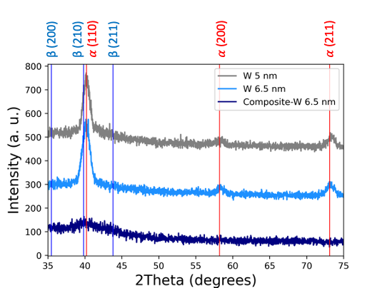
Figure S1. Gracing incident X-ray diffraction patterns of single-layer-W and composite-W samples.
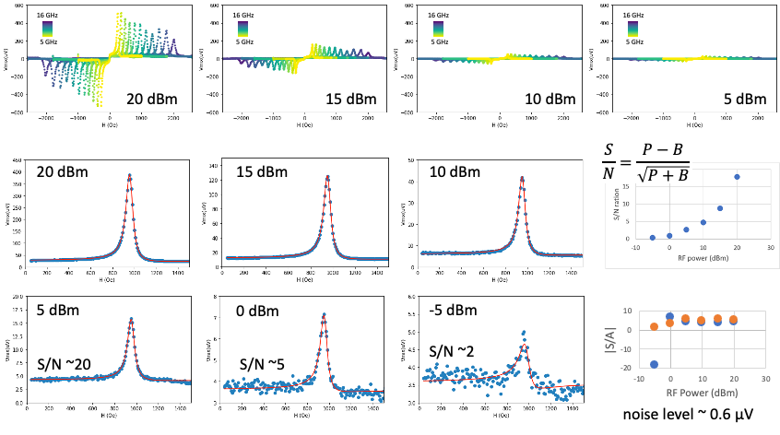
Figure S2. Power dependence on ST-FMR spectrum.
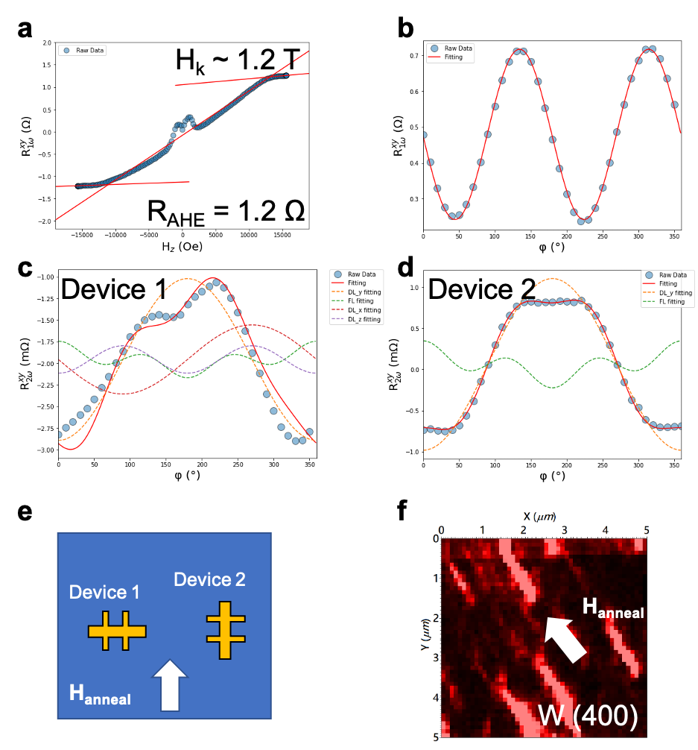
Figure S3. Harmonic Hall measurements of SOTs in the composite-W structures. a, Typical first harmonic Hall resistance under out-of-plane external field. b, Typical angular dependence of first harmonic Hall resistance. c and d, The second harmonic Hall resistance measured from two different device geometry shown in e. Device 1 has current channel perpendicular to the field annealing direction, and device 2 has the current passing parallel to the field annealing direction. f, The tungsten texture revealed by nano-X-ray diffraction mapping.
$$R_{H,2ω}=R_{AD,x}sinφ+R_{AD,y}cosφ+R_{AD,z}cos2φ+R_{FL,x}cos2φsinφ+R_{FL,y}cos2φcosφ+R_{FL,z}$$
Fig. 3S illustrates the two devices we study here, in device 1(2), the current is running perpendicularly (parallelly) to the magnetic field annealing direction. Fig. 3Sc and d show the ∅ dependence of $R_{1ω}^{xy}$ and $R_{2ω}^{xy}$of device 1 fabricated on the 6.6-nm composite W sample, respectively, under H_{ext} = 0.155 T. We can obtain the R_{P} of device 1 is 237 mΩ by the fitting result shown in Fig. 3c. The representative measured $R_{2ω}^{xy}$ (open circles) is plotted in Fig. 3d and fitted with the corresponding equation above (dash lines). We can learn that the data is well fitted with mainly $H_{DL}^{y}$term, which has $\cos{∅}$ dependence, and partially with $H_{DL}^{x}$, $H_{DL}^{z}$, and $H_{FL}^{y}$. To quantitively extract the magnitude of these terms, we conducted H_{ext} dependence measurements ranging from 277 Oe to 2100 Oe (preventing the non-linear response at the small field). Fig. S3d shows the overall fitting results that clearly exhibit asymmetric behavior (non-$\cos{∅}$ dependence). This implies the device 1 in our sample can generate a non-convectional spin polarization, which can trigger field-free switching of Type-X(Z) SOT-MRAM. On the other hand, we carried out the same measurements on device 2, in which we have R_{P} = 244 mΩ, and symmetric $R_{2ω}^{xy}$behavior ($\cos{∅}$ dependence) as shown in Fig. S3 d. From the field dependence data, we can extract all the fitted terms and calculate the damping(field)-like torque efficiency originated from three components by $ξ_{DL}^{i}=\frac{2e}{ℏ}\frac{H_{DL}M_{S}t}{j_{W-Co}}$ and $ξ_{FL}^{i}=\frac{2e}{ℏ}\frac{H_{FL}M_{S}t}{j_{W-Co}}$ summarized in table S1, where $i$ = x, y, or z, and $j_{W-Co}$ is the current density running through the W-Co layer.
Table S1. Summary table for all the terms extracted from 2nd harmonic Hall resistance measurements.
 | $$ξ_{DL}^{y}$$ | $H_{k}$ (T) | $I_{0}α∇T$ (Oe) | $$ξ_{FL}^{y}$$ | $$ξ_{DL}^{x}$$ | $$ξ_{DL}^{z}$$ | $$ξ_{FL}^{x}$$ | $θ_{SH}$ by ST-FMR
Device 1 | 0.65 | 1.1 | 1 | ~0 | 0.006 | ~0 | ~0 | 0.52
Device 2 | 0.51 | 1.1 | 1 | ~0 | ~0 | ~0 | ~0 | 0.52
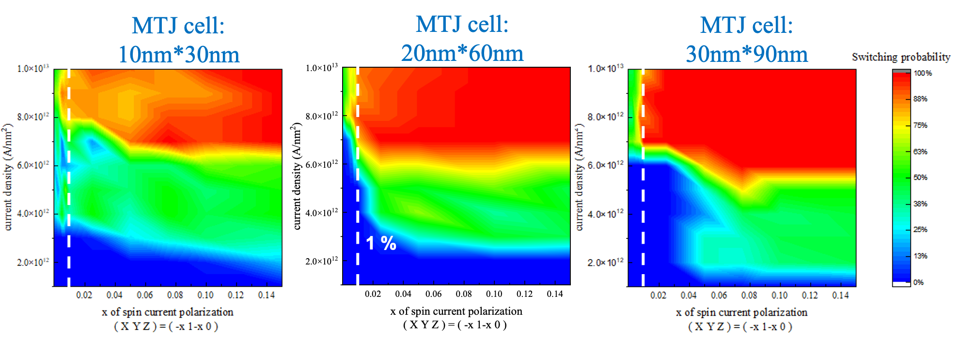
Figure 4S. Micromagnetic simulations for unconventional SOT switching.
Field-free spin–orbit torque switching
To explore the possibility of using $ξ_{DL}^{x}$to achieve field-free Type-X SOT switching, we firstly model our system by micromagnetic simulation in oommf (Object-Oriented MicroMagnetic Framework) software for switching study. In our model, we set a free-layer in three different sizes – from 30-10 nm by 90-30 nm by 1 nm elliptical disk with in-plane anisotropy along x-direction (as shown in Fig. 4S) with spin polarization vector [-x,1-x,0], where 1 represents 100% conventional spin polarization. From the simulations shown in Fig. 4S, we can find that 1% of x-component is sufficient to realize the type-x field-free switching at the high current density region. We have also demonstrated the type-x field-free switching in the array level devices in our previous publication. The simulations and nano-sized device results confirm that the composite-W layer supplies not only conventional spin-orbit torque resulting from spin Hall effect but also a damping-like torque induced by spin polarization along x-direction, enabling the field-free Type-X SOT switching.

Donahue, Michael Joseph, and Donald G. Porter. "OOMMF user's guide, version 1.0." (1999).
Song, M. Y., et al. "High speed (1ns) and low voltage (1.5 V) demonstration of 8Kb SOT-MRAM array." 2022 IEEE Symposium on VLSI Technology and Circuits (VLSI Technology and Circuits). IEEE, 2022.

