Supporting Information
Macro-chiral liquid crystal quantum dots enable large asymmetric circularly polarized luminescence
Huanan Yu¹*, Kaige Zhang¹, Qiqi Yu², Carl Redshaw³, Zhonghui Chen⁴*, Jiaxuan Zeng⁴, Zixu Sun⁵, Dongdong Xu²* and Georg H Mehl³*
¹School of Materials and Chemistry, China Jiliang University, Hangzhou 310018, China
²Key Laboratory of Organosilicon Chemistry and Materials Technology of Ministry of Education, College of Material, Chemistry, and Chemical Engineering, Hangzhou Normal University, Hangzhou 311121, China
³Department of Chemistry, University of Hull, Hull HU6 7RX, UK
⁴Advanced Optoelectronic Technology Research Institute Zhengzhou Research Institute, Harbin Institute of Technology, Zhengzhou 450052, China
⁵Key Lab for Special Functional Materials of Ministry of Education, School of Materials Science and Engineering, Henan University, Kaifeng 475004, China

*Corresponding authors.
E-mail addresses: zhonghui-chen@hit.edu.cn; DXu@hznu.edu.cn; G.H.Mehl@hull.ac.uk; huanan-yu@cjlu.edu.cn

Contents
1. Methods 3
2. HRTEM, UV-vis and Φ value of the core–shell CdSe/ZnS QDs 6
3. POM, DSC, UV-vis and FL results for the chiral mesogen (R) LC 8
4. POM, DSC, FL and Φ value results of (R) QDs/LC nanocomposite 11
5. Phase transfer of (R) QDs/LC from water to DCM 14
6. DC and TGA results of (R) QDs/LC 15
7. Photographs of (R) QDs/LC doped in 5CB 17
8. The photonic bandgap property of the SEG 18
9. The CPL emission of the SEG 19
10. CD spectra of PTA film induced by only 254 nm UV lamp 20
11. References 22

Methods
Chemicals and reagents
All reagents were used as received without further experimental purification. Cholesterol (CHOL, 95%+), (R)-(+)-1, 2-dithiolane-3-pentanoic acid (RLA, 98%), (S)-5-(1,2-dithiolan-3-yl)pentanoic acid (SLA, 97%+), 4-dimethylaminopyridine (DMAP, 99%), N,N'-diisopropylcarbodiimide (DIC, 98%), liquid crystal 5CB, cadmium sulfate (Cd(SO₄), 99.99%+), 3-mercaptopropionic acid (3-MPA, 98%), sodium hexametaphosphate ((NaPO₃)₆, 99%), sodium hydroxide (NaOH, 96%), selenium dioxide (SeO₂, 99%), nitric acid (HNO₃, 70%), hydrazine hydrate (NH₂NH₂ H₂O, 98%), zinc sulfate (ZnSO₄, 2.0 M in H₂O), sodium sulfide (Na₂S, 95%) were purchased from Aladdin. Lipoic acid (LA, 99%), dichloromethane (DCM, 99%), ethylacetate (EAC, 99%), hexane (Hex, 97%), ethanol (EtOH, 99.7%) were purchased from Macklin.
All reactions were conducted under nitrogen. All solvents were of AR quality and used without further purification. Column chromatographic separations were performed on silica gel (60-120, 100-200 & 230-400 mesh). Thin layer chromatography (TLC) was performed on aluminum sheets pre-coated with silica gel (TLC Silicagel 60 F254, Merck KGaA, Germany).
Synthesis of core–shell CdSe/ZnS QDs
The preparation of the 3-MPA capped core–shell CdSe/ZnS QDs with green emission followed the hot-injection approach in the literature.¹⁻³ The precursor solution of cadmium was prepared by mixing 20 mL (8.5 mmol/L) of cadmium sulfate solution, 60 μL (90%) of 3-mercaptopropionic acid solution, and 20 mL (15 mmol/L) of sodium hexametaphoshpate solution. The pH was adjusted to approximately 12 with 3 mol/L sodium hydroxide solution. For the selenium precursor solution, 0.029 g of selenium dioxide was dissolved in 5 mL of 70% nitric acid solution, diluted to 20 mL with deionized water, yielding a selenium ion concentration of 0.01 mmol/L. The cadmium and selenium precursor solutions were combined, and 4 mL of 80% hydrazine hydrate solution was added while stirring. After heating at 100°C and refluxing for 5 h, the solution was centrifuged with acetone solvent (7500 r/min). Subsequently, deionized water was added to obtain the CdSe quantum dot solution. This solution was then reacted with 1 mL each of zinc sulfate solution (10 mol/L) and sodium sulfide solution (10 mol/L) at a rate of 1 mL/min while stirring and purging with nitrogen for 30 minutes. The resulting reaction mixture was heated at 100°C and reflowed for 7 h. A portion of the reaction solution (20 mg) was mixed with 1 mL of chloroform and 0.1 mL of 3-mercaptopropionic acid solution (0.1 mol/L). This led to the formation of the 3-MPA capped core–shell CdSe/ZnS QDs, which were subsequently dried and heated at 60°C for 1 h.
Synthesis of (R) LC
Cholesterol (34.8 mg, 0.09 mmol), (R)-(+)-1, 2-dithiolane-3-pentanoic acid (65.0 mg, 0.32 mmol) and DMAP (37.0 mg, 0.30 mmol) were dissolved in dry DCM (15 ml). The mixture was deoxygenated with bubbling nitrogen for 1 h. Then DIC (0.16 ml, 1.00 mmol) was added in one portion and it was stirred at RT under nitrogen atmosphere for 3 days. The solvent was evaporated and the product was purified by column chromatography (hexane/ethyl acetate 4:1) to obtain the first spot on the TLC plate. After recrystallization in hexane, light yellow crystals (R) LC was obtained (47.1 mg, 91.5%). The same synthetic method is used for the preparation of (S) LC.
Preparation of homeotropic LC cells
The homeotropic cell was purchased from Japan (KSHH-25/A107P1NSS, E.H.C., Tokyo, Japan) and the known cell gap = 25 µm was used to calculate the helical pitch. On a heating stage with temperature higher than the isotropic transition temperature of host LC (105℃), the cell gap was filled with QD-LC mixtures (mixing 5.0 wt% (R) LC or 5.0 wt% (R) QDs/LC in 5CB) by capillary force and the cell was left for another 2 h before OPM observation.
Preparation of LC cells for SEG
Uniform glass beads (Diameter = 20.0 μm) were dispersed in the UV-curable adhesive by ultrasonic dispersion. The mixture was placed between two glass sheets along the edge (Fig. S1), and then irradiated by a UV lamp for 30 s to make the two glass sheets stick firmly. After that, the SEG was filled into cells via capillarity action.
Fig. S1 Fabrication of the SEG-fulfilled LC cell. a, Schematic drawing of the fabrication process of the SEG cell. b, Photographs of the empty cell, SEG under natural light and SEG under UV light. c, Schematic illustration of the CPL emission from the representative SEG.
Preparation of TA films
The uniformly cut glasses were cleaned with ethanol and acetone and dried overnight in a vacuum drying oven. TA was dissolved with the mixture of ethanol and deionized water (ethanol: deionized water = 4:1), and then gently dropped onto glass sheets. The glass sheets with TA liquid drops were placed in a constant temperature and humidity incubator to dry into films before polymerization.

HRTEM, UV-vis and Φ value of the core–shell CdSe/ZnS QDs
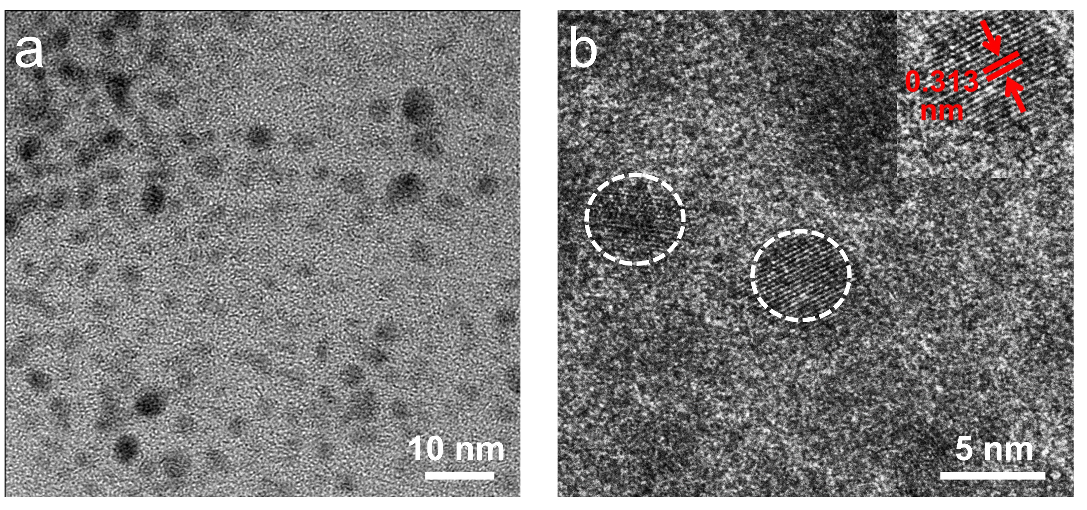
Fig. S2 Morphological characterizations of core–shell CdSe/ZnS QDs. a, HRTEM image of core–shell CdSe/ZnS QDs. b, HRTEM lattice image of core–shell CdSe/ZnS QDs.

Fig. S3 Optical characterization of core–shell CdSe/ZnS QDs. a, UV-vis. b, Φ value of the core–shell CdSe/ZnS QDs.

POM, DSC, UV-vis and FL results for the chiral mesogen (R) LC
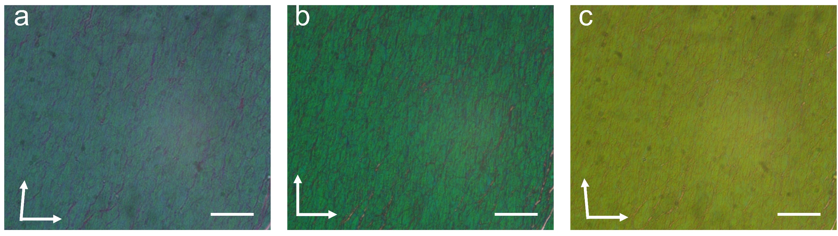
Fig. S4 Cholesteric nematic phase of chiral mesogen (R) LC. POM micrographs of (R) LC at 80℃ (x50 μm). a, 80° crossed polarizers. b, 90° crossed polarizers. c, 100° crossed polarizers.
The observed POM texture of (R) LC at 80° showed characteristic oily streaks. By changing the polarizer angles from 80° to 100°, the reflective color in texture changes because of the helically twisted LC structure.

Fig. S5 Mesophase behaviour of chiral mesogen (R) LC. DSC results of (R) LC at a heating and cooling rate of 10.0℃/min.

Fig. S6 Optical characterization of the chiral mesogen (R) LC. a, UV-vis and b, FL results of (R) LC.

POM, DSC, FL and Φ value results of (R) QDs/LC nanocomposite
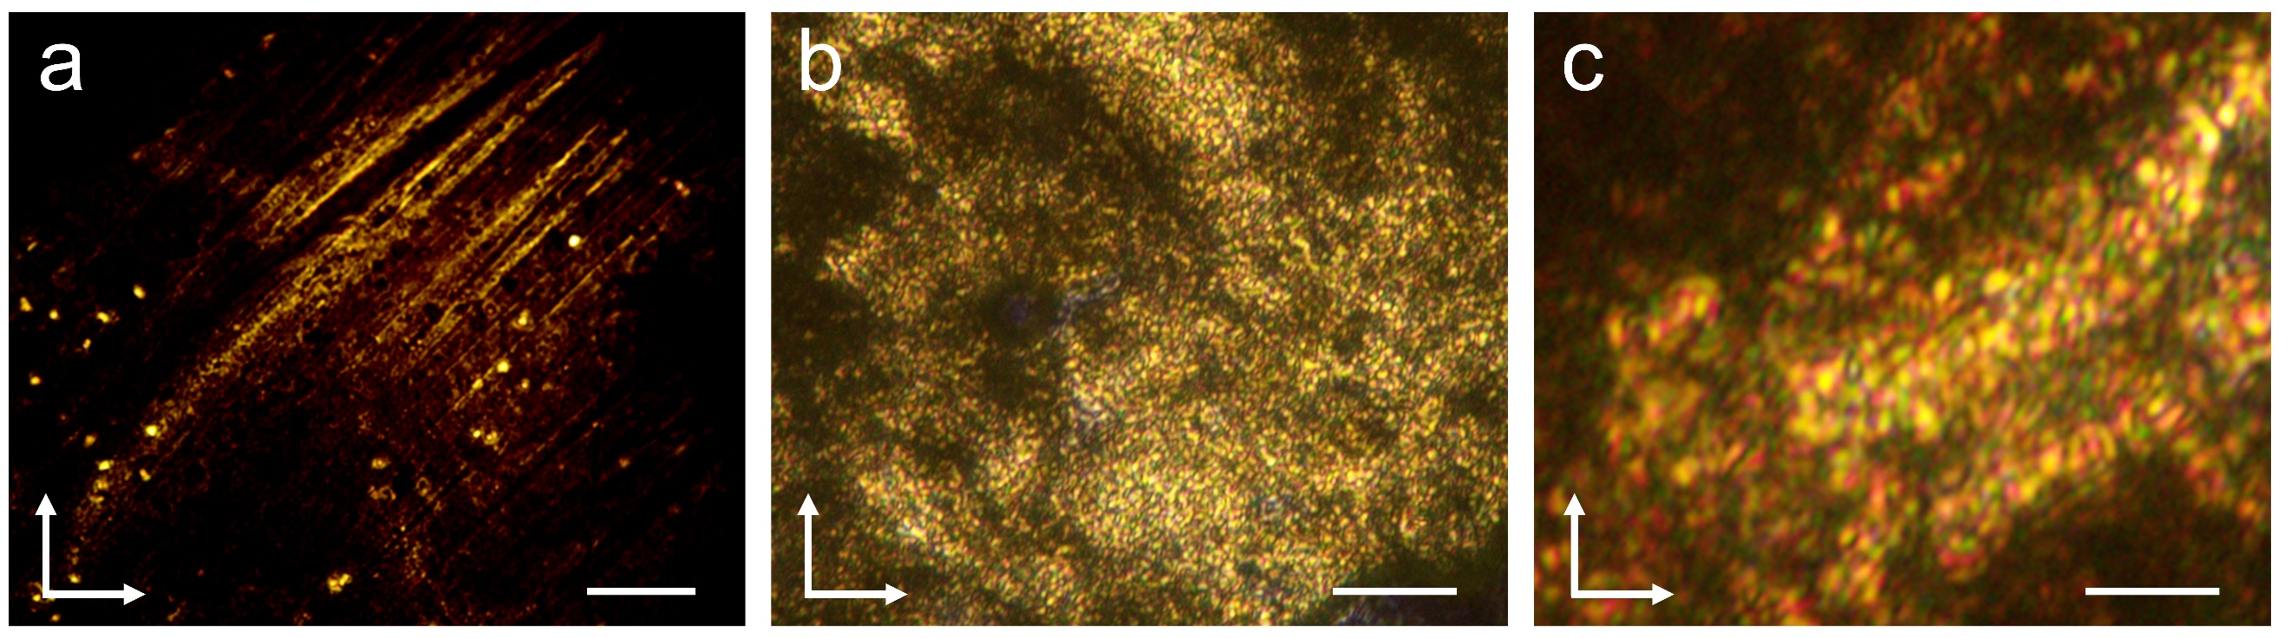
Fig. S7 POM micrographs of (R) QDs/LC at 70℃ (90° crossed polarizers). a, x100 μm. b, x50 μm. c, x25 μm.

Fig. S8 Mesophase behavior of (R) QDs/LC. DSC results of (R) QDs/LC at a heating and cooling rate of 5.0℃/min.
Owing to the plastifying effects of the MPA co-ligands and packing constraints of the LC groups attached on QDs, the (R) QDs/LC nanocomposite displays a small decrease in transition temperatures in contrast to the free (R) LC ligands Fig. S5. The hump on the heating cycle at ~57℃ demonstrates a glass transition

Fig. S9 Optical characterization of (R) QDs/LC. a. FL and b, Φ value results of (R) QDs/LC.

Phase transfer of (R) QDs/LC from water to DCM
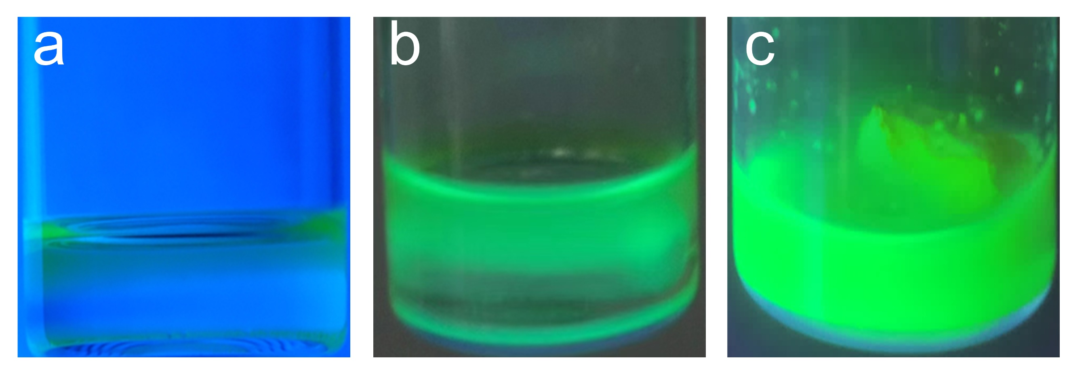
Fig. S10 Fabrication of (R) QDs/LC. During the synthetic process, it is observed that the (R) QDs/LC show green emission with higher brightness than CdSe/ZnS QDs and the obtained LC-functionalized CdSe/ZnS QDs transfer from water phase to DCM solution.

DC and TGA results of (R) QDs/LC
Fig. S11 Characterization of Ch-QDs/LC. DC spectra of Ch-QDs/LC: (R) QDs/LC and (S) QDs/LC.

Fig. S12 Component analysis of (R) QDs/LC. TGA was performed and gives the weight fraction of CdSe/ZnS in (R) QDs/LC to be 62.5% (wt/wt).
Based on the TGA results above, it can be calculated that the weight fraction of organic groups in (R) QDs/LC to be 37.5% (wt/wt). Since the amount of chiral mesogen bound to the QDs surface relative to the number of MPA groups was determined to be 2:1 in the ¹H NMR spectroscopic analysis, the molar fraction of chiral mesogen in 95.0 wt% 5CB system could be calculated. Considering there are 84 (± 3) chiral meogens per QD, the molar fraction of (R) QDs/LC in 5CB was obtained.
The calculation of the helical twisting power HTP (a measure for the ability of a chiral dopant to twist a nematic LC phase) could be calculated by the equation β_{M} = 1/pc, where p is the helical pitch in system and c is the molar concentration of chiral dopant in mixture. Here for the mixtures of 5CB doped with 5.0 wt% (R) LC and 5.0 wt% (R) QDs/LC, the HTP values are estimated to be 13.2 and 871.2 μm⁻¹, respectively.

Photographs of (R) QDs/LC doped in 5CB
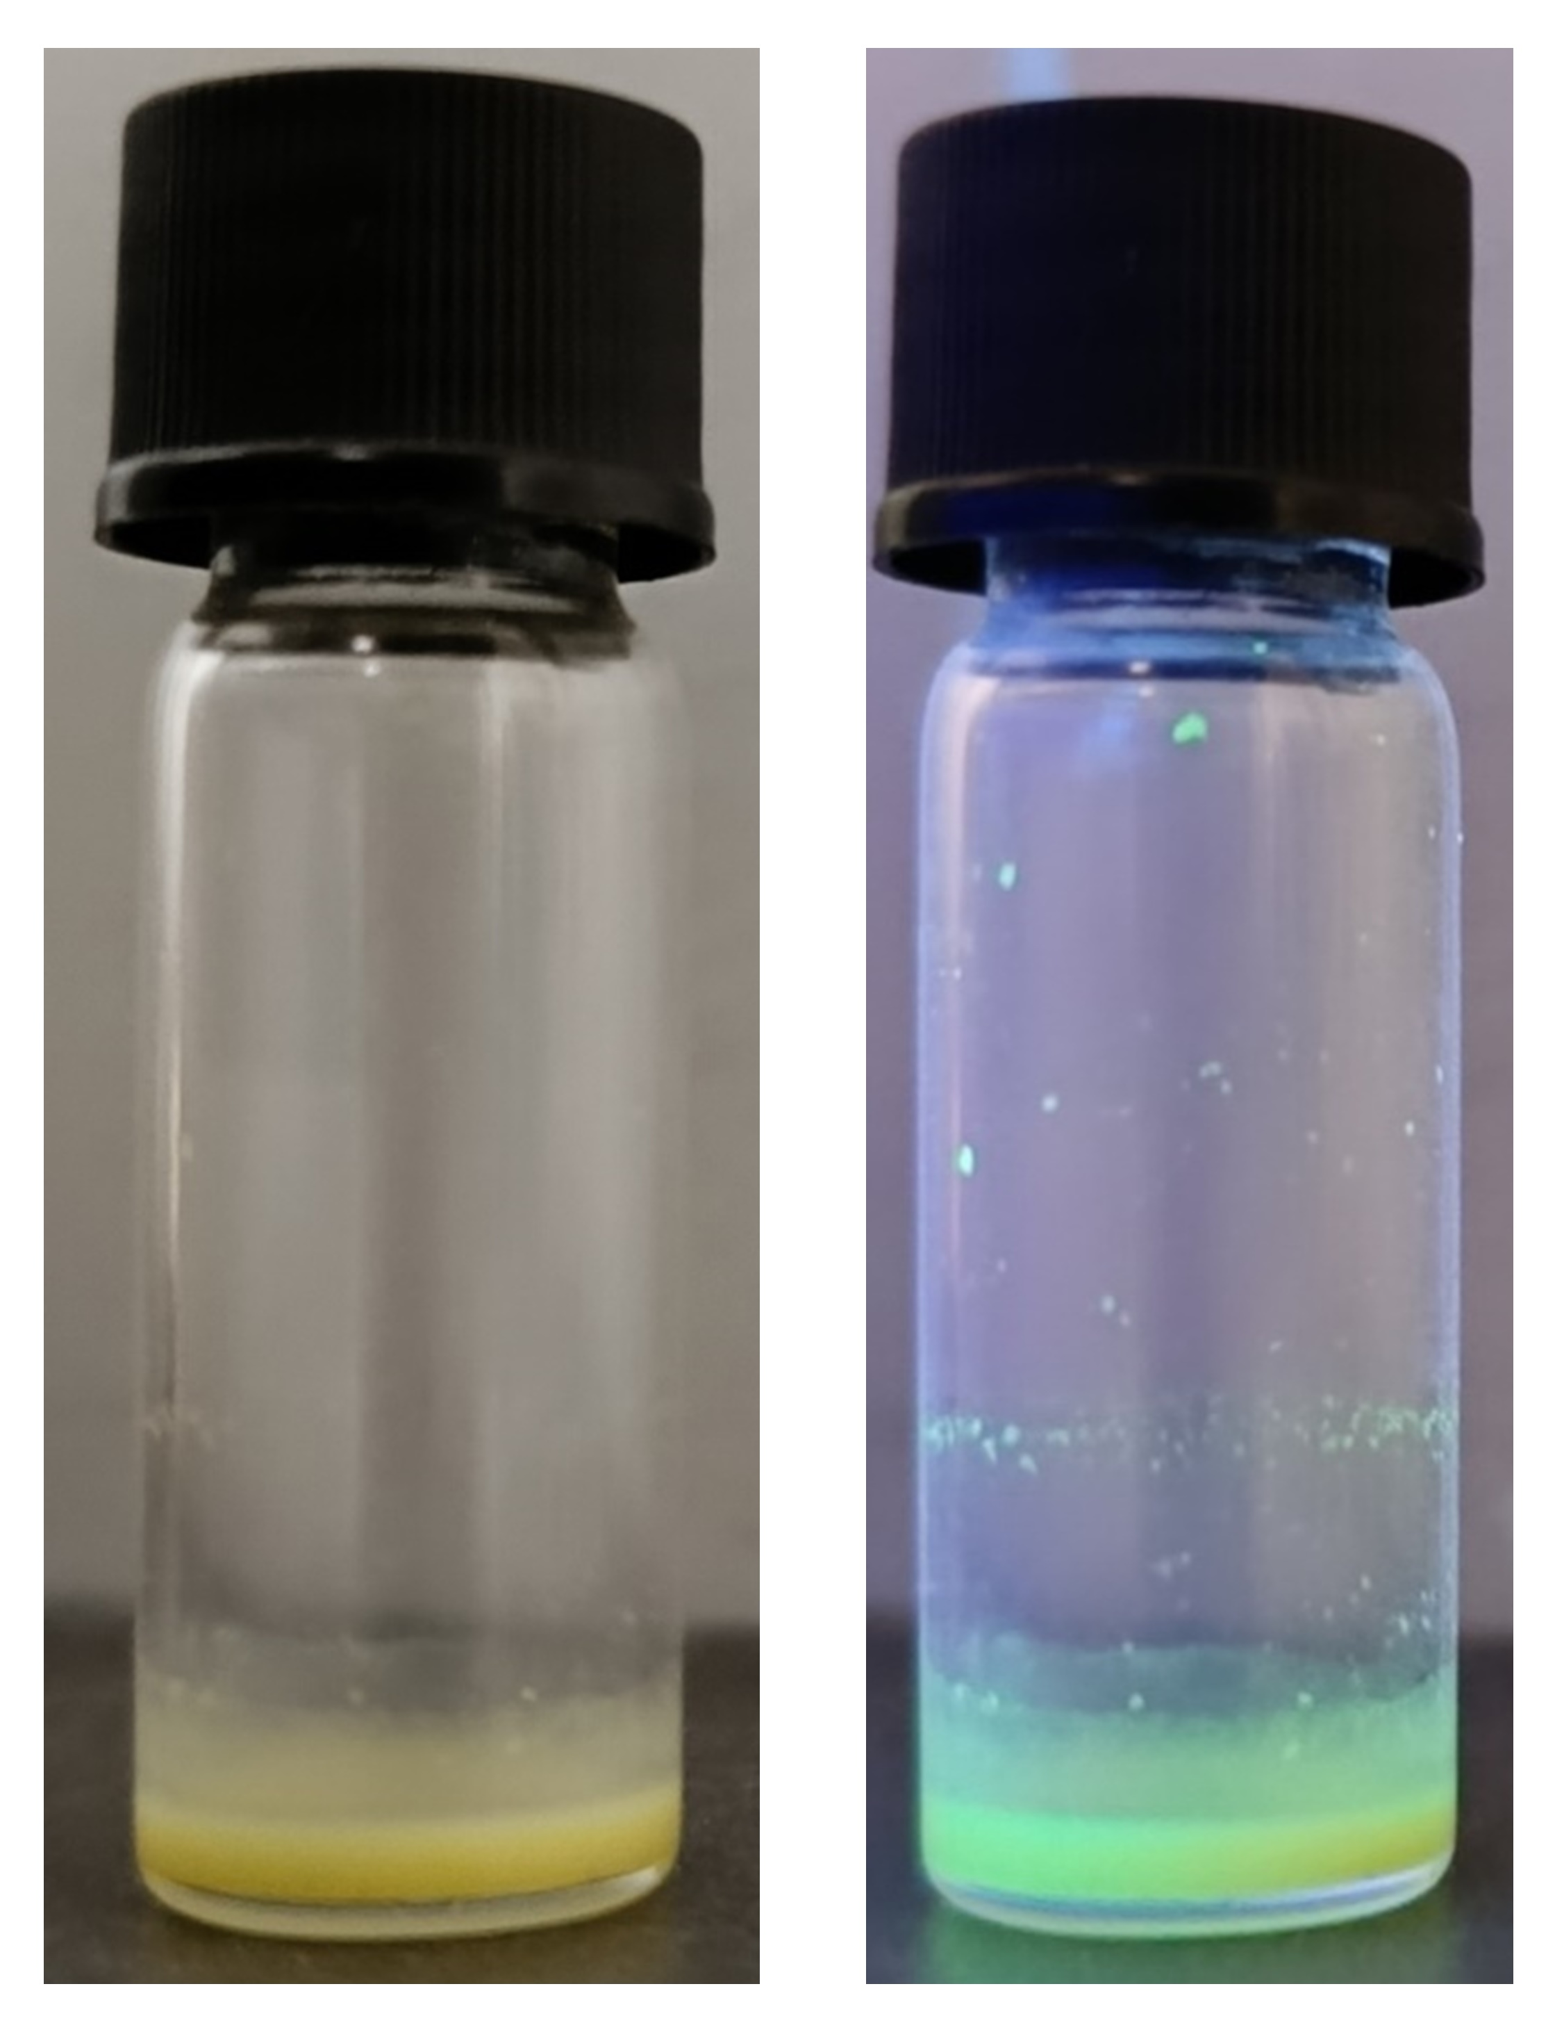
Fig. S13 Photographs of QD-LC mixture for SEG. The built SEG (doping 13.5wt% (R) QDs/LC doped in 5CB) show green emission under UV light.

The photonic bandgap property of the SEG
Fig. S14 Illustration of the mechanism of photonic bandgap selectivity and generation of CPL. By embedding the PL of (R) QDs/LC within the photonic bandgap of the cholesteric nematic LC, stronger CPL signals and larger g_{lum} values could be achieved.⁴

The CPL emission of the SEG
Fig. S15 Fabrication of SEG. a, The SEG was fulfilled with chiral nematics doped with Ch-QDs/LC in the cell. b, Schematic illustration of the CPL emission from the representative SEG.

CD spectra of PTA film induced by only 254 nm UV lamp

Fig. S16 Characterizations of the polymerization of TA. CD spectra of PTA film induced by only 254 nm UV lamp.⁵
We also conducted the comparative experiments to confirm the interaction between CPL and TA. The polymerized TA film exposed only under a 254 nm UV lamp displayed no CD signals, revealing that the enantioselectivity depends on the handedness of CPL.

Fig. S17 Characterization of the chiral mesogen (R) LC. Mass spectrum of (R) LC.

References
- Mehta J, Dilbaghi N, Singhal N K, et al. Electrochemiluminescent quantum dots as emerging next generation sensing platforms. Chem. Eng. J., 2023: 146958.
- Ma F, Li C, Zhang C. Development of quantum dot-based biosensors: principles and applications. J. Mater. Chem. B, 2018, 6(39): 6173-6190.
- Kershaw S V, Susha A S, Rogach A L. Narrow bandgap colloidal metal chalcogenide quantum dots: synthetic methods, heterostructures, assemblies, electronic and infrared optical properties. Chem. Soc. Rev., 2013, 42(7): 3033-3087.
- Zhou Y, Wang Y, Song Y, et al. Helical-caging enables single-emitted large asymmetric full-color circularly polarized luminescence. Nat. Commun., 2024, 15(1): 251.
- Huang Y, Qian Y, Chang Y, et al. Intense Left‐handed Circularly Polarized Luminescence in Chiral Nematic Hydroxypropyl Cellulose Composite Films. Adv. Mater., 2024: 2308742.

